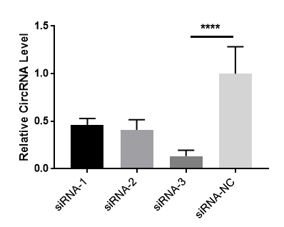
Figure S1： Relative expression level of hsa_circ0063526 in End1/E6E7 cells after siRNA transfection. Replicated 3 times involving 3 samples (**** P<0.001).

