Supplementary Information for

Chiral Phonons in Biocrystals

Won Jin Choi, Keiichi Yano, Minjeong Cha, Yichun Wang, Felippe M. Colombari, Sang Hyun Lee, John M. Kruger, André F. de Moura* and Nicholas A. Kotov*

*correspondence to: moura@ufscar.br (A.F.M.), kotov@umich.edu (N.A.K.)

This PDF file includes:

Materials and Methods
Figures S1 to S19
Table S1 to S5
References (1-69)

Other Supplementary Materials for this manuscript includes the following:

Video files imbedded in MS PowerPoint files titled Single-Molecular_Vibrations.ppt and Chiral_Phonons.ppt depicting selected vibrational modes of single molecules and crystalline supercells of L-Glu, L-Met, and L-CYT, respectively

1–1011–2021,22,31,23–3032–3839–47
Table of Contents

1. Materials and Methods:
1-1. Sample Preparation and Characterization of Crystals
- Recrystallization of 20 proteinogenic amino acids (AAs)
- Recrystallization of cystine (CYT)
- Characterization of crystalline phases and sizes of crystals
- Preparation of slurry samples
- Cystine stone samples from canine patients
- Commercial L-carnosine (L-CAR) supplements and other various dipeptide samples

2. Measurements:
2-1. Hyperspectral THz-TDP measurements
- Hyperspectral THz-TDP setup
- Configuration of three polarizers (P1, P2 and P3)
- Calculation of electric fields and Stokes equation for TA, TORD, TCD
- TCD mapping method and the reference sample
- TA and TCD spectra of all AA crystals

3. Analysis and Simulations:
3-1. Statistical analysis of TA spectra
- Correlation matrix
- ‘Violin’ plots
3-2. Analytical description
- Born-Kuhn theory
- Parametric fitting using non-linear regression method
3-3. Quantum Mechanical Simulation of the TA and TCD spectra
- DFT calculations for single AA or dipeptide in vacuum
- DFT calculations for crystalline AA or dipeptide supercell
- TA spectra derived from normal mode analysis within the harmonic approximation
- TA and TCD spectra derived from MD simulations

4. Discussion
- Effect of size of AA crystals on the THz behavior
- Slurry samples for THz spectroscopy
- THz spectra from amorphous samples
- TA and TCD spectra of AAs crystals having similar molecular structures.
- TA and TCD spectra of DL-CYT and deuterated L-CYT
- TA and TCD spectra of various dipeptide crystals

1. Materials and Methods

Unless otherwise noted, all reagents were purchased from Sigma-Aldrich and Tokyo Chemical Industry (TCI) and used as received without further purification.

1-1. Sample Preparation and Characterization of Crystals

Recrystallization of 20 proteinogenic amino acids (AAs)
A recrystallization process is described in a flow diagram in Fig. S1. In general, samples (approx. 0.5 to 2 grams) of AA enantiomers were stirred in a glass vial in boiling E-pure water until completely dissolved. The resultant hot solution was transferred into a Petri dish covered with a lid and left undisturbed for ~1 day for the crystal growth. The obtained crystals were filtered and washed with ethanol at least three times under reduced pressure. For anhydrous crystals, the filtered crystals were further dried at 60 °C under reduced pressure for 12 hours.
Specific recrystallization conditions for AAs are summarized in Table S1. E-pure water was used as solvent for most AAs, while 1 M oxalic acid solution and ethanol were used for tyrosine (Tyr) and proline (Pro), respectively, due to their low solubility in E-pure water. The hydration states of arginine (Arg) and asparagine (Asn) were controlled by the final heat drying process; as-recrystallized hydrated forms of arginine and asparagine crystals can be converted, by heat drying at 60 °C, into their anhydrous forms. Lysine (Lys) was used as received without further recrystallization.

Recrystallization of cystine (CYT)
L- and D-cystine (CYT) were recrystallized according to the aforementioned procedure using 1M HCl solution. Deuterated L-cystine was recrystallized similarly but using 1 M deuterium chloride (DCl) solution in deuterium oxide (D₂O). Racemic DL-cystine was used as received without further recrystallization.
1–1011–2021–23,28–3132–36,38,4839–47
Characterization of crystalline phases and sizes of crystals
Crystalline phases of crystals were characterized by powder X-ray diffraction (PXRD) measurements using a SmartLab Powder X-ray diffractometer (Rigaku) equipped with a 2.2-kW Cu anode (CuKα, λ = 1.54 Å), a Kβ filter, and a D/teX Ultra 250 high speed silicon strip 1D detector. The PXRD data were collected in a range of 15 to 60° in 2θ by a step-scan mode with a step size of 0.01°. The crystals were ground as fine as possible using a pestle and a mortar and mounted onto a glass plate for their PXRD measurements. The phase purity and space group of crystals were analyzed by comparing their experimental diffraction patterns with the reported data of the corresponding single crystals. The single crystal data were collected from the Cambridge Crystallographic Data Centre (CCDC)⁴⁹ and their diffraction patterns were reproduced using the Mercury software ⁵⁰. Figure S2 and S3 shows PXRD patterns of crystals and their crystalline phases are summarized in Table S2.
The precise size and crystal habit of each AA crystal was measured by scanning electron microscope (Tescan Mira3 FEG SEM) (Fig. S4). Their size distributions were estimated by static light scattering measurements using a Mastersizer 2000 (Malvern) equipped with a Hydro 2000S wet dispersion unit. The size distribution data were collected in a wide range of 0.01 to 10,000 µm (Fig. S5). The ground crystals were dispersed in 2-propanol in a measuring cell and subjected to intense stirring and agitation to ensure homogeneity. Effects of size and the crystallinity of the AA crystals on the THz behavior are discussed in the ‘Discussion’ section (Fig. S6-8).

Preparation of slurry samples
The use of slurry samples has long been adopted in infrared spectroscopy, known as the Nujol mulling method ⁵¹. Slurry samples of crystals, 50 wt%, were prepared by mixing ~150 mg of ground crystals with ~150 mg (~180 μL) of mineral oil using a micro-spatula. The slurry samples were placed between two quartz plates with a ~100 µm thick spacer, and the sandwich cell was pressed by clamps to ensure a flat surface without voids.

Cystine stone samples from canine patients
Use of archived stones obtained from client-owned animals as part of standard veterinary medical care has been approved by the Michigan State University Institutional Animal Care and Use Committee. Four naturally occurring cystine stones removed from two client-owned canine patients as part of standard veterinary medical care were analyzed. All were removed from the bladder or urethra. One patient was a 7-year-old male American pit bull terrier, the other was a 6-year-old male English mastiff. The size of the cystine stones were between 3.5 mm to 6.0 mm and measured without further treatment.

Commercial L-carnosine (L-CAR) supplements and other various dipeptide samples
Five L-CAR supplements from different manufacturers were purchased and analyzed without further treatment: L-CAR1 from Bestvite, L-CAR2 from Jarrow Formulas, L-CAR3 from Now, L-PCAR4 from Nutricost, L-CAR5 from Nova. Powders from each capsule were mixed with mineral oil (50 wt%) and 81 points were measured for 2D plot analysis. All other dipeptides including L-carnosine were purchased from Sigma-Aldrich for laboratory samples: L-carnosine ( C9625-5G), Gly-Gly (G1002-25G), Ala-Tyr (A4003-100MG), Ala-Ala (A9502-1G), Ala-Gln (A8185-5G). Each of the dipeptide samples were analyzed using the slurry method.

2. Measurements

2-1. Hyperspectral THz-TDP measurements

Hyperspectral THz-TDP setup
Hyperspectral terahertz time-domain polarimetry (THz-TDP) was used to measure the chiroptical responses of the AA samples. The generation and detection of the terahertz waveform were accomplished with a standard time-domain terahertz spectrometer (TeraSmart, Menlo Systems) using photoconductive antennas with a pulsed laser at 1560 nm. Same Tera15-FC antenna modules were used as emitter and detector, respectively. The four identical lenses (TPX50, Menlo Systems) made of TPX polymer (polymethylpentene) with a diameter of 1.5” and a focal length of 50 mm were used to make collimated THz rays. Sample scanning in the THz focal plane was achieved by motorized XY stage. Three linear polarizers were used to determine the optical rotatory dispersion, TORD, (θ) and circular dichroism, TCD, (η) of arbitrarily polarized THz waves ^{30,31}. Here, micro-patterned gold strips on the parylene C film were used for wire grid polarizers exhibiting high extinction ratio over the THz range ^{30,52}.

Configuration of three polarizers (P1, P2 and P3)
Orientation of the linear polarized THz beam from the THz emitter was fixed at a horizontal orientation to the optical breadboards (defined here as the x axis, Fig. S9) while the THz detector was fixed at a vertical orientation (defined as the y axis) ³⁰. The first polarizer (P1) was placed in front of the emitter and its transmission direction (perpendicular to the wire grid orientation) was fixed to the x axis. The third polarizer (P3) was placed right before the THz emitter and its transmission direction was fixed to the y axis, making it cross-polarized to P1 and the emitter. The second polarizer (P2) was placed between P1 and P2 and was rotated to different orientations to determine the complete polarization state of the transmitted electric field ³⁰.
When the P2 transmission axis was along the y direction (defined as 0°), it was co-polarized with P1 and the y-component of the transmitted electromagnetic waves through sample $E_{y}\left(t\right)$ was measured. The x-component $E_{x}\left(t\right)$was readily measured by rotating the orientation of P2 transmission axis to +45° and -45° and calculated by the subtraction of the two x-components $E_{+45°}\left(t\right)$ and $E_{-45°}\left(t\right)$. Because any arbitrary electric field can be decomposed into two perpendicular components, polarization states such as the TORD and TCD can be fully determined with three measurements ^{30,31}.

Calculation of electric fields and Stoke equations for TA, TORD and TCD
Obtaining terahertz absorption coefficients (TA), optical rotational dispersion (TORD) and circular dichroism (TCD) is started with calculation of the x and y components of the electric field as stated elsewhere ³⁰. The x-component of the electric field can be calculated by

$$\begin{aligned}E_{x}\left(t\right)=E_{+45°}\left(t\right)-E_{-45°}\left(t\right)\#\left(1\right)\end{aligned}$$

where $E_{+45°}\left(t\right)$ and $E_{-45°}\left(t\right)$ are the time-domain electric field for the orientation of polarizer P2, where transmission axes are at +45° and -45° relative to the y-axis, respectively.

Complex frequency-domain electric field spectra are obtained using fast Fourier transform (FFT) from the electric fields measured in the time-domain as follows:

$${\tilde{E}}_{x}={\tilde{E}}_{x}\left(ω\right)=FFT\{E_{x}\left(t\right)\}$$
$$\begin{aligned}{\tilde{E}}_{y}={\tilde{E}}_{y}\left(ω\right)=FFT\{E_{y}\left(t\right)\}\#\left(2\right)\end{aligned}$$

The transmittance spectrum of the sample and refence can be calculated from two electric fields

$T_{s}=\sqrt{{\left|{\tilde{E}}_{x}\right|}^{2}+{\left|{\tilde{E}}_{y}\right|}^{2}} (3)$
$T_{ref}=\sqrt{{\left|{\tilde{E}}_{ref,x}\right|}^{2}+{\left|{\tilde{E}}_{ref,y}\right|}^{2}} (4)$

Here, $T_{s}$ is transmittance through a quartz sandwich cell with slurry, mixture with highly concentrated sample powder with mineral oil (MO), and $T_{ref}$ is transmittance through a quartz sandwich cell with just MO as a reference.

Accordingly, TA can be obtained by

$TA =-\frac{\ln\left({T_{s}}/{T_{ref}}\right)}{d_{s}} (5)$

where d_{s} is the thickness of the sample. Here, the measured thickness for all samples is 100 μm ³⁰. For the calculation of relative TA, normalization by thickness was not achieved.

Since the polarization of the incident THz beam is linear and emitter and detector are cross-polarized, TORD and TCD can be calculated directly by the measured THz spectra of ${\tilde{E}}_{s}=\left(\begin{matrix}{\tilde{E}}_{x} \\ {\tilde{E}}_{y}\end{matrix}\right)$ using Stokes equations. The four Stokes parameters are defined as

$$S_{0}={\tilde{E}}_{x}{\tilde{E}}_{x}^{*}+{\tilde{E}}_{y}{\tilde{E}}_{y}^{*}$$
$$S_{1}={\tilde{E}}_{x}{\tilde{E}}_{x}^{* }-{\tilde{E}}_{y}{\tilde{E}}_{y }^{*}$$
$$S_{2}={\tilde{E}}_{x}{\tilde{E}}_{y}^{*}+{\tilde{E}}_{y}{\tilde{E}}_{x}^{*}$$
$$\begin{aligned}S_{3}={i(\tilde{E}}_{x}{\tilde{E}}_{y}^{*}-{\tilde{E}}_{y}{\tilde{E}}_{x}^{*})\#\left(6\right)\end{aligned}$$

And the TORD and TCD can be calculated using Stokes parameters as follows:

$$TORD=\frac{1}{2}tan^{-1}\left(\frac{S_{2}}{S_{1}}\right), -\frac{π}{2}≤TORD≤\frac{π}{2}$$
$$\begin{aligned} TCD=\frac{1}{2}sin^{-1}\left(\frac{S_{3}}{S_{0}}\right), -\frac{π}{4}≤TCD≤\frac{π}{4}\#\left(7\right)\end{aligned}$$

TCD mapping method and the reference sample
As mentioned above, since many samples have linear polarization effects such as linear birefringence, an averaging process of the THz spectra from different orientations of the randomly dispersed small-sized crystals is necessary to eliminate linear birefringence and measure signals only originating from the chirality. Here, not only each single spot is measured more than 400 times for an accumulated averaging process, but also 5 to 100 spatially different spots were typically measured for calculation of averaged values and standard deviations. Using a high precision motorized XY positioning stage, measurements of exactly the same spot for every polarization state (i.e. three different orientations of the P2 polarizer angles: -45°, 0°, 45°) were achieved. The algorithms for hyperspectral image processing and calculation of Stokes equations for each pixel were verified by a known chiral kirigami sample as a reference. Details of the reference kirigami sample can be found in elsewhere ³⁰. Briefly, the kirigami sample is made from parylene sheet that was patterned with straight cuts in a face-centred rectangular lattice. Herringbone-patterned thin layers of chromium and gold are deposited on the Parylene C using electron beam evaporator (Enerjet evaporator) after a standard photolithography process (MA/BA6 Mask/Bond aligner, Suss Microtec). Exactly the same protocols and dimensions of the kirigami cuts were used for this study. The slant angle of the gold strips was 30º. The kirigami sample is designed to have a topologically equivalent helix structure with patterned gold strips on the curved polymer sheet. Here, to show our microscopic THz-TDP’s mapping capability, kirigami samples with two chiral domains were chosen and tested. As expected, distinct mirror-like TCD peaks from each domain and zero-TCD peaks from the achiral domain boundary were successfully measured even with very short accumulation times (~2s for each pixel), showing the high signal-to-noise level performance and high accuracy of this mapping system (Fig. S10).

TA and TCD spectra of all AA crystals
TA and TCD spectra were measured by equations (5) and (8), respectively. The reference sample for TA is a quartz sandwich cell with MO as discussed earlier. 25 different spots were measured and averaged to obtain TA and TCD. MO was chosen as a host material for the slurry because it shows high transparency across the THz range and non-chiroptical responses. The raw data of transmission, TA, TCD and TORD of MO are shown in Fig. S11. Likewise, results of all AA crystals are shown in Fig. S12. Most of the multiple reflection etalon effects from quartz sandwich were eliminated by dividing the data of reference (quartz with MO) from the samples. To remove water vapor peaks, an algorithm was used to remove the data at nine points; nine peaks of water are found at 1.10, 1.16, 1.41, 1.66, 1.67, 1.71, 2.16, 2.20, 2.22 THz. Savitzky-Golay (SG) filter for 3 polynomial order was applied to remove the etalon effect from the quartz substrates. To capture low-intensity peak features in the low frequency range (peaks below 1 THz), the data at the exact peak positions were excluded for the SG processing. Averaged TA spectra were cross-checked with some of the previously reported data to confirm and justify our slurry method with a data processing algorithm (Table S3). Almost identical spectra were found when the AAs and the phase of the samples were matched.

3. Analysis and Simulations:

3-1. Statistical analysis of TA spectra

Correlation matrix
To calculate the similarity between spectra and construct a correlation matrix, we adopted the dynamic time warping (DTW) approach ^{53,54}. DTW has been widely used as a distance measure for series classification because matching is relatively elastic and robust for many cases. Since DTW determines an optimal alignment between two sequences, this allows DTW to practically match similar shape sequences together even though the sequences may be slightly shifted or distorted. Given two sequences, $X=\left(x_{1}, x_{2}, …x_{N}\right), N∈N$ and $Y=\left(y_{1}, y_{2}, …y_{M}\right), M∈N$, the optimal nonlinear warping function $ϕ_{x}$ and $ϕ_{y}$ remaps the series of X and Y, respectively. The average accumulated misalignment (distortion) between the two data series X and Y was computed by the following equation,

$$d_{ϕ}\left(X, Y\right)= \sum_{k=1}^{T}{\frac{d\left(ϕ_{x}\left(k\right), ϕ_{y}\left(k\right)\right)m_{ϕ}\left(k\right)}{M_{ϕ}} (8)}$$

where $m_{ϕ}(k)$ is a per-step weighing coefficient and $M_{ϕ}$ is the normalization constant ⁵³.
The DTW algorithm computes the optimal warping path (alignment path) by minimizing the $d_{ϕ}\left(X, Y\right),$imposing following conditions ⁵⁴:

- The starting and ending points of the warping path must be aligned with the first and the last points of the sequence.
- The data should preserve the order of points
- The warping path has to follow the step-size limitation rule, $d_{l+1}-d_{l} ∈ \left\{\left(1,1\right), \left(1,0\right), (0,1)\right\}$

In this study, we used DTW instead of the conventional Euclidean distance method because the DTW method has ability to compromise slight spectral mismatches. Since terahertz spectra from AA have some variations due to the intrinsic heterogeneity of samples, elastic matching is essential for proper analysis. Specifically, we used ‘dtaidistance’ python package (https://pypi.org/project/dtaidistance/) and alignment results with optimal warping path between TA spectra of L-cys and D-cys generated by DTW algorithm are shown in Fig. S13 ⁵⁵.

‘Violin’ plots
‘Violin’ plots are a method of plotting numeric data and can be considered a combination of conventional box plot with a kernel density plot ⁵⁶. Here, we treated TA spectra as the distribution density of magnitude of vibrations and plotted ‘grouped violin plots with split’
(specifically, the seaborn python package was used). (https://seaborn.pydata.org/examples/grouped_violinplots.html)

3-2. Coupled Bi-Oscillator Model

Born-Kuhn (BK) model
Two coupled oscillators are separated and oriented relative to each other carrying out harmonic oscillations that could be excited by an incident electromagnetic wave as follows ^{38,39}:

$∂_{t}^{2}{\vec{u}}_{1}+γ∂_{t}{\vec{u}}_{1}+w_{0}^{2}{\vec{u}}_{1}+ξu_{2}{\hat{u}}_{1}=-\frac{e}{m^{*}}({\vec{E}}_{0}∙{\hat{u}}_{1}){\hat{u}}_{1}e^{i(\vec{k}∙{\vec{r}}_{1}-wt)}$ (9)
$∂_{t}^{2}{\vec{u}}_{2}+γ∂_{t}{\vec{u}}_{2}+w_{0}^{2}{\vec{u}}_{2}+ξu_{1}{\hat{u}}_{2}=-\frac{e}{m^{*}}({\vec{E}}_{0}∙{\hat{u}}_{2}){\hat{u}}_{2}e^{i(\vec{k}∙{\vec{r}}_{2}-wt)}$ (10)

where each harmonic oscillation ${\vec{u}}_{i}$is characterized by an amplitude $u_{i}(w,t)$, resonant frequency $w_{0}$, optical damping parameter$γ$, and coupling strength $ξ$, for $i,j=1,2$. The oscillator locations can be described by ${\vec{r}}_{i}={\vec{r}}_{0}+δ{\vec{r}}_{i}$, with $δ{\vec{r}}_{i}$ being the oscillator displacement from the center of mass ${\vec{r}}_{0}$. Electron charge, effective mass and wave vector are $e$, $m^{*}$,$\vec{ k}$, respectively. In order to investigate the value of the TORD and its associated TCD, determination of refractive indices of left-and right-handed circularly polarized light are required. Here, we solved this equation using a simplified model after making some assumptions. We assumed two identical corner-stacked, vertically displaced springs that have a 90° angle between them. Also, we assumed this media as an isotropic reciprocal spatially dispersive media ^{38,39}. The displacement length between two springs in the z-axis is assumed to be $d$. The set of differential equations (9) and (10) together with Drude–Born–Fedorov constitutive equation (11) are readily solved and result in nonlocality tensor $Γ(k,w)$ ^{38,39}.

$\vec{D}\left(w,\vec{r}\right)=ε_{0}ε\vec{E}\left(w,\vec{r}\right)+ΓΔ×\vec{E}\left(w,\vec{r}\right)$ (11)

$ε_{iso}=1+ \frac{2N_{0}e^{2}}{3m}\frac{w_{0}^{2}-iγw-w^{2}}{{(w_{0}^{2}-iγw-w^{2})}^{2}-ξ^{2}}$ (12)
$Γ_{iso}=\frac{dN_{0}e^{2}}{3m}\frac{ξ}{{(w_{0}^{2}-iγw-w^{2})}^{2}-ξ^{2}}$ (13)

where $N_{0}$is number of ‘Born molecules’. In turn, this tensor is associated to TCD and TORD by the relations $TCD=\frac{2w}{c}Im\{Γ\}$ and $TORD=\frac{w}{2c}Re\left\{Γ\right\}$, respectively, where $c$ is the speed of light ^{38,39}.

Parametric fitting using non-linear regression method
From the BK model, simplified TCD and TORD can be expressed as follows:

$TCD= \frac{1}{ω^{2}}Im\left(\frac{Aξω}{{(ω_{0}^{2}-iγω-ω^{2})}^{2}-ξ^{2}}\right)$ (14)

$TORD= \frac{1}{ω^{2}}Re\left(\frac{Bξω}{{(ω_{0}^{2}-iγω-ω^{2})}^{2}-ξ^{2}}\right)$ (15)

where the amplitude coefficients A and B, $ω_{0}$, $γ$, and $ξ$ are the parameters needed to be fitted (34). The natural frequency, $ω_{0},$ was determined by the results of TA. The parametric fitting process of TCD and TORD were done separately and consequently fitting four parameters for each equation. Levenberg-Marquardt non-linear least-squares algorithm ^{57,58} was exploited to extract these fitting parameters. This algorithm is based on an iterative procedure to find the minima of the square error between the measured value and the calculated value:

$$\hat{β}∈{argmin}_{β}\sum_{i=1}^{n}{{\left[y_{i}-f\left(ω_{i}, β\right)\right]}^{2}} (16)$$

where $β$ is the fitting parameter, $y_{i}$ is the measured TCD or TORD value, and $f$ is the calculated TCD or TORD values from equations (14) and (15). Since multiple minima exist in this case, the algorithm was calculated using several different initial guesses to find the global minima. This calculation was performed using MATLAB. The results of this fitting are shown in Fig. S14 and in Table S5. It should be noted that the BK model perfectly matches with the experimental results of TCD and TORD.

3.3 Quantum Mechanical Simulation of the TA and TCD spectra

The normal modes analysis reported herein required a combination of accurate and efficient algorithms with a modern high-performance computing facility, achieving a total of 9500 hours of CPU time (meaning that a single-core CPU would have taken 13 months to have the calculations done). This timing does not include tests and validations which have not been reported here and it refers to only three out of 26 systems that were studied experimentally.
Quantum mechanical (QM) calculations were performed within the tight-binding approximation using the semiempirical GFN2-XTB Hamiltonian ²⁸ as implemented in the CP2K 7.1 package ⁴². All structural optimizations were carried out using a tighter threshold for SCC convergence (10⁻⁸ E_{h}) and gradients (2×10⁻⁶ E_{h}/bohr). Vibrational analysis was then carried out (using the same SCC convergence criteria) in order to check if the final structures correspond to true minima and also to compute the TA spectra and to assign normal modes in the region of interest. Equilibrium structures were taken as the starting structures for molecular dynamics runs (SCC convergence of 10⁻⁶ E_{h}, integration time of 0.5 fs).

DFT calculations for single AAs or dipeptide in vacuum
A single AA or dipeptide molecule was centered in a cubic cell with 1.4 nm of edge length and the Martyna-Tuckerman (MT) solver was used to treat the vacuum boundary conditions. Following the geometry optimization and vibrational analysis procedures, a short molecular dynamics equilibration run was performed in the NVT ensemble (1 ps, T = 300 K) using the Canonical Sampling through Velocity Rescale (CSVR) thermostat with a 5 fs time constant (strong coupling). Final coordinates and velocities were then taken as input for a longer molecular dynamics production run (50 ps, NVT ensemble, T = 300 K) using the Nosè-Hoover thermostat with a 100 fs time constant. Coordinates, velocities and Löwdin charges were saved for all timesteps of the production runs to compute the TA and TCD, as described below.

DFT calculations for crystalline AA or dipeptide supercell
The AA or dipeptide unit cell was replicated along a, b and/or c directions to draw the supercell model systems with edge lengths of at least 1 nm. Energy minimization was performed for each system by relaxing both the molecular geometries and cell vectors, but enforcing the shape corresponding to the corresponding space group. The pressure tolerance was set to 10 bar and an external pressure of 1 bar was applied to the diagonal elements. Following the geometry optimization and vibrational analysis procedures, a short molecular dynamics equilibration run was performed at the NVT ensemble (1 ps, T = 300 K) using the Canonical Sampling through Velocity Rescale (CSVR) thermostat with a 5 fs time constant (strong coupling). Final coordinates and velocities were taken as input for a longer molecular dynamics production run (50 ps, NpT ensemble, T = 300 K using the Nosè-Hoover thermostat with τ_{T} = 100 fs, p = 1 bar with anisotropic coupling at fixed symmetry, τ_{p} = 1 ps). Coordinates, velocities and Löwdin charges were saved for all timesteps of the production runs to compute the TA and TCD, as described below.

TA spectra derived from normal mode analysis within the harmonic approximation
The vibrational transitions for each system were computed by means of a normal mode analysis within the harmonic approximation. Since supercell calculations render hundreds of normal modes in the desired region (up to 2.5 THz), we took the most intense transition in this spectral region as the reference, normalized its intensity to 1.0 and discarded the transitions whose intensities were below 0.1 after this normalization.

TA and TCD spectra derived from MD simulations
Both TA and TCD spectra can be obtained from atomic positions r_{i} and velocities v_{i} from the molecular dynamics trajectories and the atomic partial charges q_{i} computed for each geometry, by means of the Fourier transform of either the electric dipole moment µ autocorrelation function or the electric dipole moment µ and the magnetic dipole moment M cross-correlation function, respectively:
$$μ\left(t\right)= \sum_{i}{q_{i}\left(t\right)r_{i}\left(t\right) (17)}$$
$$M\left(t\right)=\frac{1}{2c}\sum_{i}{q_{i}(t)r_{i}(t)×v_{i}(t)} (18)$$
$$TA\left(ω\right)∝ \int_{-∞}^{∞}{dte^{iωt}}〈μ\left(t\right)∙μ\left(0\right)〉 (19)$$
$$TCD\left(ω\right)≡{TAC}_{R}\left(ω\right)-{TAC}_{L}(ω)∝-Im\int_{-∞}^{∞}{dte^{iωt}〈μ(t)∙M(0)〉 (20)}$$

The partial atomic charges q_{i} were the Löwdin population computed at each timestep. Equations (17)-(20) were computed by the Travis software ⁵⁹ using the whole production run trajectories with a depth of 8192 frames, which yielded TA and TCD spectra with a resolution of 1 cm⁻¹ (0.03 THz).

4. Discussion

Effect of size of AA crystals on the THz behavior
Recrystallization processes of crystals are of primary importance because of the following reasons:
- A homogeneous phase of a biological crystal is always required for proper linkage between phase and terahertz (THz) behavior.
- Identical crystalline phases of L- and D-enantiomers are needed for understanding chiroptical properties.
- Small (< 50 μm) diameter crystals are important to prevent scattering.

Since THz spectra from biological crystals are very sensitive to their phase, including various hydration states ^{11,60,61}, obtaining single and homogeneous phases must be preceded to assign the TA and TCD properly. It should also be noted that the crystalline phases of many as-received crystals are not homogeneous. Also, the phases of the L- and D-enantiomers are frequently different (Fig. S3). This is probably due to their different chemical production processes.
The size of biological crystals affects their THz behavior. Figure S4 shows SEM images of various AAs crystals before and after recrystallization. Mostly, the sizes of as-received crystals are larger than those of recrystallized samples. Crystals shown in the SEM images are from samples after recrystallization but before grinding. After confirming the size, we further ground the recrystallized crystals to obtain small (< 50 μm) crystals for proper THz spectra. We also conducted size distribution analyses (Fig. S5) of crystals to measure their size more quantitatively. This revealed that the particle sizes become typically 3–5 times smaller after recrystallization than before, as similarly observed from SEM images.

Scattering effects from granular solids are well-known for TA in many references ^{29,62} but their effects on TCD are unknown. Here, we found when the size of the crystal is larger than 50 μm, it gets too close to the lower bound of the spectral window of interest (ca. 150 µm) and thus also severely affects optical activity due to Mie scattering, which introduces an unwanted glare that broadens the TCD signal and leads to poor resolution of the bands. Thus, the size of the biological crystals should be strictly controlled to be small (< 50 μm) to obtain proper TCD spectra and prevent linear polarization scrambling, i.e. linear birefringence and dichroism. We noticed that many as-received biological crystals exhibit TA and TCD spectra with very large deviations depending on the measurement positions due to their size and spatial and phase heterogeneity (Fig. S6 and S7), resulting in less reliable spectral data.
In particular, when the size of the crystal is relatively large (>100 μm), lower intensity and broader peaks of TA are observed relative to those of smaller size crystals (Fig. S6). This can be understood from the defect point of view. Normally, nanoparticles or smaller particles are considered as having less defects and thus more perfect crystal lattices. Since the terahertz absorption probes phonon modes, high-quality crystal could have more propagation and it gives higher absorption coefficients.
Not only for TA, TCD is also strongly affected by the size of the crystals. When the size is larger, both the positive and negative sign of the TCD were frequently observed (Fig. S7). This effect might arise from the waveguide effect from the edges of the large crystal where polarization of the THz beam could be guided or ellipticity of the large single crystal rather than the averaged circular dichroism from the random mixture of multi-crystals. After the recrystallization processes, however, these deviations typically became smaller as the size decreases with the homogeneous crystalline phase and clear cotton effects were observed in the TCD spectra (Fig. S7b and S7d). It is almost impossible to completely rule out linear polarization effects in the solid-state samples, but we strongly believe that the TCD spectra from small-sized crystals (after recrystallization) contain much less contribution from birefringence as we measure CD spectra in the visible range from chiral nanoparticles and superstructures ^{63,64}.

Slurry samples for THz spectroscopy
The use of slurries in mineral oil (MO) (instead of dry pelleted samples obtained by compression of powders) was crucial for obtaining reproducible and accurate TA, TCD, and TORD spectra because:

(1) MO has low absorption in the 0.2 – 2.5 THz region and shows no optical activity, with near zero TCD and TORD over this range;
(2) Slurries minimize Mie scattering;
(3) Similarly for the conditions needed for reproducible and accurate spectroscopy in the visible range of spectra which require homogeneous solutions of molecules, slurries enable rotational averaging of microcrystals, enabling the observation of TCD and TORD;
(4) MO protects hydrophilic and hydroscopic microcrystals from environment contaminants, including water vapor;
(5) MO with appropriate viscosity and density yielded homogeneous crystals dispersions, filling gaps or voids and also spreading smoothly between quartz plates of the optical cells in order to make a flat beam front;
(6) In sharp contrast to pellets, slurries allow the control of the volumetric loading of AA crystals (concentration).

THz spectra from amorphous samples
All sharp spectral features disappear in the frequency range of interest in amorphous samples due to the random spatial distribution of vibrational motions (Fig. S8). Similar phenomena were also observed in the previous studies using amorphous glucose and vitreous ice ^{14,48,65}.

TA and TCD spectra of crystals of AAs having similar molecular structures
A slight change in molecular structure of AAs greatly alters the THz signature of their crystals. For example, L-serine (Fig. S12f) and L-cysteine (Fig. S12t) differ only by one atom - sulfur is replaced by oxygen in cysteine. Nevertheless, their TA and TCD spectra are dramatically different ¹⁶. Another example of a large change in the THz spectra with minimal change of chemical structure is glutamine (Fig. S12i) vs asparagine (Fig. S12h). Glutamine is one CH₂ unit longer than asparagine, but the THz spectra are again markedly different. The same can also be seen for glutamic acid (Fig. S12e) and aspartic acid (Fig. S12d). These results indicate that the structure of crystals rather than the single molecules is responsible for the observed spectral features.

TA and TCD spectra of DL-CYT and deuterated L-CYT
To confirm the attribution of both bands to chiral phonons, DL-CYT and deuterated L-CYT were tested. DL-AAs are known to crystallize in P1 or P$\overline{1}$ racemic space groups ⁶⁶. Correspondingly, DL-CYT biocrystals show low-intensity peaks in TA and near-zero values in averaged TCD (Fig. S15a). On the other hand, deuterated L-CYT shows a red-shift of the second absorption peak in TA (normal: 1.51 THz; deuterated: 1.48 THz, P-value < 0.01), while other features remain the same. While the effect is weak in TA, it is stronger in the TCD spectrum manifesting as a 2.3-fold reduction of the magnitude and a 1.3-fold increase in the width (Fig. S15b), showing remarkably high detection sensitivity.

TA and TCD spectra of various dipeptide biocrystals
The library of THz fingerprints from basic AAs to complex proteins and other biomolecular complexes would open a new horizon of THz bioinformatics. In addition to AAs, registering high quality spectra of dipeptides would be the first step toward THz bioinformatics. Also, several dipeptides are physiologically and commercially significant ⁶⁷. Thus, TA and TCD spectra of dipeptides, including Cys-Cys, Ala-His, Ala-Ala, Ala-Tyr, Ala-Gln and Gly-Gly (Fig. 4b and Fig. S16) were acquired. As expected, TA and TCD from dipeptides could not be explained by simple combinations of THz results of two AAs. Since their intra- and intermolecular vibrations are totally different, their masses, spring coefficients and damping parameters, their resonance vibrations are dramatically changed. Simultaneously, the negative correlation between molecular weight and the position of the lowest resonance peak is observed (Fig. 2g).

SUPPLEMENTARY FIGURES

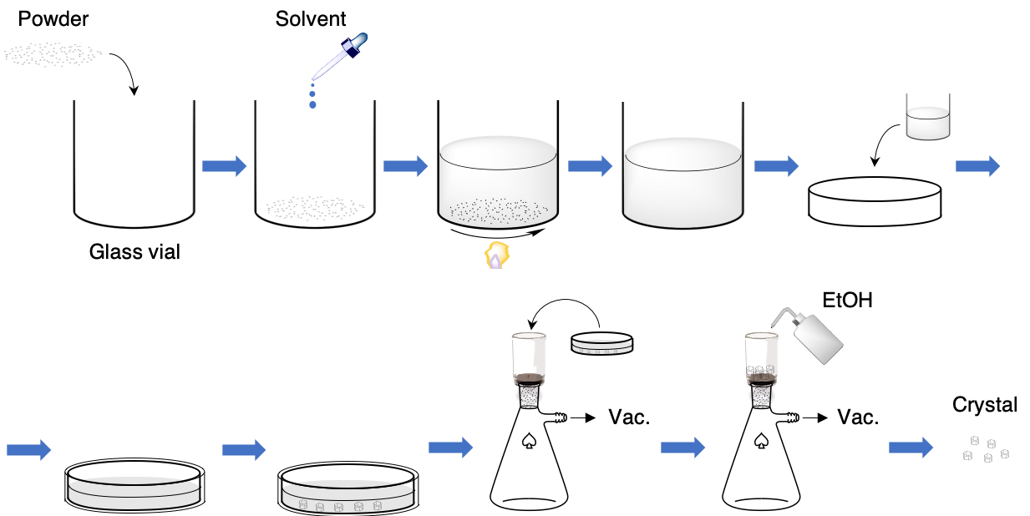

Fig. S1 Recrystallization procedure for AAs and dipeptides. A powder sample of an AA or dipeptide was added to solvent. The dispersion was heated and stirred until AAs or dipeptide completely dissolved at 100 °C. The resultant hot solution was transferred to a Petri dish covered with a lid and cooled overnight. The dispersions with recrystallized crystals were filtered under vacuum and crystals were washed with ethanol at least three times. To obtain anhydrous crystals, the filtered crystals were dried at 60 °C at low pressure for 12 hours. Specific details of the recrystallization protocol for each AA and peptide are given in Table S1.

Table S1. Conditions for recrystallization.
AAs/dipeptide | L/D | Product No. | Amount | Solvent | Volume | Yield (g, %)
Arginine  (Arg) | L | A5006-100G | 1.8 g | E-pure water | 3.0 mL | 1.5 g, 69%^{*1}
 | D | A2646-5G | 1.8 g | E-pure water | 3.0 mL | 1.7 g, 78%^{*1}
Histidine  (His) | L | H8000-25G | 1.4 g | E-pure water | 13 mL | 1.0 g, 71%
 | D | H3751-5G | 1.4 g | E-pure water | 13 mL | 1.0 g, 71%
Lysine  (Lys) | L | L5501-5G | Used as received without further recrystallization.
 | D | L8021-5G | Used as received without further recrystallization.
Glutamic acid  (Glu) | L | 128430-100G | 1.8 g | E-pure water | 35 mL | 1.5 g, 83%
 | D | G1001-25G | 1.0 g | E-pure water | 20 mL | 0.71 g, 71%
Aspartic acid  (Asp) | L | A93100-100G | 0.54 g | E-pure water | 22 mL | 0.40 g, 74%
 | D | 219096-25G | 0.54 g | E-pure water | 22 mL | 0.42 g, 74%
Glutamine  (Gln) | L | G3126-100G | 1.5 g | E-pure water | 9.0 mL | 1.2 g, 80%
 | D | D9003-1G | 0.80 g | E-pure water | 5.0 mL | 0.62 g, 78%
Asparagine  (Asn) | L | A0884-25G | 1.0 g | E-pure water | 9.0 mL | 0.95 g, 84%^{*2}
 | D | 441697-25G | 1.0 g | E-pure water | 9.0 mL | 0.79 g, 70%^{*2}
Cysteine  (Cys) | L | W326305-100G | 1.5 g | E-pure water | 5.5 mL | 0.69 g, 46%
 | D | 30095-1G | 0.80 g | E-pure water | 3.0 mL | 0.49 g, 61%
Threonine  (Thr) | L | T8625-10G | 1.5 g | E-pure water | 10 mL | 0.83 g, 55%
 | D | T8250-5G | 1.5 g | E-pure water | 10 mL | 0.80 g, 53%
Serine  (Ser) | L | S2600-100G | 1.5 g | E-pure water | 3.0 mL | 1.4 g, 93%
 | D | S4250-5G | 1.5 g | E-pure water | 3.0 mL | 1.1 g, 73%
Glycine (Gly) | – | G7126-100G | 1.5 g | E-pure water | 3.0 mL | 0.95 g, 63%
Alanine  (Ala) | L | A25802-100G | 2.0 g | E-pure water | 4.0 mL | 1.7 g. 85%
 | D | A7377-25G | 1.0 g | E-pure water | 2.0 mL | 0.44 g. 44%
Proline  (Pro) | L | 81709-25G | 1.0 g | Ethanol | 25 mL | 0.62 g, 62%
 | D | 858919-5G | 0.40 g | Ethanol | 10 mL | 0.20 g, 50%
Valine  (Val) | L | V0500-25G | 1.5 g | E-pure water | 18 mL | 0.63 g, 42%
 | D | 855987-5G | 1.0 g | E-pure water | 12 mL | 0.42 g, 42%
Isoleucine (Ile) | L | I2752-10G | 1.0 g | E-pure water | 18 mL | 0.44 g, 44%
Leucine  (Leu) | L | L8000-25G | 1.0 g | E-pure water | 20 mL | 0.38 g, 38%
 | D | 855448-2.5G | 0.80 g | E-pure water | 25 mL | 0.25 g, 31%
Methionine  (Met) | L | M9625-25G | 1.0 g | E-pure water | 18 mL | 0.13 g. 13%
 | D | M9375-5G | 1.0 g | E-pure water | 18 mL | 0.12 g, 12%
Phenylalanine  (Phe) | L | P2126-100G | 1.5 g | E-pure water | 21 mL | 0.96 g, 64%
 | D | P1751-5G | 1.0 g | E-pure water | 14 mL | 0.46 g, 46%
Tyrosine  (Tyr) | L | T3754-50G | 1.0 g | 1 M Oxalic acid solution | 16 mL | 0.50 g, 50%
 | D | 855456-5G | 1.0 g | 1 M Oxalic acid solution | 17 mL | 0.49 g, 49%
Tryptophan  (Trp) | L | T0254-25G | 0.50 g | E-pure water | 15 mL | 0.28 g, 56%
 | D | T9753-5G | 0.50 g | E-pure water | 20 mL | 0.24 g, 48%
Cystine (CYT) | L | C8755-100G | 2.0 g | 1 M HCl solution | 16 mL | 0.48 g, 24%
 | D | 286463-1G | 1.0 g | 1 M HCl solution | 7.7 mL | 0.15 g, 15%
 | DL | C8630-5G | Used as received without further recrystallization.
Deuterated Cystine (dCYT) | L | C8755-100G | 2.0 g | 1 M DCl solution in D₂O | 18 mL | 0.28 g, 14%
*1, *2: Yields were calculated based on the hydrated forms.

Table S2. The crystalline phases of AAs and CYT used for THz spectroscopies.
AAs/dipeptide | L/D | Hydration state | Space group
Arginine (Arg) | L | Dihydrate | P2₁2₁2₁
 | L | Anhydrous | P2₁
 | D | Anhydrous | P2₁
Histidine (His) | L | Anhydrous | P2₁2₁2₁
 | D | Anhydrous | P2₁2₁2₁
Lysine (Lys) | L | Hemihydrate | C2
 | D | Hemihydrate | C2
Glutamic acid (Glu) | L | Anhydrous | P2₁2₁2₁
 | D | Anhydrous | P2₁2₁2₁
Aspartic acid (Asp) | L | Anhydrous | P2₁
 | D | Anhydrous | P2₁
Glutamine (Gln) | L | Anhydrous | P2₁2₁2₁
 | D | Anhydrous | P2₁2₁2₁
Asparagine (Asn) | L | Monohydrate | P2₁2₁2₁
 | L | Anhydrous | P2₁
 | D | Anhydrous | P2₁
Cysteine (Cys) | L | Anhydrous | P2₁2₁2₁
 | D | Anhydrous | P2₁2₁2₁
Threonine (Thr) | L | Anhydrous | P2₁2₁2₁
 | D | Anhydrous | P2₁2₁2₁
Serine (Ser) | L | Anhydrous | P2₁2₁2₁
 | D | Anhydrous | P2₁2₁2₁
Glycine (Gly) | – | Anhydrous | P2₁/n
Alanine (Ala) | L | Anhydrous | P2₁2₁2₁
 | D | Anhydrous | P2₁2₁2₁
Proline (Pro) | L | Anhydrous | P2₁2₁2₁
 | D | Anhydrous | P2₁2₁2₁
Valine (Val) | L | Anhydrous | P2₁
 | D | Anhydrous | P2₁
Isoleucine (Ile) | L | Anhydrous | P2₁
Leucine (Leu) | L | Anhydrous | P2₁
 | D | Anhydrous | P2₁
Methionine (Met) | L | Anhydrous | P2₁
 | D | Anhydrous | P2₁
Phenylalanine (Phe) | L | Anhydrous | C2
 | D | Anhydrous | C2
Tyrosine (Tyr) | L | Anhydrous | P2₁2₁2₁
 | D | Anhydrous | P2₁2₁2₁
Tryptophan (Trp) | L | Not assignable. | Not assignable.
 | D | Not assignable. | Not assignable.
Cystine (CYT) | L | Anhydrous | P6₁22
 | D | Anhydrous | P6₁22
 | DL | Not assignable | Not assignable
Deuterated Cystine (dCYT) | L | Anhydrous | P6₁22

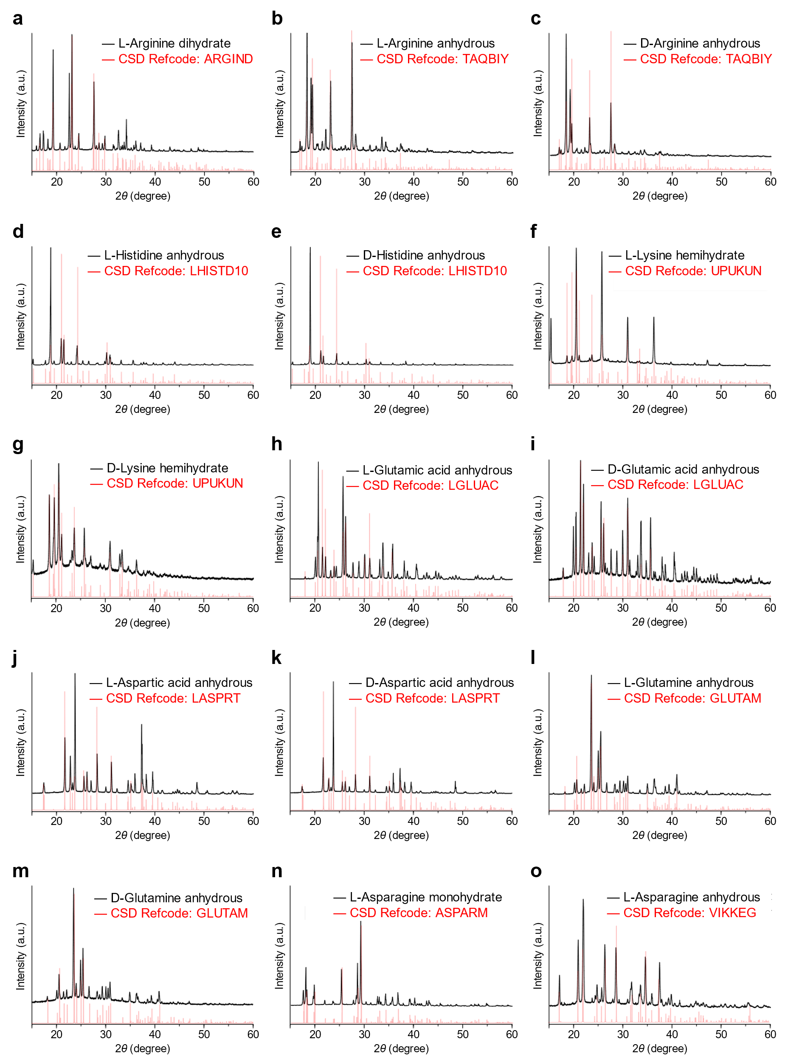
(Continued)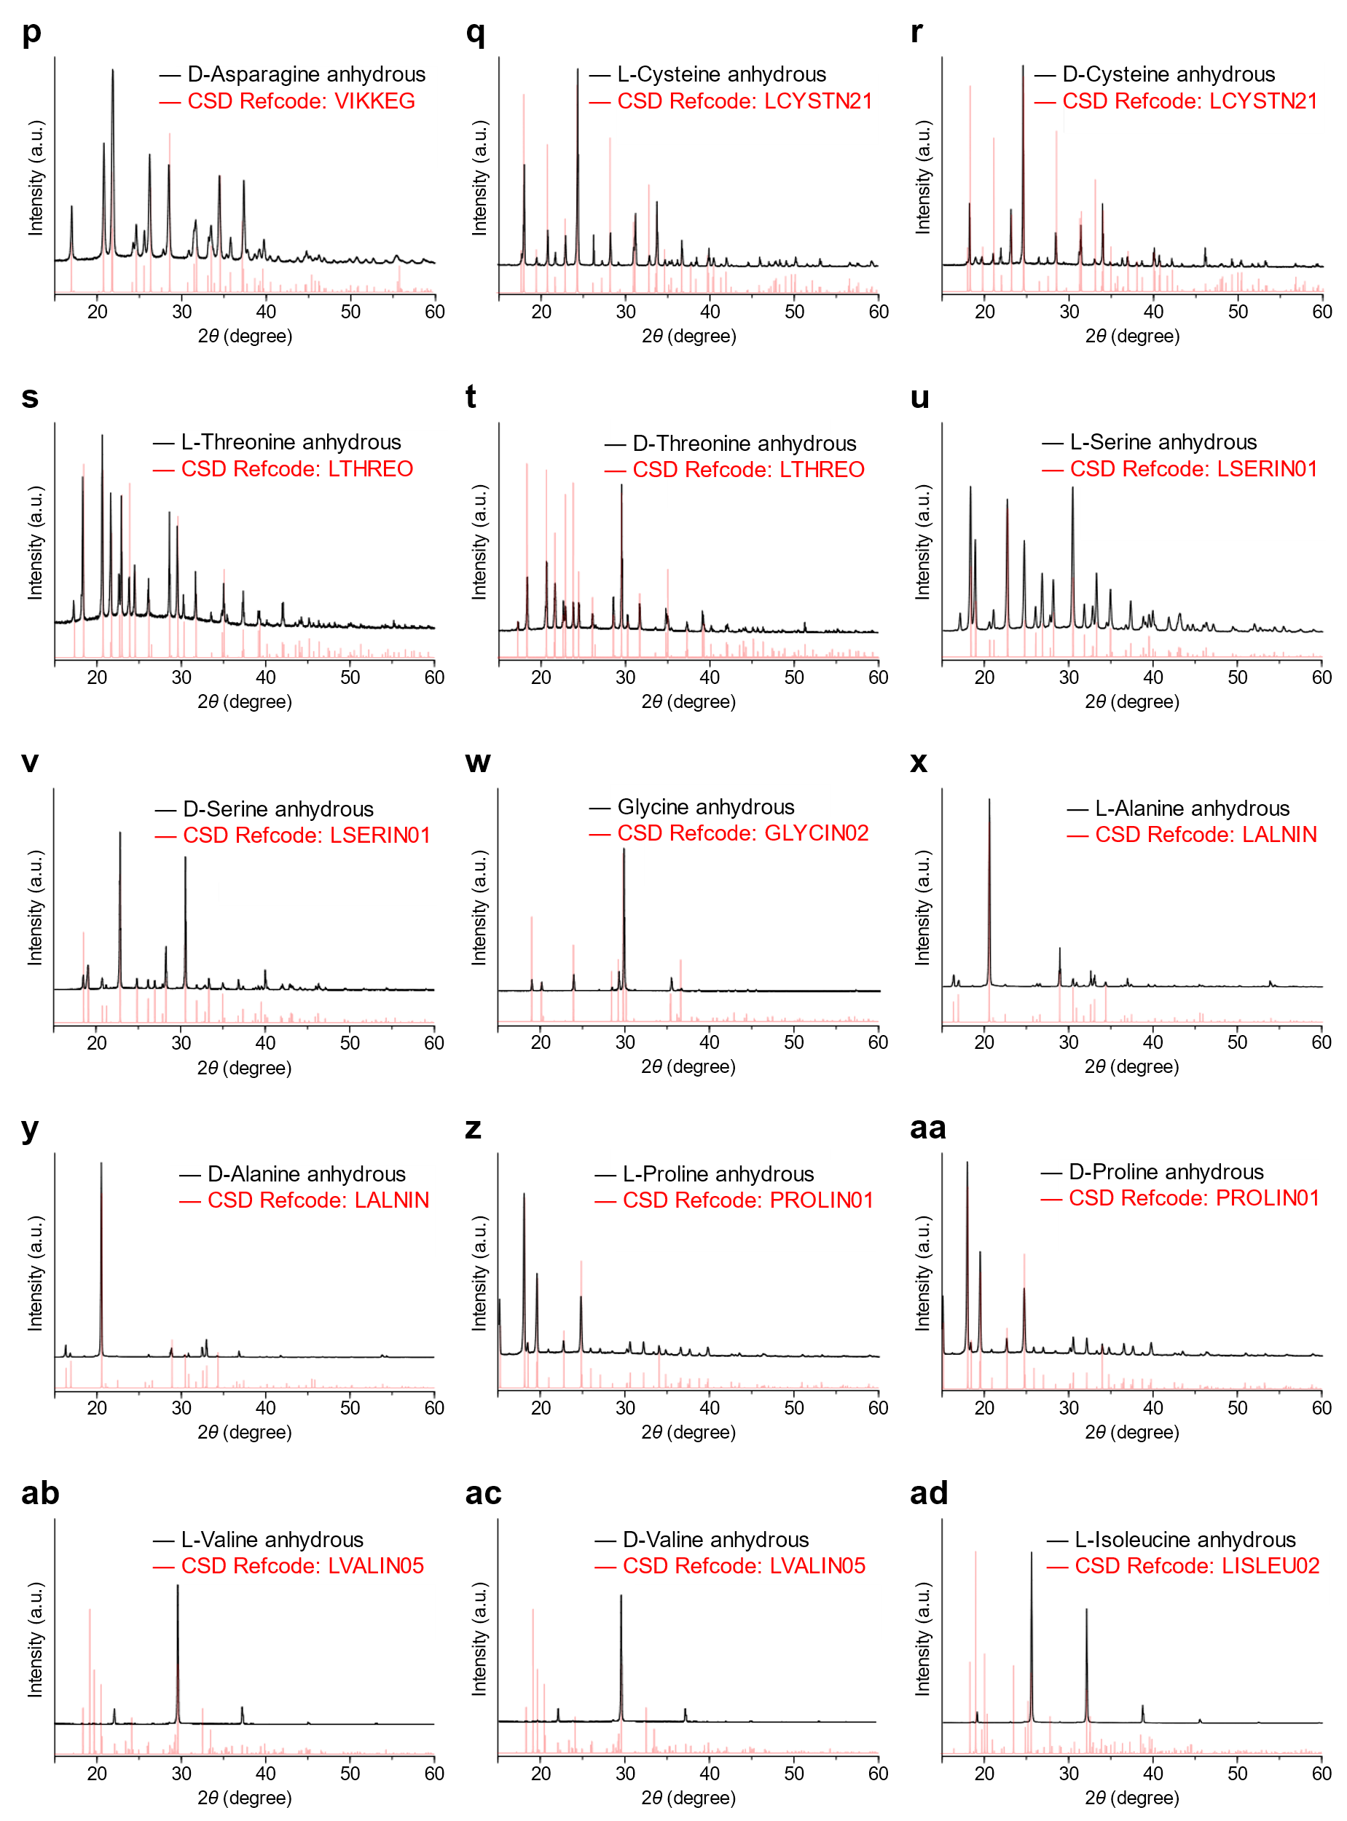
(Continued)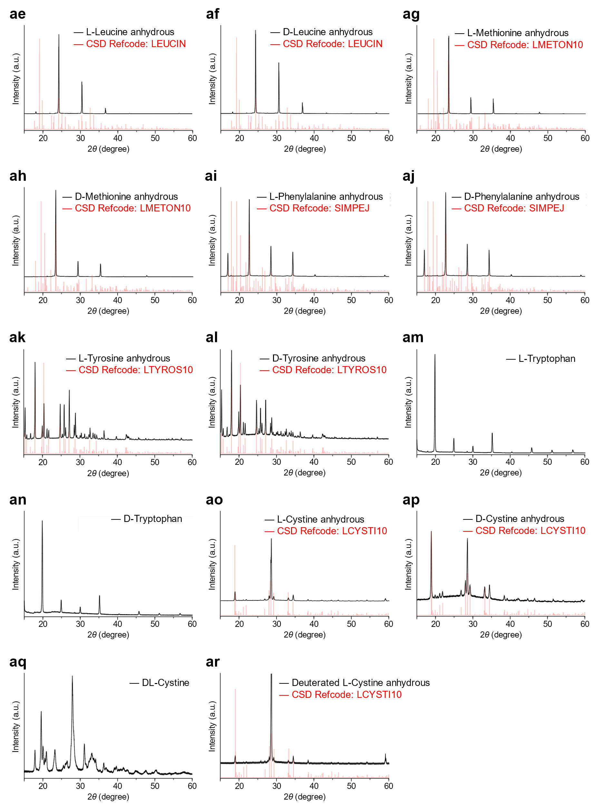
Fig. S2 Powder XRD patterns of crystals from proteinogenic AAs and dipeptides. (a–c) arginine (Arg), (d, e) histidine (His), (f, g) lysine (Lys), (h, i) glutamic acid (Glu), (j, k) aspartic acid (Asp), (l, m) glutamine (Gln), (n–p) asparagine (Asn), (q, r) cysteine (Cys), (s, t) threonine (Thr), (u, v) serine (Ser), (w) glycine (Gly), (x, y) alanine (Ala), (z, aa) proline (Pro), (ab, ac) valine (Val), (ad) isoleucine (Ile), (ae, af) leucine (Leu), (ag, ah) methionine (Met) , (ai, aj) phenylalanine (Phe), (ak, al) tyrosine (Tyr), (am, an) tryptophan (Trp), and (ao–ar) cystine (CYT). Note that abbreviations for cysteine and cystine are not the same, Cys and CYT, respectively. Experimental data were shown in black, and the reference data, collected from CCDC, are shown in red with their CSD reference codes (refcodes). All AAs except for lysine were recrystallized as described in Table S1.

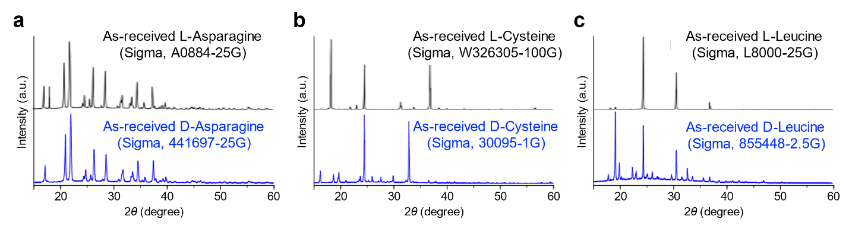

Fig. S3 Powder XRD patterns of as-received L- and D-enantiomers of Asp, Cys, and Leu. Crystalline phases of many as-received crystals are different and especially between L- and D-enantiomers due to their different chemical production processes. Most L-enantiomers of AAs are natural whereas D-enantiomers of AAs are chemically synthesized, and therefore have different impurities and structures.

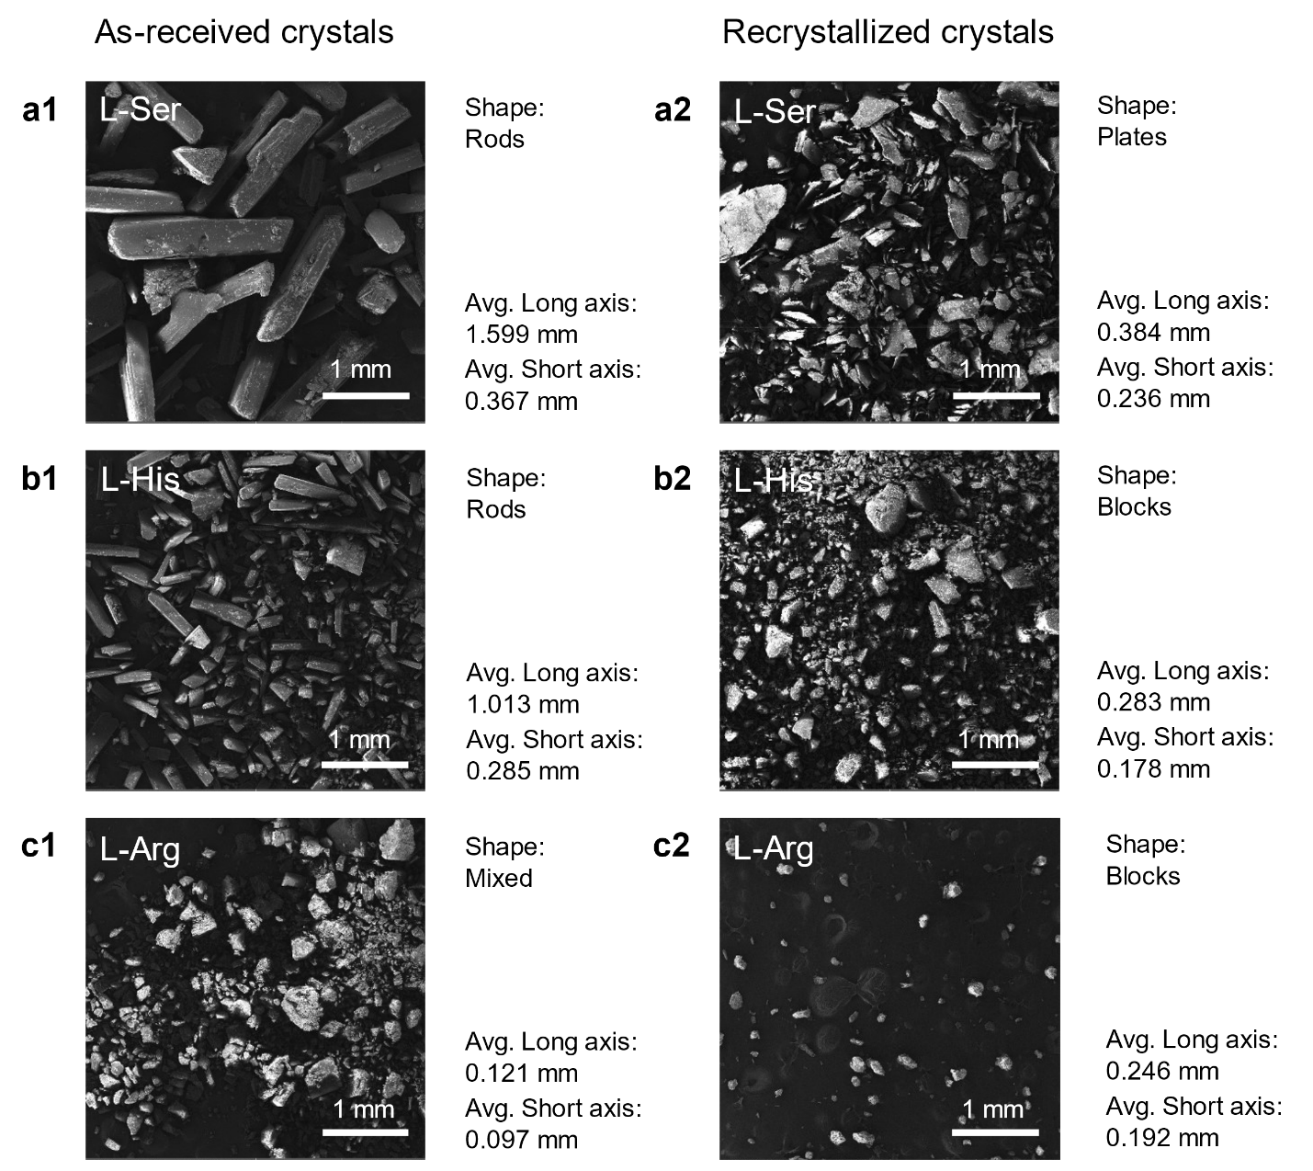

(Continued)
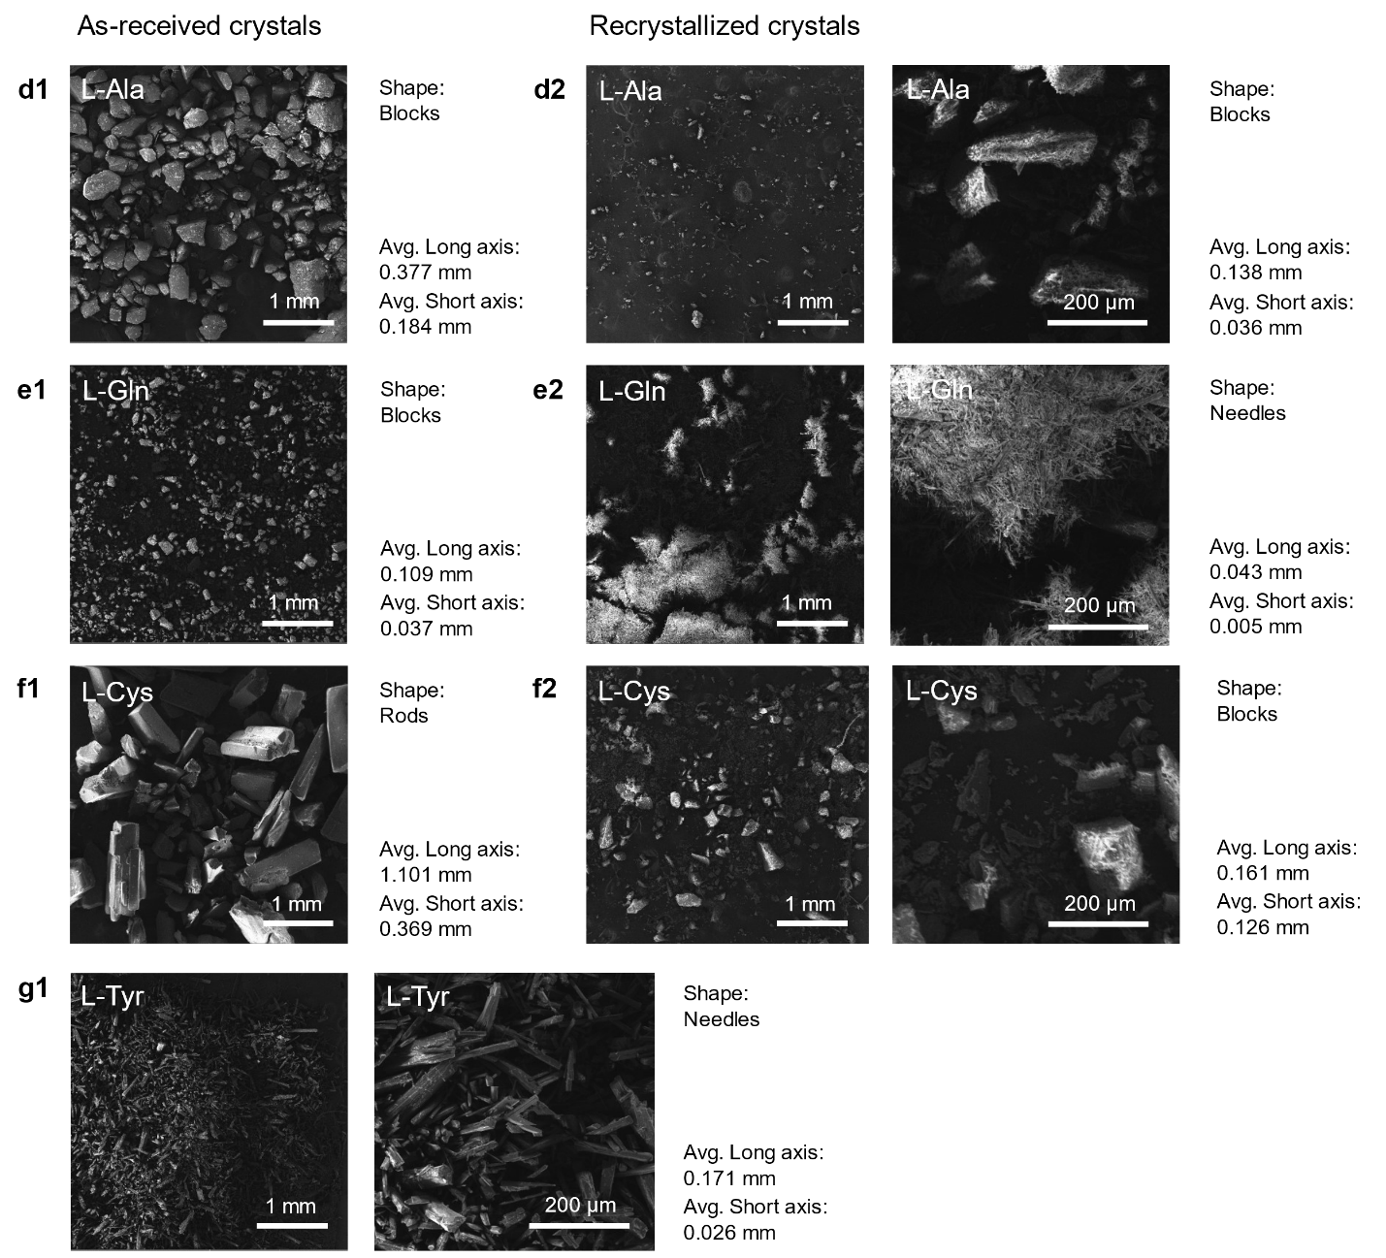

Fig. S4 SEM images of AA crystals before and after recrystallization. Crystals in as-received samples have larger sizes than those after recrystallization. Crystals larger than 100 μm need to be ground and dispersed into a slurry to obtain accurate THz spectra. SEM images of (a1 and a2) as-received and recrystallized L-serine. (b1 and b2) As-received and recrystallized L-histidine. (c1 and c2) As-received and recrystallized L-arginine. (d1 and d2) As-received and recrystallized L-alanine. (e1 and e2) As-received and recrystallized L-glutamine. (f1 and f2) As-received and recrystallized L-cysteine. (g1) As-received L-tyrosine.

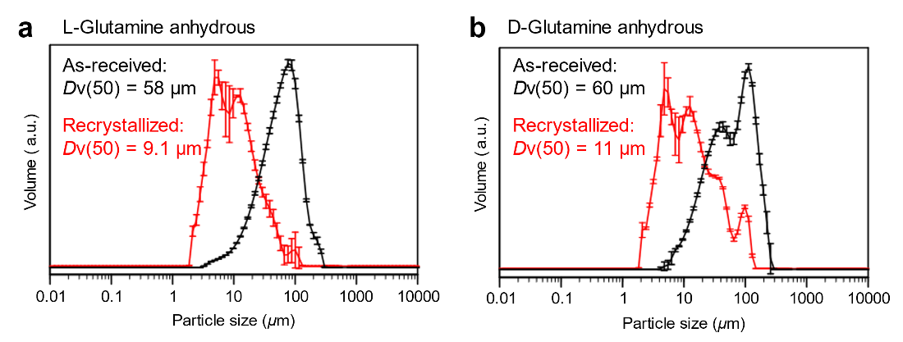

Fig. S5 Size distribution analyses of L- and D-glutamine powders before and after recrystallization. The particle sizes of as-received and recrystallized powders from anhydrous (a) L- and (b) D-glutamine were measured in triplicate and averaged. Dv(50) refers to the median diameter in volume or the particle size that splits the distribution of volume with half above and half below this diameter.

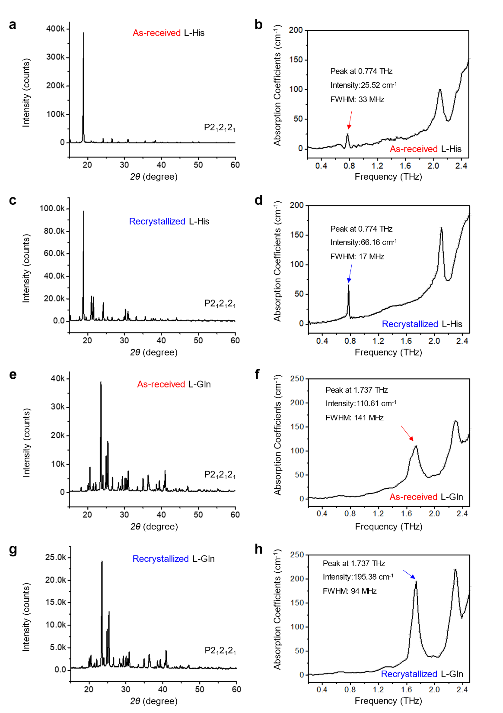

Fig. S6 THz absorption (TA) spectra of L-histidine and L-glutamine for samples with different degrees of crystallinity. XRD (a and c) and averaged TA spectra (b and d) of as-received and recrystallized L-histidine. XRD (e and g) and averaged TA spectra (f and h) of as-received and recrystallized L-glutamine. After recrystallization, the average size of the crystals is generally smaller; stronger and sharper TA peaks are observed as a result.

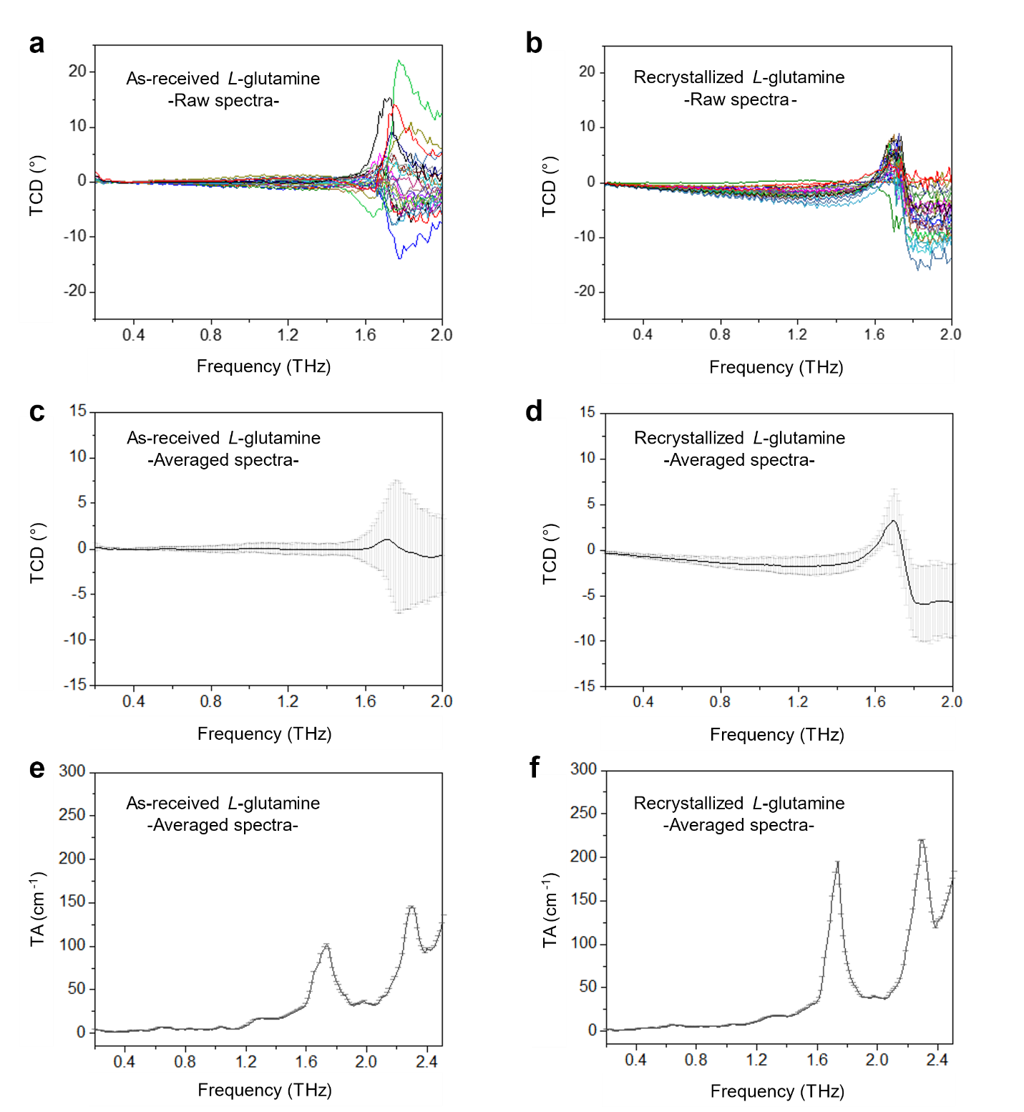

Fig. S7 The effects of recrystallization on TCD spectra. a,b, TCD raw spectra of as-received and recrystallized L-glutamine at each of 25 different positions. c,d, averaged TCD spectra with standard deviation of as-received L-glutamine (Sigma, G3126-100G) and recrystallized one. e,f, averaged TA spectra with standard deviation of as-received L-glutamine (Sigma, G3126-100G) and recrystallized samples.

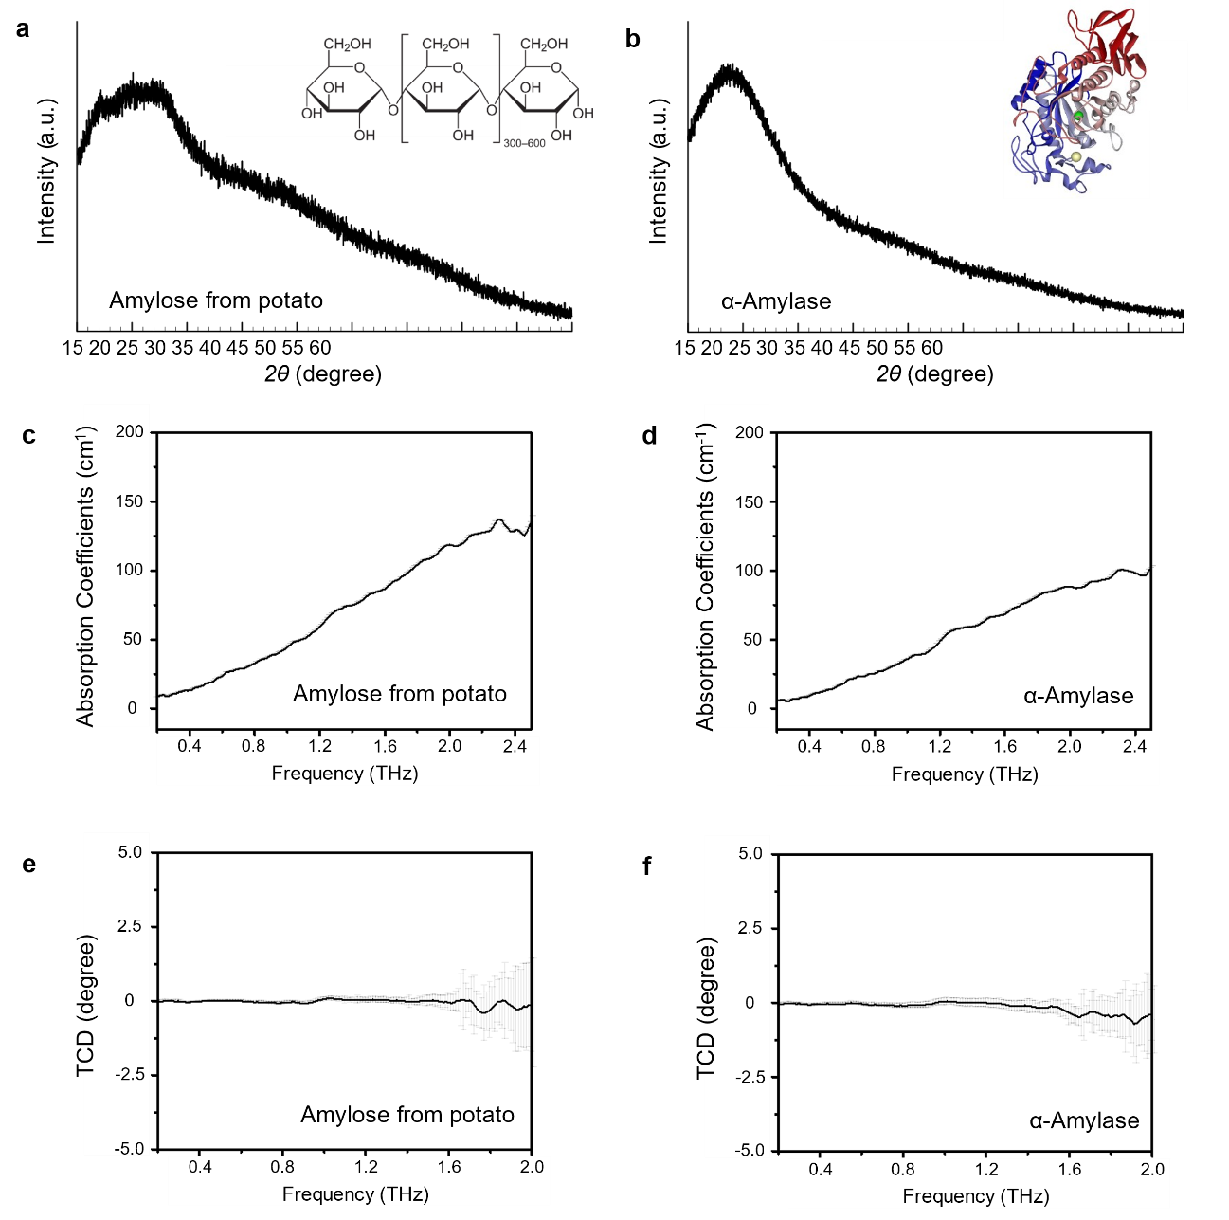

Fig. S8 TA and TCD spectra from amorphous biomolecules. a,b, XRD data of amylose and α-amylase, respectively. Insets are reprinted from references^{68,69}. Both charts are featureless, indicating their amorphous structures. c,d, averaged TA spectra with standard deviations of amylose and α-amylase, respectively. e,f, averaged TCD spectra with standard deviations of amylose and α-amylase, respectively.

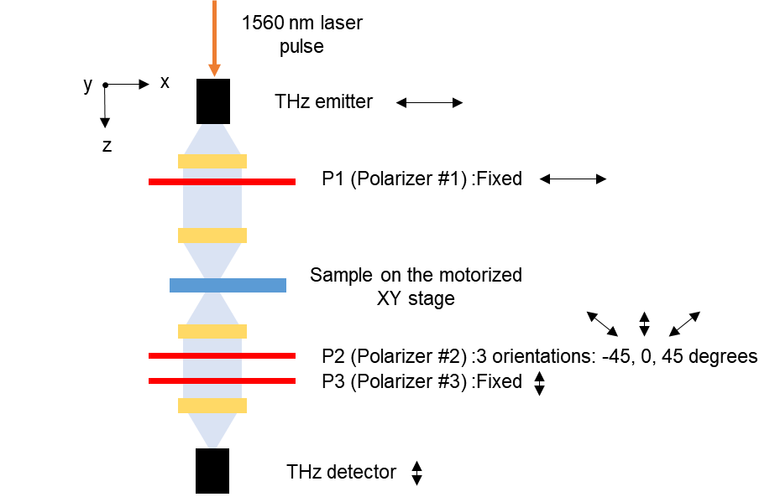

Fig. S9 Schematic of hyperspectral THz-TDP setup. Three polarizers were used to determine polarization states of the THz beam after passing through the samples. Since P1 and P3 are cross-polarized, if there is no optical activity induced by the sample, the amplitude of ${\tilde{E}}_{y}$, the electric field in the y axis, is zero, and therefore TCD and TORD show near-zero values. Sample scanning in the THz focal plane was achieved using the motorized XY stage.

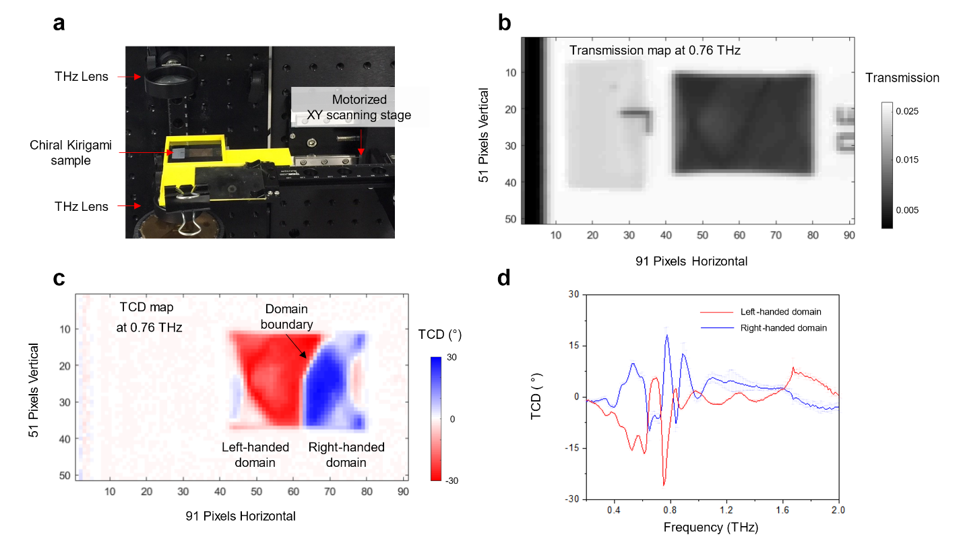

Fig. S10 Mapping of chiral kirigami metamaterial as a reference sample. a, Photograph of chiral kirigami sample³⁰ on the focal plane between two lenses. A stretched chiral kirigami sample is placed on the 3D printed holder with a motorized XY scanning stage. b, Transmission map of kirigami sample at 0.76 THz. The size of each pixel is 0.5 mm. c, TCD map of kirigami sample with two domains at 0.76 THz. The handedness of the kirigami sample was determined by the curvature of the 3D helical topology and the domain boundary was induced by mechanical defect. Here, we can clearly observe the hidden chiral domain by TCD mapping. d, Mirror-symmetric averaged TCD spectra from red and blue domains, respectively.

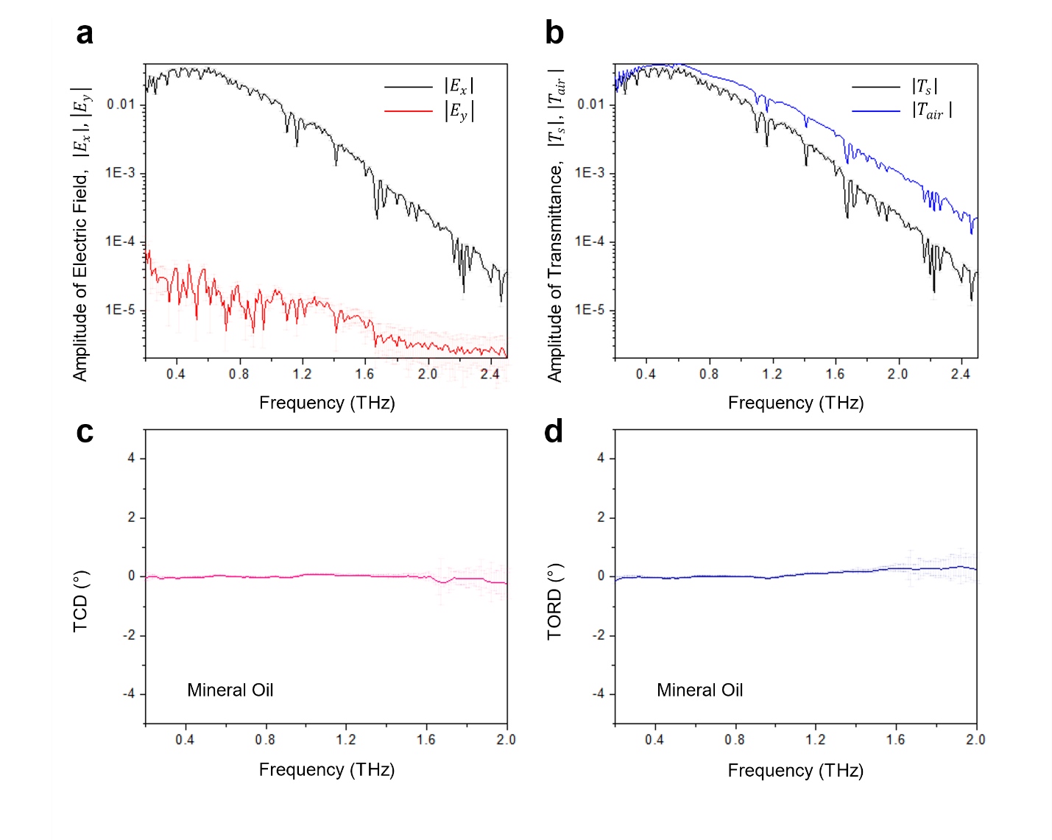
Figure. S11. Spectral characteristics of mineral oil (MO) in the THz range. a, Raw data of the averaged amplitude of the electric field from MO. b, Raw data of averaged transmittance from MO and air, respectively, showing the high transparency of MO across the THz range. c and d, Near-zero-TCD and TORD spectra from MO indicating there is no optical activity in this THz range, respectively.

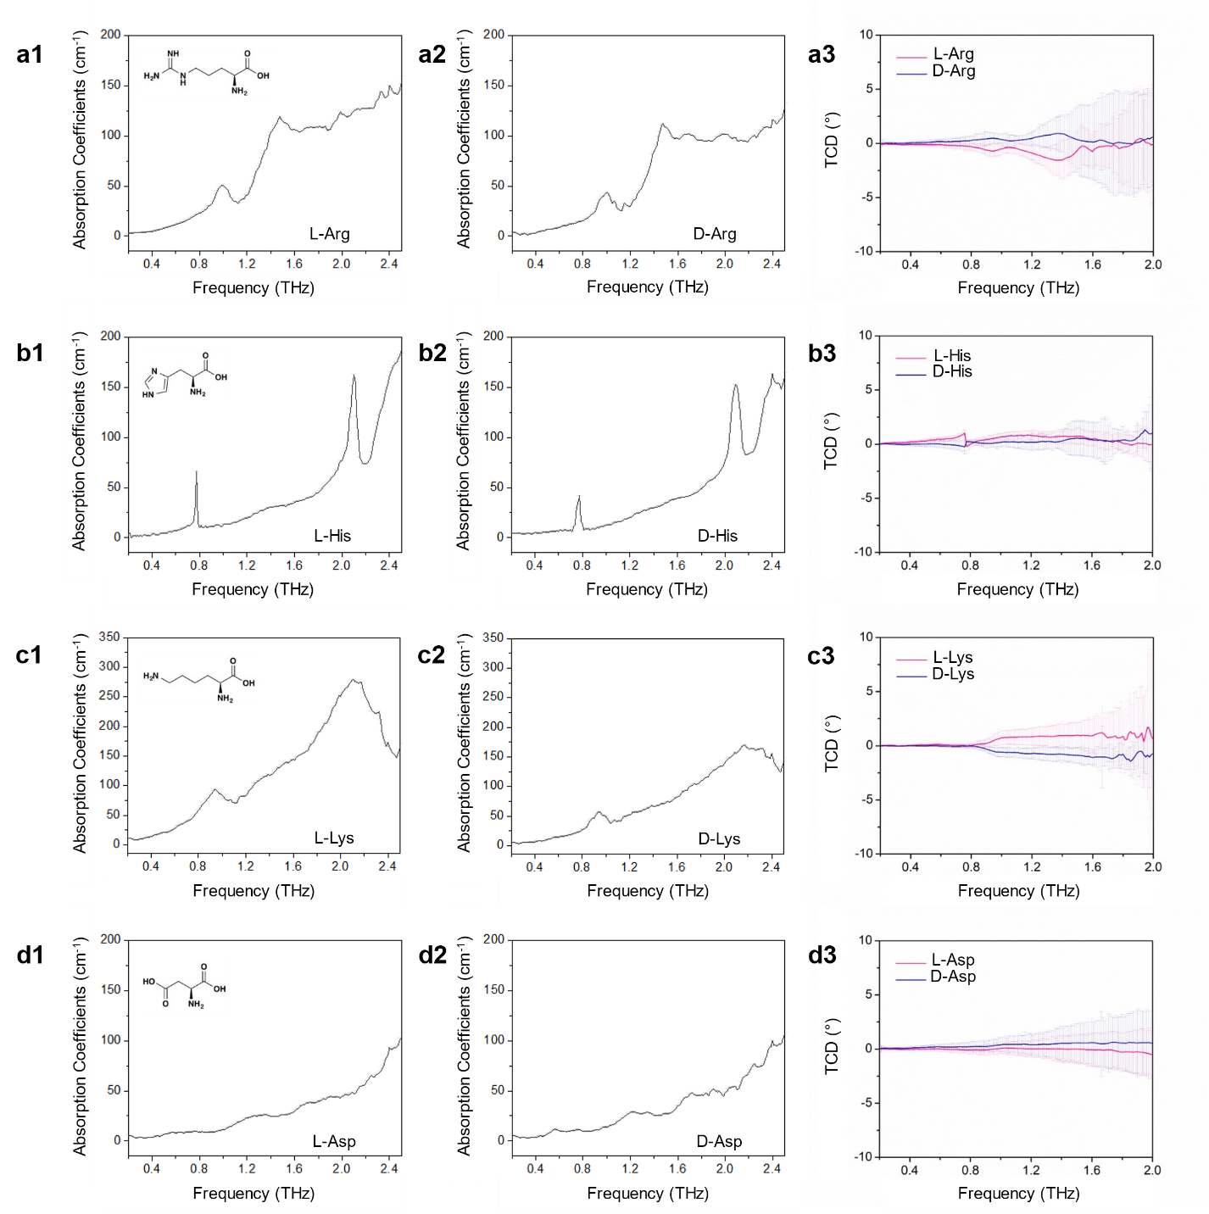
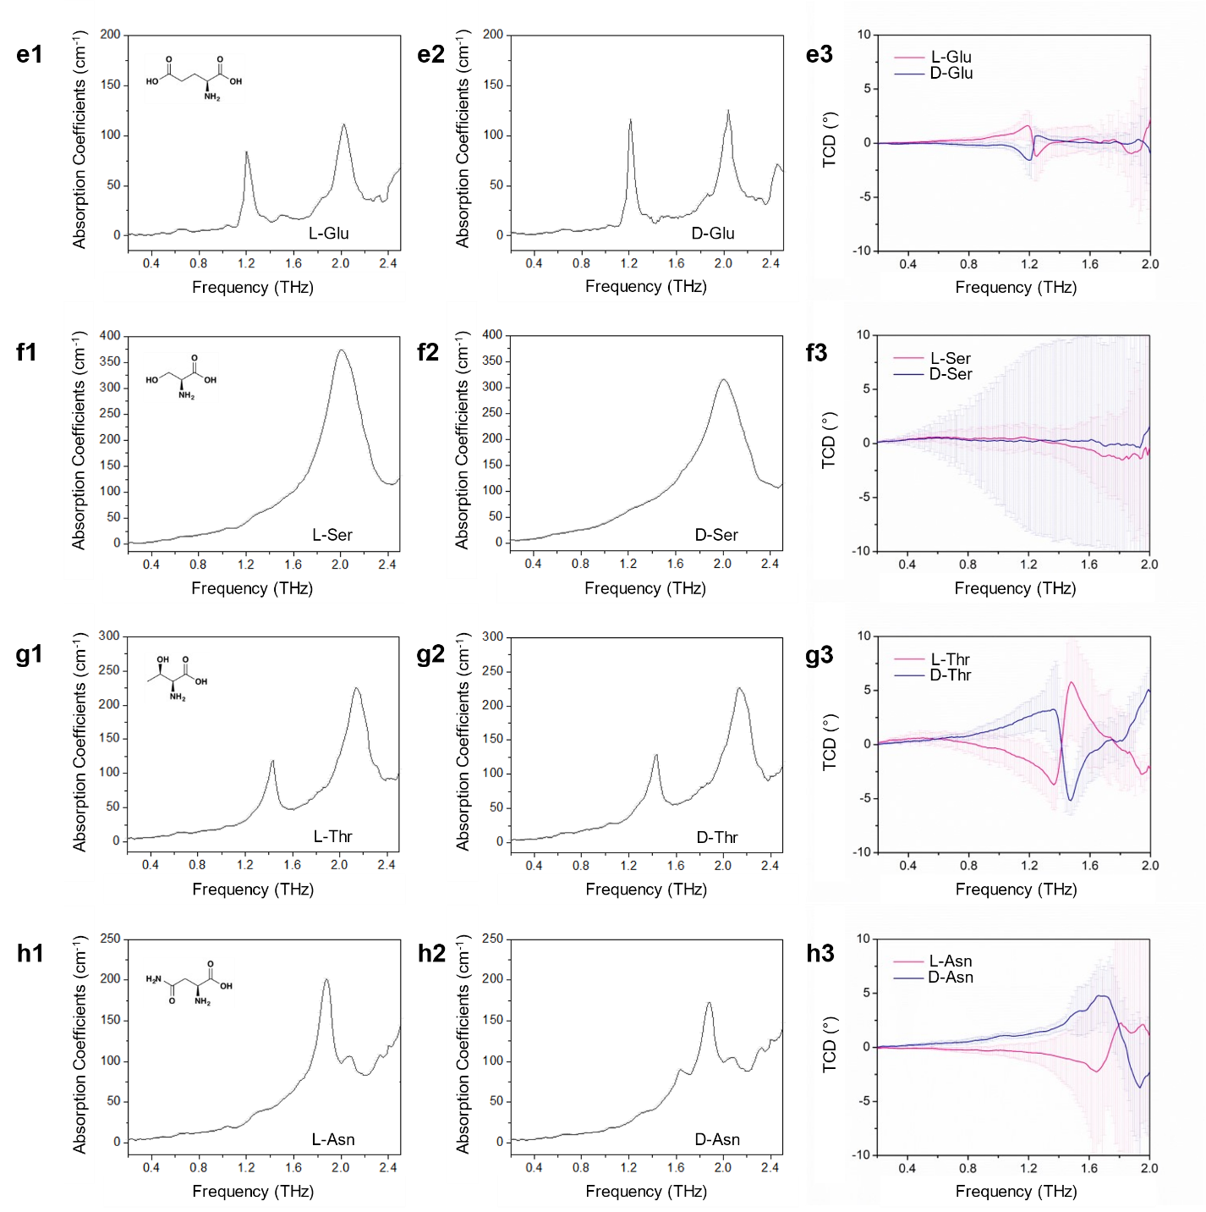
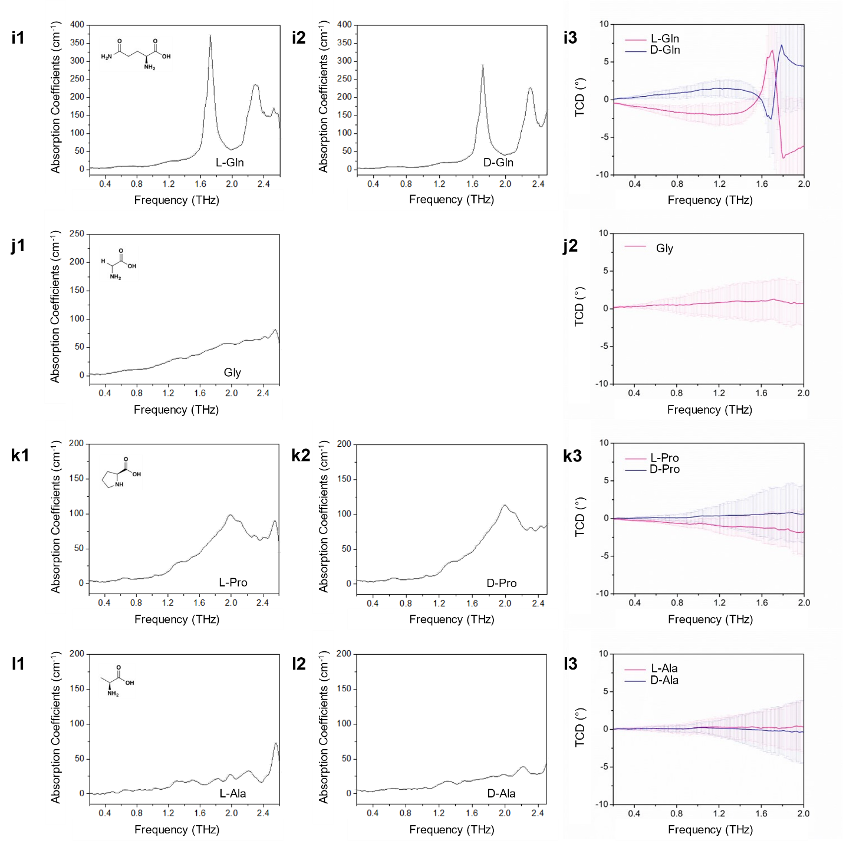
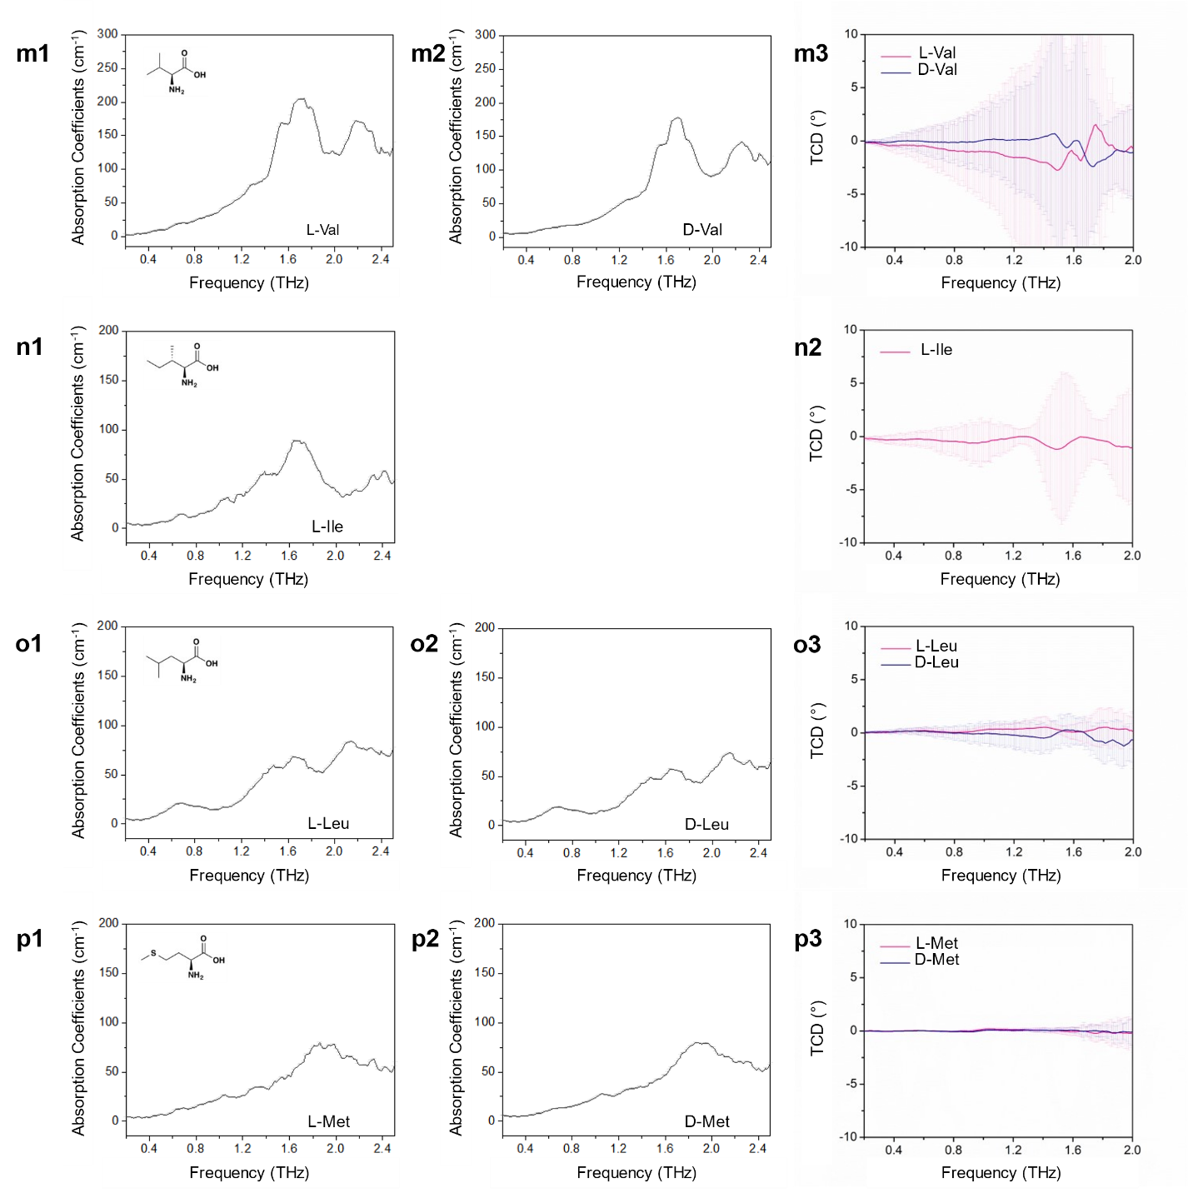
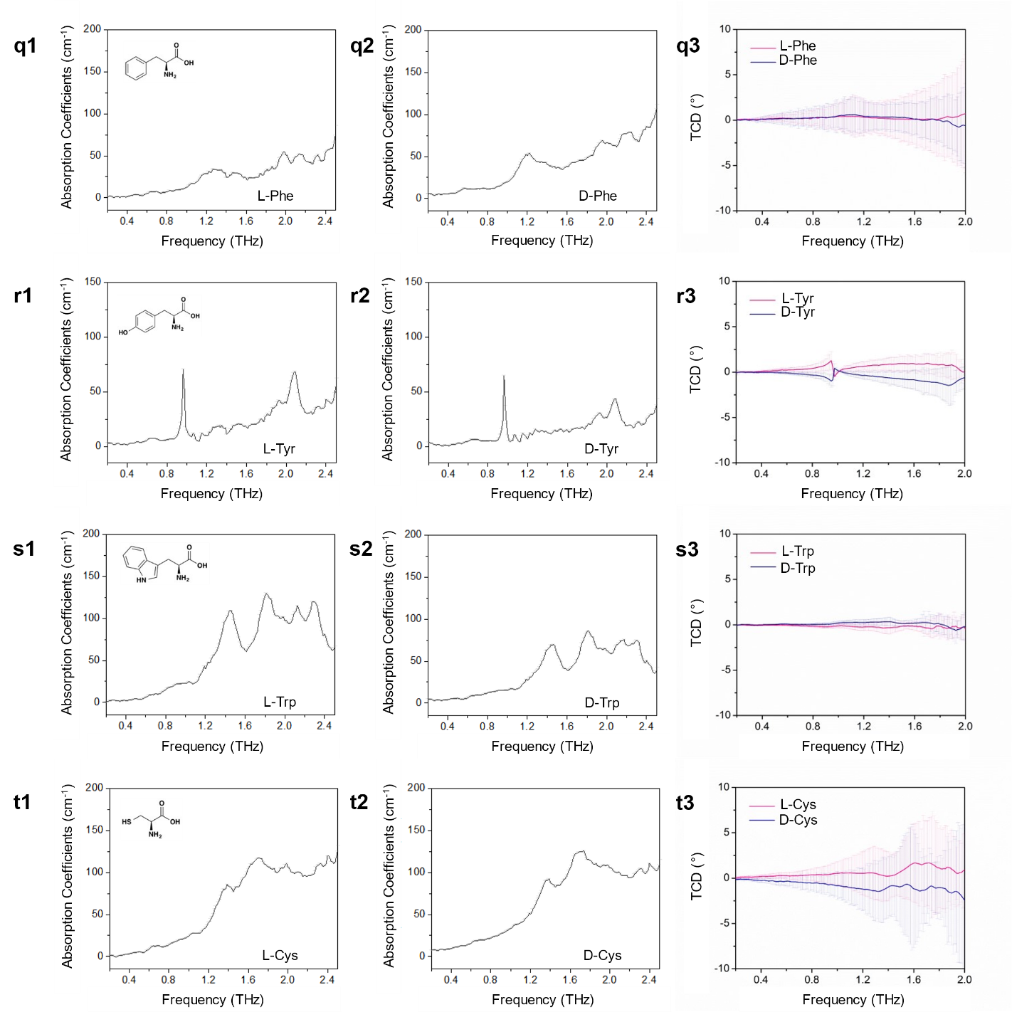

Fig. S12 TA and TCD spectra from AAs crystals for (a1 to a3) recrystallized L- and D-arginine. (b1 to b3) Recrystallized L- and D-histidine. (c1 to c3) L- and D-lysine. (d1 to d3) Recrystallized L- and D-aspartic acid. (e1 to e3) Recrystallized L- and D-glutamic acid. (f1 to f3) Recrystallized L- and D-glutamic acid. (g1 to g3) Recrystallized L- and D-threonine. (h1 to h3) Recrystallized L- and D-asparagine. (i1 to i3) Recrystallized L- and D-glutamine. (j1 and j2) Recrystallized glycine. (k1 to k3) Recrystallized L- and D-proline. (l1 to l3) Recrystallized L- and D-alanine. (m1 to m3) Recrystallized L- and D-valine. (n1 and n2) Recrystallized L- isoleucine. (o1 to o3) Recrystallized L- and D-leucine. (p1 to p3) Recrystallized L- and D-methionine. (q1 to q3) Recrystallized L- and D-phenylalanine. (r1 to r3) Recrystallized L- and D-tyrosine. (s1 to s3) Recrystallized L- and D-tryptophan. (t1 to t3) Recrystallized L- and D-cysteine.

Table S3. Reduced masses calculated for selected normal modes of L-Met, L-Glu
and L-CYT.
System | Reduced mass (g/mol) | Frequency (THz)
L-Glu vacuum | 8.57 | 1.15
L-Glu supercell | 6.99 | 1.31
L-Met vacuum | 4.62 | 1.40
L-Met supercell | 6.20 | 1.74
L-CYT vacuum | 3.67 | 2.23
L-CYT supercell | 9.36 | 0.61

The reduced masses arising from the normal mode calculations in Table S3 are much smaller than the molecular weights of the AA and dipeptides (Table S4) because the observed chiral phonons involve collective partial deformations of AA segments in multiple molecules, which is confirmed by their visualization in Supplementary Movies.

Table S4. Summary of the peak positions of all samples
Molecule name and abbreviation | Molecular weight (g/mol) | Peak positions (THz)
Glycine, Gly | 75.07 | 2.55
Alanine, Ala | 89.09 | 2.23, 2.56
Serine, Ser | 105.09 | 1.99
Proline, Pro | 115.13 | 1.99, 2.11, 2.29, 2.54
Valine, Val | 117.15 | 1.53, 1.74, 1.78, 2.17
Threonine, Thr | 119.12 | 1.44, 2.15, 2.31
Cysteine, Cys | 121.16 | 1.39, 1.7, 1.99
Isoleucine, Ile | 131.17 | 1.39, 1.64, 2.32, 2.41
Leucine, Leu | 131.17 | 0.67, 1.47, 1.64, 2.11
Asparagine, Asn | 132.12 | 1.87, 2.07, 2.32
Aspartic Acid, Asp | 133.11 | 1.25, 1.7, 2.25
Glutamine, Gln | 146.14 | 1.72, 2.29, 2.52
Lysine, Lys | 146.19 | 0.94, 1.37, 1.86, 2.1
Glutamic Acid, Glu | 147.13 | 1.22, 1.5, 1.85, 2.2
Methionine, Met | 149.21 | 1.04, 1.31, 1.81, 1.98
Histidine, His | 155.15 | 0.77, 2.09
Phenylalanine, Phe | 165.19 | 1.26, 1.49, 1.97, 2.14
Arginine, Arg | 174.2 | 0.99, 1.47, 1.74, 1.99
Tyrosine, Tyr | 181.19 | 0.96, 1.92, 2.08
Tryptophan, Trp | 204.23 | 0.85, 0.94, 1.45, 1.81
Ala-Ala | 160.17 | 1.23, 1.65, 1.94, 2.11
Ala-Gln | 217.22 | 0.61, 1.21, 1.68, 1.92
Carnosine, Ala-His, CAR | 226.23 | 0.56, 1.53, 1.87
Cystine, Cys-Cys, CYT | 240.3 | 0.71, 1.51, 2.01
Ala-Tyr | 252.27 | 0.55, 0.76, 1.22, 1.72

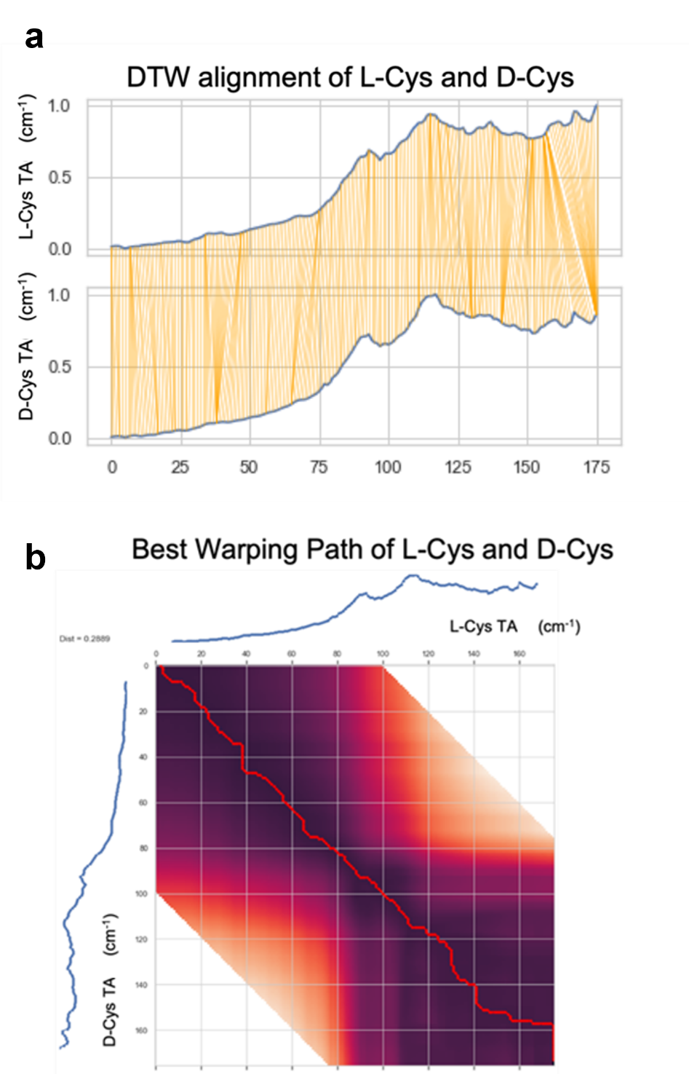

Fig. S13 Example of warping path analysis of TA spectra of L-Cys and D-Cys. a, The DTW algorithm finds the optimal path (pairing) between two spectra that yields the smallest dissimilarity between the spectra. b, The optimal warping path aligning experimental spectra from (a).

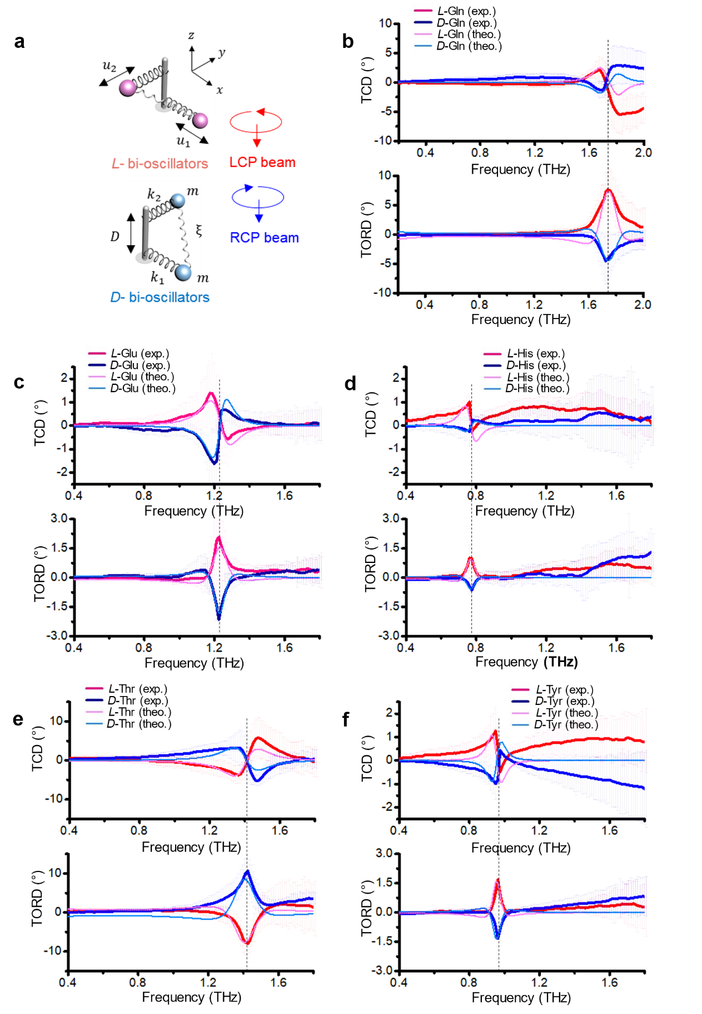
Fig. S14 Experimental and calculated TCD and TORD spectra for L and D enantiomers of five Type 2 AAs. a, Coupled bi-oscillator BK models for L and D enantiomers. b, glutamine (Gln). c, Glutamic acid (Glu). d, Histidine (His). e, Threonine (Thr). f, Tyrosine (Tyr)
Table S5. Fitted values of BK parameters for crystals of five Type 2 AAs.
Amino Acid | BK Parameters  : $\frac{DN_{0}e^{2}}{3m}{,w}_{0}$, γ, ξ | Values
Glutamine  (Gln) | A for L-Gln | 37.806
 | A for D-Gln | -35.749
 | B for L-Gln | -36.017
 | B for D-Gln | 19.665
 | $$w_{0}$$ | 1.233
 | γ | 0.0256
 | ξ | 0.0023
Glutamic Acid  (Glu) | A for L-Glu | 5.544
 | A for D-Glu | -2.502
 | B for L-Glu | -7.199
 | B for D-Glu | 4.009
 | $$w_{0}$$ | 1.748
 | γ | 0.06482
 | ξ | 0.16046
Histidine  (His) | A for L-His | 4.043
 | A for D-His | -0.899
 | B for L-His | -2.519
 | B for D-His | 1.519
 | $$w_{0}$$ | 0.771
 | γ | 0.00657
 | ξ | 0.08755
Threonine  (Thr) | A for L-Thr | -310.105
 | A for D-Thr | 260.105
 | B for L-Thr | 455.874
 | B for D-Thr | -505.874
 | $$w_{0}$$ | 1.412
 | γ | 0.037712
 | ξ | 0.234758
Tyrosine  (Tyr) | A for L-Tyr | 6.092
 | A for D-Tyr | -5.084
 | B for L-Tyr | -6.251
 | B for D-Tyr | 5.341
 | $$w_{0}$$ | 0.965
 | γ | 0.03771
 | ξ | 0.07892

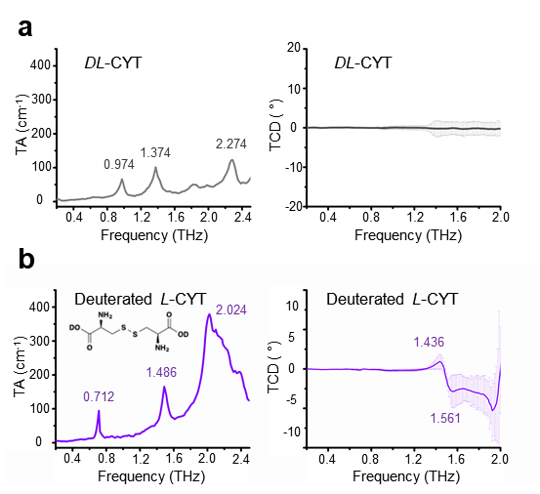

Fig. S15 Averaged TA and TCD spectra for CYT crystals. a, DL- CYT. b, Deuterated L-CYT.

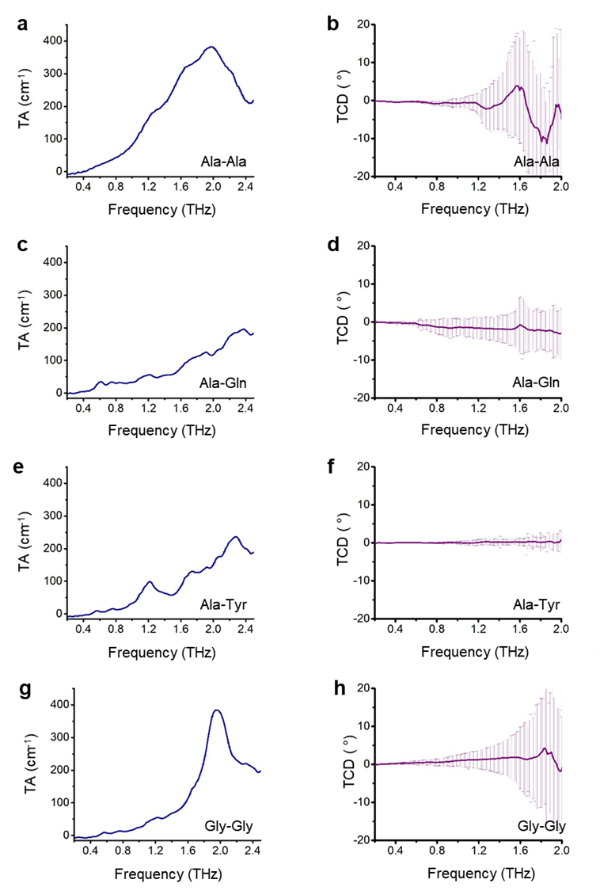

Fig. S16 Averaged TA and TCD spectra from biocrystals of dipeptides. a,b, Ala-Ala. c,d, Ala-Gln. e,f, Ala-Tyr. g,h, Gly-Gly. Ala-Ala and Gly-Gly show large standard deviations in TCD spectra.
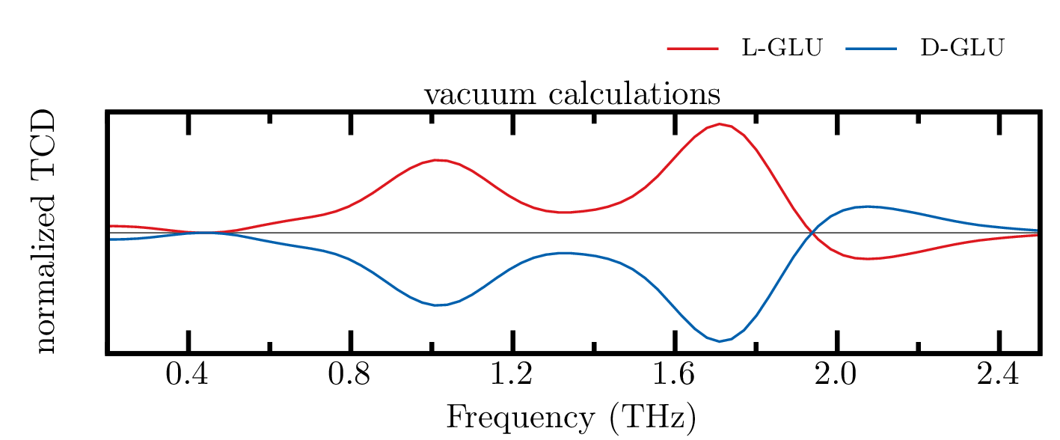

Fig. S17 TCD spectra of L-Glu and D-Glu obtained from MD simulations of a single molecule in vacuum.
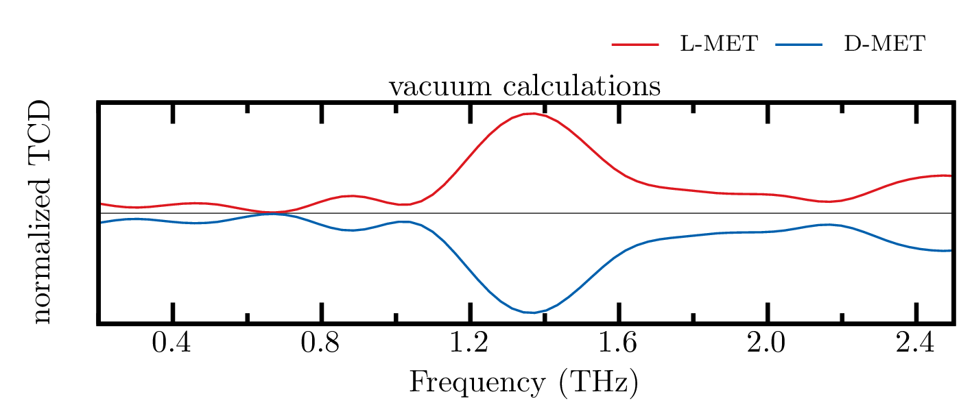
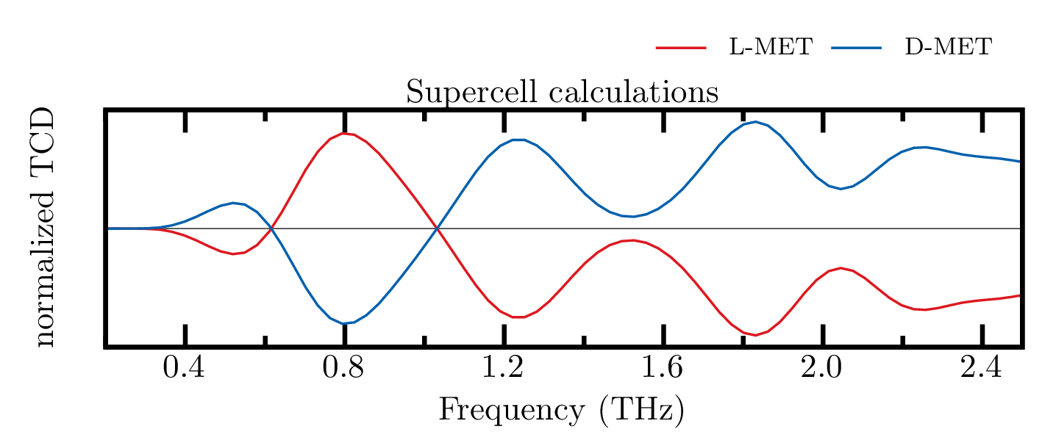

Fig. S18 TCD spectra of L-Met and D-Met obtained from MD simulations of a single molecule in vacuum (top) or a periodic supercell (bottom).
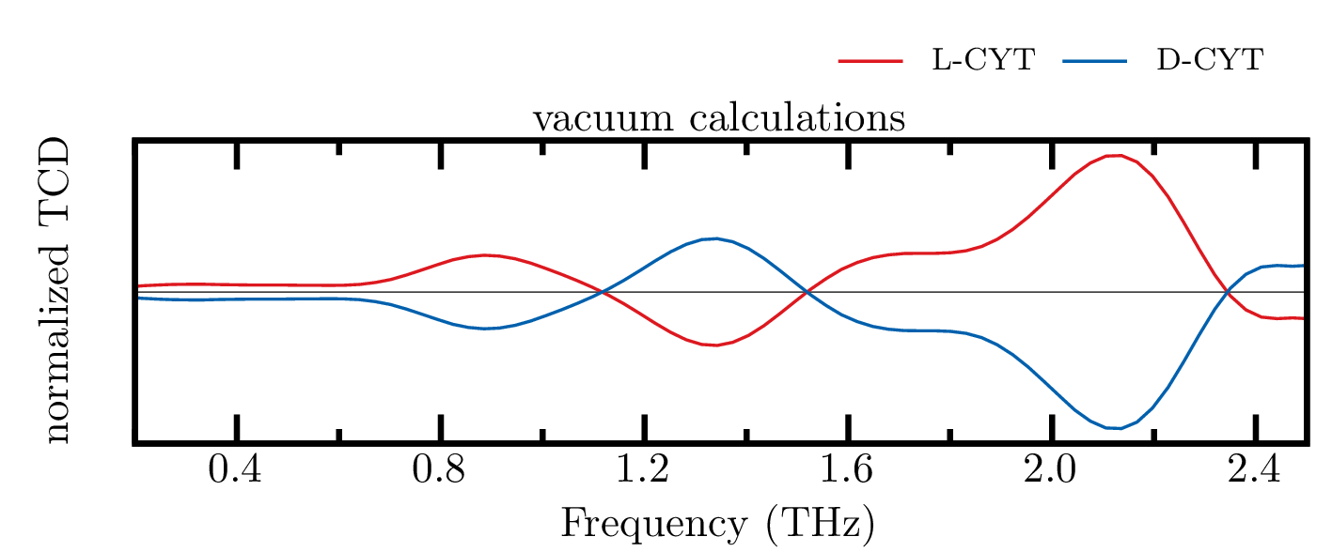
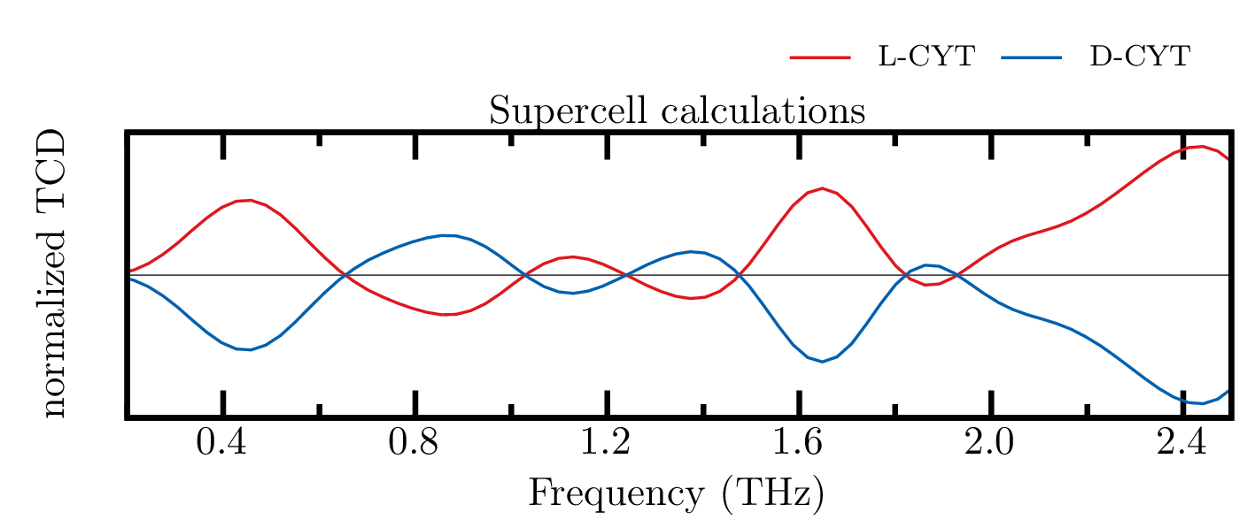

Fig. S19 TCD spectra of L-CYT and D-CYT obtained from MD simulations of a single molecule in vacuum (top) or a periodic supercell (bottom).

References and Notes:
1. Zhu, H. et al. Observation of chiral phonons. Science 359, 579–582 (2018).
2. Chen, X. et al. Entanglement of single-photons and chiral phonons in atomically thin WSe 2. Nat. Phys. 15, 221–227 (2019).
3. Zhang, L. & Niu, Q. Chiral Phonons at High-Symmetry Points in Monolayer Hexagonal Lattices. Phys. Rev. Lett. 115, 1–5 (2015).
4. Yuan, X. et al. The discovery of dynamic chiral anomaly in a Weyl semimetal NbAs. Nat. Commun. 11, 1–7 (2020).
5. Yeom, J. et al. Chiromagnetic nanoparticles and gels. Science 359, 309–314 (2018).
6. Valev, V. K., Baumberg, J. J., Sibilia, C. & Verbiest, T. Chirality and chiroptical effects in plasmonic nanostructures: Fundamentals, recent progress, and outlook. Adv. Mater. 25, 2517–2534 (2013).
7. Hooper, D. C. et al. Strong Rotational Anisotropies Affect Nonlinear Chiral Metamaterials. Adv. Mater. 29, (2017).
8. Oh, S. J. et al. Nanoparticle-enabled terahertz imaging for cancer diagnosis. Opt. Express 17, 3469 (2009).
9. Ma, W. et al. Chiral Inorganic Nanostructures. Chem. Rev. 117, 8041–8093 (2017).
10. Shen, Y. C. Terahertz pulsed spectroscopy and imaging for pharmaceutical applications: A review. Int. J. Pharm. 417, 48–60 (2011).
11. Zeitler, J. A. et al. Terahertz pulsed spectroscopy and imaging in the pharmaceutical setting - a review. J. Pharm. Pharmacol. 59, 209–223 (2007).
12. Keiderling, T. A. Protein and peptide secondary structure and conformational determination with vibrational circular dichroism. Curr. Opin. Chem. Biol. 6, 682–688 (2002).
13. Woutersen, S. et al. Peptide conformational heterogeneity revealed from nonlinear vibrational spectroscopy and molecular-dynamics simulations. J. Chem. Phys. 117, 6833–6840 (2002).
14. Walther, M., Fischer, B. M. & Jepsen, P. U. Noncovalent intermolecular forces in polycrystalline and amorphous saccharides in the far infrared. Chem. Phys. 288, 261–268 (2003).
15. Gao, Y. et al. Chiral terahertz wave emission from the Weyl semimetal TaAs. Nat. Commun. 11, (2020).
16. Korter, T. M. et al. Terahertz spectroscopy of solid serine and cysteine. Chem. Phys. Lett. 418, 65–70 (2006).
17. Jepsen, P. U. & Clark, S. J. Precise ab-initio prediction of terahertz vibrational modes in crystalline systems. Chem. Phys. Lett. 442, 275–280 (2007).
18. Williams, M. R. C., Aschaffenburg, D. J., Ofori-Okai, B. K. & Schmuttenmaer, C. A. Intermolecular vibrations in hydrophobic amino acid crystals: Experiments and calculations. J. Phys. Chem. B 117, 10444–10461 (2013).
19. Markelz, A. G., Roitberg, A. & Heilweil, E. J. Pulsed terahertz spectroscopy of DNA, bovine serum albumin and collagen between 0.1 and 2.0 THz. Chem. Phys. Lett. 320, 42–48 (2000).
20. Markelz, A., Whitmire, S., Hillebrecht, J. & Birge, R. THz time domain spectroscopy of biomolecular conformational modes. Phys. Med. Biol. 47, 3797–3805 (2002).
21. González-Jiménez, M. et al. Observation of coherent delocalized phonon-like modes in DNA under physiological conditions. Nat. Commun. 7, (2016).
22. Rungsawang, R., Ueno, Y., Tomita, I. & Ajito, K. Angle-dependent terahertz time-domain spectroscopy of amino acid single crystals. J. Phys. Chem. B 110, 21259–21263 (2006).
23. Singh, R., George, D. K., Benedict, J. B., Korter, T. M. & Markelz, A. G. Improved mode assignment for molecular crystals through anisotropic terahertz spectroscopy. J. Phys. Chem. A 116, 10359–10364 (2012).
24. Choi, J. H. & Cho, M. Terahertz Chiroptical Spectroscopy of an α-Helical Polypeptide: A Molecular Dynamics Simulation Study. J. Phys. Chem. B 118, 12837–12843 (2014).
25. Williams, M. R. C. et al. Terahertz spectroscopy of enantiopure and racemic polycrystalline valine. Phys. Chem. Chem. Phys. 13, 11719–11730 (2011).
26. King, M. D., Buchanan, W. D. & Korter, T. M. Investigating the anharmonicity of lattice vibrations in water-containing molecular crystals through the terahertz spectroscopy of l-serine monohydrate. J. Phys. Chem. A 114, 9570–9578 (2010).
27. Korter, T. M. & Plusquellic, D. F. Continuous-wave terahertz spectroscopy of biotin: Vibrational anharmonicity in the far-infrared. Chem. Phys. Lett. 385, 45–51 (2004).
28. Grimme, S., Bannwarth, C. & Shushkov, P. A Robust and Accurate Tight-Binding Quantum Chemical Method for Structures, Vibrational Frequencies, and Noncovalent Interactions of Large Molecular Systems Parametrized for All spd-Block Elements (Z = 1-86). J. Chem. Theory Comput. 13, 1989–2009 (2017).
29. Garet, F., Hofman, M., Meilhan, J., Simoens, F. & Coutaz, J. L. Evidence of Mie scattering at terahertz frequencies in powder materials. Appl. Phys. Lett. 105, (2014).
30. Choi, W. J. et al. Terahertz circular dichroism spectroscopy of biomaterials enabled by kirigami polarization modulators. Nat. Mater. 18, 820–826 (2019).
31. Kan, T. et al. Enantiomeric switching of chiral metamaterial for terahertz polarization modulation employing vertically deformable MEMS spirals. Nat. Commun. 6, 1–7 (2015).
32. Dhillon, S. S. et al. The 2017 terahertz science and technology roadmap. J. Phys. D. Appl. Phys. 50, (2017).
33. Provenzano, C., Pagliusi, P., Mazzulla, A. & Cipparrone, G. Method for artifact-free circular dichroism measurements based on polarization grating. Opt. Lett. 35, 1822 (2010).
34. Claborn, K., Puklin-Faucher, E., Kurimoto, M., Kaminsky, W. & Kahr, B. Circular Dichroism Imaging Microscopy: Application to Enantiomorphous Twinning in Biaxial Crystals of 1,8-Dihydroxyanthraquinone. J. Am. Chem. Soc. 125, 14825–14831 (2003).
35. Burnett, A. D. et al. Effect of molecular size and particle shape on the terahertz absorption of a homologous series of tetraalkylammonium salts. Anal. Chem. 85, 7926–7934 (2013).
36. Wukovitz, S. W. & Yeates, T. Space-Groups Over Others. Nat. Struct. Biol. 2, 1062–1067 (1995).
37. Zhang, F. et al. Application of THz Vibrational Spectroscopy to Molecular Characterization and the Theoretical Fundamentals: An Illustration Using Saccharide Molecules. Chem. - An Asian J. 12, 324–331 (2017).
38. Yin, X., Schäferling, M., Metzger, B. & Giessen, H. Interpreting chiral nanophotonic spectra: The plasmonic Born-Kuhn model. Nano Lett. 13, 6238–6243 (2013).
39. Davis, M. S., Zhu, W., Lee, J. K., Lezec, H. J. & Agrawal, A. Microscopic origin of the chiroptical response of optical media. Sci. Adv. 5, (2019).
40. Sala, J., Gurdia, E. & Masia, M. The polarizable point dipoles method with electrostatic damping: Implementation on a model system. J. Chem. Phys. 133, (2010).
41. Dos Santos, L. H. R., Krawczuk, A. & Macchi, P. Distributed atomic polarizabilities of amino acids and their hydrogen-bonded aggregates. J. Phys. Chem. A 119, 3285–3298 (2015).
42. Kühne, T. D. et al. CP2K: An electronic structure and molecular dynamics software package -Quickstep: Efficient and accurate electronic structure calculations. J. Chem. Phys. 152, (2020).
43. Rimer, J. D. et al. Crystal Growth Inhibitors for the Stones Through Molecular Design. Science 330, 337–341 (2010).
44. Neu, J. & Schmuttenmaer, C. A. Terahertz Spectroscopy and Density Functional Theory Investigation of the Dipeptide L-Carnosine. J. Infrared, Millimeter, Terahertz Waves 41, 1366–1377 (2020).
45. Fitzgerald, A. J. et al. An introduction to medical imaging with coherent terahertz frequency radiation. Phys. Med. Biol. 47, R67–R84 (2002).
46. Kawase, M. et al. Application of Terahertz absorption spectroscopy to evaluation of aging variation of medicine. Anal. Sci. 27, 209–212 (2011).
47. Xiong, R. et al. Biopolymeric photonic structures: Design, fabrication, and emerging applications. Chem. Soc. Rev. 49, 983–1031 (2020).
48. Bertie, J. E. and Whalley, E. Optical Spectra of Orientationally Disordered Crystals. II. Infrared Spectrum of Ice Ih and Ice Ic from 360 to 50 cm−1. 1271, (1967).
49. Allen, F. H. The Cambridge Structural Database: A quarter of a million crystal structures and rising. Acta Crystallogr. Sect. B Struct. Sci. 58, 380–388 (2002).
50. Macrae, C. F. et al. Mercury: Visualization and analysis of crystal structures. J. Appl. Crystallogr. 39, 453–457 (2006).
51. Conley, R. T. IR—Theory and practice of infrared spectroscopy (Szymanski, Herman A.; Alpert, Nelson L.). J. Chem. Educ. 42, A316 (1965).
52. Liu, X. et al. Metamaterials on parylene thin film substrates: Design, fabrication, and characterization at terahertz frequency. Appl. Phys. Lett. 96, 1–4 (2010).
53. Giorgino, T. Computing and visualizing dynamic time warping alignments in R: The dtw package. J. Stat. Softw. 31, 1–24 (2009).
54. Senin, P. Dynamic Time Warping Algorithm Review. Science (80-. ). 2007, 1–23 (2008).
55. Meert, W., Craenedonck, T. V. Time seires distances: Dynamic time warping (DTW). (2018).
56. https://towardsdatascience.com/violin-plots-explained-fb1d115e023d.
57. Levenberg, K. A method for the solution of certain non-linear problems in least squares. Q. Appl. Math. 2, 164–168 (1944).
58. Mathematics, A. An Algorithm for Least-Squares Estimation of Nonlinear Parameters Author ( s ): Donald W . Marquardt Source : Journal of the Society for Industrial and Applied Mathematics , Vol . 11 , No . 2 Published by : Society for Industrial and Applied Mathematics S. 11, 431–441 (2019).
59. Brehm, M., Thomas, M., Gehrke, S. & Kirchner, B. TRAVIS—A free analyzer for trajectories from molecular simulation. J. Chem. Phys. 152, (2020).
60. Cherkasova, O. P., Nazarov, M. M., Konnikova, M. & Shkurinov, A. P. THz Spectroscopy of Bound Water in Glucose: Direct Measurements from Crystalline to Dissolved State. J. Infrared, Millimeter, Terahertz Waves 41, 1057–1068 (2020).
61. Liu, H. B., Chen, Y. & Zhang, X. C. Characterization of anhydrous and hydrated pharmaceutical materials with THz time-domain spectroscopy. J. Pharm. Sci. 96, 927–934 (2007).
62. Bandyopadhyay, A. et al. Effects of scattering on THz spectra of granular solids. Int. J. Infrared Millimeter Waves 28, 969–978 (2007).
63. Kim, J. Y. et al. Assembly of Gold Nanoparticles into Chiral Superstructures Driven by Circularly Polarized Light. J. Am. Chem. Soc. 141, 11739–11744 (2019).
64. Jiang, W. et al. Emergence of complexity in hierarchically organized chiral particles. Science (80-. ). 368, 642–648 (2020).
65. Bertie, J. E., Labbé, H. J. & Whalley, E. Far-infrared spectra of Ice II, V, and IX. J. Chem. Phys. 49, 775–780 (1968).
66. Matthews, B. W. Racemic crystallography - Easy crystals and easy structures: What’s not to like? Protein Sci. 18, 1135–1138 (2009).
67. Yagasaki, M. & Hashimoto, S. I. Synthesis and application of dipeptides; Current status and perspectives. Appl. Microbiol. Biotechnol. 81, 13–22 (2008).
68. Amylose. Available at: https://en.wikipedia.org/wiki/Amylose.
69. Amylase. Available at: https://en.wikipedia.org/wiki/Amylase.

