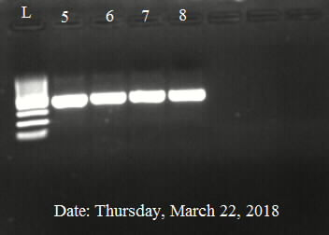
Original uncropped gel image

Figure legend
L: 1000 bp ladder
5: goat sample
6: goat sample
7: goat sample
8: cattle sample

