Quaternary Ammonium Salts Based on (-)-Borneol as Effective Inhibitors of Influenza Virus
Anastasiya S. Sokolova,*ª Оlga I. Yarovayaª, Darya V. Baranovaª, Anastasia V. Galochkina^{b}, Anna A. Shtro^{c}, Sophia S. Borisevich^{d}, Yuriy V. Gatilovª, Vladimir V. Zarubaev^{b}, Nariman F. Salakhutdinovª
ªN.N. Vorozhtsov Novosibirsk Institute of Organic Chemistry, Siberian Branch, Russian Academy of Sciences, Lavrentjev Avenue 9, 630090 Novosibirsk, Russia
^{b}Pasteur Institute of Epidemiology and Microbiology, 14 Mira str., 197101 St. Petersburg, Russia
^{c}Department of Chemotherapy, Influenza Research Institute, 15/17 Prof. Popova St., 197376 St. Petersburg, Russia
^{d}Laboratory of Chemical Physics, Ufa Institute of Chemistry Ufa Federal Research Center, 71 Pr. Oktyabrya, 450078, Ufa, Russia

Corresponding author: *Dr. Anastasiya S. Sokolova, Ph.D., tel.: +7-383-330-88-70, e-mail: asokolova@nioch.nsc.ru

SUPPORTING INFORMATION
NMR ¹H and ¹³C spectra of the compounds 6, 7, 10a, 10c, 11a, 11b

Compound 6
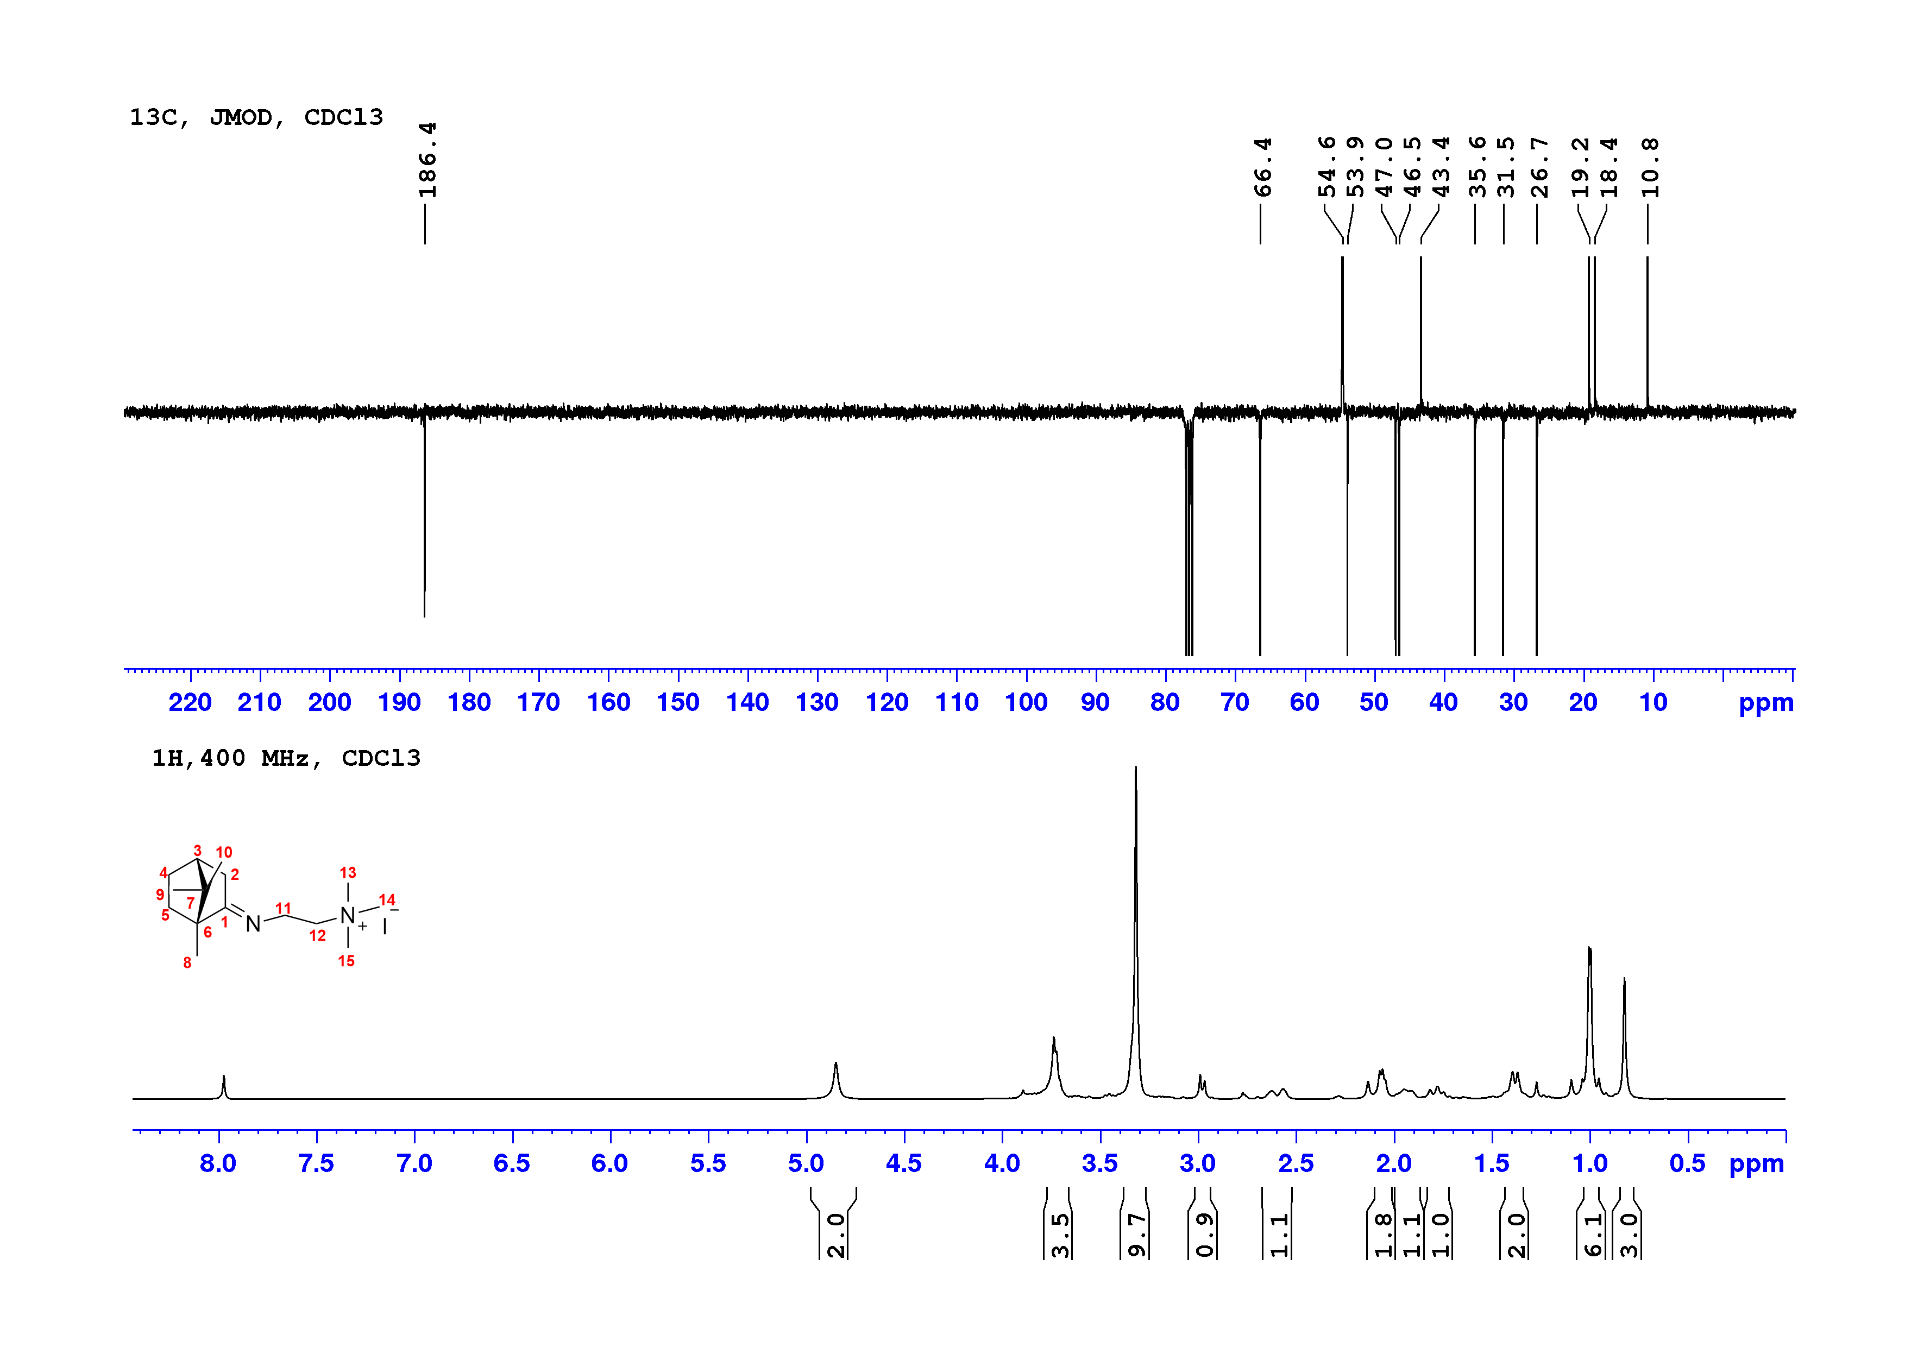
Compound 7
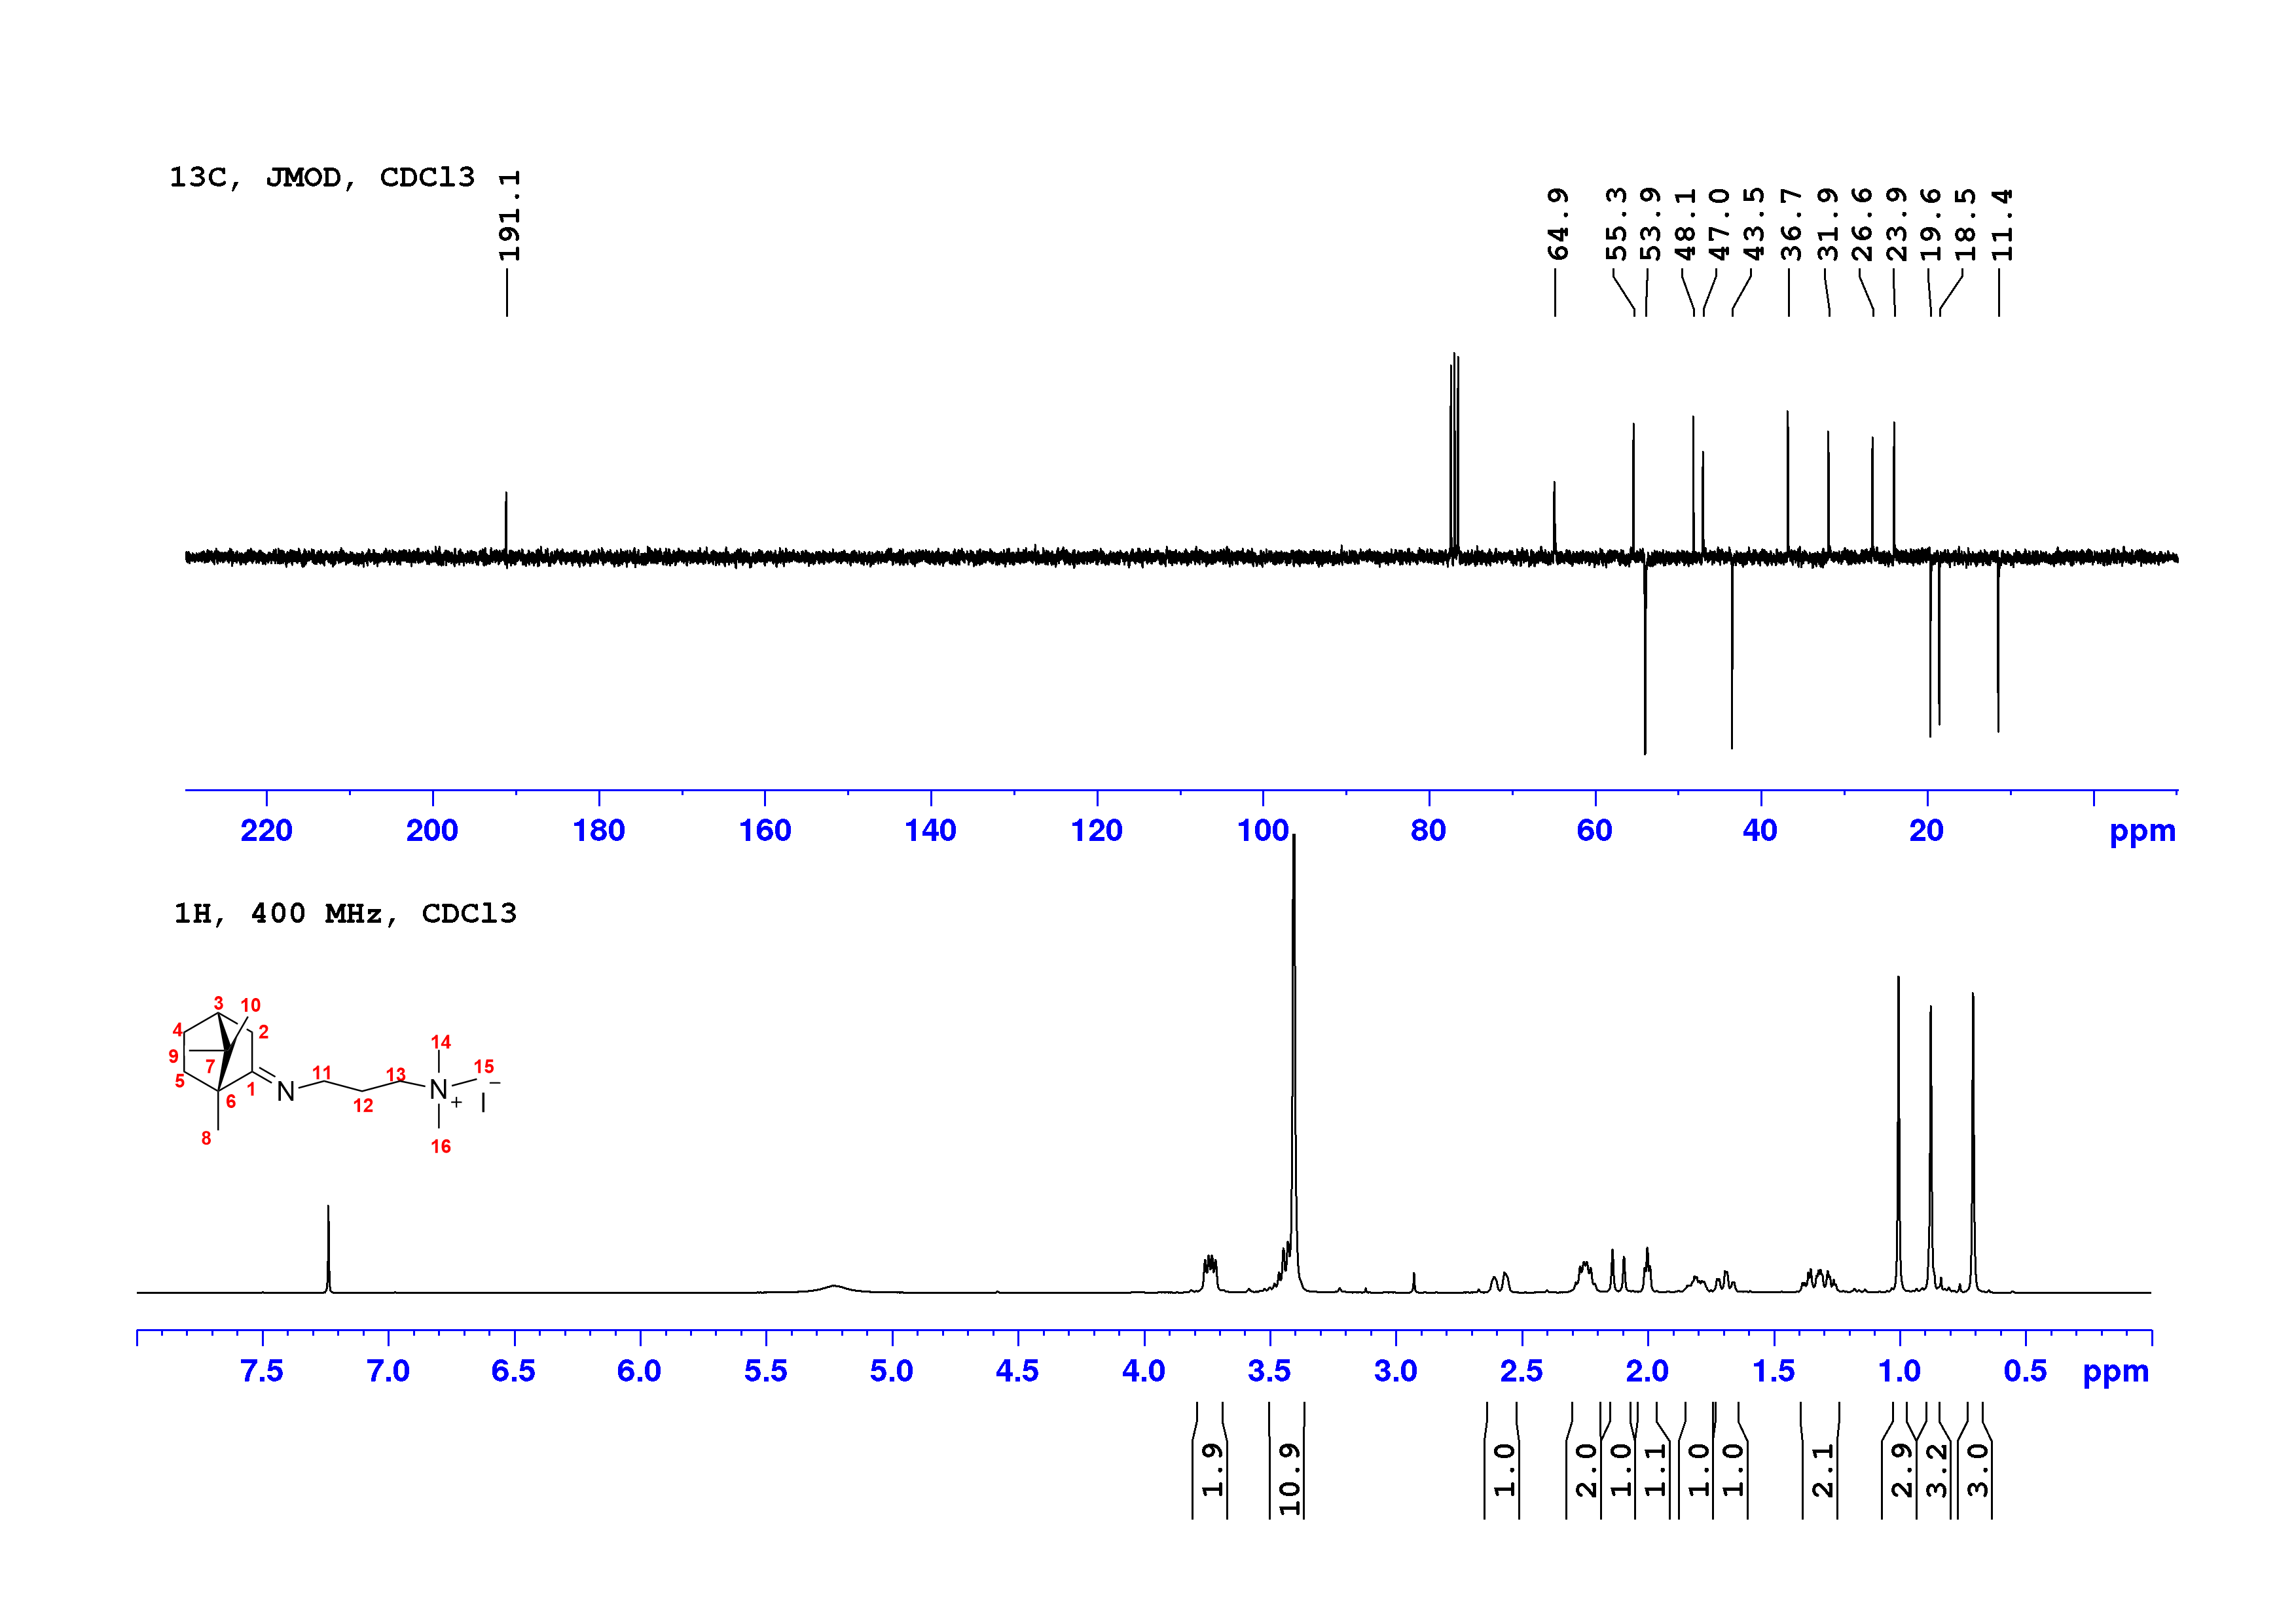
Compound 10a
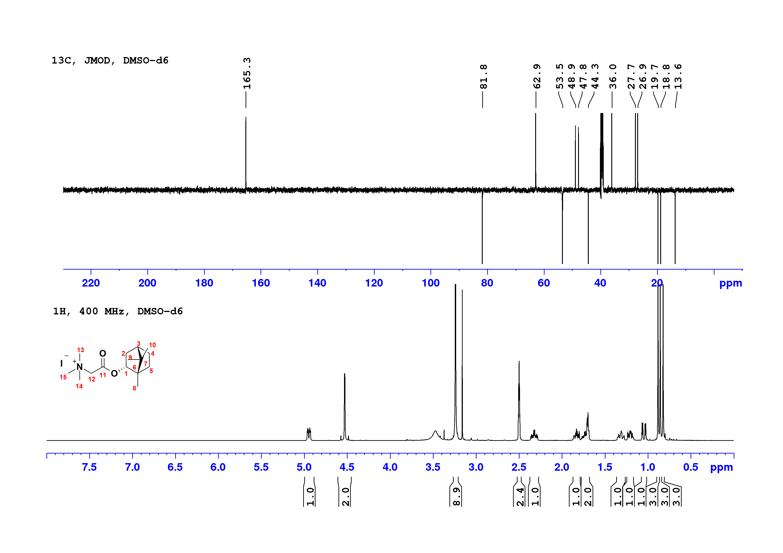
Compound 10c
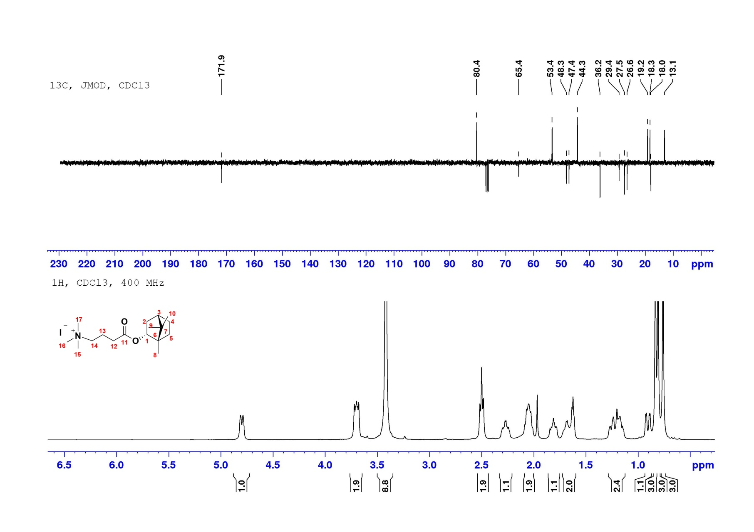
Compound 11a
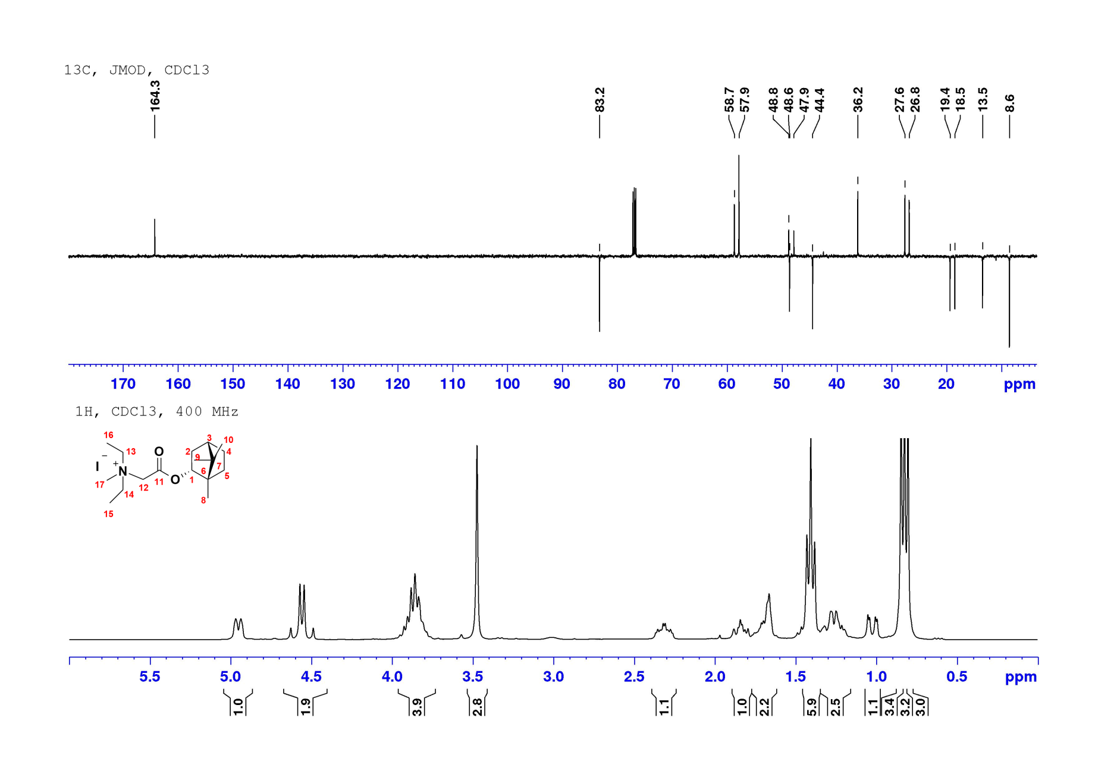
Compound 11b
