Supporting Information
Preparation of Zinc(II) phthalocyanine-based LB thin film: Experimental characterization, the determination of optical properties and harmful organic vapor sensing ability
Yaser Acikbas^{a,}, Matem Erdogan^{b}, Rifat Capan^{b}, Cansu Ozkaya^{b}, Yasemin Baygu^{c}, Nilgün Kabay^{d}, Yaşar Gök^{e}
ªDepartment of Materials Science and Nanotechnology Engineering, Faculty of Engineering, University of Usak, 64200, Usak, Turkey
^{b}Department of Physics, Faculty of Science, University of Balikesir, 10145, Balikesir, Turkey
^{c}Tavas Vocational High School, Pamukkale University, Denizli-Turkey,
^{d}Department of Biomedical Engineering, Pamukkale University, Kınıklı/Denizli, Turkey,
^{e}Department of Chemical Engineering, Usak University, Usak, Turkey

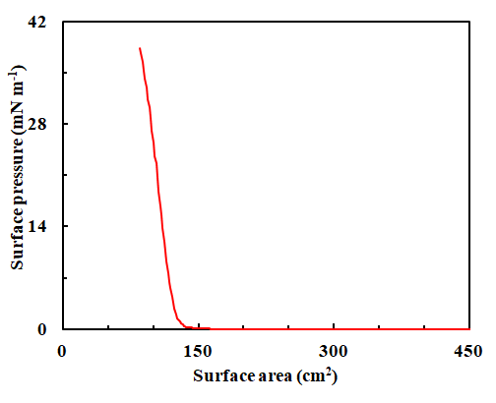
Fig. S1. Isotherm graph of the Zn(II)Pc monolayer.

QCM and SPR Techniques
For QCM studies, the Zn(II)Pc material was fabricated onto quartz crystal substrates. After each deposition period, the LB film sample was left drying and the change in mass was checked utilizing the QCM measurement system controlled with a home-made computer. Dedicated software permits online recording of the variations in quartz resonance frequency. All the measurements were performed on an in-house designed oscillating circuit at room temperature with standard quartz crystals having a nominal resonance frequency of 3.5 MHz. The frequency of oscillation was checked as an element of time utilizing a PC after the quartz crystal was embedded into the electronic control unit. The frequency variation values, which specify the amount of reaction, were measured with a precision of 1 Hz while providing organic vapour. Also, a gas cell was built to investigate the Zn(II)Pc LB film reaction while exposing to organic vapours by measuring the frequency change. The Zn(II)Pc thin film sensor was periodically exposed to organic vapours for 2 min and afterwards was allowed to recuperate after injection of dry air. Moreover, during exposure to organic vapours the variation in resonance frequency were recorded in real time. In order to observe the reproducibility of Zn(II)Pc thin film sensor this procedure was performed over several times. The schematic diagram of QCM measurement system was presented in Fig. S2a.
BIOSUPLAR 6Model Surface Plasmon Resonance Spectrometer was preferred to carry out all SPR measurements and the angular resolution of the SPR measurement was determined as 0.003°. As a light source, a laser diode at a wavelength of 632.8 nm was performed for these measurements. A glass prism of reflective index 1.62 was installed to holder to take measurements in air environment, and glass slides which coated 50 nm gold layer were used for all SPR measurements. In order to obtain SPR kinetic measurements, a semi-transparent plastic flow cell was preferred. Thanks to the channels of inlets and outlets, the silicon tubes can be fastened to the cell. The SPR system settings, the data acquiring, and data presentation were controlled by software. The photodetector response (the intensity of the reflected light) was observed as a function of time by using three different modes (slope mode, tracking mode or single measurements). Differences between these modes can be seen simultaneously via software interface. All kinetic measurements were actualized by exposure fresh air and organic vapour for periodically 2 minutes. In this work, the fitting of experimental SPR curves was fixed with WINSPALL software. Some important optical properties such as the thickness and refractive index of the fabricated LB thin films can be determined with these fitting data. These parameters’ values of Zn(II)Pc LB thin film can be calculated through its fitting SPR data. The SPR measurement system as a schematic diagram was presented in Fig. S2b.
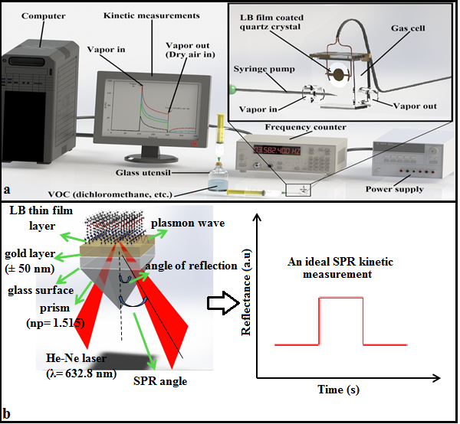

Fig. S2. A schematic diagram of a) the QCM kinetic measurement process b) the SPR measurement technique.

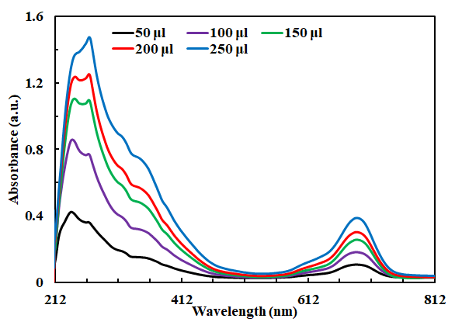
Fig. S3. UV-Vis spectra of the Zn(II)Pc in a chloroform solution.

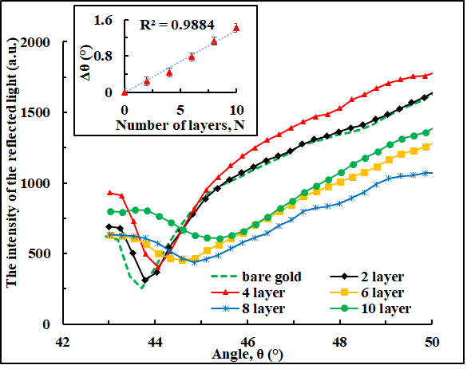
Fig. S4. SPR curves of Zn(II)Pc LB film layers (Inset: linear increase in Δθ as depending on the number of layers)

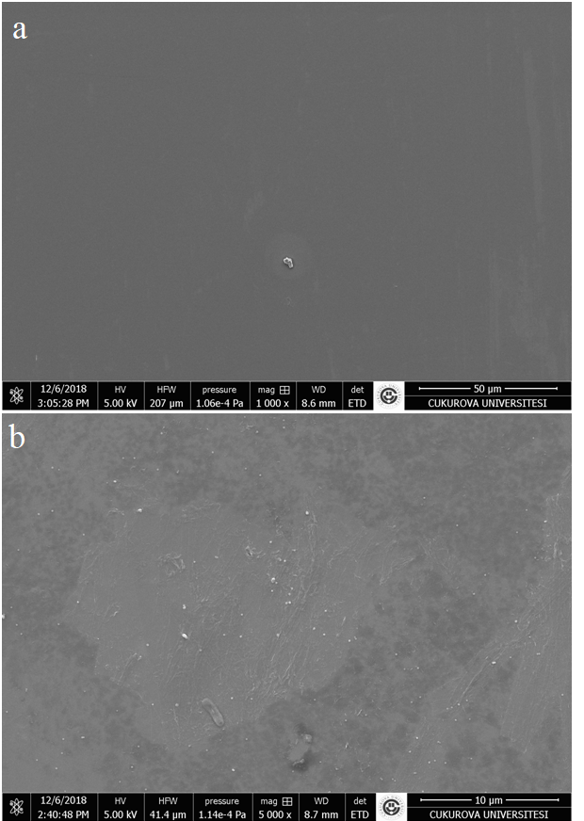
Fig. S5. SEM images of bare glass (a) and Zn(II)Pc LB film.

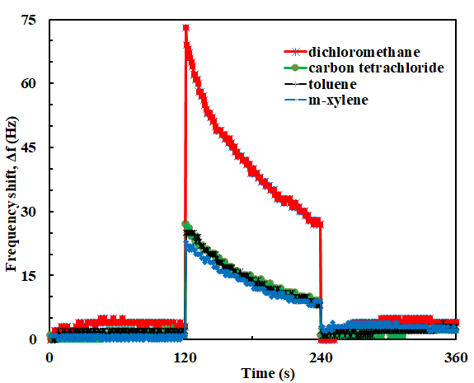
Fig. S6. The QCM kinetic results of Zn(II)Pc LB film sensor for VOCs.
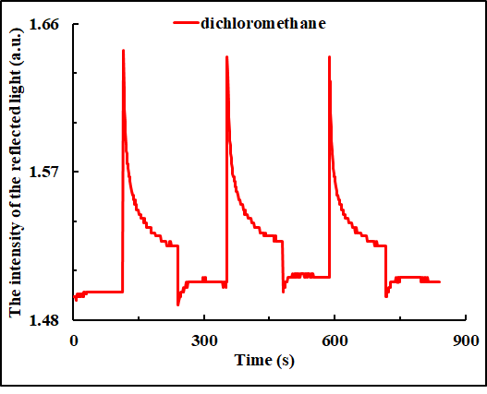
Fig. S7. SPR kinetic measurements of Zn(II)Pc LB film against to DCM for three cycles.

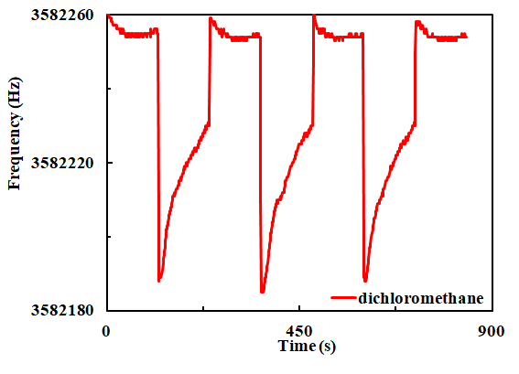
Fig. S8. QCM kinetic measurements of Zn(II)Pc LB film against to DCM for three cycles.

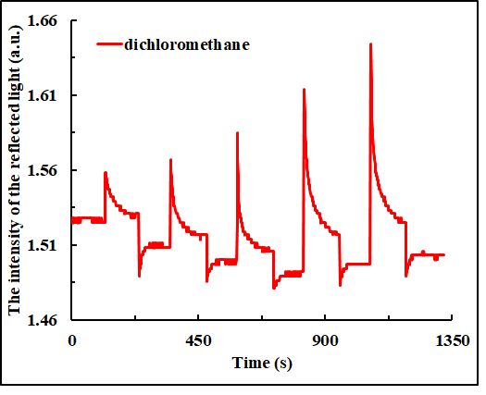
Fig. S9. SPR kinetic measurements of Zn(II)Pc LB film at different concentrations.

Corresponding author. E-mail address: yaser.acikbas@usak.edu.tr (Y. Acikbas).

