Graphical Abstract

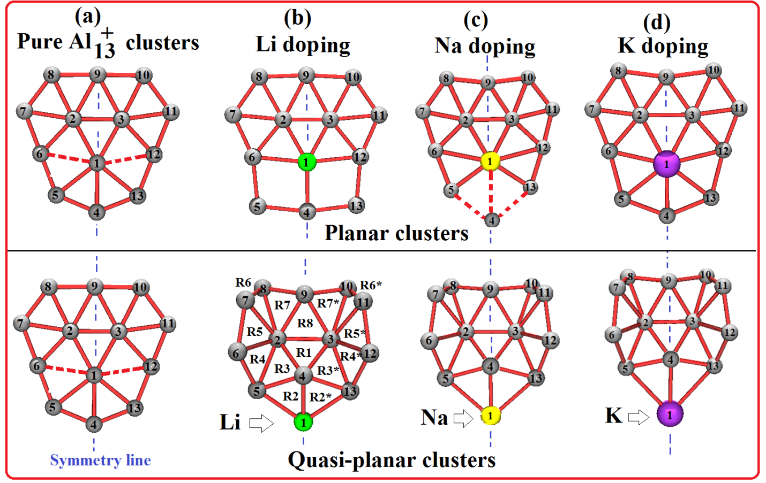
Effect of alkali atom doping to Al₁₃⁺ cluster

