Table 3 Status of the shoreline in different time periods
S.No | Period | Statistical method | Eroding coast | Accreting coast | Stable coast | Transects records erosion/accretion/stable coast
1 | 1976-2004 | EPR | Between Kalapathar and Indira bazar, Onge Tikry, Ekiti Bay, north of Jackson Creek | Between BurmilaCreek and Dugong Creek, Sandy point, south of West Bay. | Between Dugong Creek and Butler Bay, West Bay | 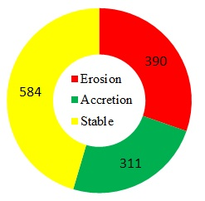
2 | 2004-2005 | EPR | Dugong Creek, Vivekanandpur,  Between Kalapathar and Indira bazar, South Bay | entire western part of Little Andaman, between BumilaCreek and north of Dugong Creek, Onge Tikry, Sandy point | Few transects north of Onge Tikry | 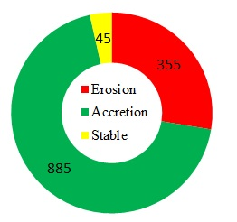
3 | 2005-2018 | EPR | between south of West Bay and Sandy point, between Jackson Creek and Apl island | Dugong Creek, Between Kalapathar and Indira bazar, between South Bay to Sandy point, West Bay, south of Ekiti Bay | Between south of Dugong Creek and Butler Bay, Onge Tikry | 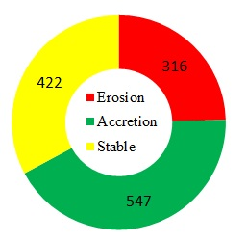
4 | 1976-2018 | LRR | Between Kalapathar and Indira bazar, Onge Tikry | Entire western and northern part (except Jackson Creek), Dugong Creek | Between north of Vivekanandpur and Kalapathar, few transects in north of Onge Tikry and Jackson Creek | 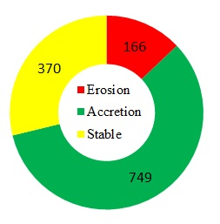
5 | 1976-2018 | WLR | Between Few transects in Hut Bay, Onge Tikry | Entire western and northern part (except Jackson Creek), Dugong Creek | Between North Of Vivekanandpur And Hut Bay, Few Transects In North Of Onge Tikry And Jackson Creek | 