Appendix
Appendix A. Abundance of sixteen tree species in the overstory and the regeneration layer that accounted for 51 % of total tree species abundance in the overstory and 72 % in the regeneration: S.mac, Streblus macrophyllus; P.het, Pterospermum heterophyllum; P.tav, Pheobe tavoyana; D.dec, Diospyros decandra; D.ton, Deutzianthus tonkinensis; D.fum, Dimocarpus fumatus; M.fer, Mesua ferrea; S.lan, Sterculia lanceolate; M.pan, Microcos paniculata; D.dup, Dracontomelon duperreanum; D.pil, Diospyros pilosula; A.ebr, Acanthus ebracteatus; C.pan, Chisocheton paniculatus; E.rox, Engelhardtia roxburghiana; E.gri, Elaeocarpus griffithii; C.exc, Clausena excavate; S.div, Saraca dives; F.alo, Ficus alongensis; C.alb, Canarium album; D.het, Dillenia heterosepala, B.bal, Bridelia balansae). Abundance columns show the number of tree species individuals. Percentage column was calculated by dividing the abundance of each species by all species abundance. Accumulation aggregated the percentage column from the first to the last species.
Nº | Overstory Species | Abundance | Percentage (%) | Accumulation (%) | Regeneration Species | Abundance | Percentage (%) | Accumulation (%)
1 | S.mac | 378 | 6.109 | 6.109 | P.het | 1530 | 13.736 | 13.736
2 | P.het | 363 | 5.867 | 11.976 | S.mac | 1197 | 10.746 | 24.483
3 | P.tav | 321 | 5.188 | 17.165 | D.fum | 1078 | 9.678 | 34.162
4 | D.dec | 309 | 4.994 | 22.159 | P.tav | 805 | 7.227 | 41.389
5 | D.ton | 245 | 3.959 | 26.119 | D.ton | 446 | 4.004 | 45.394
6 | D.fum | 216 | 3.491 | 29.610 | E.gri | 389 | 3.492 | 48.886
7 | M.fer | 159 | 2.569 | 32.180 | D.dec | 349 | 3.133 | 52.020
8 | S.lan | 156 | 2.521 | 34.701 | S.div | 303 | 2.720 | 54.740
9 | M.pan | 155 | 2.505 | 37.207 | F.alo | 302 | 2.711 | 57.451
10 | D.dup | 147 | 2.375 | 39.582 | C.alb | 283 | 2.540 | 59.992
11 | D.pil | 133 | 2.149 | 41.732 | C.pan | 256 | 2.298 | 62.291
12 | A.ebr | 128 | 2.068 | 43.801 | D.dup | 256 | 2.298 | 64.589
13 | C.pan | 114 | 1.842 | 45.644 | S.lan | 251 | 2.253 | 66.843
14 | E.rox | 108 | 1.745 | 47.389 | D.pil | 245 | 2.199 | 69.042
15 | E.gri | 107 | 1.729 | 49.119 | D.het | 189 | 1.696 | 70.739
16 | C.exc | 103 | 1.664 | 50.783 | B.bal | 172 | 1.544 | 72.284

Appendix B. The species accumulation curve of overstory tree species layer, the x-axis shows the abbreviation name of species in overstory tree species layer (see more in Appendix A)

Appendix C. The species accumulation curve of regeneration tree species layer, the x-axis shows the abbreviation name of species in overstory tree species layer (see more in Appendix A)
Appendix D. Diversity estimates with rarefied and extrapolated samples of overstory layer from iNEXT results. m = sample size as number of individuals; order = Hill number with 0 = species richness; 1 = Shannon diversity, 2 = Simpson diversity; qD = the estimated diversity for a given sample size and order; SC = the estimated sample coverage; qD.LCL, qD.UCL = the lower and upper confidence level for the estimated diversity at the default value of 0.95; SC.LCL, SC.UCL= the lower and upper confidence level for the estimated sample coverage with a default value of 0.95.
m | method | order | qD | qD.LCL | qD.UCL | SC | SC.LCL | SC.UCL
5 | interpolated | 0 | 4.754 | 4.737 | 4.772 | 0.118 | 0.110 | 0.125
30 | interpolated | 0 | 22.138 | 21.776 | 22.500 | 0.455 | 0.439 | 0.470
200 | interpolated | 0 | 66.979 | 64.856 | 69.102 | 0.857 | 0.849 | 0.865
2301 | observed | 0 | 136.000 | 129.965 | 142.035 | 0.992 | 0.989 | 0.995
8000 | extrapolated | 0 | 143.343 | 131.444 | 155.242 | 1.000 | 0.999 | 1.001
5 | interpolated | 1 | 4.665 | 4.643 | 4.688 | 0.118 | 0.110 | 0.125
30 | interpolated | 1 | 19.826 | 19.396 | 20.257 | 0.455 | 0.440 | 0.469
200 | interpolated | 1 | 45.989 | 44.105 | 47.873 | 0.857 | 0.849 | 0.864
2301 | observed | 1 | 61.111 | 58.297 | 63.926 | 0.992 | 0.989 | 0.995
8000 | extrapolated | 1 | 63.018 | 60.079 | 65.957 | 1.000 | 0.999 | 1.001
5 | interpolated | 2 | 4.534 | 4.511 | 4.558 | 0.118 | 0.112 | 0.124
30 | interpolated | 2 | 17.199 | 16.786 | 17.612 | 0.455 | 0.442 | 0.467
200 | interpolated | 2 | 32.748 | 31.220 | 34.275 | 0.857 | 0.850 | 0.863
2301 | observed | 2 | 38.331 | 36.235 | 40.428 | 0.992 | 0.989 | 0.995
8000 | extrapolated | 2 | 38.780 | 36.634 | 40.926 | 1.000 | 0.999 | 1.001

Appendix E. Diversity estimates with rarefied and extrapolated samples of regeneration layer from iNEXT results. m = sample size as number of individuals; order = Hill number with 0 = species richness; 1 = Shannon diversity, 2 = Simpson diversity; qD = the estimated diversity for a given sample size and order; SC = the estimated sample coverage; qD.LCL, qD.UCL = the lower and upper confidence level for the estimated diversity at the default value of 0.95; SC.LCL, SC.UCL= the lower and upper confidence level for the estimated sample coverage with a default value of 0.95.
m | method | order | qD | qD.LCL | qD.UCL | SC | SC.LCL | SC.UCL
5 | interpolated | 0 | 4.564 | 4.540 | 4.587 | 0.201 | 0.192 | 0.211
30 | interpolated | 0 | 18.551 | 18.190 | 18.912 | 0.599 | 0.586 | 0.613
200 | interpolated | 0 | 49.660 | 48.275 | 51.044 | 0.904 | 0.900 | 0.909
3622 | observed | 0 | 96.998 | 93.500 | 100.495 | 0.998 | 0.996 | 0.999
8000 | extrapolated | 0 | 100.489 | 93.245 | 107.733 | 1.000 | 0.999 | 1.001
5 | interpolated | 1 | 4.414 | 4.386 | 4.442 | 0.201 | 0.193 | 0.210
30 | interpolated | 1 | 15.541 | 15.199 | 15.884 | 0.599 | 0.591 | 0.608
200 | interpolated | 1 | 29.309 | 28.405 | 30.213 | 0.904 | 0.900 | 0.908
3622 | observed | 1 | 35.955 | 34.762 | 37.149 | 0.998 | 0.996 | 0.999
8000 | extrapolated | 1 | 36.331 | 35.123 | 37.539 | 1.000 | 0.999 | 1.001
5 | interpolated | 2 | 4.205 | 4.163 | 4.247 | 0.201 | 0.191 | 0.212
30 | interpolated | 2 | 12.654 | 12.198 | 13.110 | 0.599 | 0.588 | 0.611
200 | interpolated | 2 | 19.219 | 18.144 | 20.294 | 0.904 | 0.900 | 0.908
3622 | observed | 2 | 21.038 | 19.746 | 22.331 | 0.998 | 0.996 | 0.999
8000 | extrapolated | 2 | 21.102 | 19.802 | 22.403 | 1.000 | 0.999 | 1.001

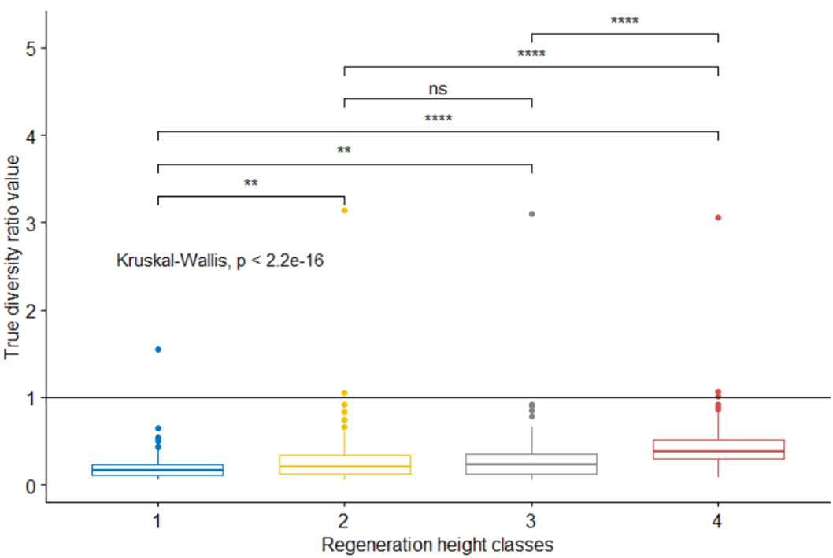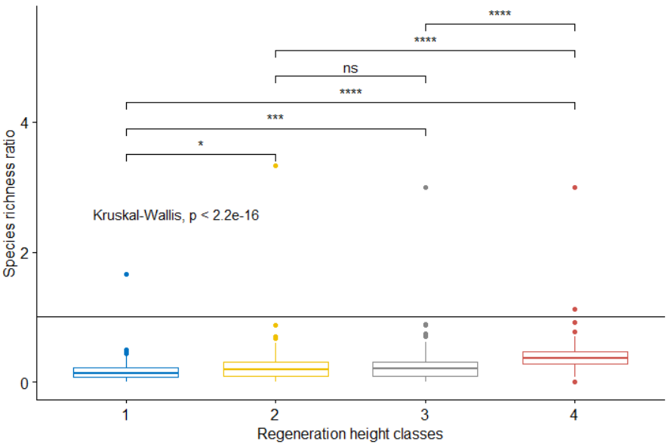
Appendix F. Boxplots of true diversity and species richness ratio in four regeneration height classes (1 = < 50 m; 2 = 50 – 100 cm, 3 = 100 – 200 cm, 4 = > 200 cm). Ratios were compared among height classes using Krukal-Wallis test with post-hoc Wilcoxon test. ***, <0.001; **, <0.01; *,<0.05; ns, not significant.
Appendix G. The correlation coefficients of variables with the first three principal components (PC1, PC2, PC3) of the PCA analysis of environmental variables. Shown correlation coefficients are significant with a p-value < 0.05.
Principal components | Variables | Acronym | Correlation coefficient
PC1 | Total site factor | L_TSF | 0.974
 | Gap fraction | L_GF | 0.960
 | Openness | L_OPN | 0.959
 | Indirect site factor | L_ISF | 0.922
 | Direct site factor | L_DSF | 0.910
 | pH | S_pH | -0.279
 | Ellipsoidal leaf area distribution | L_ELAD | -0.421
 | Leaf area index | L_LAI | -0.794
PC2 | Cation exchange capacity | S_CEC | 0.852
 | Rock surface | T_RS | 0.822
 | pH | S_pH | 0.785
 | Soil moisture | S_SM | 0.733
 | Soil humus content | S_SH | 0.727
 | Base saturation | S_BS | 0.649
 | Slope | T_Sl | 0.596
 | Elevation | T_Ele | 0.262
 | Clay | S_Clay | 0.245
 | Footpaths | H_FP | -0.214
 | Silt | S_Silt | -0.285
 | Hydrolytic acidity | S_HA | -0.329
 | Soil depth | S_SD | -0.642
PC3 | Clay | S_Clay | 0.722
 | Silt | S_Silt | 0.542
 | Soil depth | S_SD | 0.482
 | Soil moisture | S_SM | 0.439
 | Animal traps | H_AT | 0.362
 | Cation exchange capacity | S_CEC | 0.280
 | Leaf area index | L_LAI | 0.256
 | Rock surface | T_RS | -0.223
 | Elevation | T_Ele | -0.235
 | Rock in soil | S_SR | -0.312
 | Slope | T_Sl | -0.369
 | Sand | S_Sand | -0.837
Appendix H. Model selection result of linear mixed effect models of species richness ratio and six environmental variables. Intercept = intercept of model; columns two to seven show the slope of each model. Acronyms are defined in Table 5; df = degree of freedom of model; logLik = log-likelihood estimation; AICc = Akaike information criterion; Weight = model weight.
Intercept | L_GF | L_TSF | S_CEC | S_Clay | S_Silt | T_RS | Df | logLik | AICc | Weight
0.886 |  |  |  |  |  | -0.004 | 4 | -55.167 | 118.8 | 0.994
0.832 | 0.004 |  |  |  |  | -0.004 | 5 | -59.105 | 128.9 | 0.006
0.853 | 0.019 | -0.023 |  |  |  | -0.004 | 6 | -61.450 | 135.9 | 0.000
0.680 | 0.019 | -0.024 |  |  | 0.005 | -0.004 | 7 | -65.422 | 146.2 | 0.000
0.742 | 0.019 | -0.022 |  | -0.003 | 0.005 | -0.004 | 8 | -69.603 | 157.0 | 0.000
0.705 | 0.019 | -0.022 | 0.008 | -0.003 | 0.005 | -0.004 | 9 | -71.949 | 164.1 | 0.000

Appendix I. Model selection result of linear mixed effect models of species richness ratio and the first three principal components (PC1, PC2, PC3). Columns five to eight show the slope of interaction of two or three principal component to each other; Df = degree of freedom of model; logLik = log-likelihood estimation; AIC = Akaike information criterion; Weight = model weight.
Intercept | PC1 | PC2 | PC3 | PC1:PC2 | PC1:PC3 | PC2:PC3 | PC1:PC2:PC3 | Df | logLik | AICc | Weight
0.683 |  | -0.052 |  |  |  |  |  | 4 | -52.750 | 114.0 | 0.831
0.683 |  |  | 0.015 |  |  |  |  | 4 | -55.071 | 118.6 | 0.082
0.683 | 0.006 |  |  |  |  |  |  | 4 | -55.545 | 119.6 | 0.051
0.683 |  | -0.053 | 0.017 |  |  |  |  | 5 | -55.237 | 121.2 | 0.022
0.683 | 0.005 | -0.052 |  |  |  |  |  | 5 | -55.785 | 122.3 | 0.013
0.683 | 0.005 |  | 0.014 |  |  |  |  | 5 | -58.071 | 126.9 | 0.001
0.683 | 0.004 | -0.053 | 0.017 |  |  |  |  | 6 | -58.277 | 129.6 | 0.000
0.683 | 0.004 | -0.055 | 0.023 | -0.014 | -0.000 | -0.016 | -0.003 | 10 | -71.099 | 165.0 | 0.000

Appendix J. Best fit model selection result of linear mixed effect models of species richness ratio.
Intercept | T_RS | PC2 | Df | logLik | AICc | Weight
0.683 |  | -0.052 | 4 | -52.750 | 114.0 | 0.918
0.886 | -0.004 |  | 4 | -55.167 | 118.8 | 0.082

Appendix K. Model selection result of linear mixed effect models of true diversity ratio and six environmental variables. Intercept = intercept of model; columns two to seven give the slope of each model. Acronyms are defined in Table 1; df = degree of freedom of model; logLik = log-likelihood estimation; AICc = Akaike information criterion; Weight = model weight.
Intercept | L_GF | L_TSF | S_CEC | S_Clay | S_Silt | T_RS | Df | logLik | AICc | Weight
0.956 |  |  |  |  |  | -0.005 | 4 | -57.157 | 122.8 | 0.991
0.877 | 0.006 |  |  |  |  | -0.005 | 5 | -60.814 | 132.3 | 0.008
0.894 | 0.021 | -0.022 |  |  |  | -0.005 | 6 | -63.200 | 139.4 | 0.000
0.741 | 0.023 | -0.025 | 0.025 |  |  | -0.005 | 7 | -65.368 | 146.1 | 0.000
0.665 | 0.023 | -0.025 | 0.024 |  | 0.002 | -0.005 | 8 | -69.555 | 156.9 | 0.000
0.685 | 0.022 | -0.023 | 0.028 | -0.002 | 0.002 | -0.005 | 9 | -73.755 | 167.8 | 0.000

Appendix L. Model selection result of linear mixed effect models of true diversity ratio and the first three principal components (PC1, PC2, PC3). Columns five to eight show the slope of interaction of two or three principal component to each other; df = degree of freedom of model; logLik = log-likelihood estimation; AICc = Akaike information criterion; Weight = model weight.
Intercept | PC1 | PC2 | PC3 | PC1:PC2 | PC1:PC3 | PC2:PC3 | PC1:PC2:PC3 | Df | logLik | AICc | Weight
0.699 |  | -0.048 |  |  |  |  |  | 4 | -56.344 | 121.2 | 0.681
0.699 |  |  | 0.022 |  |  |  |  | 4 | -57.839 | 124.1 | 0.153
0.699 | 0.011 |  |  |  |  |  |  | 4 | -58.352 | 125.2 | 0.091
0.683 | 0.005 |  | 0.014 |  |  |  |  | 5 | -58.071 | 126.9 | 0.039
0.699 |  | -0.050 | 0.025 |  |  |  |  | 5 | -58.608 | 127.9 | 0.023
0.699 | 0.009 | -0.047 |  |  |  |  |  | 5 | -59.257 | 129.2 | 0.012
0.699 | 0.009 | -0.049 | 0.025 |  |  |  |  | 6 | -61.538 | 136.1 | 0.000
0.699 | 0.008 | -0.050 | 0.030 | -0.014 | -0.000 | -0.017 | -0.005 | 10 | -74.225 | 171.2 | 0.000

Appendix M. Best fit model selection result of linear mixed effect models of true diversity ratio.
Intercept | T_RS | PC2 | Df | logLik | AICc | Weight
0.699 |  | -0.048 | 4 | -56.344 | 121.2 | 0.693
0.956 | -0.005 |  | 4 | -57.157 | 122.8 | 0.307

Appendix N. Model selection result of linear mixed effect models of same species ratio and six environmental variables. Intercept = intercept of model; columns two to seven show the slope of each model. Acronyms are defined in Table 1; df = degree of freedom of model; logLik = log-likelihood estimation; AICc = Akaike information criterion; Weight = model weight.
Intercept | L_GF | L_TSF | S_CEC | S_Clay | S_Silt | T_RS | Df | logLik | AICc | Weight
0.494 |  |  |  |  |  | -0.002 | 4 | 31.970 | -55.5 | 0.997
0.592 |  |  |  |  | -0.002 | -0.002 | 5 | 27.420 | -44.1 | 0.003
0.537 |  |  |  | 0.002 | -0.003 | -0.002 | 6 | 22.842 | -32.7 | 0.000
0.545 |  | -0.002 |  | 0.003 | -0.003 | -0.002 | 7 | 18.274 | -21.2 | 0.000
0.533 | 0.007 | -0.011 |  | 0.003 | -0.003 | -0.002 | 8 | 14.693 | -11.6 | 0.000
0.486 | 0.007 | -0.011 | 0.009 | 0.003 | -0.003 | -0.002 | 9 | 11.544 | -2.8 | 0.000

Appendix O. Model selection result of linear mixed effect models of same species ratio and the first three principal components (PC1, PC2, PC3). Columns five to eight show the slope of interaction of two or three principal component to each other; df = degree of freedom of model; logLik = log-likelihood estimation; AICc = Akaike information criterion; Weight = model weight.
Intercept | PC1 | PC2 | PC3 | PC1:PC2 | PC1:PC3 | PC2:PC3 | PC1:PC2:PC3 | Df | logLik | AICc | Weight
0.385 |  |  | 0.013 |  |  |  |  | 4 | 30.900 | -53.3 | 0.474
0.385 |  | -0.009 |  |  |  |  |  | 4 | 30.418 | -52.4 | 0.292
0.385 | -0.006 |  |  |  |  |  |  | 4 | 30.140 | -51.8 | 0.221
0.385 |  | -0.009 | 0.013 |  |  |  |  | 5 | 27.589 | -44.5 | 0.006
0.385 | -0.007 |  | 0.013 |  |  |  |  | 5 | 27.291 | -43.9 | 0.004
0.385 | -0.007 | -0.009 |  |  |  |  |  | 5 | 26.811 | -42.9 | 0.003
0.385 | -0.007 | -0.010 | 0.014 |  |  |  |  | 6 | 24.020 | -35.0 | 0.000
0.385 | -0.006 | -0.011 | 0.015 | 0.002 | 0.005 | -0.006 | -0.002 | 10 | 7.084 | 8.6 | 0.000

Appendix P. Best fit model selection result of linear mixed effect models of same species ratio.
Intercept | T_RS | PC3 | Df | logLik | AICc | Weight
0.494 | -0.002 |  | 4 | 31.97 | -55.5 | 0.745
0.385 |  | 0.013 | 4 | 30.90 | -53.3 | 0.255

Appendix Q. Model selection result of linear mixed effect models of new existent species ratio and six environmental variables. Intercept = intercept of model; columns two to seven give the slope of each model. Acronyms are defined in Table 1; df = degree of freedom of model; logLik = log-likelihood estimation; AICc = Akaike information criterion; Weight = model weight.
Intercept | L_GF | L_TSF | S_CEC | S_Clay | S_Silt | T_RS | Df | logLik | AICc | Weight
0.482 |  |  |  |  |  | -0.004 | 4 | -58.830 | 126.1 | 0.989
0.152 |  |  |  |  | 0.008 | -0.004 | 5 | -62.225 | 135.2 | 0.011
0.338 |  |  |  | -0.007 | 0.008 | -0.003 | 6 | -65.641 | 144.3 | 0.000
0.311 |  | 0.006 |  | -0.008 | 0.008 | -0.003 | 7 | -69.244 | 153.9 | 0.000
0.298 | 0.009 | -0.006 |  | -0.008 | 0.008 | -0.003 | 8 | -72.276 | 162.3 | 0.000
0.338 | 0.009 | -0.006 | -0.008 | -0.007 | 0.008 | -0.003 | 9 | -74.593 | 169.4 | 0.000

Appendix R. Model selection result of linear mixed effect models of new existence species ratio and the first three principal components (PC1, PC2, PC3). Columns five to eight show the slope of interaction of two or three principal component to each other; df = degree of freedom of model; logLik = log-likelihood estimation; AICc = Akaike information criterion; Weight = model weight.
Intercept | PC1 | PC2 | PC3 | PC1:PC2 | PC1:PC3 | PC2:PC3 | PC1:PC2:PC3 | Df | logLik | AICc | Weight
0.297 |  | -0.061 |  |  |  |  |  | 4 | -55.019 | 118.5 | 0.871
0.297 |  |  | 0.007 |  |  |  |  | 4 | -57.828 | 124.1 | 0.052
0.297 | 0.011 |  |  |  |  |  |  | 4 | -58.106 | 124.7 | 0.040
0.297 |  | -0.061 | 0.003 |  |  |  |  | 5 | -57.673 | 126.1 | 0.020
0.297 | 0.011 | -0.061 |  |  |  |  |  | 5 | -57.905 | 126.5 | 0.016
0.297 | 0.011 |  | 0.007 |  |  |  |  | 5 | -60.690 | 132.1 | 0.001
0.297 | 0.011 | -0.061 | 0.003 |  |  |  |  | 6 | -60.555 | 134.1 | 0.000
0.297 | 0.010 | -0.060 | 0.007 | -0.015 | -0.003 | -0.007 | -0.002 | 10 | -73.809 | 170.4 | 0.000

Appendix S. Best fit model selection result of linear mixed effect models of same species ratio.
Intercept | T_RS | PC2 | Df | logLik | AICc | Weight
0.297 |  | -0.061 | 4 | -55.019 | 118.5 | 0.978
0.482 | -0.004 |  | 4 | -58.830 | 126.1 | 0.022

Appendix T. Model selection result of linear mixed effect models of threatened species ratio and six environmental variables. Intercept = intercept of model; columns two to seven give the slope of each model. Acronyms are defined in Table 1; df = degree of freedom of model; logLik = log-likelihood estimation; AICc = Akaike information criterion; Weight = model weight.
Intercept | L_GF | L_TSF | S_CEC | S_Clay | S_Silt | T_RS | Df | logLik | AICc | Weight
0.485 | -0.009 |  |  |  |  |  | 4 | -68.490 | 145.5 | 0.998
0.423 | -0.010 |  |  |  |  | 0.001 | 5 | -73.594 | 157.9 | 0.002
0.709 | -0.010 |  | -0.049 |  |  | 0.003 | 6 | -75.153 | 163.3 | 0.000
0.704 | -0.018 | 0.012 | -0.051 |  |  | 0.003 | 7 | -77.771 | 170.9 | 0.000
0.615 | -0.018 | 0.012 | -0.051 |  | 0.002 | 0.003 | 8 | -81.843 | 181.5 | 0.000
0.624 | -0.018 | 0.012 | -0.048 | -0.001 | 0.002 | 0.003 | 9 | -85.959 | 192.2 | 0.000
Appendix U. Model selection result of linear mixed effect models of threatened species ratio and the first three principal components (PC1, PC2, PC3). Columns five to eight show the slope of interaction of two or three principal component to each other; df = degree of freedom of model; logLik = log-likelihood estimation; AICc = Akaike information criterion; Weight = model weight.
Intercept | PC1 | PC2 | PC3 | PC1:PC2 | PC1:PC3 | PC2:PC3 | PC1:PC2:PC3 | Df | logLik | AICc | Weight
0.360 | -0.026 |  |  |  |  |  |  | 4 | -67.496 | 143.5 | 0.389
0.360 |  |  | -0.024 |  |  |  |  | 4 | -67.550 | 143.6 | 0.369
0.360 |  | 0.006 |  |  |  |  |  | 4 | -68.094 | 144.7 | 0.214
0.360 | -0.026 |  | -0.024 |  |  |  |  | 5 | -69.738 | 150.2 | 0.013
0.360 | -0.026 | 0.006 |  |  |  |  |  | 5 | -70.283 | 151.3 | 0.008
0.360 |  | 0.004 | -0.025 |  |  |  |  | 5 | -70.327 | 151.4 | 0.007
0.360 | -0.026 | 0.005 | -0.024 |  |  |  |  | 6 | -72.521 | 158.1 | 0.000
0.360 | -0.030 | 0.001 | -0.027 | 0.005 | -0.007 | -0.008 | -0.007 | 10 | -85.363 | 193.5 | 0.000

Appendix V. Best fit model selection result of linear mixed effect models of threatened species ratio.
Intercept | L_GF | PC1 | Df | logLik | AICc | Weight
0.359 |  | -0.026 | 4 | -67.496 | 143.5 | 0.73
0.486 | -0.009 |  | 4 | -68.490 | 145.5 | 0.27

