Supplementary Data

VH Domain | WT (VH-1C5) | D104A (VH-M4) | D104A_S108R_F120I (VH-S4)
Q5 | H33 (85.9)  Y34 (63.5) | H33 (79.6) | H33 (82.3)  Y34 (61.1)
A102 | W73 (98.2) | W73 (95.7) | W73 (99.1)
D104 / A104 | Y76 (80.6)  L131 (66.1) | L131 (67.0) | L131 (71.1)  Y76 (51.3)
L104 | L135 (29.5)  W73 (24.7)  L131 (16.5) | W73 (31)  L135 (23.1)  L131 (22.6) | W73 (39.2)  L135 (27.3)  L131 (21.5)
S108 / R108 | - | - | R118 (20.1)
T116 | R186 (92.8) | R186 (73.1) | R186 (90.0)
Y117 | E132 (99.9)  R186 (96.3)  L135 (92.4) | E132 (99.6)  L135 (89.7)  R186 (84.1) | E132 (100)  R186 (97.8)  L135 (96.3)
F120 / I120 | W73 (98.3)  G139 (87.1)  V69 (83.9) | W73 (99.4)  G139 (90.7)  V69 (87.1) | W73 (99.0)  V69 (93.1)  L135 (75.2)
Y124 | Y34 (98.3) | Y34 (96.1) | Y34 (95.7)
R125 | Y34 (99.7)  H37 (94.3) | Y4 (99.5)  H37 (91.3) | Y34 (95.9)  H37 (88.0)

Table S1: Pair-wise residue contact analysis of the protein:protein interface dynamics sampled during the MD simulations of the eIF4E:VH-1C5 and eIF4E:VH-S4 complexes. The values in brackets represent occupancy for each residue pairs. VH domain mutations are shown in red.

PDB ID: | 7D8B | 7D6Y
Resolution (Å) | 70.2- 2.46, (2.59-2.46) | 44.22-1.67, 9, (1.76-1.67)
Space Group | P2₁ | C2
Unit Cell Dimensions (Å) | a = 47.60, b = 140.39, c = 61.96, α = γ = 90°, β = 140.39 | a = 198.85, b = 45.32, c = 39.76, α = γ = 90°, β = 93.19
Temp (K) | 100 | 100
Redundancy | 7.7, (7.6)
Unique Collected Reflections | 28611, (4143) | 41261, (5689)
Completeness (%) | 99.9, (99.9) | 99.4, (96.2)
R Sym (%) | 0.177, (0.876) | 0.116, (0.673)
I/sigma | 3.6, (0.9) | 6.1, (1.1)
R factor (%) | 25.00 | 18.15
R free (%) | 29.18 | 20.64
RMS Bonds (Å) | 0.0022 | 0.0039
RMS Angles (°) | 1.185 | 1.197
Wilson B-factor (Å²) | 31.06 | 3.26
Average Refined B Factors
Chain A | 40.88, (eIF4E) | 13.14, (eIF4E)
Chain B | 34.44, (VH-S4) | 10.22, (VH-1C5)
Chain C | 38.59, (eIF4E) | 18.41 (m⁷GTP)
Chain D | 33.57, (VH-S₄) | 21.98, (MES)
Waters | 29.64 | 22.87
Number of Water Molecules | 102 | 408
Ramachandran Data (Rampage). Number of Residues in (%):
Favoured Region | 99.0 | 98.4
Allowed Region | 1.0 | 1.6
Outlier Region | 0 | 0

Table S2: Crystallographic data collection and refinement statistics. Highest resolution bin data stated in parentheses.

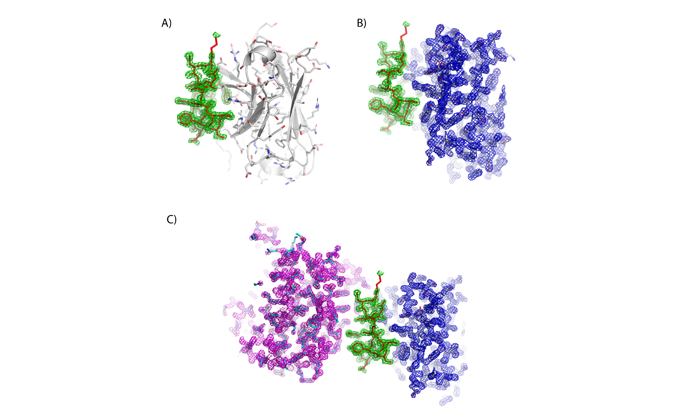
Figure S1: Cartoon and stick presentation of the VH-1C5 structure from the complex with eIF4E (PDB ID: 7D6Y): A) The 2Fo-Fc electron density map contoured at 1.5σ for the CDR3 region that interacts with eIF4E is shown in green. B) 2Fo-Fc electron density map contoured at 1.5 σ of the main body of the VH domain highlighted in blue. C) Cartoon and stick presentation structure of VH-1C5 in complex with eIF4E. The magenta mesh highlights the 2Fo-Fc electron density map contoured at 1.5σ of eIF4E. The VH-1C5 domain is shown as illustrated in A) and B).

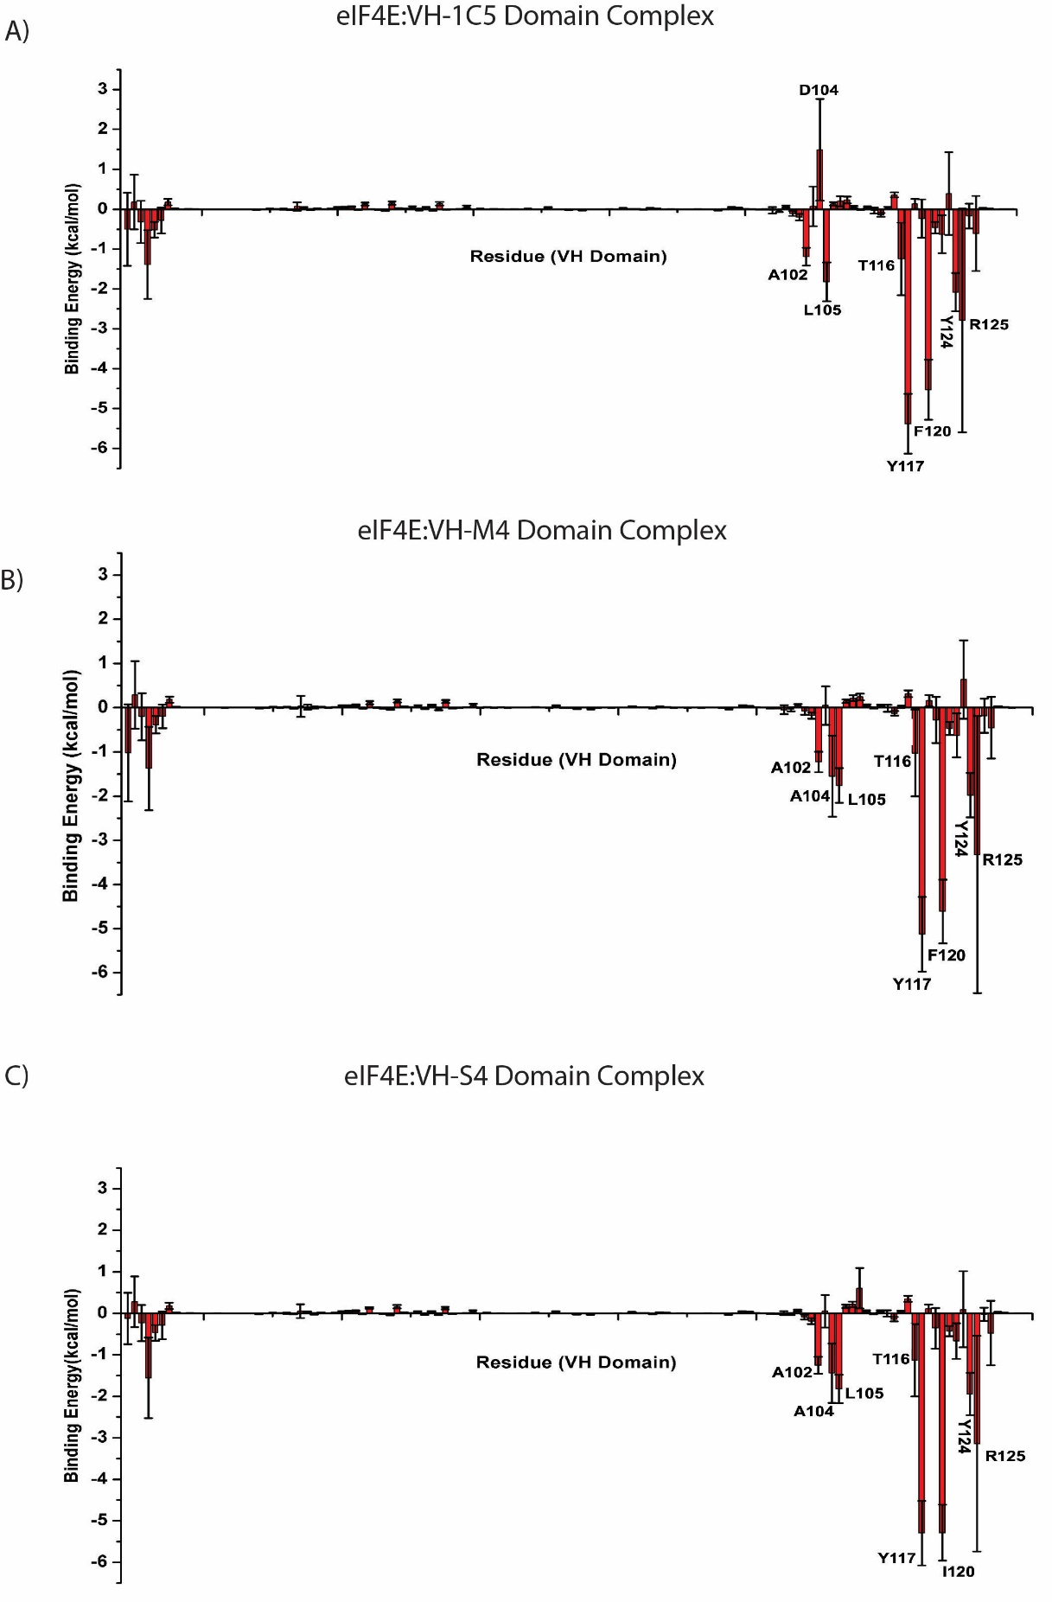
Figure S2: Residue-wise binding energy decomposition of the various eIF4E:VH-domain complexes: A) eIF4E:VH-1C5 complex, B) eIF4E:VH-M4 complex that contains the mutation D104A and C) eIF4E:VH-S4 complex, which contains the D104A, S108R And F120I mutations. The residues which make ≥ -1.0 kcal/mol contribution to the binding energy are explicitly labelled in the plot.

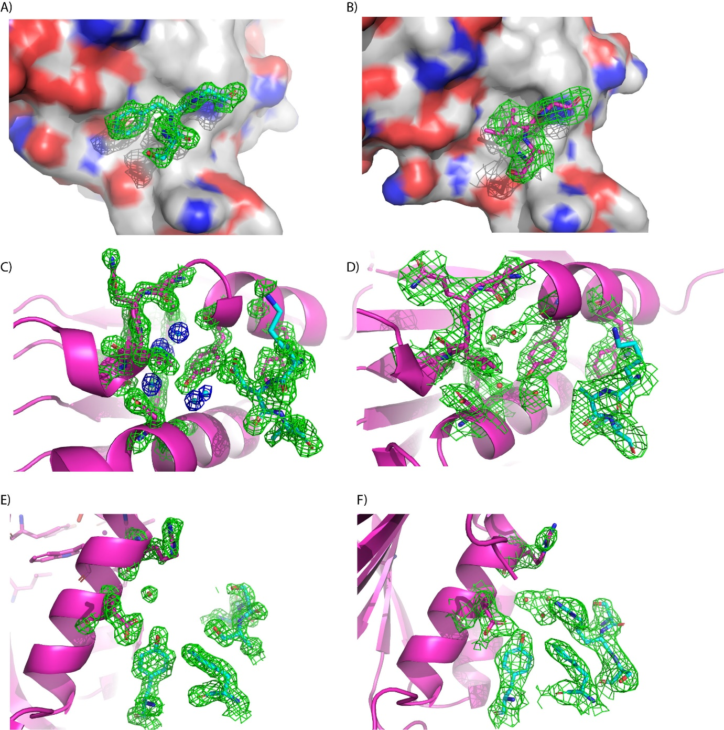
Figure S3: A) 2Fo-Fc electron density map (1.5σ) showing the F119 residue from VH-1C5 interacting with the eIF4E protein surface, and B) the corresponding 2Fo-Fc electron density map (1.1σ) of the I119 residue in VH-S4 interacting with the eIF4E protein surface. C) 2Fo-Fc electron density map (1.5σ) of the D103 residue from VH-1C5 and the network of eIF4E residues and water molecules it interacts with, compared to D) showing the corresponding A103 in VH-S4 and its interaction network. E) 2Fo-Fc electron density map of S107 from VH-1C5 and the local protein protein interface compared to F) the corresponding R107 in VH-S4, where the formation of a structured water network can be observed mediating interactions between the two proteins.

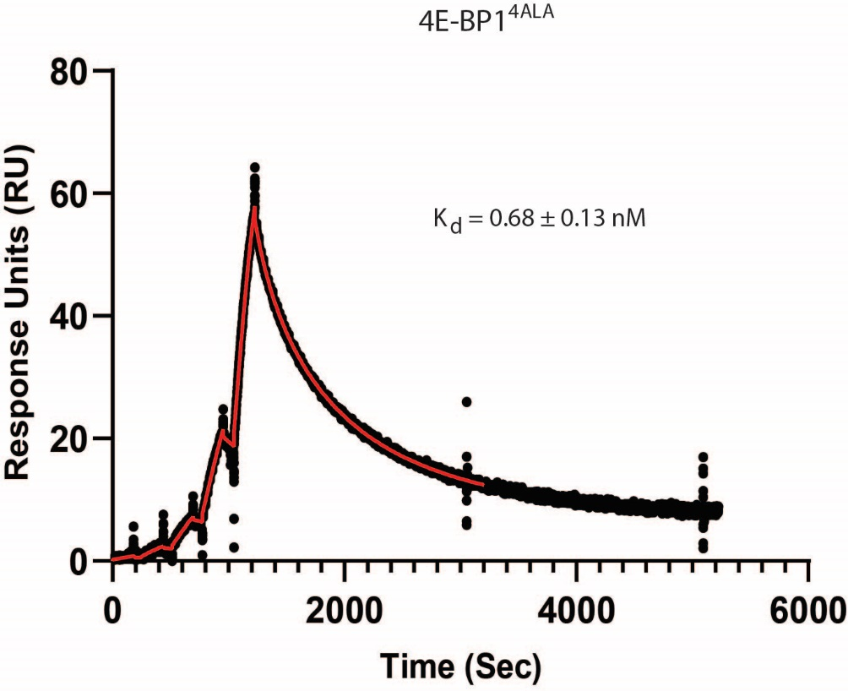

Figure S4: Surface plasmon resonance sensogram of 4E-BP1^{4ALA} being titrated against eIF4E immobilised via amine coupling on a CM5 sensor chip (see materials and methods). Binding and kinetic parameters are shown in table 1. The 2-state binding curve fit is shown in red and was performed with BiaEvaluation (Cytiva, Ltd) software.

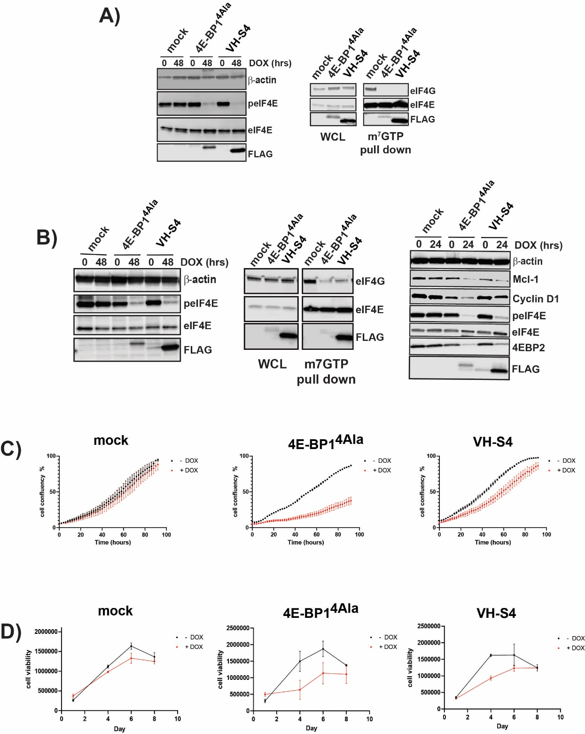

Figure S5: Stably transfected A) A375 cells and B) MBA-MD-231 cells harbouring doxycycline (DOX) inducible Mock, 4E-BP1^{4Ala} and VH-S4 were incubated for 48 hrs with or without 1μg/ml of doxycycline. Whole cell lysate (left-hand western blot) was blotted pre- and post- doxycycline induction and blotted for eIF4E, phosphorylated eIF4E, the FLAG-tagged 4E-BP1^{4Ala} and VH-S4 constructs and β-actin as a loading control. Parallel m⁷GTP pull-down experiments (centre panel) were performed to analyse eIF4F complex formation cell lysate obtained from the DOX induced samples. In the right-hand side panel, MBA-MD-231 cell were treated with doxycycline and after 48 hours were assessed for the following protein levels, Mcl-1, Cyclin D1, peIF4E, eIF4E and 4E-BP2. Β-actin was used as aloading control. C) MBA-MD-231 mock, 4E-BP1^{4Ala} and VH-S4 inducible cell line confluence was measured in presence or absence of doxycycline for the indicated time (hrs) using an Incucyte (EssenBiosciences). D) A375 stable cell lines treated as in C) were assayed for viability over the indicated time (days). All values represent mean +/- SD (n=3).
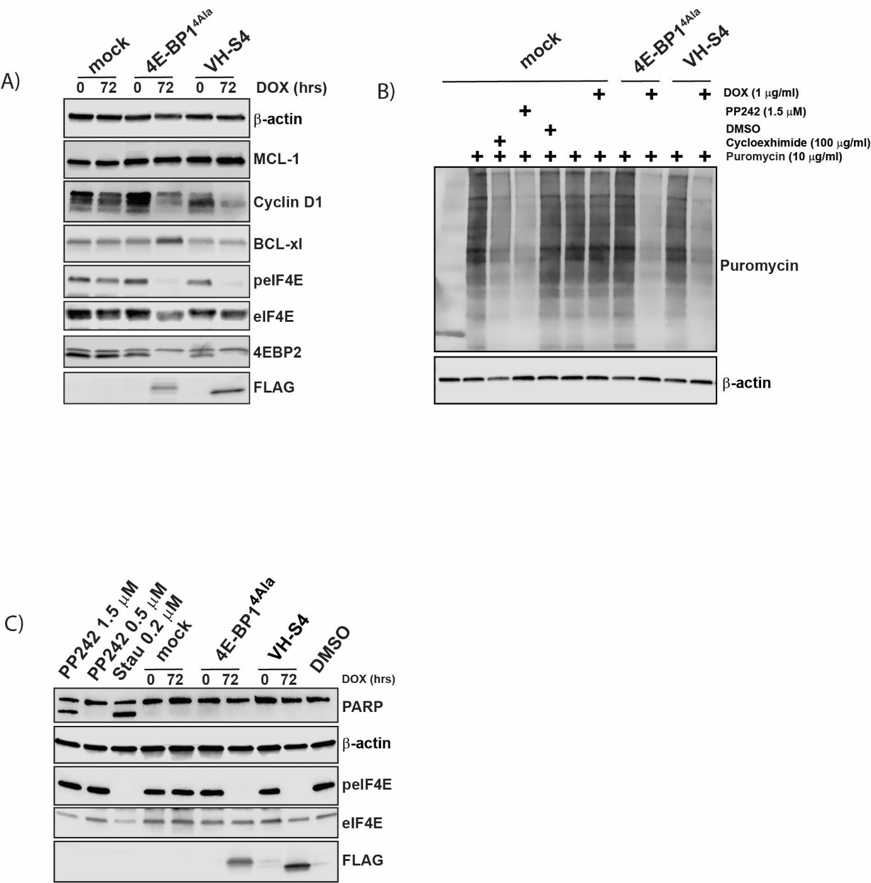

Figure S6: A) Inducible A375 cells harbouring Mock, 4E-BP1^{4Ala} and VH-S4 constructs were incubated for 72 hrs with or without 1μg/ml of Doxycycline. Lysates were analysed by western blot using the anti-bodies indicated in the blot (for further details see materials and methods). Levels of 4E-BP1^{4Ala} and VH-S4 were assessed using ant-FLAG. Β-Actin was used as a loading control. B) Inducible A375 cells harbouring Mock, 4E-BP1^{4Ala} and VH-S4 constructs were treated with DOX, PP442, cyclohexamide or vehicle control (DMSO 1% v/v) and then pulse labelled with puromycin post 24 hours after treatment. X ug of whole cell lysates were analysed for puoromycin labelling wing ant-Puoro. β-actin was blotted as a representative protein whose levels should not be affected by 4E-BP1^{4Ala} and VH-S4 induction. C) Inducible A375 cells harbouring Mock, 4E-BP1^{4Ala} and VH-S4 constructs were incubated for 72 hrs with or without 1μg/ml of Doxycycline, whilst mock cells were also treated with either PP242 or Staurosporine (Stau) with a residual DMSO concentration of 1 % (v/v). A DMSO vehicle control was also included.

Methods and Materials
Library generation for stability improvement
Random mutagenesis libraries were created by error-prone PCR using Genemorph II Mutagenesis Kit (Stratagene). The cloned wild-type genes (for first library) or improved variants (for subsequent libraries) were used as templates, and the reactions were performed according to the manufacturer’s protocol. The primers used annealed to sequences flanking the open reading frame (ORF) to be mutated. An average of 50 ng of insert template was used, in a 30 cycles PCR reaction with phosphorylated primers, leading to an average of ~2-3 amino-acid mutations per gene in the final plasmid library. The error-prone PCR product was gel purified using a Qiagen Gel purification Kit.
The plasmid library was created by Megaprimer PCR of Whole Plasmid (MEGAWHOP) reaction¹, using an optimized protocol described here. Typically, 1-10 ng of plasmid containing the wild-type (WT) gene was used as template, and amplified using approximately 1 ng of insert per bp of insert length of purified error prone PCR product as the megaprimer (e.g., 500 ng for a 500 bp insert), in a PCR reaction with KOD Xtreme polymerase (Merck). The buffer composition was the standard recommended by the manufacturer, with the addition of 1 mM NAD+, 40 U of Taq DNA ligase, and using 0.5 U of KOD Xtreme polymerase. The PCR conditions were as follows: 94°C for 2 min, (98°C for 10 sec, 65°C 30 sec, 68°C for 6 min) for 30 cycles, 4°C on hold. After PCR, 20 U of DpnI (NEB) was added to the PCR reaction, and incubated for 3 h at 37°C.
To generate a library that would allow the identification of a disulphide-free version of VH36, first the stII signal sequence was removed by site-directed mutagenesis, generating clone VH36i. Then, a site directed mutagenesis library was generated by MEGAWHOP, in which residue positions C22, A24 and C96 were randomized. A PCR using phosphorylated forward (5’-GGCTCACTCCGTTTGTCCNNKGCANNKTCTGGCTTCAACATTAAAGAC-3’) and reverse (5’- CCTCCCCAGCGGCCMNN ATAATAGACGGCAGTG-3’) primers was performed using VH-36i as template, and KOD HotStart polymerase (Merck), according to the manufacturer’s protocol. The PCR product was gel purified, and the MEGAWHOP reaction performed as described previously, after which DpnI treatment was performed. DH10B cells were electroporated with the DpnI-treated, purified MEGAWHOP product yielding libraries of ~10⁵ unique members.
Solubility and stability screening using colony filtration (CoFi)
Rosetta2 cells were transformed with the mutagenesis libraries and plated on 24.5 cm diameter square LB-Agar plates supplemented with 50 μg/mL kanamycin and 34 μg/mL chloramphenicol. These were termed the master plates. Colonies were transferred to a Durapore 0.45 μm filter membrane (Millipore), and placed on LB-Agar plates (colonies facing up) supplemented with antibiotics and 30 μM Isopropyl β-D-1-thiogalactopyranoside (IPTG). Induction was performed overnight at room temperature (RT) for protein expression.
After protein production, the induction plates were subjected to the desired temperature (room temperature (RT) for solubility screen (termed CoFi), or higher temperatures for the stability screen (termed Hot-CoFi) for 30 min. The Durapore membrane was transferred to a lysis sandwich composed of a Whatman paper, soaked in CoFi lysis buffer [20 mM Tris, pH 8.0, 100 mM NaCl, 0.2 mg/ml lysozyme, 11.2 U/mL Benzonase Endonuclease (Merck) and 1:1000 dilution of Protease Inhibitor Cocktail Set III, EDTA-Free (Merck)], a nitrocellulose membrane (Millipore) and incubated at the screening temperature for another 30 min. Cell lysis was further improved by three freeze-thaw cycles at -80°C and RT, respectively (30 min each). The Durapore membrane and the Whatman paper were discarded, and the nitrocellulose membrane was incubated in blocking buffer [TBS-T buffer (20 mM Tris, pH 7.5, 500 mM NaCl, 0.05% (vol/vol) Tween 20) and 1% Bovine Serum Albumin (BSA)] for 1 h at RT.
After blocking, the nitrocellulose membrane was washed three times in TBS-T, 10 min at room temperature, with shaking at 70 revolutions per minute (rpm). The presence of soluble protein was detected either by incubating the membrane in TBS-T containing a 1:5,000 dilution of HisProbe-HRP (Thermo Scientific), or with a 1:10,000 dilution of protein A-HRP probe (Life Technologies) in TBS-T with 1% BSA, for 1 h at RT, with shaking at 30 rpm. Three washing were then performed as previously described. The nitrocellulose membrane was developed using Super Signal West Dura chemiluminescence kit (Thermo Scientific) and imaged using a CCD camera (Fujifilm LAS-4000).
Determination of temperature of cellular aggregation (T_{cagg})
Starter cultures composed of 1 mL Terrific Broth (TB) supplemented with antibiotics were inoculated from glycerol stocks of the clones to test and incubated overnight at 37°C with shaking. The next day, 200 μL were used to inoculate 20 mL of TB supplemented with antibiotics and incubated at 37°C with shaking until an OD₆₀₀ of approximately 2 was reached. The cultures were then induced with 30 μM IPTG and incubated overnight at 18°C. The expression cultures were centrifuged at 4,800 g for 15 min at 4°C, and the pellets resuspended in 5 mL of CoFi lysis buffer. Cell lysis was performed through three freeze-thawing cycles at -80°C and RT, respectively. The samples were then transferred to a PCR plate in 100 μL aliquots. Each aliquot was then subjected to a different temperature, using a temperature gradient in a PCR machine, for 15 min and then cooled down to 4°C. The heat-treated samples were centrifuged at 3,200 g for 15 min at 4°C. The supernatant was transferred to a 0.65 μm filter plate and filtered by centrifugation at 2,000 g for 15 min at 4°C. 2 μL of the filtrate was dotted onto a nitrocellulose membrane and developed using HisProbe-HRP as described. After development, the average intensity of each dot was calculated using ImageJ software (NIH) and the midpoint of the transition determined using the Boltzmann equation on Prism software (Graphpad Software).
Determination of melting temperature (T_{m})
To perform Differential Scanning Fluorimetry², 5 μg of protein was diluted into a 25 μL PBS buffer solution containing 5x SYPRO Orange fluorescent dye (Bio-Rad). Proteins were tested in triplicates, the fluorescence was monitored using a 96-well Real-Time PCR detection system (iCycler iQ, from Bio-Rad), from 25°C to 95°C, with a gradual temperature increase of 1°C every 10 sec. The melting temperature was determined using the Boltzmann equation with the instrument’s software.
Phage display library generation
The open reading frame coding for VH-38i was synthetized with a stII signal sequence at the 5’ end and the C-terminal domain of the M13 gene 3 at the 3’ end. The gene sequence was then cloned into a pPCR-Script-SK+ derived vector, downstream of the lac promoter. This vector is referred to a pVH1 vector. The phage display library creation was performing according to Bostrom J. et al.³ and Tonikian R. et al.⁴ pVH1 vector was transformed into CJ236 cells (Lucigen) and the cells subsequently plated on 2YT-Agar plates supplemented with 50 μg/mL carbenicillin. After overnight incubation at 37°C, colonies were picked and used to inoculate 5mL of 2YT media supplemented with 50 μg/mL carbenicillin. The culture was then incubated at 37°C with shaking for 6h, after which M13K07 helper phage (NEB) was added to a final concentration of 10¹⁰ pfu/mL. After 1 h incubation at 37°C, the culture was transferred to 25 mL 2YT supplemented with 50 μg/mL carbenicillin and 25 μg/mL kanamycin and incubated overnight at 37°C with agitation. Phage was precipitated with 1:5 volumes of PEG/NaCl buffer (20% PEG 8,000 / 2.5 M NaCl), followed by single stranded DNA (ssDNA) purification using Qiaprep Spin M13 Kit (Qiagen).

Fifteen sub-libraries were created by Kunkel mutagenesis, using the following phosphorylated primers:
Primer name | Primer Sequence
H1 | CCTCTGCAATTTCTGGCTTC [XYZ] NTT [XYZ][XYZ] ACT [XYZ] ATAGACTGGGTGCGTCAGG
H2 | CTGGAATGGGTTGCAAGGATT [XYZ] CCT [XYZ][XYZ] GGT [XYZ] ACT [XYZ] TATGCCGATAGCGTCAAGGG
H3.6 | GCCGTCTATTATACTGKCCGC [XYZ][XYZ][XYZ][XYZ][XYZ][XYZ] GSTNTKGACTACCGGGGTCAAG
H3.7 | GCCGTCTATTATACTGKCCGC [XYZ][XYZ][XYZ][XYZ][XYZ][XYZ][XYZ] GSTNTKGACTACCGGGGTCAAG
H3.8 | GCCGTCTATTATACTGKCCGC [XYZ][XYZ][XYZ][XYZ][XYZ][XYZ][XYZ][XYZ] GSTNTKGACTACCGGGGTCAAG
H3.9 | GCCGTCTATTATACTGKCCGC [XYZ][XYZ][XYZ][XYZ][XYZ][XYZ][XYZ][XYZ][XYZ] GSTNTKGACTACCGGGGTCAAG
H3.10 | GCCGTCTATTATACTGKCCGC [XYZ][XYZ][XYZ][XYZ][XYZ][XYZ][XYZ][XYZ][XYZ][XYZ] GSTNTKGACTACCGGGGTCAAG
H3.11 | GCCGTCTATTATACTGKCCGC [XYZ][XYZ][XYZ][XYZ][XYZ][XYZ][XYZ][XYZ][XYZ][XYZ][XYZ] GSTNTKGACTACCGGGGTCAAG
H3.12 | GCCGTCTATTATACTGKCCGC [XYZ][XYZ][XYZ][XYZ][XYZ][XYZ][XYZ][XYZ][XYZ][XYZ][XYZ][XYZ] GSTNTKGACTACCGGGGTCAAG
H3.13 | GCCGTCTATTATACTGKCCGC [XYZ][XYZ][XYZ][XYZ][XYZ][XYZ][XYZ][XYZ][XYZ][XYZ][XYZ][XYZ][XYZ] GSTNTKGACTACCGGGGTCAAG
H3.14 | GCCGTCTATTATACTGKCCGC [XYZ][XYZ][XYZ][XYZ][XYZ][XYZ][XYZ][XYZ][XYZ][XYZ][XYZ][XYZ][XYZ][XYZ] GSTNTKGACTACCGGGGTCAAG
H3.15 | GCCGTCTATTATACTGKCCGC [XYZ][XYZ][XYZ][XYZ][XYZ][XYZ][XYZ][XYZ][XYZ][XYZ][XYZ][XYZ][XYZ][XYZ][XYZ] GSTNTKGACTACCGGGGTCAAG
H3.16 | GCCGTCTATTATACTGKCCGC [XYZ][XYZ][XYZ][XYZ][XYZ][XYZ][XYZ][XYZ][XYZ][XYZ][XYZ][XYZ][XYZ][XYZ][XYZ][XYZ] GSTNTKGACTACCGGGGTCAAG
H3.17 | GCCGTCTATTATACTGKCCGC [XYZ][XYZ][XYZ][XYZ][XYZ][XYZ][XYZ][XYZ][XYZ][XYZ][XYZ][XYZ][XYZ][XYZ][XYZ][XYZ][XYZ] GSTNTKGACTACCGGGGTCAAG
H3.18 | GCCGTCTATTATACTGKCCGC [XYZ][XYZ][XYZ][XYZ][XYZ][XYZ][XYZ][XYZ][XYZ][XYZ][XYZ][XYZ][XYZ][XYZ][XYZ][XYZ][XYZ] [XYZ] GSTNTKGACTACCGGGGTCAAG
H3.19 | GCCGTCTATTATACTGKCCGC [XYZ][XYZ][XYZ][XYZ][XYZ][XYZ][XYZ][XYZ][XYZ][XYZ][XYZ][XYZ][XYZ][XYZ][XYZ][XYZ][XYZ] [XYZ][XYZ] GSTNTKGACTACCGGGGTCAAG
H3.20 | GCCGTCTATTATACTGKCCGC [XYZ][XYZ][XYZ][XYZ][XYZ][XYZ][XYZ][XYZ][XYZ][XYZ][XYZ][XYZ][XYZ][XYZ][XYZ][XYZ][XYZ] [XYZ][XYZ][XYZ] GSTNTKGACTACCGGGGTCAAG
Where X = 0.2G + 0.2A + 0.5T + 0.1C, Y = 0.4A + 0.2T + 0.4C and Z = 0.1G + 0.9C.

The phosphorylated primers (0.6 μg of each H1, H2 and H3.6 to H3.20) were annealed to 20 μg ssDNA by incubation for 2 min at 90 °C, followed by 5 min at 50°C and then placed on ice. The complementary, mutagenized strand was synthetized by T7 DNA polymerase and ligated with T4 DNA ligase, overnight at RT. After purification, the sub-libraries were electroporated into TG1 cells (Lucigen) infected with M13KO7 helper phage. The electroporated sub-libraries were incubated overnight at 37°C in 2YT supplemented with 50 μg/mL carbenicillin and 25 μg/mL kanamycin, with agitation. They were purified by precipitation with PEG/NaCl buffer, followed by resuspension in PBS + 50% glycerol, and stored at -20°C until use. The library size was determined at approximately 2.87 x 10¹⁰ unique clones, by plating serial dilutions of the electroporated products, and the quality of the library verified by sequencing 24 random clones from each individual sub-library.
eIF4E expression and purification
Full-length human eIF4E was expressed and purified as described previously⁵.

eIF4E biotinylation for use in phage selections
Sulfo-NHS–LC–LC biotin was added in an equimolar ratio to a solution of eIF4E at a concentration of a 100 µM and incubated at room temperature (Thermofisher Scientific). After 1 h, unreacted biotin was removed by passing the solution over a fast desalting column (equilibrated with Phosphate Buffered Saline) twice. Biotinylated eIF4E was stored at 4°C for a maximum period of up till 1 week.
eIF4E Phage display library screening
500 μL of the phage display library (~ 2.5 × 10¹³ pfu) was precipitated with PEG/NaCl buffer and resuspended in BSA block buffer (BBB): 4% BSA in PBS supplemented with 0.05% Tween20 (PBST). Immunotubes (nunc) were coated with NeutrAvidin (Thermofisher Scientific, 5 µg/ml of Neutravidin in PBS) and incubated at 4 °C overnight. The coated tubes were then washed with PBS (1x) and blocked with BBB for 1 h at RT. After washing the tube with PBST, 100 µl of biotinylated eIF4E (5 µg/ml in PBST) was then added and incubated in the tubes for 1 hour at RT. A negative selection tube was also prepared as described above, but without adding eIF4e. The tubes were then washed with PBST (3x). The phage library was first incubated for 1h at RT in the negative selection tube, then transferred to the eIF4E coated immunotube and incubated with the target protein for 1 h with rotation. The non-bound phage were then washed away with three washes of BBB, followed by three washes with PBST and then two washes with PBS. The bound phage were eluted with 1 mL of 1 mg/mL trypsin in trypsin buffer (TBS + 2mM CaCl₂). The eluted phages were used to infect 5 mL of a TG1 culture (in 2YT media) in exponential growth phase (OD600 ~ 0.5), incubated 30 min at 37°C. From round 2 onwards, 1.2 mL of infected TG1 cells were stored with 20% glycerol at -80°C, to be used for monoclonal screening (glycerol stocks for monoclonal screening). The remaining infected TG1 cells were transferred to 50 mL 2YT. The culture was incubated at 37°C with shaking until OD₆₀₀ ~ 0.5, infected with 1 x 10¹⁰ pfu/mL M13K07 helper phage and incubated for 30 min at 37°C. The culture was centrifuged at 4,800 g for 10 min at 4°C, the pellet resuspended in 500 μL 2YT and plated onto 24.5 cm square 2YT-Agar plates supplemented with 100 μg/mL carbenicillin and 50 μg/mL kanamycin. After overnight incubation at 30°C, the bacterial-lawn obtained was resuspended into 25 mL TBS, and phage purified by precipitation with PEG/NaCl buffer. After two rounds of PEG/NaCl precipitation, the phage were then resuspended in PBS + 10% glycerol. From the second selection round onwards, the number of washes was increased to seven washes with BBB, seven washes with PBST, and two washes with PBS. The rest of the panning procedure was identical.

Plating and Sequencing of Selected Phage
To identify unique anti-EIF4e VH domains, the glycerol stocks for monoclonal screening were plated onto 2YT agar plates supplemented with 100 μg/mL Carbenicilin and incubated overnight at 37°C. Individual colonies were infected with 1x 1010 pfu/mL M13K07 helper phage and grown in 1 mL 2YT broth supplemented with 100 μg/mL Carbenicilin and 50 μg/mL Kanamycin overnight at 30°C. The cells were pelleted by centrifugation at 3,300 g for 15 mins at 4°C, and the supernatant used for phage monoclonal ELISA. To do so, NeutrAvidin was immobilized at 5 μg/mL onto a Maxisorp 96-well plate (Thermo Scientific) overnight at 4°C, washed twice with PBS and blocked for 1h at RT with BBB. Biotinylated EIF4e was added at a concentration of 2 μg/mL, and incubated for 1 h at RT. The plate was washed twice with PBS, and 25 µL of culture was mixed with 25 µL of block buffer, added to the plate and incubated for 2 hrs at RT. The plate was washed 8 times with PBST, 50 µL of anti-M13 antibody HRP conjugate (GE Healthcare) was added at a 1:7,000 dilution in block buffer, and incubated for 1 h at RT. The plate was washed 8 times with PBST, and developed with 50 µL 3,3′,5,5′-Tetramethylbenzidine (TMB) substrate (GeneTex). After 5-15 min, the reactions were stopped by adding 50 µL of H2SO4, and signal was measured at an absorbance of 450nm. Monoclonal cultures leading to high signal intensity (Absorbance higher than 1) were sequenced by Sanger sequencing to identify the unique VH domains binding to the target.

Fluorescence Competition Assays

eIF4E:4G Binding Site: Competitive fluorescence experiments were carried out with the concentration of eIF4E constant at 200 nM and the labelled peptide (Ac-KKRYSRDFLLALQK-(FAM)-NH_{2,} Mimotopes) at 50 nM. Candidate VH domains were then titrated against the complex of the FAM labelled peptide and eIF4E. m⁷GTP Binding Site: Competitive fluorescence experiments were carried out with the concentration of eIF4E constant at 200 nM and carboxyfluorescein (FAM) labeled m⁷GTP (JenaBiosciences) at 50 nM. Candidate VH domains were then titrated against the complex of the FAM labelled m⁷GTP and eIF4E. The IC₅₀ values were then determined for the candidate VH domains by fitting the experimental data to a four-parameter logistic regression model shown below:
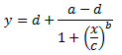
x = denotes the candidate VH domain concentration and y = measured fluorescence anisotropy. The 4 parameters derived from the fitting procedure performed in Prism 8.0 (GraphPad Software): a = the fluorescence anisotropy value at minimum dose, d = maximum fluorescence anisotropy value measured at maximum dose, c = the point of inflection (IC50) and b = the Hill’s coefficient. The tracer peptide and FAM labelled m⁷GTP were dissolved in DMSO at 1 mM and diluted into experimental buffer. Readings were carried out with a Envision Multi-label Reader (PerkinElmer). Experiments were carried out in PBS (2.7mM KCl, 137mM NaCl, 10mM Na₂HPO₄ and 2mM KH₂PO₄ (pH 7.4)) and 0.1% Tween 20 buffer. All titrations were carried out in triplicate.
SPR Binding Assays
eIF4E Immobilisation
Pure eIF4E was immobilized on a CM5 sensor chip. The CM5 chip was conditioned with a 6 s injection of 100mM HCL, followed by a 6 s injection of 0.1% SDS and completed with a 6 s injection of 50 mM NaOH at a flow rate of 100µl/min. Activation of the sensor chip surface was performed with a mixture of NHS (115 mg ml⁻¹) and EDC (750 mg ml⁻¹) for 7 min at 10 µl min⁻¹. Purified eIF4E was diluted with 10 mM sodium acetate buffer (pH 5.0) to a final concentration of 0.5 µM with m⁷GTP present in a 2∶1 ratio to stabilize eIF4E. The amount of eIF4E immobilized on the activated surface was controlled by altering the contact time of the protein solution and was approximately 250 RU. After the immobilization of the protein, a 7-min injection (at 10 µl min⁻¹) of 1 M ethanolamine (pH 8.5) was used to quench excess active succinimide ester groups. Six buffer blanks were first injected to equilibrate the instrument fully. Surface Plasmon resonance experiments were performed on a Biacore T100 machine. Stock protein solutions were serially diluted into running buffer immediately prior to analysis. Running buffer consisted of 10 mM Hepes pH 7.6, 0.15 M NaCl, 1 mM DTT and 0.1% Tween20.
Multi-cycle injection experiments
Multi-cycle injection experiments were performed using a flow rate of 50 µl/min, compounds were injected for 60s and dissociation was monitored for 180s. Individual proteins were injected across the CM5 chip in 3-fold dilution series to at appropriated concentration to determine their respective binding constants. Each independent protein injection sampled one concentration only and was immediately followed by a similar injection of SPR buffer to enable the chip surface to be full regenerated by dissociation. Any protein which possessed extremely slow off -rates, and thus making dissociation an unsuitable method for regenerating the CM5 chip surface, were analysed using single-injection cycles. Responses from the target protein surface were transformed by: i) subtracting the responses obtained from the reference surface that contained no immobilised protein, and (ii) subtracting the responses of the buffer injections from those of peptide injections. The last step is known as double referencing, which corrects the systematic artefacts. K_{d}s were determined using the BiaEvaluation software (Biacore) and calculated from both the response of the eIF4E coated CM5 chips at equilibrium and kinetically from the dissociation and association phase data for each of the peptides. Both the equilibrium and kinetic data were fitted to 1∶1 binding model. Each individual peptide K_{d} was determined from three separate titrations. Within each titration at least two concentration points were duplicated to ensure stability and robustness of the chip surface.
Single Injection Experiments
Proteins that possessed extremely slow off-rates were analysed using a single-cycle kinetics approach. For each independent protein, samples are injected consecutively across the CM5 chip surface at different concentrations with no intervening regeneration steps. Concentrations used sampled a 3-fold dilution series with the series proceeding from the lowest concentration to the highest. A complementary single injection was performed over a reference surface containing no immobilised eIF4E. The response from the target protein surface was then transformed by: i) subtracting the response the control surface and then 2) the response from of the buffer injections from those of the protein injections. The transformed response was analysed using the BiaEvaluation software (Biacore) to derive the binding and kinetic parameters using a 1:1 binding model.
Expression and purification of GST-fused eIF4E and 4E-BP1^{4ALA}
eIF4E and 4EBP1^{4ALA} mutants were cloned into the GST fusion expression vector pGEX-6P1 (GE Lifesciences). BL21 DE3 competent bacteria were then transformed with the GST-tagged fusion constructs. A single colony was picked and transformed cells were grown in LB medium at 37 °C to an OD600 of ~ 0.6 and induction was carried out overnight with 0.3 mM IPTG at 16 °C. Cells were harvested by centrifugation, and the cell pellets were resuspended in PBS (Phosphate Buffered Saline, 2.7 mM KCl and 137 mM NaCl, pH 7.4) and then sonicated. The sonicated sample was centrifuged for 60 min at 17,000g at 4 °C. The supernatant was applied to a 5 ml FF GST column (Amersham) pre-equilibrated in PBS buffer with 1 mM DTT. The column was then further washed by 6 volumes of PBS. Proteins were then purified from the column by cleavage with PreScission (GE Lifesciences) protease. Ten units of PreScission protease, in one column volume of PBS with 1 mM DTT buffer, were injected onto the column. The cleavage reaction was allowed to proceed overnight at 4 °C. The cleaved protein was then eluted off the column with wash buffer. Protein fractions were analysed with SDS page gel and concentrated using a Centricon (3.5 kDa MWCO) concentrator (Millipore). Protein samples were then dialyzed into a buffer solution containing 20 mM Tris pH 8.0 with 1 mM DTT and loaded onto a mono Q column pre-equilibrated in buffer A (20 mM Tris, pH 8.0, 1 mM DTT). The column was then washed in 6 column volumes of buffer A and bound protein was eluted with a linear gradient of 1 M NaCl over 25 column volumes. Protein fractions were analysed with SDS page gel and concentrated using a Centricon (3.5 kDa MWCO) concentrator (Millipore). The cleaved constructs were then purified to 90% purity. Protein concentration was determined using A280.
Sortase (SrtA^{8M}) Expression and Purification
The protein sequence corresponding to 61-206 of SrtA (Staphylococcus aureus) containing the following mutations (P94R, D160N, D165A, K190E, K196T, E105K, E108A and G167E) was ordered as a gene fragment from IDT (Integrated DNA technologies). The sequence was PCR amplified and inserted into a pNIC-CH bacterial expression plasmid via ligation independent cloning in frame with a C-terminal 6xHis tag. The pNIC-CH-(61-206)SrtA^{8M} (termed SrtA^{8M}) expression vector was transformed into BL21(DE3) Rosetta competent cells and a single colony was used to inoculate a 20 ml starter culture in TB (terrific broth containing 25ug/ml of chloramphenicol and 20ug/ml of kanamycin), which was incubated overnight at 37°C and shaken at 200 rpm. The starter culture was used to inoculate 750 ml of TB and was incubated at 37°C until a O.D₆₀₀ reading of 2.0 was attained. Where upon the temperature of the culture was lowered to 18°C and protein expression induced with 0.5 mM of IPTG overnight. Cells were harvested by centrifugation, and the cell pellets were resuspended in 20 mls of lysis buffer (100 mM HEPES pH 8.0, 500 mM NaCl, 10 mM Imidazole, 10 % glycerol, 0.5 mM TCEP, 1000u Benzonase (Merck)) and then sonicated. The sonicated sample was centrifuged for 30 min at 17,000g at 4 °C. Supernatants were then filtered through 1.2 μm syringe filters and were loaded onto a Ni-nitrilotriacetic acid (NTA) column, pre-equilibrated with 20 mM HEPES pH 7.5, 100 mM NaCl, and 0.5 mM TCEP. The column was then washed with 5 column volumes of the same buffer containing 10 mM Immidazole. Hexahistidine tagged SrtA^{8M} was then eluted with a 1 M imidazole linear gradient. The protein was further purified by size exclusion chromatography (HiLoad 16/60 Superdex 75 prep grade, Cytiva Lifescience) using a 20 mM HEPES pH 7.5, 300 mM NaCl, 10% (v/v) glycerol, 0.5 mM TCEP, buffer. Protein concentration was determined using A280 with an extinction coefficient determined from the primary sequence of the construct determined by ProtPARAM.
N-Terminal biotin labelling of eIF4E mediated by SrtA^{8M}
Sortase-mediated ligation was used to specifically label eIF4E at the N-terminal with biotin. Cleavage of the GST-fused eIF4E with thrombin leaves a single glycine at the N-terminal. The ligation was carried out with thrombin cleaved eIF4E at 50 µM, SrtA^{8M} at 1 µM, and biotin-KGGGLPET-GG-OHse(Ac)-amide peptide at 200 µM in 200 µL of ligation buffer (50 mM Tris pH 8.0, 150 mM NaCl, 1 mM TCEP). SortaseA61-206/8M contains mutations that increase ligation efficiency⁶ and make it calcium-independent⁷. The ligation was incubated at room temperature for 4 hours. SrtA^{8M} which contains a C-terminal 6×His-tag was removed with Dynabeads His-Tag (cat# 10104D, Thermo Fisher). The biotinylated protein was then dialyzed at 4 °C using slide-A-Lyzer cassette (10k MWCO) against 2L of an appropriate buffer. The buffer was changed after 4−5 hours and the dialysis was repeated for overnight. The biotinylated protein was aliquoted, snap-frozen with liquid nitrogen, and stored at -80 °C.
Yeast surface display (YSD)
Alanine Scanning Mutagenesis: Yeast display protocols were adapted from Wittrup and co-workers⁸. The VH-1C5 gene was ordered from Integrated DNA Technologies and the pCT-CON vector was digested using SalI, NheI, and BamHI restriction enzymes (NEB) to ensure complete linearization and absence of full-length insert therefore preventing transformation of yeast cells with parental plasmid. The VH-1C5 gene was then PCR amplified using primers containing 50 base pairs of homology to the pCT-CON2 vector. 300 ng of VH-1C5 gene and 1 μg of plasmid vector were combined with 50–100 μL of electrocompetent EBY100 yeast cells and electroporated at 0.54 kV and 25 μF. Homologous recombination of the linearized vector and VH-1C5 insert yielded intact plasmid. Cells were grown in YPD (1% yeast extract, 2% peptone, 2% glucose) for 1 h at 30 °C, 250 rpm. The pCTCON2-VH-1C5 plasmid was then isolated and purified from EBY100 yeast cells using a Zymoprep kit II and then cleaned using the Qiagen PCR Purification kit. The CDR3 loop of the VH-1C5 gene was then sequentially mutated to alanine via site-directed mutagenesis using an in-fusion HD cloning Plus kit (Takara Bio), following the manufacturer’s instructions, to generate the following plasmids pCTCON2-VH-M1 to VH-M20. This corresponded to an alanine scan of the following range of amino acids in the VH-1C5 scaffold: 100-120.
pCTCON2-VH1-C5 alanine scanning mutants were then electroporated into electrocompetent EBY100 yeast cells (0.54 kV and 25 μF). Individual transformed yeast clones were then grown in SD-CAA, pH 5.3 3 (0.07 M sodium citrate, pH 5.3, 6.7 g/L yeast nitrogen base, 5 g/L casamino acids, 20 g/L glucose, 0.1 g/L kanamycin, 100 kU/L penicillin, and 0.1 g/L streptomycin), at 30 °C, 250 rpm to logarithmic phase, pelleted, and resuspended to 1 × 10⁷ cells/mL in SG-CAA, pH 6.0 (0.1M sodium phosphate, pH 6.0, 6.7 g/L yeast nitrogen base, 5 g/L casamino acids, 19 g/L dextrose, 1 g/L glucose, 0.1 g/L kanamycin, 100 kU/L penicillin, and 0.1 g/L streptomycin) to induce protein expression. Induced cells were grown at 30 °C, 250 rpm for 12–24h. Yeast were then pelleted, washed in 1 mL PBSA (0.01 M sodium phosphate, pH 7.4, 0.137 M sodium chloride, 1 g/L bovine serum albumin), resuspended in PBSA to a density of 1 x10⁷ cell per ml and then added to individual tubes corresponding to each VH-1C5 alanine scanning mutant.
Purified sortase biotinylated eIF4E was then added to each mutant at a concentration of 2 µM and samples were incubated at 20 °C for 1 hour. Cells were then pelleted by centrifugation (14,000g for 30 s at 4 °C), the supernatant aspirated and then washed with 1 ml ice-cold PBSA. Yeast were resuspended in 500 µl PBSA containing Anti-HA Ab Alexa Fluor 488 (Invitrogen) and Streptavidin-phycoerythrin or neutravidin-phycoerythrin (ThermoFisher Scientific) and incubated for 30 mins. Cells were then pelleted at 14,000g for 30 s at 4°C, aspirate supernatant and wash with 1 ml PBSA buffer. Each VH-1C5 alanine mutant was then analysed by flow cytometry using Aria (Becton Dickinson) cytometer. Cell positive anti-HA and eIF4E were selected and mean fluorescence intensity determined.

Affinity Maturation: The library for affinity maturation was prepared using pCT-CON2-VH-M4 as a template for error-prone PCR. Error prone PCR was performed using the conditions outlined in Angelini et al⁹ to introduce on average 1 or more amino acid change per 500 base pairs. PCR primers containing 50 base pairs of homology to the pCT-CON2 vector. Multiple aliquots of ∼ 10 μg of mutagenized pCT-CON2-VH1C5^{M4} and 3 μg of linearised pCT-CON2 plasmid vector were combined with 50–100 μL of electrocompetent EBY100 and electroporated at 0.54 kV and 25 μF. Homologous recombination of the linearized vector and degenerate insert yielded intact plasmid. Cells were grown in YPD (1% yeast extract, 2% peptone, 2% glucose) for 1 h at 30 °C, 250 rpm. The number of total transformants was 5.7 × 10⁷ cells as determined by serial dilutions plated on SD-CAA plates (0.1 M sodium phosphate, pH 6.0, 182 g/L sorbitol, 6.7 g/L yeast nitrogen base, 5 g/L casamino acids, 20 g/L glucose). The library was propagated by selective growth in SD-CAA, pH 5.3 (0.07 M sodium citrate, pH 5.3, 6.7 g/L yeast nitrogen base, 5 g/L casamino acids, 20 g/L glucose, 0.1 g/L kanamycin, 100 kU/L penicillin, and 0.1 g/L streptomycin) at 30 °C, 250 rpm.
FACS selections of the mutagenized VH-M4 library was conducted with kinetic competition. Three rounds of kinetic selection were performed. Yeast were washed and incubated with 200nM of biotinylated eIF4E. Yeast were then washed and resuspended with PBSA (phosphate-buffered saline with bovine serum albumin) 2 µM of unbiotinylated eIF4E (to prevent further association of labelled target) and incubated at room temperature for 8 minutes to enable dissociation of biotinylated eIF4E. Cells were washed in PBSA, resuspended in PBSA with Anti-HA Ab Alexa Fluor 488 (Invitrogen) and Streptavidin-phycoerythrin or neutravidin-phycoerythrin (ThermoFisher Scientific) for 10 min, and incubated on ice. Labelled cells were washed with 1 mL PBSA, resuspended in 0.5–2.0 mL PBSA and analysed by flow cytometry using an Aria (Becton Dickinson) cytometer. Cells positive for anti-HA and eIF4E were selected and sorted. Collected cells were grown in SD-CAA, pH 5.3, at 30 °C, 250 rpm and either induced in SG-CAA, pH 6.0, for further selection or used for plasmid recovery. Two further rounds of kinetic selection were performed as described above extending the periods of dissociation to 60 mins and 120 mins, respectively. Yeast isolated from each round for plasmid recovery were serially diluted and plated on SD-CAA plates (0.1 M sodium phosphate, pH 6.0, 182 g/L sorbitol, 6.7 g/L yeast nitrogen base, 5 g/L casamino acids, 20 g/L glucose) and individual clones grown. Plasmid DNA was then isolated using the Zymoprep kit II, cleaned using the Qiagen PCR Purification kit, and transformed into DH5α (Invitrogen) cells. Purified plasmids were then sequenced using BigDye chemistry.

Bacterial Expression and Purification of VH-Domain constructs
VH-1C5 and VH-1A2 sequences were ordered as gene fragments from Integrated DNA Technologies (IDT). Both coding sequences were PCR amplified and cloned directly into the bacterial expression vector pET-22b(+) with an in-frame C-terminal six-hisitidine tag. VH-M4 was directly PCR amplified from the pETCON2 plasmid used in the yeast alanine scanning experiments, whilst VH-S4 was amplified from the plasmid isolated through the affinity maturation selection. Both sequences were then cloned into pET-22b(+) as described earlier. Using VH-M4 as a template sequence, the in-fusion mutagenesis kit (Takara) was used to generate the following mutants in the pET-22b(+) backbone (VH-1C5^{D104A/S108R} and VH-1C5 ^{D104A/F120I}). Each VH-domain plasmid was separately transformed into E. coli BL21 (DE3) cells and used to inoculate 10 mls of LB broth (containing 100µg/ml) started culture, which were incubated overnight before being used to seed 1000 mls of fresh LB broth. Bacterial cultures were grown at 37 °C and when they reached a OD₆₀₀ of 0.6–0.8, the cells were induced with a final concentration 0.5 mM of IPTG and incubated overnight at 25 °C. Cells were harvested by centrifugation at 5,000 rpm for 10 minutes and pellets were resuspended in lysis buffer (25 mM HEPES pH 7.5, 300 mM NaCl, 20 mM imidazole, 1 mM DTT) and then sonicated for 5 minutes. Bacterial supernatants were then filtered through 1.2 μm syringe filters. Proteins were purified through a standard two-steps protocol: first, supernatant were loaded onto a 1 ml HisTrap column (Cytiva Lifesciences), which was pre-equilibrated then extensively washed with buffer A (25 mM HEPES pH 7.5, 300 mM NaCl, 1mM DTT) and then eluted with buffer A that also contained 500 mM imidazole; second, the eluted proteins were subjected to gel filtration chromatography on a Superdex 75 column (Cytiva Lifesciences) using PBS buffer containing 1 mM DTT. Protein fractions were analysed by SDS page gel and concentrated. Protein concentration was determined using absorbance at A280 nm.
Protein Crystallization
The eIF4E:VH-1C5 and eIF4E:VH:VH-S4 complexes were crystallized by vapour diffusion using the sitting drop method. Crystallization drops contained eIF4E, m⁷GTP and VH-1C5 at concentrations of 100 µM, 300 µM and 100 µM respectively. Sitting drops were set up in 48 well Intelli-Plates (Hampton research) with 1 µl of the protein sample mixed with 1 µl of the mother-well solution. eIF4E:VH-1C5 crystals grew over a period of one week in 25% PEG6000, 0.01-02M Ammonium Sulphate and 100mM Tris at pH 8.5. eIF4E:VH-S4 crystals grew over a similar period of time but in 0.01M Tri-sodium citrate and 16% PEG6000 (v/v). For X-ray data collection at 100 K, crystals for both sets of crystallization conditions were transferred to an equivalent mother liquor solution containing 25% (v/v) glycerol and then flash frozen in liquid nitrogen.

Data collection and refinement

X-ray diffraction data was collected at the Australian synchrotron (MX1 beamline) using a CCD detector, and integrated and scaled using XDS. The initial phases of the VH-domain complexed crystals of eIF4E were solved by molecular replacement with the program PHASER¹⁰ using the human eIF4E structure (PDB accession code: 1EJ4) and the VH domain structure (PDB accession code: 5TDP, chain B) as independent search models. The starting models were subjected to rigid body refinement and followed by iterative cycles of manual model building in Coot and restrained refinement in Refmac 6.0.¹¹ Models were validated using PROCHECK¹² and the MOLPROBITY webserver.¹³ Final models were analysed using PYMOL (Schrödinger). See table S2 for data collection and refinement statistics. The eIF4E complex structures with VH-1C5 and VH-S4 has been deposited in the PDB under the submission codes 7D6Y and 7D8B, respectively.

Computer Simulations and Molecular Dynamics
The atomic coordinates of the structures of the complexes of VH with eIF4E and of free VH domain were subjected to molecular dynamics (MD) simulations using AMBER 16¹⁴ employing the all-atom ff14SB¹⁵ force field parameters. The N- and C-termini were capped using ACE (acetylate) and NME (N-methylamide) functional groups respectively. The systems were placed inside a cuboid box and solvated with water molecules represented by the TIP3P¹⁶ model, ensuring a minimum distance of 10 Å between any solute atom and the edge of the box. The net charge of the respective systems were neutralized by adding appropriate numbers and types of counterions. The system was then subjected to energy minimization using steepest descent followed by conjugate gradient, heated to a temperature of 300 K in the NVT (constant number, volume and temperature) ensemble and equilibrated for 500 ps in the NPT (constant number, pressure and temperature) ensemble, at 1 atm pressure. Production dynamics, under NTP conditions, were carried out for 100ns in triplicate (each simulation was initiated at with different velocity distributions) for the VH: eIF4E complexes and for 1 µs for the free VH domain. The protocol followed has been described earlier by Lama et al.¹⁷
Residue-wise binding energy was computed using the MM/GBSA (Molecular Mechanics / Generalized Born Surface Area) method¹⁸ as implemented in the MMPBSA.py¹⁹ script available in AMBER 16. The single trajectory protocol (STP) was employed wherein the binding energy is computed as the difference between the energies of the VH:eIF4E complex and the sum of the energies of free VH and of free eIF4E; the conformations of the free VH and eIF4E were generated from the conformations of the VH”eIF4E complex.. 1000 representative structures of the VH:eIF4E complex, spread over the entire simulation period, were extracted at equal intervals from the concatenated trajectories. Explicit water molecules and counterions were removed from the structures and the solvent effect was approximated using the implicit Generalized Born Solvation Model (IGB=2) with salt concentration set to 150 mM. Secondary structure evolution of the free VH domain as a function of the simulation time was analysed using the Dictionary of Secondary Structure of Proteins (DSSP) algorithm²⁰.
Cell Biology
Plasmid and Reagents
All plasmids were purchased from Addgene where not indicated otherwise. 4D5 VH domain plasmid was provided by DotBIO. Mutant VH domains were generated with In-fusion mutagenesis kit (Clontech).VH mutants were cloned into a pCDNA3.1 vector (Thermo Fisher Scientific) harbouring a C-terminal 3× FLAG tag via NheI/BamHI sites to allow mammalian cell overexpression. For bacterial expression, VH domain mutants were cloned into either a pET22B or pCW57 plasmid using either BamHI/XhoI or BamHI/AvrII cloning sites, respectively. pcDNA3-rLuc-polIRES-fLuc (bicistronic reporter), eIF4E and eIF4G^{604–646} NanoBIT and 4E-BP1 mutant plasmids generation have been described previously in the literature (Frosi et al 2019). PP242 and Staurosporine were purchased from Tocris Bioscience, whilst all other chemicals unless otherwise stated were purchased from Selleck Chemicals.
Cell Culturing Conditions
All cell lines were cultured in DMEM cell media supplemented with 10% foetal calf serum (FBS) and penicillin/streptomycin. For A375 and MDA-MB 231 stable cell lines medium FBS was replaced with TET-system approved FBS (Thermo Fisher Scientific). Cells were maintained in a 37 °C humidified incubator with 5% CO₂ atmosphere.
Generation of VH-S4 and 4E-BP1^{4ALA} Inducible Stable Cell Lines.
Confluent HEK293FT cells were used to generate lentivirus for infection of target cells. Packaging cells were transfected using calcium phosphate transfection described by Trono laboratory (https://www.epfl.ch/labs/tronolab). 6 μg of pCW57 plasmid (Addgene, USA) harbouring either 4EBP1^{4ALA} or VH-S4 or no insert were co-transfected into HEK293T cells with plasmids encoding pLVSVG (viral envelope), pLP1 (gag-pol) and pLP2 (rev), in a ratio of 2:1:2:2 to generate viral particles. 48 hours later the conditioned medium harboring viral particles from the transfected HEK293T cells was filtered and viral particles were concentrated by ultracentrifugation. A375 and MBA-MD-231 cells were seeded in 12 well plates and infected with viral particles over a 12 hour period prior to cell media replacement with fresh medium. 72 hours post infection, A375 and MBA-MD-231 cells were supplemented with 800 ug/ml of geneticin and selections for stably transfected cells were carried out for 2 weeks, replacing the antibiotic containing media every 3 days. Polyclonal geneticin resistant pools of cells were then obtained. These were then incubated with 1 µg/ml of doxycycline for 24 hours, where upon GFP positive single clones were isolated by FACs into 96 well plates. Monoclonal stable cell lines were verified using western blot and then expanded for subsequent analysis.
Immunoprecipitation and m⁷GTP pull down experiments
Twenty-four hours prior to transfection or drugging, cells were seeded at a cell density of 1000,000 (HEK293) or 250,000 (Hela) or 300,000 (A375) cells per well of a six-well plate (ThermoFisher Scientific). Transfections were performed using Lipofectamine 3000 (ThermoFisher Scientific) with either 1 μg or the indicated amount of plasmid vectors per well according to the manufacturer’s instructions. After a 48 hours (or as indicated in the relevant figure) incubation period, the cell media was then removed and the cells washed with PBS saline. Cells were directly lysed in the wells with 300 μl of lysis buffer containing 20 mM Hepes pH 7.4, 100 mM NaCl, 5 mM MgCl₂, 0.5% NP-40, 1 mM DTTl with protease (Roche) and phosphatase (Sigma-Aldrich) inhibitor cocktail sets added as outlined by the manufacturer’s protocols. Cellular debris was removed by centrifugation, and the protein concentration was then determined using the BCA system (Pierce). m⁷GTP pulldown and FLAG immunoprecipitation experiments were performed with 200 μg of cell lysate, which was either incubated with 20 μl of m⁷GTP (Jena Bioscience) or anti-FLAG M2 antibody (Roche) immobilised agarose beads for 2–4 hours at 4 °C on a rotator. Beads were then washed four times with lysis buffer containing no protease or phosphatase inhibitors. This was then followed by the addition of Laemlee buffer (2×) and the beads boiled for 5 min at 95 °C. Samples were centrifuged and the supernatant removed for western blot analysis.
NanoBit® eIF4E:eIF4G^{604–646} complementation Assay
Opaque 96-well plates were seeded with 30,000 HEK293 cells per well in DMEM and 10% FCS. Transfections in 96-well plate format were performed using FUGENE6 (Roche) with 30 ng total DNA of the two NanoBit plasmid vectors (eIF4G-LgBiT and SmBiT-eIF4E in a 1:1 ratio) and 100 µg of the indicated plasmid per well. 48 hours after transfection, the medium was replaced with 100 μl of Opti-MEM cell media containing 0% FCS with no added red phenol (Thermo Fisher Scientific) and luminescence activity was assayed as described elsewhere²¹ by an Envision Multi-Plate reader.
Cap-Dependent Translation and AlphaScreen®Surefire® Assays
Opaque 96-well plates were seeded with 30,000 HEK293 cells per well in DMEM and 10% FCS. Transfections were performed using FUGENE6 (Roche) with 30 ng of the bicistronic reporter (pcDNA3-rLuc-polIRES-fLuc) plasmid and 150 ng of the indicated plasmid. 48 hours after transfection, Renilla and firefly luminescence activity was determined using the Dual Glo Luciferase Assay System (PROMEGA). A replicate plate following the experimental conditions above was also concurrently prepared, where the cells were instead lysed with 50 μl of passive lysis buffer (PerkinElmer) for 15 min and 10 μl of lysate from each well was transferred into a white bottom 384-well plate. GAPDH and pS209 eIF4E levels were then determined using the Alphascreen®Surefire® GAPDH and eIF4E (p-Ser209) assays (PerkinElmer) as outlined in the manufacturer’s instructions. Luminescence readings were performed using an Envision Multi-plate reader (PerkinElmer).
Protein Expression Analysis
Transfected HEK293 cells (prepared as described in the NanoBit and Cap-dependent translation Experiments sections) were seeded with 30,000 cells per well in 96-well plates. After an incubation period indicated in the relevant figure, cells were washed with PBS and directly lysed in the wells of the plate with 50 μl of cell lysis buffer (20 mM Hepes pH 7.4, 100 mM NaCl, 5 mM MgCl₂, 0.5% NP-40, 1 mM dithiothreitol) with protease (Roche) and phosphatase (Sigma-Aldrich) inhibitor cocktail sets added as outlined by the manufacturer’s protocols. Cellular debris was separated by centrifugation, and without further quantification, samples were analysed by western blot.
Western Blot analysis
Samples were resolved on midi or mini Tris-Glycine 4–20% gradient gels (Bio-Rad) according to the manufacturer’s protocol. Western transfer was performed with an Immuno-blot PVDF or nitrocellulose membrane (Bio-Rad) using a Trans-Blot Turbo system (Bio-Rad). Western blots were then performed. Antibodies against peIF4E^{S209} and 4E-BP1, or Puromycin and FLAG were purchased from Abcam or Sigma, respectively. All other antibodies used were purchased from Cell Signalling Technology. Β-actin levels were measured to ensure equal loading.
Cell Proliferation Assay
A375 cell lines were plated in 96-well clear bottom plates at a density of 4000 cells per well in 200 ul DMEM and 10% FCS medium. After 24 hours, cell media was replaced with 200 µl of medium containing doxycycline at 1 ng/ml. Cell confluence and cell growth was then measured continuously over 7 days using an IncuCyte FLR instrument (EssenBioscience).
Cell Viability Assay
Opaque 96-well plates were seeded with A375 cells and cells treated with doxycycline as described in Cell Proliferation Assay section. At the indicated time points, CellTiter-GLO 2.0 reagent (Promega) wasto each well and cellular viability determined according to the manufacturer’s instruction. Luminescence readings were performed using an Envision Multi-plate reader (PerkinElmer).
Global Protein Synthesis Measurements
A375 cell lines were seeded in 12 well-plates at a cell density of 120,000 cells per well in 1 ml of DMEM and 10% FCS medium. The SUnSET assay was used to monitor the rate of protein synthesis (REF). Transfected cells were pulse labelled with the addition of 10 µg/ml of puromycin (ThermoFisher Scientific) to the cell media prior to cell lysis. As a control, cycloheximide (Sigma) was added at 10 µg/ml five minutes before puromycin addition, resulting in complete blockade of protein synthesis. All other drugs were added for the period indicated in the figures. Cell extracts were processed and analysed for western blotting using anti-puromycin antibody, as outlined in the western blot analysis section.
1. Miyazaki, K. & Takenouchi, M. Creating random mutagenesis libraries using megaprimer PCR of whole plasmid. Biotechniques 33, 1033–1034, 1036–1038 (2002).
2. Pantoliano, M. W. et al. High-density miniaturized thermal shift assays as a general strategy for drug discovery. J Biomol Screen 6, 429–440 (2001).
3. Bostrom, J., Lee, C. V., Haber, L. & Fuh, G. Improving antibody binding affinity and specificity for therapeutic development. Methods Mol. Biol. 525, 353–376, xiii (2009).
4. Tonikian, R., Zhang, Y., Boone, C. & Sidhu, S. S. Identifying specificity profiles for peptide recognition modules from phage-displayed peptide libraries. Nat Protoc 2, 1368–1386 (2007).
5. Brown, C. J., McNae, I., Fischer, P. M. & Walkinshaw, M. D. Crystallographic and mass spectrometric characterisation of eIF4E with N7-alkylated cap derivatives. J. Mol. Biol. 372, 7–15 (2007).
6. Chen, I., Dorr, B. M. & Liu, D. R. A general strategy for the evolution of bond-forming enzymes using yeast display. Proc. Natl. Acad. Sci. U.S.A. 108, 11399–11404 (2011).
7. Hirakawa, H., Ishikawa, S. & Nagamune, T. Design of Ca2+-independent Staphylococcus aureus sortase A mutants. Biotechnol. Bioeng. 109, 2955–2961 (2012).
8. Chao, G. et al. Isolating and engineering human antibodies using yeast surface display. Nat Protoc 1, 755–768 (2006).
9. Angelini, A. et al. Protein Engineering and Selection Using Yeast Surface Display. Methods Mol Biol 1319, 3–36 (2015).
10. McCoy, A. J. et al. Phaser crystallographic software. J Appl Crystallogr 40, 658–674 (2007).
11. Murshudov, G. N., Vagin, A. A. & Dodson, E. J. Refinement of macromolecular structures by the maximum-likelihood method. Acta Crystallogr. D Biol. Crystallogr. 53, 240–255 (1997).
12. Laskowski, R. A., MacArthur, M. W., Moss, D. S. & Thornton, J. M. PROCHECK: a program to check the stereochemical quality of protein structures. J Appl Crystallogr 26, 283–291 (1993).
13. Chen, V. B. et al. MolProbity: all-atom structure validation for macromolecular crystallography. Acta Crystallogr. D Biol. Crystallogr. 66, 12–21 (2010).
14. Case, D. A. AMBER 2020. University of California, San Francisco. (2020).
15. Maier, J. A. et al. ff14SB: Improving the Accuracy of Protein Side Chain and Backbone Parameters from ff99SB. J Chem Theory Comput 11, 3696–3713 (2015).
16. Jorgensen, W. L., Chandrasekhar, J., Madura, J. D., Impey, R. W. & Klein, M. L. Comparison of simple potential functions for simulating liquid water. The Journal of Chemical Physics 79, 926–935 (1983).
17. Lama, D. et al. Rational optimization of conformational effects induced by hydrocarbon staples in peptides and their binding interfaces. Sci Rep 3, 3451 (2013).
18. Genheden, S. & Ryde, U. The MM/PBSA and MM/GBSA methods to estimate ligand-binding affinities. Expert Opin Drug Discov 10, 449–461 (2015).
19. Miller, B. R. et al. MMPBSA.py: An Efficient Program for End-State Free Energy Calculations. J Chem Theory Comput 8, 3314–3321 (2012).
20. Kabsch, W. & Sander, C. Dictionary of protein secondary structure: pattern recognition of hydrogen-bonded and geometrical features. Biopolymers 22, 2577–2637 (1983).
21. Frosi, Y., Usher, R., Lian, D. T. G., Lane, D. P. & Brown, C. J. Monitoring flux in signalling pathways through measurements of 4EBP1-mediated eIF4F complex assembly. BMC Biol. 17, 40 (2019).

