Supplementary Materials for

Low-sintering-temperature garnet oxides by conformal sintering-aid coating

Shaojie Chen†, Xiangchen Hu†, Wenda Bao, Zeyu Wang, Qun Yang, Lu Nie, Xun Zhang, Jingxuan Zhang, Yilan Jiang, Yi Han, Chunlei Wan, Jin Xie, Yi Yu* and Wei Liu*

*Correspondence to: yuyi1@shanghaitech.edu.cn; liuwei1@shanghaitech.edu.cn
†These authors contributed equally to this work.

This PDF file includes:

Materials and Methods
Supplementary Text
Figs. S1 to S13
Tables S1 to S2

Materials and Methods
Garnet powders and pellets preparation
The pristine Li_{6.4}La₃Zr_{1.4}Ta_{0.6}O₁₂ (LLZTO) powders were synthesized via a conventional solid-state reaction method. Precursor powders of LiOH·H₂O (≥98%, Aladdin), La₂O₃ (99.99%, Macklin), ZrO₂ (99.99%, Aladdin) and Ta₂O₅ (99.99%, Macklin) with the above ratios were ball milled in isopropanol at 600 rpm for 6 h. 20 wt% excess of LiOH·H₂O was used to compensate the lithium volatilization during high-temperature calcination process. The mixture was then dried and calcinated in air at 950 ºC for 6 h. The as-prepared LLZTO powders were then ground and sieved through 400 grits to uniform particle size. The LLZTO@alumina powders were synthesized through homogeneously deposit alumina coating layer onto the entire surface of LLZTO powders using ALD technology. And the thickness of alumina coating can be accurately adjusted at nanoscale by changing the cycles of ALD process. To obtain garnet ceramic pellets, the LLZTO@alumina powders were then uniaxially pressed into green pellets, followed by isostatic pressing under 200 MPa. The green pellets were then sintered at 980 ºC, 1000 ºC and 1100 ºC with same mother powders, which were marked as LLZTO@alumina-980, LLZTO@alumina-1000 and LLZTO@alumina-1100, respectively. Besides, the samples prepared by conventional sintering additive adding method were also investigated. 2 wt% γ-alumina (99.99%, Energy Chemical) powders were added into LLZTO powders through ball milling, and then sintered into pellets as same as the above process. The samples prepared by adding sintering aid physically were marked LLZTO+alumina-980, LLZTO+alumina-1000 and LLZTO+alumina-1100. The pristine LLZTO pellets sintered without alumina at 980, 1100 ºC and 1200 ºC were marked as LLZTO w/o alumina-980, LLZTO w/o alumina-1100 and LLZTO w/o alumina-1200. Every garnet pellet used in this experiment was carefully polished inside a glove box with sandpaper from 400 to 2000 grits to remove the impurities on the surface.

Mechanical test
After polishing, the thickness of pellet was about 1 mm. The density was measured by Archimedes’ method. A theoretical density of 5.5 g cm⁻³ was used to calculate the relative density of samples.

The Vickers hardness of samples was measured by micro-hardness testing system (Buehler, Omnimet MHT, USA).The Vickers hardness (Hv) is calculated from:
$$H_{v}=0.464\frac{P}{d^{2}}$$
where P is the pressing load applied in the present experiment, d is the half length of the average diagonal of the indents.

The fracture strength of LLZTO pellets was tested using three-point bending experiment on Instron 5966. The LLZTO pellets were processed into sticks with width and length of 6 mm and 8 mm. The size of support span is 5 mm. The fracture strength (S) is calculated using a formula as follow:
$$S=\frac{3PL}{2bd^{2}}$$
Where P = break force (N); L = support span (m); b = specimen width (m); d = specimen thickness (m).
Characterization
X-ray diffraction (XRD) was performed on a Bruker D8 Advance using a Cu Kα radiation source. Inductively coupled plasma optical emission spectrometer (ICP-OES) was conducted on an iCAP 7400 Radial. Scanning electron microscopy (SEM) images were recorded using a JEOL JSM-7800F. For better distinguishing the regions of grain and grain boundary, the cross-section of solid electrolyte was polished using ion-beam (JEOL, IB-19520CCP). Auger electron spectroscopy (AES) spectra were collected at 5 kV accelerating voltage on a JEOL JAMP-9510F. The incident angle of the electron beam was 60° and the current was 4 nA. Transmission electron microscopy (TEM) observation, energy-dispersive X-ray spectroscopy (EDS) and in-situ pillar compression were conducted using a JEOL F200 equipped with a field emission gun. The scanning transmission electron microscopy (STEM), electron energy loss spectroscopy (EELS) and aberration-corrected high-resolution TEM (AC-HRTEM) were collected on a JEOL Grand ARM-300F, operate at 300 kV with a Gatan Oneview camera and a K2 summit direct electron counting detector. The sintered LLZTO pellets for TEM observation were prepared by both ion milling and focused ion beam (FIB). For ion milling, samples were polished in ethanol to a thickness of ~50 μm, then thinned to electron transparency at a temperature below -100 ºC using an JEOL IB-09060CIS cryo ion slicer. A low voltage of 0.5 kV was used for final polishing to remove the surface impurity. FIB samples were prepared on a JEOL JIB-4700F. Single crystal LLZTO nanopillars with a diameter ranging from 280 to 460 nm and aspect ratio (diameter: height) of ~1:3 was fabricated by cutting annular trenches with the FIB using a JEOL 4700F. X-ray photoelectron spectroscopy (XPS) spectra were recorded with the ThermoFisher ESCA 250XI using an Al Kα (λ = 0.83 nm, hυ = 1486.7 eV). And the X-ray source was operated at 2 kV, 20 mA.

Battery assembly and electrochemical tests
For measurement for the ionic conductivity, the blocking electrode was formed via sputtering gold for 5 min on the both sides of LLZTO pellet. The electrochemical impedance spectrum (EIS) measurement was performed using a Biologic VMP300 potentiostat over a frequency range from 1 to 7 MHz. In a typical Li|LLZTO assembly, Li foil (Adamas-beta®) was gently pressed onto one or two sides of LLZTO pellet, and then pressed under ~1 MPa at 165 ºC. The Li|LLZTO was then ready to use after natural cooling down to room temperature. For Li|LLZTO|Li symmetry cells, the critical current density (CCD) value was determined under an initial current density of 0.02 mA cm⁻² with an increasing step of 0.02 mA cm⁻². The charge and discharge duration is set to be 30 min. The cells were also tested by galvanostatic cycling at 0.1 mA cm⁻² and 0.1 mAh cm⁻². The synthesis of Li_{1.2}Ni_{0.2}Mn_{0.6}O₂ (LNMO) can be found in our previous work¹. And the LNMO cathode was made by mixing LNMO powders, carbon black and polyvinylidene fluoride (PVDF) at a weight ratio of 8:1:1 in N-methyl-2-pyrrolidone (NMP). The slurry was then coated on a carbon-coated Al foil and dried at 80 ºC in a vacuum oven overnight. The mass loading of active material was about 1.0 mg cm⁻². The high-voltage cells were assembled by using LNMO cathode material, LLZTO solid electrolyte and Li metal anode. The cells were packaged in 2032 coin cell cases and a tiny amount (~15 μL) of high-voltage liquid electrolyte was added between the cathode and LLZTO pellet. The coin cells were tested by LAND system and Neware battery cycler at a voltage range of 2.0 to 4.8 V at room temperature.

Density functional theory calculations
The crystal structure of LiAlO₂ was obtained from the ICSD database (ICSD: 23815)². The Vienna ab initio simulation package (VASP) was adopted in the first-principle calculations, with the use of projector-augmented wave (PAW) potentials^{3,4}. The generalized gradient approximation (GGA) with the Perdew-Burke-Ernzerhof (PBE) functional was used to treat the exchange-correlation functional⁵. The plane wave energy cutoff was set to 550 eV, while the force convergence criterion was set to 0.01 eV/Å. For the total and partial density of states (DOS) calculations, a Monkhorst-Pack scheme with a 15*15*15 k-point mesh was used for the Brillouin zone. And the line-mode was used to generate 100 k-points in each high symmetry lines during the calculations of the band structure. The climbing-image nudged elastic band (CI-NEB) method was employed in the calculations of various transition states⁶.

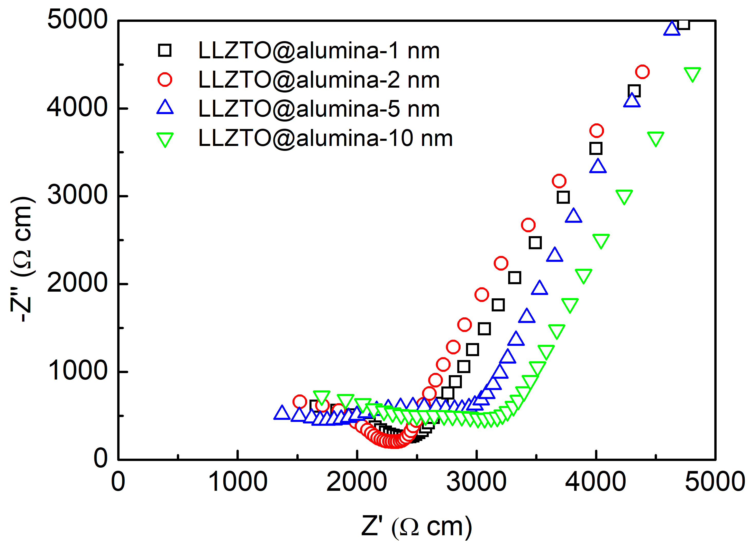

Fig. S1. Normalized EIS curves of different LLZTO@alumina pellets with different coating thickness.

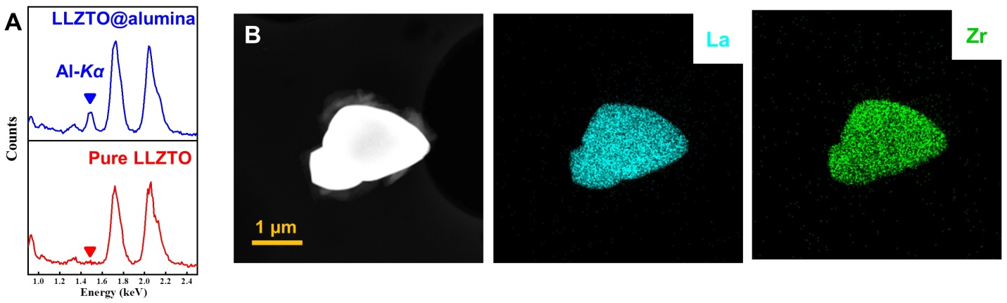

Fig. S2. EDS and corresponding mapping images of pure LLZTO particle.

Fig. S3. SEM-EDS mapping of LLZTO@alumina powders.

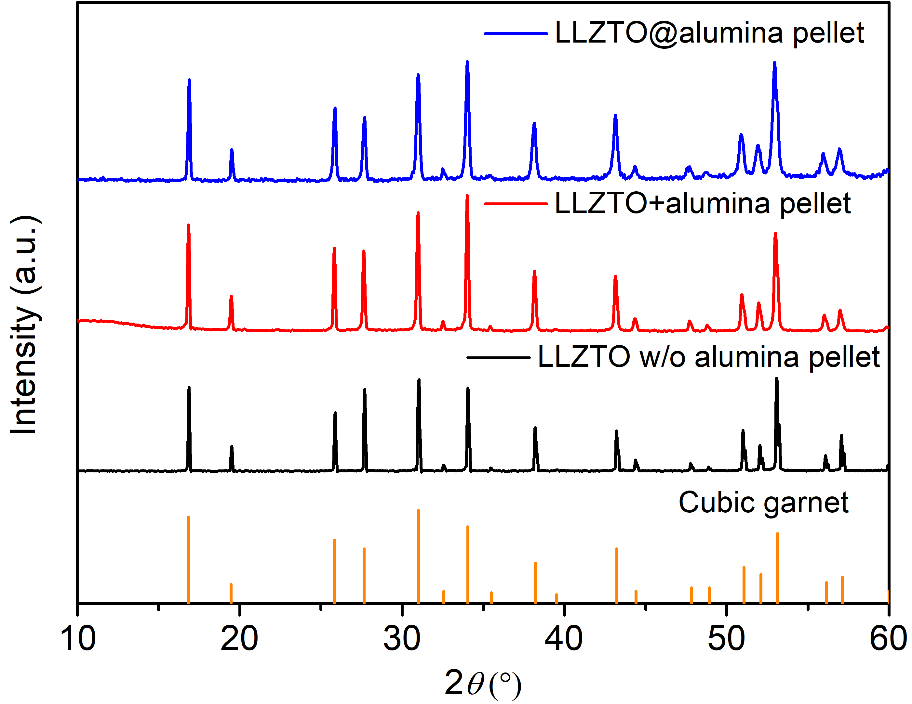

Fig. S4. XRD patterns of different LLZTO pellets.

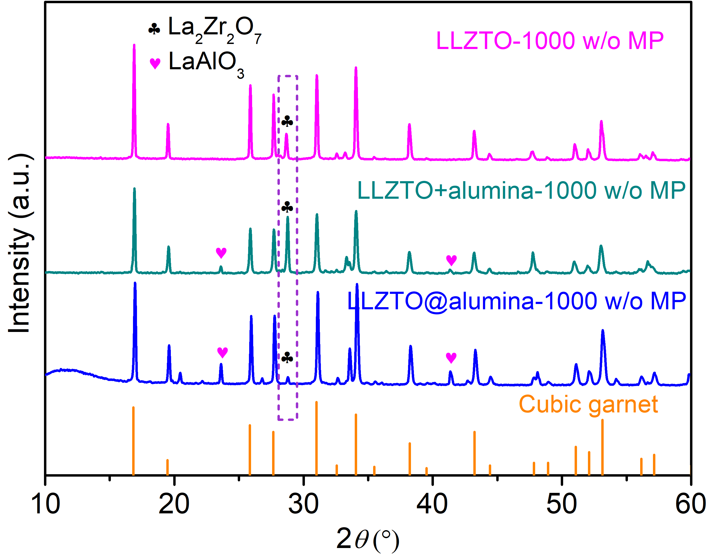

Fig. S5. XRD patterns of different LLZTO pellets sintered without covering mother powder.

Fig. S6. (A to C) Cross section SEM images of the LLZTO w/o alumina pellets sintered at 980, 1100 and 1200 ºC, respectively.

Fig. S7. Distribution of grain size of different LLZTO pellets under different sintering conditions.

Fig. S8. TEM characterization of γ-LiAlO₂ second phase for LLZTO@alumina pellet. (A) TEM image of LLZTO@alumina sample and corresponding SAED of second phase area which viewed along zone axis $[\overline{2}61]$. (B) TEM image of LLZTO@alumina sample and corresponding SAED of second phase area which viewed along zone axis [$\overline{1}11$].

Fig. S9. Optical micrographs of Vickers indentations for different LLZTO samples.

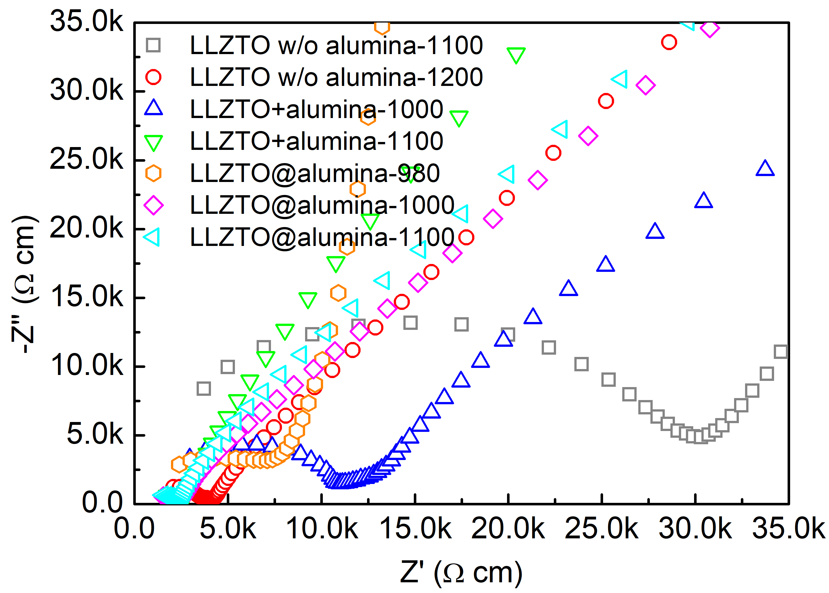

Fig. S10. Normalized EIS curves of different LLZTO pellets.

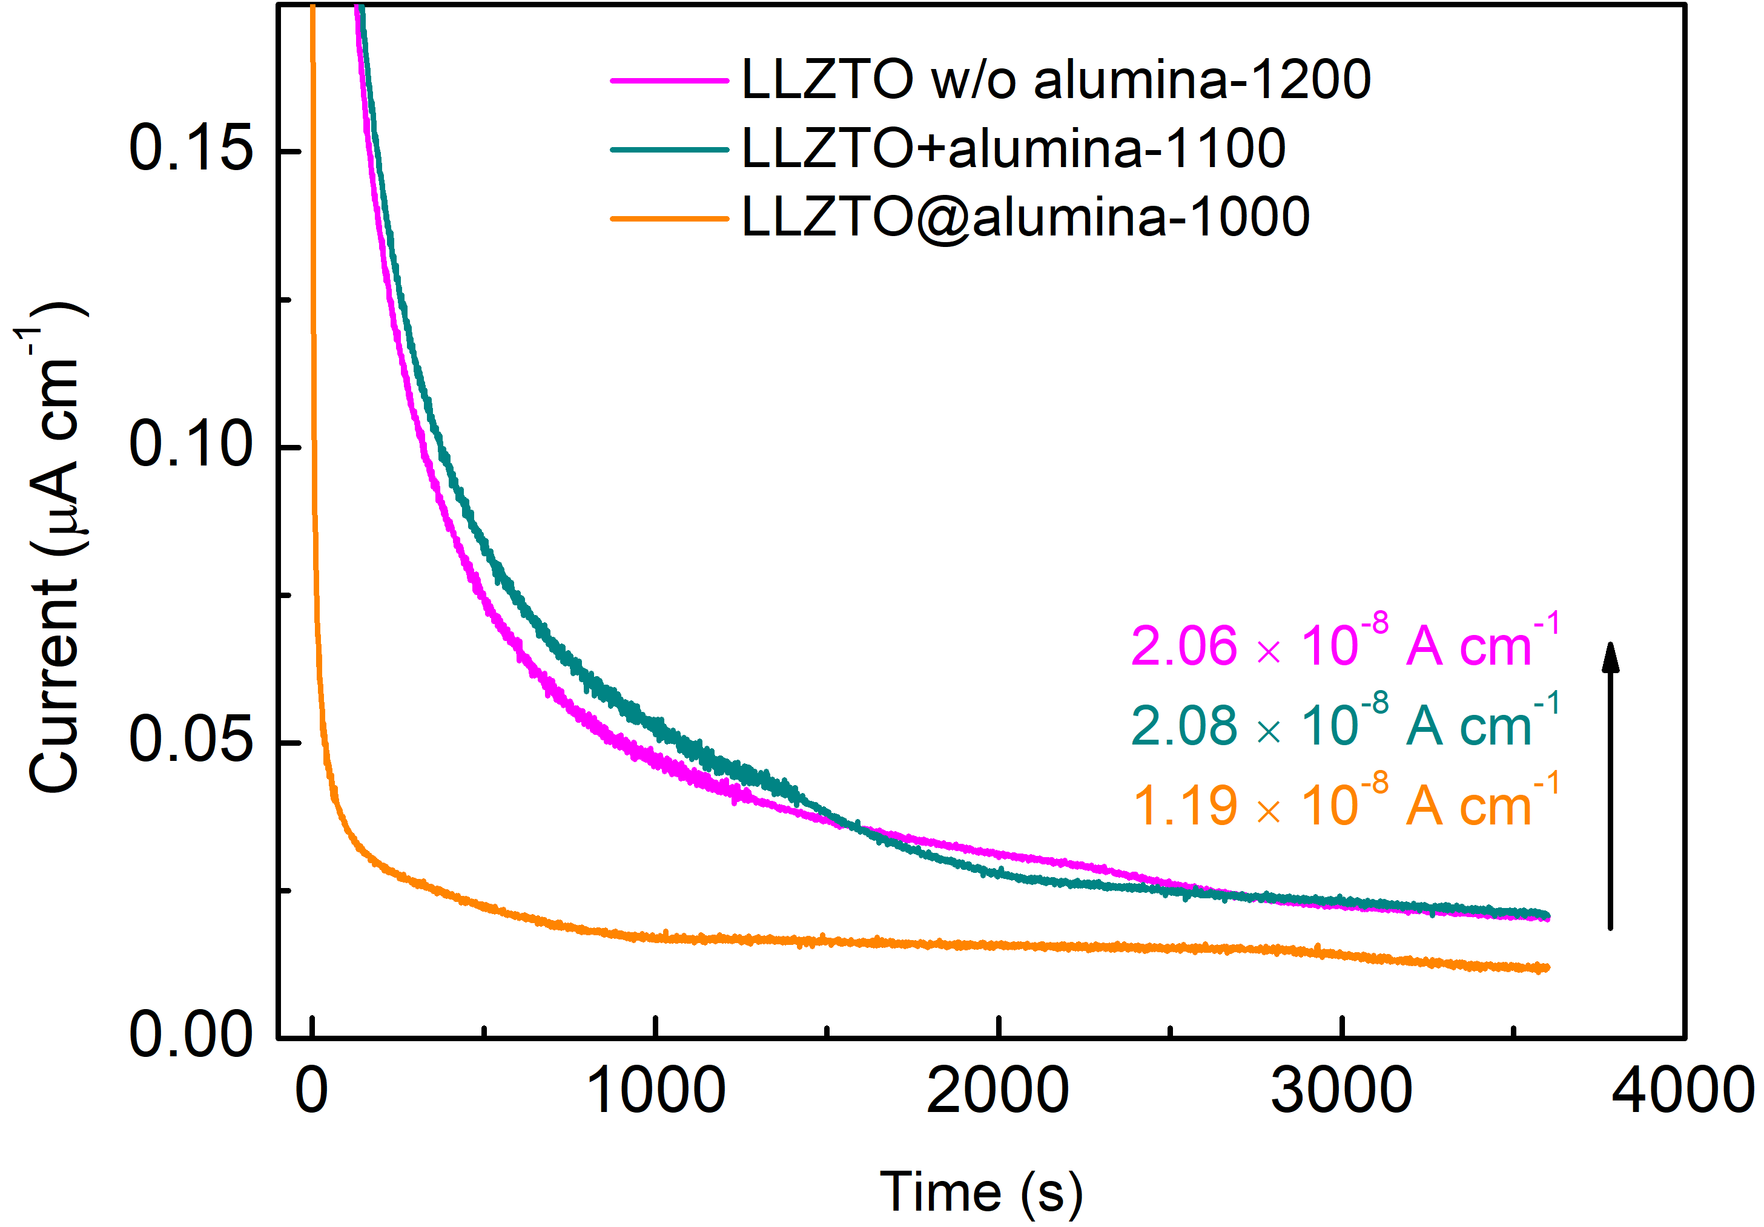

Fig. S11. Normalized Chronoamperometry results of various LLZTO pellets with an applied voltage of 2.5 V.

Fig. S12. EIS curves of various Li|LLZTO|Li symmetry cells and the inset is the fitting circuit.

Fig. S13. EIS curve of Li|LLZTO@alumina|LNMO cell and the inset is the fitting circuit.

Table S1. The element composition of the various LLZTO samples.
Samples | Li (wt %) | La (wt %) | Zr (wt %) | Ta (wt %) | Al (wt %) | O (wt %)
LLZTO powder | 4.96 | 44.86 | 13.52 | 11.83 | 0 | 24.83
LLZTO w/o alumina | 4.44 | 46.49 | 13.93 | 12.33 | 0.69 | 22.12
LLZTO+alumina | 4.79 | 46.72 | 12.84 | 10.52 | 1.09 | 24.04
LLZTO@alumina | 4.63 | 49.38 | 13.28 | 11.09 | 1.54 | 20.08

Table S2. Summary of fitted data for different LLZTO pellets.
Samples | R_{b}  (Ω cm²) | R_{gb}  (Ω cm²) | C_{Q} (F) | n | C (F)
LLZTO w/o alumina-1100 | 124.46 | 2696.21 | 5.11E-11 | 0.98 | 3.70E-11
LLZTO w/o alumina-1200 | 41.74 | 288.80 | 1.88E-9 | 0.81 | 6.38E-11
LLZTO+alumina-980 | 96.90 | 4168.60 | 9.58E-11 | 0.94 | 3.74E-11
LLZTO+alumina-1000 | 77.22 | 817.00 | 3.38E-10 | 0.90 | 6.31E-11
LLZTO+alumina-1100 | 42.75 | 192.85 | 5.84E-8 | 0.62 | 5.41E-11
LLZTO@alumina-980 | 42.75 | 647.90 | 5.15E-10 | 0.88 | 6.74E-11
LLZTO@alumina-1000 | 38.10 | 150.10 | 3.56 E-8 | 0.67 | 9.01E-11
LLZTO@alumina-1100 | 39.09 | 154.09 | 3.27E-9 | 0.80 | 8.71E-11
R_{b} and R_{gb} represent the area specific resistances of grain and grain boundary, respectively. The capacitance of grain boundary (C) is calculated using the formula: $C={(R^{1-n}C_{Q})}^{1/n}$

References
1 Nie, L. et al. Biofilm nanofiber-coated separators for dendrite-free lithium metal anode and ultrahigh-rate lithium batteries. ACS Appl Mater Interfaces 11, 32373-32380 (2019).
2 Marezio, M. The crystal structure and anomalous dispersion of γ-LiAlO₂. Acta Crystallographica 19, 396-400 (1965).
3 Kresse, G. & Furthmuller, J. Efficient iterative schemes for ab initio total-energy calculations using a plane-wave basis set. Phys Rev B Condens Matter 54, 11169-11186 (1996).
4 Blochl, P. E., Jepsen, O. & Andersen, O. K. Improved tetrahedron method for brillouin-zone integrations. Phys Rev B Condens Matter 49, 16223-16233 (1994).
5 Perdew, J. P., Burke, K. & Ernzerhof, M. Generalized gradient approximation made simple. Phys. Rev. Lett. 77, 3865-3868 (1996).
6 Henkelman, G., Uberuaga, B. P. & Jónsson, H. A climbing image nudged elastic band method for finding saddle points and minimum energy paths. The Journal of Chemical Physics 113, 9901-9904 (2000).

