SF 1 The corresponding P values in PGC of the newly identified SigGWAS loci in CLOZUK+PGC. The plot shows that a big portion of new sigGWAS loci of CLOZUK+PGC has at least one LD correlated variant with P values falling in different subGWAS hresholds (5 x 10⁻⁸ < P ≤ 1 x 10⁻⁶ or 5 x 10 ⁻⁸ < P ≤ 1 x 10⁻⁵) at different LD thresholds ([0.2, 1]). 2
SF 2 An example of that subGWAS locus (rs28374258) in PGC become sigGWAS locus in CLOZUK+PGC. Different colors indicate the SNPs in different LD regions with the subGWAS locus. 3
SF 3 (A, B) Number of loci in 145 sigGWAS (A,red vertical line) and 180 subGWAS (B) overlapped with enhancers of DLPFC comparing against 1000 permutation of randomly selected control loci lists. (C, D) Mean enhancers overlapped by 145 sigGWAS (C) and subGWAS (D) comparing against to random controls 4
SF 4 Enrichment of enhancers in subGWAS loci regions in brain. A. 145 sigGWAS. B. 180 subGWAS. Blue: nonbrain tissue; Red: Brain tissue; Green: DLPFC 5
SF 5 LDSC analysis of HRGs excluding distance from the input features (±10Kb) 6
SF 6 LDSC analysis of HRGs excluding distance from the input features (±100kb) 7
SF 7 GTEx_2015_adult brain specificity of sigHRGs and SubHRGs. 8
SF 8 SigGWAS and subGWAS shows early-stage expression in BrainSpan. 9
SF 9 DAG plot of enrichment of MPO. Longest branch in the plot is the term of nervous system phenotype 10
SF 10 All biological progress terms 11
SF 11 Signaling term cluster. SigGWAS is likely to enrich in synaptic signaling terms. 12
SF 12 ion transport terms. SigGWAS mainly enriched in calcium ion related terms. 12
SF 13 locomotion terms 13
SF 14 Behavior terms 13
SF 15 QQ plot of -log10(P) of rare variants of DD and DM genes comparing to random sampled background (orange). 14
SF 16 eQTL of LRP8 and ASAP1 in GTEx_2015_adult (upper panel) and Jaffe_2018_adult (bottom panel). Plots are adapted from https://gtexportal.org/home/locusBrowserPage/ and http://eqtl.brainseq.org/phase1/eqtl/ 15
SF 17 Expression of pluripotency-associated markers in human iPSC lines. Shown are sample images of immunostaining of pluripotency-associated markers NANOG and SSEA4 for different iPSC lines. Scale bar: 50 µm. 16

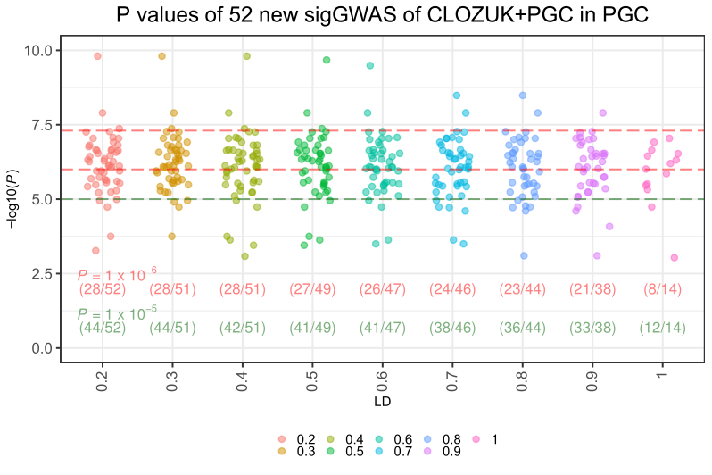
SF 1 The corresponding P values in PGC of the newly identified SigGWAS loci in CLOZUK+PGC. The plot shows that a big portion of new sigGWAS loci of CLOZUK+PGC has at least one LD correlated variant with P values falling in different subGWAS hresholds (5 x 10⁻⁸ < P ≤ 1 x 10⁻⁶ or 5 x 10 ⁻⁸ < P ≤ 1 x 10⁻⁵) at different LD thresholds ([0.2, 1]).

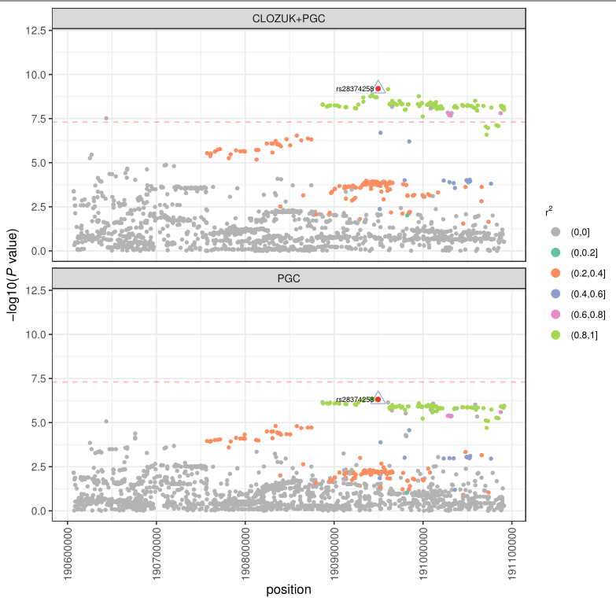
SF 2 An example of that subGWAS locus (rs28374258) in PGC become sigGWAS locus in CLOZUK+PGC. Different colors indicate the SNPs in different LD regions with the subGWAS locus.
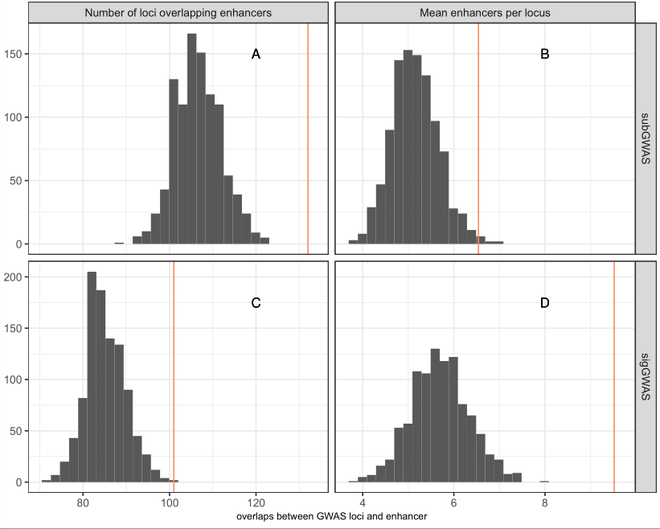
SF 3 (A, B) Number of loci in 145 sigGWAS (A,red vertical line) and 180 subGWAS (B) overlapped with enhancers of DLPFC comparing against 1000 permutation of randomly selected control loci lists. (C, D) Mean enhancers overlapped by 145 sigGWAS (C) and subGWAS (D) comparing against to random controls

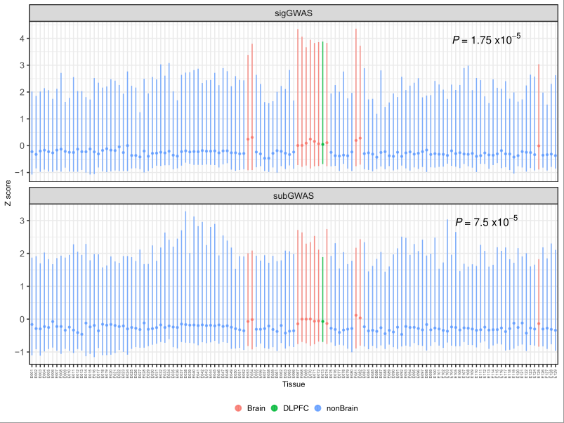
SF 4 Enrichment of enhancers in subGWAS loci regions in brain. A. 145 sigGWAS. B. 180 subGWAS. Blue: nonbrain tissue; Red: Brain tissue; Green: DLPFC
A
B

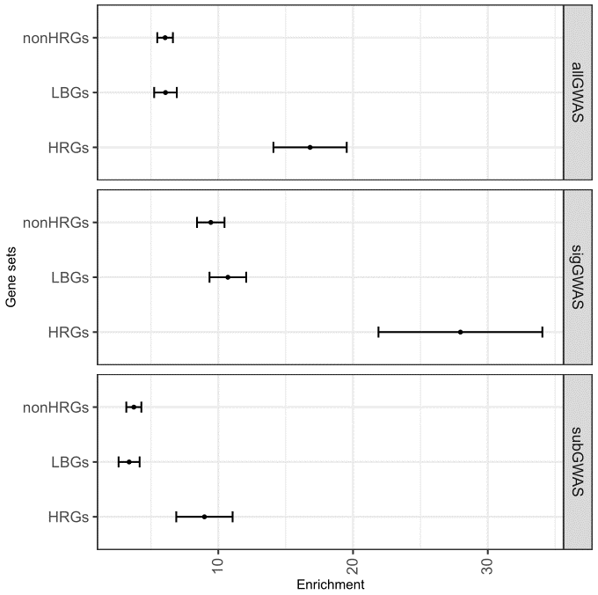
SF 5 LDSC analysis of HRGs excluding distance from the input features (±10Kb)
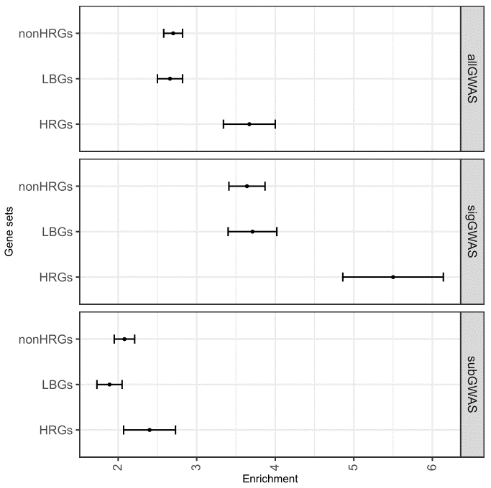
SF 6 LDSC analysis of HRGs excluding distance from the input features (±100kb)

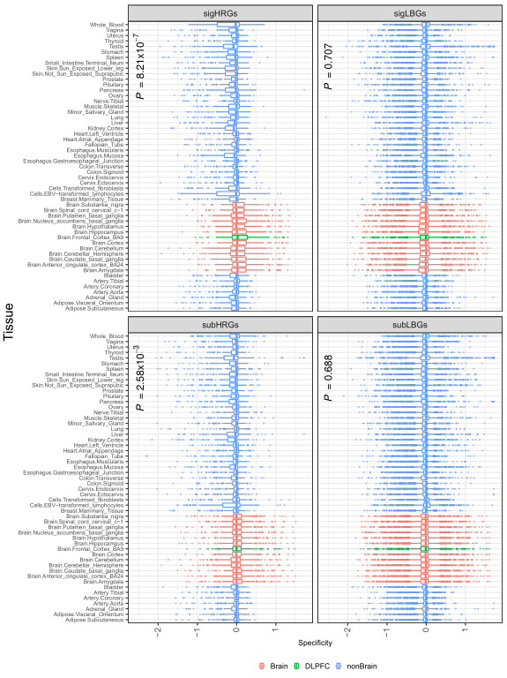
SF 7 GTEx_2015_adult brain specificity of sigHRGs and SubHRGs.
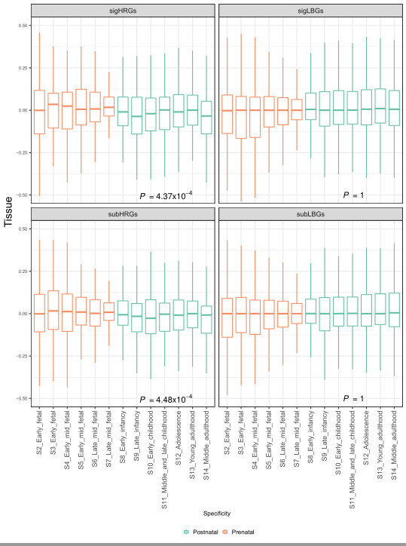
SF 8 SigGWAS and subGWAS shows early-stage expression in BrainSpan.
. A. sigGWAS. B. subGWAS. C. LBG

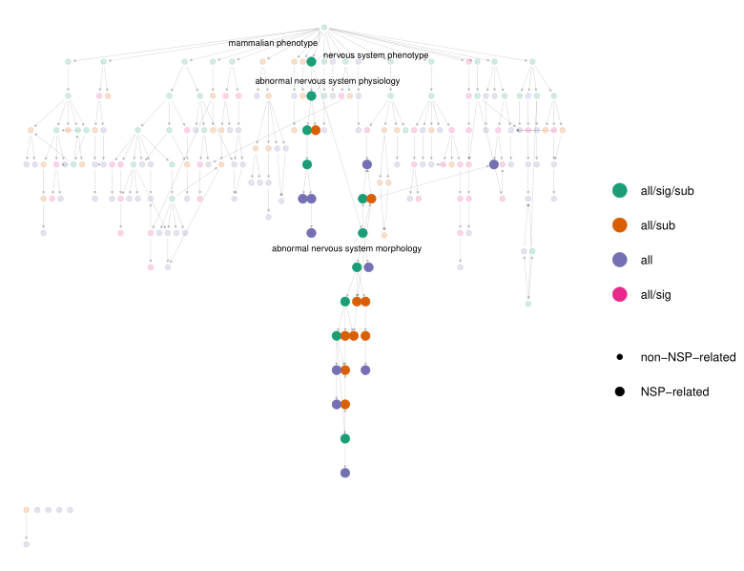
SF 9 DAG plot of enrichment of MPO. Longest branch in the plot is the term of nervous system phenotype

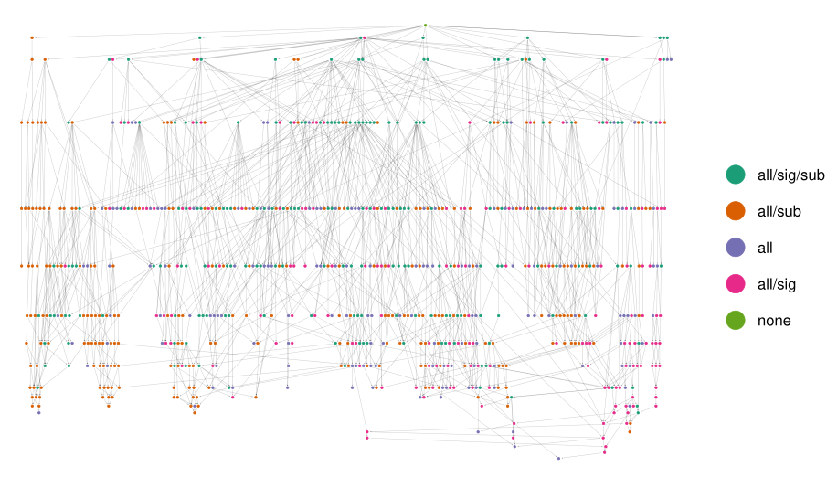
SF 10 All biological progress terms

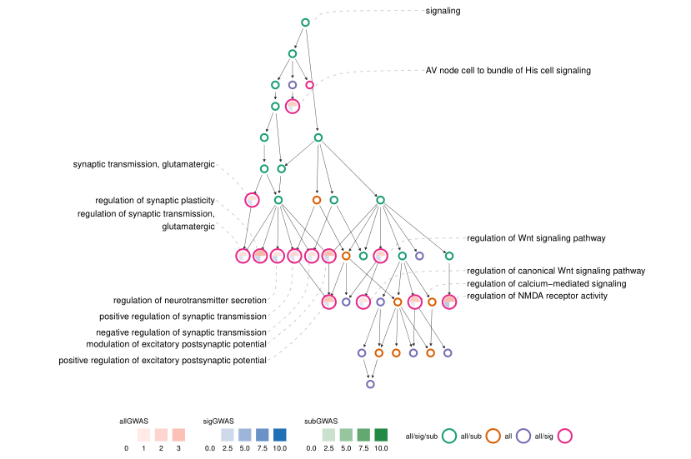
SF 11 Signaling term cluster. SigGWAS is likely to enrich in synaptic signaling terms.
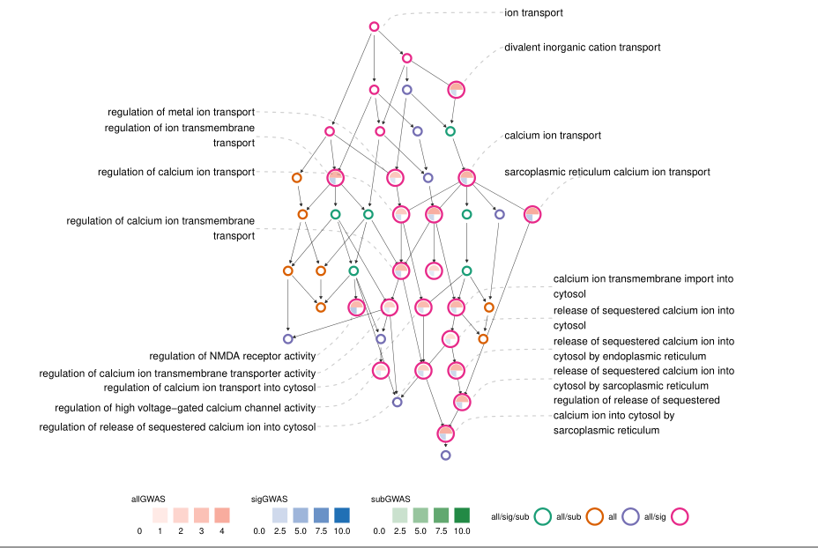
SF 12 ion transport terms. SigGWAS mainly enriched in calcium ion related terms.

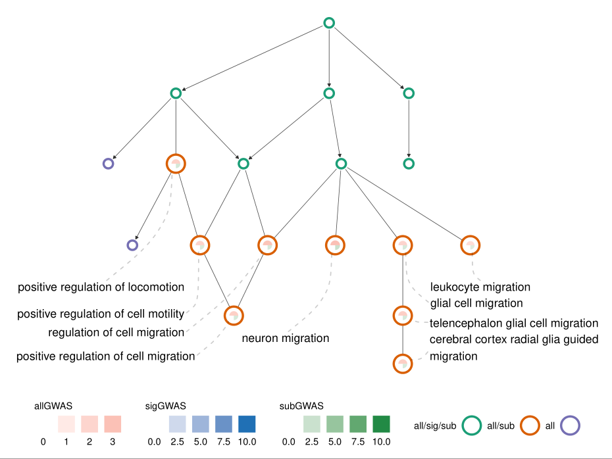
SF 13 locomotion terms

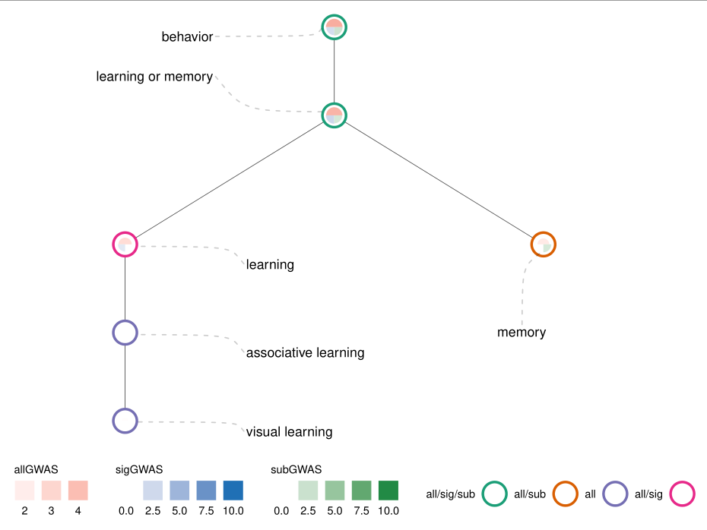
SF 14 Behavior terms

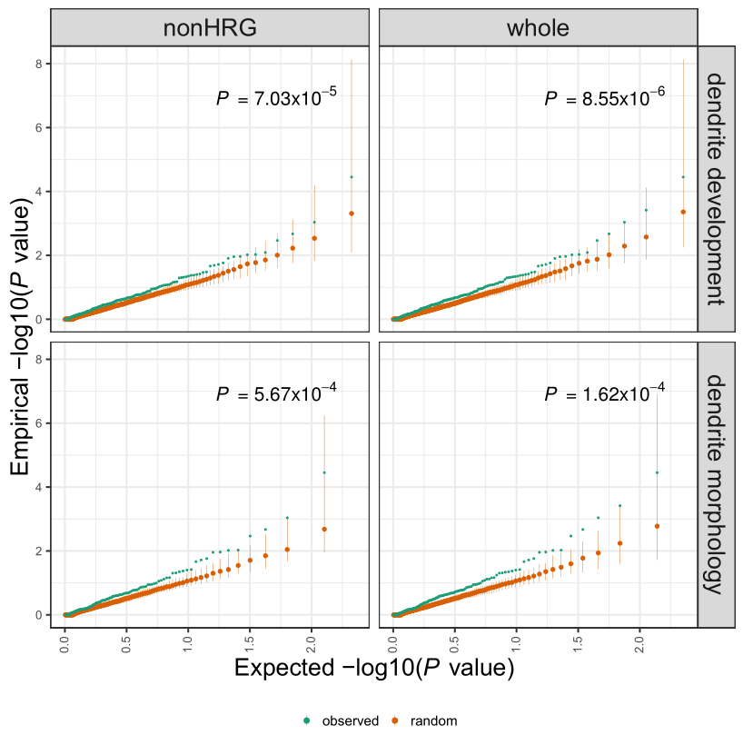
SF 15 QQ plot of -log10(P) of rare variants of DD and DM genes comparing to random sampled background (orange).

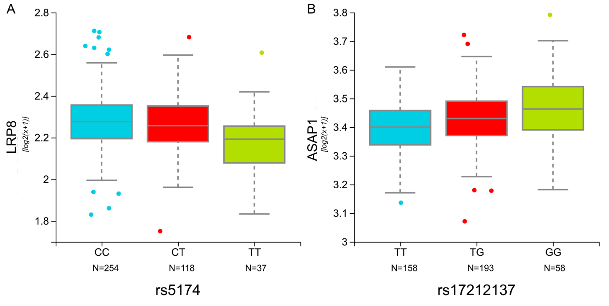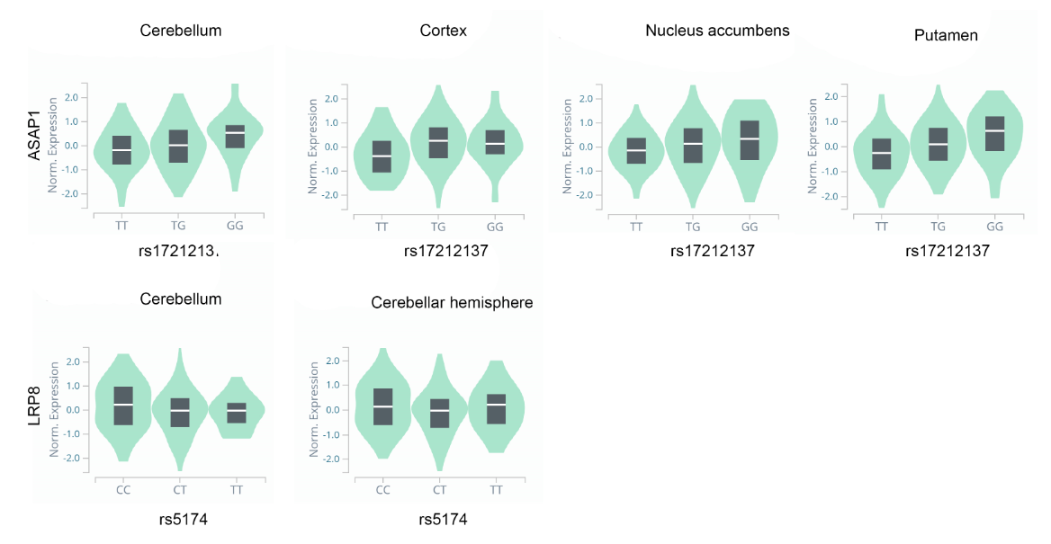
SF 16 eQTL of LRP8 and ASAP1 in GTEx_2015_adult (upper panel) and Jaffe_2018_adult (bottom panel). Plots are adapted from https://gtexportal.org/home/locusBrowserPage/ and http://eqtl.brainseq.org/phase1/eqtl/

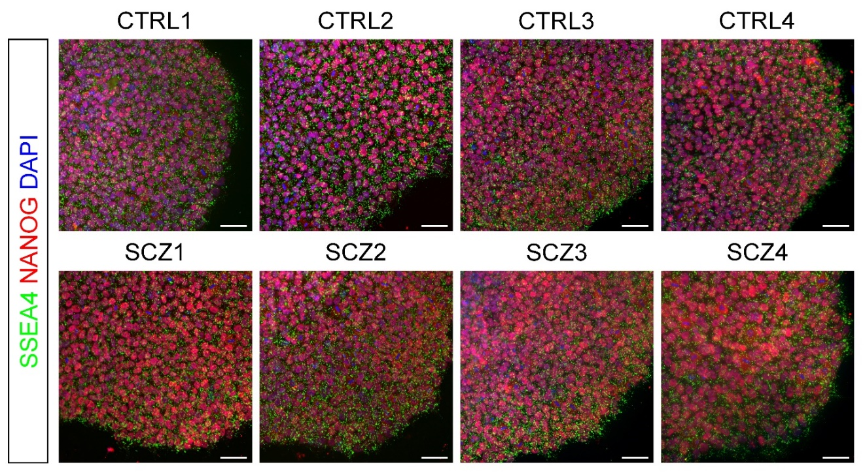
SF 17 Expression of pluripotency-associated markers in human iPSC lines. Shown are sample images of immunostaining of pluripotency-associated markers NANOG and SSEA4 for different iPSC lines. Scale bar: 50 µm.

