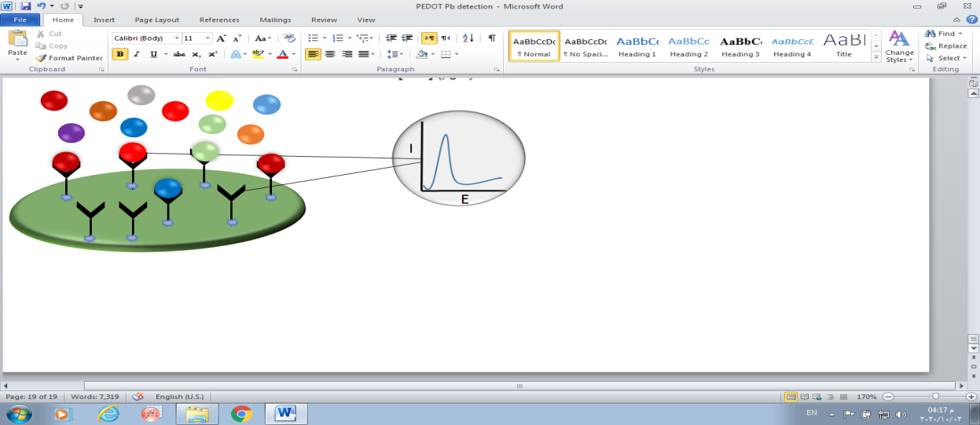

**Metal ions**

**Reactive sites**

**Receptor/ ligand**

**Poly EDOT/ Schiff electrode**

**Square wave voltammetry**

**Computer processing**

