Supplementary Appendix

Methods
Pathology
Assessment of Pathological Characteristics
The assessment of pathological characteristics of all the 21 patients were completed by same two pathologists (W. S. and XY. L.). They describe the characteristics of the dissected primary tumor after neoadjuvant chemotherapy or immunotherapy combine with chemotherapy. The characteristics include: the existence of necrosis, infiltration of lymphocytes or chronic inflammatory cells, form of foam cells and cholesterol crystal, and collection of monocytes or phagocytes. The results are shown in Figure 3.

Evaluation of Residual Viable Tumor Cells
The residual viable tumor cells were evaluated by two pathologists (W. S. and XY. L.) by (1) measuring the gross maximum diameter, (2) then take hematoxylin and eosin-stained slides of at least 1 section per greatest tumor diameter, (3) measure percentage of viable tumor cells in each slide, and (4) sum the percentage of viable tumor cells in each slide and divide by number of slides examined. The number of each tumor was recorded, and Major pathological response (MPR) is defined as no more than 10% residual viable tumor cells.

Immunohistochemical analysis
Selected specimens were assessed with multiplexed immunofluorescence staining (information of the specimen is shown in the table below). Primary tumors and lymph nodes (normal or metastased) were stained for simultaneous detection of cytokeratin (Tumor cells), CD8 (cytotoxic T cells), FoxP3 (regulatory T cells), CD68 (macrophages), and CD56 (Natural Killer cells).
Group | Patient Number | Residual Viable Tumor Cells (%) | Pathological Evaluation | Specimen
 |  |  |  | Primary Tumor | Lymph Node (Metastased) | Lymph Node  (Not Metastased)
IM | 2 | 0 | CR | Yes | N/A | Yes (No. 7*)
 | 7 | 27.5 | PR | Yes | Yes (No. 13*) | Yes (No. 7)
 | 8 | 44.5 | PR | Yes | Yes (No. 12*) | Yes (No. 7)
C | 1 | 0 | CR | Yes | N/A
 | 6 | 27.27 | PR | Yes | N/A
 | 13 | 91.45 | SD | Yes | Yes (No. 12*)
* No. 7=subcarinal lymph node; No. 12=lobar lymph node; No. 13=segmental lymph node

Multiplexed immunofluorescence staining by PANO 7-plex IHC kit, cat 0004100100 (Panovue, Beijing, China) was performed according to the Opal immunostaining protocol to visualize the expression of the above-mentioned markers. Different primary antibodies were sequentially applied to the corresponding FFPE tumor sections (4-5um), followed by horseradish peroxidase-conjugated secondary antibody incubation and tyramide signal amplification. The slides were microwave heat-treated after each TSA operation. Nuclei were stained with 4’-6’-diamidino-2-phenylindole (DAPI, SIGMA-ALDRICH) after all the human antigens had been labelled.
The Mantra System (PerkinElmer, Waltham, Massachusetts, USA) was used to scan the stained slides for obtaining of multispectral images. Images of unstained and single-stained sections were used to extract the spectrum of autofluorescence of tissues and each fluorescein. The extracted images were further used to establish a spectral library required for multispectral unmixing by inForm image analysis software (Version 2.4, PerkinElmer, Waltham, Massachusetts, USA).

T cell receptor (TCR) sequencing
Sample Collection and DNA extraction
In total 15 samples, as shown in “Immunohistochemical analysis”, were collected from primary cancer tissue (PT), normal lymph node (nLN), metastased node (LNM) during the surgery. All the samples were Formalin-fixed and paraffin-embedded (FFPE) fixed and was stored until further analysis.
DNA was extracted from each FFPE tissue using the QIAamp DNA FFPE Tissue Kit (Qiagen, Hilden, Germany), following the manufacturer’s protocol. All DNA was quantified using Qubit dsDNA High Sensitivity Assay Kit with the Qubit 3.0 fluorometer (Invitrogen, Carlsbad, CA). Each sample has sufficient DNA and they were stored in - 20°C freezer until further library preparation.

TCR sequencing
Multiplex PCR was designed to amplify rearranged TCR-β CDR3 regions from genomic DNA. Briefly, gDNA (800ng) for each sample was amplified using the QIAGEN Multiplex PCR Kit (Qiagen, Hilden, Germany). The assay utilized a suite of 32 forward (F) primers that were each specific for a functional TCR-Vβ segment (VF pool) and 13 reverse (R) primers for the Jβ segment (JR pool). Universal forward and reverse primer sequences were contained at their 5' ends of the forward and reverse primers, respectively, which were compatible with the Illumina HiSeq platform. The PCRs (50 µL) were configured with 1x QIAGEN Multiplex PCR master mix, 20 µM VF pool, 20 µM JR pool, 800 ng gDNA, and 1 µL Q-solution (QIAGEN). The amplification protocol was as follows: 15 min at 95℃, 26 cycles of 30 s at 94℃, 90 s at 60℃, and 1 min at 72℃, followed by a final extension cycle of 10 min at 72℃. The PCR products were purified with Beckman AMPure XP beads followed by another round of indexing PCR. The PCR products were purified to generate the final library, quantified using Qubit and Agilent 4150 tape station.

TCR sequencing data analysis
The raw data were stored in FASTQ format and the Q30 were all above 85%. Low-quality sequences were firstly filtered out according to the proportion of low-quality bases >40% and undetected bases (base N) > 1. Paired-end reads were then aligned to VDJ regions and TCR clonotypes were identified by MiXCR 3.0.5 pipeline (Nature methods, doi:10.1038). The clonotype was defined as a unique CDR3 amino acid (AA) sequence which were translated from a complete variable sequence containing Variable (V) gene, Joining (J) gene and Constant (C) gene.
The diversity of each sample was calculated by the Shannon’s entropy (H) index, which took into consideration of the sample richness and the clonotype frequencies of CDR3. Entropy was calculated by summation of the minus log (base 2) clonotype frequency times the frequency of each clonotype. The higher H index indicates the more diverse the CDR3 clones distribution. The similarity or sample overlap (SO) was the sum of the counts for all the shared sequences observed in both samples divided by the total number of counts for all the sequences (shared and unshared) in the two samples.

Table S1. Neoadjuvant treatment regimen

Patients number | Study ID number* | Neoadjuvant Chemotherapy Regimen | Anti-PD-1 inhibitor agent
IM Group
1 | IM-3 | Nab-Paclitaxel + Cisplatin | Pembrolizumab
2 | IM-7 | Gemcitabine + Cisplatin | Pembrolizumab
3 | IM-8 | Nab-Paclitaxel + Cisplatin | Pembrolizumab
4 | IM-2 | Gemcitabine + Cisplatin | Pembrolizumab
5 | IM-5 | Gemcitabine + Cisplatin | Toripalimab
6 | IM-1 | Gemcitabine + Cisplatin | Pembrolizumab
7 | IM-4 | Nab-Paclitaxel + Cisplatin | Pembrolizumab
8 | IM-6 | Gemcitabine + Cisplatin | Pembrolizumab
C Group
1 | C-8 | Nab-Paclitaxel + Cisplatin | NA
2 | C-11 | Gemcitabine + Cisplatin | NA
3 | C-4 | Paclitaxel + Carboplatin | NA
4 | C-6 | Nab-Paclitaxel + Cisplatin | NA
5 | C-7 | Nab-Paclitaxel + Cisplatin | NA
6 | C-9 | Gemcitabine + Cisplatin | NA
7 | C-13 | Gemcitabine + Cisplatin | NA
8 | C-3 | Gemcitabine + Cisplatin | NA
9 | C-2 | Gemcitabine + Cisplatin | NA
10 | C-10 | Paclitaxel + Carboplatin | NA
11 | C-5 | Gemcitabine + Cisplatin | NA
12 | C-1 | Gemcitabine + Cisplatin | NA
13 | C-12 | Paclitaxel + Cisplatin | NA
* Study ID number is assigned base on the date of surgery

Table S2. Treatment-related adverse events

 | Chemotherapy with Immunotherapy  (IM group, n=8) |  | Chemotherapy Only  (C group, n=13)
 | Grade 1-2  n (%) | Grade 3-4  n (%) | Grade 1-2  n (%) | Grade 3-4  n (%)
Fever | 3 (37.5) | 0 | 1 (7.69) | 0
Fatigue | 1 (12.5) | 0 | 0 | 0
Nausea/Vomiting | 1 (12.5) | 0 | 3 (23.08) | 0
Diarrhea | 0 | 0 | 2 (15.38) | 0
Leukopenia | 3 (37.5) | 1 (12.5) | 5 (38.46) | 0
Neutropenia | 3 (37.5) | 1 (12.5) | 3 (23.08) | 0
Thrombocytopenia | 1 (12.5) | 0 | 3 (23.08) | 0
Erythropenia | 1 (12.5) | 0 | 0 | 0
Pneumonia | 0 | 1 (12.5) | 0 | 0

Table S3. Pre-treatment clinical stage and post-treatment pathological stage

Patients number | Study ID number* | Pre-treatment clinical stage  TNM (stage group) | Pathologic stage at resection  TNM (Stage group) | Residual viable tumor cellS (%) | Major Pathologic Response  (yes/no) | Pathologic downstaging  (yes/no)
IM Group
1 | IM-3 | T1cN2 (IIIA) | T0N0 | 0 | Yes | Yes
2 | IM-7 | T2bN1 (IIB) | T0N0 | 0 | Yes | Yes
3 | IM-8 | T3N0 (IIB) | T0N0 | 0 | Yes | Yes
4 | IM-2 | T3N1 (IIIA) | T1bN0 (IA) | 13.4 | Yes# | Yes
5 | IM-5 | T3N1 (IIIA) | T1bN0 (IA) | 16.5 | No | Yes
6 | IM-1 | T2bN0 (IIA) | T1bN0 (IA) | 20.6 | No | Yes
7 | IM-4 | T1cN1 (IIB) | T1aN1 (IIB) | 27.5 | No | No
8 | IM-6 | T2aN1 (IIB) | T1bN1 (IIB) | 44.5 | No | No
C Group
1 | C-8 | T2bN2 (IIIA) | T0N0 | 0 | Yes | Yes
2 | C-11 | T4N0 (IIIA) | T2bN0 (IIA) | 2.96 | Yes | Yes
3 | C-4 | T1cN2 (IIIA) | T1aN0 (IA) | 3 | Yes | Yes
4 | C-6 | T1cN2 (IIIA) | T1aN0 (IA) | 6 | Yes | Yes
5 | C-7 | T3N2 (IIIB) | T1bN0 (IA) | 7.47 | Yes | Yes
6 | C-9 | T1cN1 (IIB) | T1bN0 (IA) | 27.27 | No | Yes
7 | C-13 | T2aN2 (IIIA) | T1cN1 (IIB) | 30.7 | No | Yes
8 | C-3 | T2aN1 (IIB) | T1cN2a2 (IIIA) | 49.27 | No | No
9 | C-2 | T2aN1 (IIB) | T2aN1a (IIB) | 50.18 | No | No
10 | C-10 | T3N2 (IIIB) | T2bN0 (IIA) | 55.93 | No | Yes
11 | C-5 | T3N1 (IIIA) | T3N0 (IIB) | 65.7 | No | Yes
12 | C-1 | T1cN1 (IIB) | T1cN1 (IIB) | 87.42 | No | No
13 | C-12 | T2bN1 (IIB) | T2aN1(IIB) | 91.45 | No | No
* Study ID number is assigned base on the date of surgery
# this patient is diagnosed with lung squamous cell carcinoma with neuroendocrine component after surgery. Although there were 13.4% residual tumor cells, the squamous carcinoma component is less than 10%.

Figure S1. Immunohistochemical staining on primary tumor from patient accepted neoadjuvant chemotherapy with PD-1 blockade

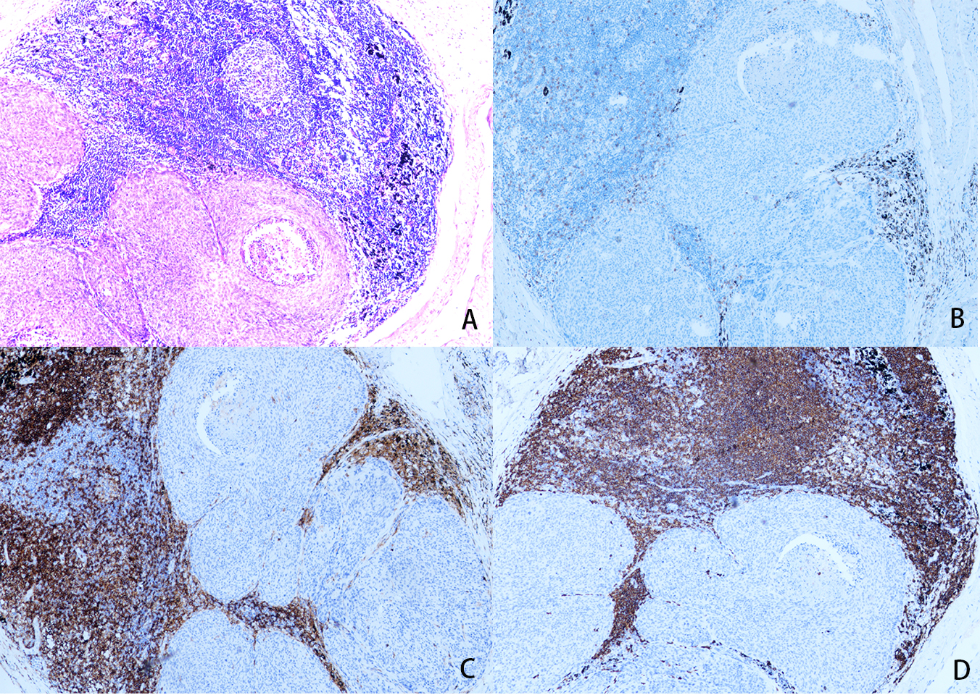
A. H&E staining
B. CD8+ cells
C. CD4+ cells
D. CD20+ cells

Figure S2. Immunohistochemical staining on primary tumor from patient accepted neoadjuvant chemotherapy alone

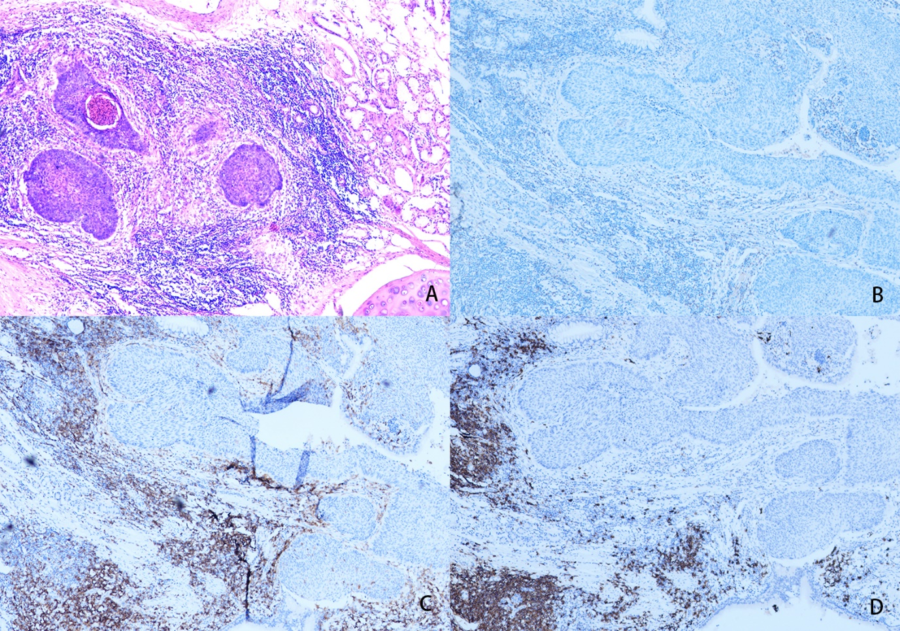
A. H&E staining
B. CD8+ cells
C. CD4+ cells
D. CD20+ cells

Figure S3. The amino acid clonotype

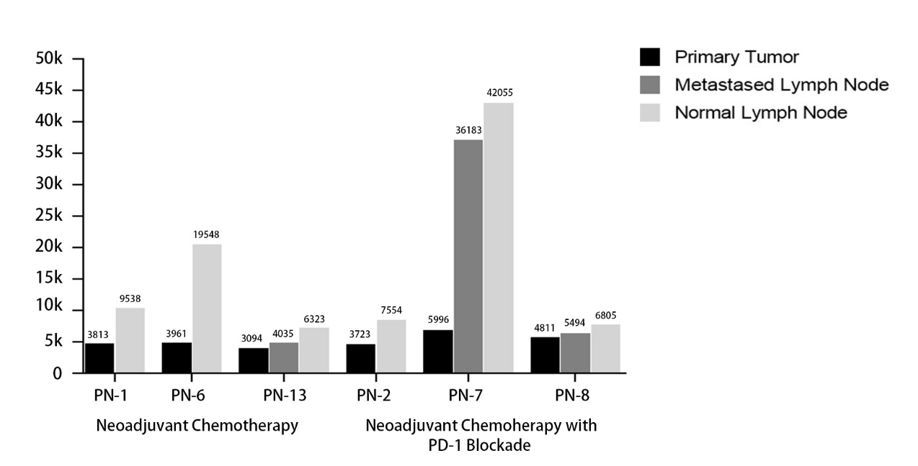

Figure S4. Top 100 amino acid overlap among different specimen

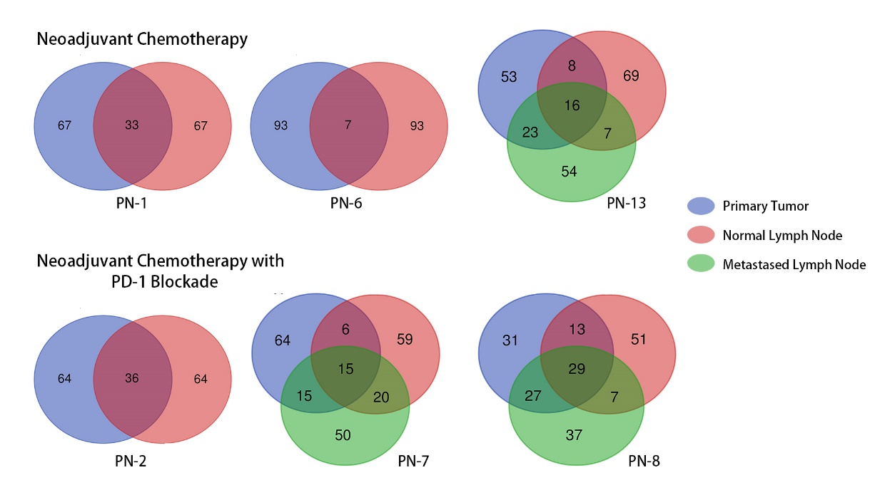
PN-1=patient number 1

Figure S5. Top 100 amino acid overlap among different patients

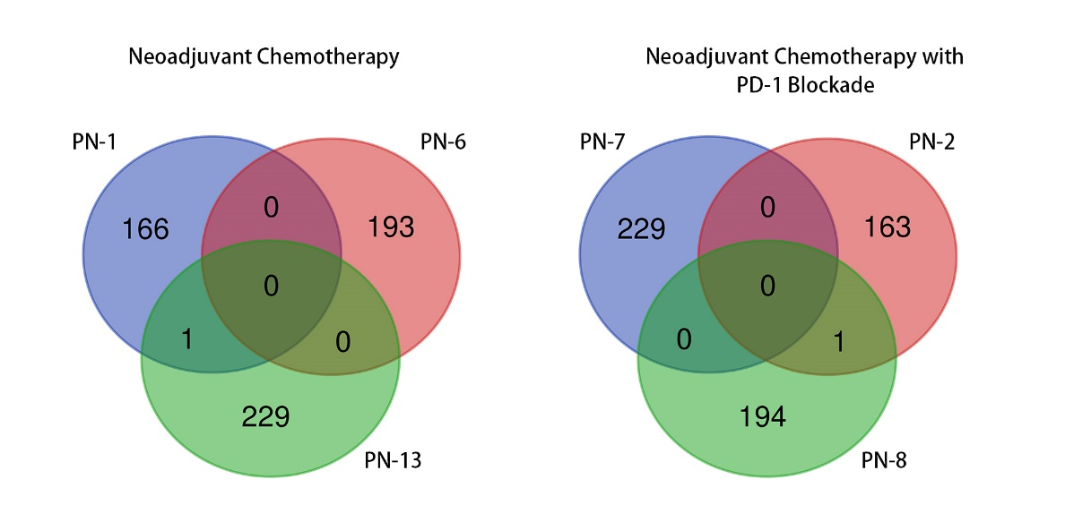
PN-1=patient number 1

