Table S1. Proteins identified by non-targeted data-dependent acquisition and database search using Spectrum Mill









Table S2. Target list for targeted MS/MS data acquisition.

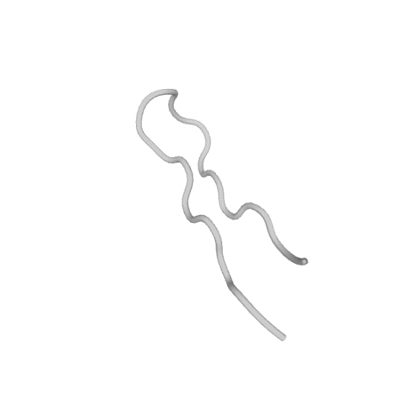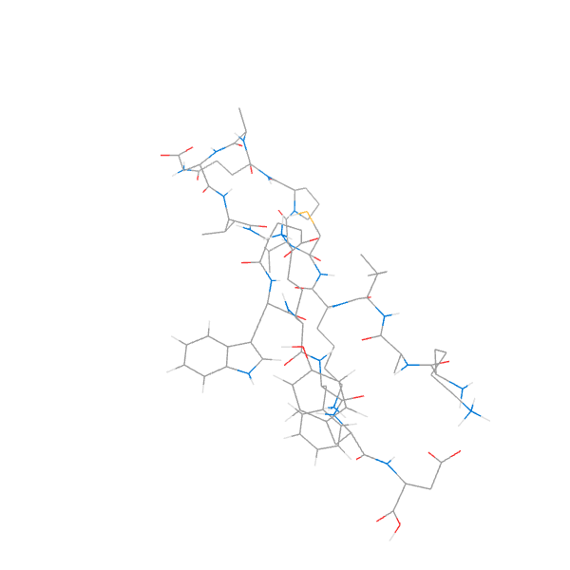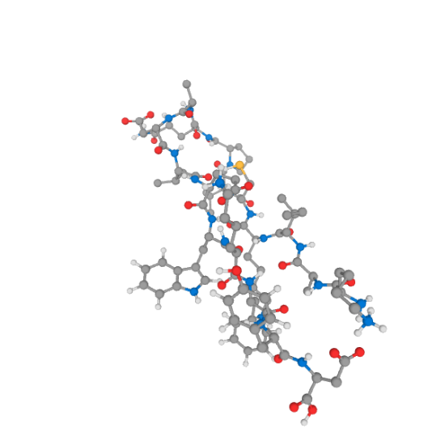

c

b

a

Figure S1. PEP-FOLD3 modelled peptide (KAIKCVPQADVEWKFYD) in cartoon (a), line (b), and ball and stick (c) views. https://mobyle.rpbs.univ-paris-diderot.fr/cgi-bin/portal.py#jobs::PEP-FOLD.S06809981149912.

# Acquisition Method Info

Method Name Method Path Method Description Device List

Multisampler

Binary Pump Column Comp. Q-TOF

Agilent_training_peptides_slope4_it_5uL.m D:\MassHunter\Methods\peptides\Agilent_training_peptides_slope4_it_5uL.

# TOF/Q-TOF Mass Spectrometer

|  |  |  |  |
| --- | --- | --- | --- |
| **Component Name**  **Ion Source**  **Can wait for temp.** | MS Q-TOF  Dual AJS ESI  Enable | **Component Model**  **Stop Time (min)**  **Fast Polarity** | G6545A  No Limit/As Pump  False |
| **MS Abs. threshold** | 200 | **MS Rel. threshold(%)** | 0.010 |
| **MS/MS Abs. threshold** | 5 | **MS/MS Rel. threshold(%)** | 0.010 |
| **Time Segments** |  |  |  |
| **Time Segment #**  1 | **Start Time (min) Diverter Valve State**  0 MS | **Storage Mode Ion Mode**  Both Dual AJS ESI |  |

Time Segment 1

|  |  |  |  |  |  |  |  |
| --- | --- | --- | --- | --- | --- | --- | --- |
| **Acquisition Mode AutoMS2** | |  | | | | | |
| **MS Min Range (m/z)** | |  | 100 | | | | |
| **MS Max Range (m/z)** | |  | 1700 | | | | |
| **MS Scan Rate (spectra/sec)** | |  | 3.00 | | | | |
| **MS/MS Min Range (m/z)** | |  | 50 | | | | |
| **MS/MS Max Range (m/z)** | |  | 1700 | | | | |
| **MS/MS Scan Rate (spectra/sec)**  **Isolation Width MS/MS Decision Engine** | |  | 2.00  Medium (~4 amu) Adv | | | | |
| **Ramped Collision Energy** | |  |  | | | | |
| **Charge Slope**  All 4  **Auto MS/MS Preferred/Exclude Tabl** | | **Offset**  2  **e** |  | | | | |
| **Mass Delta**  921.9686 | **Mass (ppm)** 100 | **Charge**  1 | **Type**  Exclude | **Retention Time (min)**  0 | **Delta Ret. Time (min)** | **Isolation**  **Width**  Narrow (~1.3 | **Collision Energy** |
|  |  |  |  |  |  | amu) |  |

Precursor Selection

Max Precursors Per Cycle 10

Threshold (Abs) 500

**Threshold (Rel)(%)** 0.010

Precursor abundance-based scan speed Yes

**Target (counts/spectrum)** 25000.000

Use MS/MS accumulation time limit Yes

Use dynamic precursor rejection No

**Purity Stringency (%)** 100.000

**Purity Cutoff (%)** 30.000

**Isotope Model** Peptides

Active exclusion enabled Yes

Active exclusion excluded after (spectra) 2

Active exclusion released after (min) 0.20

**Sort precursors** By abundance only

Static Exclusion Ranges

StartMZ EndMZ

25 300

Charge State Preference

Selected Charges

2

3

>3

Instrument Parameters

|  |  |
| --- | --- |
| **Parameter** | **Value** |
| Gas Temp (°C) | 325 |
| Gas Flow (l/min) | 8 |
| Nebulizer (psig) | 35 |
| SheathGasTemp | 350 |
| SheathGasFlow | 11 |

Scan Segments

Scan Seg # Ion Polarity

1 Positive

Scan Segment 1

Scan Source Parameters

|  |  |
| --- | --- |
| **Parameter** | **Value** |
| VCap | 4500 |
| Nozzle Voltage (V) | 1000 |
| Fragmentor | 180 |
| Skimmer1 | 65 |
| OctopoleRFPeak | 750 |

ReferenceMasses

|  |  |  |  |
| --- | --- | --- | --- |
| **Ref Mass Enabled**  **Ref Nebulizer (psig)** | Disabled |  | |
| **Chromatograms** |  |
| **Chrom Type** | **Label** | **Offset** | **Y-Range** |
| TIC | TIC | 15 | 10000000 |
| TIC | TIC | 15 | 10000000 |

Name: Multisampler Sampling Speed Module: G7167A

**Draw Speed** 100.0 µL/min

**Eject Speed** 400.0 µL/min

Wait Time After Drawing 1.2 s

Injection

**Needle Wash Mode** Standard Wash

**Injection Volume** 5.00 µL

Standard Needle Wash

**Needle Wash Mode** Flush Port

**Duration** 10 s

High Throughput

Injection Valve to Bypass for Delay Volume Reduction No

Sample Flush-Out Factor 5.0 Overlapped Injection

Overlap Injection Enabled No

Needle Height Position

**Draw Position Offset** -1.0 mm

Use Vial/Well Bottom Sensing No

Stop Time

**Stoptime Mode** No Limit

Post Time

Posttime Mode Off

Name: Binary Pump Module: G7112B

**Flow** 0.100 mL/min

Use Solvent Types Yes

**Low Pressure Limit** 0.00 bar

**High Pressure Limit** 400.00 bar

**Maximum Flow Gradient** 100.000 mL/min²

Stroke A

Automatic Stroke Calculation A Yes

Stroke B

Automatic Stroke Calculation B Yes

Stop Time

**Stoptime Mode** Time set

**Stoptime** 50.00 min

Post Time

Posttime Mode Off

Solvent Composition

|  |  |  |  |  |  |  |  |  |
| --- | --- | --- | --- | --- | --- | --- | --- | --- |
|  | **Channel** | **Solvent 1** | **Name 1** | **Solvent 2** | **Name 2** | **Selected** | **Used** | **Percent (%)** |
| **1** | A | H20 |  | IPA |  | Ch. 1 | Yes | 98.0 % |
| **2** | B | premixed ACN(95%) - H2O(5%) |  | IPA |  | Ch. 1 | Yes | 2.0 % |

Timetable

|  |  |  |  |  |
| --- | --- | --- | --- | --- |
|  | **Time (min)** | **A (%)** | **B (%)** | **Flow (mL/min)** |
| **1** | 0.00 min | 98.0 % | 2.0 % | 0.100 mL/min |
| **2** | 2.00 min | 98.0 % | 2.0 % | 0.100 mL/min |

|  |  |
| --- | --- |
|  | **Pressure (bar)** |
| **1** | 400.00 bar |
| **2** | 400.00 bar |

|  |  |  |  |  |
| --- | --- | --- | --- | --- |
|  | **Time (min)** | **A (%)** | **B (%)** | **Flow (mL/min)** |
| **3** | 27.00 min | 60.0 % | 40.0 % | 0.100 mL/min |
| **4** | 32.00 min | 40.0 % | 60.0 % | 0.100 mL/min |
| **5** | 32.01 min | 15.0 % | 85.0 % | 0.100 mL/min |
| **6** | 37.00 min | 15.0 % | 85.0 % | 0.100 mL/min |
| **7** | 37.01 min | 98.0 % | 2.0 % | 0.100 mL/min |

Name: Column Comp. Left Temperature Control

Module: G7116A

Temperature Control Mode Temperature Set

**Temperature** 40.0 °C

Enable Analysis Left Temperature

Enable Analysis Left Temperature On Yes

Enable Analysis Left Temperature Value 1.0 °C

Left Temp. Equilibration Time 0.0 min

Right Temperature Control

**Right temperature Control Mode** Not Controlled

Enable Analysis Right Temperature

Enable Analysis Right Temperature On Yes

Enable Analysis Right Temperature Value 0.8 °C

Right Temp. Equilibration Time 0.0 min

Enforce column for run

Enforce column for run enabled No

Stop Time

**Stoptime Mode** As pump/injector

Post Time

Posttime Mode Off

Timetable

**Valve Position** Position 2 (Port 1 -> 2)

**Position Switch After Run** Do not switch

|  |  |
| --- | --- |
|  | **Pressure (bar)** |
| **3** | 400.00 bar |
| **4** | 400.00 bar |
| **5** | 400.00 bar |
| **6** | 400.00 bar |
| **7** | 400.00 bar |

# Acquisition Method Info

Method Name Method Path Method Description Device List

Multisampler

Binary Pump Column Comp. Q-TOF

targetted_slope4_WW_test2.m D:\MassHunter\Methods\peptides\targetted_slope4_WW_test2.m

# TOF/Q-TOF Mass Spectrometer

|  |  |  |  |
| --- | --- | --- | --- |
| **Component Name**  **Ion Source**  **Can wait for temp.** | MS Q-TOF  Dual AJS ESI  Enable | **Component Model**  **Stop Time (min)**  **Fast Polarity** | G6545A  No Limit/As Pump  False |
| **MS Abs. threshold** | 200 | **MS Rel. threshold(%)** | 0.010 |
| **MS/MS Abs. threshold** | 5 | **MS/MS Rel. threshold(%)** | 0.010 |
| **Time Segments** |  |  |  |
| **Time Segment #**  1 | **Start Time (min) Diverter Valve State**  0 MS | **Storage Mode Ion Mode**  Both Dual AJS ESI |  |

Time Segment 1

Acquisition Mode TargetedMS2

|  |  |  |
| --- | --- | --- |
| **MS Min Range (m/z)** |  | 100 |
| **MS Max Range (m/z)** |  | 1700 |
| **MS Scan Rate (spectra/sec)** |  | 3.00 |
| **MS/MS Min Range (m/z)** |  | 50 |
| **MS/MS Max Range (m/z)** |  | 1700 |
| **MS/MS Scan Rate (spectra/sec)**  **Max Time Between MS (sec) Decision Engine** |  | 2.00  Disabled Native |
| **Ramped Collision Energy** |  |  |
| **Charge Slope**  All 4 | **Offset**  2 |  |

|  |  |  |  |  |  |  |
| --- | --- | --- | --- | --- | --- | --- |
| **Targeted Mass Table**  **Start Mass** | **Z** | **Ret. Time** | **Delta Ret.** | **Isolation** | **Collision** | **Acq. Time** |
|  |  | **(min)** | **Time (min)** | **Width** | **Energy** | **(ms/spec)** |
| 604.8429 | 2 | 15 | 2 | Medium (~4 |  | 1000 |
|  |  |  |  | amu) |  |  |
| 633.7451 | 5 | 19 | 3 | Medium (~4 |  | 1000 |
|  |  |  |  | amu) |  |  |
| 633.7451 | 5 | 20 | 1 | Medium (~4 |  | 1000 |
|  |  |  |  | amu) |  |  |
| 633.7451 | 5 | 20 | 1 | Medium (~4 |  | 1000 |
|  |  |  |  | amu) |  |  |
| 642.3427 | 3 | 17 | 5 | Medium (~4 |  | 1000 |
|  |  |  |  | amu) |  |  |
| 676.027 | 3 | 20 | 4 | Medium (~4 |  | 1000 |
|  |  |  |  | amu) |  |  |
| 676.027 | 3 | 21 | 4 | Medium (~4 |  | 1000 |
|  |  |  |  | amu) |  |  |
| 737.3753 | 3 | 17 | 10 | Medium (~4 |  | 1000 |
|  |  |  |  | amu) |  |  |
| 737.3753 | 3 | 18 | 3 | Medium (~4 |  |  |
|  |  |  |  | amu) |  |  |
| 737.3753 | 3 | 13 | 5 | Medium (~4 |  | 1000 |
|  |  |  |  | amu) |  |  |
| 786.0772 | 3 | 22 | 3 | Medium (~4 |  | 1000 |
|  |  |  |  | amu) |  |  |
| 802.4194 | 3 | 13 | 5 | Medium (~4 |  | 1000 |
|  |  |  |  | amu) |  |  |
| 820.4224 | 2 | 20 | 10 | Medium (~4 |  | 1000 |
|  |  |  |  | amu) |  |  |
| 878.212 | 4 | 22 | 2 | Medium (~4 |  | 1000 |
|  |  |  |  | amu) |  |  |
| 878.212 | 4 | 26 | 2 | Medium (~4 |  | 1000 |
|  |  |  |  | amu) |  |  |
| 882.4681 | 3 | 26 | 2 | Medium (~4 |  | 1000 |
|  |  |  |  | amu) |  |  |
| 890.1353 | 3 | 20 | 5 | Medium (~4 |  | 1000 |
|  |  |  |  | amu) |  |  |
| 890.1353 | 3 | 24 | 2 | Medium (~4 |  | 1000 |
|  |  |  |  | amu) |  |  |
| 918.4691 | 2 | 15 | 5 | Medium (~4 |  | 1000 |
|  |  |  |  | amu) |  |  |
| 919.1262 | 3 | 25 | 1.5 | Medium (~4 |  | 1000 |
|  |  |  |  | amu) |  |  |
| 919.1262 | 3 | 21 | 6 | Medium (~4 |  | 1000 |
|  |  |  |  | amu) |  |  |
| 955.012 | 4 | 25 | 1.5 | Medium (~4 |  | 1000 |
|  |  |  |  | amu) |  |  |
| 996.7676 | 4 | 21 | 5 | Medium (~4 |  |  |
|  |  |  |  | amu) |  |  |
| 996.7676 | 4 | 50 | 5 | Medium (~4 |  |  |
|  |  |  |  | amu) |  |  |
| 996.7676 | 4 | 24 | 4 | Medium (~4 |  |  |
|  |  |  |  | amu) |  |  |
| 1043.0443 | 2 | 25 | 25 | Medium (~4 |  | 1000 |
|  |  |  |  | amu) |  |  |
| 1086.4947 | 2 | 25 | 25 | Medium (~4 |  | 1000 |
|  |  |  |  | amu) |  |  |

Instrument Parameters

|  |  |
| --- | --- |
| **Parameter** | **Value** |
| Gas Temp (°C) | 325 |
| Gas Flow (l/min) | 8 |
| Nebulizer (psig) | 35 |
| SheathGasTemp | 350 |
| SheathGasFlow | 11 |

Scan Segments

Scan Seg # Ion Polarity

1 Positive

Scan Segment 1

Scan Source Parameters

|  |  |
| --- | --- |
| **Parameter** | **Value** |
| VCap | 4500 |
| Nozzle Voltage (V) | 1000 |
| Fragmentor | 180 |
| Skimmer1 | 65 |
| OctopoleRFPeak | 750 |

ReferenceMasses

|  |  |  |  |
| --- | --- | --- | --- |
| **Ref Mass Enabled**  **Ref Nebulizer (psig)** | Disabled |  | |
| **Chromatograms** |  |
| **Chrom Type** | **Label** | **Offset** | **Y-Range** |
| TIC | TIC | 15 | 10000000 |
| TIC | TIC | 15 | 10000000 |

Name: Multisampler Sampling Speed

Module: G7167A

**Draw Speed** 100.0 µL/min

**Eject Speed** 400.0 µL/min

Wait Time After Drawing 1.2 s

Injection

**Needle Wash Mode** Standard Wash

**Injection Volume** 5.00 µL

Standard Needle Wash

**Needle Wash Mode** Flush Port

**Duration** 10 s

High Throughput

Injection Valve to Bypass for Delay Volume Reduction No

Sample Flush-Out Factor 5.0 Overlapped Injection

Overlap Injection Enabled No

Needle Height Position

**Draw Position Offset** -1.0 mm

Use Vial/Well Bottom Sensing No

Stop Time

**Stoptime Mode** No Limit

Post Time

Posttime Mode Off

Name: Binary Pump Module: G7112B

**Flow** 0.100 mL/min

Use Solvent Types Yes

**Low Pressure Limit** 0.00 bar

**High Pressure Limit** 400.00 bar

**Maximum Flow Gradient** 100.000 mL/min²

Stroke A

Automatic Stroke Calculation A Yes

Stroke B

Automatic Stroke Calculation B Yes

Stop Time

**Stoptime Mode** Time set

**Stoptime** 50.00 min

Post Time

Posttime Mode Off

Solvent Composition

|  |  |  |  |  |  |  |  |  |
| --- | --- | --- | --- | --- | --- | --- | --- | --- |
|  | **Channel** | **Solvent 1** | **Name 1** | **Solvent 2** | **Name 2** | **Selected** | **Used** | **Percent (%)** |
| **1** | A | H20 |  | IPA |  | Ch. 1 | Yes | 98.0 % |

|  |  |  |  |  |  |  |  |  |
| --- | --- | --- | --- | --- | --- | --- | --- | --- |
|  | **Channel** | **Solvent 1** | **Name 1** | **Solvent 2** | **Name 2** | **Selected** | **Used** | **Percent (%)** |
| **2** | B | premixed ACN(95%) - H2O(5%) |  | IPA |  | Ch. 1 | Yes | 2.0 % |

Timetable

|  |  |  |  |  |
| --- | --- | --- | --- | --- |
|  | **Time (min)** | **A (%)** | **B (%)** | **Flow (mL/min)** |
| **1** | 0.00 min | 98.0 % | 2.0 % | 0.100 mL/min |
| **2** | 2.00 min | 98.0 % | 2.0 % | 0.100 mL/min |
| **3** | 27.00 min | 60.0 % | 40.0 % | 0.100 mL/min |
| **4** | 32.00 min | 40.0 % | 60.0 % | 0.100 mL/min |
| **5** | 32.01 min | 15.0 % | 85.0 % | 0.100 mL/min |
| **6** | 37.00 min | 15.0 % | 85.0 % | 0.100 mL/min |
| **7** | 37.01 min | 98.0 % | 2.0 % | 0.100 mL/min |

Name: Column Comp. Left Temperature Control

Module: G7116A

**Temperature Control Mode** Temperature Set

**Temperature** 40.0 °C

Enable Analysis Left Temperature

Enable Analysis Left Temperature On Yes

Enable Analysis Left Temperature Value 1.0 °C

Left Temp. Equilibration Time 0.0 min

Right Temperature Control

**Right temperature Control Mode** Not Controlled

Enable Analysis Right Temperature

Enable Analysis Right Temperature On Yes

Enable Analysis Right Temperature Value 0.8 °C

Right Temp. Equilibration Time 0.0 min

Enforce column for run

Enforce column for run enabled No

Stop Time

**Stoptime Mode** As pump/injector

Post Time

Posttime Mode Off

Timetable

**Valve Position** Position 2 (Port 1 -> 2)

**Position Switch After Run** Do not switch

|  |  |
| --- | --- |
|  | **Pressure (bar)** |
| **1** | 400.00 bar |
| **2** | 400.00 bar |
| **3** | 400.00 bar |
| **4** | 400.00 bar |
| **5** | 400.00 bar |
| **6** | 400.00 bar |
| **7** | 400.00 bar |