Supplementary Material
The Five-Pattern Personality Inventory (FPPI) , a Chinese localized personality scale, relates to topological properties of resting-state brain networks

Xiaozhen Li^{1,2,†}, Yanfang Wang^{1,2,†}, Hao Guo^{3,†}, Jian Du⁴, Hao Wang⁴, Junjie Wang², Yao Li³, Jing Li², Chao Sun³, Qiuli Yang^{4*}, Yong Xu^{1,2,*}

*Correspondence to:

Yong Xu: xuyongsmu@vip.163.com

Qiuli Yang: yql126@126.com

1. Mathematical Definitions of Nodal Metrics
Unless otherwise mentioned, all formulas introduced below are based on G = (N,K), a network G with N nodes and K edges. Formally, the degree of node i is defined as:
${ K}_{i}=\sum_{j∈G}{a_{ij}}$ (1)
where aij is the element (i,j) in the network. Degree is a simple measurement of connectivity of a node with the rest of nodes in a network.

The betweenness centrality of node is measured as [1]:
${BC}_{i}=\sum_{m≠i≠n∈G}{\frac{σ_{mn}(i)}{σ_{mn}}}$ (2)
where σmn is the total number of shortest paths (paths with the shortest path length) from node m to node n, and σmn(i) is the number of shortest paths from node m to node n that pass through the node i. Betweenness centrality of a node captures the influence of the node over information flow between all the other nodes in the network.

The Clustering coefficient of node is measured as [2]:
$C_{i}=\frac{ei}{Ki(Ki−1)/2}$ (3)
where ei is the number of edges in the subgraph G. The clustering coefﬁcient of the network C is the mean of C_{i} of all the nodes in the network.

The Minimum path length is measured as [3]:
$L_{i}=\frac{1}{N−1}\sum_{i≠j∈G}{min\left\{L_{i,j}\right\}}$ (4)
where min {L_{i,j}} is the shortest absolute path length between node i and node j,and the absolute path length is the number of edges included in the path connecting two nodes. The characteristic path length L is the mean of L_{i} of all the nodes in the network.

C_{rand} and L_{rand} were calculated as the averaged clustering coefﬁcient and characteristic path length of a set of 100 random networks with the same degree distribution as that of the examined functional connectivity network [2]. The random networks were generated based on a Markov-chain algorithm.

2. Associations between the ShaoYin scores and global network metrics
 | Personality dimension | Global metrics | Sparsity  % | r | Adjusted p-value
1 | Shao Yin | γ | 11 | 0.209 | 0.044
2 |  | γ | 12 | 0.199 | 0.044
3 |  | γ | 13 | 0.197 | 0.044
Abbreviations: γ represents normalized cluster coefficient.

3. Small-wordness in different sparsities
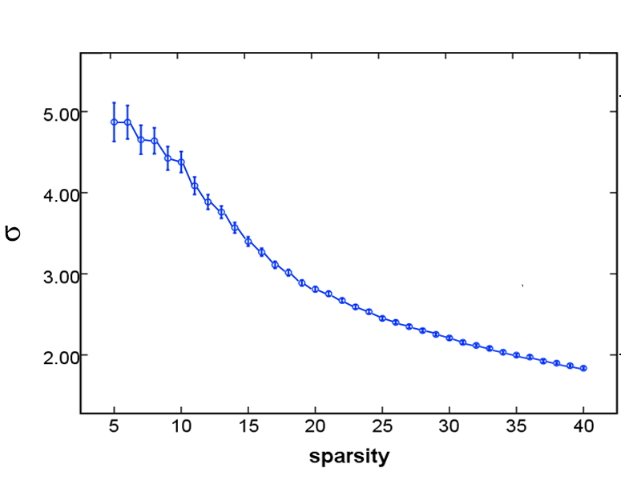
Abbreviations: σ represents small-wordness. The sparsity was computed over the range of 0.05 ≤ T ≤ 0.40 (interval=0.01).
References
1. Freeman, L.C., A set of measures of centrality based on betweenness. Sociometry, 1977. 40(1): p. 35-41.
2. Mp, V.D.H., C.J. Stam, R.S. Kahn, and H.E. Hulshoff Pol, Efficiency of functional brain networks and intellectual performance. Journal of Neuroscience, 2009. 29(23): p. 7619-7624.
3. Wang, J., X. Zuo, and Y. He, Graph-Based Network Analysis of Resting-State Functional MRI. Frontiers in Systems Neuroscience, 2010. 4(16): p. 16.

