Table S1. Adverse Event (AE) | Dose-Limiting Toxicity Definition
Any AE | Any Grade 5 toxicity attributed to study treatment
Hematologic | Any Grade 4 neutropenia lasting more than 7 days
 | Febrile neutropenia
 | Grade 4 thrombocytopenia
Nervous system disorders | Any Grade ischemia cerobrovascular
 | Any Grade stroke
 | Any Grade transient ischemic attack
Other non-hematologic | Any non-hematological AEs grade 3 or greater lasting for 14 or more days
 | Any non-hematologic laboratory criteria which is Grade > 3 and lasting ≥ 14 days that is of clinical significance (e.g. elevated lipase only qualifies as DLT if it is in the presence of clinical pancreatits)

Table S2. Demographics and Baseline Characteristics of Hepatocellular Carcinoma patients (N =12)
 | 0  [Sor 200/Evo 240]  (N=4) | 1  [Sor 200/Evo 480]  (N=2) | +1a  [Sor 200/Evo 340]  (N=6) |  | Total  (N=12) |  | p value
Age (years) |  |  |  |  |  |  | 0.3560¹
N | 4 | 2 | 6 |  | 12
Mean (SD) | 72.3 (7.4) | 63.0 (4.2) | 67.8 (10.4) |  | 68.5 (8.8)
Median | 73.0 | 63.0 | 64.0 |  | 66.0
Range | (63.0-80.0) | (60.0-66.0) | (59.0-86.0) |  | (59.0-86.0)
Gender |  |  |  |  |  |  | 0.5000²
Female | 1 (25.0%) | 0 (0.0%) | 0 (0.0%) |  | 1 (8.3%)
Male | 3 (75.0%) | 2 (100.0%) | 6 (100.0%) |  | 11 (91.7%)
Race |  |  |  |  |  |  | 0.4091²
White | 2 (50.0%) | 2 (100.0%) | 6 (100.0%) |  | 10 (83.3%)
Black or African American | 1 (25.0%) | 0 (0.0%) | 0 (0.0%) |  | 1 (8.3%)
Native Hawaiian or Other Pacific Islander | 1 (25.0%) | 0 (0.0%) | 0 (0.0%) |  | 1 (8.3%)
ECOG PS |  |  |  |  |  |  | 1.0000²
0 | 0 (0.0%) | 0 (0.0%) | 1 (16.7%) |  | 1 (8.3%)
1 | 4 (100.0%) | 2 (100.0%) | 5 (83.3%) |  | 11 (91.7%)
Child Pugh Score |  |  |  |  |  |  | 0.4285¹
Mean (SD) | 6.5 (0.6) | 6.0 (1.4) | 5.8 (0.8) |  | 6.1 (0.8)
Median | 6.5 | 6.0 | 6.0 |  | 6.0
Range | (6.0-7.0) | (5.0-7.0) | (5.0-7.0) |  | (5.0-7.0)
Child Pugh Classification |  |  |  |  |  |  | 0.4141²
A | 2 (50.0%) | 1 (50.0%) | 5 (83.3%) |  | 8 (66.7%)
B | 2 (50.0%) | 1 (50.0%) | 1 (16.7%) |  | 4 (33.3%)
Bilirubin |  |  |  |  |  |  | 0.7212¹
Mean (SD) | 1.3 (0.9) | 0.8 (0.0) | 0.8 (0.5) |  | 1.0 (0.6)
Median | 1.0 | 0.8 | 0.8 |  | 0.8
Range | (0.6-2.5) | (0.8-0.8) | (0.2-1.5) |  | (0.2-2.5)
Albumin |  |  |  |  |  |  | 0.8817¹
Mean (SD) | 3.6 (0.4) | 3.3 (0.8) | 3.6 (0.2) |  | 3.5 (0.4)
Median | 3.7 | 3.3 | 3.6 |  | 3.6
Range | (3.0-3.8) | (2.7-3.8) | (3.2-3.8) |  | (2.7-3.8)
AFP |  |  |  |  |  |  | 0.7403²
<= 400 ng/ml | 1 (25.0%) | 1 (50.0%) | 4 (66.7%) |  | 6 (50.0%)
> 400 ng/ml | 3 (75.0%) | 1 (50.0%) | 2 (33.3%) |  | 6 (50.0%)
Disease Status |  |  |  |  |  |  | 1.0000²
Intrahepatic | 2 (50.0%) | 1 (50.0%) | 2 (33.3%) |  | 5 (41.7%)
Extrahepatic | 2 (50.0%) | 1 (50.0%) | 4 (66.7%) |  | 7 (58.3%)
Vascular Invasion |  |  |  |  |  |  | 0.4192²
Yes | 3 (75.0%) | 0 (0.0%) | 2 (33.3%) |  | 5 (41.7%)
No | 1 (25.0%) | 2 (100.0%) | 4 (66.7%) |  | 7 (58.3%)
History of Cirrhosis |  |  |  |  |  |  | 1.0000²
Yes | 3 (75.0%) | 2 (100.0%) | 5 (83.3%) |  | 10 (83.3%)
No | 1 (25.0%) | 0 (0.0%) | 1 (16.7%) |  | 2 (16.7%)
Hepatitis B |  |  |  |  |  |  | 0.1879²
Yes | 1 (25.0%) | 2 (100.0%) | 1 (16.7%) |  | 4 (33.3%)
No | 3 (75.0%) | 0 (0.0%) | 5 (83.3%) |  | 8 (66.7%)
Hepatitis C |  |  |  |  |  |  | 0.1313²
Yes | 2 (50.0%) | 0 (0.0%) | 5 (83.3%) |  | 7 (58.3%)
No | 2 (50.0%) | 2 (100.0%) | 1 (16.7%) |  | 5 (41.7%)
Alcohol Related |  |  |  |  |  |  | 0.5758²
Yes | 1 (25.0%) | 0 (0.0%) | 3 (50.0%) |  | 4 (33.3%)
No | 3 (75.0%) | 2 (100.0%) | 3 (50.0%) |  | 8 (66.7%)
NASH
No | 4 (100.0%) | 2 (100.0%) | 6 (100.0%) |  | 12 (100.0%)
Other Etiology
No | 4 (100.0%) | 2 (100.0%) | 6 (100.0%) |  | 12 (100.0%)
Prior Chemoembolization |  |  |  |  |  |  | 0.3455²
Yes | 0 (0.0%) | 1 (50.0%) | 2 (33.3%) |  | 3 (25.0%)
No | 4 (100.0%) | 1 (50.0%) | 4 (66.7%) |  | 9 (75.0%)
Previous Tumor Directed Therapy |  |  |  |  |  |  | 0.2687²
Yes | 0 (0.0%) | 1 (50.0%) | 3 (50.0%) |  | 4 (33.3%)
No | 4 (100.0%) | 1 (50.0%) | 3 (50.0%) |  | 8 (66.7%)
¹Kruskal Wallis ²Fisher Exact
Sor, sorafenib; Evo, evofosfamide; ECOG PS, Eastern Cooperative Oncology Group Performance Status; AFP; alphafeto protein; NASH, Non-alcoholic steatohepatitis

Table S3. Best Response by RECIST 1.1 | Dose Level 0  (N=6 Evaluable) | Dose Level 1 (N=5 evaluable) | Dose Level +1a (N=7 evaluable)
Best Response  PR  SD  PD  Not assessed | 1**  5  0  0 | 0  1  2  2* | 1  2  1  3*
Confirmed Response Rate | 0/6 (0%) | 0/5 (0%) | 1/7 (14%) – (PR)
* Tumor was not assessed due to early discontinuation of trial.
**Unconfirmed
PR, partial response; SD, stable disease; PD, progressive disease

Figure S1. Progresion-Free Survival All Patients*
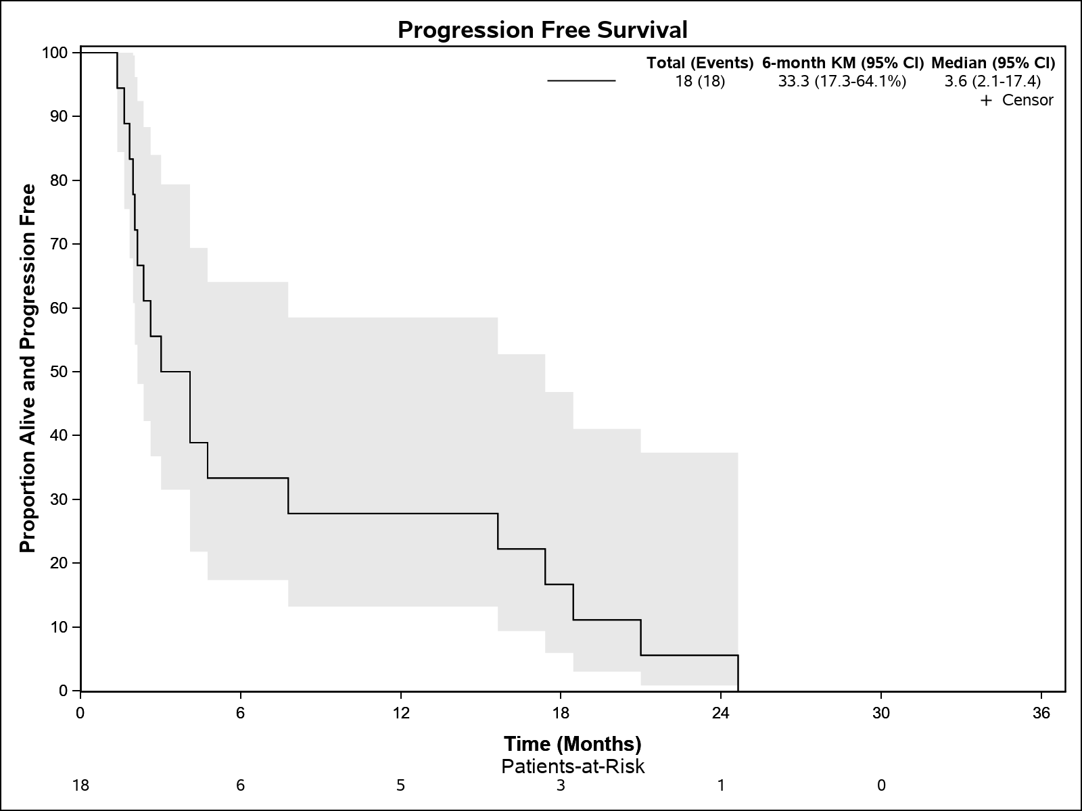
*Kaplan-Meier analysis was performed

Figure S2. Overall Survival All Patients*
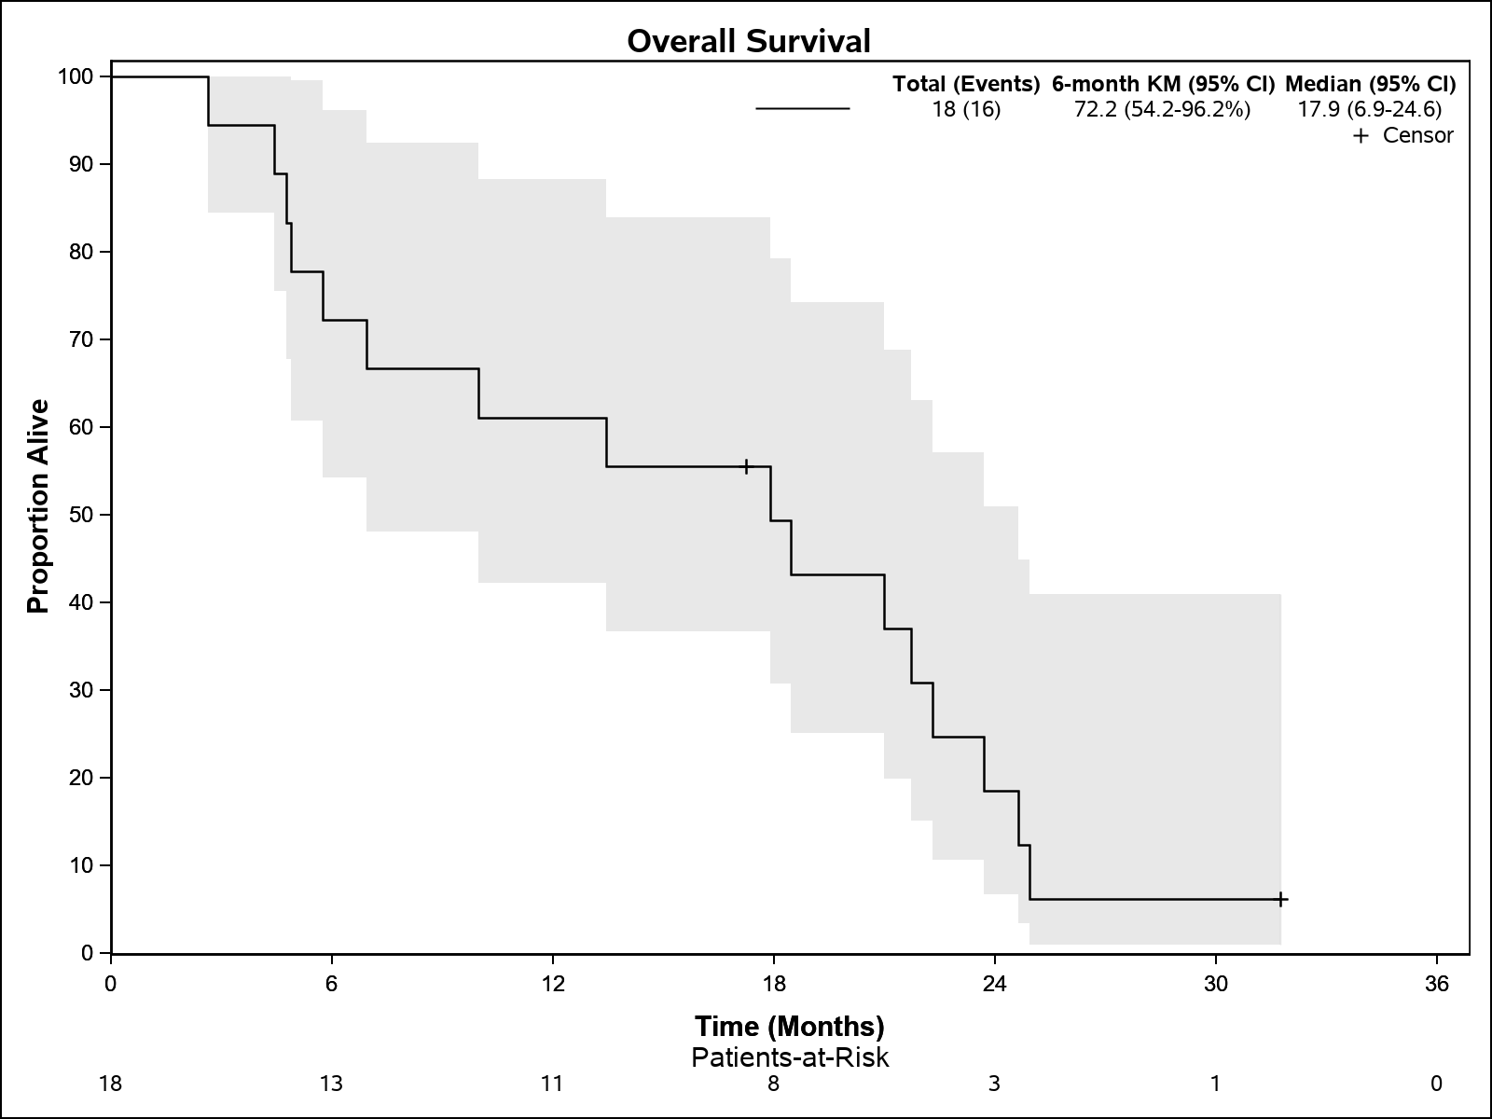
*Kaplan-Meier analysis was performed

Figure S3. Progression-Free Survival HCC patients*
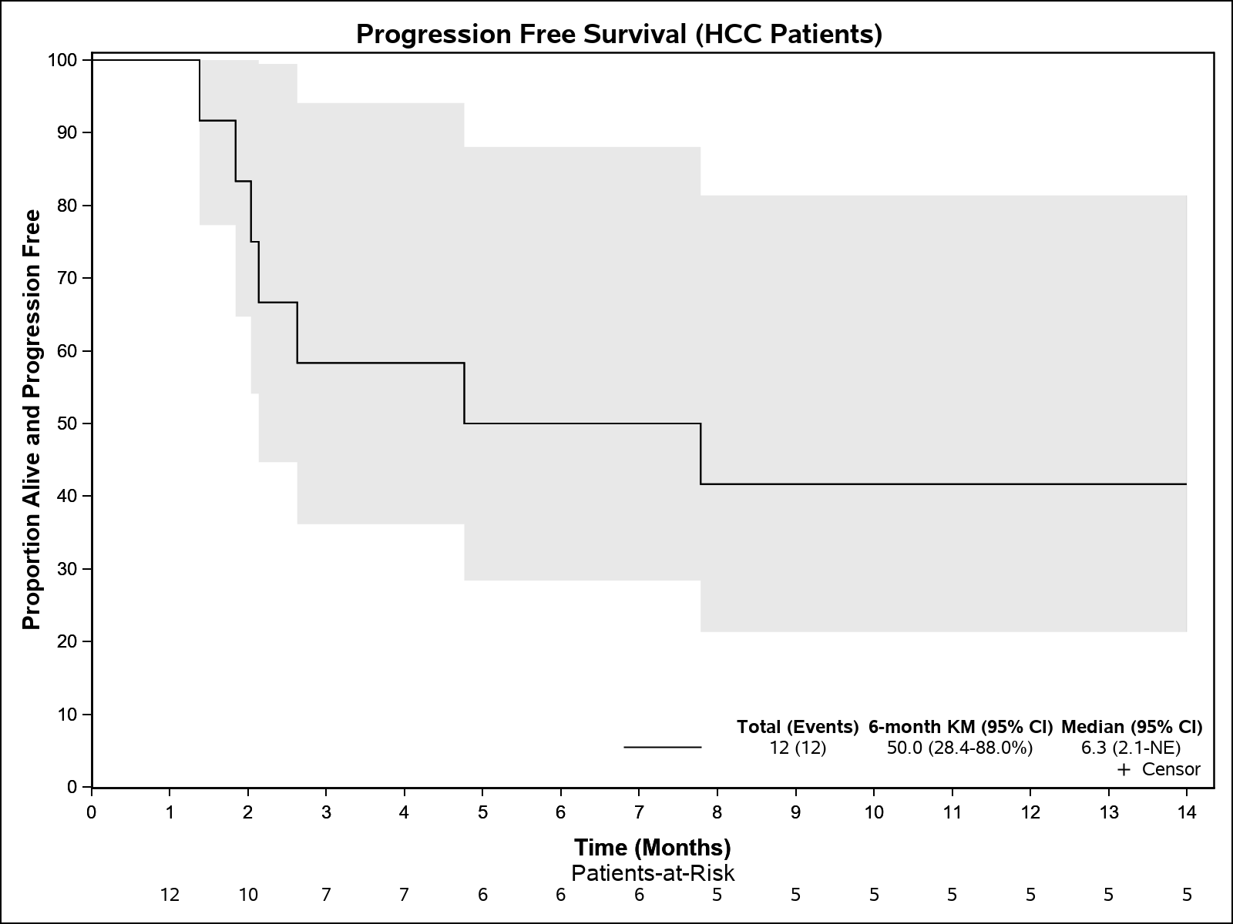

*Kaplan-Meier analysis was performed

Figure S4. Overall Survival HCC patients*
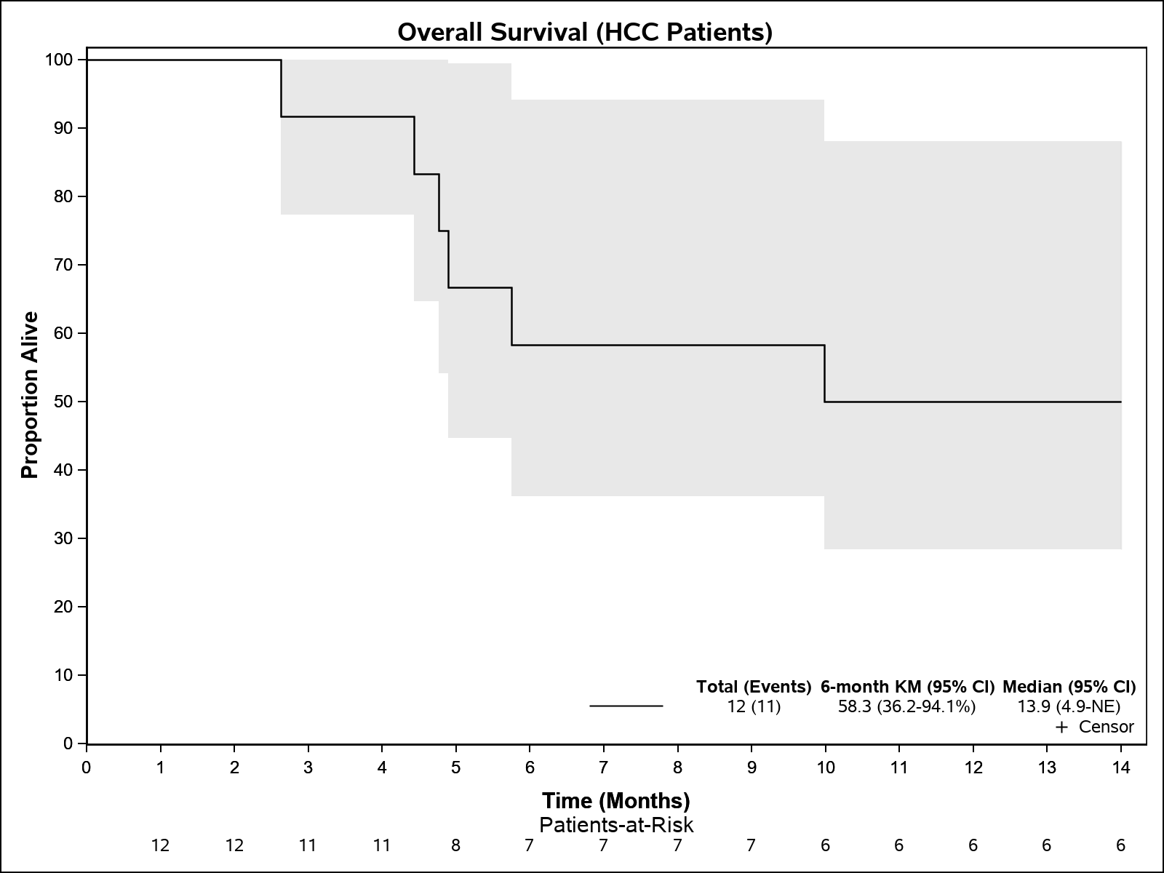
*Kaplan-Meier analysis was performed

