Supplementary materials

Evaluating the effect of COVID-19 on dispensing patterns: a national cohort analysis
Authorship list
Fatemeh Torabi*: Population Data Science and Health Data Research UK, Swansea University
Ashley Akbari*: Population Data Science and Health Data Research UK, Swansea University
Laura North: Population Data Science and Health Data Research UK, Swansea University
Daniel Harris: Population Data Science and Health Data Research UK, Swansea University
Gareth Davies: Population Data Science and Health Data Research UK, Swansea University
Mike Gravenor: Swansea University
Rowena Griffiths: Population Data Science and Health Data Research UK, Swansea University
Jane Lyons: Population Data Science and Health Data Research UK, Swansea University
Neil Jenkins: NHS Wales Shared Services Partnership
Andrew Morris: Swansea University
Julian Halcox: Population Data Science and Health Data Research UK, Swansea University
Ronan A. Lyons: Population Data Science and Health Data Research UK, Swansea University

* Lead Author(s)

Supplementary information
Supplementary Figure 1
1. a: Mapping of DM+D codes from WDDS to BNF codes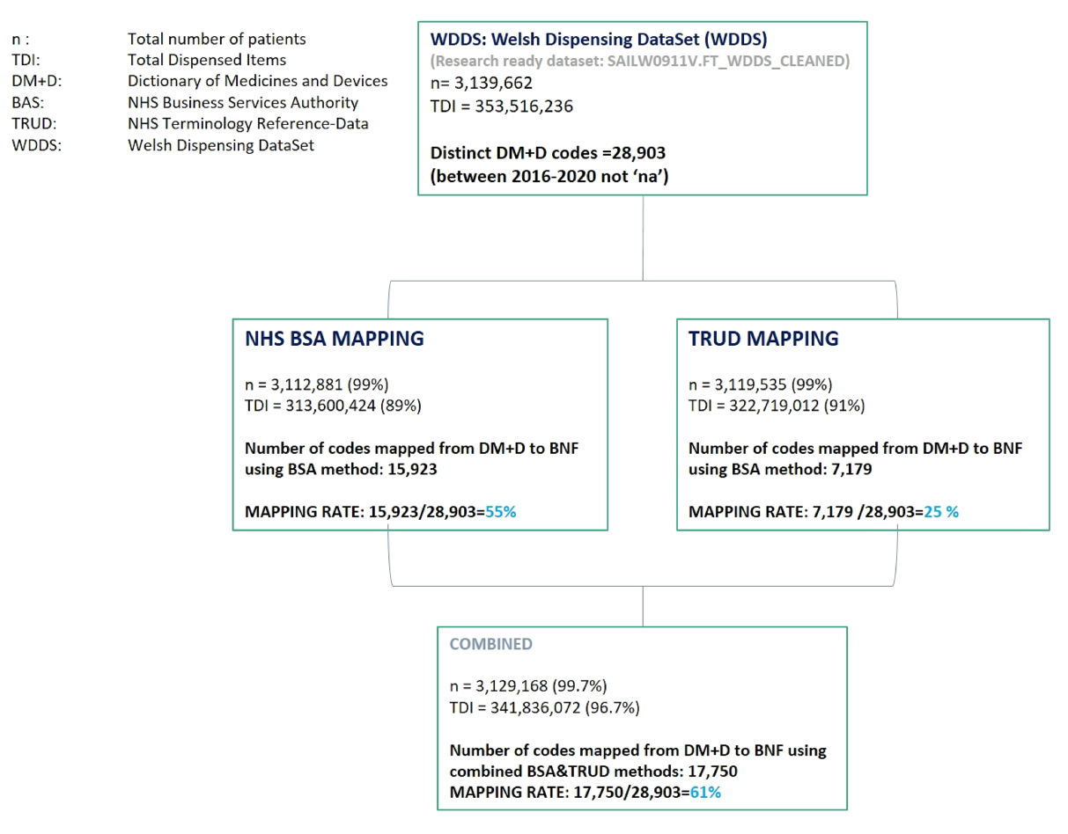
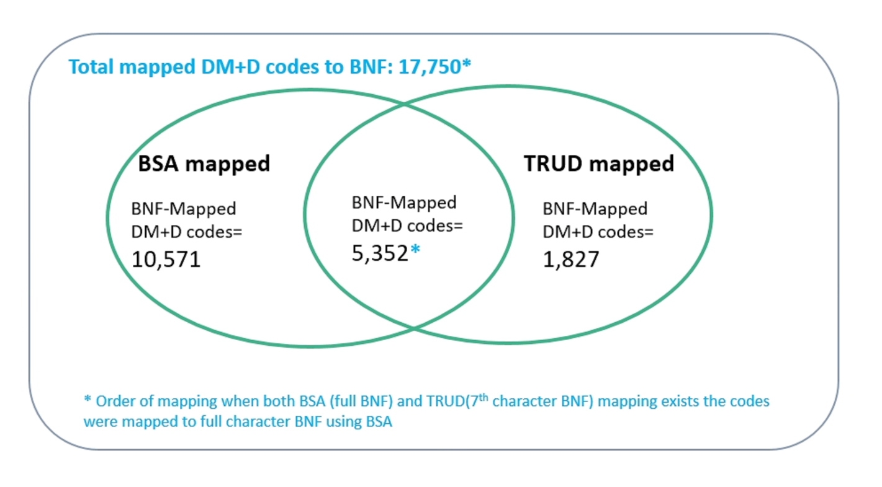

1.b: Number of dispensed items for individuals residing in Wales and linked to WDDS
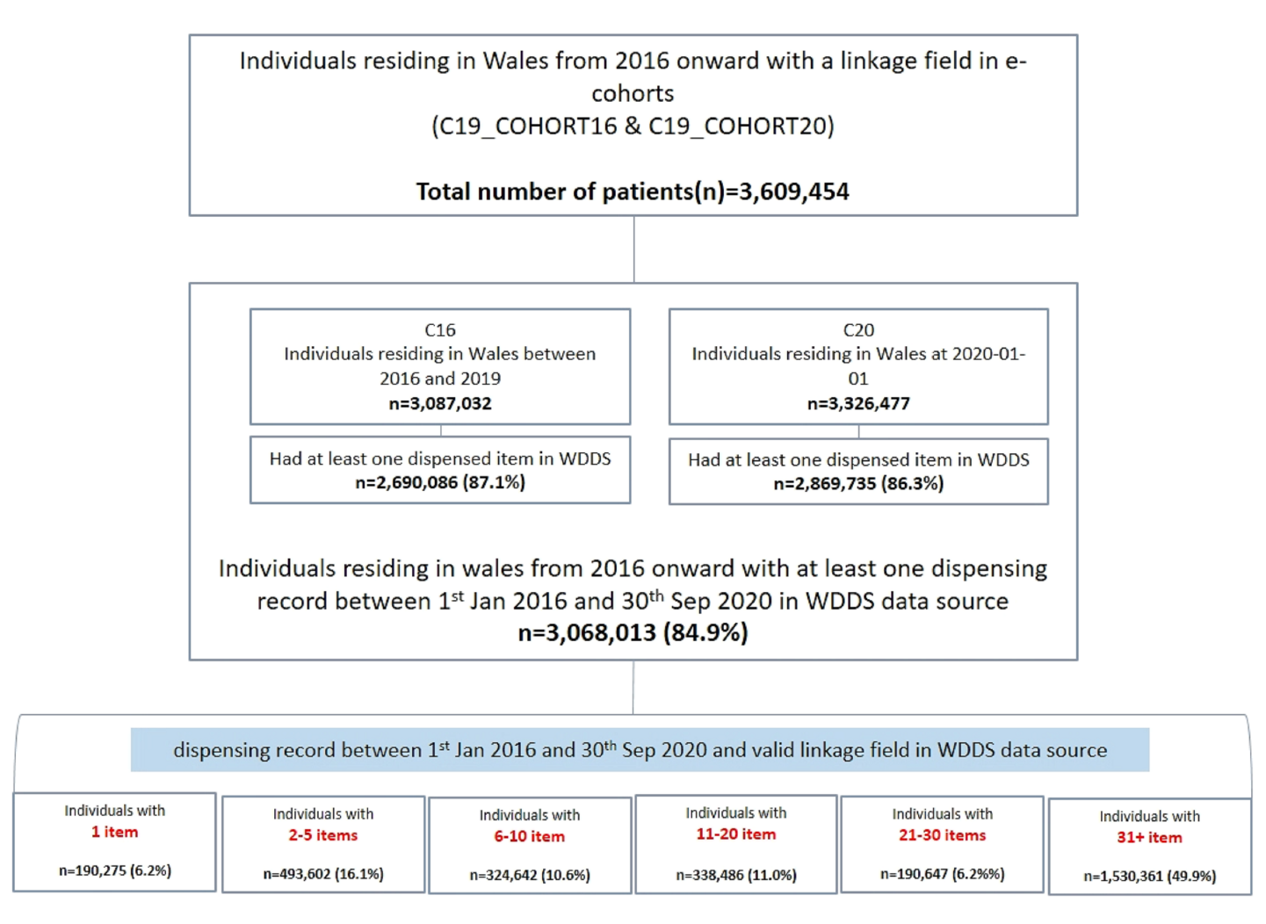

List of abbreviations
Full term | Abbreviation
D | Difference
RC | Relative Change
WDDS | Welsh Dispensing DataSet
C16 | Electronic cohort for period of 2016-2019 (3)
C20 | Electronic cohort for 2020
WDDS | Welsh Dispensing DataSet
CVS | Cardiovascular Systems
CNS | Central Nervous Systems
IVP | Immunological Products and Vaccines
NHS TRUD | Terminology Reference-Data Update Distribution
NHS BSA | NHS Business Services Authority
TDI | Total Dispensed Items
DM+D | Dictionary of medicines and devices
BNF | British National Formulary
Pop’n | Population

Supplementary Figure 2.1- Number of dispensed items per BNF chapter-2020 vs 2019 harmonized scale

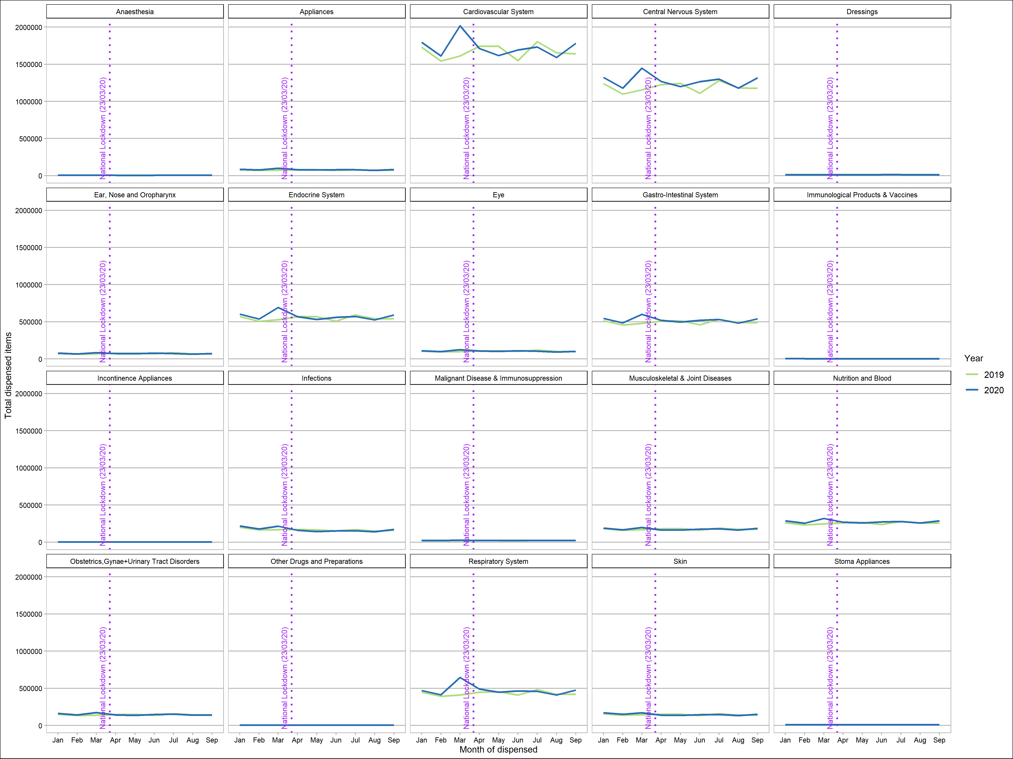

Supplementary Figure 2.2- Number of dispensed items per BNF chapter per month –in all years (numbers of each chapter are individually scaled)

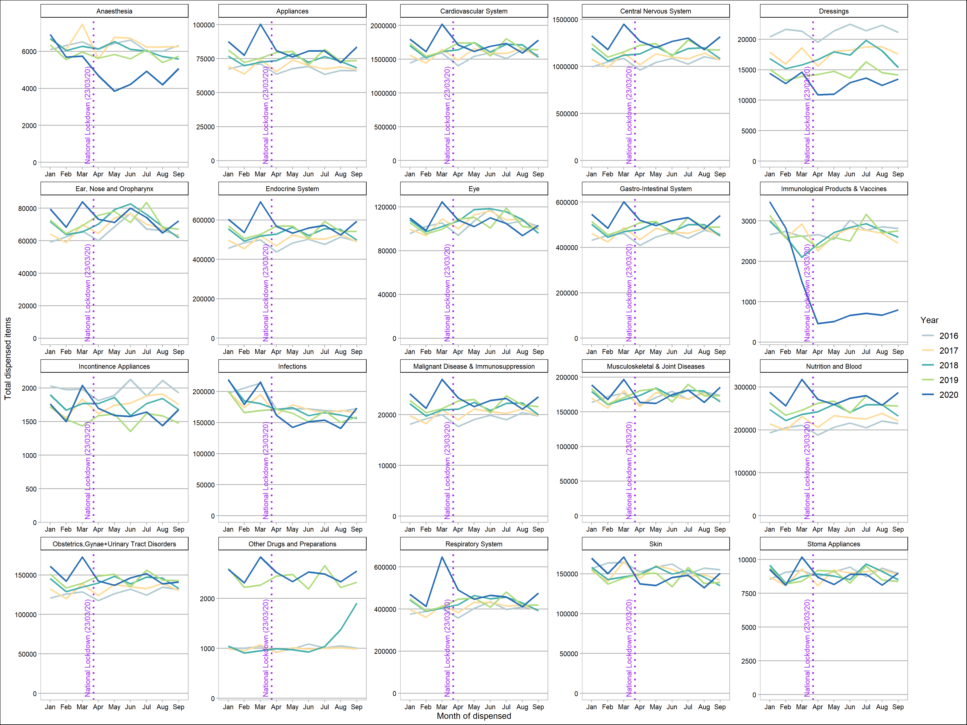

Supplementary Figure 2.3- Number of dispensed items per BNF chapter per month –in all years - harmonized scale
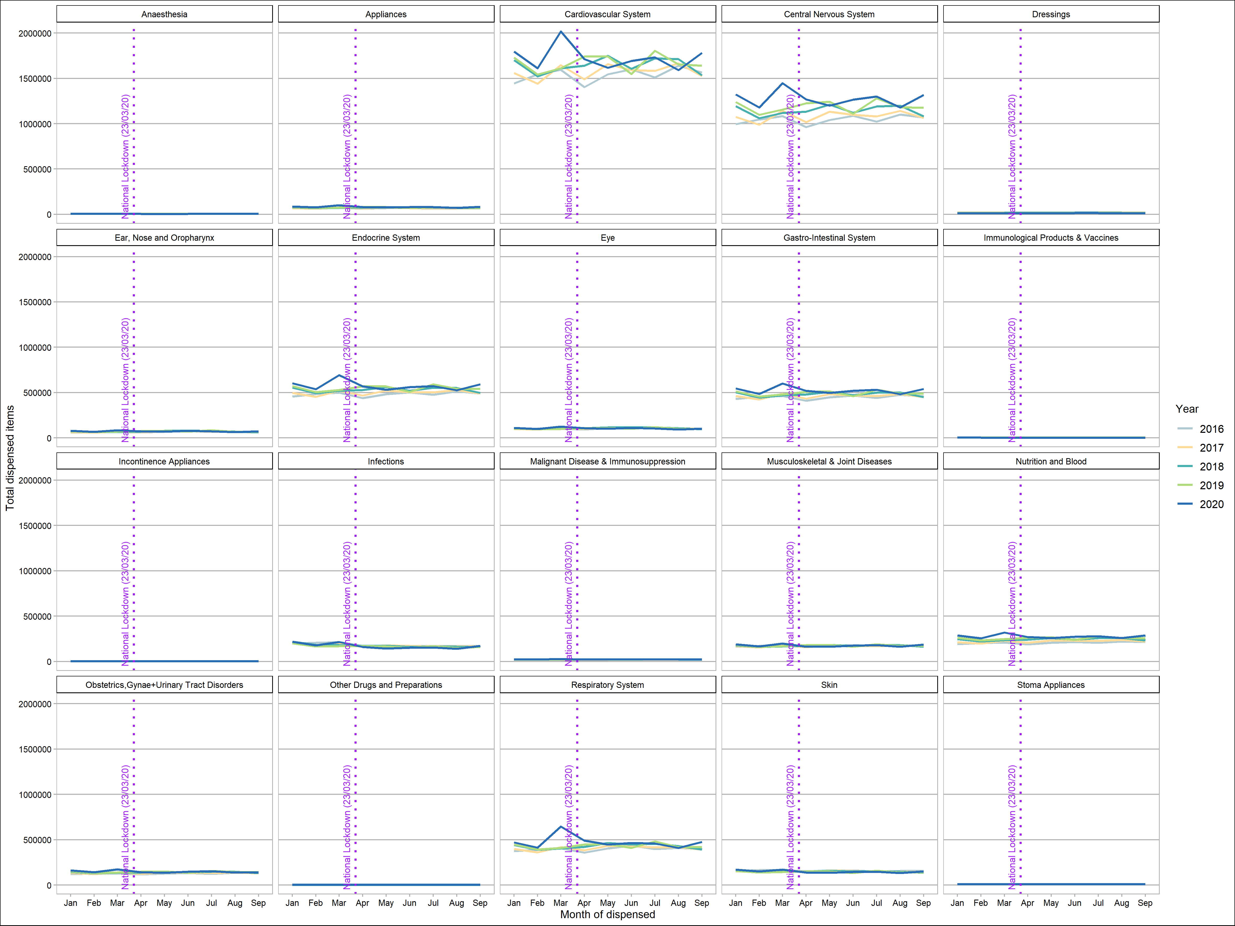
Supplementary Figure 3.1- Age-standardized dispensing rates for cardiovascular system in per 100,000 pop’n per year and month 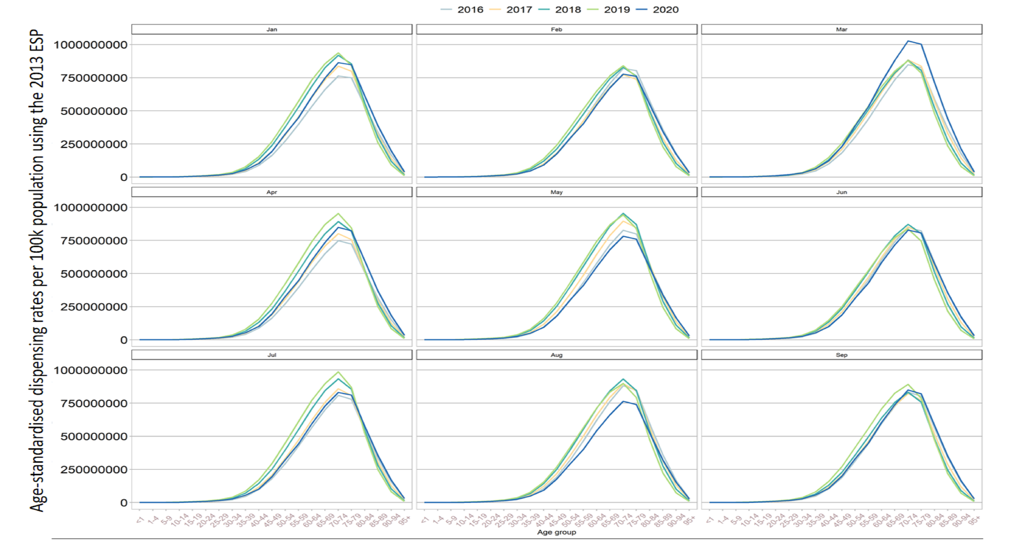
Supplementary Figure 3.2- Age-standardized dispensing rates for Central Nervous System in per 100,000 pop’n per year and month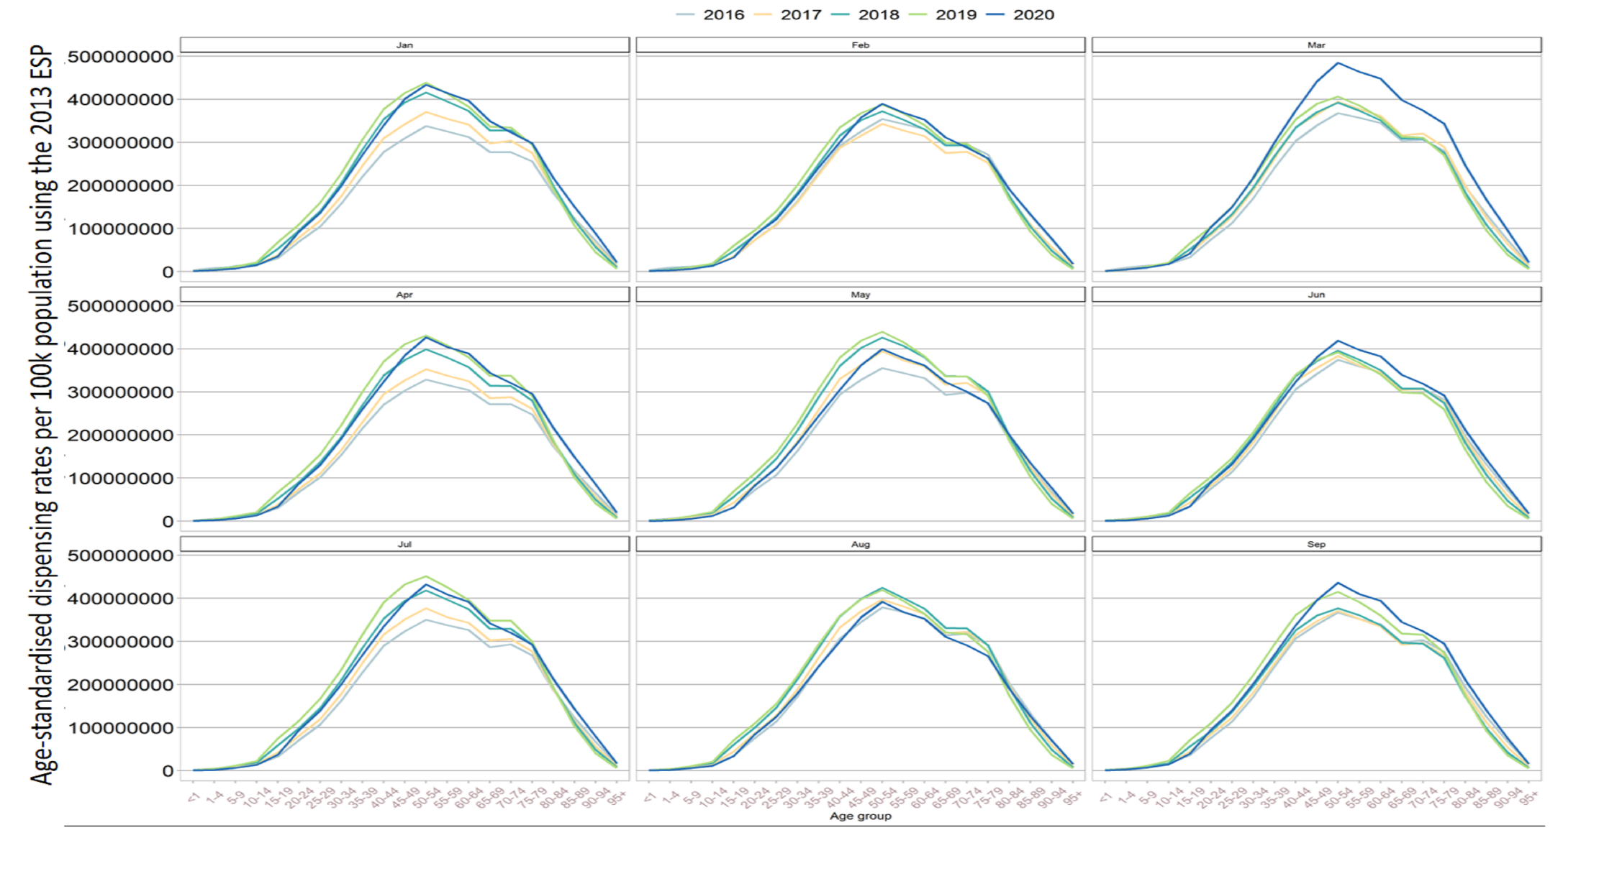
Supplementary Figure3.3- Age-standardized dispensing rates for Immunological Products & Vaccines in per 100,000 pop’n per year and month
