Liquid metal-tailored gluten network for protein-based e-skin
Bin Chen^{1,4#}, Yudong Cao^{1,4#}, Zhuo Yan², Rui Liu³, Yunjiao Zhao³, Xiang Zhang⁵, Minying Wu⁴, Yixiu Qin², Chang Sun², Wei Yao¹, Ziyi Cao^{1,4}, Pulickel M. Ajayan⁵, Mason Oliver Lam Chee ⁶, Pei Dong⁶, Zhaofen Li⁷, Jianfeng Shen^{1*}, Mingxin Ye^{1*}
¹ Institute of Special Materials and Technology, Fudan University, Shanghai, China
² State Key Laboratory of Molecular Engineering of Polymers, Department of Macromolecular Science, Fudan University, Shanghai, China
³ State Key Laboratory of Food Nutrition and Safety, Tianjin University of Science & Technology, Tianjin, China
⁴ Department of Chemistry, Fudan University, Shanghai, China
⁵ Department of Materials Science and NanoEngineering, Rice University, Houston, TX, USA
⁶ Department of Mechanical Engineering, George Mason University, VA, USA
⁷ RENISHAW (SHANGHAI) TRADING CO.LTD, SPD, Shanghai, China
# These authors contribute equally

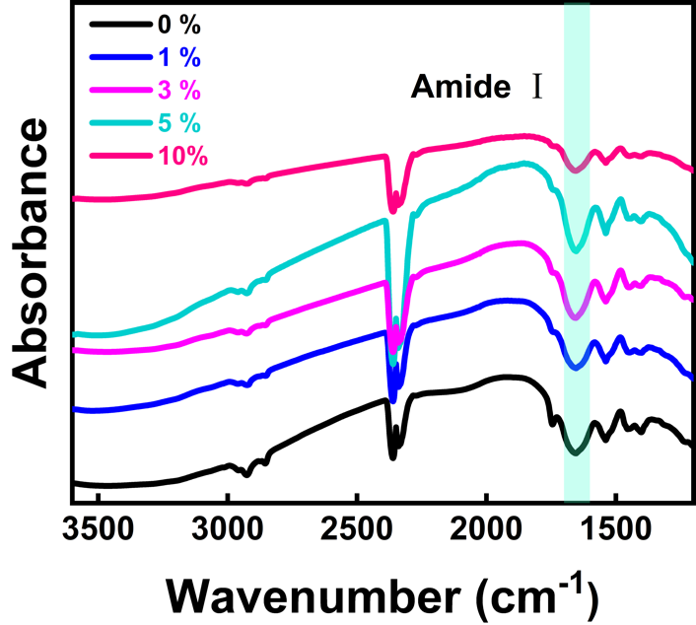
Supplementary Figure 1. Fourier transform infrared spectroscopy (FTIR) of different E-GES samples. The information of the gluten backbone conformation can be obtained through the analysis of the Amide I bands (1700-1600 cm⁻¹).

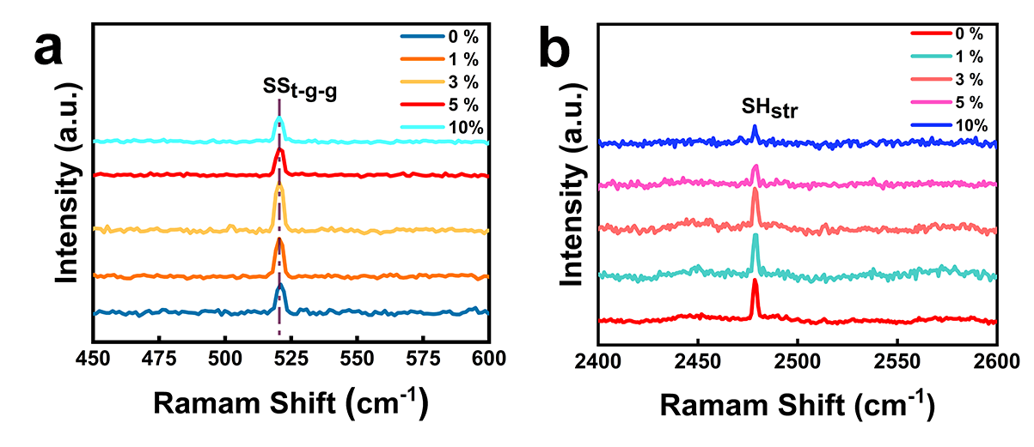
Supplementary Figure 2. Raman spectra of different E-GES samples. The peaks at around 521 cm⁻¹ and 2478 cm⁻¹ represent the trans-gauche-gauche conformation of S-S (a) and the -SH stretching mode (b) respectively.^{1, 2} These results confirm the presence of S-S and -SH groups in E-GES.

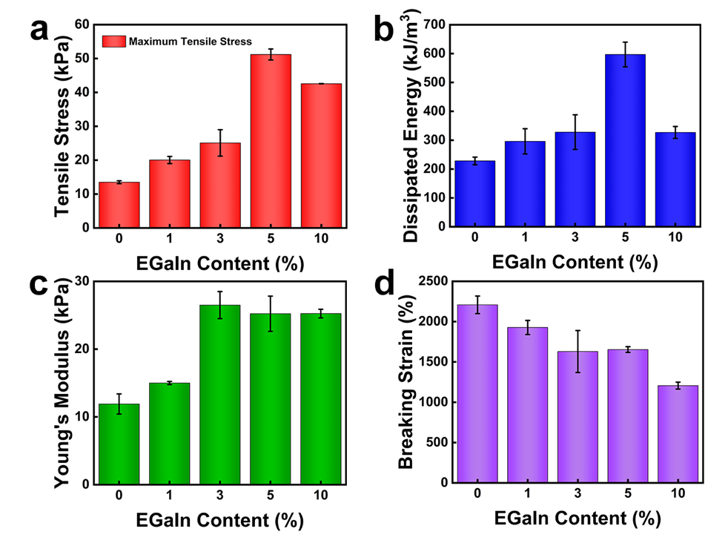
Supplementary Figure 3. Mechanical properties of different E-GES samples. a, The maximum tensile stress (a), dissipated energy (b), Young’s modulus (c) and breaking strain (d) of different E-GES samples. It is clear that with the increase in EGaIn content, the maximum tensile stress, dissipated energy and Young’s modulus increase, while the breaking strain decreases. In higher EGaIn content, EGaIn particles aggregation may appear inside the E-GES network, thus forming defects and causing the decreasing performances in the tensile tests.

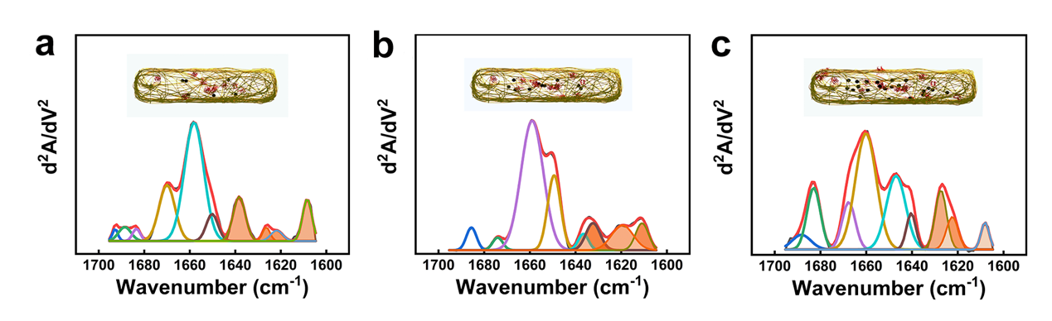
Supplementary Figure 4. Secondary structure analysis of different E-GES samples. The calculated secondary structure results of the 1% (a), 3% (b) and 10% (c) E-GES samples from the analysis of the amide I band in their FTIR spectra respectively. Insets, schematic illustrations of the content of β-sheet and EGaIn in the E-GES network. The increase in EGaIn induce the changes of the gluten backbone conformation and obtain more β-sheets.

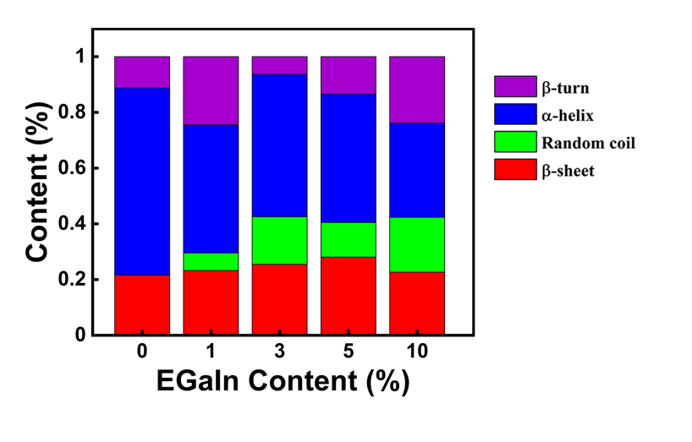
Supplementary Figure 5. Secondary structure content analysis of different E-GES samples. It has been reported that the peaks at 1650-1658 cm⁻¹, 1610-1640 cm⁻¹, 1660-1700 cm⁻¹, and 1640-1650 cm⁻¹ are attributed to α-helices, β -sheets, β -turns, and random coil, respectively.³ Therefore, the content of different secondary structures can be calculated from the results shown in Supplementary Figure 4. The calculated results are consistent with the proposed Schematic drawings shown above.

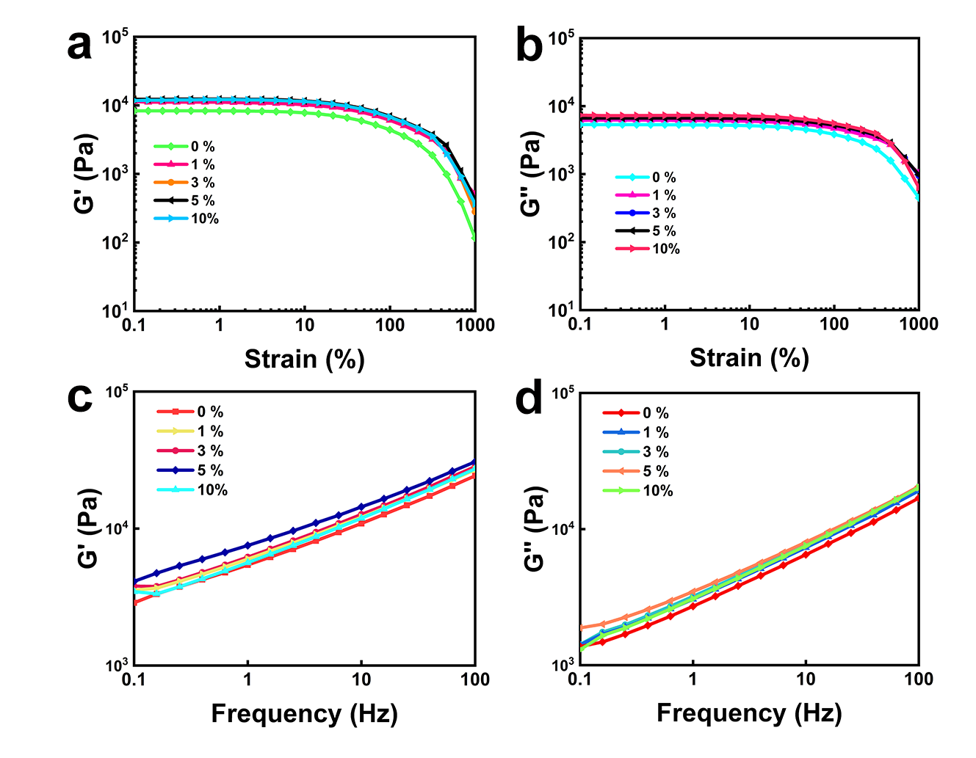
Supplementary Figure 6. The rheological Characterization. The linear viscoelastic region was obtained by the oscillation measurement with strain values changing from 0.1 % to 1000 % at a constant frequency of 1 Hz (a and b), and then the frequency sweeps were carried out in a frequency range of 0.1 Hz to 100 Hz at a fixed strain of 0.5 % (c and d). Under the same test conditions, the storage modulus (G′) greater and the loss modulus (G″) of 5% E-GES are the highest, meaning that the optimal content of EGaIn is 5%, consistent with the result in tensile tests.

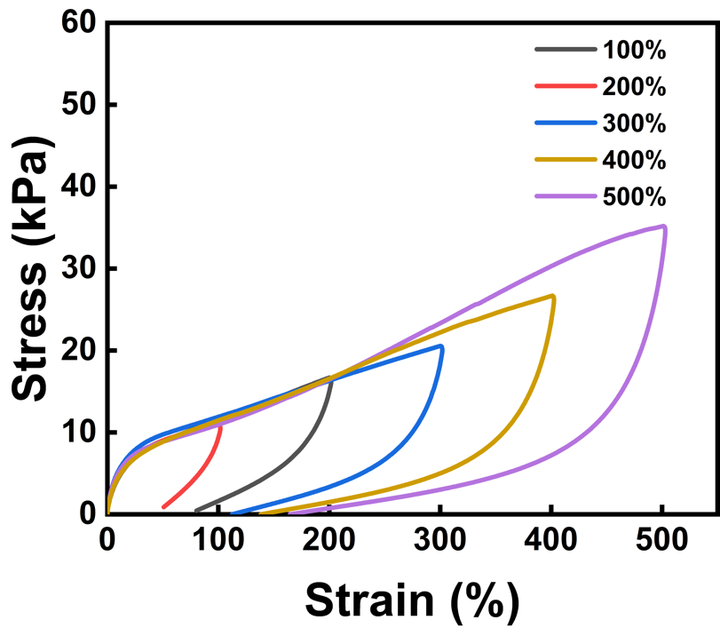
Supplementary Figure 7. The loading-unloading cycle tests of 5% E-GES with varying maximum strains. The area of the stress-strain curves increases with the increase in the tensile strain, meaning that E-GES can dissipate more energies to withstand the strain change without breakage.

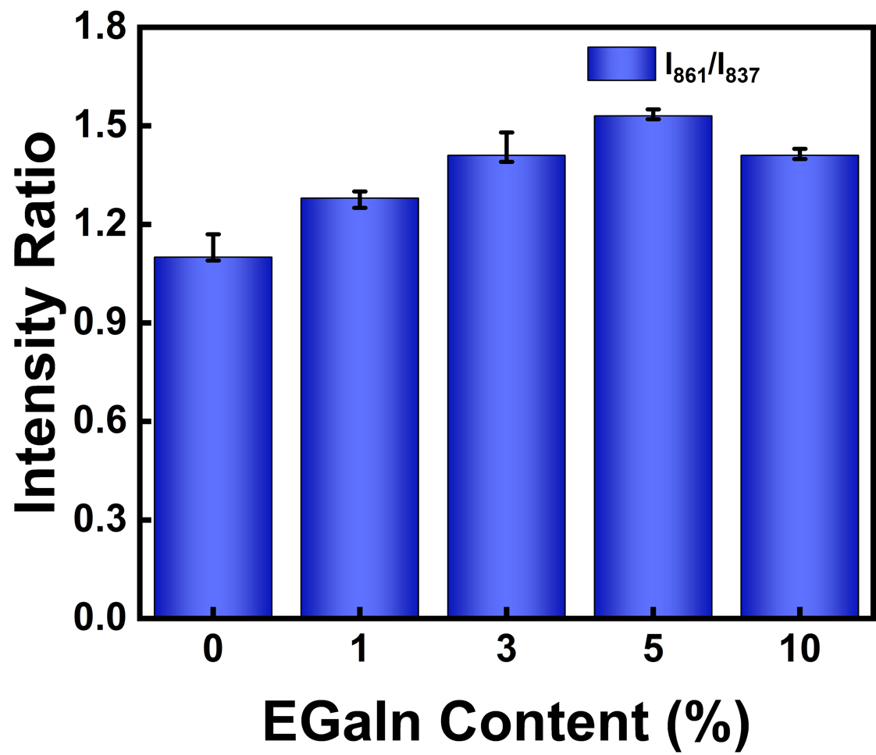
Supplementary Figure 8. The intensity ratio of tyrosine doublets. The higher values of the tyrosine doublet indicate strong hydrogen bonding in which the phenolic oxygen serves as a proton acceptor.²

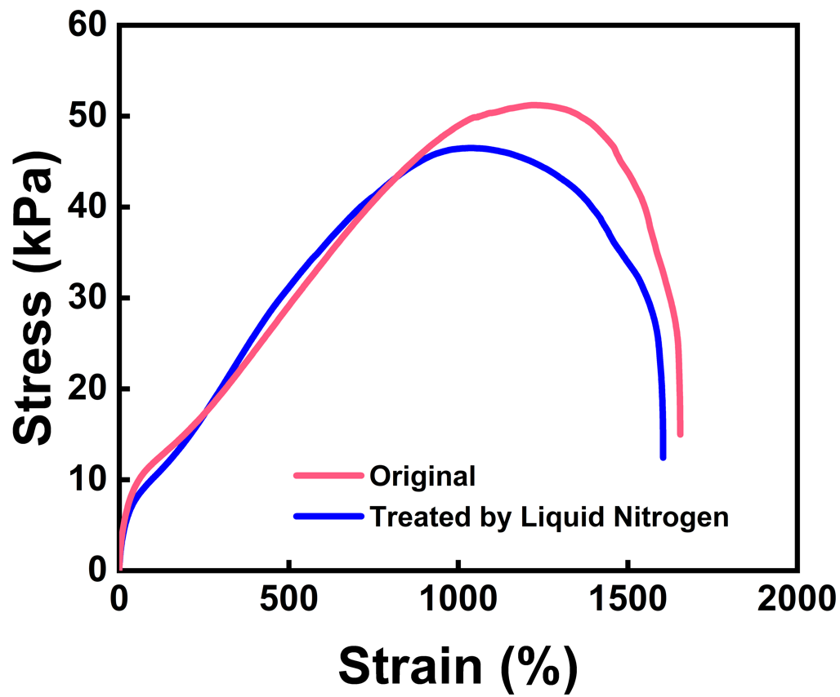
Supplementary Figure 9. Stress-strain curves of pristine (red) and freeze-and-thaw (blue) 5% E-GES. The E-GES was treated by liquid nitrogen firstly, and then naturally recovered to the room temperature. The ultra-low temperature cannot cause permanent damage to the E-GES network.

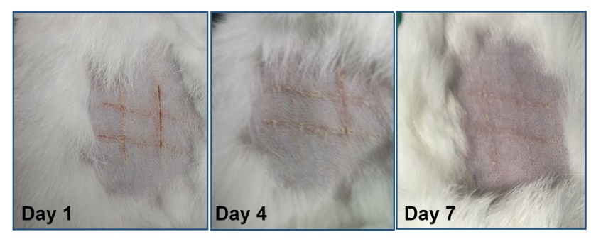
Supplementary Figure 10. Photographs of the recover situation of the skin with an artificial #-shaped wound. The wound without any treatments born new rabbit hair after 4 days, but it should be noted that this wound used as control was less serious than that used for E-GES attachment test.

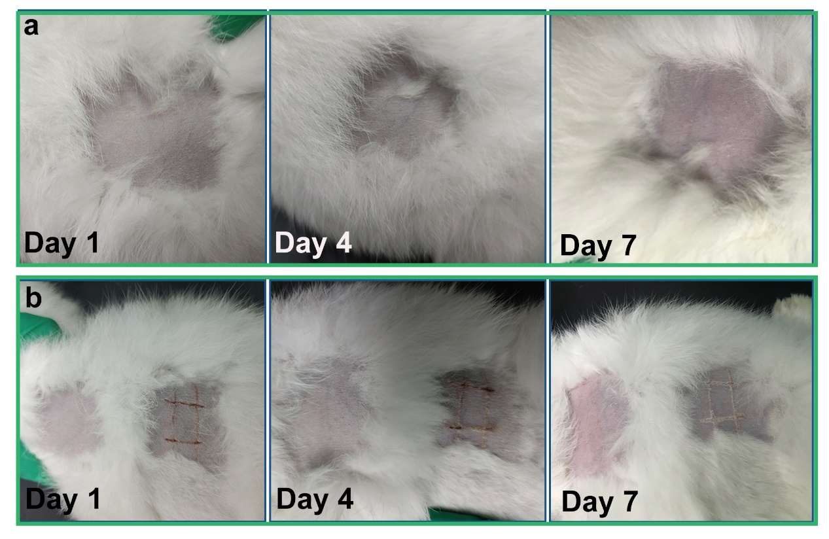
Supplementary Figure 11. Photographs of the skin treated by the artificial sweat that fully reacts with E-GES. The skin treated with artificial sweat shows no dropsy, no erythema, and no stimulus, and the recovery situation of the wound is similar to the wound shown in Supplementary Figure 10.

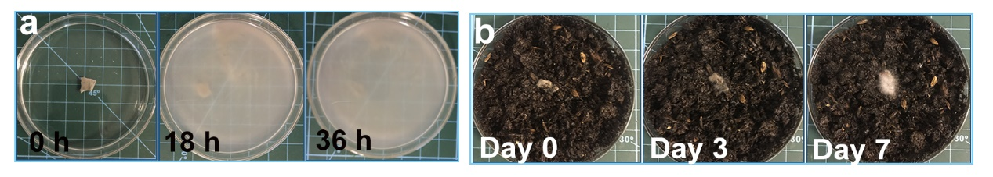
Supplementary Figure 12. Photographs of the degradation process of E-GES in the pepsin solution and the moist soil. The dynamic evolution of a piece of E-GES in the pepsin solution (a) and the moist soil (b).

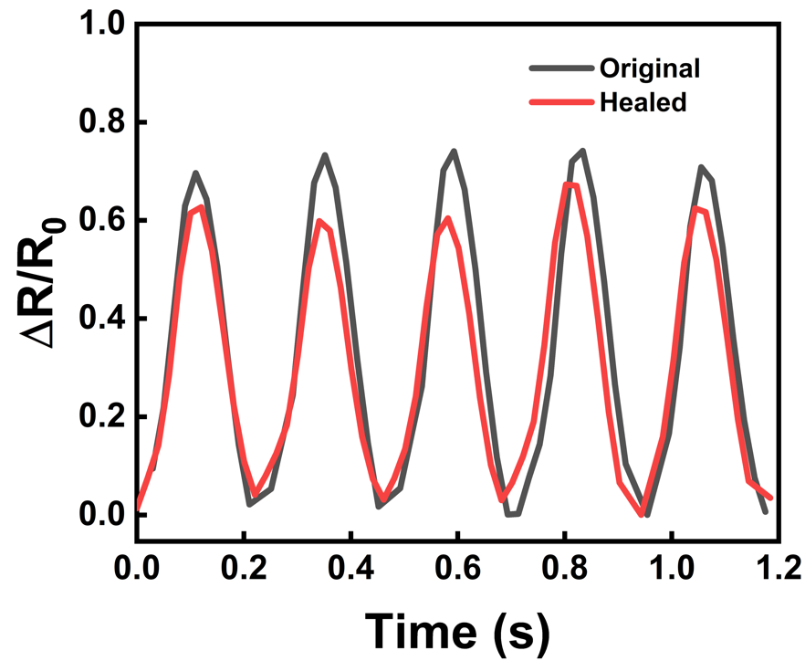
Supplementary Figure 13. Real-time resistance changes of the pristine E-GES (black) and the E-GES with a notch (red).

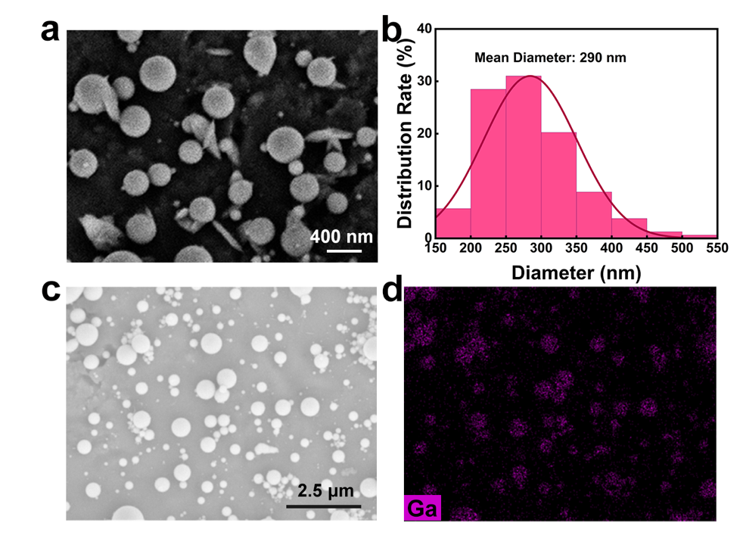
Supplementary Figure 14. SEM of the EGaIn-dispersed solution. a, c, SEM micrograph of EGaIn particles with different resolution. For the sample preparation, a EGaIn-dispersed solution was cast into a titanium sheet. b, The size distributions of EGaIn particles. The diameters were obtained by counting more than 200 particles in several SEM micrographs. d, The EDS mapping micrograph of Ga element in EGaIn particles.

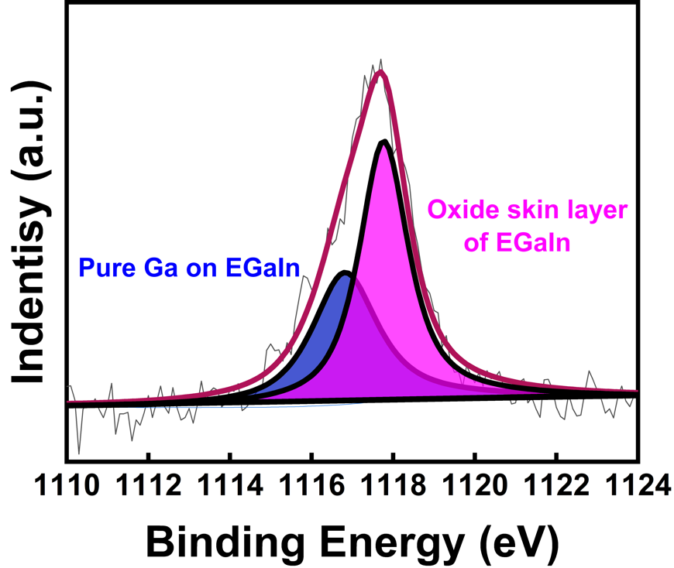
Supplementary Figure 15. XPS of 5% E-GES. The XPS result demonstrates the incorporation of EGaIn⁴.

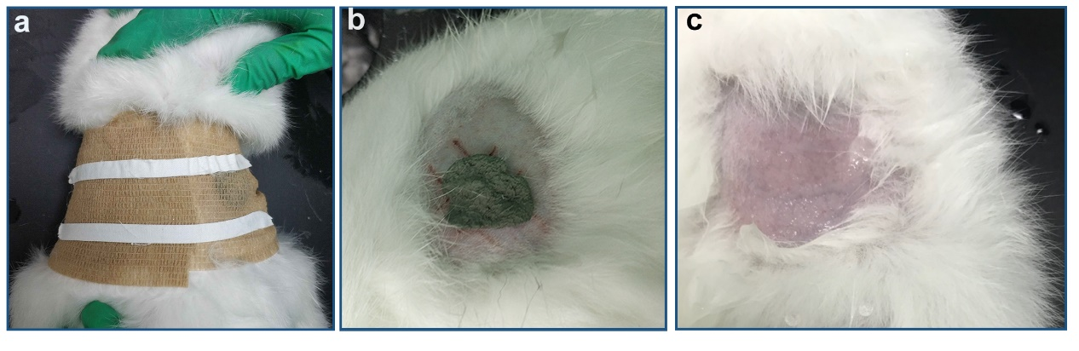
Supplementary Figure 16. Photographs of the on-skin biocompatibility experiments. In order to attach the E-GES on the rabbit skin, the bandage was used to fix the E-GES (a). b, E-GES on the skin. c, Artificial sweat on the skin.

Supplementary Table 1 The denaturation temperature of different E-GES samples
EGaIn Content (%) | Denaturation temperature (℃)
0 | 48.26
1 | 51.84
3 | 57.15
5 | 56.18
10 | 58.17

References
1. Bazylewski P, Divigalpitiya R, Fanchini G. In situ Raman spectroscopy distinguishes between reversible and irreversible thiol modifications in l-cysteine. RSC Adv. 7, 2964-2970 (2017).

2. Nawrocka A, Szymańska-Chargot M, Miś A, Wilczewska AZ, Markiewicz KH. Effect of dietary fibre polysaccharides on structure and thermal properties of gluten proteins – A study on gluten dough with application of FT-Raman spectroscopy, TGA and DSC. Food Hydrocolloids 69, 410-421 (2017).

3. Liu R, Shi C, Song Y, Wu T, Zhang M. Impact of oligomeric procyanidins on wheat gluten microstructure and physicochemical properties. Food Chem. 260, 37-43 (2018).

4. Yu Y, Miyako E. Manipulation of Biomolecule-Modified Liquid-Metal Blobs. Angew. Chem., Int. Ed. Engl. 56, 13606-13611 (2017).

