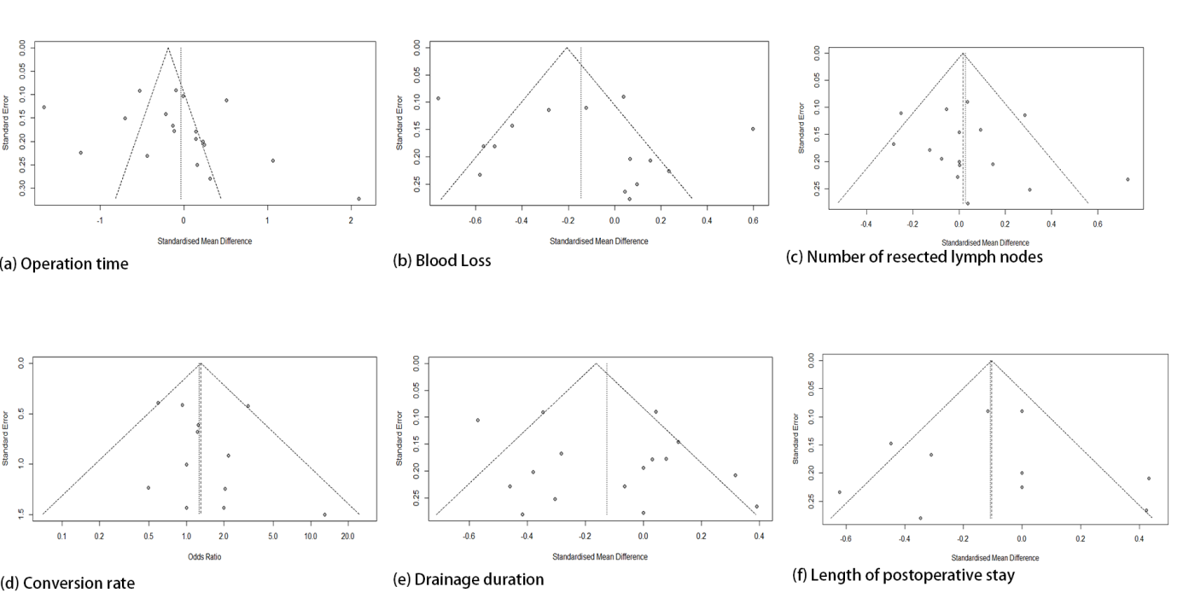
Comparative outcomes | Number of estimates | Begg's test (p) | Egger's test (p)
Operation time | 18 | 0.09 | 0.23
Blood loss | 14 | 0.59 | 0.37
Number of resceted lymph nodes | 15 | 0.13 | 0.42
Conversion rate | 13 | 0.22 | 0.44
Drainage duration | 18 | 0.72 | 0.37
Length of postoperative stay | 12 | 0.81 | 0.95

