Assessment of triboelectricity in colossal-surface-area-lanthanum oxide nanocrystals synthesized via low-temperature hydrothermal process
Sunil Meti¹, Hosangadi Prutvi Sagar², Mohammad Rizwanur Rahman¹, Udaya Bhat K.¹*
¹Department of Metallurgical and Materials Engineering, National Institute of Technology Karnataka, Surathkal, India - 575025
²Department of Metallurgical Engineering and Materials Science, Indian Institute of Technology Bombay, Powai, India - 400076.
*Corresponding author: Tel: +91-824-2473050, E-mail: udayabhatk@gmail.com

Supplementary information
Fig. S1. Schematic diagram of external load resistance connection to the La₂O₃ TENG device.
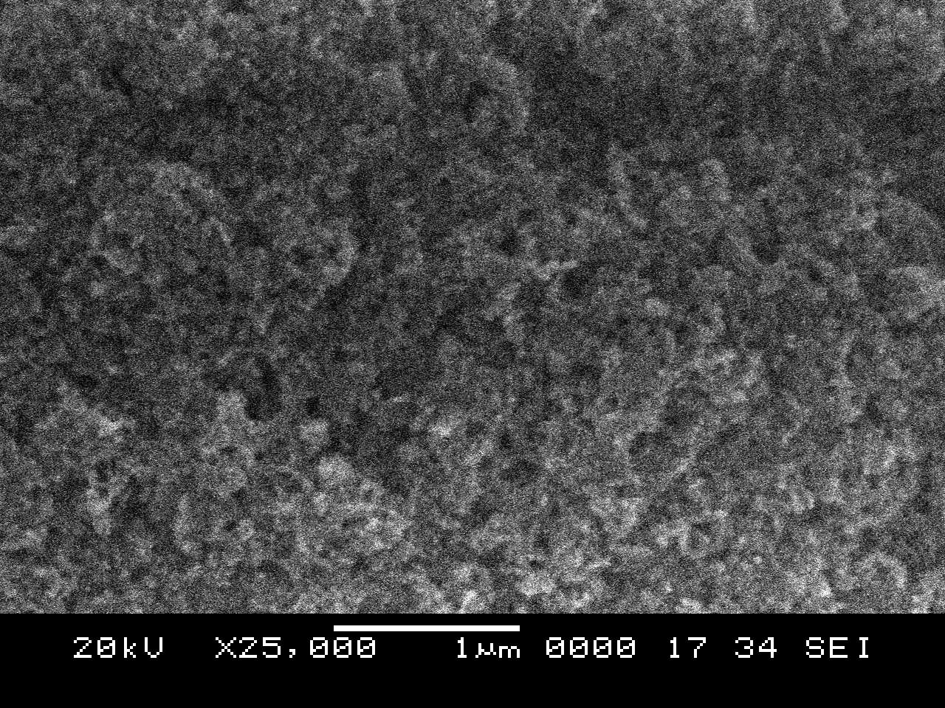
(a)
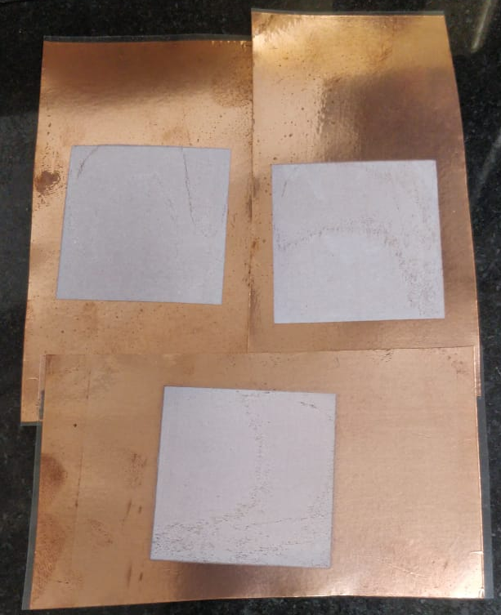
(b)
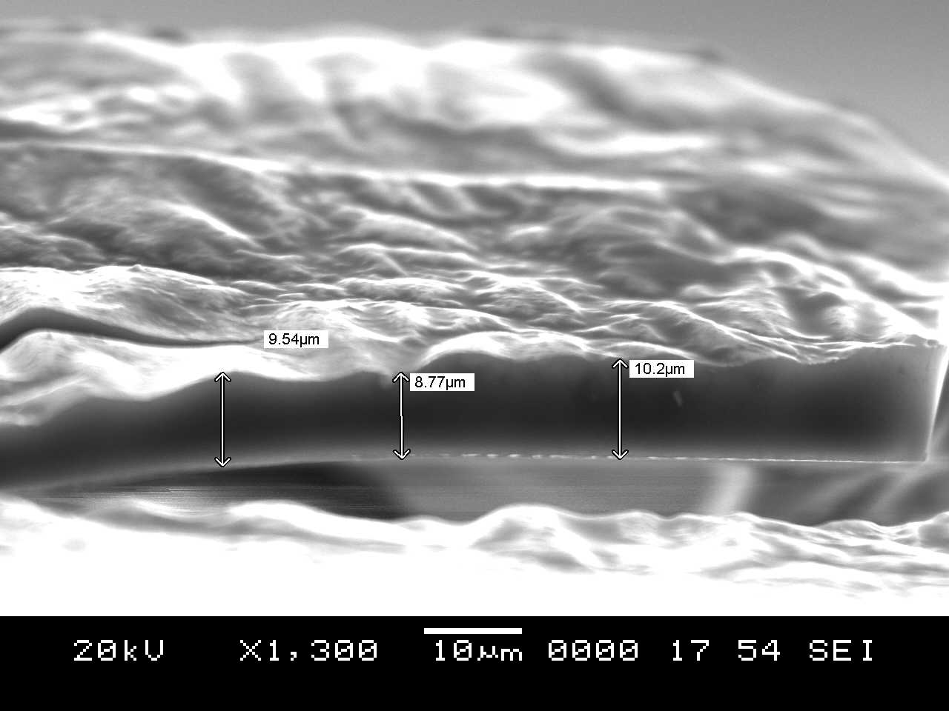
(c)
Fig. S2. (a) SEM morphology of La₂O₃ screen printed film on copper foil, (b) photograph of La₂O₃ screen printed film on copper foil and (c) cross sectional SEM micrograph showing the film thickness.
Fig. S3. The crystal structure of La₂O₃ (green-lanthanum and red-oxygen).
Table. S1. Specific surface area of La₂O₃ nanocrystals published by researchers.
Si. No. | Method | Specific surface area (m²/g) | References
1. | La₂O₃-SiO₂ -  sol-gel and combustion method | 16.7 | [1]
2. | La₂O₃ - homogeneous precipitation method | 18.76 | [2]
3. | La₂O₃ - reverse micelle method | 12.5 | [3]
4. | La₂O₃ - Hydrothermal method | 35.61 | [4]
5. | Precipitation method | 34 | [5]
6. | Physical mixing and impregnation method | 19.44 | [6]
7. | Hydrothermal method | 72.33 | Present work

Fig. S4. The Raman spectrum of La₂O₃ nanocrystals.
The Raman spectrum of La₂O₃ nanocrystals from 1600 to 50 cm⁻¹ is shown in Fig. S4. The Raman shifts for La₂O₃ are present at 104, 190, 282, 407 and 849 cm⁻¹, respectively. The observed bands are in good agreement with the already reported literature [7] [8]. The Raman peaks are due to the polycrystalline nature of La₂O₃ nanocrystals.
Fig. S5. The schematic showing movement of unshared pair of electrons from the carbon atoms towards fluorine atoms, creating highest electron density/polarity around fluorine atom.
The fluorine content in the Teflon is highly reactive with highest electronegativity. The electronegativity of carbon in the Teflon polymer chain is lower than fluorine. Consequentially, the unshared electron pairs are pulled towards fluorine from the carbon (Fig. S5). This phenomenon results in high electron density or polarity around the fluorine atoms.

References
1. W. Nowicki, Z. S. Piskuła, P. Kuźma, and P. Kirszensztejn, J. Sol-Gel Sci. Technol. 82, 574 (2017).
2. J. Liu, G. Wang, L. Lu, Y. Guo, and L. Yang, RSC Adv. 7, 40965 (2017).
3. M. R. Sovizi and S. Mirzakhani, New J. Chem. 44, 4927 (2020).
4. S. Jafari Nejad, H. Abolghasemi, M. A. Moosavian, A. Golzary, and M. G. Maragheh, J. Supercrit. Fluids 52, 292 (2010).
5. A. A. Badawy and S. M. Ibrahim, Int. J. Ind. Chem. 7, 287 (2016).
6. K. Ngaosuwan, W. Chaiyariyakul, O. Inthong, W. Kiatkittipong, D. Wongsawaeng, and S. Assabumrungrat, Catal. Commun. 149, 106247 (2021).
7. J. Zarembowitch, J. Gouteron, and A. M. Lejus, Phys. Status Solidi 94, 249 (1979).
8. Y. Yang, Y. Yu, G. Ma, J. Nan, H. Chen, Z. Zhang, and W. Lin, Ceram. Int. 45, 9017 (2019).

