Supplementary tables
Table S1 – demographic and clinical features in validation cohort
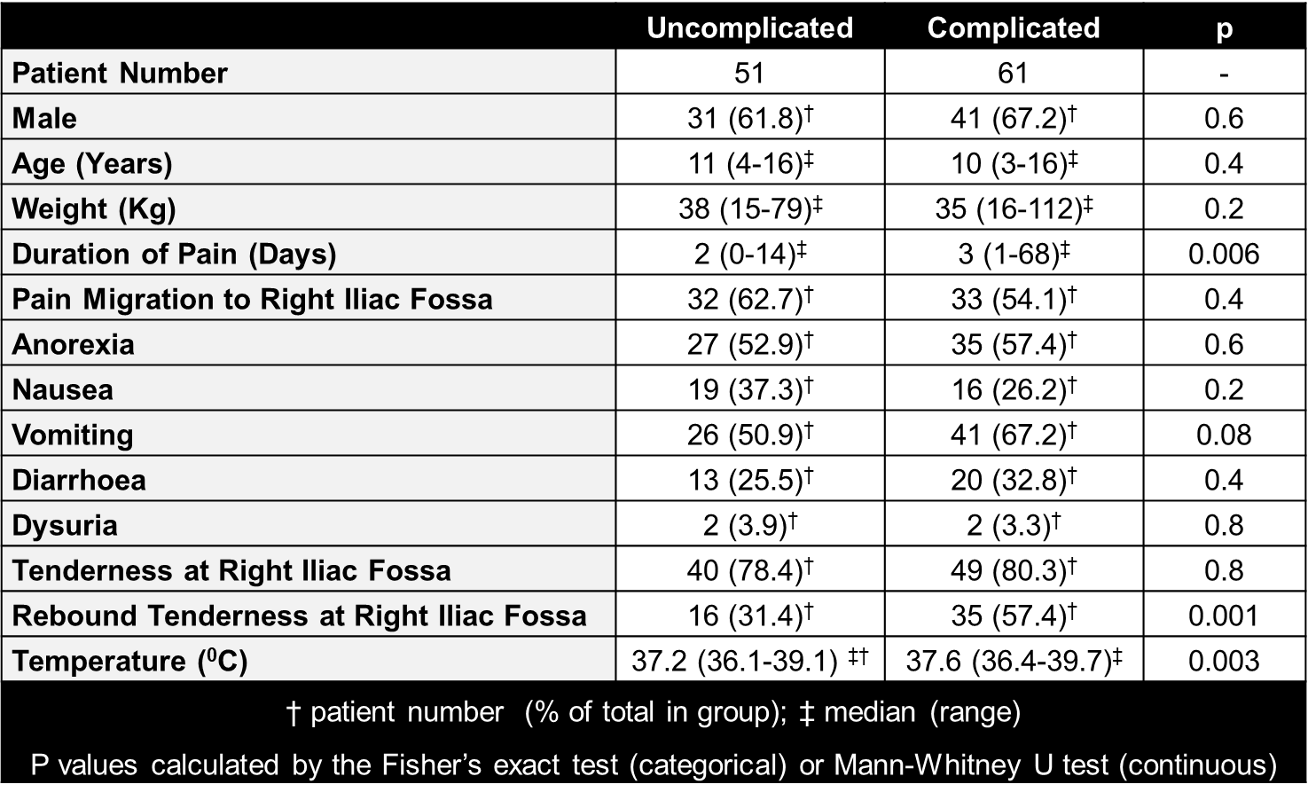

Table S2 – laboratory parameters in validation cohort
