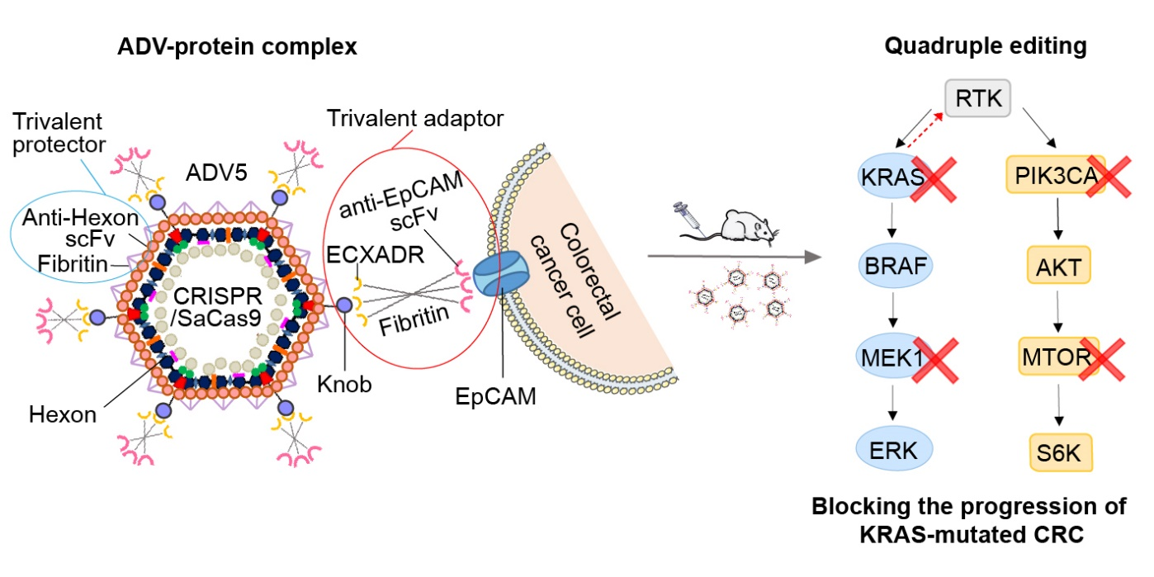
Figure S5. Graphical abstract. A quadruple depleting system of KRAS, MEK1, PIK3CA and MTOR, which was delivered by ADV5-protein complex (ADV5 surrounded by adaptor and protector proteins) in vivo, could effectively and specifically blocked the tumor progression of KRAS-mutated CRC models.

