Graphical abstract
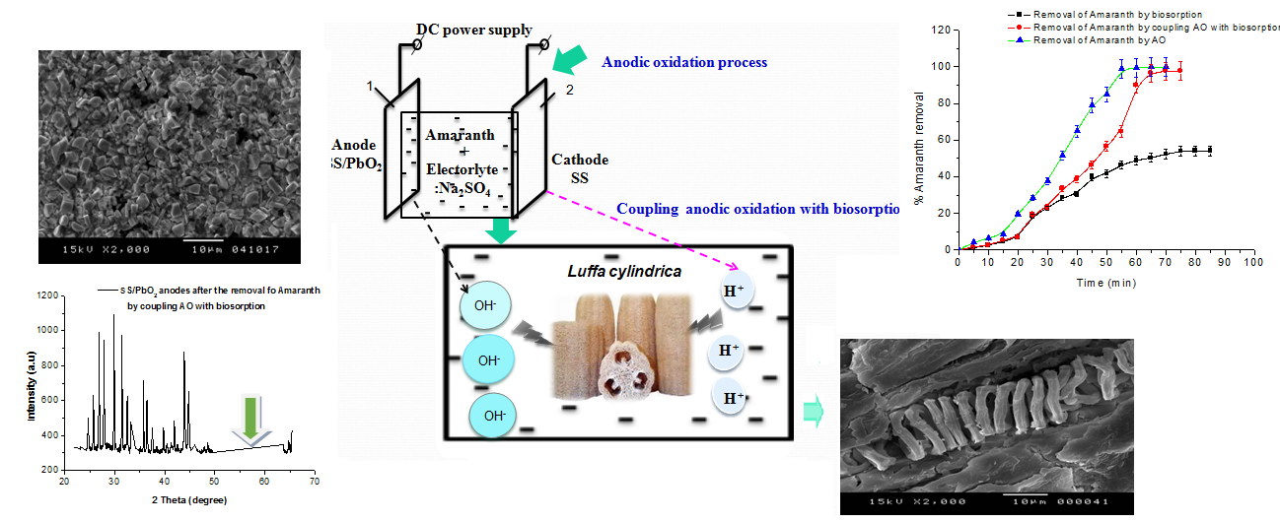

Highlights
- Coupling biosorption with anodic oxidation offers high efficiency at low energy consumption when degrading Amaranth Red (E123)
- Coupling process is proved to be effective for the enhancement of the stability of SS/PbO₂ anodes
- Luffa cylindrica ability for reuse was confirmed after three regeneration cycles

