Supplemental Study 2 Analyses
Though not related to the primary hypotheses of interest, we observed an interaction between political orientation and age on climate engagement intentions, b = -.005, SE = .002, t(782) = -2.97, p = .003. A floodlight analysis (examining only the interaction between political orientation and age) revealed that the negative relationship between political conservatism and climate engagement intentions was weaker in magnitude for younger adults and not statistically significant for those 18-23 years old (10% of the sample).
Figure S1. Interactive effect of age and political conservatism on climate action intentions.
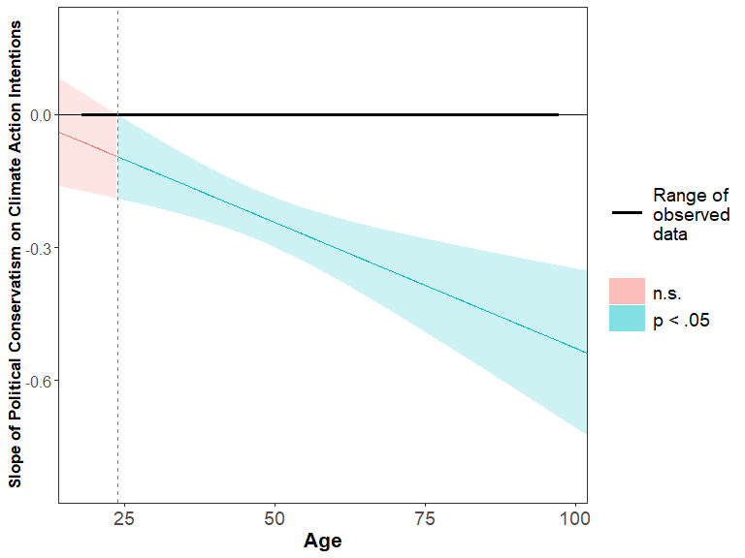We also conducted a supplemental mediation analysis exploring the mechanism by which the interaction between consideration of future consequences and age influenced intentions to take action. According to socioemotional selectivity theory, age should lead to decreased intentions to take action on climate change for those who do not find climate change to be emotionally meaningful. Thus, CFC-F and CFC-I should predict the extent to which one would find climate change to be emotionally meaningful, and this emotional meaningfulness, in turn, would interact with age to predict intentions to take action. However, to our knowledge a measure of emotional meaningfulness does not yet exist. Thus, in the supplemental mediation analysis we used the measure from our data that we believed might most closely map onto emotional meaning – a single-item measure capturing the extent to which an individual believes climate change is an important concern (Swim & Geiger, 2017). Aside from the fact that this is not a direct measure of emotional meaningfulness ascribed to climate change, additional weaknesses stem from the fact that this variable is a single-item, six-point ordinal measure (ranging from “Alarmed” to “Dismissive”) and that the measure was also used to screen the 6% out who did not believe in climate change (i.e., the “Dismissive”), thus leaving us with a slightly restricted five-point range in the final data. Nonetheless, we present the mediation analysis in Figure S2, conducted using Hayes PROCESS model 15 (Hayes, 2012), a mediated moderation model which examines whether the relationship between the mediator and the outcome variable is conditional on the moderator, as preliminary (though inconclusive) evidence in support of socioemotional selectivity theory.
As shown in Figure S2, both CFC-F and CFC-I uniquely predict the level of importance that individuals attach to climate change. In turn, the level of importance that individuals ascribe to climate change (which serves as a proxy for the level of emotional meaningfulness that individuals attach to climate change) interacts with age to predict intentions to engage in climate action (when controlling for CFC-F and CFC-I). The indices of moderated mediation demonstrate that the level of importance attached to climate change mediates both interactive relationships (the interactive effect of both CFC-F and CFC-I with age) to predict climate engagement. Thus, the results of the mediation model are consistent with predictions derived from socioemotional selectivity theory.

Figure S2. Mediation model demonstrating that the importance individuals ascribe to climate change mediates the CFC*Age relationship. DE = Direct effects, TE = Total effects

