Supplementary Section

DNCON2_Inter: Predicting interchain contacts for homodimeric and homomultimeric protein complexes using multiple sequence alignments of monomers and deep learning
Farhan Quadir¹, Raj Roy¹, Randal Halfmann², Jianlin Cheng^{1,*}

¹Bioinformatics and Machine Learning (BML) Lab, Department of Electrical Engineering and Computer Science (EECS), University of Missouri- Columbia, Missouri, USA
²Stowers Institute for Medical Research, Kansas City, Missouri, USA
* Corresponding author: chengji@missouri.edu

1.0 DNCON2 Deep Learning Network Architecture for Predicting Intra-chain contacts
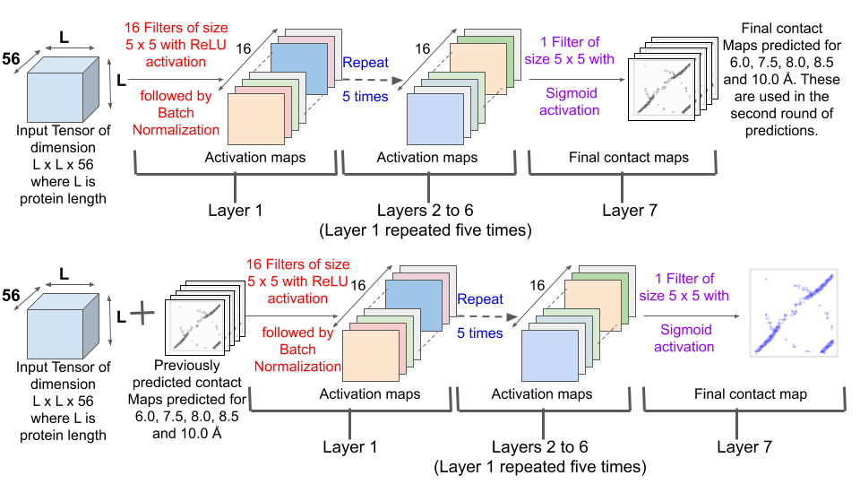
Figure S1: The 2D deep convolutional neural network (CNN) architecture of DNCON2. The input is an L x L x 56 tensor (L: length of the protein), and 56 is the number of channels. (Top) The input is passed through a CNN where the first six layers consist of 16 different 5 x 5 filters, activated using the Rectified Linear Unit (ReLU) followed by batch normalization. The final output layer consists of one 5 x 5 filter, followed by sigmoid activation to predict the L x L contact map. Five different CNNs of similar architecture were trained to predict contacts at thresholds 6.0, 7.5, 8.0, 8.5, and 10.0 Å. (Bottom). These contact maps are then concatenated to the initial input tensor and then trained using a similar network to predict the final contact map at 8.0 Å. The loss function used is binary cross-entropy with Nesterov Adam (nadam) optimizer.

2.0 DNCON2 features

Table S1. List of features used by DNCON2. Shannon entropy, CCMPred, FreeContact, PSICOV, Mean Contact Potential, Normalized Mutual Information, and Mutual information are co-evolution-based features derived from multiple sequence alignment (MSA).
Feature | Dimensions | Features | Channels after augmentation
Log of sequence length | Scalar | 1 | 1
Log of number of sequences in the alignment | Scalar | 1 | 1
Log of the number of effective number of sequences in the alignment | Scalar | 1 | 1
The ratio of number of 'buried' residues and length of the protein | 1D | 1 | 1
The ratio of number of 'beta-strand' residues and length of the protein | 1D | 1 | 1
Ratio of number of 'helical' residues and length of the protein | 1D | 1 | 1
Atchley factors normalized by sigmoid function | 1D | 5 | 10
Binary predictions for helix, coil, and strand residues by SCRATCH | 1D | 3 | 6
Solvent accessibility predicted by SCRATCH | 1D | 1 | 2
Position Specific Scoring Matrix (PSSM) | 1D | 1 | 2
PSSM Sums (divided by 100) | 1D | 1 | 2
PSSM sum cosines | 1D | 1 | 2
Ratio of sequence separation and length of protein | 2D | 1 | 1
Flag for sequence separation between 23 and 28 | 2D | 1 | 1
Flag for sequence separation between 28 and 38 | 2D | 1 | 1
Flag for sequence separation between 38 and 48 | 2D | 1 | 1
Flag for sequence separation 48+ | 2D | 1 | 1
Probabilities of PSIPRED predictions for helix, coil, and strand residues | 1D | 3 | 6
Probabilities of PSISOLV predictions for solvent accessibility | 1D | 1 | 2
Pre-computed statistical potentials | 2D | 6 | 6
Shannon entropy sum of the alignment columns | 2D | 1 | 1
CCMpred co-evolution prediction from MSA | 2D | 1 | 1
FreeContact co-evolution prediction from MSA | 2D | 1 | 1
PSICOV co-evolution prediction from MSA | 2D | 1 | 1
Mean contact potential from MSA | 2D | 1 | 1
Normalized mutual information from MSA | 2D | 1 | 1
Mutual information from MSA | 2D | 1 | 1
Total |  | 40 | 56

3.0 Table for Contact Density distribution of proteins

Table S2: Table showing the contact density distribution of homodimers and homomultimers.
Number of proteins
Contact Density Range | Homodimers | Homomultimers
0.00-0.25 | 1291 | 1480
0.25-0.50 | 2591 | 2053
0.50-0.75 | 2085 | 1616
0.75-1.00 | 1302 | 871
1.00-1.25 | 561 | 392
1.25-1.50 | 341 | 179
1.50-1.75 | 163 | 77
1.75-2.00 | 130 | 37
2.00-2.25 | 80 | 22
2.25-2.50 | 43 | 16
2.50-2.75 | 35 | 15
2.75-3.00 | 24 | 2
3.00-3.25 | 16 | 1
3.25-3.50 | 4 | 1
3.50-3.75 | 4 | 1
3.75-4.00 | 2 | 0
4.00-4.25 | 5 | 0
4.25-4.50 | 3 | 1
4.50-4.75 | 1 | 0

4.0 Random Prediction Precision

Table S3: Table showing the precision of the random prediction of homodimers for different relaxation removal and relaxation values.
Precision (%)
Relax Removal | Relaxation | Top-5 | Top-10 | Top-L/10 | Top-L/5 | Top-L/2 | Top-L | Top-2L
0 | 0 | 0.69 | 0.72 | 0.69 | 0.69 | 0.68 | 0.67 | 0.65
0 | 1 | 3.07 | 3.13 | 3.09 | 3.10 | 3.09 | 3.11 | 3.04
0 | 2 | 5.73 | 5.93 | 5.84 | 5.89 | 5.83 | 5.79 | 5.61
1 | 0 | 0.66 | 0.71 | 0.70 | 0.70 | 0.69 | 0.67 | 0.59
1 | 1 | 2.95 | 3.01 | 2.98 | 3.04 | 3.04 | 3.03 | 2.69
1 | 2 | 5.57 | 5.74 | 5.66 | 5.76 | 5.71 | 5.64 | 4.99
2 | 0 | 0.70 | 0.73 | 0.70 | 0.73 | 0.69 | 0.68 | 0.54
2 | 1 | 2.95 | 3.01 | 2.95 | 3.01 | 3.02 | 3.01 | 2.43
2 | 2 | 5.54 | 5.67 | 5.55 | 5.65 | 5.56 | 5.51 | 4.44

Table S4: Table showing the precision of the random prediction of homomultimers for different relaxation removal and relaxation values.
Precision (%)
Relax Removal | Relaxation | Top-5 | Top-10 | Top-L/10 | Top-L/5 | Top-L/2 | Top-L | Top-2L
0 | 0 | 0.52 | 0.56 | 0.59 | 0.61 | 0.61 | 0.60 | 0.58
0 | 1 | 2.67 | 2.74 | 2.77 | 2.76 | 2.74 | 2.70 | 2.63
0 | 2 | 4.92 | 5.07 | 5.08 | 5.12 | 5.11 | 5.10 | 4.94
1 | 0 | 0.52 | 0.56 | 0.58 | 0.59 | 0.60 | 0.59 | 0.52
1 | 1 | 2.59 | 2.66 | 2.68 | 2.70 | 2.66 | 2.65 | 2.31
1 | 2 | 4.92 | 4.98 | 4.96 | 4.98 | 4.96 | 4.97 | 4.33
2 | 0 | 0.49 | 0.54 | 0.56 | 0.57 | 0.59 | 0.59 | 0.46
2 | 1 | 2.52 | 2.60 | 2.63 | 2.63 | 2.61 | 2.61 | 2.05
2 | 2 | 4.73 | 4.83 | 4.86 | 4.82 | 4.84 | 4.83 | 3.79

5.0 ComplexContact vs DNCON2_Inter

Table S5: A comparison between the precisions (%) of the interchain contacts predicted by ComplexContact, and DNCON2_Inter on 25 random non-zero precision sampled from the homodimer dataset:
ComplexContact (%) |  |  |  |  |  |  |  | DNCON2_Inter (%)
Relax | Top-5 | Top-10 | Top-L/10 | Top-L/5 | Top-L/2 | Top- L | Top-2L | Top-5 | Top-10 | Top-L/10 | Top-L/5 | Top-L/2 | Top- L | Top-2L
0 | 4.00 | 4.00 | 3.30 | 3.79 | 4.73 | 4.48 | 4.37 | 58.4 | 60.00 | 57.45 | 51.27 | 40.35 | 27.59 | 14.24
1 | 8.00 | 11.6 | 10.17 | 9.19 | 9.19 | 9.38 | 9.06 | 61.6 | 68.8 | 64.67 | 60.72 | 50.79 | 37.05 | 19.31
2 | 17.6 | 19.2 | 14.59 | 13.86 | 13.97 | 13.54 | 12.69 | 71.2 | 76.00 | 71.49 | 65.53 | 57.40 | 42.23 | 22.24

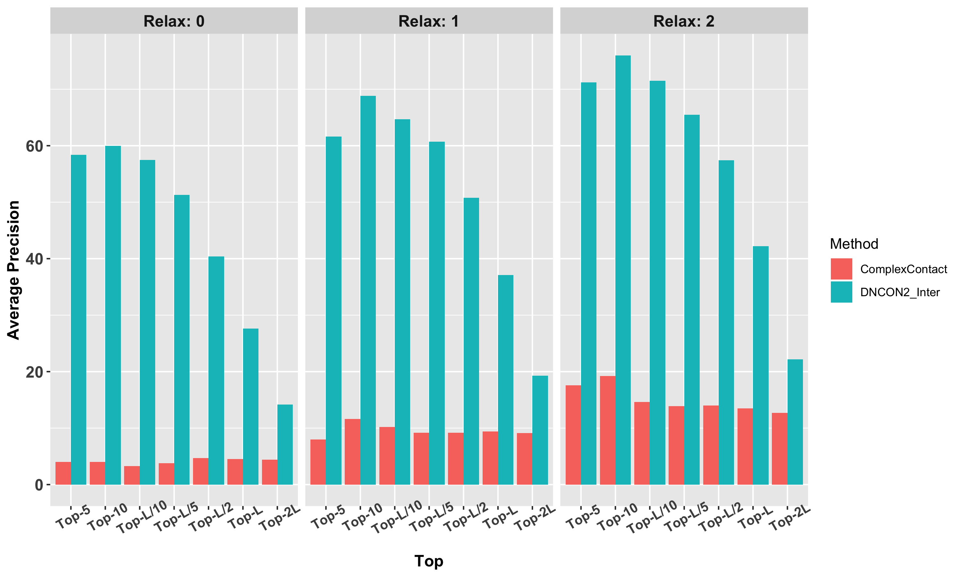

Table S6: A comparison between the precisions of the interchain contacts predicted by ComplexContact, and DNCON2_Inter on 25 random non-zero precision sampled from the homodimer dataset after removing the true contacts from the predicted intrachain contacts:

 |  | ComplexContact_Intra - True_intra |  |  |  |  |  |  | DNCON2_Inter
Relax  removal | Relax | Top-5 | Top-10 | Top-L/10 | Top-L/5 | Top-L/2 | Top- L | Top-2L | Top-5 | Top-10 | Top-L/10 | Top-L/5 | Top-L/2 | Top- L | Top-2L
0 | 0 | 35.2 | 38.4 | 28.52 | 33.8 | 27.45 | 17.87 | 9.2 | 58.4 | 60 | 57.45 | 51.27 | 40.35 | 27.59 | 14.24
0 | 1 | 36.8 | 42 | 42.68 | 38.88 | 34.17 | 23.47 | 12.38 | 61.6 | 68.8 | 64.67 | 60.72 | 50.79 | 37.05 | 19.31
0 | 2 | 43.2 | 47.6 | 48.65 | 44.87 | 39.4 | 27.53 | 14.53 | 71.2 | 76 | 71.49 | 65.53 | 57.4 | 42.23 | 22.24
1 | 0 | 39.2 | 43.2 | 46.12 | 41.52 | 28.76 | 16.56 | 8.28 | 74.4 | 75.6 | 71.39 | 61.55 | 41.26 | 24.84 | 12.49
1 | 1 | 43.2 | 45.2 | 50.79 | 46.28 | 33.6 | 20.44 | 10.32 | 77.6 | 80 | 76.17 | 69.89 | 51.28 | 31.8 | 16.12
1 | 2 | 44.8 | 46 | 52.49 | 47.64 | 35.26 | 21.93 | 11.06 | 79.2 | 81.6 | 78.49 | 72.14 | 54.5 | 34.34 | 17.45
2 | 0 | 40.8 | 40.8 | 38.47 | 38.47 | 26.4 | 15.24 | 7.62 | 74.4 | 73.6 | 70.64 | 61.11 | 38.12 | 23.02 | 11.56
2 | 1 | 43.2 | 43.2 | 46.66 | 41.87 | 29.78 | 18.4 | 9.29 | 78.4 | 79.2 | 76.67 | 69.48 | 46.39 | 28.96 | 14.66
2 | 2 | 43.2 | 44.4 | 47.69 | 42.47 | 30.72 | 19.2 | 9.69 | 80 | 81.6 | 79.08 | 71.34 | 48.96 | 31.09 | 15.79

6.0 Line Graph showing how relax removal and relaxation affect top-k precisions

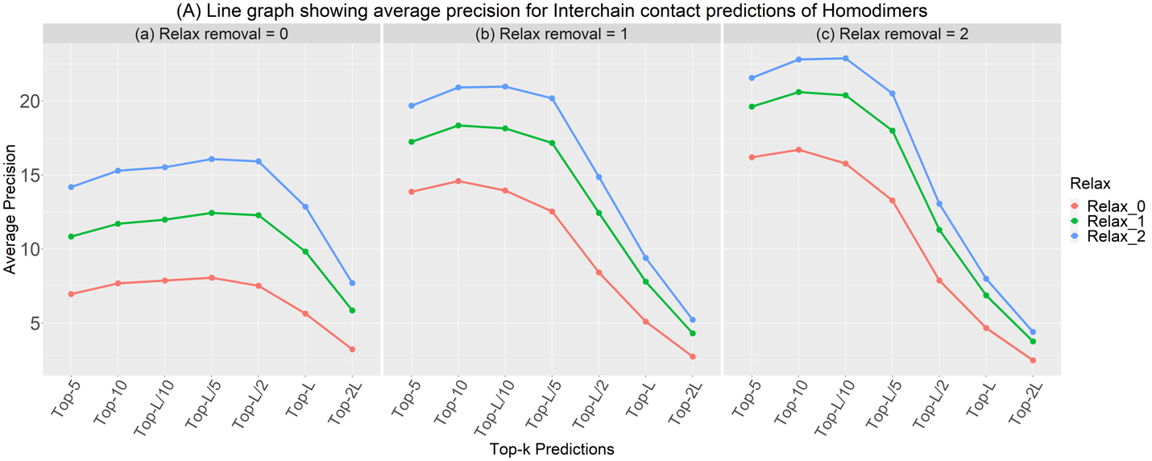
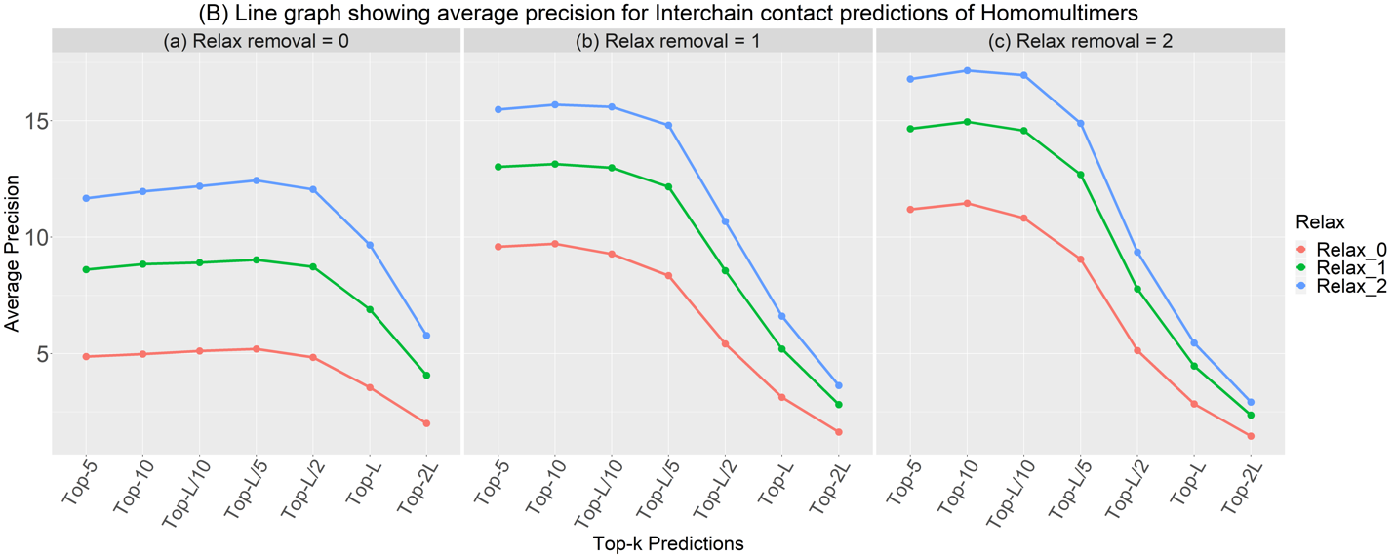
Figure S2: The figure shows how relaxation removal and relaxation affect interchain contact prediction precision (A) for homodimers and (B) for homomultimers. For homodimers, (a) there is no relaxation removal. Precision steadily increases for all relaxation thresholds until Top L/5, then sharply decreases. Similar observations are seen for (b) and (c) with maximum precision occurring at Top-10 for (b) and top-L/10 for (c). Increasing relaxation thresholds from 0 to 2 always increases precision.
7.0 Detailed results for 1A64

Table S7: The precision (%) of intrachain and interchain contact predictions for PDB 1A64. The last three rows correspond to interchain precision at different relaxation removal levels.
Relax removal | Relaxation | Top-5 | Top-10 | Top-L/10 | Top-L/5 | Top-L/2 | Top-L | Top-2L
Intrachain Precision |  | 0 | 40.0 | 33.33 | 52.63 | 46.81 | 38.30 | 32.45
0 | 0 | 100 | 100 | 100 | 100 | 100 | 100 | 100
1 | 0 | 100 | 100 | 100 | 100 | 100 | 100 | 100
2 | 0 | 100 | 100 | 100 | 100 | 100 | 100 | 100

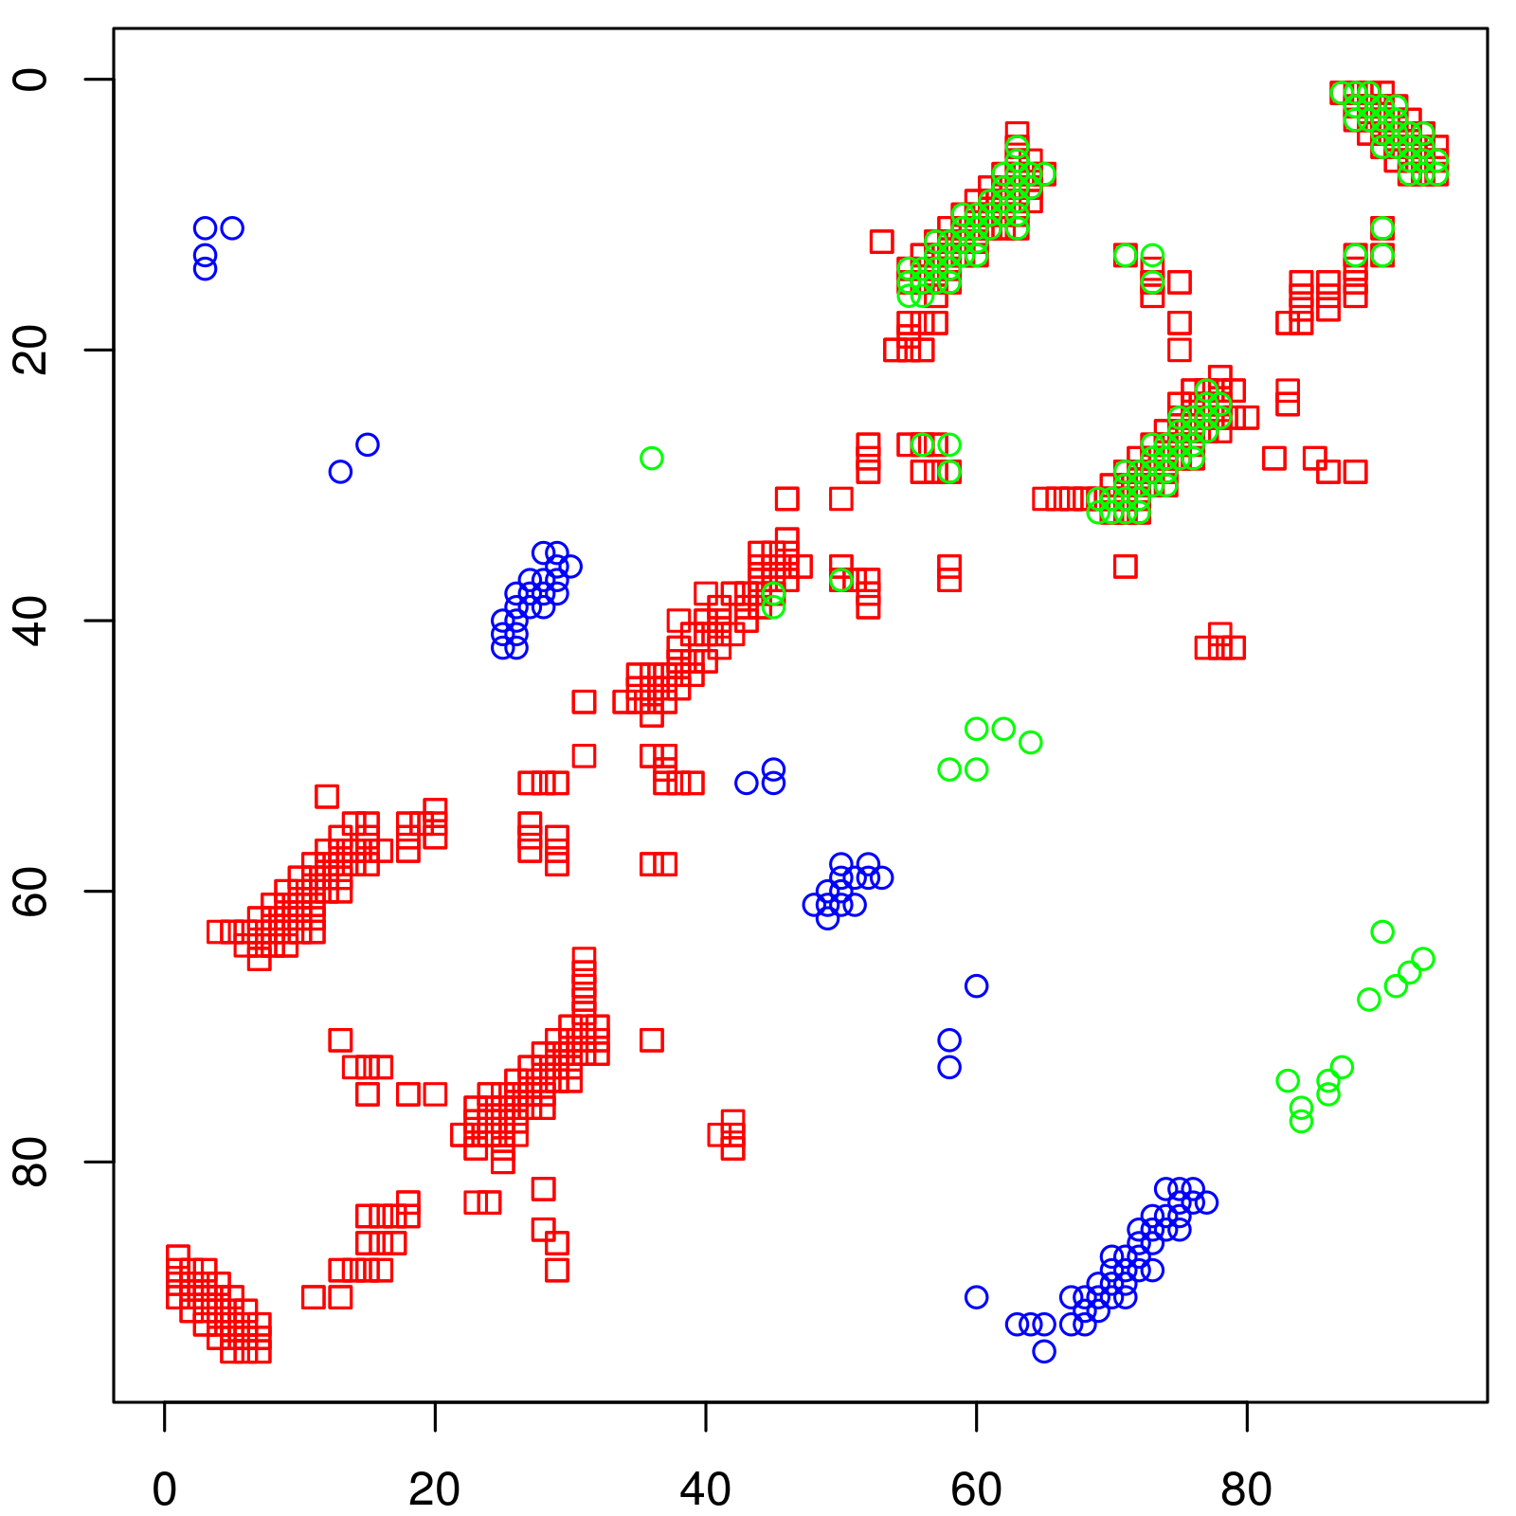(a) No relax removal | 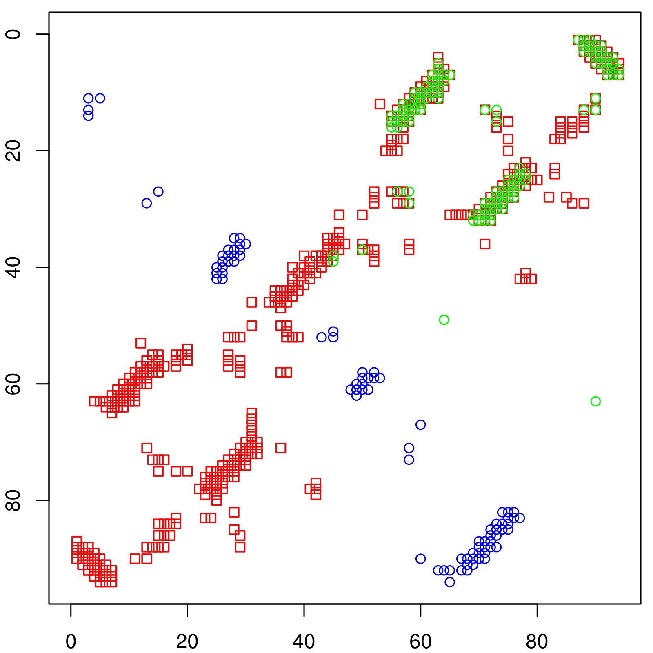  (b) Relax removal = 1 | 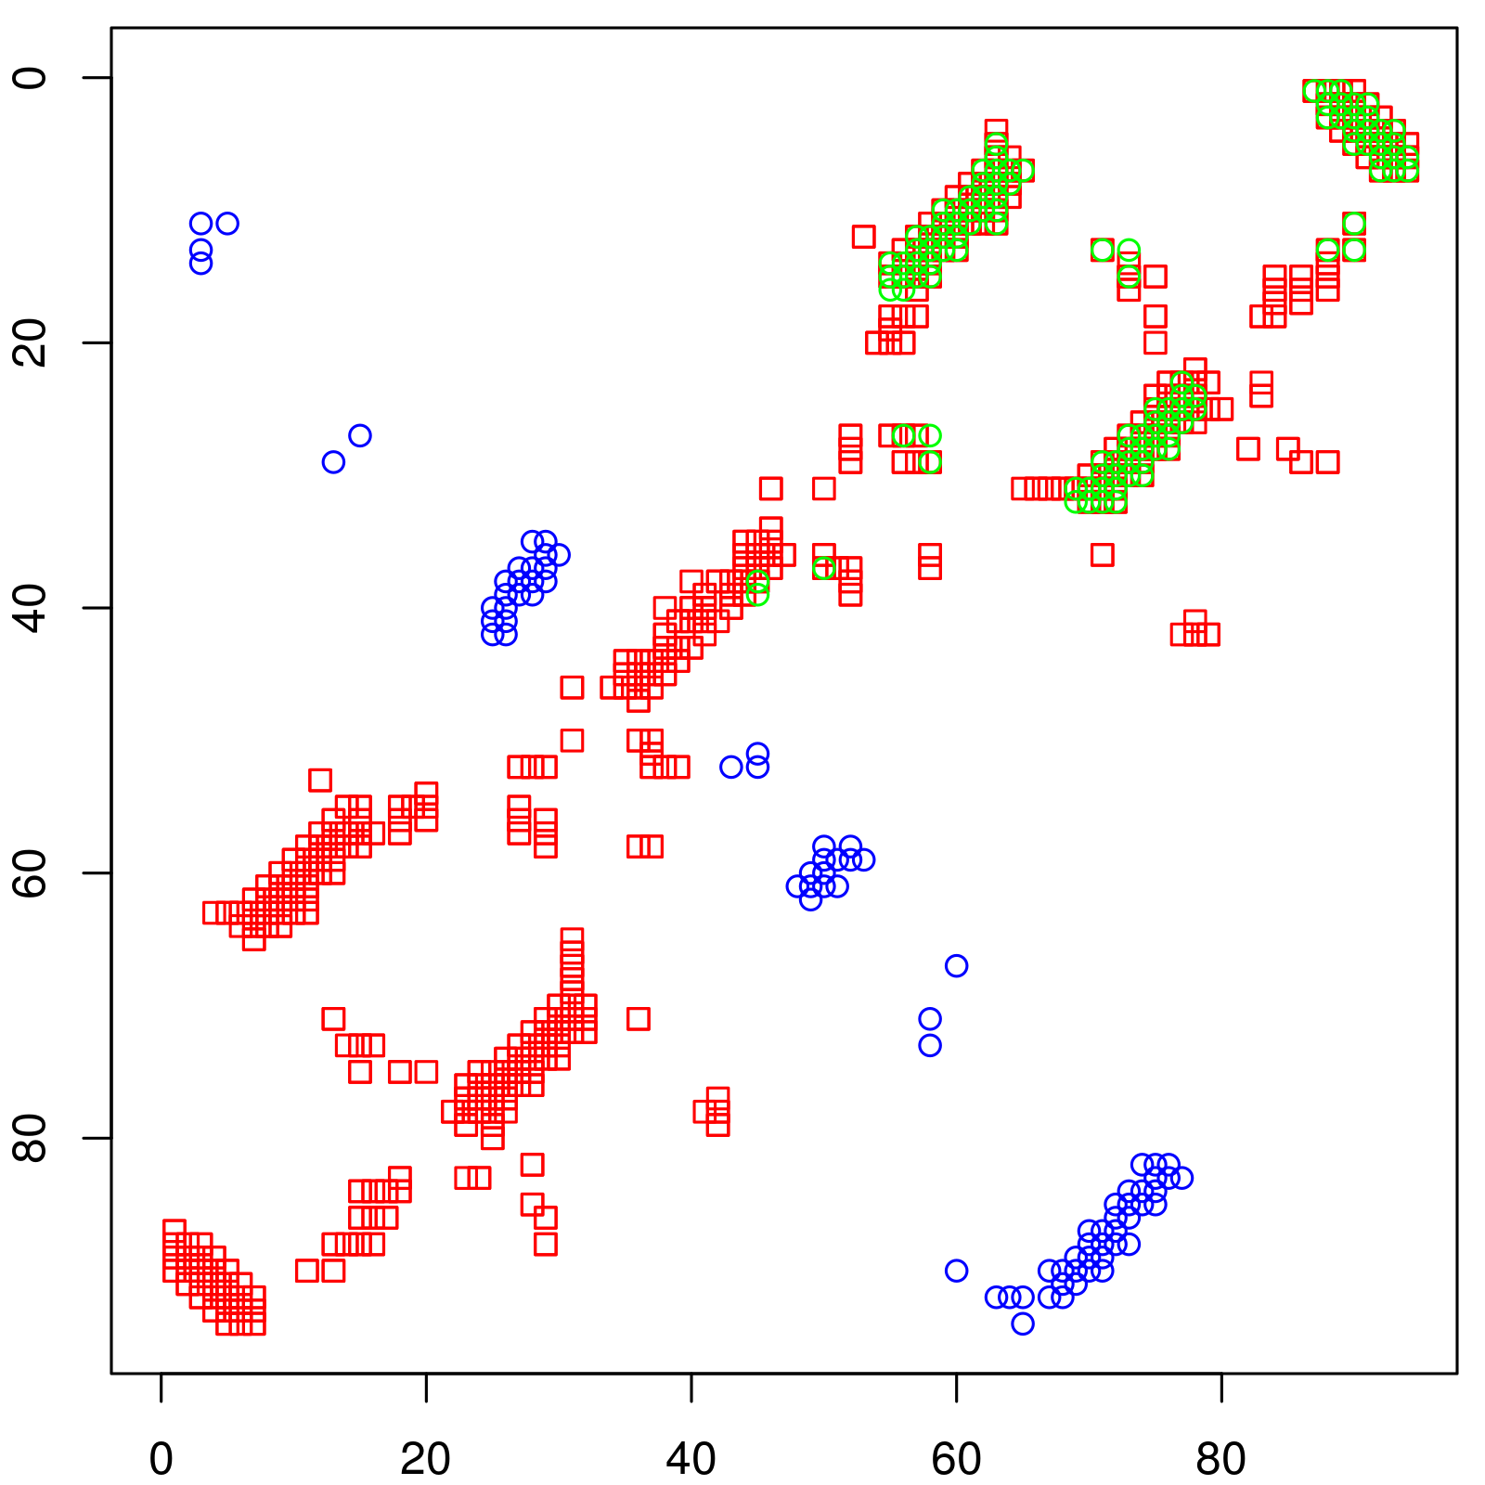  (c) Relax removal = 2
Figure S3: Contact map comparison between true intrachain (blue), predicted interchain (green), and true interchain (red) contacts for 1A64. Since the true intrachain contacts and predicted inter-chain contacts are symmetric, only the lower triangle and upper triangle contacts are, respectively, shown. (a) shows more green spots since no relax removal was done. From (b) to (c), the green contacts become sparse due to removing more predicted contacts assumed to be intrachain. The green dots that overlap with the red dots are correct inter-chain contact predictions.
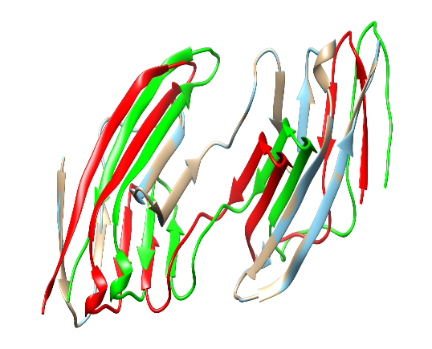  (a) No relax removal | 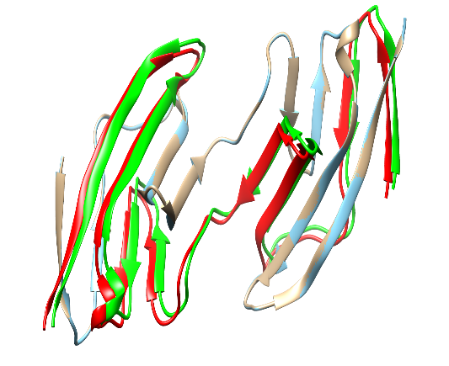  (b) Relax removal = 1 | 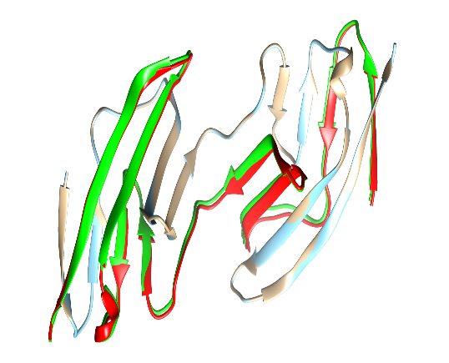  (b) Relax removal = 2
TM-Score 0.83465  RMSD 2.27  Length 94  Interchain precision 100% (2L) | TM-Score 0.97733  RMSD 0.78  Length 94  Interchain precision 100% (2L) | TM-Score 0.99481  RMSD 0.37  Length 94  Interchain precision 100% (2L)
Figure S4: Comparison for target 1A64 between its true homodimer structure and the structure derived from our predicted contacts built by CNS (Crystallography and NMR System). (Golden: original chain A; Cyan: reconstructed chain A; red: original chain B; green: reconstructed chain B) The TM-score and RMSDs were obtained using TM-Align. From (a) to (c), as we perform relax removal, we remove more intrachain contacts to obtain a higher proportion of true-positive interchain contacts (as seen in the previous contact map diagram Figure 7). As a result, the final structures become more accurate, and TM-score increases with decreasing RMSD.

8.0 Detailed results for 1IHR

Table S8: Table showing the precisions (%) of some top predictions done by our system for PDB 1IHR.
Relax remove | Relaxation | Top-5 | Top-10 | Top-L/10 | Top-L/5 | Top-L/2 | Top-L | Top-2L
Intrachain precision |  | 40.00 | 50.00 | 28.57 | 57.33 | 45.95 | 29.73 | 18.24
0 | 0 | 100 | 100 | 100 | 100 | 100 | 100 | 99.32
1 | 0 | 100 | 100 | 100 | 100 | 100 | 100 | 97.97
2 | 0 | 100 | 100 | 100 | 100 | 100 | 100 | 89.86

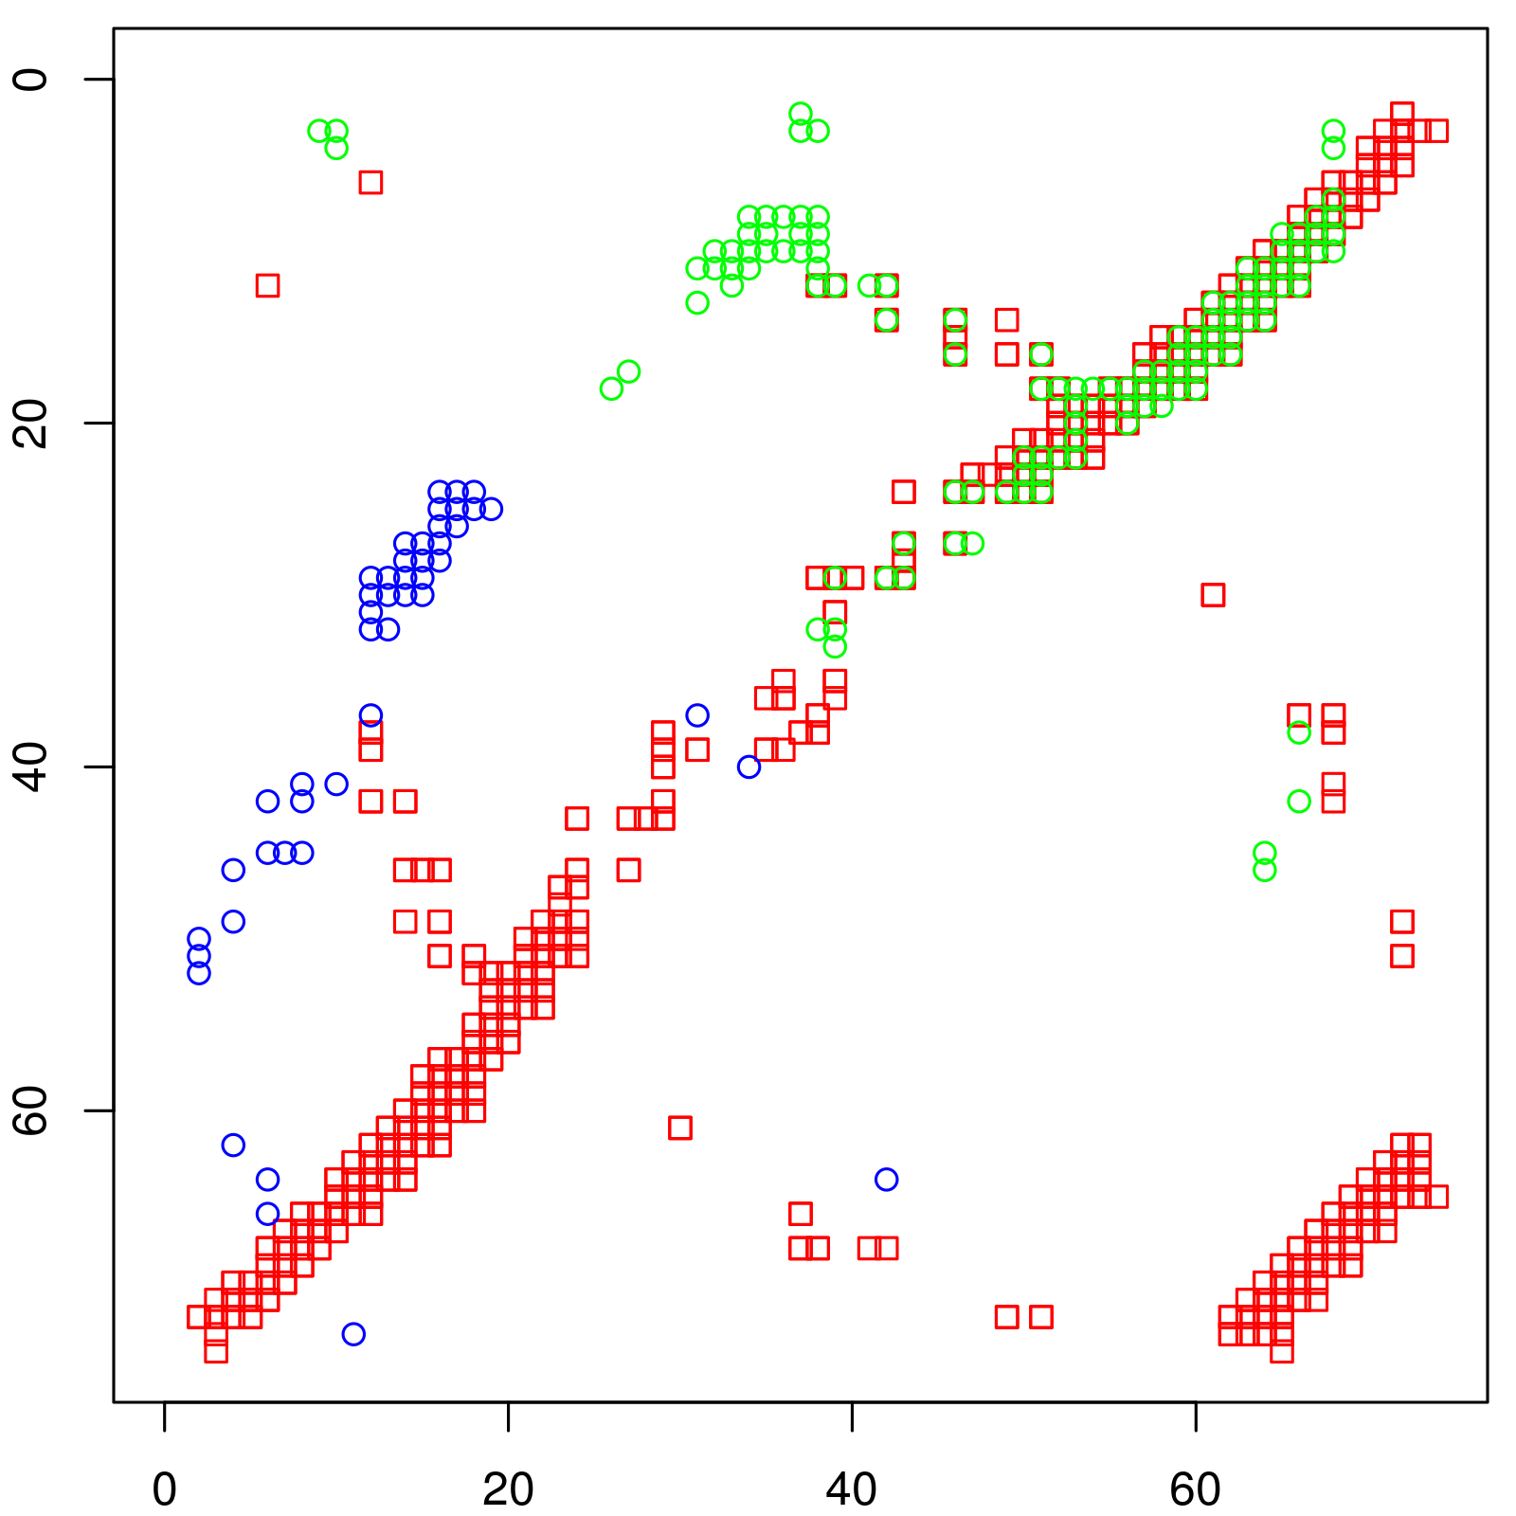(a) No relax removal | 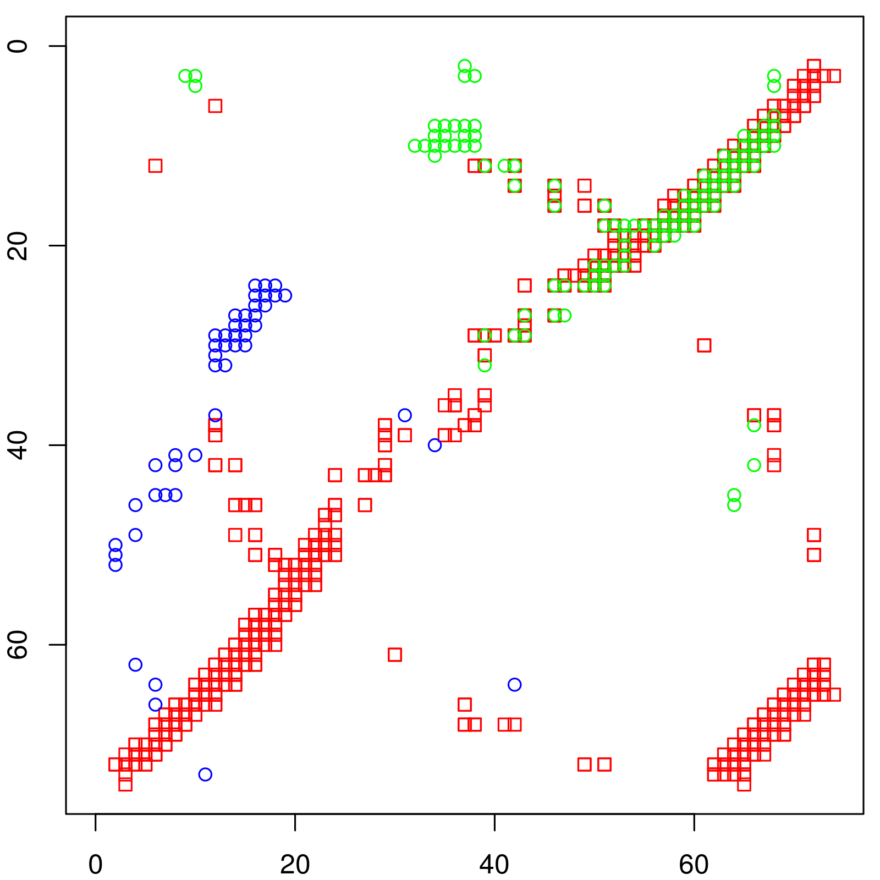  (b) Relax removal = 1 | 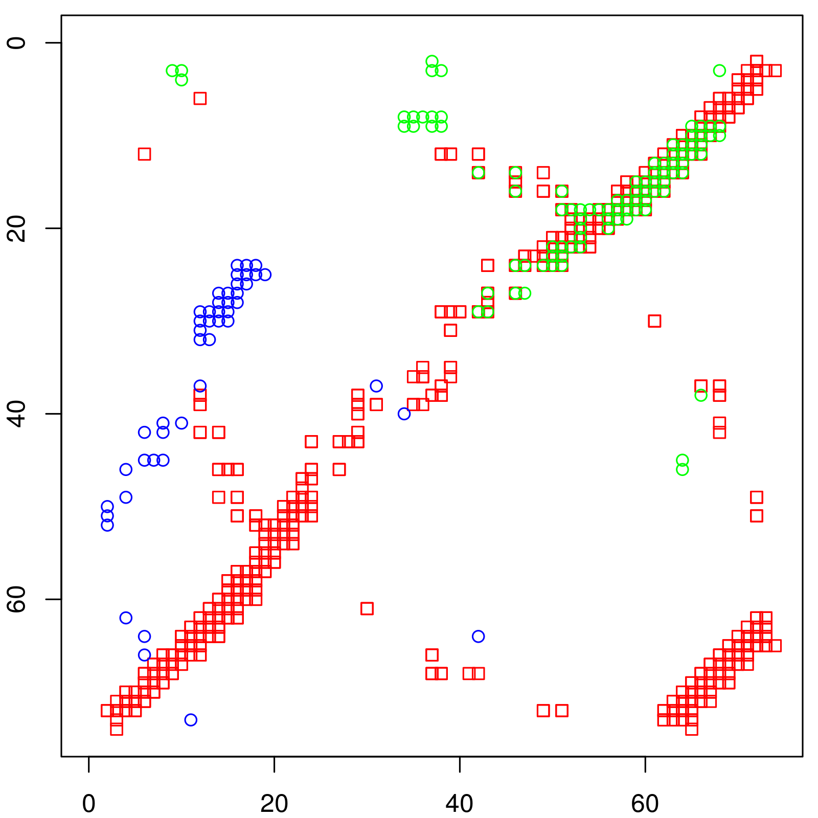  (c) Relax removal = 2
Figure 8: Contact map comparison of the Top-L true intrachain (blue), predicted interchain (green), and true interchain (red) contacts for 1IHR for different relaxation removals. (a) shows more green spots since no relax removal was done. From (b) to (c), the green contacts become sparser due to removing more predicted contacts assumed to be intrachain. According to Table 1, the final Top-5, Top-10, Top-L/10, Top-L/5, Top-L/2, and Top-L precisions for this prediction are all 100%. Only the Top-2L precision drops to 99.32%, 97.97%, and 89.86% for relax removal 0, 1 and 2, respectively.

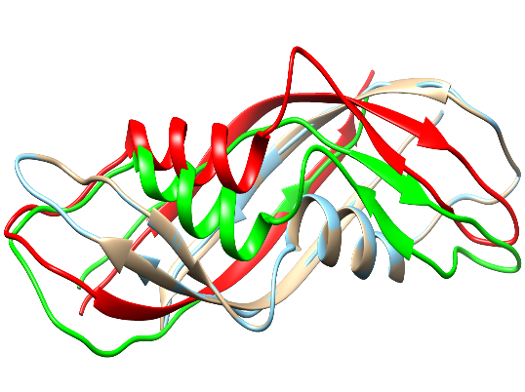  (a) No relax removal | 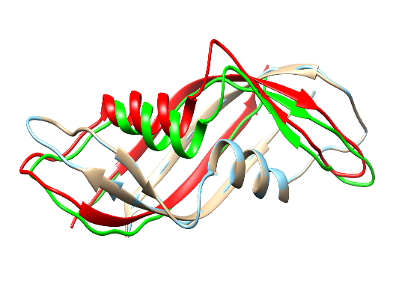  (b) Relax removal = 1 | 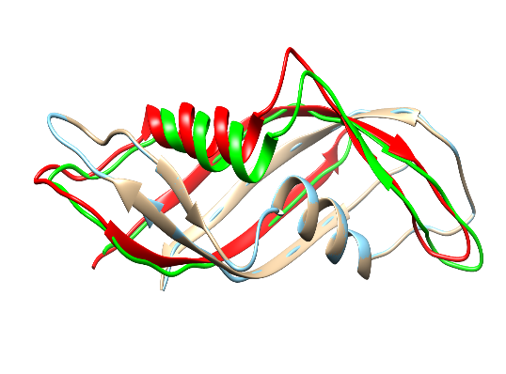  (b) Relax removal = 2
TM-Score 0.79282  RMSD 2.49  Length 74  Interchain precision 99.32% (2L) | TM-Score 0.90649  RMSD 1.42  Length 74  Interchain precision 97.97% (2L) | TM-Score 0.91896  RMSD 1.29  Length 74  Interchain_precision 89.86% (2L)
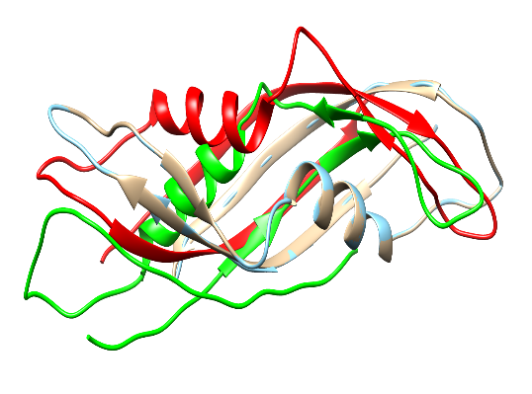  (d) No relax removal | 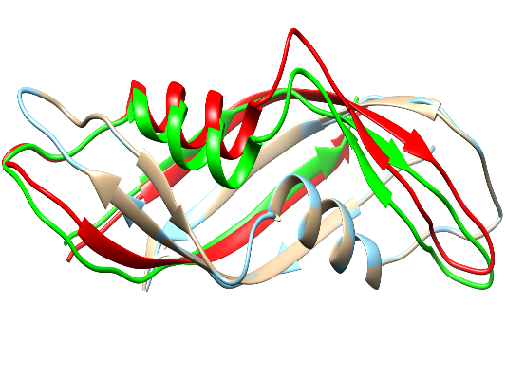  (e) Relax removal = 1 | 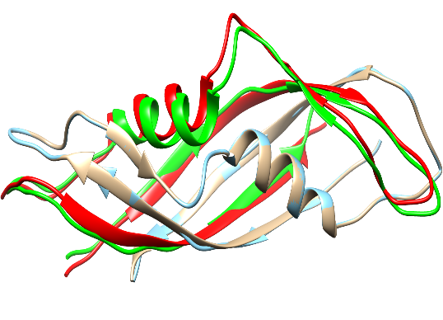  (f) Relax removal = 2
TM-Score 0.63100  RMSD 3.99  Length 74  Interchain precision 100% (L) | TM-Score 0.93180  RMSD 1.19  Length 74  Interchain precision 100% (L) | TM-Score 0.94390  RMSD 1.04  Length 74  Interchain precision 100% (L)
Figure 9: Comparison for target 1IHR between its true homodimer structure (Golden: original chain A; red: original chain B) and the structure derived from predicted contacts (Cyan: reconstructed chain A; green: reconstructed chain B). The TM-score and RMSDs were obtained using TM-Align. From (a) to (c), as we perform relax removal, the TM-score increases while RMSD decreases. But interchain precision (Top-2L) decreases slightly. Structures (d) to (f) are based on Top-L contacts, all of which have 100% precision leading to much higher TM-score and lower RMSD values. The TM-score of (d) was low (even less than (a)) due to the low overlap of the alpha-helix and some noodle regions.
9.0 The Precision of Intrachain Contact Prediction

Table S9: Table showing the average precision of predicted intrachain contacts obtained for the homodimers and homomultimers using ConEVA. The sequence separation of contacts is short-range or above (>= 6). L represents the length of the protein sequence.
Precision (%)
Dataset | Top-5 | Top-L/10 | Top-L/5 | Top-L/2 | Top-L | Top-2L
Dimer | 96.01 | 94.25 | 92.08 | 85.54 | 74.81 | 57.05
Multimer | 89.41 | 87.60 | 85.33 | 79.47 | 70.11 | 54.02

Table S9 shows the average precision of intrachain contact predictions for homodimers and homomultimers. Precision is relatively high because both short-range and medium/long-range contacts are considered, and generally good multiple sequence alignments are obtained for the proteins in the dataset. Precision values drop as the number of predicted contacts is increased from Top-5 to Top-2L (L being the protein length). The average intrachain precision for the homomultimers is slightly lower than that of the homodimers.

10.0 Explanation for Drops in Precision and how Relaxation and relax removal affects precision

We explain this using Figure 4, which shows the frequency of proteins (y-axis) for which a given range of contacts (x-axis) was successfully predicted. Relaxation and relax removal were also varied. The number of successful contact predictions is divided into five categories (x-axis), where 0 means no successful contact was predicted for this protein. A protein is tallied in the range 1-20 if the total number of true-positive predictions for this protein is at least one but less than or equal to 20; and so forth. We show only the Top-L/10 (a) and Top-2L (b) graphs for homodimers in Figure 4 in this analysis for simplicity. A bulk of our samples (especially for Top-L/10) remains mispredicted by DNCON2_Inter (has zero predictions). There are more successful predictions if the number of contacts present in the proteins is within the 1-20 range (Figure 4 (a)). If proteins have more than 20 contacts, the number of successful predictions is low. As we perform relaxation, we can see that the incorrect predictions (zero contact prediction) go down, while successful predictions, especially in the 1-20 range, increases drastically, leading to an increase in precision. As we perform relax removal, the number of proteins in the 1-20 range remains similar, but more well-predicted contacts appear for proteins with more than 20 contacts. This is expected since relax removal removes false-positive contacts from the Top L/10 predictions leading to more true-positive predictions being discovered, thereby increasing precision.

However, we see sharp precision drops in the cases of Top-L/5 and beyond (Figure 3 and Figure S2). We look at the Top-2L graph (Figure 4 (b)) to analyze this observation. Unlike the Top-L/10 graph (Figure 4 (a)), in Top-2L, we see fewer mispredictions (zero value category in x-axis) and more proteins that have been successfully predicted to have 1-100 contacts because 2L is a more expansive range compared to L/10. So more true-positive contacts are encountered. However, during the precision calculation, we are dividing the total number of true-positives by 2L, which is comparatively a higher number. If L is large, the precision drops drastically. As we perform relax removal, we see very little increase in precision for Top-L/5 and beyond, while precision also decreases in some instances (Figure 3 and Figure S2). The Top-2L graph from Figure 4 (b) further suggests that relax removal increases the number of mispredictions (zero value category in the x-axis) while the number of proteins for which successful contacts were predicted decreases. This is due to removing some well-predicted interchain contacts from the predicted contact map when performing the relax removal. In some cases, we discovered that all the predicted contacts get removed, resulting in precisions to become zero.

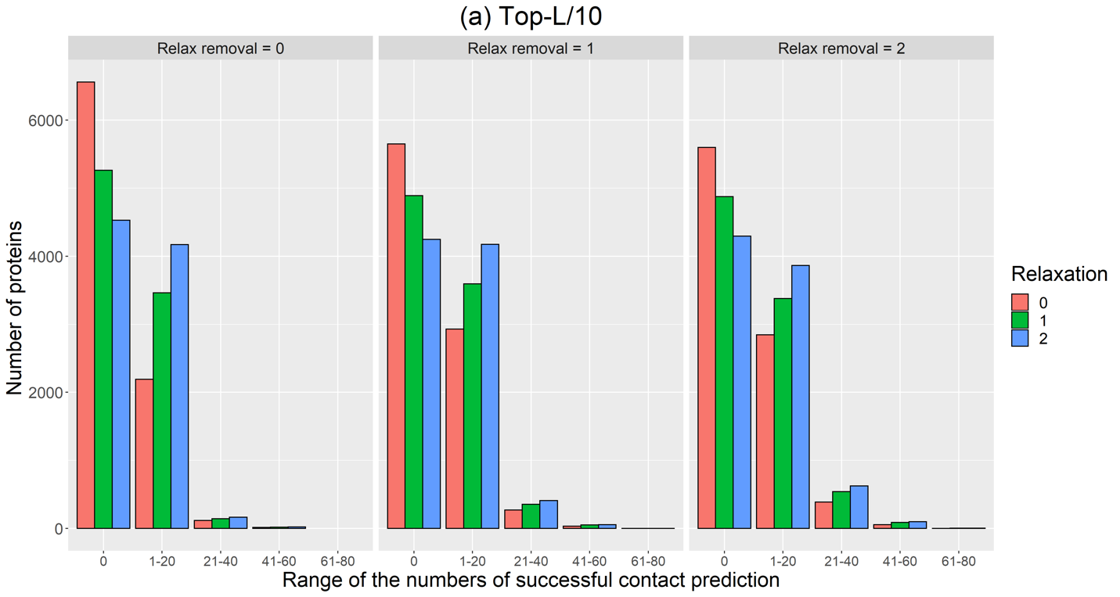
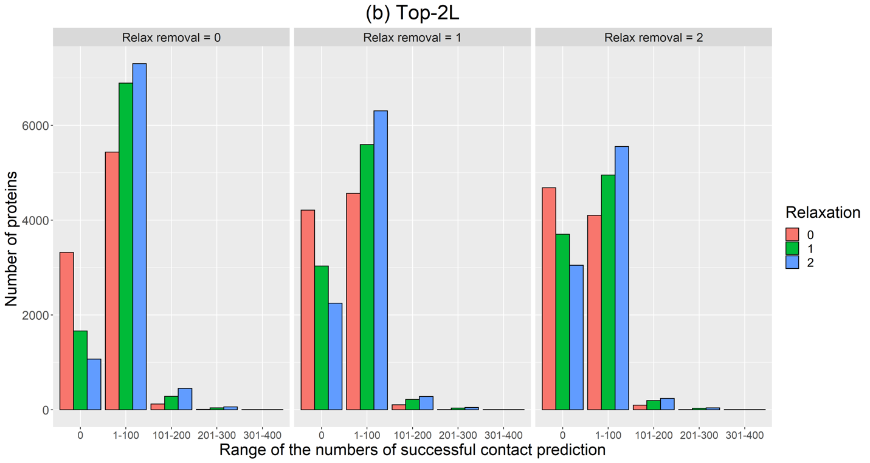
Figure 4: The number of homodimeric proteins (y-axis) for which the total number of contacts were successfully predicted within given ranges of total true-positive contacts (x-axis) at different combinations of relaxations and relax removals for (a) Top-L/10 and (b) Top-2L, respectively. (a) The L/10 shows more mispredictions (zero value in x-axis). Among the proteins whose contacts were successfully predicted, most of the proteins have one to 20 true-positive contacts. (b) The bottom graph shows similar results for Top-2L, but most proteins have total contacts within the 1-100 range. In both graphs, we see relaxation increases the number of proteins with well-predicted contacts. Relax removal for the Top-L/10 group increased the number of proteins having more than 20 true-positive contacts. However, for Top-2L, relax removal decreased the number of well-predicted proteins, especially those with one to 100 contacts.

