VAS Scale

Group | PreT. | PostT. d | PostT. 1m | PostT. 3m | PostT. 6m | P value
RFA | 8,33±1,07^{a*} | 4,83±1,03^{b,c} | 3,67±1,07^{,b} | 4,50±1,57 | 4,42±1,08^{c} | a*= p< 0.001  b= p < 0.001  c= p < 0.05
RFA+VP | 7,44±1,06^{a*} | 4,38±1,00^{*b} | 2,94±1,04*^{c} | 2,44±1,61 | 2,31±1,42 | a*= p < 0.001  b*= p<0.001  c*= p < 0,05
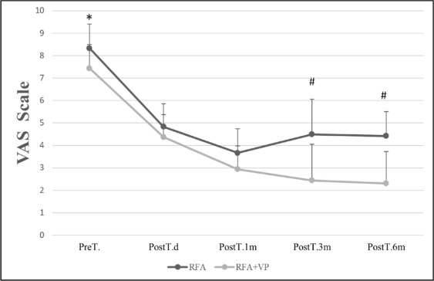
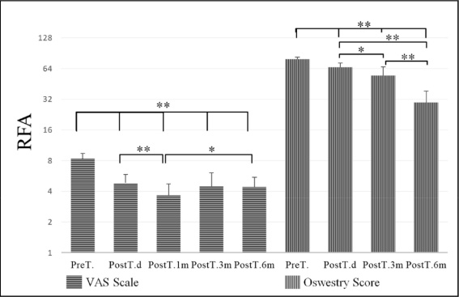

Table 1: VAS: Visual Analog Scale RFA: Radiofrequency ablation RFA+VP:Radiofrequency ablation+vertebroplasty, Pre T.:Pre-treatment, Post T.d: Post-treatment one day, Post T 1m, 3m, 6 m: Post-treatment one month, three month, six month
a*: According toPre-T among others
b*:According to PostT.damong PostT. 1m, PostT. 3m, PostT. 6m
c*: According to PostT.1m among PostT. 3m, PostT. 6m

