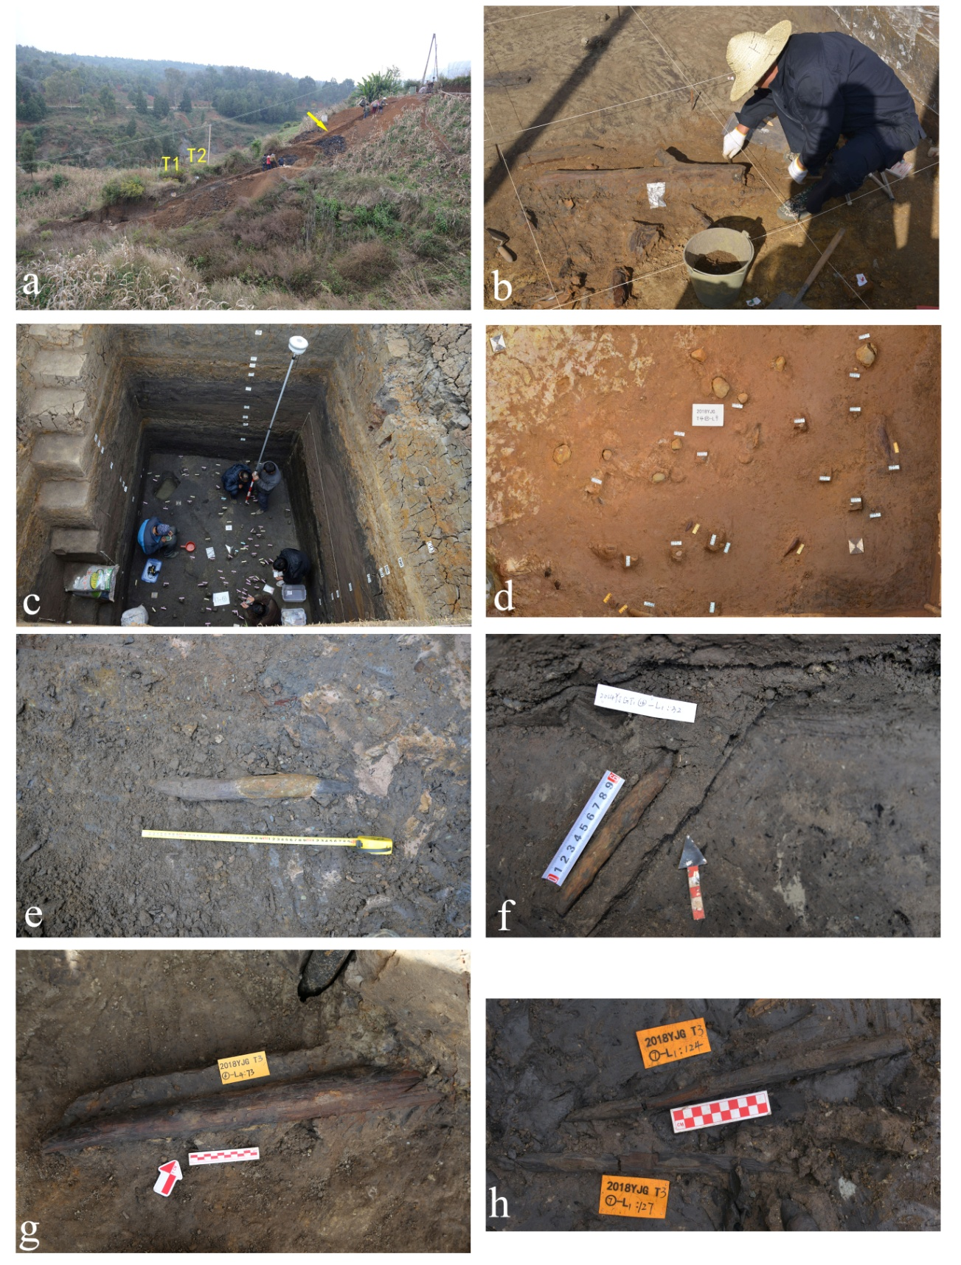
Extended Data Figure 1 | Excavation images. a, Photograph showing the excavation in 2015; drilling was underway and a trench was dug along the exposed slope of the site. b, Photo of a freshly exposed wooden artefact. c, Photo of T1; coordinates were being measured using real-time kinematics. d, Distribution of excavated objects in Layer 10 of T4. e-h, In situ wooden artefacts (e: T1-1901, f: T1-32, g: T3-73, h: T3-124).

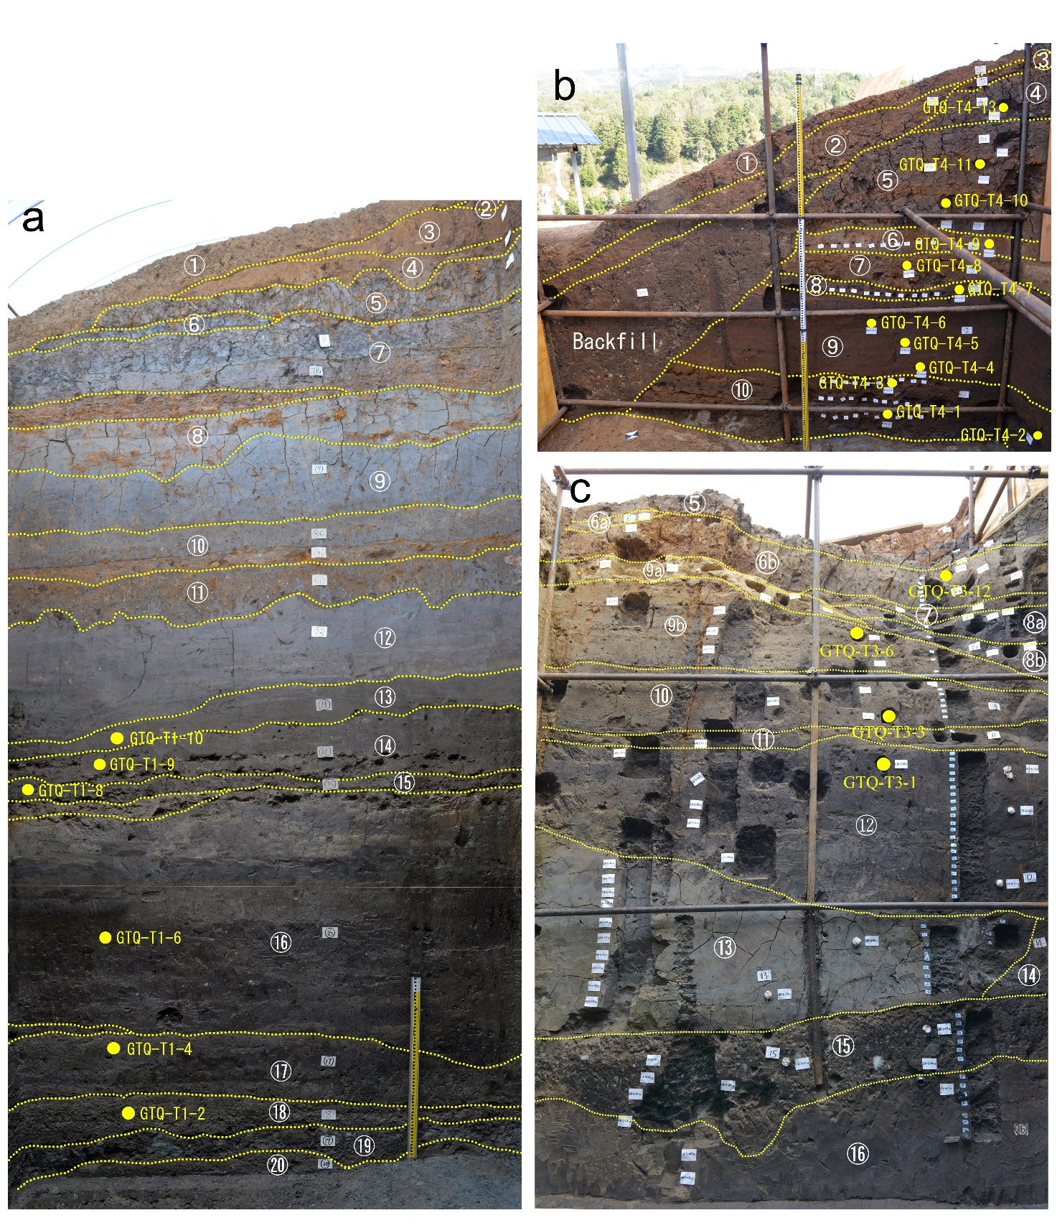
Extended Data Figure 2 | Stratigraphy and optical dating sample locations. a, South wall of T1. b, South wall of T3. c, East wall of T4. The locations of optical dating samples are indicated as yellow dots with accompanying sample codes. The dashed lines represent layer boundaries. Individual layers are marked with circled numbers.
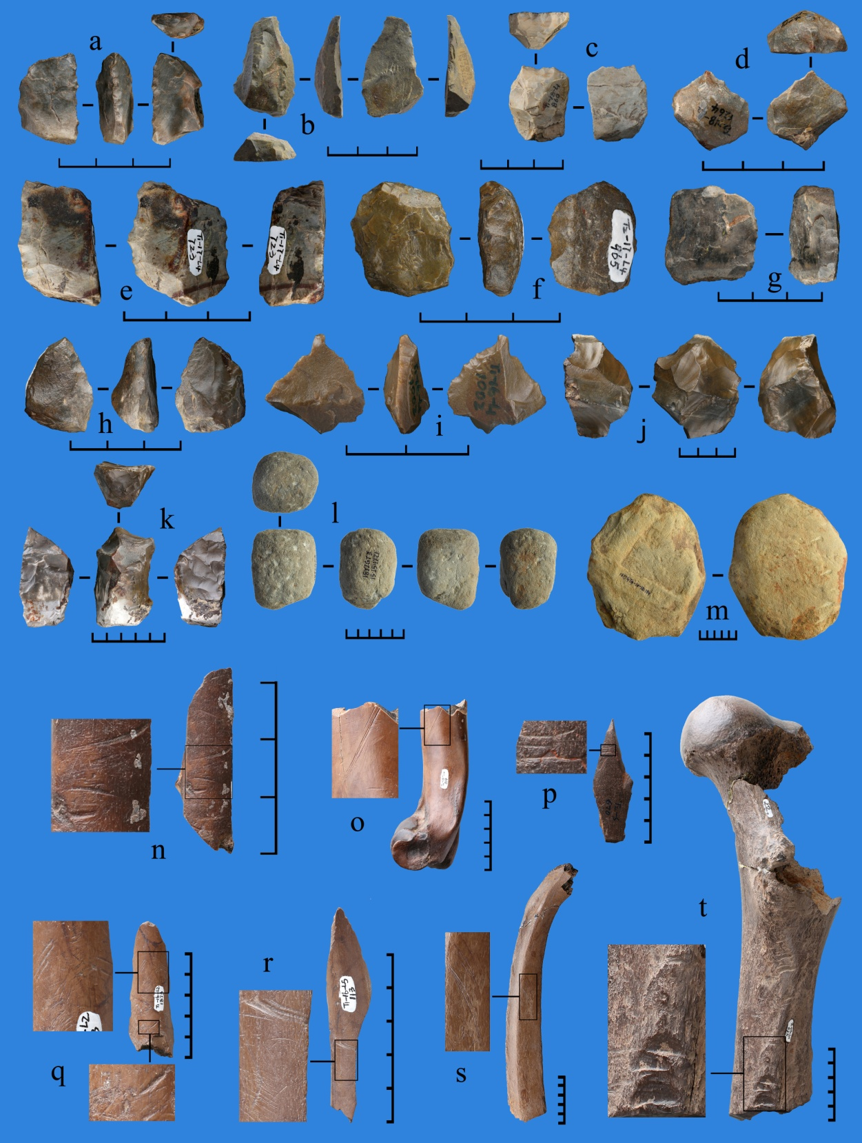
Extended Data Figure 3 | Stone artefacts and modified bones. a-c, e-i, Scrapers. d, Point. j, k, Hard hammer percussed core. l, Hammer stone. m, Anvils. n-s, Broken bones with artificial cutting marks. t, Broken bone with artificial chopping marks. Each sub-division on the scale = 1cm.
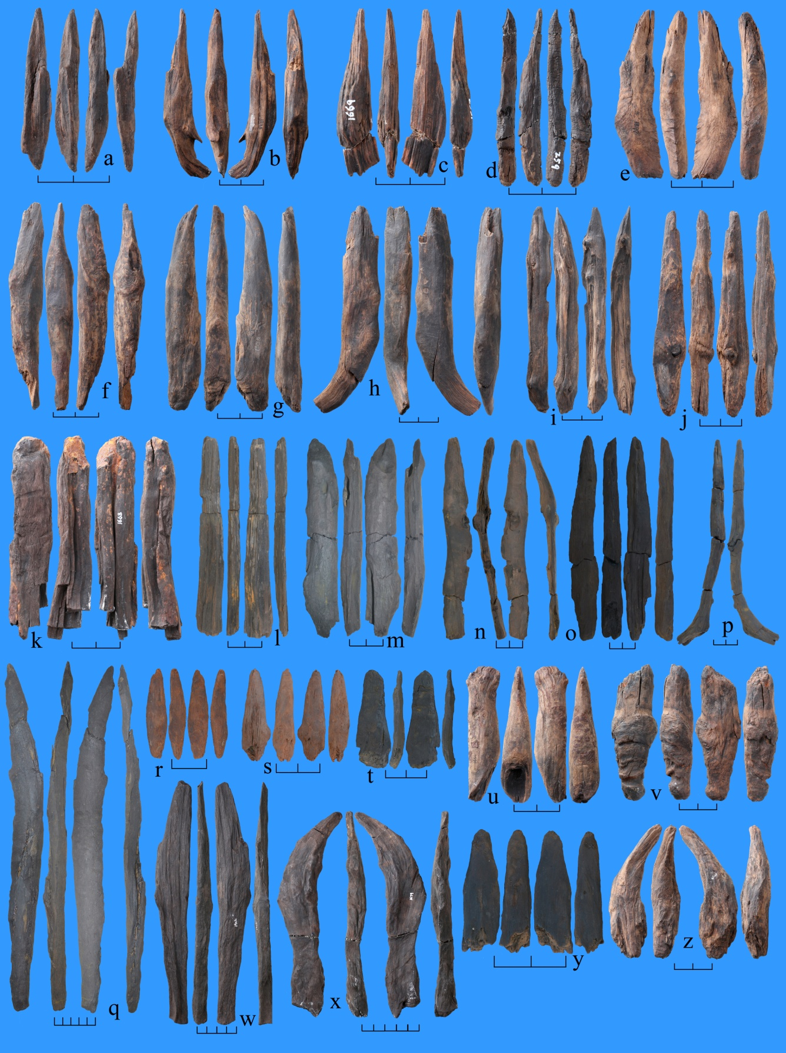
Extend Data Figure 4 | Wooden implements. a, T1-1897. b, T1-1898. c, T2-1669. d, T1-259. e, T1-1899. f, T2-1670. g, T2-1675. h, T2-1671. i, T2-1672. j, T2-1673. k, T2-1668. l, T3-177. m, T3-630. n, T3-817. o, T3-1068. p, T3-1364. q, T3-486. r, T4-193. s, T4-219. t, T3-981. u, T2-1666. v, T1-1896. w, T1-1902. x, T2-1679. y, T3-1760. z, T1-1900. Each sub-division of the scale bars is 2 cm.

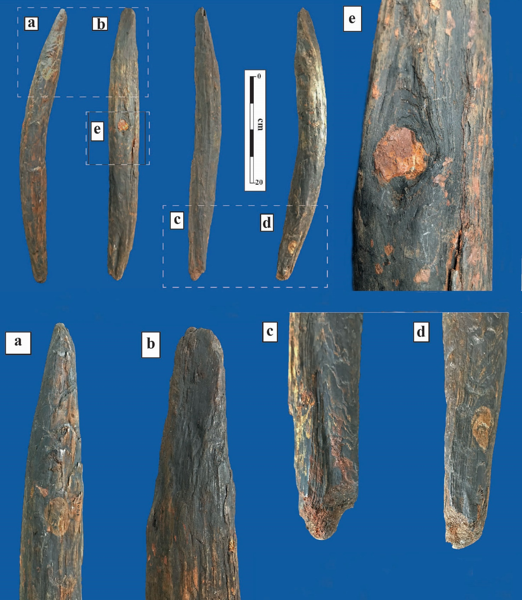
Extended Data Figure 5 | Photographs of artefact T1-1901. Note the chisel-like beveled tip (a and b); the truncated knot or side branch on the mid-shaft (e); and the rounded tip retaining some sediment (c and d).

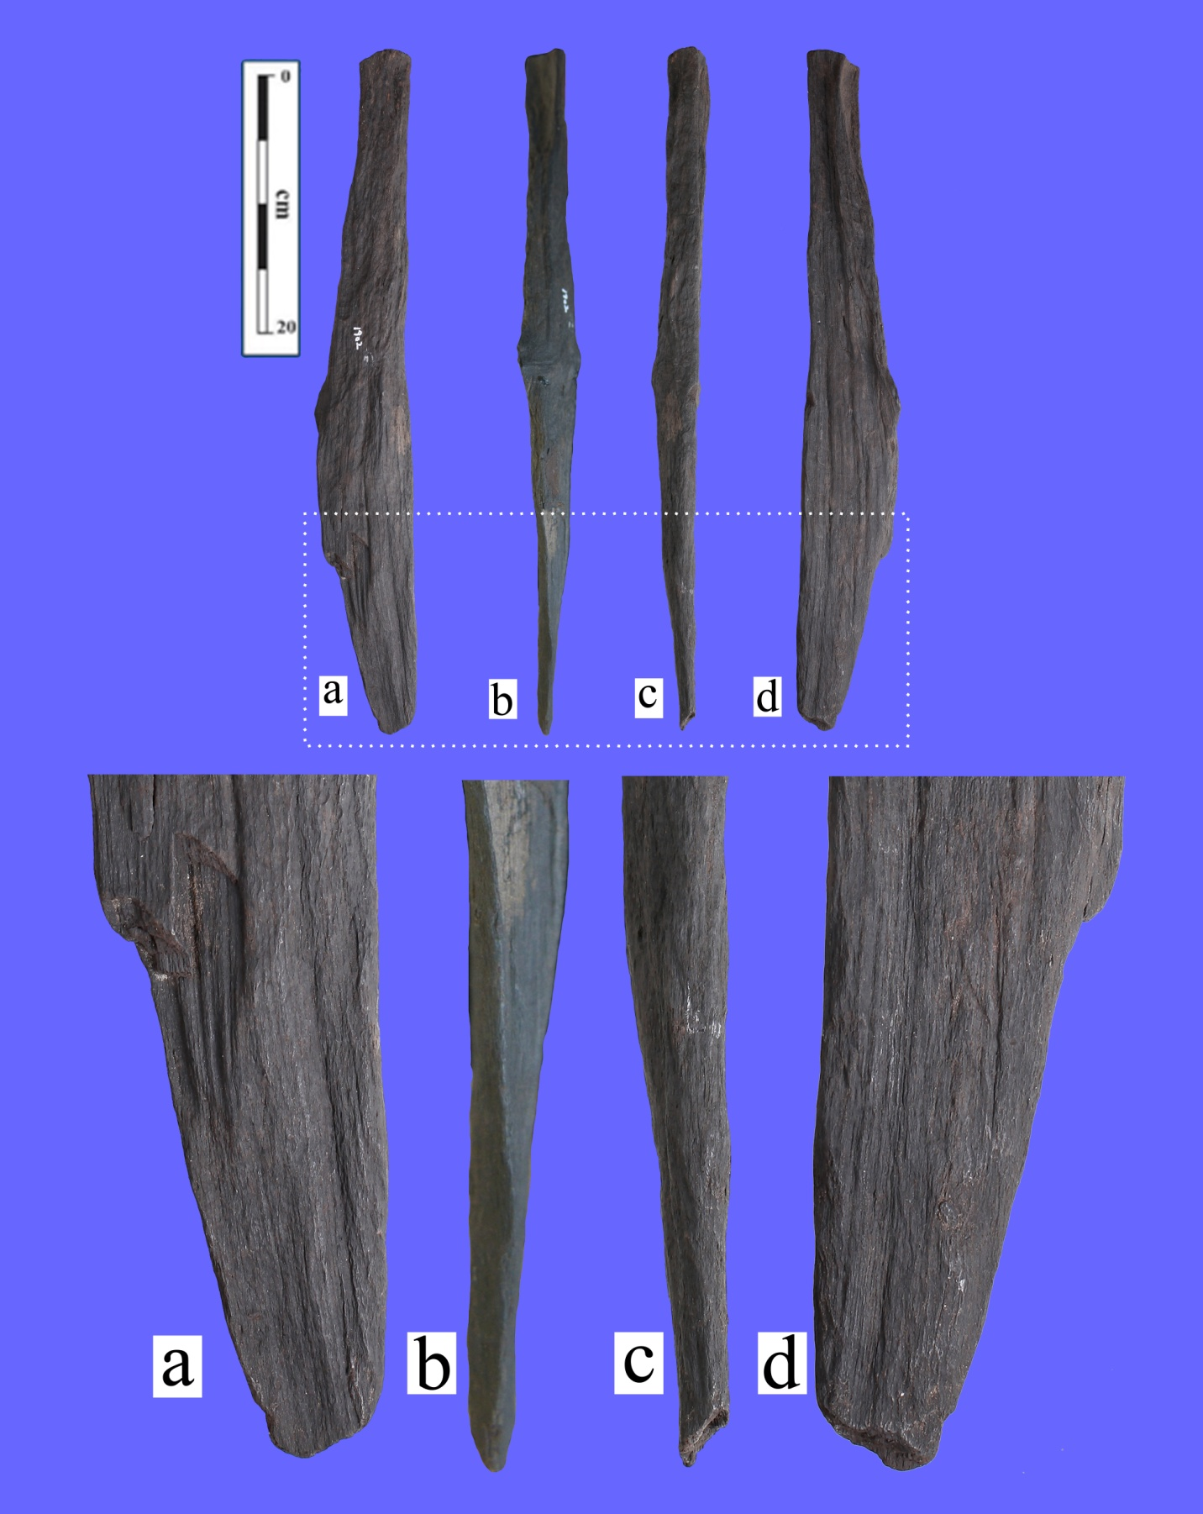
Extended Data Figure 6 | Photographs of artefact T1-1902. Note the flattened tip, with a long, thin and slightly convex blade.

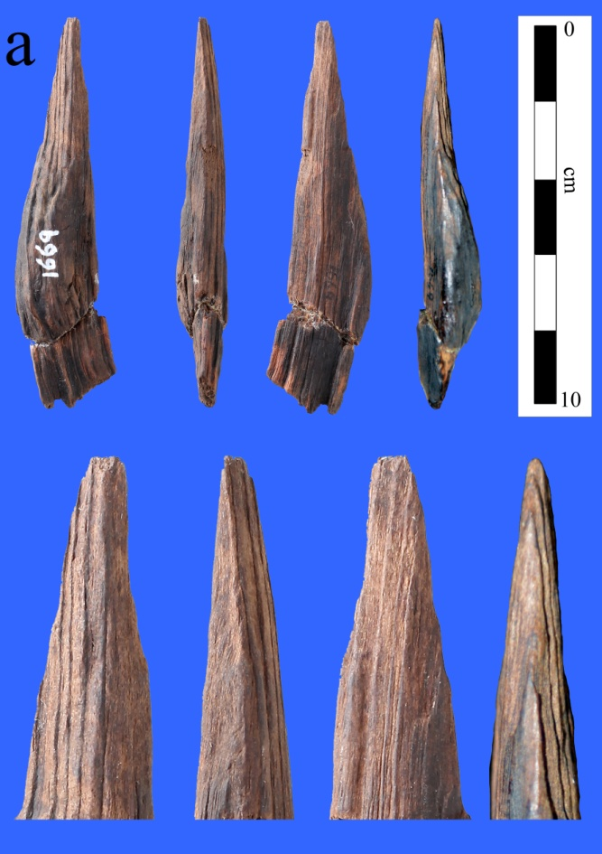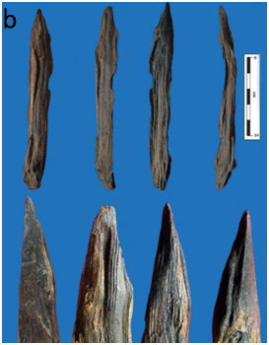
Extended Data Figure 7 | Photographs of artefact T2-1669 (a) and T2-1672 (b). Note the slender, chisel-like tip in a, and the sharp, smooth-faced convergent point in b.

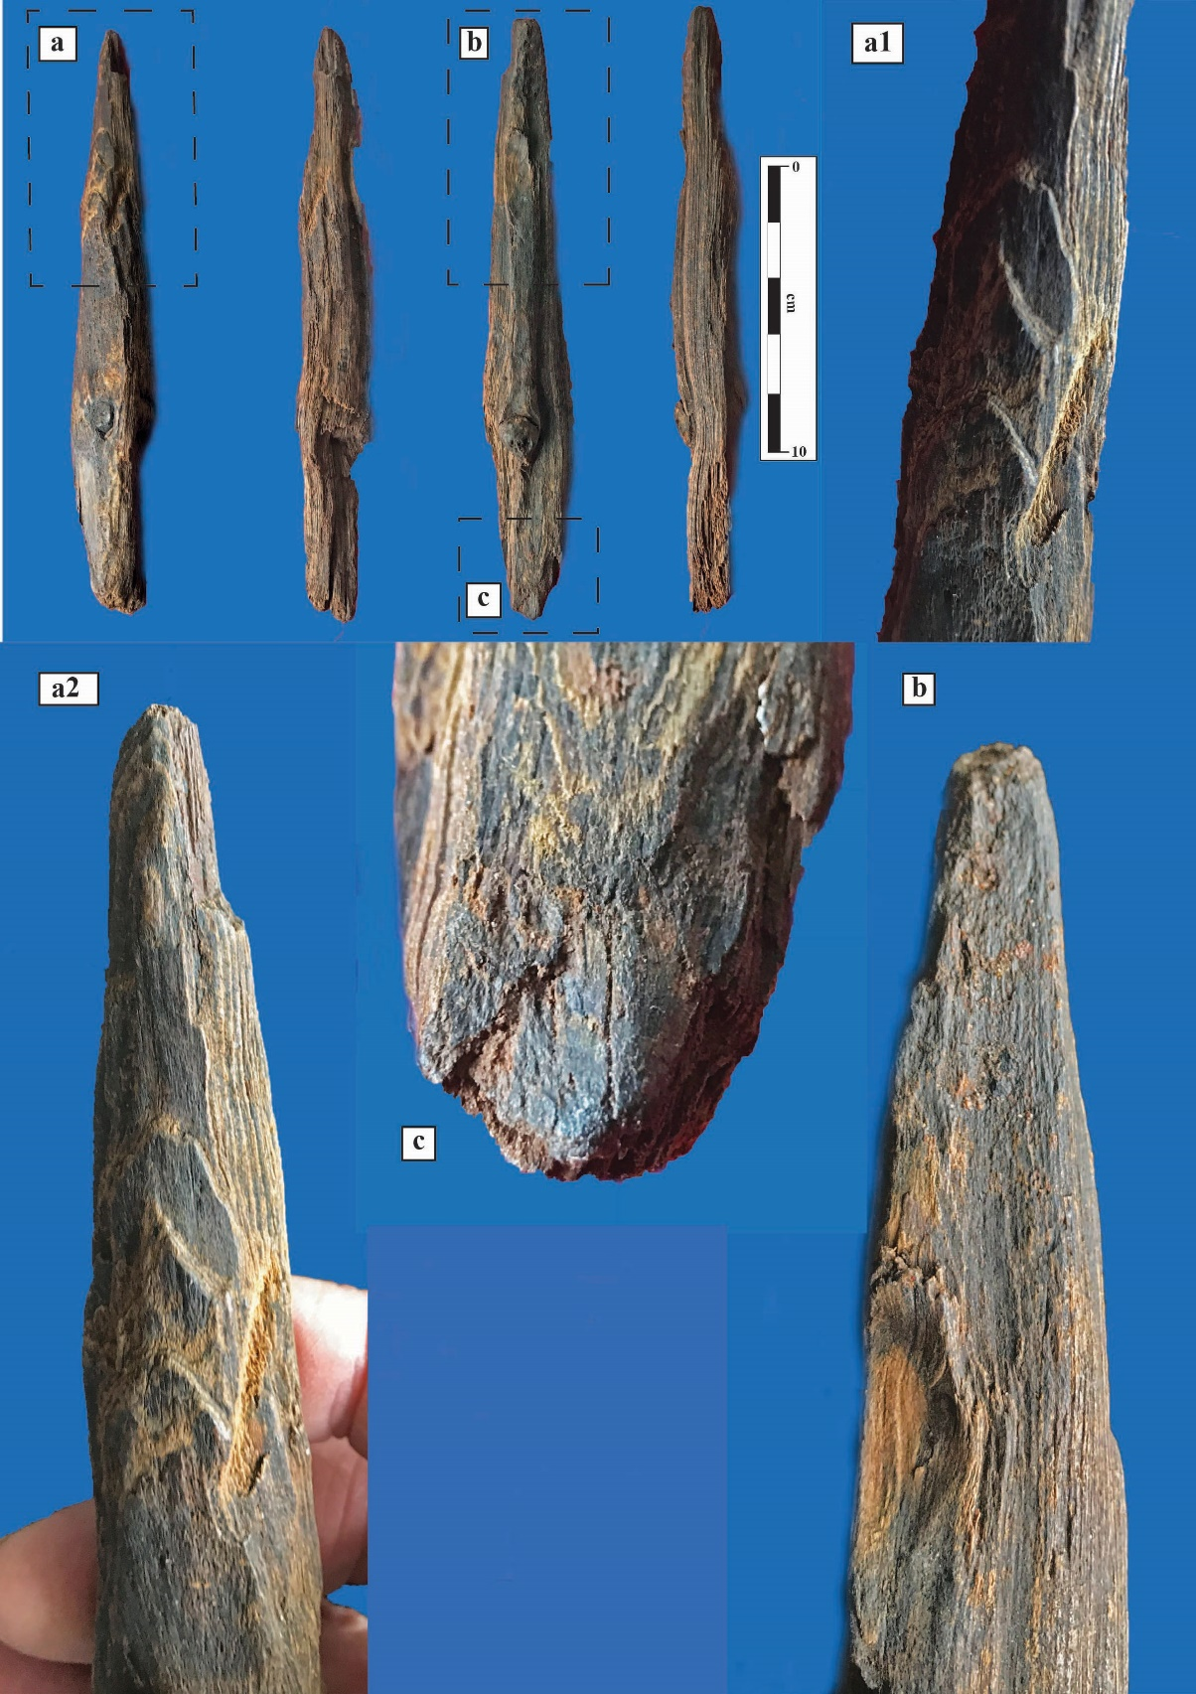
Extended Data Figure 8 | Photographs of artefact T2-1673. Note the whittling marks on one side (a1 and aii) and the shaped conical point that is slightly blunt and flat on one side (a2 and b). The other end is rounded and worn from use (c).
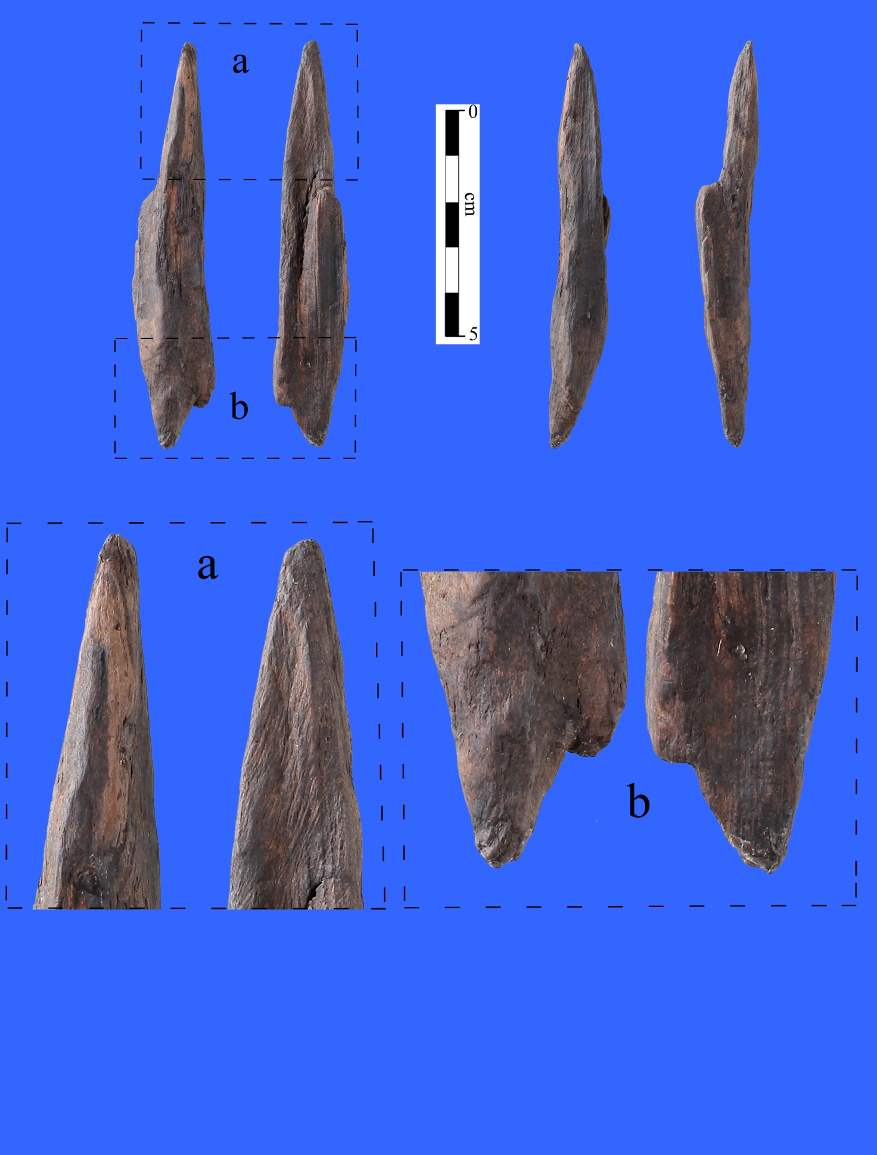
Extended Data Figure 9 | Photographs of artefact T1-1897. Note the conical tip, with a flat surface on one side similar to artefact T2-1673 (Extended Data Fig. 8).

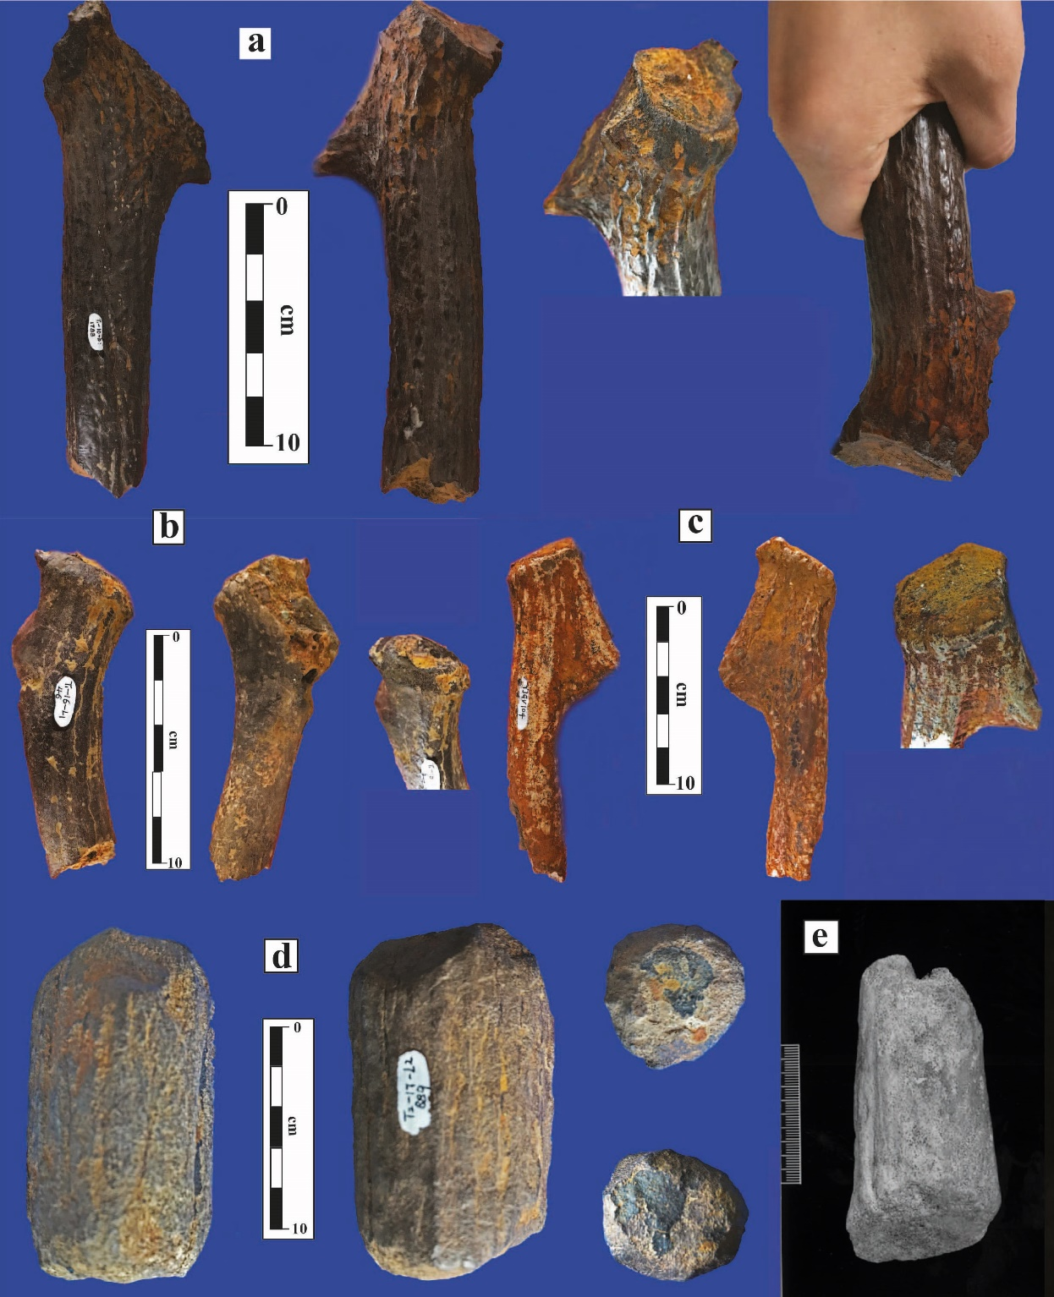
Extended Data Figure 10 | Antler soft hammers from Gantangqing. a, T1-1798. b, Tl-46. C, YJGV 104. d, T2-889. e, Antler soft hammer from Boxgrove, UK, ca. 500 ka (from Fig. 5 in Stout et al. 2014).

