Supplementary Information for

Liquid-vapor Growth of Atomically Thin Metal Tellurides with Controllable Polymorphism

Xingxing Zhang, Xu Zhang, Yimo Han, Pin-Chun Shen, Yuxuan Lin, Qingqing Ji, Ya-Qing Bie, Jiaojian Shi, Ahmad Zubair, Xiaochuan Dai, Nan Yao, Tomás Palacios, Jing Kong*, Lin Zhou*

*Corresponding author. Email: [jingkong@mit.edu](mailto:jingkong@mit.edu); [linzhou@mit.edu](mailto:linzhou@mit.edu)

**Materials and Methods**

Growth of monolayer 2H MoTe2 on mica substrate

Since Te vacancies triggers phase transition from 2H to 1T′ MoTe2, sufficient Te during growth should be a key point to obtain monolayer 2H MoTe2. Besides thermodynamic considerations which strongly determine the resulting phase of MoTe2, kinetic factor also plays an essential role in ensuring a necessary growth rate. The reaction of Te with metal precursor is weak, much weaker compared to S and Se, thus MoTe2 is harder to obtain than MoS2 and MoSe2. To address this issue, high chemical reactivity metal precursor is vital to obtain high-quality MoTe2. Similar as the stepwise reaction from MoO3+S to MoS2 1, complete tellurization of MoO3 to MoTe2 requires several nucleophilic addition-elimination reactions, and intermediates such as molybdenum dioxide and 1T′ MoTe2 mixture were often observed (fig. S4). Interestingly, 1T′ MoTe2 is always obtained from MoO3 (fig. S5). A possible underlying reason could be that the stepwise reaction and long-time growth is prone to generating Te vacancies in the as-grown MoTe2, and the presence of Te vacancies lowers the formation energy of the 1T′ phase than that of the 2H phase 2. In contrast, complete tellurization of MoCl5 to MoTe2 is much faster (0.5 h for MoO3 vs 5 min for MoCl5), which translates to high reaction rate and low possibility to generate Te vacancies. In addition, the total oxygen-free growth condition further ensures the high quality of as-grown metal telluride. Therefore, we chose metal chlorides such as MoCl5 as precursors to obtain metal tellurides.

Control the nucleation and mass flux of Mo precursor is essential to obtain ultrathin large flakes of MoTe2. MoTe2 film grown from MoCl5 usually consists of crystal domains with only tens of nanometer sizes. The low melting point of MoCl5 gives rise to high mass flux of MoCl5 precursor during vaporization, together with the high reactivity of MoCl5, leading to high nucleation density, small crystalline size film (fig. S6). Moreover, excess Mo precursor cause thick MoTe2 flake (fig. S7). Therefore, we use a long ampoule (10 cm) with a narrow neck to contain MoCl5 (fig. S8) to reduce the cross-section of the diffusion path and increase diffusion length 3, which strongly reduces the mass flux of MoCl5. The semi-enclosed design avoids hydrolysis and avoids quick reduction of MoCl5 by hydrogen. The MoCl5 precursor, mica substrates with pre- deposited Te and Te powder were loaded in CVD setup with a growth temperature of 700 ℃ (fig. S8). Under such conditions, the Te droplet which comes from pre-deposited Te on the substrate serves as a preferential reservoir for gas precursors, and subsequently MoTe2 flakes precipitate (fig. S9). Te droplets provide a higher atomic diffusion rate for Mo, favoring fast growth of MoTe2. With kinetic, thermodynamic and nucleation control as mentioned above, we synthesize high-quality monolayer 2H MoTe2.

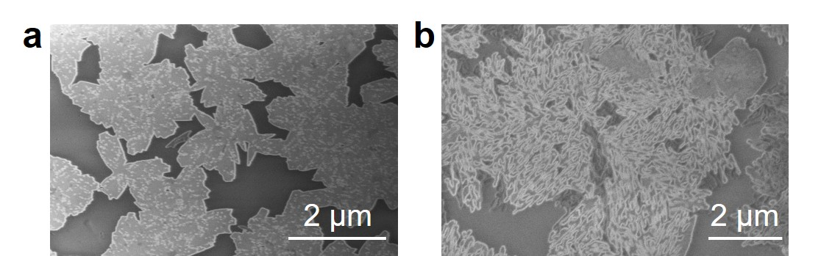

**Figure S1**. SEM image of CVD grown MoTe2 on mica. White dots on flake in (a) and white holes in (b) are defects from decomposition.

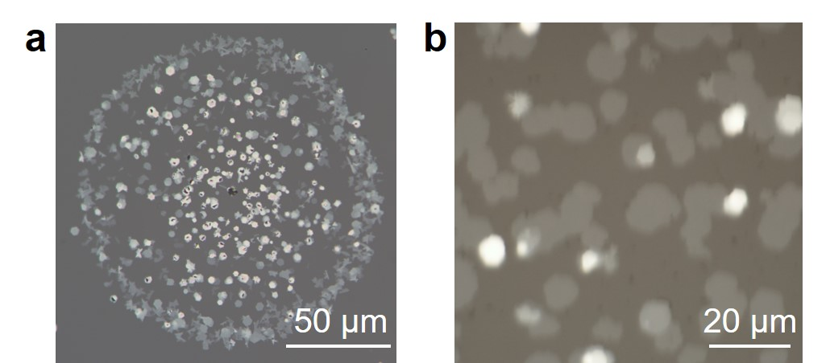

**Figure S2**. (a) The “droplet” morphology after LV growth. The white regions are as-grown MoTe2. (b) OM image of worm-like MoTe2 grown on mica.



**Figure S3.** Raman spectrum of the CVD grown GaTe shown in Figure 1f.

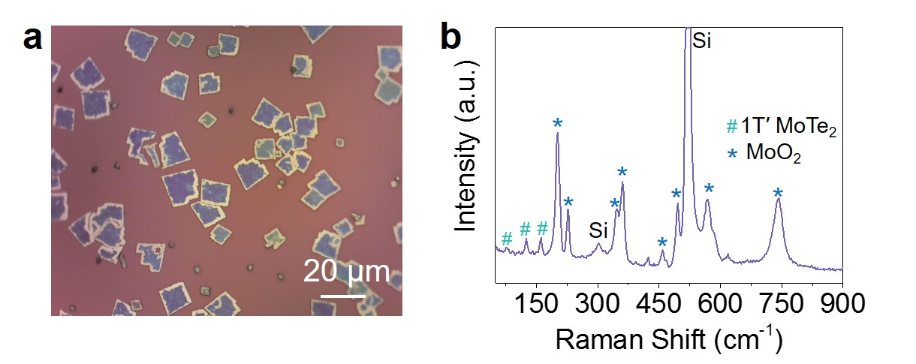 **Figure S4**. (a) Optical image of as-obtained microplates grown from MoO3. (b) Typical Raman spectra of the microplates. Peaks marked with * and # correspond to MoO2 and 1T′ MoTe2, respectively. The possible stepwise process: MoO3 + H2→MoO2; MoO2 + Te + H2→MoO2-xTe + x H2O; MoO2-xTe + Te + (3-x) H2 → MoTe2 + H2O.

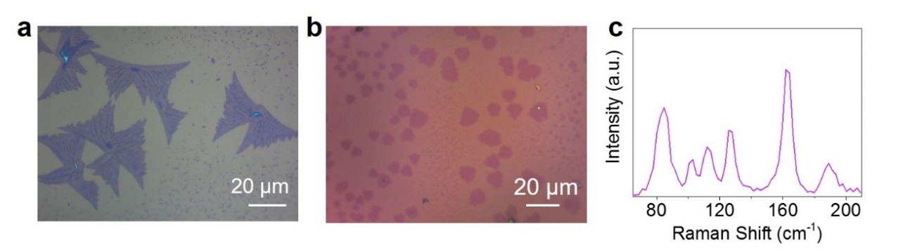

**Figure S5**. (a) and (b) Optical image of 1T′ MoTe2 flakes after tellurization of MoO3 under different conditions. (c) Typical Raman spectrum of the 1T′ MoTe2 flake.

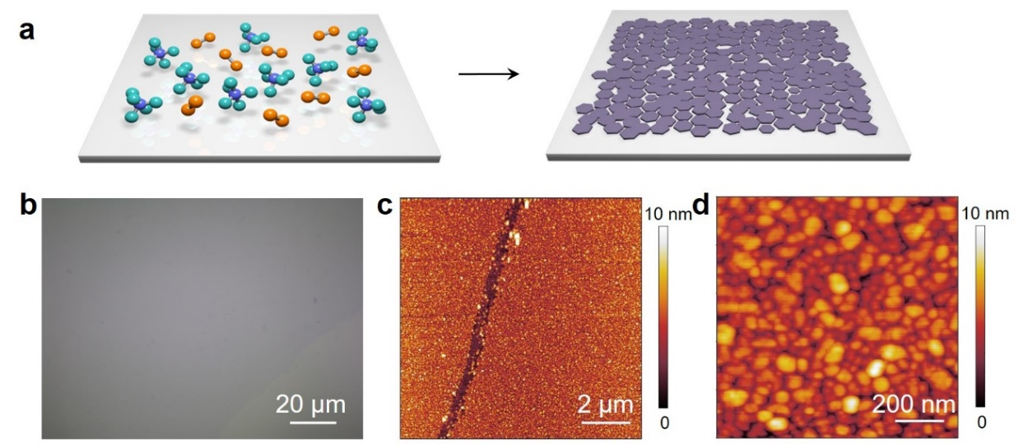

**Figure S6**. (a) High mass flux of MoCl5 leads to MoTe2 film with high-density nucleation and small crystal size. b, Typical optical image of MoTe2 film grown from high mass flux of MoCl5 (no ampoule tube). (c) AFM image of the CVD grown MoTe2 film. (d) The film is composed of high-density, small crystal size flakes.

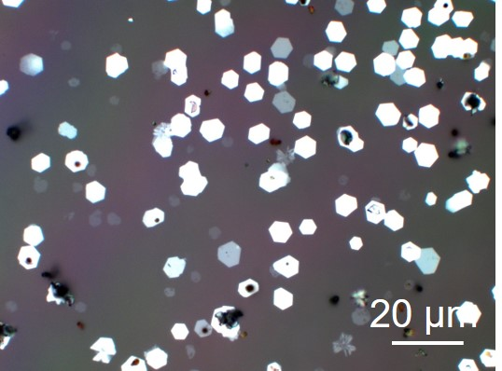

**Figure S7.** Thick MoTe2 flakes were obtained when excess MoCl5 (1.5 times) are applied.

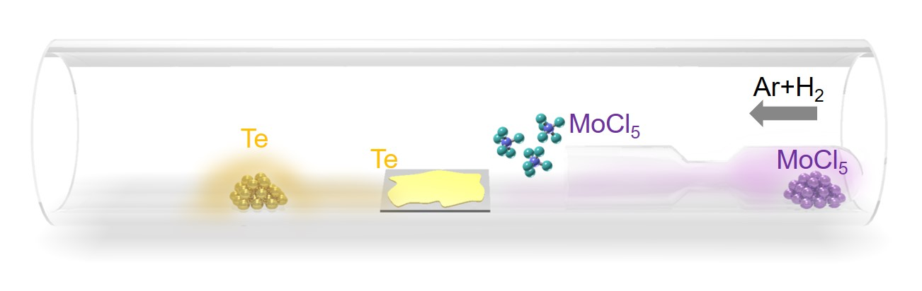

**Figure S8.** The CVD setup for the growth of 2D MoTe2. The substrates are put in the middle of the furnace, with another ampoule containing MoCl5 upstream at the edge of furnace.

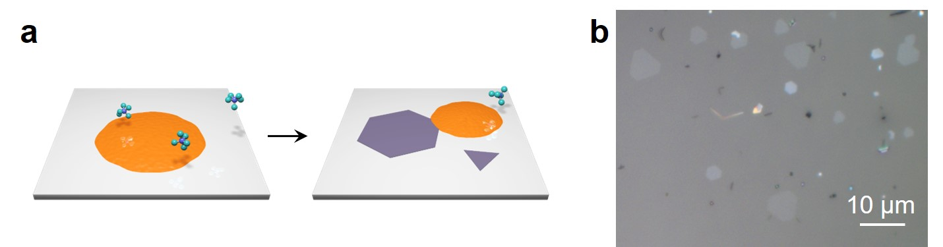

**Figure S9.** (a) MoTe2 flakes were obtained when low mass flux of MoCl5 and liquid Te were used as precursors. (b) Typical optical image of 2H MoTe2 flakes when low mass flux of MoCl5 (with ampoule tube) and pre-deposited Te were applied.

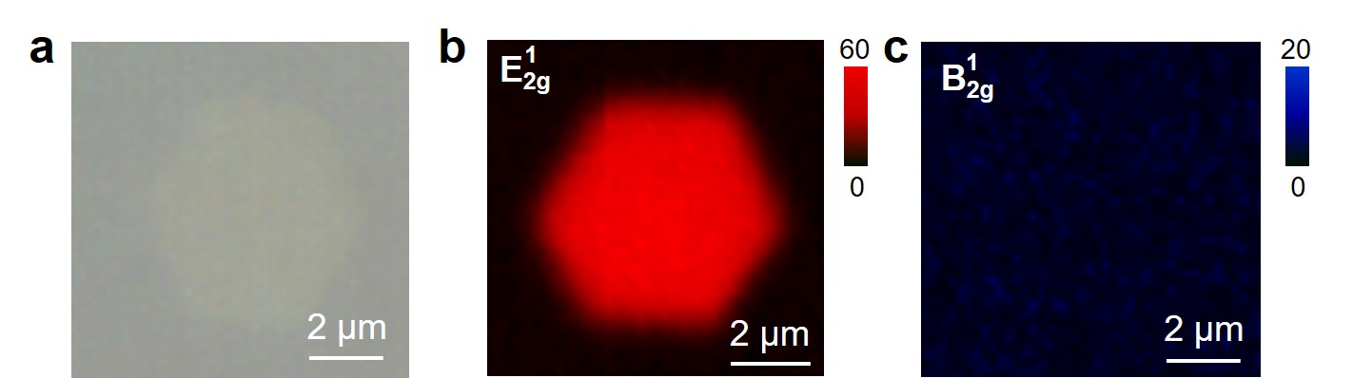

**Figure S10.** (a) Optical Microscope (OM) image of the monolayer 2H MoTe2 flake in Fig. 2d in the main text. (b) and (c) E2g1 and B2g1 intensity map of the monolayer 2H MoTe2 flake, respectively.

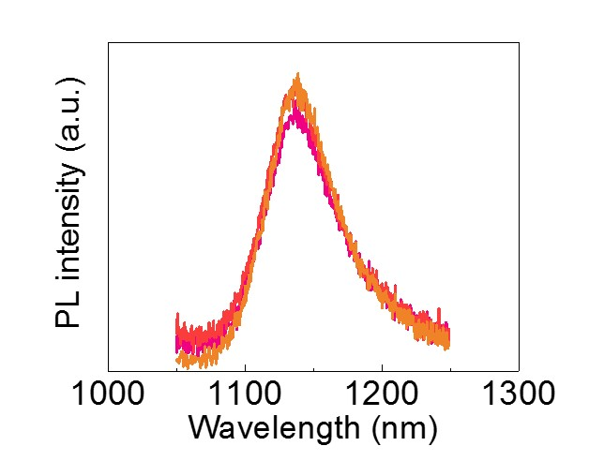

**Figure S11.** PL spectra of monolayer 2H MoTe2 film at different locations.

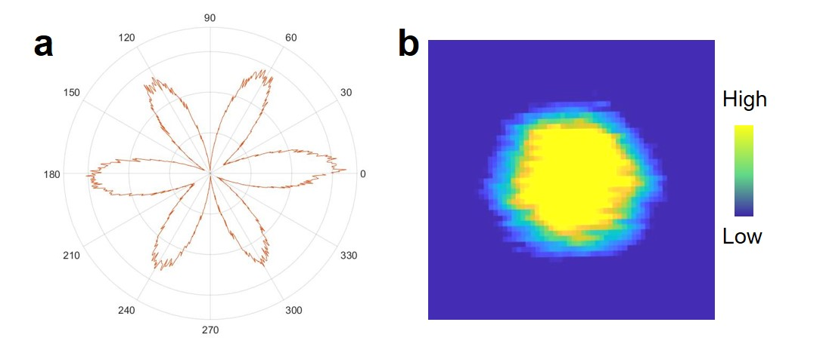

**Figure S12.** SHG property of few-layer 2H MoTe2 flake shown in figure 3A. (a) SHG intensity from a tri-layer MoTe2 flake as a function of angle. The sixfold pattern of SHG indicates the flake is 2H MoTe2. (b) SHG mapping of the tri-layer MoTe2 flake. The uniformly distributed strong SHG signal over the whole flake suggests that the flake is single crystal and homogenous. The color bar indicates the SHG intensity in arbitrary units.

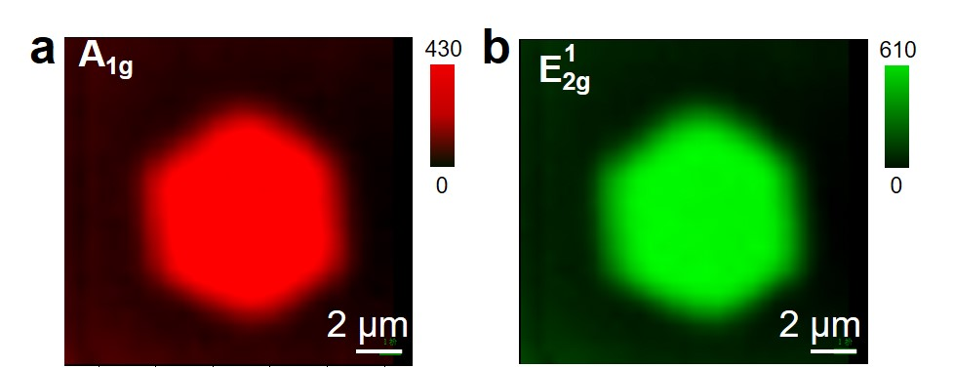

**Figure S13.** Raman mapping of the intensity of A1g (a) and E2g1 peaks (b) for the tri-layer 2H MoTe2 flake.

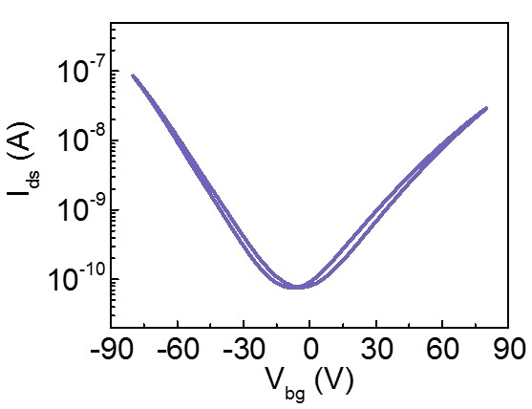

**Figure S14.** Transfer characteristics curve for a few-layer 2H MoTe2 device (Vds=5 V). The device has a channel length of 6.5 m, and a channel width of 11 m.

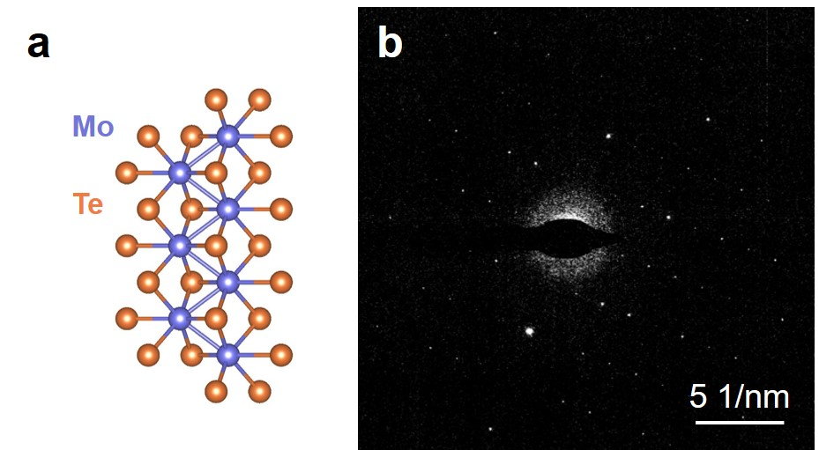

**Figure S15.** (a) Atomic structure of monolayer 1T′ MoTe2. (b) SAED patterns obtained from the as-grown 1T′ MoTe2 flake.

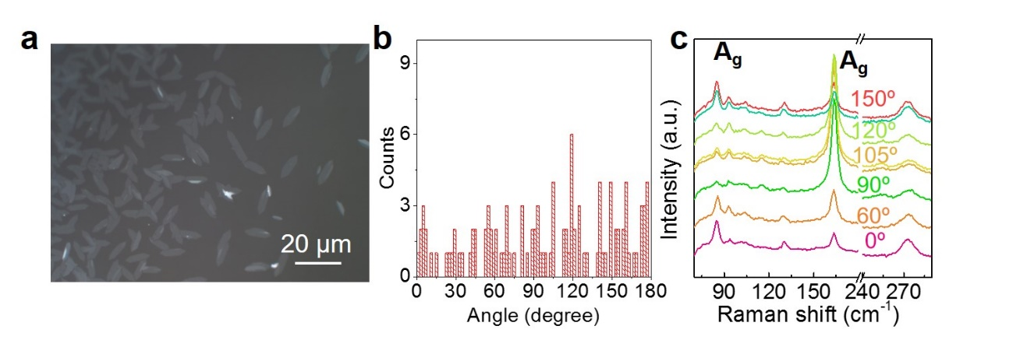

**Figure S16.** (a) Optical image of the CVD grown 1T′ MoTe2 flakes. (b) Histogram of counts and orientation angle of 1T′ MoTe2 flake. The orientation angle of a flake is defined as the angle between elongated direction and the horizontal axis. The statistical results indicate that there are preferential orientations at a period about ~30°. Given the fact that fluorphlogopite mica substrate also has a hexagonal lattice, the crystal orientation of 1T′ MoTe2 flakes could be mediated by the underlying substrate. (c) Raman spectra of 1T′ MoTe2 with different orientation angles.

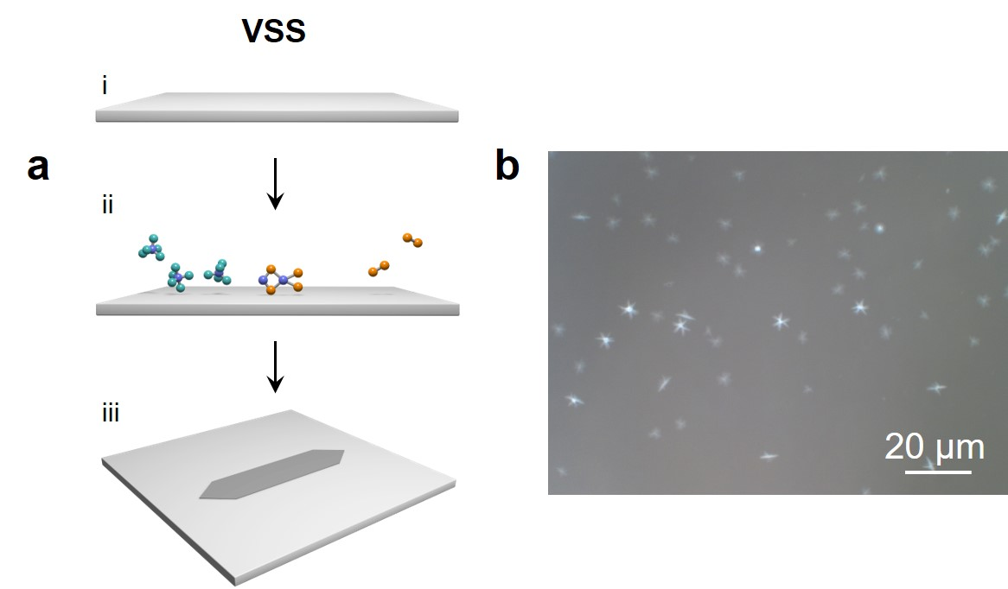

**Figure S17.** (a) The growth process of 1T′ MoTe2 *via* VSS growth. (b) Typical optical image of sample after growth when no Te was pre-deposited on the substrate. For normal vapor deposition, gaseous molecules attach on substrate, diffuse to form bonds to each other, having a low probability of crystal formation. Meanwhile, the as-formed crystal is prone to decompose and form defects because of insufficient reactants. Therefore, only sparse and small 1T′ MoTe2 (metastable phase stabilized by Te vacancy) flakes are obtained.

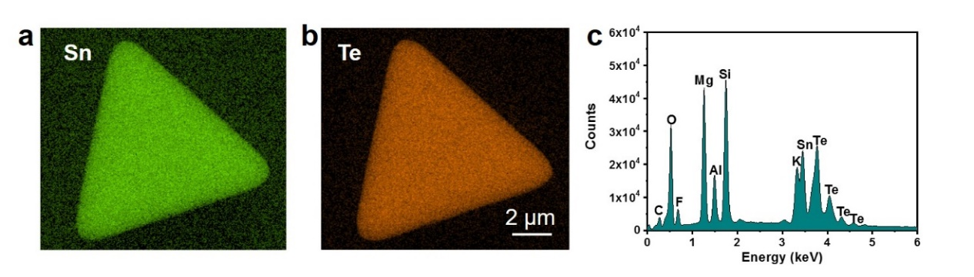

**Figure S18**. Typical EDX data of the triangle-shape SnTe flake. The atomic ratio of Sn to Te for flakes is in the range of 1.08 ~ 1.15.

**REFERENCES**

1 Pondick, J. V., Woods, J. M., Xing, J., Zhou, Y. & Cha, J. J. Stepwise Sulfurization from MoO3 to MoS2 via Chemical Vapor Deposition. *ACS Appl. Nano Mater.* **1**, 5655-5661 (2018).

2 Cho, S. et al. Phase patterning for ohmic homojunction contact in MoTe2. *Science* **349**, 625-628 (2015).

3 Wang, J. et al. Controlled Synthesis of Two-Dimensional 1T-TiSe2 with Charge Density Wave Transition by Chemical Vapor Transport. *J. Am. Chem. Soc.* **138**, 16216-16219 (2016).