Title page
Title: TRIM27 interacts with Iκbα to promote the growth of human renal cancer cells through regulating the NF-κB pathway
Chengwu Xiao, Wei Zhang, Meimian Hua, Huan Chen, Bin Yang,
Ye Wang, Qing Yang*
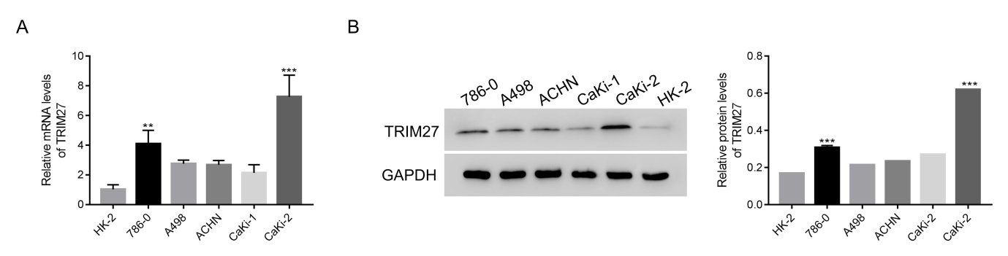
Figure S1: TRIM27 was upregulated in human renal cancer cells. A. The relative mRNA levels of TRIM27 were much higher in human renal 786-0 and Caki-2 cells than that of HK-2 cells. ** p < 0.01 vs HK-2, *** p < 0.001 vs HK-2. B. Western blot was performed to examine the protein contents of TRIM27 in HK-2, 786-0, A498, ACHN, CaKi-1 and CaKi-2 cells respectively. *** p < 0.001 vs HK-2.

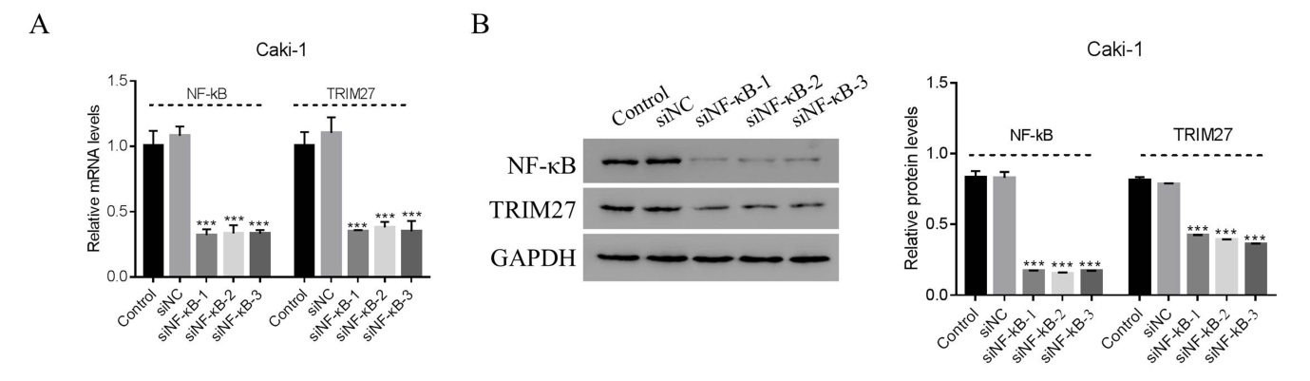
Figure 2: siNF-κB inhibited the expression of TRIM27 in Caki-1 cells. A and B. The relative mRNA and protein levels of NF-κB and TRIM27 in Caki-1 cells that transfecting with siNC, siNF-κB-1, siNF-κB-2 and siNF-κB-3 respectively. *** p < 0.001 vs siNC.

