Supplementary Tables are online at https://github.com/DooYal/Supplementary-Table-for-submitting-relatively-...-/tree/DooYal-patch-manuscript_folded/supplementary%20tables

Supplementary Figures

Figure S1
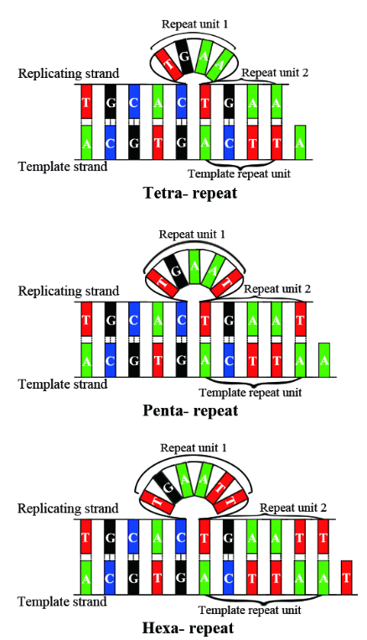
Impossible straight slippage models for tetra- to hexanucleotide repeats when the slippage bubble occurs at the replicating strand. The model drawing was based on the strict geometric calculation of the space of a nucleotide and the stability of hydrogen and phosphodiester bonds.

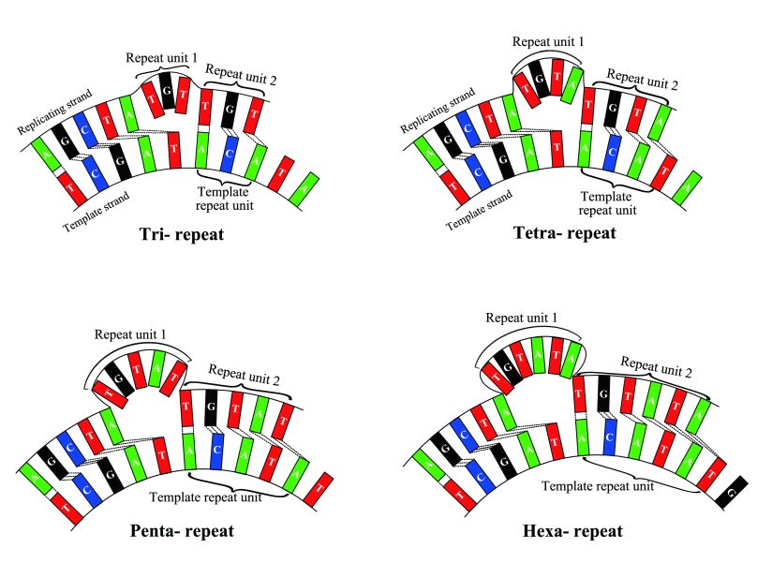
Figure S2

Impossible curved slippage models for tri- to hexanucleotide repeats when the template strand in the inner side of the models.

Figure S3
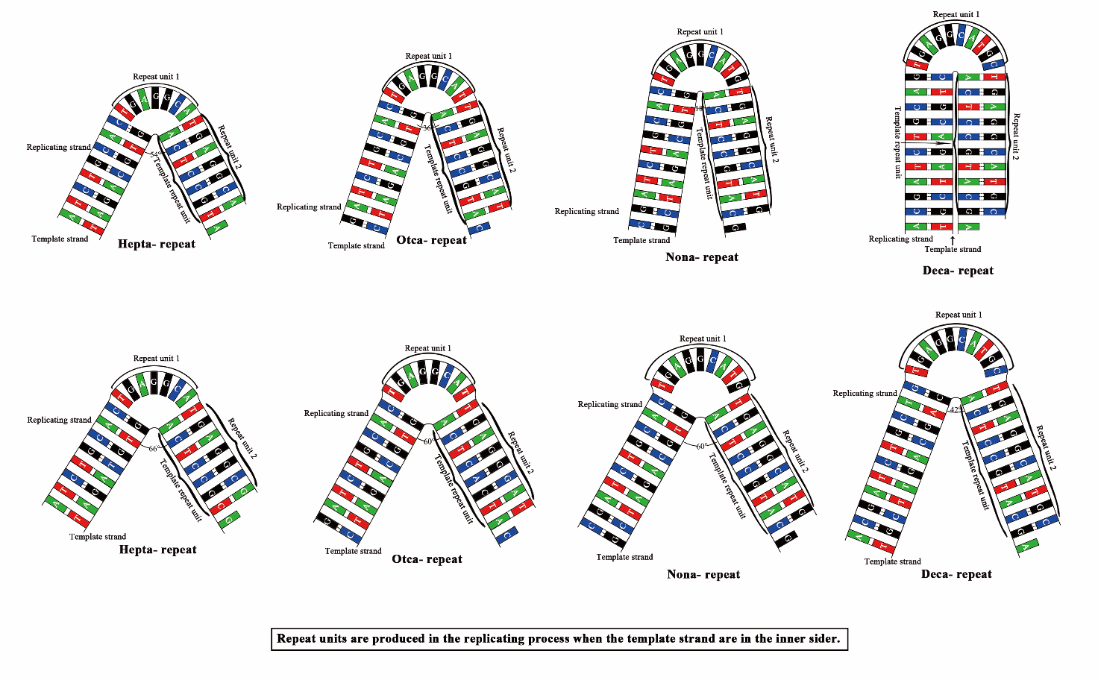
The possible folded slippage models for hepta- to decanucleotide repeat amplification. Repeat units tend to be expanded in the replicating strands when the template strands are on the inner side of the folded slippage models respectively.

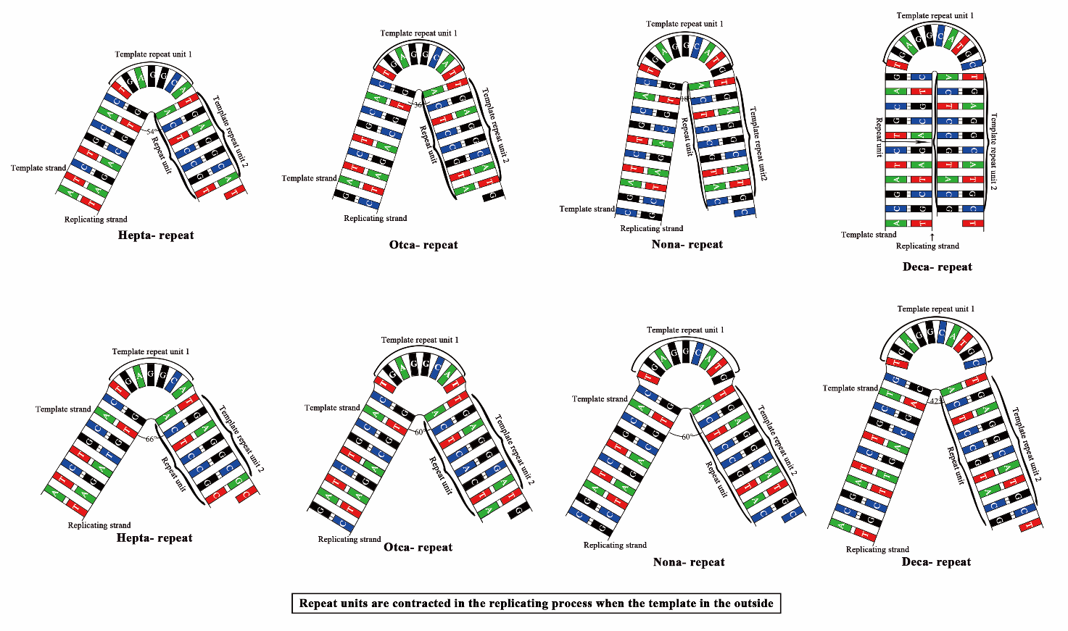
Figure S4

The possible folded slippage models for hepta- to decanucleotide repeat contraction. Repeat units tend to be subtracted in the replicating strands when the template strands are on the outside of the folded slippage models respectively.

