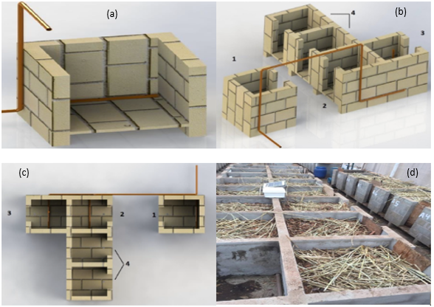
Figure S1. (a), (b), (c): graphical representations of masonry composers. (d) installation of the experiment.
Source (a), (b), (c): Passos, 2014.

