Electronic Supporting Information

Adsorption of the guanine molecule over the pristine, Nb- and Au-doped boron nitride nanosheets: a DFT study

Meryem Derdare, Abdel-Ghani Boudjahem *

Computational Catalysis Group, Laboratory of Applied Chemistry, University of Guelma, Box 401, 24000, Guelma, Algeria

* Author corresponding
E-mail address: Boudjahem@yahoo.fr (A. Boudjahem)

Figure S1. The most stable complexes obtained upon interaction of the guanine molecule with the surface of the NbBN cluster (H, I, J, K and L).

(H)
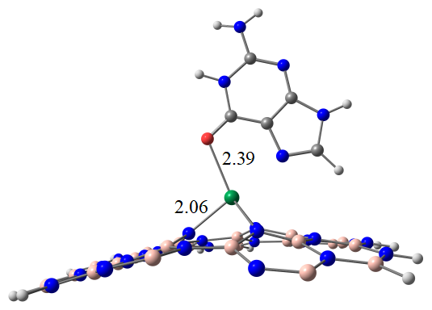
(I)  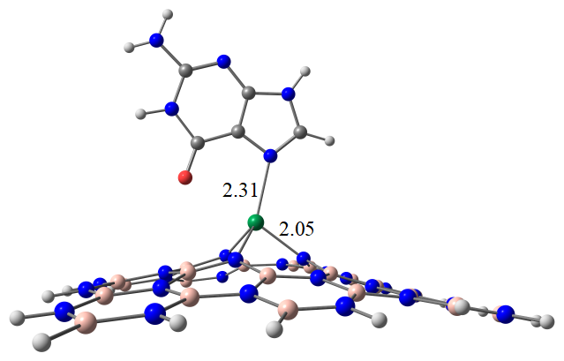 | (J)  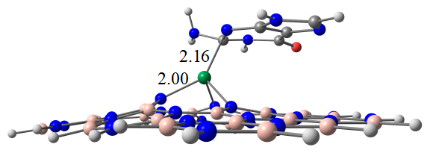
(K)  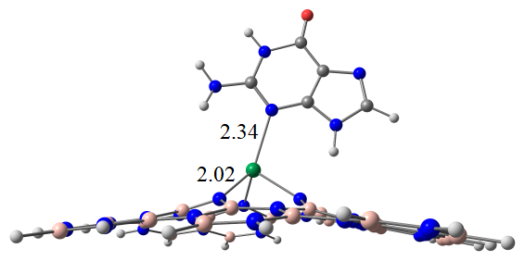 | (L)  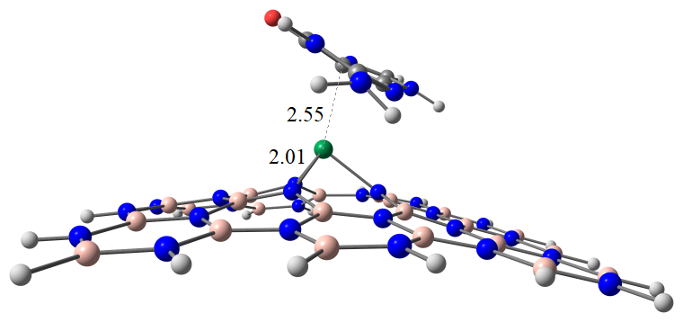

Figure S2. Frontier molecular orbitals (FMO) plots of the Nb-doped BN nanosheet and their formed complexes upon interaction with the guanine molecule (H, I, J, K and L).

HOMO LUMO
Au-BN
Complex C
Complex D
Complex E
Complex F
Complex G

Figure S3. The electron density difference (EDD) isosurfaces for the complexes H, I, J, K and L.
 | (H)
(I) |  | (J)
(K) |  | (L)

