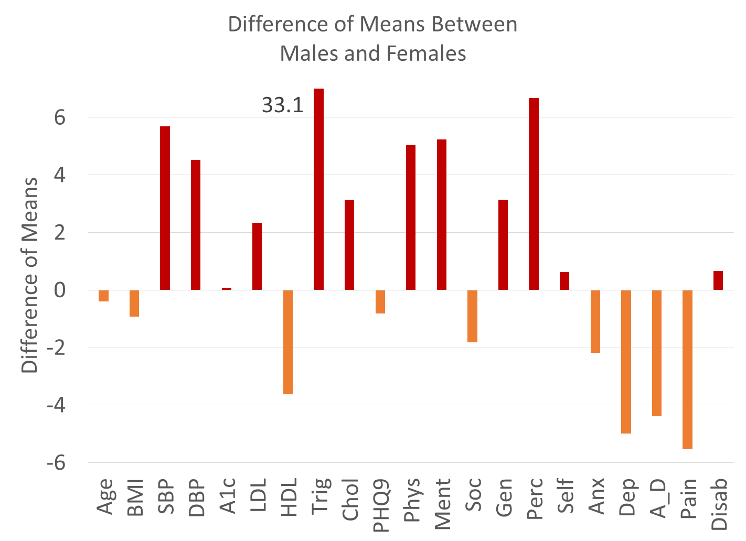
Figure . The plot of the difference of means as calculated by Hoteling T2 is the squared difference of mean vectors scaled against the co-variance matrix for age (yrs), BMI, SBP (systolic blood pressure), DBP diastolic blood pressure), A1c (HbA1C), LDL, HDL, Trig (Triglycerides), Chol (Cholesterol), PHQ9, physical health, mental health, social health, general health, perceived health, self-esteem, anxiety, depression, anxiety-depression, pain, disability. Above zero reflects a higher male value (red) and below zero reflects a higher female value (orange)

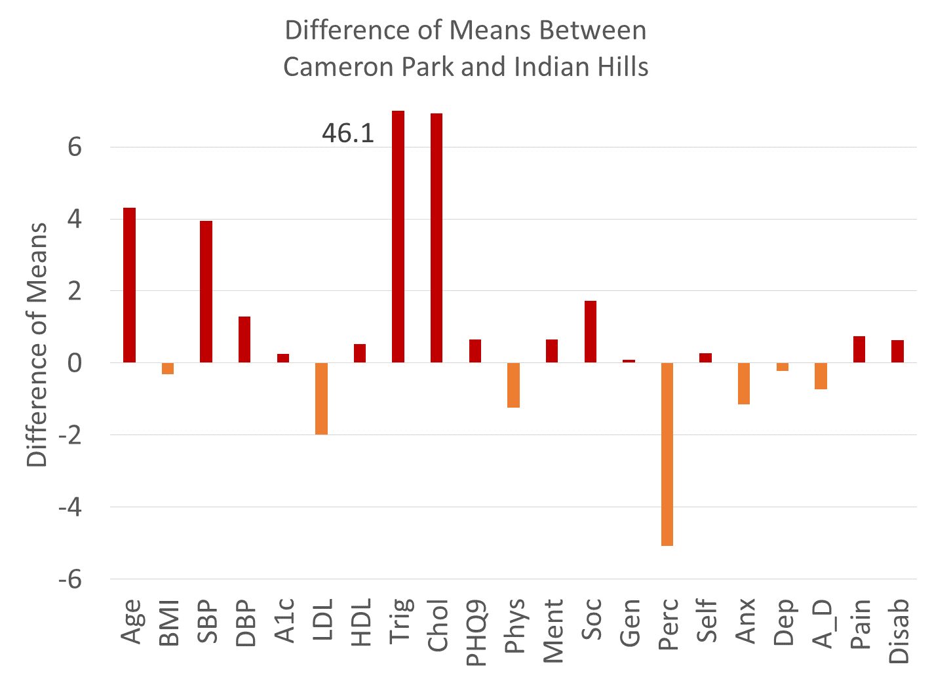

Figure. The plot of the difference of means as calculated by Hoteling T2 is the squared difference of mean vectors scaled against the co-variance matrix for age (yrs), SBP (systolic blood pressure), A1c (HbA1C), HDL, Chol (Cholesterol), physical health, social health, perceived health, anxiety, A_D (anxiety-depression), pain, and disability. Above zero reflects a greater value in CP (red) and below zero reflects a greater value in Indian Hills (orange).

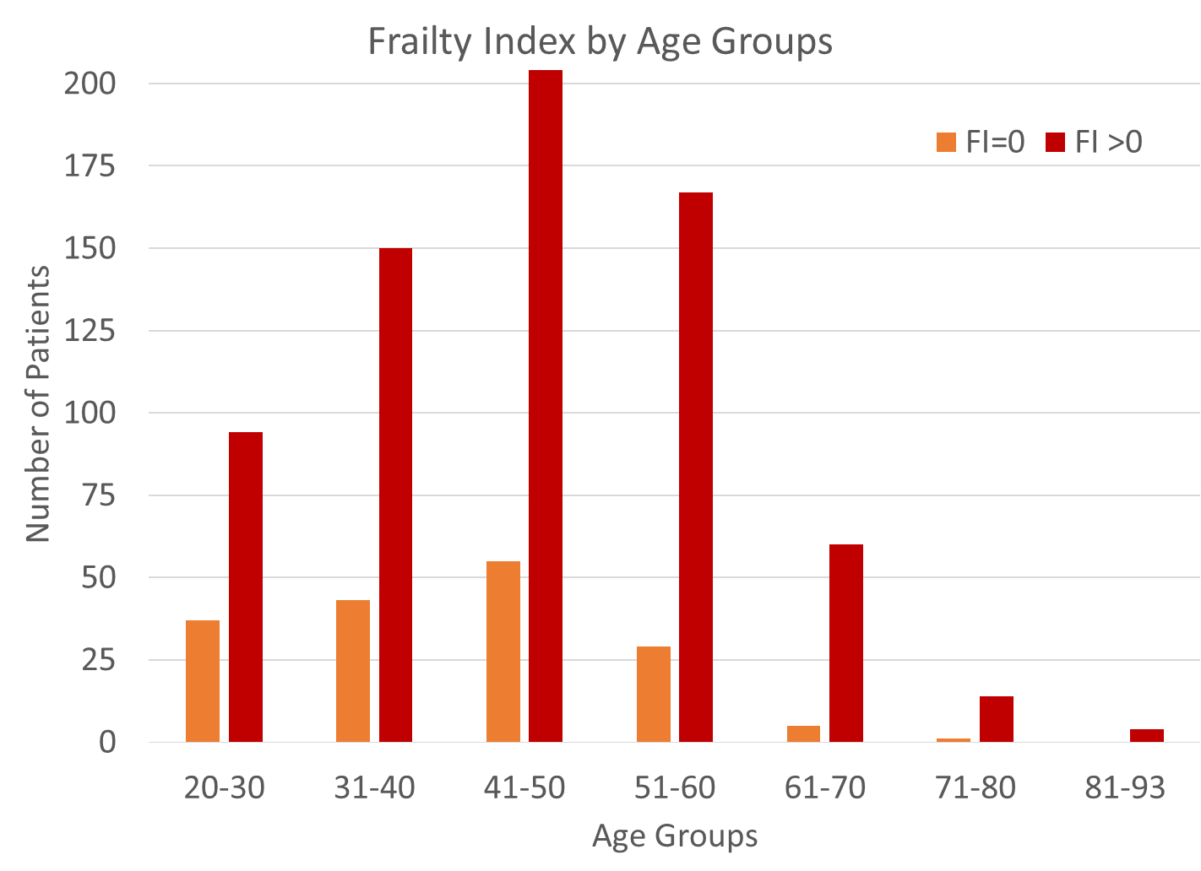

Figure . Proportion of FI=0 and FI greater than zero. The proportion of patients with a non-zero Frailty Index increased significantly (p<.001) from the younger to older age groups (20-45 vs. 46-93).

