Supplementary 1. Table 1. List of primers used in qRT-PCR

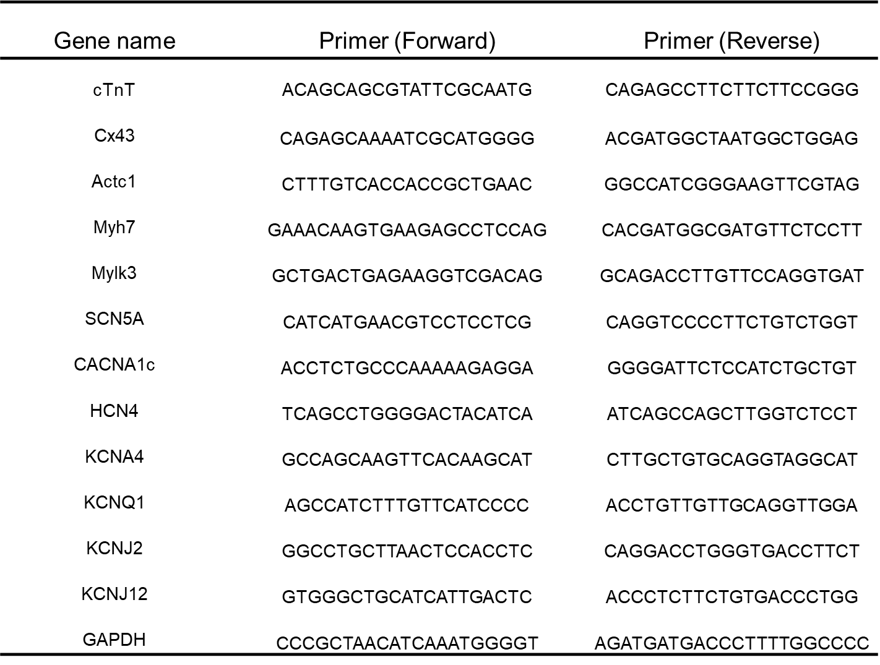

Supplementary 2. live images a, b, c, and d. Comparison of live imaging between control at (a) day 7, (b) day 14 and stimulated groups at (c) day 7, (d). The beating area of the stimulated group gradually increased during culture compared to that in the control group.

