Additional file 1: Data collected and used for social network analysis per task
# | Task | HIS data | Documents | Observations | Interview
1 | Make OTC master schedule |  | - Internal presentation on working procedures  - OTC master schedules |  | - OTC capacity planner  - Surgeon  - Anesthesiologist
2 | Make clinical bed plan |  | - Clinical bed plan  - Internal presentation on clinical bed planning |  | - OTC capacity planner
3 | Schedule surgeons and anesthesiologists | - Number of surgeons and anesthesiologists involved in surgeries in 2017 | - Number of surgeons and anesthesiologists on hospital website | - Three outpatient departments with 7 secretaries  - Preoperative department with 1 secretary | - 2 surgeons  - 1 anesthesiologist  - OTC capacity planner
4 | Schedule OT nurses | - Number of OCT nurses involved in surgeries in 2017 | - Working schedules OTC nurses  - Overview of OTC nurses  - Clusters of OTC nurses  - Sign up forms working shifts  - Overview of working day preferences |  | - 3 team leaders of the OTC
5 | Plan equipment maintenance |  |  |  | - OTC capacity planner
6 | Plan surgery | - Number of surgeons and anesthesiologists involved in surgeries in 2017 | - Number of surgeons and anesthesiologists on hospital website  - Planning rules for general surgery  - Time out procedure | - Three outpatient departments with 6 secretaries | - OTC capacity planner  - 2 surgeons  - 1 anesthesiologist
7 | Order materials |  | - Overview of OTC nurses responsible for ordering materials for specific surgeries | - 3 outpatient departments with 6 secretaries  - OTC day coordinator | - Team leader of the OTC  - OTC capacity planner
8 | Preoperative screening | - Number of anesthesiologists involved in surgeries in 2017 | - Overview of staff in preoperative screening  - Time out procedure | - Preoperative screening department with preoperative secretary, preoperative nurse,  - pharmacy assistant and anesthesiologist | - OTC capacity planner
9 | Make appointment |  | - Overview of staff in preoperative screening | - Preoperative secretary  - 3 outpatient departments with 6 secretaries
10 | Plan OT nurses |  | - Overview number of OTC nurses  - Planning of OTC nurses | - OTC day coordinator | - Team leader of the OTC
11 | Control planning |  | - Planning checklist OTC program | - OTC day coordinator  - Surgeries in two Operating Rooms  - 3 outpatient departments with 6 secretaries | - OTC capacity planner
12 | Pick materials |  |  | Logistical staff on OTC

# | Task | HIS data | Documents | Observations | Interview
13 | Emergency admission |  |  | OTC day coordinator | - Team leader Emergency Department
14 | Prepare patient on ward | Surgery registration data including the ward for each patient | - Overview of number of ward nurses for each nursing ward  - Day program  - Time out procedure | 2 nursing wards
15 | Prepare patient in holding | Surgery registration data of 2017 | - Holding checklists  - Process flow scheme holding  - Time out procedure | Holding
16 | Make Radiology image |  |  | - Surgeries in two Operating Rooms  Recovery
17 | Doing surgery | - Surgeons, anesthesiologists, OTC staff involved in each surgery in 2017 | - Time out procedure | - Surgeries in two Operating Rooms  - OTC day coordinator | - 2 surgeons  - 1 anesthesiologist
18 | Clean OR |  |  | - Surgeries in two operating rooms | - OTC capacity planner
19 | Order emergency CSD services |  |  | - OTC day coordinator  - Central Sterilization Department
20 | Patient care recovery | - Surgery registration data | - Time out procedure | Recovery | - Team leader Recovery
21 | Aftercare of patient | - Surgery registration data including the ward for each patient, surgeons involved in the surgery and patient transfers | - Overview of number of ward nurses for each nursing ward  - Time out procedure | - 2 nursing wards | - 2 surgeons
22 | Manage OT day program |  |  | - OTC day coordinator  - Surgeries in two Operating Rooms | - 1 anesthesiologist  - 2 surgeons
23 | Manage OT tasks |  | - Emails including planning of management meetings |  | - Cluster manager OTC and Services  - OTC capacity planner  - 3 team leaders of the OTC

Additional file 2: Social network per task

- Make the OR master schedule

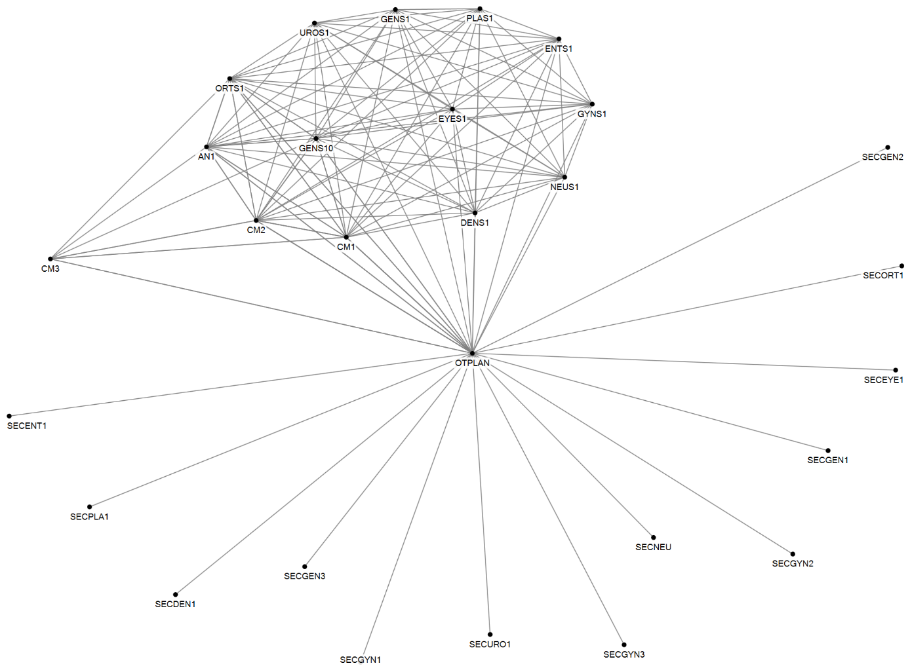
Figure 1 Social network of Task 1: Making the OR master schedule
Parameter | Value
Number of agents | 28
Number of unique ties | 110
Density | 0.29
Number of cliques | 2
Highest betweenness centrality | OTPLAN

The Operating Room (OR) master schedule is made in the Tactical Planning Meeting (TPM). Three cluster managers who are responsible, respectively, for outpatient, inpatient departments and Operating Theatre Complex (OTC), three general surgeons, an orthopedic surgeon, an anesthesiologist and the OTC capacity planner participate in this meeting. The OR master schedule is prepared by four participants of the TPM, who then propose the scheme to the entire TPM. The OR master schedule is then presented to the OTC commission. The OTC commission discusses and advises OTC management on planning, staff and budget issues. The OTC commission includes one surgeon from every surgical discipline, the cluster manager responsible for the OTC and the OTC capacity planner. When the session schedule is final, the OTC capacity planner informs all outpatient secretaries of all changes made.

- Make the clinical bed plan

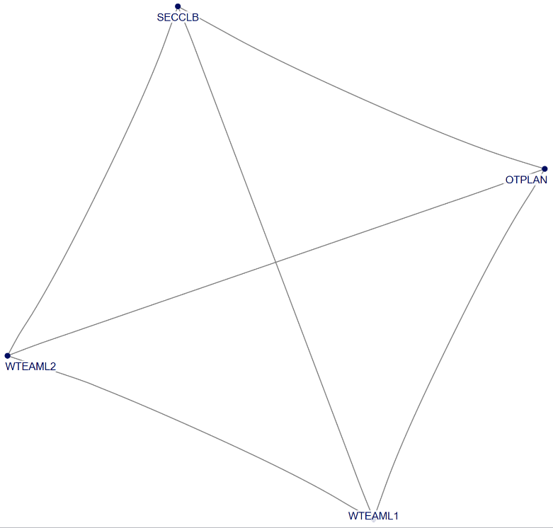
Figure 2 Social network of Task 2: Making the clinical bed plan

Parameter | Value
Number of agents | 4
Number of unique ties | 6
Density | 1
Number of cliques | 1
Highest betweenness centrality | N/A
In the clinical bed plan, beds are assigned to a medical discipline for each nursing department. The clinical bed plan is established in consultation between the OTC capacity planner, one secretary from the nursing department and the two team leaders of the three nursing wards who host most surgery patients. The team leaders of these nursing wards are also involved in making the clinical bed plan, but one nurse ward secretary has the informal role of ‘clinical bed plan boss’. She uses this plan to correct outpatient clinics when they take a bed they cannot claim.

- Schedule surgeons and anesthesiologists

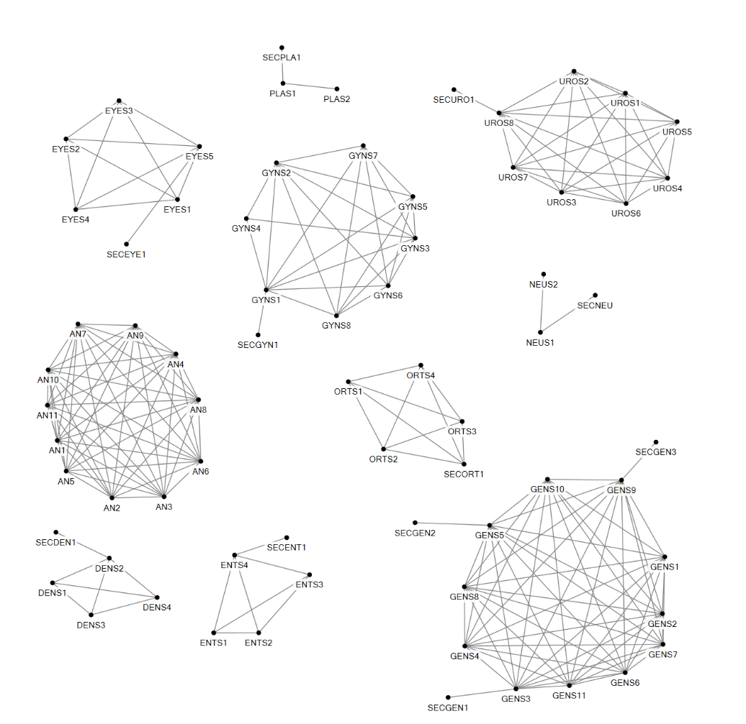

Figure 3 Social network of Task 3: Scheduling surgeons and anesthesiologists

Parameter | Value
Number of agents | 70
Number of unique ties | 206
Density | 0.09
Number of cliques | 10
Highest betweenness centrality | GENS3/GENS9
The OR master schedule is also used for preparing staff planning schemes. The surgeons of each outpatient department and anesthesiologists make these schedules for themselves and allocate surgeons to the time slots in the OR master schedule. One surgeon within each medical discipline group proposes the schedule and discusses it with the other surgeons. In some outpatient departments the secretary of the outpatient department is involved in this.

- Schedule OTC nurses

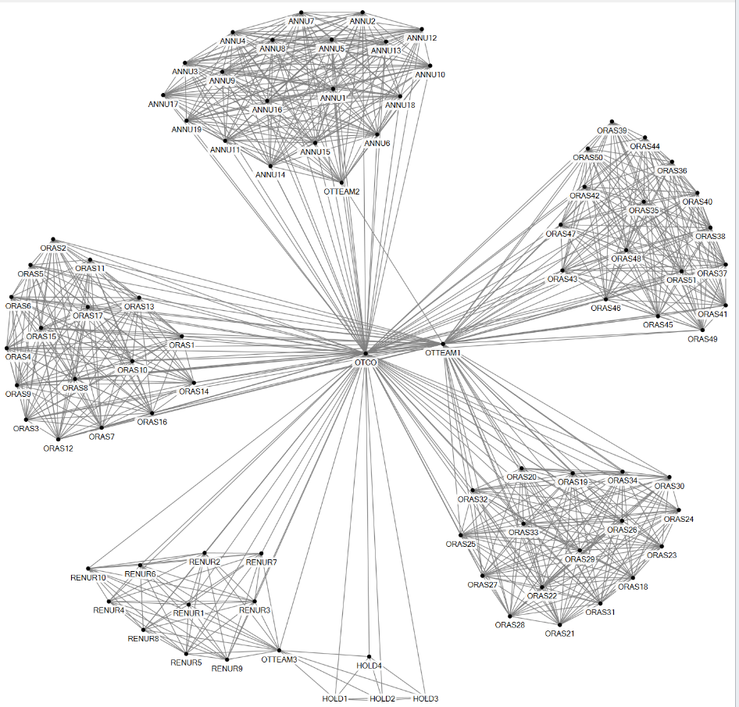
Figure 4 Social network of Task 4: Scheduling OTC nurses

Parameter | Value
Number of agents | 88
Number of unique ties | 801
Density | 0.2
Number of cliques | 6
Highest betweenness centrality | OTCO
The OTC surgery team leader plans the schedule with the OR nurses. He makes a schedule based on the OR master schedule and communicates with OR nurses about it. In this planning process a number of factors which require interaction are taken into account. OR nurses sign up for shifts outside regular operating times on nights and weekends. The surgery team leader verifies if the nurses have signed up for the agreed number of shifts and, if necessary, makes changes in this scheme to create a fair division of shifts. When all shifts are filled, the team leader fills in the OR day schedule, taking into account the clusters of medical disciplines to which each OR nurse belongs. He also takes into account the employees who want to work on fixed days and after that the shifts for the more flexible nurses are planned. In the event of an expected shortage of OR nurses, the team leader sends an email to the OR nurses, asking them to volunteer for that particular day. If they do not volunteer, the surgery team leader picks someone. The complete OR schedule is then released to all OR nurses via the IT system. At this point OR nurses are allowed to exchange hours among themselves within the three clusters of medical disciplines. If a 'deal' has been concluded between two or more OR assistants and the date at issue is at least two weeks in advance, they make a proposal to the surgery team leader, who assesses this and agrees. If it concerns a date within the next two weeks, the proposal is presented to the OTC day coordinator and he approves or disapproves it. The OTC day coordinator is responsible for the daily operation of the OTC, making sure that all surgeries are performed according to plan.
The OTC anesthesia team leader makes the schedule for the nurse anesthetists and the team leader holding and recovery makes the schedule for the holding and recovery nurses following a similar procedure.

- Plan equipment maintenance

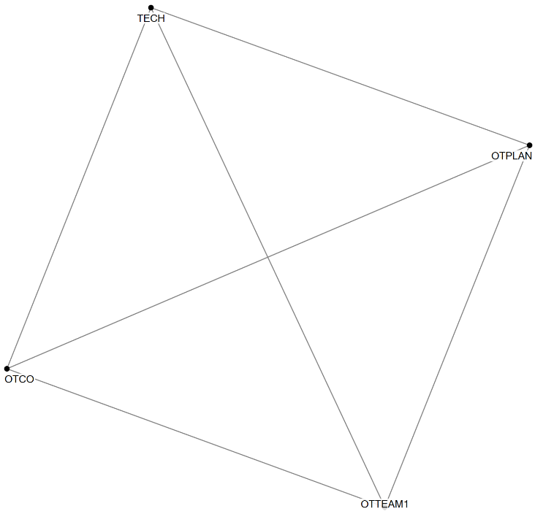
Figure 5 Social network of Task 5: Planning equipment maintenance

Parameter | Value
Number of agents | 4
Number of unique ties | 6
Density | 1
Number of cliques | 1
Highest betweenness centrality | none
Planning is also made for OTC equipment maintenance. Technical staff from the Medical Equipment Department send an email to the OTC capacity planner with a request to perform maintenance on specific equipment. The OTC capacity planner checks with the OTC day coordinator and the surgery team leader whether this is possible, given the OR master schedule and (expected) surgeries in that period of time.

- Plan patient

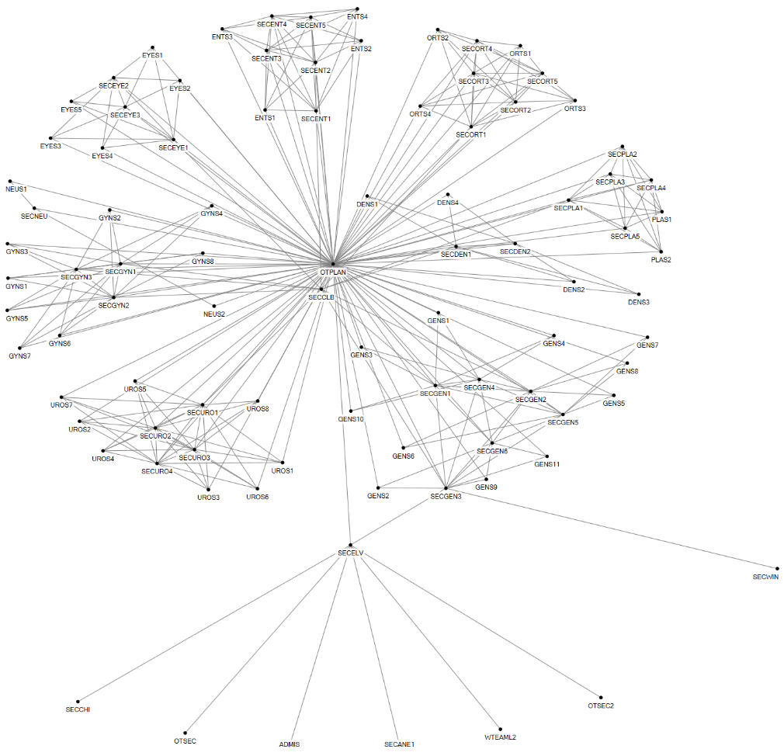

Figure 6 Social network of Task 6: Planning surgery

Parameter | Value
Number of agents | 92
Number of unique ties | 315
Density | 0.08
Number of cliques | 48
Highest betweenness centrality | OTPLAN
The planning for surgeries takes place at one of the nine outpatient clinics after the diagnosis has been made by the physician. The surgeon agrees with the patient that he or she will be operated in an outpatient visit and takes the patient to a secretary of the outpatient department, who informs the patient about the surgery, what is to be expected and when and how the patient will be called to set a final surgery date. The secretary puts the patient on the waiting list or a surgery date right away. There can be interaction between secretaries and the OTC capacity planner on specific surgery requirements or in case the OR master schedule is almost filled. Also sessions are ‘traded’ between the secretaries and the OTC capacity planner in case sessions are under or over utilized. Surgeons also email or phone the OTC capacity planner for specific patient cases that require tuning.

Vascular patients of the Queen Beatrix Hospital are operated on in Slingeland Hospital. For these patients the outpatient secretary of the vascular surgery in the Queen Beatrix Hospital emails the vascular surgery outpatient secretary of Slingeland Hospital, who then plans these patients in.

The ‘clinical bed plan boss’ checks how the secretaries fill in the OR master schedule and how many beds are planned. If the secretaries of the outpatient departments take too many beds, she corrects them. The OTC capacity coordinator and ‘clinical bed plan boss’ evaluate how the clinical bed plan is followed and provide feedback to the secretaries on their planning activities.

- Request and order materials

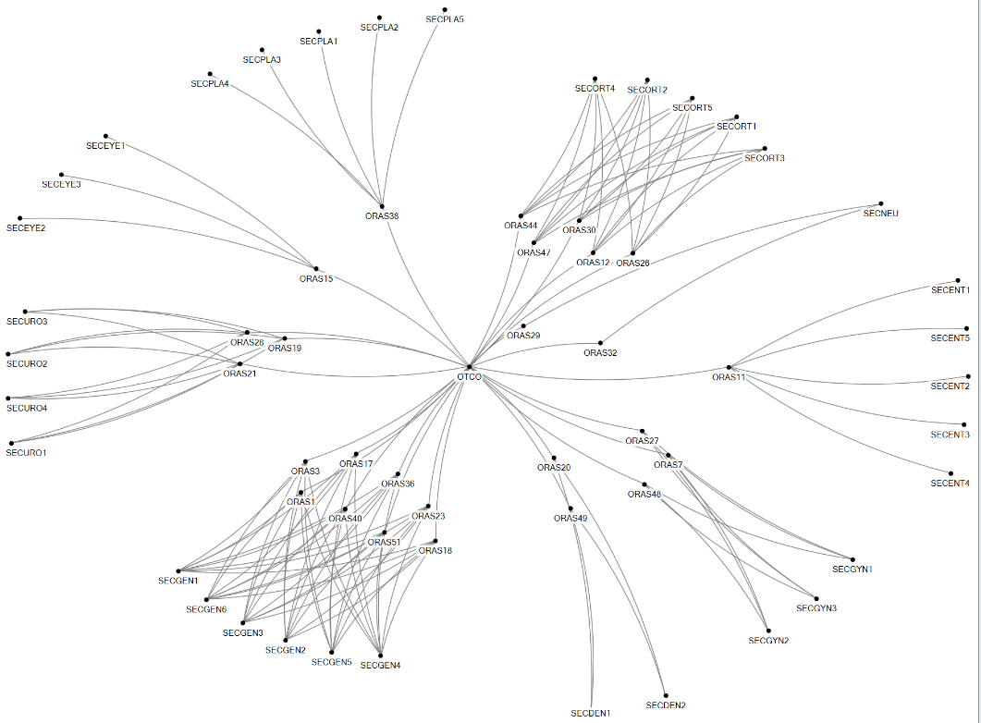

Figure 7 Social network of Task 7: Order materials

Parameter | Value
Number of agents | 61
Number of unique ties | 139
Density | 0.08
Number of cliques | 0
Highest betweenness centrality | OTCO

If specific materials are required for an operation, the secretary of the outpatient clinic informs the OR assistant, who is specialized in the medical discipline it concerns. The OR nurse then orders the required materials via the OTC day coordinator, who then orders the materials from external suppliers via the Purchasing Department.
Other material related tasks are the cleaning of medical instruments which are delivered to the OTC by the Central Sterilization Department (CSD) every day. Further, medication, consumables and implants are delivered every day by a variety of external suppliers. One logistical staff member receives these materials and puts these in the right storage room.

- Preoperative screening

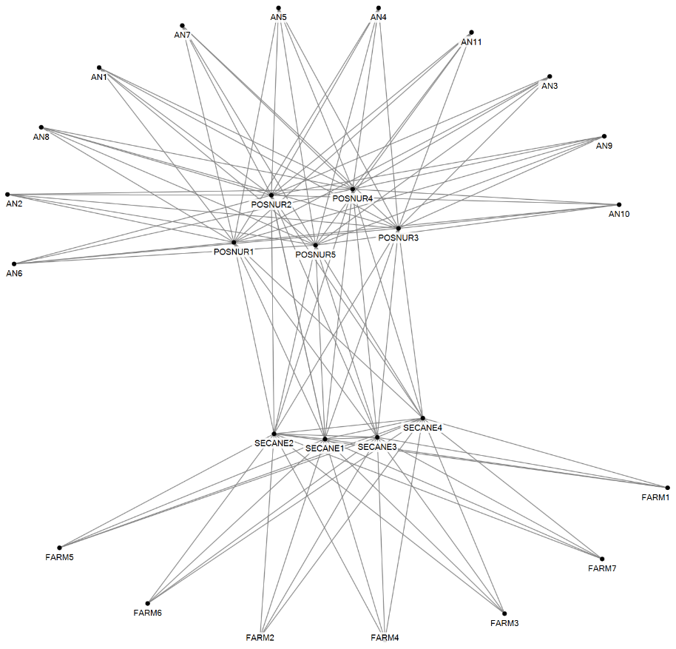

Figure 8 Social network of Task 8: Preoperative screening
Parameter | Value
Number of agents | 27
Number of unique ties | 109
Density | 0.31
Number of cliques | 12
Highest betweenness centrality | All SECAN/ POSNUR

Before a final date can be set for the surgery, the patient must be screened by the anesthesiologist and prepared accordingly in the preoperative department. In the preoperative visit the patient first visits the pharmacy assistant (FARM), who checks which medication the patient is using. Subsequently, a physical examination is performed, after which the patient discusses with the anesthesiologist (AN) which anesthetic technique will be used, which medication he or she may continue to use on the day of the operation and then the anesthesiologist approves the operation. Right after this the patient meets the preoperative nurse (POSNUR), who further prepares the patient for surgery by providing information and discussing the preparations and aftercare the patient requires.

- Request and make appointment

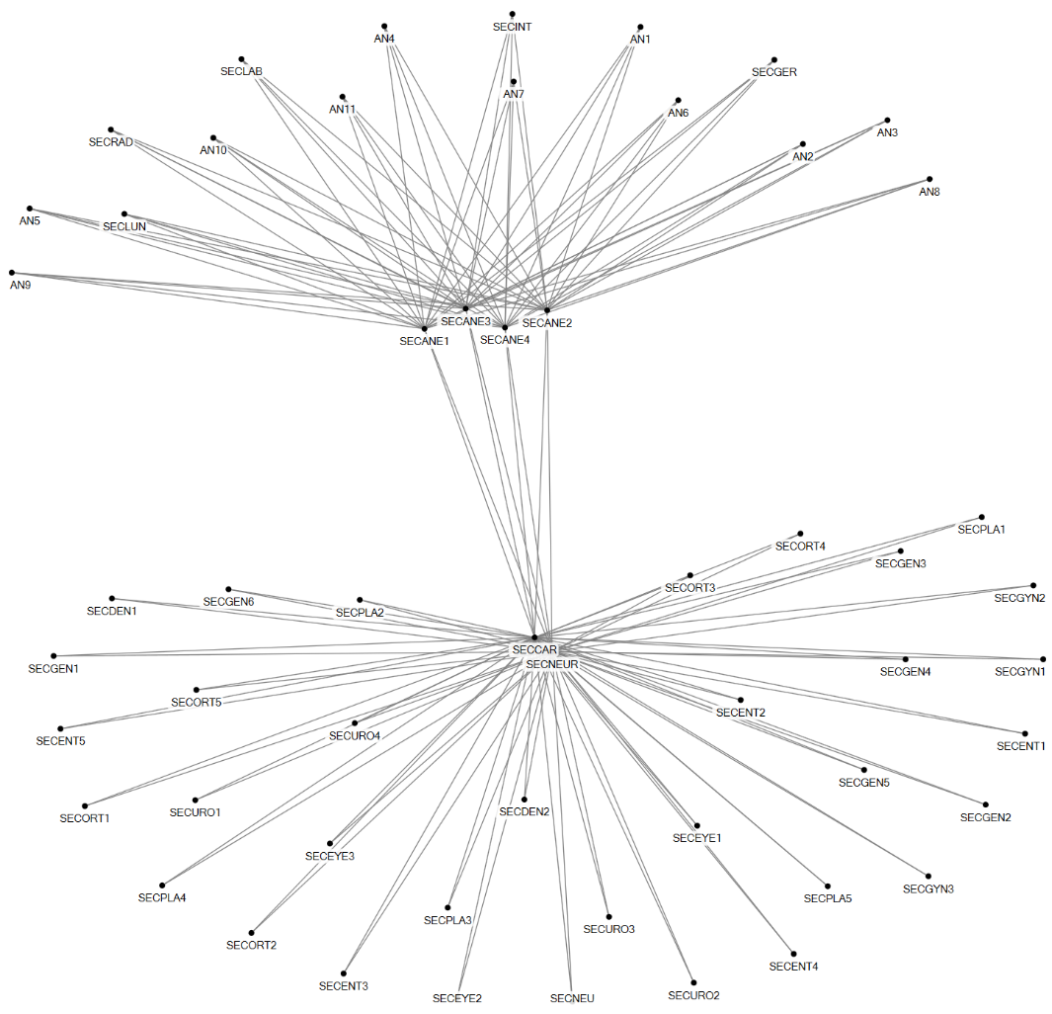

Figure 9 Social network of Task 9: Make appointment

Parameter | Value
Number of agents | 56
Number of unique ties | 140
Density | 0.09
Number of cliques | 0
Highest betweenness centrality | SECNEUR/SECCAR
The anesthesiologist can decide, based on the patient's health situation, that the patient has to visit other physicians, prior to the operation, such as the cardiologist or the neurologist. The secretary at the pre-operative outpatient clinic arranges this for the patient, as well as any necessary blood tests or making an ECG image. Any appointments that need to be made for this are made by the secretary of the preoperative outpatient department.

After the consultation with the anesthesiologist, the patient goes to a nurse who informs the patient about the operation and prepares him or her more extensively.

In case a patient uses anticoagulants, the outpatient department of the surgeon who will perform the surgery arranges a visit to the neurologist or cardiologist.

- Plan OTC nurses

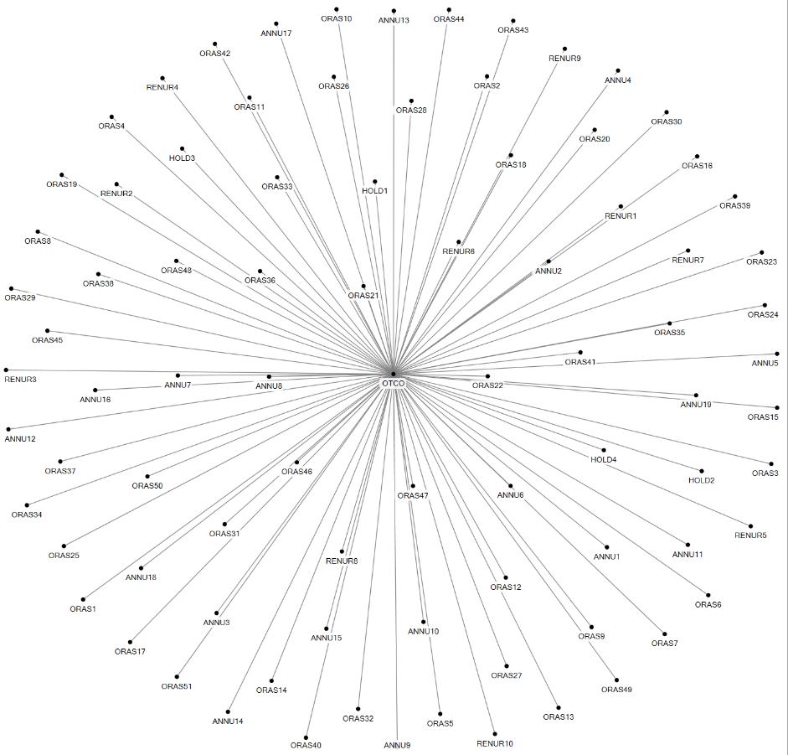

Figure 10 Social network of Task 10: Plan OTC nurses

Parameter | Value
Number of agents | 85
Number of unique ties | 84
Density | 0.02
Number of cliques | 0
Highest betweenness centrality | OTCO

A week before surgeries are performed, the day coordinator allocates the OR nurses to surgeries for the upcoming week and he handles all communication with regard to their availability, illness or other casualties.

- Control planning

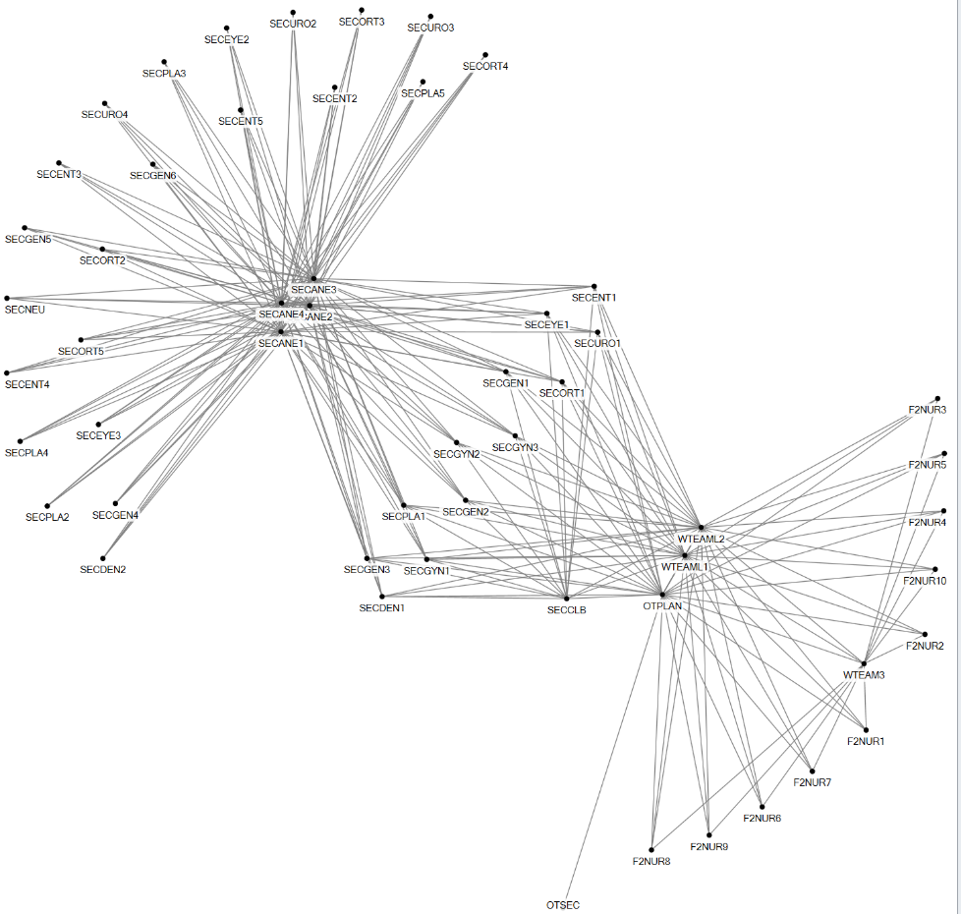
Figure 11 Social network of Task 11: Control planning

Parameter | Value
Number of agents | 54
Number of unique ties | 234
Density | 0.16
Number of cliques | 2
Highest betweenness centrality | All SECANE
In the process towards the surgery taking place, the planning is checked and revised. Preoperative screening needs to be performed before the date of surgery is final. The preoperative secretaries interact with all outpatient secretaries on whether everything is arranged for the surgery to take place.

In the weekly ‘Tuesday morning’ meeting the planning for the upcoming week is discussed between the outpatient secretaries, the ward team leaders and the OTC capacity planner. Also a weekly bed meeting takes place between ward team leaders, a nurse and the OTC capacity planner. In this meeting all checks for the next day’s OR program are made.

The OTC capacity planner views the daily OTC schedule the day before to determine the exact sequence of the operations. For planning surgeries and determining the sequence of the procedures, a large number of control rules are set and these need to be checked. The OTC capacity planner reviews the electronic patient file of each individual patient, checking if all information has been taken into account. When everything is checked, she informs the OTC day coordinator regarding any specific details in the next day’s OTC program.

- Pick materials

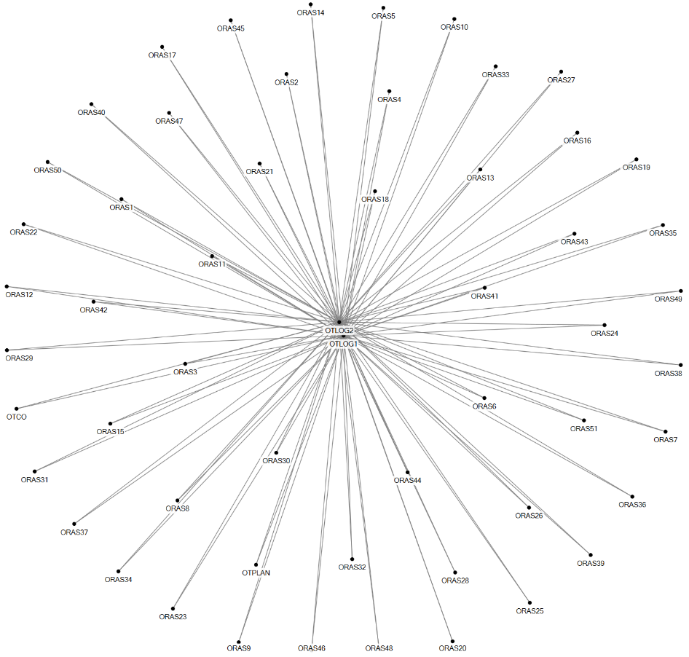
Figure 12 Social network of Task 12: Picking materials

Parameter | Value
Number of agents | 55
Number of unique ties | 107
Density | 0.07
Number of cliques | 53
Highest betweenness centrality | All OTLOG
Medical instruments, consumables and implants are collected a day in advance by two logistical OTC staff members. Sterile and non-sterile materials stored in three storage rooms at the OTC are picked and placed in carts, which are then put in the preparation rooms which are located beside each OR. Materials are mainly collected on the basis of bills of material, which are available for every surgery. Logistical staff members consult the OTC capacity planner, OTC day coordinator and OR nurses on what particular surgeries involve, in case the bill of material doesn’t provide enough information or in case they are not familiar with a surgery type.

- Emergency admission
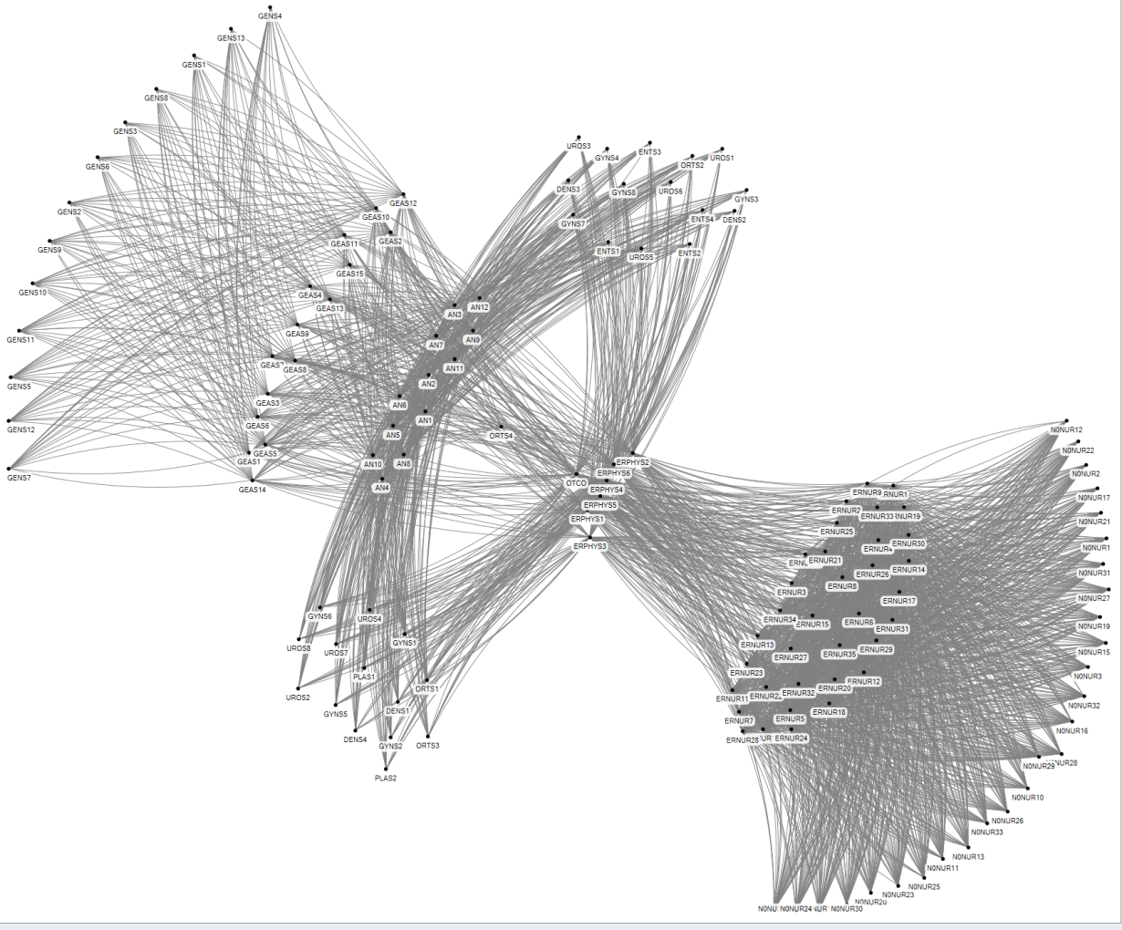

Figure 13 Social network of Task 13: Emergency admission
Parameter | Value
Number of agents | 139
Number of ties | 2840
Density | 0.30
Number of cliques | 1
Highest betweenness centrality | OTC day coordinator (OTCO)

Patients who arrive at the Emergency Department (ED) are examined by the ED physician (ERPHYS). He calls the assistant surgeon or a surgeon if he thinks that the patient requires surgery. The assistant surgeon or surgeon comes to the ED and sets the diagnosis. If necessary blood samples or images are made. If they decide to operate, the general surgeon is called, as well as the OTC day coordinator. The ED nurse takes care of the patient and calls the OTC day coordinator as well to see if the patient goes straight to the OTC or to the nursing ward that admits emergency patients. The surgeon orders preoperative screening with the anesthesiologist, who executes this by screening the patient file. Planning the surgery into the OR program is done through communication between the OTC day coordinator, surgeon and anesthesiologist.
- Prepare patient on ward

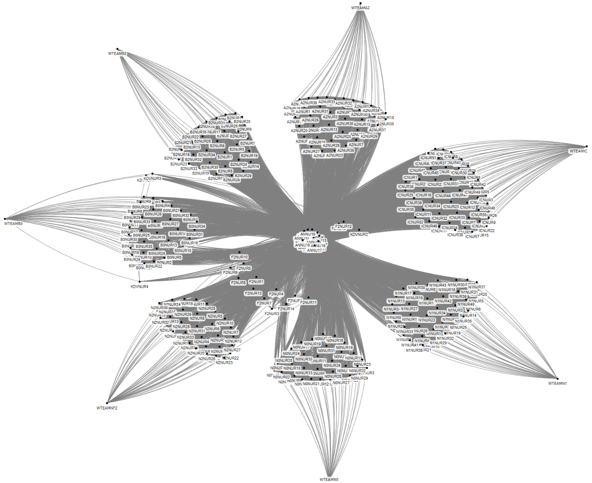
Figure 14 Social network of Task 14: Prepare patient on nursing ward
Parameter | Value
Number of agents | 314
Number of ties | 11,071
Density | 0.23
Number of cliques | 9
Highest betweenness centrality | All ANNU

From the moment the patient is admitted to the hospital, a series of tasks including a lot of communication is performed within a short period of time. First the patient is admitted to one of the nursing wards. During the intake interview a number of checks are made to see if the patient is well prepared for the surgery. The nurse anesthetist then calls the nurse to indicate that premedication should be given to the patient, mostly 2 hours before the expected starting time of the surgery. The nurse anesthetist makes a second call to the nurse to say that the patient is to be taken to holding.

- Prepare patient on holding

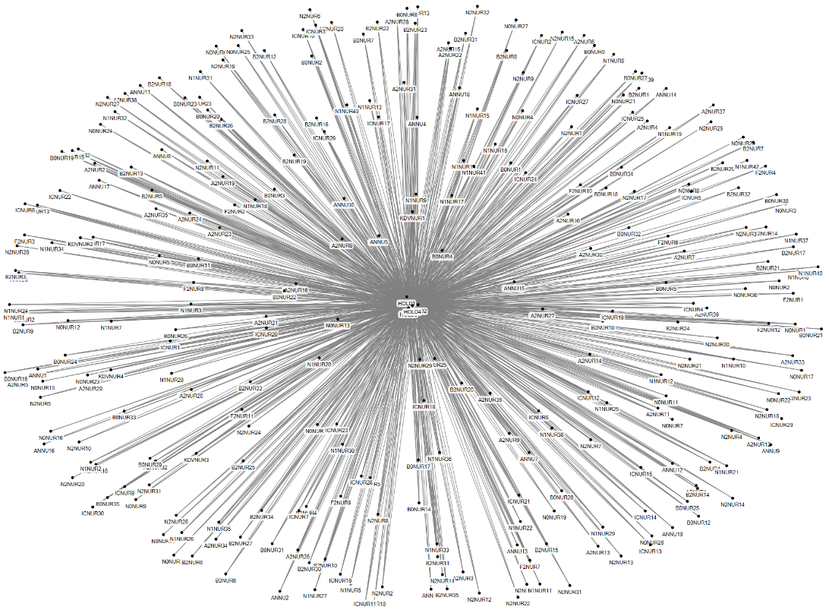
Figure 15 Social network of Task 15: Prepare patient in holding
Parameter | Value
Number of agents | 289
Number of unique ties | 1100
Density | 0.03
Number of cliques | 65
Highest betweenness centrality | All ANNU

After the nurse hands over the patient to one of the holding nurses, following a standard transfer protocol, the second stage starts. The holding nurse prepares the patient by, among other things, preparing the infusion devices. When it is time to go to the OR the nurse anesthetist enters holding and has a small chat with the patient. The holding nurse hands the patient over to the nurse anesthetist, using the standard transfer protocol.

- Make Radiology image
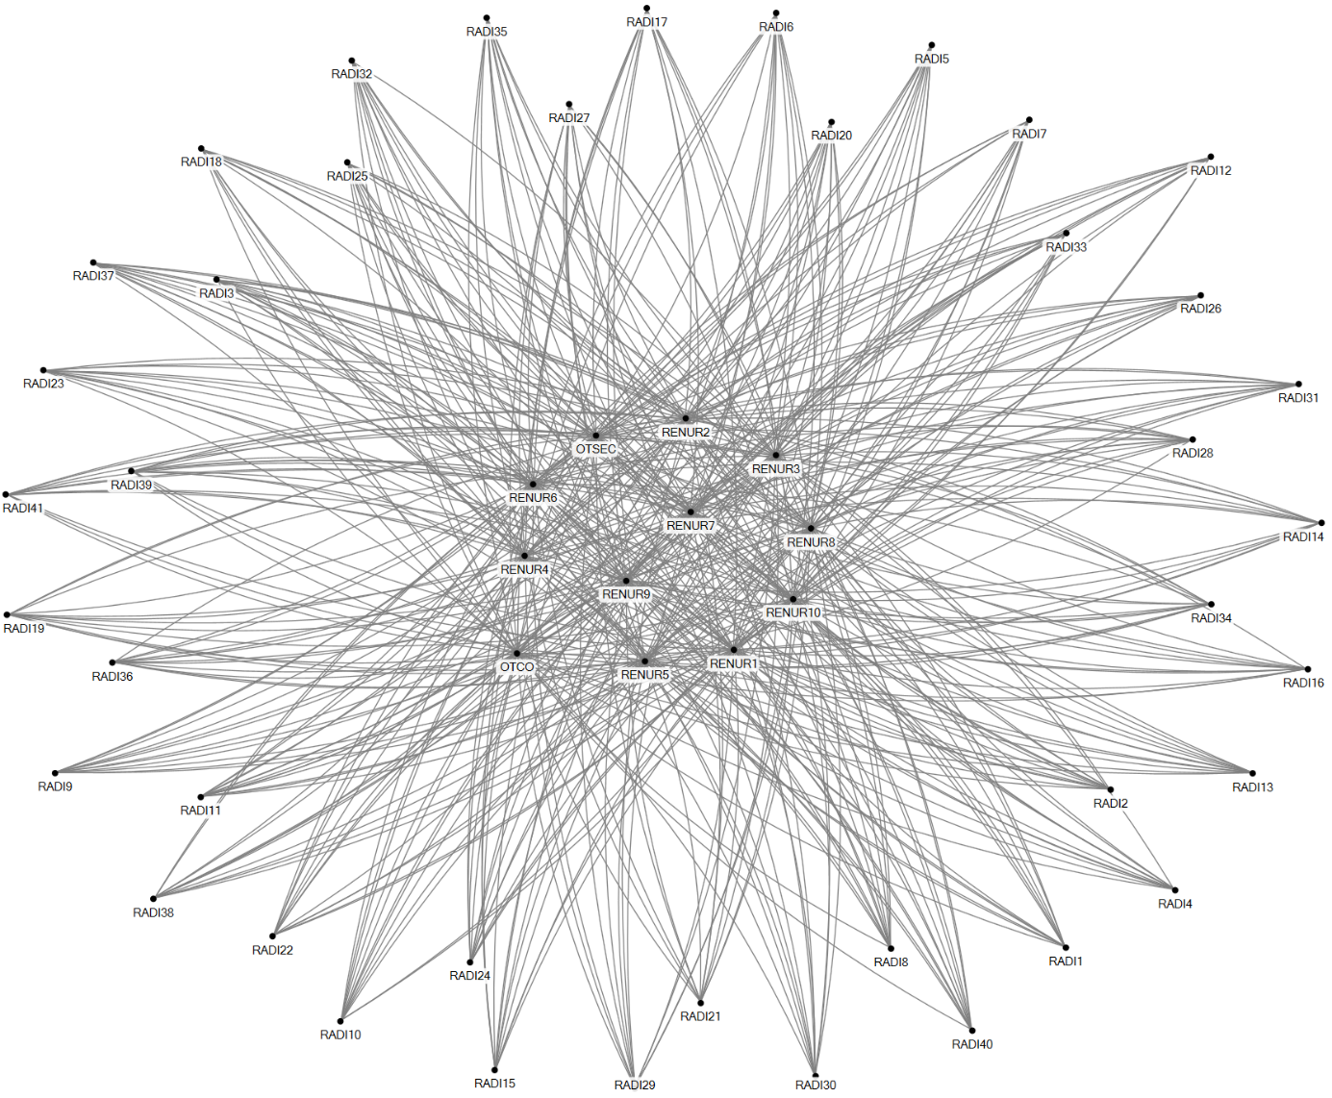
Figure 16 Social network of Task 16: Making radiology image

Parameter | Value
Number of agents | 53
Number of unique ties | 491
Density | 0.36
Number of cliques | 0
Highest betweenness centrality | All Recovery nurses, OTC day coordinator and OTC secretary
Images can be made before or after surgery. When images are needed before surgery, the OTC day coordinator puts in a request to the radiology department, and they send someone in. When an image is required post-surgery, while the patient is in recovery, the recovery nurse calls the radiology department.

- Perform surgery
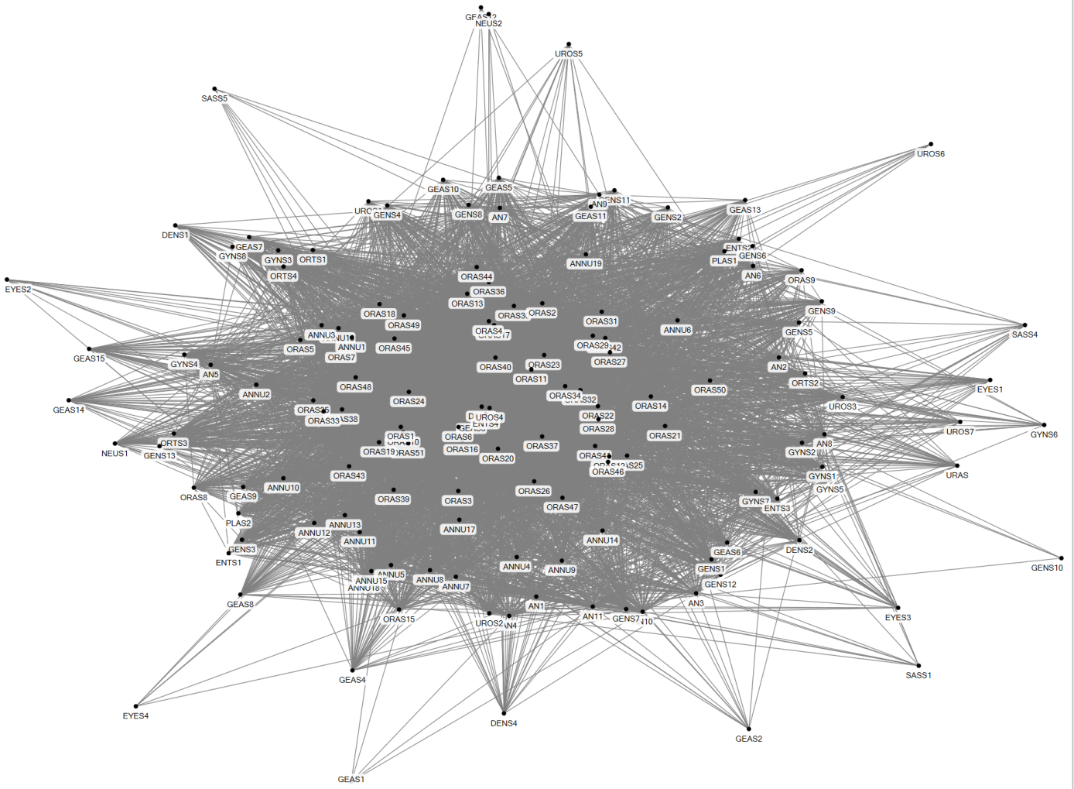
Figure 17 Social network of Task 17: Collaborating in the OR

Parameter | Value
Number of agents | 148
Number of unique ties | 5444
Density | 0.5
Number of cliques | 7640
Highest betweenness centrality | ORAS17

Once the patient is in the OR the nurse anesthetist mentions any relevant details about the patient to the rest of the OR team. The anesthesiologist administers anesthetics prior to the surgery and leaves once the patient is asleep. The surgery is performed by the surgeon, assisted by the OR nurses. The nurse anesthetist monitors the patient and calls the anesthesiologist if necessary.

- Clean the OR

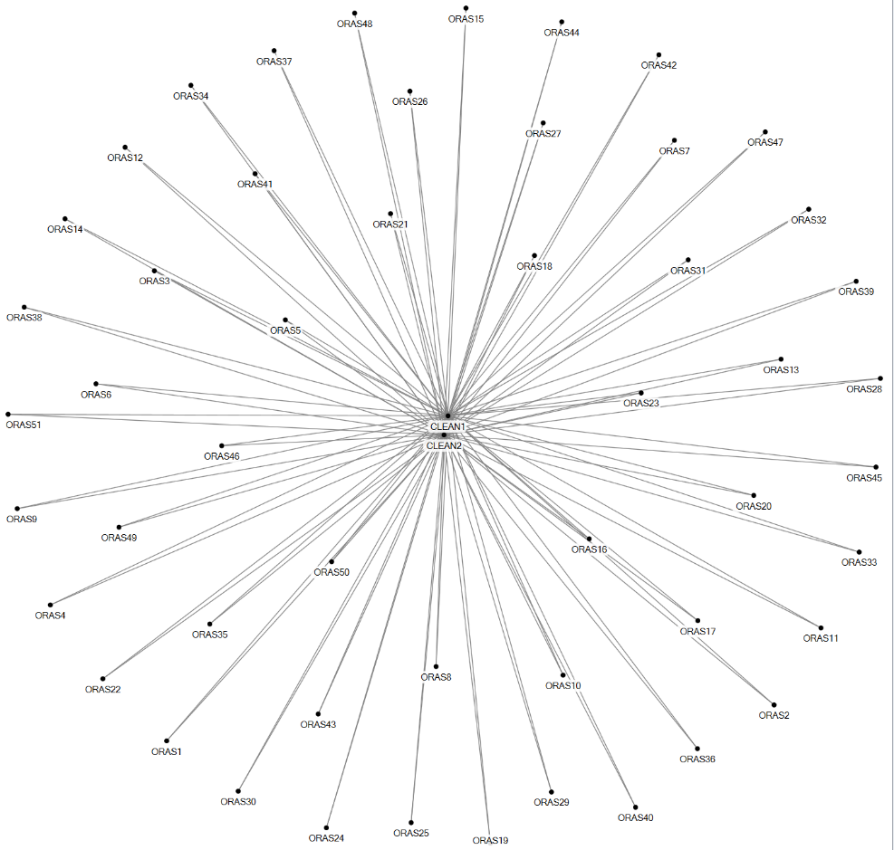
Figure 18 Social network of task 18: Cleaning the OR

Parameter | Value
Number of agents | 53
Number of unique ties | 102
Density | 0.07
Number of cliques | 0
Highest betweenness centrality | All CLEAN

At the end of the surgery the anesthesiologist wakes the patient and the OR assistant calls the cleaning staff. If body tissue has been removed from the patient, it will be sent to pathology to investigate abnormalities.

- Order emergency CSD services

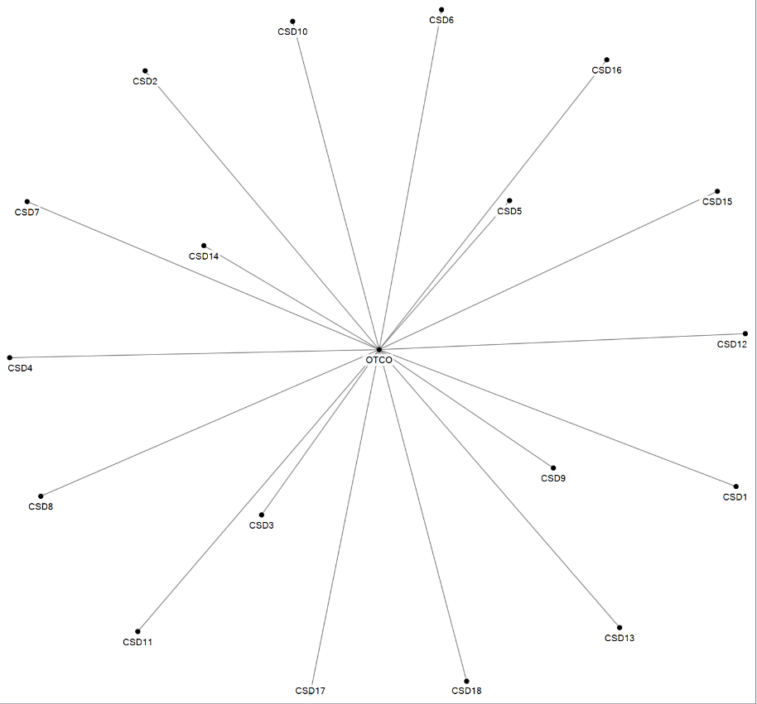

Figure 19 Social network of task 19: Order emergency CSD services

Parameter | Value
Number of agents | 19
Number of unique ties | 18
Density | 0.11
Number of cliques | 0
Highest betweenness centrality | OTCO
After surgery an OR nurse presses a button that switches on a light at the CSD, signaling that the used medical instruments need to be collected and brought to the CSD. There is no social interaction for this, so it is not visualized in this figure. If medical instruments need to be cleaned and sterilized immediately, so they can be reused for a surgery on the same day, the OTC day coordinator calls the CSD with an emergency order.

- Patient care in recovery

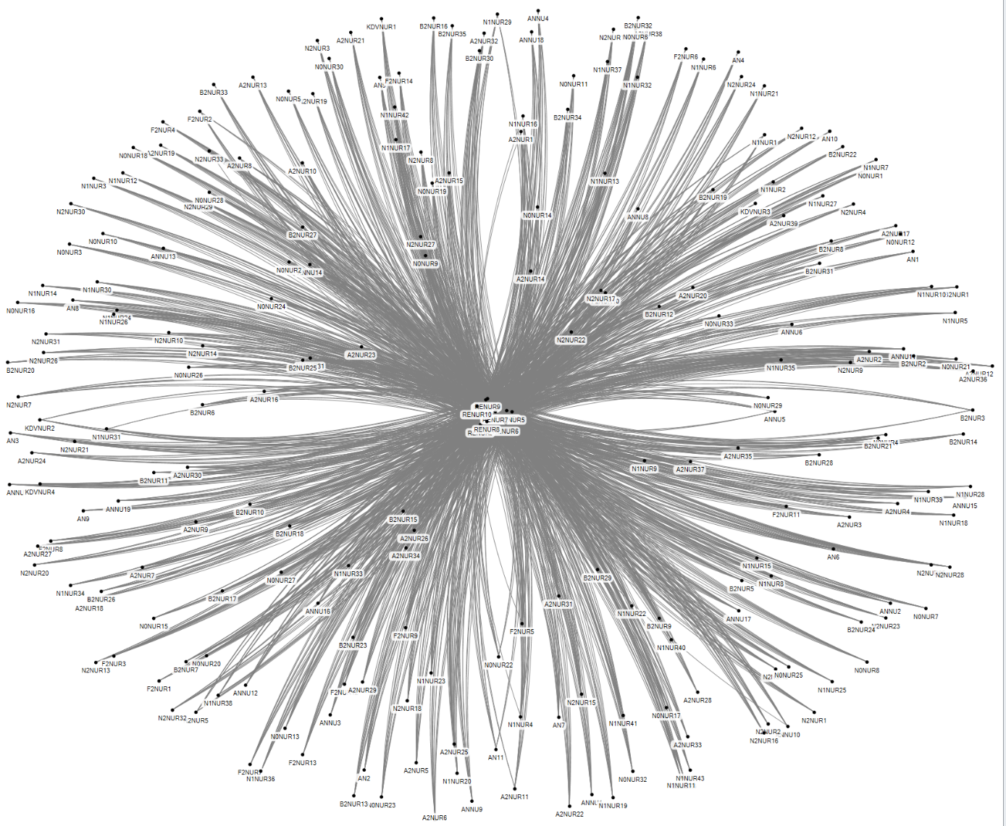
Figure 20 Social network of task 20: Patient care in recovery
Parameter | Value
Number of agents | 241
Number of unique ties | 2,355
Density | 0.08
Number of cliques | PM
Highest betweenness centrality | PM

After surgery the patient is transferred to recovery by the nurse anesthetist. Again the transfer is performed using the standard transfer protocol. In recovery an image might be made of the surgery result, for which a radiology staff member is called. The recovery nurses interact with anesthesiologists on the medication policy if necessary.

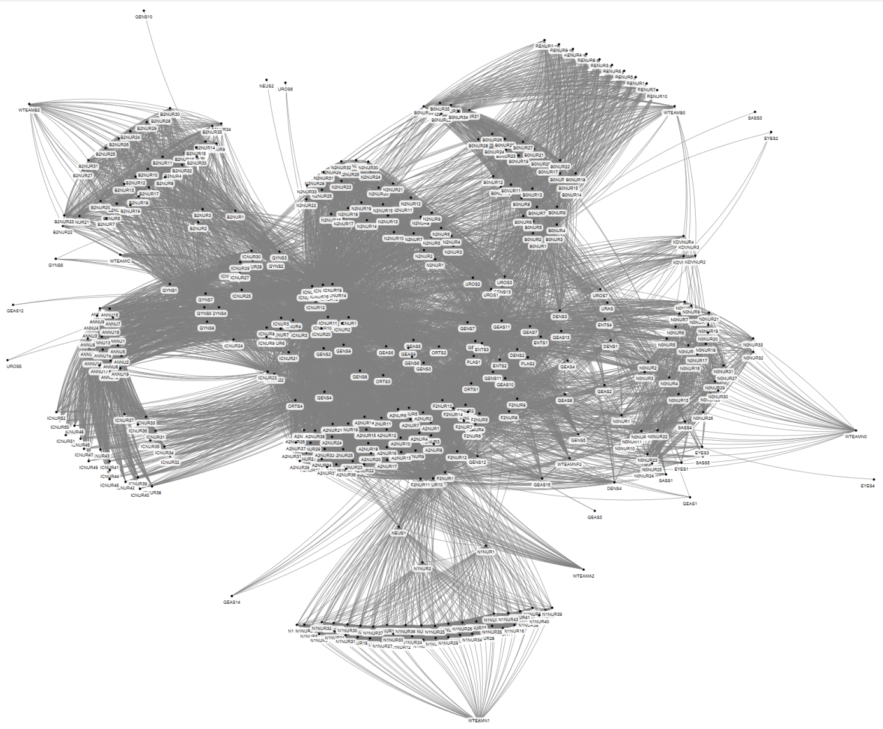
- Aftercare of patient
Figure 21 Social network of task 21: Aftercare of patient
Parameter | Value
Number of agents | 391
Number of unique ties | 12,537
Density | 0.16
Number of cliques | 178
Highest betweenness centrality | Nurse 1 ward F2

When the patient is completely awake and is not experiencing too much pain in recovery, he is transferred to the nursing ward. The recovery nurse calls the nursing ward to indicate that the patient is to be picked up. The recovery nurse then hands the patient over to the ward nurse, using the standard transfer protocol. The patient is taken care of in one of the nursing wards until he or she is recovered well enough to be discharged. Some patients are transferred to another nursing ward and a transfer from nurses from one department to the nurse of the receiving department takes place. Surgeons visit the patients in the nursing ward and discuss their patients with the nurse and physician responsible for the ward on that day.

- Manage the OTC day program

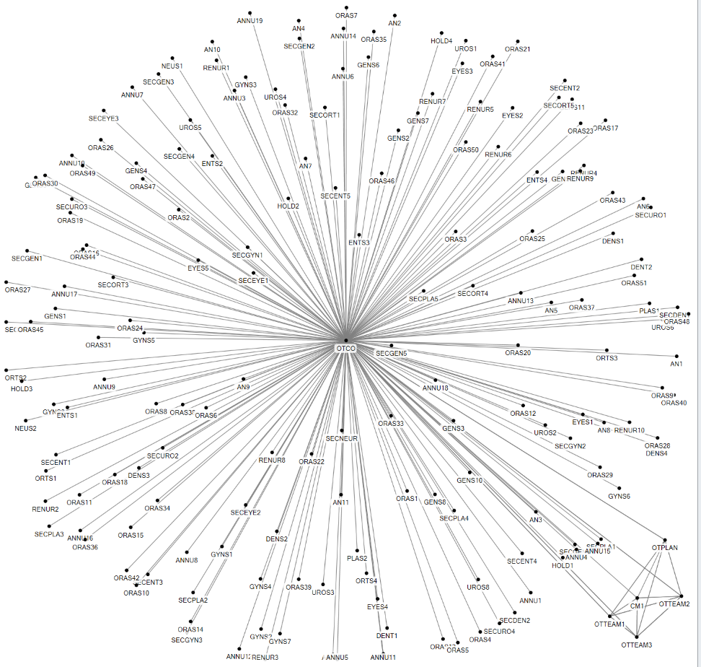
Figure 22 Social network of task 22: Managing the OTC day program

Parameter | Value
Number of agents | 185
Number of unique ties | 181
Density | 0.01
Number of cliques | 2
Highest betweenness centrality | OTCO
There are several tasks, performed at various moments in time, aimed at making sure that the surgeries that are planned for one day are executed well and on time. Every day starts with a start of day meeting between the OTC day coordinator and the three OTC team leaders, in which the expectations and special surgeries are discussed.

During the course of the day the day coordinator monitors the progress of each OR, in order to prevent bottlenecks in case surgeries last longer than planned or unexpected events occur, such as emergency patients, failing equipment and such. If the day coordinator foresees that more than two ORs will be running late, he communicates with an anesthesiologist or surgeons about any alterations required in the OR scheme. The anesthesiologist plays a role here, because they work across different ORs throughout the day and they have an interest in the OR scheme being executed as planned. They are used as the intermediate between the day coordinator and the surgeons, who take more interest in completing the entire scheme, taking any overtime or reshuffling for granted. This relationship is included in the task Collaborating in the OR.

- Manage OTC tasks

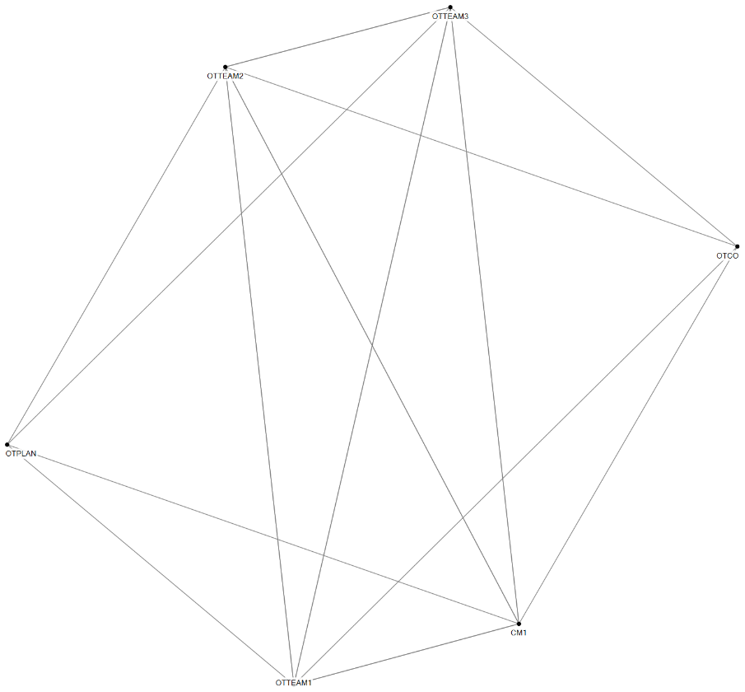

Figure 23 Social network of task 23: Manage OTC tasks

Parameter | Value
Number of agents | 6
Number of unique ties | 14
Density | 0.93
Number of cliques | 2
Highest betweenness centrality | CM1/ OTTEAM1/ OTTEAM2/ OTTEAM3
There are several regular meetings between the OTC cluster manager, OTC team leaders, the OTC capacity planner and the OTC day coordinator to discuss operations over a longer period of time.

Additional file 3: Description and degree of agents in social networks

Agent code | Description | Degree
ANNU17 | Nurse anesthetist 17 | 399
ANNU16 | Nurse anesthetist 16 | 393
ANNU1 | Nurse anesthetist 1 | 390
ANNU11 | Nurse anesthetist 11 | 390
ANNU5 | Nurse anesthetist 5 | 389
ANNU12 | Nurse anesthetist 12 | 388
ANNU2 | Nurse anesthetist 1 | 388
ANNU2 | Nurse anesthetist 2 | 388
ANNU10 | Nurse anesthetist 10 | 387
ANNU13 | Nurse anesthetist 13 | 387
ANNU3 | Nurse anesthetist 3 | 387
ANNU15 | Nurse anesthetist 15 | 386
ANNU18 | Nurse anesthetist 18 | 386
ANNU6 | Nurse anesthetist 6 | 386
ANNU7 | Nurse anesthetist 7 | 386
ANNU14 | Nurse anesthetist 14 | 385
ANNU19 | Nurse anesthetist19 | 384
ANNU4 | Nurse anesthetist 4 | 384
ANNU9 | Nurse anesthetist 9 | 384
ANNU8 | Nurse anesthetist 8 | 383
RENUR1 | Recovery nurse 1 | 318
RENUR10 | Recovery nurse 10 | 318
RENUR2 | Recovery nurse 2 | 318
RENUR3 | Recovery nurse 3 | 318
RENUR4 | Recovery nurse 4 | 318
RENUR5 | Recovery nurse 5 | 318
RENUR6 | Recovery nurse 6 | 318
RENUR7 | Recovery nurse 7 | 318
RENUR8 | Recovery nurse 8 | 318
RENUR9 | Recovery nurse 9 | 318
HOLD2 | Holding nurse 2 | 312
HOLD3 | Holding nurse 3 | 312
HOLD4 | Holding nurse 4 | 312
OTCO | OTC day coordinator | 294
HOLD1 | Holding nurse 1 | 266
GENS6 | General surgeon 6 | 263
GEAS6 | Assistant surgeon 6 | 260
GENS1 | General surgeon 1 | 251
GEAS9 | Assistant surgeon 9 | 247
GENS7 | General surgeon 7 | 246
ICNUR1 | Intensive care nurse 1 | 220
GENS9 | General surgeon 9 | 218
GENS3 | General surgeon 3 | 213
GENS8 | General surgeon 8 | 211
GENS2 | General surgeon 2 | 209
ICNUR2 | Intensive care nurse 2 | 209
GENS4 | General surgeon 4 | 203
ORTS2 | Orthopedic surgeon 2 | 203
GEAS5 | Assistant surgeon 5 | 202
ICNUR10 | Intensive care nurse 10 | 202
ICNUR11 | Intensive care nurse 11 | 201
ICNUR12 | Intensive care nurse 12 | 198
F2NUR1 | Ward F2 nurse 1 | 194
ICNUR13 | Intensive care nurse 13 | 192
ICNUR14 | Intensive care nurse 14 | 192
ORTS4 | Orthopedic surgeon 4 | 192
ICNUR15 | Intensive care nurse 15 | 190
GENS11 | General surgeon 11 | 189
F2NUR10 | Ward F2 nurse 10 | 188
PLAS1 | Plastic surgeon 1 | 188
ICNUR16 | Intensive care nurse 16 | 187
ICNUR17 | Intensive care nurse 17 | 187
ORTS3 | Orthopedic surgeon 3 | 187
ICNUR18 | Intensive care nurse 18 | 184
F2NUR11 | Ward F2 nurse 11 | 183
ICNUR19 | Intensive care nurse 19 | 183
ICNUR20 | Intensive care nurse 20 | 182
UROS2 | Urology surgeon2 | 176
ORTS1 | Orthopedic surgeon 1 | 173
ENTS3 | Ear Nose Throat surgeon 3 | 170
UROS1 | Urology surgeon1 | 169
UROS3 | Urology surgeon3 | 169
GEAS10 | Assistant surgeon 10 | 164
ENTS1 | Ear Nose Throat surgeon 1 | 163
ICNUR21 | Intensive care nurse 21 | 163
PLAS2 | Plastic surgeon 2 | 161
GEAS11 | Assistant surgeon 11 | 160
ENTS2 | Ear Nose Throat surgeon 2 | 156
F2NUR12 | Ward F2 nurse 12 | 155
F2NUR2 | Ward F2 nurse 2 | 155
F2NUR3 | Ward F2 nurse 3 | 155
F2NUR4 | Ward F2 nurse 4 | 153
GENS5 | General surgeon 5 | 153
F2NUR5 | Ward F2 nurse 5 | 151
DENS2 | Dental surgeon 2 | 149
F2NUR6 | Ward F2 nurse 6 | 149
F2NUR7 | Ward F2 nurse 7 | 149
ICNUR22 | Intensive care nurse 22 | 147
GENS12 | General surgeon 12 | 146
ICNUR23 | Intensive care nurse 23 | 144
GYNS7 | Gynecological surgeon 7 | 143
GYNS2 | Gynecological surgeon 2 | 141
N0NUR1 | Ward N0 nurse 1 | 141
F2NUR13 | Ward F2 nurse 13 | 140
GYNS4 | Gynecological surgeon 4 | 140
A2NUR1 | Ward A2 nurse 1 | 139
A2NUR2 | Ward A2 nurse 2 | 139
F2NUR14 | Ward F2 nurse 14 | 139
GYNS3 | Gynecological surgeon 3 | 137
N0NUR2 | Ward N0 nurse 2 | 137
A2NUR3 | Ward A2 nurse 3 | 136
A2NUR4 | Ward A2 nurse 4 | 136
DENS3 | Dental surgeon 3 | 136
N0NUR3 | Ward N0 nurse 3 | 136
A2NUR5 | Ward A2 nurse 5 | 135
A2NUR6 | Ward A2 nurse 6 | 135
A2NUR7 | Ward A2 nurse 7 | 135
GENS13 | General surgeon 13 | 135
GYNS5 | Gynecological surgeon 5 | 135
ICNUR3 | Intensive care nurse 3 | 135
ORAS17 | OR nurse 17 | 135
GEAS7 | Assistant surgeon 7 | 134
ORAS1 | OR nurse 1 | 134
ICNUR4 | Intensive care nurse 4 | 133
A2NUR8 | Ward A2 nurse 8 | 132
A2NUR10 | Ward A2 nurse 10 | 131
A2NUR11 | Ward A2 nurse 11 | 131
ORAS11 | OR nurse 11 | 131
ORAS40 | OR nurse 40 | 131
GYNS1 | Gynecological surgeon 1 | 130
ICNUR5 | Intensive care nurse 5 | 130
ORAS23 | OR nurse 23 | 130
A2NUR12 | Ward A2 nurse 12 | 129
A2NUR9 | Ward A2 nurse 9 | 129
GYNS8 | Gynecological surgeon 8 | 129
ICNUR6 | Intensive care nurse 6 | 129
ICNUR7 | Intensive care nurse 7 | 129
ORAS27 | OR nurse 27 | 129
ORAS3 | OR nurse 3 | 129
A2NUR13 | Ward A2 nurse 13 | 128
ORAS13 | OR nurse 13 | 128
ORAS29 | OR nurse 29 | 128
A2NUR14 | Ward A2 nurse 14 | 127
A2NUR15 | Ward A2 nurse 15 | 127
A2NUR16 | Ward A2 nurse 16 | 127
ORAS18 | OR nurse 18 | 127
ORAS19 | OR nurse 19 | 127
ORAS21 | OR nurse 21 | 127
ORAS10 | OR nurse 10 | 126
ORAS16 | OR nurse 16 | 126
A2NUR17 | Ward A2 nurse 17 | 125
A2NUR18 | Ward A2 nurse 18 | 125
ICNUR8 | Intensive care nurse 8 | 125
ICNUR9 | Intensive care nurse 9 | 125
ORAS2 | OR nurse 2 | 125
ORAS20 | OR nurse 20 | 125
ORAS28 | OR nurse 28 | 125
ORAS36 | OR nurse 36 | 125
A2NUR19 | Ward A2 nurse 19 | 124
A2NUR20 | Ward A2 nurse 20 | 124
ORAS12 | OR nurse 12 | 124
ORAS14 | OR nurse 14 | 124
ORAS30 | OR nurse 30 | 124
ORAS31 | OR nurse 31 | 124
F2NUR8 | Ward F2 nurse 8 | 123
NEUS1 | Neurosurgeon 1 | 123
ORAS24 | OR nurse 24 | 123
ORAS38 | OR nurse 38 | 123
ORAS47 | OR nurse 47 | 123
A2NUR21 | Ward A2 nurse 21 | 122
B0NUR1 | Ward B0 nurse 1 | 122
A2NUR22 | Ward A2 nurse 22 | 121
GEAS13 | Assistant surgeon 13 | 121
ORAS32 | OR nurse 32 | 121
ORAS34 | OR nurse 34 | 121
A2NUR23 | Ward A2 nurse 23 | 120
A2NUR24 | Ward A2 nurse 24 | 120
A2NUR25 | Ward A2 nurse 25 | 120
ORAS22 | OR nurse 22 | 120
ORAS4 | OR nurse 4 | 120
ORAS42 | OR nurse 42 | 120
A2NUR26 | Ward A2 nurse 26 | 119
A2NUR27 | Ward A2 nurse 27 | 119
A2NUR28 | Ward A2 nurse 28 | 119
A2NUR29 | Ward A2 nurse 29 | 119
A2NUR32 | Ward A2 nurse 32 | 119
A2NUR33 | Ward A2 nurse 33 | 119
A2NUR34 | Ward A2 nurse 34 | 119
A2NUR35 | Ward A2 nurse 35 | 119
A2NUR36 | Ward A2 nurse 36 | 119
A2NUR37 | Ward A2 nurse 37 | 119
A2NUR38 | Ward A2 nurse 38 | 119
ORAS26 | OR nurse 26 | 119
ORAS33 | OR nurse 33 | 119
ORAS37 | OR nurse 37 | 119
ORAS39 | OR nurse 39 | 119
ORAS46 | OR nurse 46 | 119
A2NUR30 | Ward A2 nurse 30 | 118
A2NUR31 | Ward A2 nurse 31 | 118
ORAS51 | OR nurse 51 | 118
A2NUR39 | Ward A2 nurse 39 | 117
N0NUR10 | Ward N0 nurse 10 | 117
ORAS25 | OR nurse 25 | 117
ORAS35 | OR nurse 35 | 117
ORAS45 | OR nurse 45 | 117
ORAS48 | OR nurse 48 | 117
ORAS49 | OR nurse 49 | 117
ORAS7 | OR nurse 7 | 117
AN1 | Anesthesiologist 1 | 116
N0NUR11 | Ward N0 nurse 11 | 116
AN11 | Anesthesiologist 11 | 115
B0NUR2 | Ward B0 nurse 2 | 115
GEAS15 | Assistant surgeon 15 | 114
N0NUR12 | Ward N0 nurse 12 | 114
N2NUR1 | Ward N2 nurse 1 | 113
ORAS41 | OR nurse 41 | 113
AN10 | Anesthesiologist 10 | 112
AN2 | Anesthesiologist 2 | 112
AN4 | Anesthesiologist 4 | 112
AN7 | Anesthesiologist 7 | 112
AN8 | Anesthesiologist 8 | 112
ORAS43 | OR nurse 43 | 112
AN3 | Anesthesiologist 3 | 111
AN6 | Anesthesiologist 6 | 111
GEAS8 | Assistant surgeon 8 | 111
ORAS44 | OR nurse 44 | 111
ORAS6 | OR nurse 6 | 111
AN5 | Anesthesiologist 5 | 110
AN9 | Anesthesiologist 9 | 110
B0NUR3 | Ward B0 nurse 3 | 110
N0NUR13 | Ward N0 nurse 13 | 110
N0NUR14 | Ward N0 nurse 14 | 110
N0NUR15 | Ward N0 nurse 15 | 110
N0NUR16 | Ward N0 nurse 16 | 109
F2NUR9 | Ward F2 nurse 9 | 108
N0NUR17 | Ward N0 nurse 17 | 108
OTPLAN | OTC capacity planner | 108
N0NUR18 | Ward N0 nurse 18 | 107
N0NUR19 | Ward N0 nurse 19 | 107
N0NUR20 | Ward N0 nurse 20 | 107
N0NUR21 | Ward N0 nurse 21 | 107
N0NUR22 | Ward N0 nurse 22 | 107
ORAS50 | OR nurse 50 | 107
ICNUR24 | Intensive care nurse 24 | 106
ICNUR25 | Intensive care nurse 25 | 106
N0NUR23 | Ward N0 nurse 23 | 106
N2NUR2 | Ward N2 nurse 2 | 106
ICNUR26 | Intensive care nurse 26 | 105
ICNUR27 | Intensive care nurse 27 | 105
ICNUR28 | Intensive care nurse 28 | 105
ICNUR29 | Intensive care nurse 29 | 105
ICNUR30 | Intensive care nurse 30 | 105
N0NUR24 | Ward N0 nurse 24 | 105
N0NUR25 | Ward N0 nurse 25 | 105
N0NUR26 | Ward N0 nurse 26 | 105
N0NUR27 | Ward N0 nurse 27 | 105
N0NUR28 | Ward N0 nurse 28 | 105
N0NUR29 | Ward N0 nurse 29 | 105
N0NUR30 | Ward N0 nurse 30 | 105
N0NUR31 | Ward N0 nurse 31 | 105
B0NUR4 | Ward B0 nurse 4 | 104
N2NUR3 | Ward N2 nurse 3 | 104
B0NUR5 | Ward B0 nurse 5 | 103
N0NUR32 | Ward N0 nurse 32 | 103
N0NUR33 | Ward N0 nurse 33 | 103
ORAS5 | OR nurse 5 | 103
N2NUR4 | Ward N2 nurse 4 | 102
N2NUR5 | Ward N2 nurse 5 | 102
B0NUR6 | Ward B0 nurse 6 | 101
N2NUR6 | Ward N2 nurse 6 | 101
N2NUR7 | Ward N2 nurse 7 | 100
B2NUR1 | Ward B2 nurse 1 | 99
DENS1 | Dental surgeon 1 | 98
GEAS4 | Assistant surgeon 4 | 98
N2NUR10 | Ward N2 nurse 10 | 98
N2NUR8 | Ward N2 nurse 8 | 97
N2NUR9 | Ward N2 nurse 9 | 97
B0NUR7 | Ward B0 nurse 7 | 95
N0NUR4 | Ward N0 nurse 4 | 94
B0NUR8 | Ward B0 nurse 8 | 93
N0NUR5 | Ward N0 nurse 5 | 93
N2NUR11 | Ward N2 nurse 11 | 93
N2NUR12 | Ward N2 nurse 12 | 93
N2NUR13 | Ward N2 nurse 13 | 93
B0NUR9 | Ward B0 nurse 9 | 92
N2NUR14 | Ward N2 nurse 14 | 92
N2NUR15 | Ward N2 nurse 15 | 92
N2NUR16 | Ward N2 nurse 16 | 91
N2NUR17 | Ward N2 nurse 17 | 91
N2NUR18 | Ward N2 nurse 18 | 91
N2NUR19 | Ward N2 nurse 19 | 91
B0NUR10 | Ward B0 nurse 10 | 89
B2NUR2 | Ward B2 nurse 2 | 89
ENTS4 | Ear Nose Throat surgeon 4 | 89
ICNUR31 | Intensive care nurse 31 | 89
ICNUR32 | Intensive care nurse 32 | 89
ICNUR33 | Intensive care nurse 33 | 89
ICNUR34 | Intensive care nurse 34 | 89
N0NUR6 | Ward N0 nurse 6 | 89
N2NUR20 | Ward N2 nurse 20 | 89
N2NUR21 | Ward N2 nurse 21 | 89
ICNUR36 | Intensive care nurse 36 | 88
N2NUR22 | Ward N2 nurse 22 | 88
B0NUR11 | Ward B0 nurse 11 | 87
B0NUR12 | Ward B0 nurse 12 | 87
DENS4 | Dental surgeon 4 | 87
ICNUR35 | Intensive care nurse 35 | 87
ICNUR37 | Intensive care nurse 37 | 87
N0NUR7 | Ward N0 nurse 7 | 87
N2NUR23 | Ward N2 nurse 23 | 87
N2NUR24 | Ward N2 nurse 24 | 87
N2NUR25 | Ward N2 nurse 25 | 87
B0NUR13 | Ward B0 nurse 13 | 86
ICNUR38 | Intensive care nurse 38 | 86
N2NUR26 | Ward N2 nurse 26 | 86
N2NUR27 | Ward N2 nurse 27 | 86
N2NUR28 | Ward N2 nurse 28 | 86
N2NUR29 | Ward N2 nurse 29 | 86
N2NUR30 | Ward N2 nurse 30 | 86
N2NUR31 | Ward N2 nurse 31 | 86
N2NUR32 | Ward N2 nurse 32 | 86
N2NUR33 | Ward N2 nurse 33 | 86
ICNUR39 | Intensive care nurse 39 | 85
N1NUR1 | Ward N1 nurse 1 | 85
ORAS15 | OR nurse 15 | 85
B2NUR3 | Ward B2 nurse 3 | 84
ICNUR40 | Intensive care nurse 40 | 84
N0NUR8 | Ward N0 nurse 8 | 84
B0NUR14 | Ward B0 nurse 14 | 83
ICNUR41 | Intensive care nurse 41 | 83
ICNUR42 | Intensive care nurse 42 | 83
ICNUR43 | Intensive care nurse 43 | 83
N0NUR9 | Ward N0 nurse 9 | 83
B2NUR10 | Ward B2 nurse 10 | 82
B2NUR11 | Ward B2 nurse 11 | 82
B2NUR12 | Ward B2 nurse 12 | 82
B2NUR13 | Ward B2 nurse 13 | 82
B2NUR14 | Ward B2 nurse 14 | 82
B2NUR15 | Ward B2 nurse 15 | 82
B2NUR16 | Ward B2 nurse 16 | 82
B2NUR17 | Ward B2 nurse 17 | 82
B2NUR18 | Ward B2 nurse 18 | 82
B2NUR19 | Ward B2 nurse 19 | 82
B2NUR20 | Ward B2 nurse 20 | 82
B2NUR21 | Ward B2 nurse 21 | 82
B2NUR22 | Ward B2 nurse 22 | 82
B2NUR23 | Ward B2 nurse 23 | 82
B2NUR24 | Ward B2 nurse 24 | 82
B2NUR25 | Ward B2 nurse 25 | 82
B2NUR26 | Ward B2 nurse 26 | 82
B2NUR27 | Ward B2 nurse 27 | 82
ICNUR44 | Intensive care nurse 44 | 82
N1NUR2 | Ward N1 nurse 2 | 82
B0NUR15 | Ward B0 nurse 15 | 81
B2NUR28 | Ward B2 nurse 28 | 81
B2NUR29 | Ward B2 nurse 29 | 81
B2NUR9 | Ward B2 nurse 9 | 81
ICNUR45 | Intensive care nurse 45 | 81
ICNUR46 | Intensive care nurse 46 | 81
ICNUR47 | Intensive care nurse 47 | 81
ICNUR48 | Intensive care nurse 48 | 81
B2NUR30 | Ward B2 nurse 30 | 80
B2NUR31 | Ward B2 nurse 31 | 80
B2NUR32 | Ward B2 nurse 32 | 80
B2NUR33 | Ward B2 nurse 33 | 80
B2NUR4 | Ward B2 nurse 4 | 80
B2NUR8 | Ward B2 nurse 8 | 80
ERPHYS1 | ER physician 1 | 80
ERPHYS4 | ER physician 4 | 80
ERPHYS5 | ER physician 5 | 80
ERPHYS6 | ER physician 6 | 80
ICNUR49 | Intensive care nurse 49 | 80
N1NUR10 | Ward N1 nurse 10 | 80
N1NUR11 | Ward N1 nurse 11 | 80
N1NUR12 | Ward N1 nurse 12 | 80
N1NUR13 | Ward N1 nurse 13 | 80
N1NUR14 | Ward N1 nurse 14 | 80
N1NUR15 | Ward N1 nurse 15 | 80
N1NUR16 | Ward N1 nurse 16 | 80
N1NUR17 | Ward N1 nurse 17 | 80
N1NUR18 | Ward N1 nurse 18 | 80
N1NUR19 | Ward N1 nurse 19 | 80
N1NUR20 | Ward N1 nurse 20 | 80
N1NUR21 | Ward N1 nurse 21 | 80
N1NUR22 | Ward N1 nurse 22 | 80
N1NUR23 | Ward N1 nurse 23 | 80
N1NUR24 | Ward N1 nurse 24 | 80
N1NUR25 | Ward N1 nurse 25 | 80
N1NUR26 | Ward N1 nurse 26 | 80
N1NUR27 | Ward N1 nurse 27 | 80
N1NUR28 | Ward N1 nurse 28 | 80
N1NUR29 | Ward N1 nurse 29 | 80
N1NUR3 | Ward N1 nurse 3 | 80
N1NUR30 | Ward N1 nurse 30 | 80
N1NUR31 | Ward N1 nurse 31 | 80
N1NUR32 | Ward N1 nurse 32 | 80
N1NUR33 | Ward N1 nurse 33 | 80
N1NUR34 | Ward N1 nurse 34 | 80
N1NUR35 | Ward N1 nurse 35 | 80
N1NUR36 | Ward N1 nurse 36 | 80
N1NUR37 | Ward N1 nurse 37 | 80
N1NUR38 | Ward N1 nurse 38 | 80
N1NUR39 | Ward N1 nurse 39 | 80
N1NUR4 | Ward N1 nurse 4 | 80
N1NUR40 | Ward N1 nurse 40 | 80
N1NUR41 | Ward N1 nurse 41 | 80
N1NUR42 | Ward N1 nurse 42 | 80
N1NUR43 | Ward N1 nurse 43 | 80
N1NUR5 | Ward N1 nurse 5 | 80
N1NUR6 | Ward N1 nurse 6 | 80
N1NUR7 | Ward N1 nurse 7 | 80
N1NUR8 | Ward N1 nurse 8 | 80
N1NUR9 | Ward N1 nurse 9 | 80
B0NUR16 | Ward B0 nurse 16 | 79
B0NUR17 | Ward B0 nurse 17 | 79
B2NUR5 | Ward B2 nurse 5 | 79
B2NUR6 | Ward B2 nurse 6 | 79
B2NUR7 | Ward B2 nurse 7 | 79
ICNUR50 | Intensive care nurse 50 | 79
ICNUR51 | Intensive care nurse 51 | 79
B0NUR18 | Ward B0 nurse 18 | 78
ICNUR52 | Intensive care nurse 52 | 78
B0NUR19 | Ward B0 nurse 19 | 77
B0NUR20 | Ward B0 nurse 20 | 77
ERPHYS3 | ER physician 3 | 77
B0NUR21 | Ward B0 nurse 21 | 76
B0NUR22 | Ward B0 nurse 22 | 76
B0NUR23 | Ward B0 nurse 23 | 76
B0NUR24 | Ward B0 nurse 24 | 76
ERPHYS2 | ER physician 2 | 76
B0NUR25 | Ward B0 nurse 25 | 75
B0NUR26 | Ward B0 nurse 26 | 75
B0NUR27 | Ward B0 nurse 27 | 75
B0NUR28 | Ward B0 nurse 28 | 75
B0NUR29 | Ward B0 nurse 29 | 74
B0NUR30 | Ward B0 nurse 30 | 74
B0NUR31 | Ward B0 nurse 31 | 74
B0NUR32 | Ward B0 nurse 32 | 74
B0NUR33 | Ward B0 nurse 33 | 74
B0NUR34 | Ward B0 nurse 34 | 74
B0NUR35 | Ward B0 nurse 35 | 74
B2NUR34 | Ward B2 nurse 34 | 74
B2NUR35 | Ward B2 nurse 35 | 74
ORAS8 | OR nurse 8 | 74
ERNUR1 | ER nurse 1 | 68
ERNUR10 | ER nurse 10 | 68
ERNUR11 | ER nurse 11 | 68
ERNUR12 | ER nurse 12 | 68
ERNUR13 | ER nurse 13 | 68
ERNUR14 | ER nurse 14 | 68
ERNUR15 | ER nurse 15 | 68
ERNUR16 | ER nurse 16 | 68
ERNUR17 | ER nurse 17 | 68
ERNUR18 | ER nurse 18 | 68
ERNUR19 | ER nurse 19 | 68
ERNUR2 | ER nurse 2 | 68
ERNUR20 | ER nurse 20 | 68
ERNUR21 | ER nurse 21 | 68
ERNUR22 | ER nurse 22 | 68
ERNUR23 | ER nurse 23 | 68
ERNUR24 | ER nurse 24 | 68
ERNUR25 | ER nurse 25 | 68
ERNUR26 | ER nurse 26 | 68
ERNUR27 | ER nurse 27 | 68
ERNUR28 | ER nurse 28 | 68
ERNUR29 | ER nurse 29 | 68
ERNUR3 | ER nurse 3 | 68
ERNUR30 | ER nurse 30 | 68
ERNUR31 | ER nurse 31 | 68
ERNUR32 | ER nurse 32 | 68
ERNUR33 | ER nurse 33 | 68
ERNUR34 | ER nurse 34 | 68
ERNUR35 | ER nurse 35 | 68
ERNUR4 | ER nurse 4 | 68
ERNUR5 | ER nurse 5 | 68
ERNUR6 | ER nurse 6 | 68
ERNUR7 | ER nurse 7 | 68
ERNUR8 | ER nurse 8 | 68
ERNUR9 | ER nurse 9 | 68
EYES1 | Eye surgeon1 | 68
ORAS9 | OR nurse 9 | 67
SECANE1 | Secretary1 Anesthesia | 67
SECANE2 | Secretary2 Anesthesia | 67
SECANE3 | Secretary3 Anesthesia | 67
SECANE4 | Secretary4 Anesthesia | 67
GEAS14 | Assistant surgeon 14 | 65
WTEAMA2 | Ward team leader A2 | 65
UROS7 | Urology surgeon7 | 63
WTEAMNF2 | Ward team leader F2 | 63
KDVNUR1 | Pediatric ward nurse 1 | 60
URAS | Urology assistant surgeon | 60
GEAS2 | Assistant surgeon 2 | 59
KDVNUR2 | Pediatric ward nurse 2 | 57
OTTEAM1 | Team leader Surgery | 57
KDVNUR3 | Pediatric ward nurse 3 | 54
KDVNUR4 | Pediatric ward nurse 4 | 54
OTLOG1 | OTC logistical staff member 1 | 54
OTLOG2 | OTC logistical staff member 1 | 54
CLEAN1 | Cleaning staff member 1 | 51
CLEAN2 | Cleaning staff member 2 | 51
WTEAMIC | Ward team leader Intensive Care | 50
EYES3 | Eye surgeon 3 | 49
GYNS6 | Gynecology surgeon 6 | 47
AN12 | Anesthesiologist 12 | 46
GENS10 | General surgeon 10 | 46
SASS4 | Physician assistant 4 | 44
UROS5 | Urology surgeon5 | 44
WTEAMN1 | Ward team leader N1 | 43
OTSEC | OTC secretary | 42
GEAS1 | Assistant surgeon 1 | 39
SECNEUR | Secretary of Neurology outpatient department | 39
UROS6 | Urology surgeon 6 | 39
WTEAMB0 | Ward team leader B0 | 39
SECCAR | Secretary of Cardiology outpatient department | 38
GEAS12 | Assistant surgeon 12 | 37
GEAS3 | Assistant surgeon 3 | 36
WTEAMB2 | Ward team leader B2 | 35
UROS4 | Urology surgeon4 | 34
WTEAMN0 | Ward team leader N0 | 33
SASS1 | Physician assistant 1 | 32
UROS8 | Urology surgeon 8 | 31
SECGEN1 | Secretary 1 General surgery | 28
SECGEN2 | Secretary 2 General surgery | 28
SECGEN3 | Secretary 3 General surgery | 28
SECGEN4 | Secretary 4 General surgery | 25
SECGEN5 | Secretary 5 General surgery | 25
SECURO1 | Secretary 1 Urology outpatient department | 25
EYES2 | Eye surgeon 2 | 24
OTTEAM2 | Team leader Anesthesia | 24
SECGEN6 | Secretary 6 General surgery | 24
SECGYN1 | Secretary 1 Gynecology | 24
SECGYN2 | Secretary 2 Gynecology | 24
SECGYN3 | Secretary 3 Gynecology | 24
SECORT1 | Secretary 1 Orthopedics outpatient department | 24
SASS5 | Physician assistant 5 | 22
SECURO2 | Secretary 2 Urology outpatient department | 22
SECURO3 | Secretary 3 Urology outpatient department | 22
SECURO4 | Secretary 4 Urology outpatient department | 22
SECORT2 | Secretary 2 Orthopedics outpatient department | 21
SECORT3 | Secretary 3 Orthopedics outpatient department | 21
SECORT4 | Secretary 4 Orthopedics outpatient department | 21
SECORT5 | Secretary 5 Orthopedics outpatient department | 21
SECENT1 | Secretary1 ENT | 20
OTTEAM3 | Team leader Recovery/holding | 19
SECEYE1 | Secretary 1 Ophthalmology | 19
CM1 | Cluster manager OTC and Services | 18
SECDEN1 | Secretary1 Dental Surgery | 18
SECPLA1 | Secretary1 Plastic surgery outpatient department | 18
SECENT2 | Secretary2 ENT | 17
SECENT3 | Secretary3 ENT | 17
SECENT4 | Secretary4 ENT | 17
SECENT5 | Secretary5 ENT | 17
EYES4 | Eye surgeon4 | 16
SECEYE2 | Secretary2 Ophthalmology | 16
SECEYE3 | Secretary3 Ophthalmology | 16
POSNUR1 | Preoperative nurse 1 | 15
POSNUR2 | Preoperative nurse 2 | 15
POSNUR2 | Preoperative nurse 3 | 15
POSNUR3 | Preoperative nurse 4 | 15
POSNUR4 | Preoperative nurse 5 | 15
POSNUR5 | Preoperative nurse 6 | 15
SECCLB | Clinical plan boss | 15
SECDEN2 | Secretary2 Dental Surgery | 15
SECPLA2 | Secretary2 Plastic surgery outpatient department | 15
SECPLA3 | Secretary3 Plastic surgery outpatient department | 15
SECPLA4 | Secretary4 Plastic surgery outpatient department | 15
SECPLA5 | Secretary5 Plastic surgery outpatient department | 15
CM2 | Cluster manager Surgery | 14
WTEAM3 | Team leader in training | 13
RADI1 | Radiology staff member 1 | 12
RADI10 | Radiology staff member 10 | 12
RADI11 | Radiology staff member 11 | 12
RADI13 | Radiology staff member 13 | 12
RADI14 | Radiology staff member 14 | 12
RADI15 | Radiology staff member 15 | 12
RADI16 | Radiology staff member 16 | 12
RADI17 | Radiology staff member 17 | 12
RADI18 | Radiology staff member 18 | 12
RADI19 | Radiology staff member 19 | 12
RADI2 | Radiology staff member 2 | 12
RADI20 | Radiology staff member 20 | 12
RADI21 | Radiology staff member 21 | 12
RADI22 | Radiology staff member 22 | 12
RADI23 | Radiology staff member 23 | 12
RADI24 | Radiology staff member 24 | 12
RADI25 | Radiology staff member 25 | 12
RADI26 | Radiology staff member 26 | 12
RADI27 | Radiology staff member 27 | 12
RADI28 | Radiology staff member 28 | 12
RADI29 | Radiology staff member 29 | 12
RADI3 | Radiology staff member 3 | 12
RADI30 | Radiology staff member 30 | 12
RADI31 | Radiology staff member 31 | 12
RADI32 | Radiology staff member 32 | 12
RADI33 | Radiology staff member 33 | 12
RADI34 | Radiology staff member 34 | 12
RADI35 | Radiology staff member 35 | 12
RADI36 | Radiology staff member 36 | 12
RADI37 | Radiology staff member 37 | 12
RADI38 | Radiology staff member 38 | 12
RADI39 | Radiology staff member 39 | 12
RADI4 | Radiology staff member 4 | 12
RADI40 | Radiology staff member 40 | 12
RADI41 | Radiology staff member 41 | 12
RADI5 | Radiology staff member 5 | 12
RADI6 | Radiology staff member 6 | 12
RADI7 | Radiology staff member 7 | 12
RADI8 | Radiology staff member 8 | 12
RADI9 | Radiology staff member 9 | 12
RADI12 | Radiology staff member 12 | 11
SECNEU | Secretary Neurosurgery | 11
EYES5 | Eye surgeon 5 | 9
NEUS2 | Neuro surgeon 2 | 9
CM3 | Cluster manager Women and Child | 6
FARM1 | Pharmacy assistant 1 | 4
FARM2 | Pharmacy assistant 2 | 4
FARM3 | Pharmacy assistant 3 | 4
FARM4 | Pharmacy assistant 4 | 4
FARM5 | Pharmacy assistant 5 | 4
FARM6 | Pharmacy assistant 6 | 4
FARM7 | Pharmacy assistant 7 | 4
SECGER | Secretary of Geriatric outpatient department | 4
SECINT | Secretary of Internal medicine department | 4
SECLAB | Secretary of Laboratory | 4
SECLUN | Secretary of Lung disease outpatient department | 4
SECRAD | Secretary of Radiology | 4
TECH | Technical staff member | 3
CSD1 | Central Sterilization Department staff member 1 | 1
CSD10 | Central Sterilization Department staff member 10 | 1
CSD11 | Central Sterilization Department staff member 11 | 1
CSD12 | Central Sterilization Department staff member 12 | 1
CSD13 | Central Sterilization Department staff member 13 | 1
CSD14 | Central Sterilization Department staff member 14 | 1
CSD15 | Central Sterilization Department staff member 15 | 1
CSD16 | Central Sterilization Department staff member 16 | 1
CSD17 | Central Sterilization Department staff member 17 | 1
CSD18 | Central Sterilization Department staff member 18 | 1
CSD2 | Central Sterilization Department staff member 2 | 1
CSD3 | Central Sterilization Department staff member 3 | 1
CSD4 | Central Sterilization Department staff member 4 | 1
CSD5 | Central Sterilization Department staff member 5 | 1
CSD6 | Central Sterilization Department staff member 6 | 1
CSD7 | Central Sterilization Department staff member 7 | 1
CSD8 | Central Sterilization Department staff member 8 | 1
CSD9 | Central Sterilization Department staff member 9 | 1
SASS3 | Physician assistant 3 | 1
SECWIN | Secretary Winterswijk Surgery outpatient department | 1

