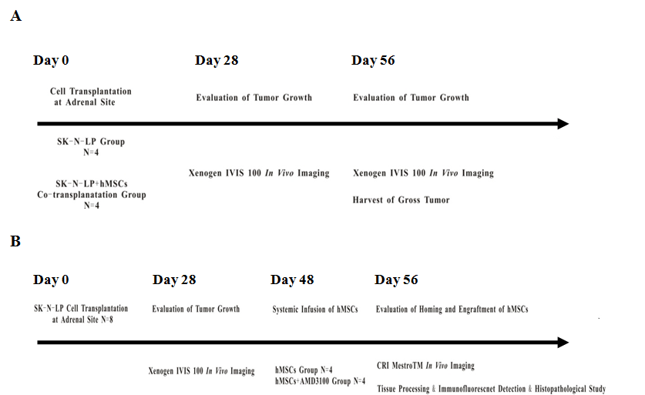

Schematic representation of the study design. Experimental design for exploring the role of human MSCs in the growth and metastasis of neuroblastoma (A). Mice were randomized into SK-N-LP group and hMSCs co-transplantation group by picking numbers out of a hat. Experimental design for exploring the tumor tropism property of human MSCs towards primary tumor and metastatic loci (B). Animals were randomized into hMSCs group and hMSCs+AMD3100 group by picking numbers out of a hat.

