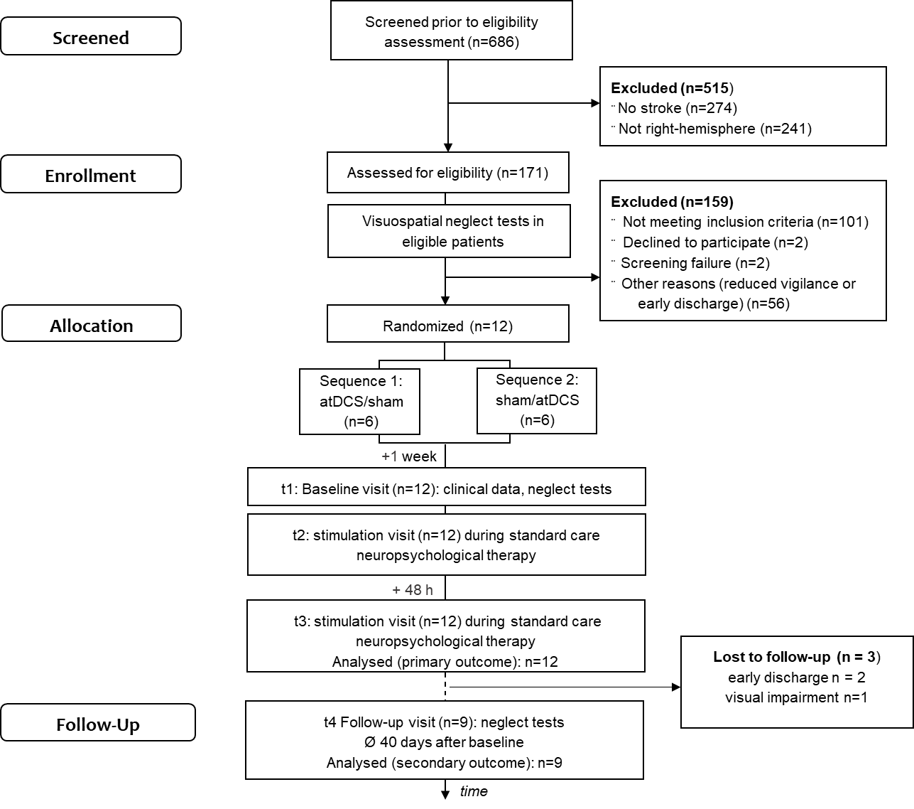
Figure S1. Flowchart of cross-over study.

Legend: Six hundred eighty-six patients were pre-screened at the neurological rehabilitation ward of the Kliniken Beelitz GmbH in Brandenburg, Germany, for presence of left-sided visuospatial neglect. Patients with no (n=274) or no right-hemisphere stroke (n=241) were excluded. Remaining patients were screened for inclusion/exclusion criteria. One hundred one patients did not meet the inclusion criteria, 2 patients declined to participate, and 58 were excluded due to screening failure (n=2) or other reasons (n=56) leaving 12 patients diagnosed with left-sided visuospatial neglect for participation in this cross-over study. These patients were randomly assigned to one of two sequences (sequence 1: active transcranial direct current stimulation (atDCS), sham stimulation (stDCS); sequence 2: stDCS, atDCS). After baseline visit (t1) atDCS or stDCS (t2) was applied simultaneous to standard care neuropsychological therapy. After 48 h the other (not yet applied) stimulation condition was conducted (t3). Due to early discharge (n=2) and visual impairment (n=1) only 9 patients performed follow-up tests on the last day of the hospital stay. Thus, 12 patients were analysed for primary objective, and 9 patients for secondary objective.

