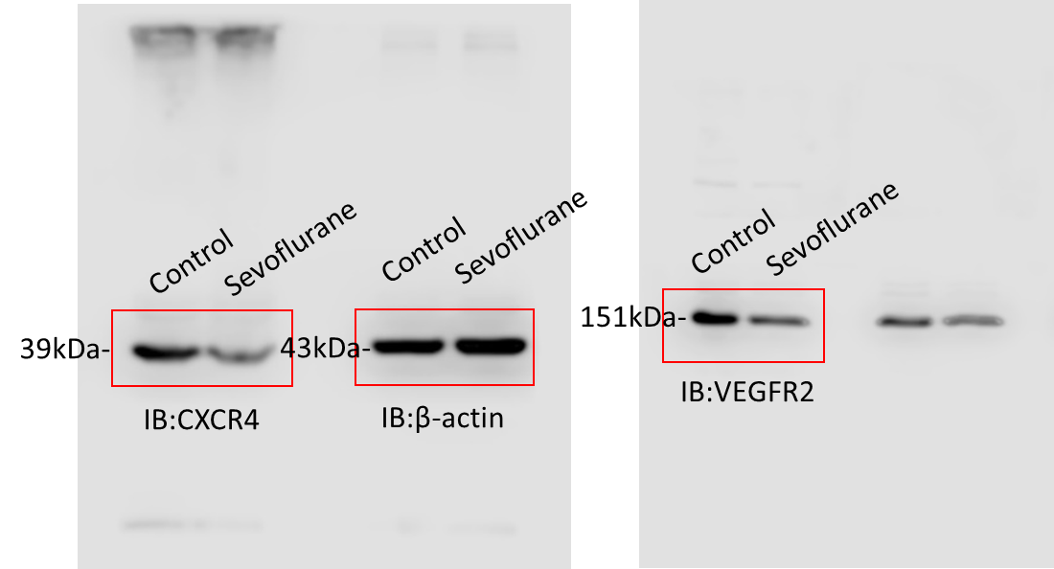

Fig. S1. Uncropped western blots – related to Figure 5. Immunoblot analysis of BMSCs in Control group or after long-term sevoflurane exposure. The same blots were probed with anti-CXCR4 (left panel), anti-VEGFR2 (right panel), and anti-β-actin (middle panel). Red square frames indicate the cropped regions shown in Fig. 5C.

