Table S1 The arrangement of the MSAP DNA methylation characteristics for regenerants obtained via in vitro anther culture
Sample | Trial | CG_DN (%) | CXG_DNM  (%) | CG_DM  (%) | CXG_DM  (%) | Cu²⁺  (µM) | Ag⁺  (µM) | Time  (days) | GPs
1 | M1 | 11.36 | 16.793 | 13.001 | 19.178 | 0.1 | 0 | 21 | 0.64
2 | M1 | 11.377 | 16.811 | 13.002 | 19.287 | 0.1 | 0 | 21 | 0.64
3 | M1 | 11.403 | 16.752 | 13.033 | 19.214 | 0.1 | 0 | 21 | 0.64
4 | M1 | 11.411 | 16.724 | 13.044 | 19.128 | 0.1 | 0 | 21 | 0.634
5 | M1 | 11.362 | 16.74 | 12.987 | 19.222 | 0.1 | 0 | 21 | 0.64
6 | M2 | 12.002 | 19.092 | 12.272 | 17.157 | 0.1 | 10 | 28 | 0.67
7 | M2 | 12.016 | 19.079 | 12.244 | 17.339 | 0.1 | 10 | 28 | 0.67
8 | M2 | 12.022 | 18.983 | 12.248 | 17.209 | 0.1 | 10 | 28 | 0.67
9 | M3 | 12.127 | 18.788 | 12.184 | 17.104 | 0.1 | 60 | 35 | 1.09
10 | M3 | 12.109 | 18.746 | 12.134 | 17.167 | 0.1 | 60 | 35 | 1.09
11 | M3 | 12.121 | 18.755 | 12.151 | 17.181 | 0.1 | 60 | 35 | 1.09
12 | M3 | 12.129 | 18.786 | 12.18 | 17.096 | 0.1 | 60 | 35 | 1.09
13 | M3 | 12.126 | 18.794 | 12.162 | 17.147 | 0.1 | 60 | 35 | 1.09
14 | M4 | 11.515 | 18.906 | 12.35 | 18.182 | 5 | 60 | 28 | 0.45
15 | M4 | 11.51 | 18.947 | 12.344 | 18.247 | 5 | 60 | 28 | 0.45
16 | M5 | 6.735 | 0.162 | 6.964 | 0.87 | 5 | 0 | 35 | 0.10
17 | M5 | 10.422 | 0.382 | 10.886 | 0.458 | 5 | 0 | 35 | 0.10
18 | M5 | 6.664 | 0.161 | 6.946 | 0.663 | 5 | 0 | 35 | 0.10
19 | M5 | 10.419 | 0.624 | 10.949 | 0.221 | 5 | 0 | 35 | 0.10
20 | M6 | 12.118 | 19.406 | 11.981 | 16.693 | 5 | 10 | 21 | 2.12
21 | M6 | 12.175 | 19.12 | 11.951 | 16.699 | 5 | 10 | 21 | 2.12
22 | M6 | 12.119 | 19.386 | 12.01 | 16.557 | 5 | 10 | 21 | 2.12
23 | M6 | 12.127 | 19.39 | 11.983 | 16.691 | 5 | 10 | 21 | 2.12
24 | M6 | 12.198 | 19.157 | 11.953 | 16.862 | 5 | 10 | 21 | 2.12
25 | M7 | 11.703 | 18.206 | 12.489 | 17.483 | 10 | 10 | 35 | 2.91
26 | M7 | 11.731 | 18.268 | 12.501 | 17.605 | 10 | 10 | 35 | 2.91
27 | M7 | 11.702 | 18.277 | 12.491 | 17.5 | 10 | 10 | 35 | 2.91
28 | M8 | 12.023 | 19.237 | 12.277 | 17.382 | 10 | 60 | 21 | 1.77
29 | M8 | 12.016 | 19.259 | 12.244 | 17.54 | 10 | 60 | 21 | 1.77
30 | M8 | 12.057 | 19.192 | 12.265 | 17.521 | 10 | 60 | 21 | 1.77
31 | M9 | 12.227 | 19.97 | 11.955 | 16.172 | 10 | 0 | 28 | 0.54
32 | M9 | 12.275 | 19.99 | 11.976 | 16.301 | 10 | 0 | 28 | 0.54
33 | M9 | 12.254 | 19.98 | 11.969 | 16.256 | 10 | 0 | 28 | 0.54
34 | M9 | 12.273 | 19.922 | 11.952 | 16.356 | 10 | 0 | 28 | 0.54
35 | M9 | 12.268 | 19.924 | 11.957 | 16.329 | 10 | 0 | 28 | 0.54
M1-M9 trials used to regenerate GPs; Cu²⁺ and Ag⁺ reflect ion concentration in mM in the medium; T is the time of in vitro tissue cultures in days; GPs states for the number of green plants per 100 anthers (GPs) for each of the trials tested.

Table S2 The arrangement of statistics for conditional moderation analyses based on model 3. RL – relative likelihood, AW - Akaike's weight, LLCI – ULCI is a 95% confidence interval

Analysis | Conditional moderation | Model summary |  |  |  |  |  |  | Figure
 |  | Predictors | β | SE | LLCI | ULCI | RL | AW
A | CG-DNM moderated by Cu conditional on time for GPs | CG_DNM | -8.88** | 0.61 | -10.12 | -7.64 | 1 | 0.132 | Fig. S1
 |  | Cu | -36.29** | 2.19 | -40.79 | -31.79
 |  | Int_1 = CG_DNM x Cu | 3.02** | 0.18 | 2.64 | 3.39
 |  | Time | -6.03** | 0.28 | -6.61 | -5.46
 |  | Int_2 = CG_DNM x Time | 0.49** | 0.023 | 0.44 | 0.54
 |  | Int_3 = Cu x Time | 1.61** | 0.08 | 1.45 | 1.77
 |  | Int_4 = CG_DNM x Cu x Time | -0.13** | 0.01 | -0.15 | -0.12
Model Summary: F(7,27) = 258.17, p < 0.00, R² = 0.985
Test of highest order unconditional interaction (X* W * Z): F(1,27) = 425.77, p < 0.00
B | CG-DNM moderated by Ag conditional on Time for GPs | CG_DNM | 1.24* | 0.73 | -0.26 | 2.74 | 0.95 | 0.12 | Fig. S2
 |  | Ag | -31.63** | 2.74 | -37.25 | -26.01
 |  | Int_1 = CG_DNM x Ag | 2.62** | 0.23 | 2.16 | 3.09
 |  | Time | 0.36* | 0.25 | -0.14 | 0.87
 |  | Int_2 = CG_DNM x Time | -0.03* | 0.02 | -0.08 | 0.01
 |  | Int_3 = Ag x Time | 1.09** | 0.09 | 0.9 | 1.29
 |  | Int_4 = CG_DNM x Ag x Time | -0.09** | 0.01 | -0.11 | -0.07
Model Summary: F(7,27) = 27.06, p < 0.001, R² = 0.875
Test of highest order unconditional interaction (X* W * Z): F(1,27)=132.36, p < 0.001
C | CXG-DNM moderated by Cu conditional on Time for GPs | CXG_DNM | -5.01** | 1.25 | -7.57 | -2.45 | 0.93 | 0.12 | Fig. S3
 |  | Cu | -34.45** | 11.41 | -57.86 | -11.03
 |  | Int_1 = CXG_DNM x Cu | 1.83** | 0.6 | 0.59 | 3.07
 |  | Time | -4.63** | 1.02 | -6.72 | -2.5263
 |  | Int_2 = CXG_DNM x Time | 0.25** | 0.05 | 0.1329 | 0.36
 |  | Int_3 = Cu x Time | 1.37** | 0.4 | 0.55 | 2.18
 |  | Int_4 = CXG_DNM x Cu x Time | -0.07** | 0.02 | -0.12 | -0.03
Model Summary: F(7,27) = 18.06, p < 0.001, R² = 0.824
Test of highest order unconditional interaction (X* W * Z): F(1,27) = 11.74, p < 0.001
D | CXG-DNM moderated by Ag conditional on Time for GPs | CXG_DNM | 1.19** | 0.29 | 0.59 | 1.79 | 0.92 | 0.12 | Fig. S4
 |  | Ag | -7.79** | 1.59 | -11.06 | -4.54
 |  | Int_1 = CXG_DNM x Ag | 0.42** | 0.08 | 0.25 | 0.59
 |  | Time | 0.52** | 0.14 | 0.23 | 0.81
 |  | Int_2 = CXG_DNM x Time | -0.03* | 0.01 | -0.05 | -0.02
 |  | Int_3 = Ag x Time | 0.47** | 0.0576 | 0.35 | 0.59
 |  | Int_4 = CXG_DNM x Ag x Time | -0.02** | 0.003 | -0.03 | -0.02
Model Summary: F(7,27) = 17.66, p < 0.001, R² = 0.8206
Test of highest order unconditional interaction (X* W * Z): F(1,27) = 68.97, p < 0.001
E | CG-DM moderated by Cu conditional on Time for GPs | CG_DM | 14.03** | 0.86 | 12.27 | 15.79 | 0.99 | 0.13 | Fig. S5
 |  | Cu | 53.27** | 3.27 | 46.56 | 59.99
 |  | Int_1 = CG_DM x Cu | -4.33** | 0.26 | -4.88 | -3.79
 |  | Time | 8.30** | 0.43 | 7.42 | 9.19
 |  | Int_2 = CG_DM x Time | -0.68** | 0.035 | -0.75 | -0.61
 |  | Int_3 = Cu x Time | -2.21** | 0.12 | -2.45 | -1.97
 |  | Int_4 = CG_DM x Cu x Time | 0.18** | 0.01 | 0.16 | 0.19
Model Summary: F(7,27) =190.27, p < 0.001, R² = 0.98
Test of highest order unconditional interaction (X* W * Z): F(1,27) = 360.01, p < 0.001
F | CG-DM moderated by Ag conditional on Time for GPs | CG_DM | 2.16* | 0.93 | 0.25 | 4.08 | 0.9 | 0.12 | Fig. S6
 |  | Ag | 29.21** | 3.84 | 21.34 | 37.08
 |  | Int_1 = CG_DM x Ag | -2.38** | 0.31 | -3.02 | -1.74
 |  | Time | 0.77* | 0.34 | 0.064 | 1.47
 |  | Int_2 = CG_DM x Time | -0.05 | 0.03 | -0.11 | 0
 |  | Int_3 = Ag x Time | -0.92** | 0.12 | -1.177 | -0.6696
 |  | Int_4 = CG_DM x Ag x Time | 0.07 | 0.01 | 0.0545 | 0.096
Model Summary: F(7,27) = 13.92, p < 0.001, R² = 0.783
Test of highest order unconditional interaction (X* W * Z): F(1,27) = 55.53, p < 0.001
G | CXG-DM moderated by Cu conditional on Time for GPs | CXG_DM | 7.29** | 0.56 | 6.1328 | 8.44 | 0.99 | 0.13 | Fig. S7
 |  | Cu | 35.79** | 2.67 | 30.3 | 41.27
 |  | Int_1 = CXG_DM x Cu | -2.06** | 0.15 | -2.37 | -1.75
 |  | Time | 5.99** | 0.41 | 5.14 | 6.84
 |  | Int_2 = CXG_DM x Time | -0.35** | 0.02 | -0.39 | -0.3
 |  | Int_3 = Cu x Time | -1.51** | 0.1 | -1.72 | -1.29
 |  | Int_4 = CXG_DM x Cu x Time | 0.09** | 0 | 0.07 | 0.1
Model Summary: F(7,27) = 116.46, p < 0.001, R² = 0.968
Test of highest order unconditional interaction (X* W * Z): F(1,27) =221.23, p < 0.001
H | CXG-DM moderated by Ag conditional on Time for GPs | CXG_DM | 0.67 | 0.37 | -0.09 | 1.44 | 0.88 | 0.12 | Fig. S8
 |  | Ag | 12.69** | 2.24 | 8.09 | 17.29
 |  | Int_1 = CXG_DM x Ag | -0.72** | 0.13 | -0.99 | -0.46
 |  | Time | 0.42* | 0.2 | 0.011 | 0.83
 |  | Int_2 = CXG_DM x Time | -0.02 | 0.01 | -0.04 | 0
 |  | Int_3 = Ag x Time | -0.42** | 0.08 | -0.58 | -0.26
 |  | Int_4 = CXG_DM x Ag x Time | 0.02** | 0 | 0.015 | 0.033
Model Summary: F(7,27) = 11.16, p < 0.001, R² = 0.743
Test of highest order unconditional interaction (X* W * Z): F(1,29) = 29.83, p < 0.001
I | delta moderated by Cu conditional on Time for GPs | delta | 3.06** | 0.12 | 2.81 | 3.31 | 0.99 | 0.49 | Fig. 1
 |  | Ag | -0.93** | 0.05 | -1.03 | -0.84
 |  | Int_1 = delta x Cu | -0.86** | 0.04 | -0.95 | -0.77
 |  | Time | -0.21** | 0.01 | -0.23 | -0.19
 |  | Int_2 = delta x Time | -0.15** | 0 | -0.16 | -0.14
 |  | Int_3 = Cu x Time | 0.04** | 0 | 0.04 | 0.04
 |  | Int_4 = delta x Cu x Time | 0.03** | 0 | 0.03 | 0.04
 |  | Model Summary: F(7,27) = 249.55, p < 0.001, R² = 0.985
 |  | Test of highest order unconditional interaction (X* W * Z): F(1,27) = 527.15, p < 0.00
J | delta moderated by Cu conditional on Time for GPs | delta | 0.71** | 0.19 | 0.32 | 1.09 | 1 | 0.51 | Fig. 2
 |  | Ag | -0.87** | 0.06 | -0.99 | -0.75
 |  | Int_1 = delta x Cu | -0.61** | 0.04 | -0.69 | -0.52
 |  | Time | 0.02 | 0.01 | -0.01 | 0.04
 |  | Int_2 = delta x Time | -0.03** | 0 | -0.04 | -0.01
 |  | Int_3 = Cu x Time | 0.03** | 0 | 0.03 | 0.03
 |  | Int_4 = delta x Cu x Time | 0.02* | 0 | 0.02 | 0.02
Model Summary: F(7,27) = 46.99, p < 0.00, R²=.924
Test of highest order unconditional interaction (X* W * Z): F(1,27) = 219.76, p< 0.001
K | delta moderated by Ag + Cu conditional on Time for GPs | delta | 0.85** | 0.21 | 0.41 | 1.29 | NC | NC | Fig. 3
 |  | Ag + Cu | -0.57** | 0.04 | -0.65 | -0.49
 |  | Int_1 = delta x (Ag+Cu) | -0.39** | 0.03 | -0.45 | -0.34
 |  | Time | -0.05** | 0.01 | -0.08 | -0.03
 |  | Int_2 = delta x Time | -0.03** | 0 | -0.05 | -0.01
 |  | Int_3 = (Ag+Cu) x Time | 0.02** | 0 | 0.02 | 0.02
 |  | Int_4 = delta x (Ag+Cu) x Time | 0.014** | 0 | 0.01 | 0.02
Model Summary: F(7,27)= 45.23, p < 0.001, R²=.921
Test of highest order unconditional interaction (X* W * Z): F(1,27)= 200.75, p < 0.001

GP100Ant – green plants per 100 anthers is the dependent variable; CG-DN, CXG-DN, CG-DM, CXG-DM, and delta are predictors (X), whereas Cu, Ag and Cu+Ag – moderators conditional on the time of in vitro anther cultures. LLCI and ULCI state for 95% confidence interval. RL – relative likelihood of the model. AW - Akaike weights. NC – not calculated.

Table S3 The arrangement of conditional X*W interaction at values of Z
Analysis | Test of conditional X*W interaction at value(s) of Z
 | Time | Effect | F | df1 | df2 | p
A | 21.0000 | .2061 | 15.4195 | 1.0000 | 27.0000 | .0005
 | 28.0000 | -.7325 | 770.4137 | 1.0000 | 27.0000 | .0000
 | 35.0000 | -1.6711 | 1006.1677 | 1.0000 | 27.0000 | .0000
B | 21.0000 | .7112 | 135.3943 | 1.0000 | 27.0000 | .0000
 | 28.0000 | .0739 | 57.1721 | 1.0000 | 27.0000 | .0000
 | 35.0000 | -.5635 | 122.4555 | 1.0000 | 27.0000 | .0000
C | 21.0000 | .3051 | 3.6267 | 1.0000 | 27.0000 | .0676
 | 28.0000 | -.2030 | 43.5984 | 1.0000 | 27.0000 | .0000
 | 35.0000 | -.7111 | 25.0175 | 1.0000 | 27.0000 | .0000
D | 21.0000 | -.1110 | 6.0551 | 1.0000 | 27.0000 | .0205
 | 28.0000 | -.2882 | 37.1531 | 1.0000 | 27.0000 | .0000
 | 35.0000 | -.4654 | 64.7329 | 1.0000 | 27.0000 | .0000
E | 21.0000 | -.5485 | 60.4222 | 1.0000 | 27.0000 | .0000
 | 28.0000 | .7128 | 536.4972 | 1.0000 | 27.0000 | .0000
 | 35.0000 | 1.9741 | 677.4036 | 1.0000 | 27.0000 | .0000
F | 21.0000 | -.7983 | 56.5029 | 1.0000 | 27.0000 | .0000
 | 28.0000 | -.2717 | 30.4939 | 1.0000 | 27.0000 | .0000
 | 35.0000 | .2550 | 18.3148 | 1.0000 | 27.0000 | .0002
G | 21.0000 | -.2306 | 54.6913 | 1.0000 | 27.0000 | .0000
 | 28.0000 | .3792 | 481.0660 | 1.0000 | 27.0000 | .0000
 | 35.0000 | .9889 | 327.4424 | 1.0000 | 27.0000 | .0000
H | 21.0000 | -.2204 | 35.7084 | 1.0000 | 27.0000 | .0000
 | 28.0000 | -.0525 | 33.9460 | 1.0000 | 27.0000 | .0000
 | 35.0000 | .1154 | 19.2444 | 1.0000 | 27.0000 | .0002
I | 21.0000 | -.1212 | 98.6626 | 1.0000 | 27.0000 | .0000
 | 28.0000 | .1252 | 665.1685 | 1.0000 | 27.0000 | .0000
 | 35.0000 | .3716 | 1074.4112 | 1.0000 | 27.0000 | .0000
J | 21.0000 | -.1599 | 231.6092 | 1.0000 | 27.0000 | .0000
 | 28.0000 | -.0111 | 28.1299 | 1.0000 | 27.0000 | .0000
 | 35.0000 | .1376 | 189.8337 | 1.0000 | 27.0000 | .0000
K | 21.0000 | -.1037 | 206.3139 | 1.0000 | 27.0000 | .0000
 | 28.0000 | -.0074 | 12.0382 | 1.0000 | 27.0000 | .0018
 | 35.0000 | .0889 | 160.0681 | 1.0000 | 27.0000 | .0000

The CG_DM, CXG_DM, CG_DNM, CXG_DNM were the predictors of GPs in the A-H analysis moderated by either Cu²⁺ or Ag⁺ conditional on the time. In the analysis I-J delta was used as a predictor of the GPs whereas Cu²⁺ was a moderator in I, Ag⁺ in J and (Cu+Ag) in K conditional on the time of in vitro anther cultures. The moderation conditional on the time with p>0.05 were not significant. For more details refer to Supplementary Table 4-14).

Table S4 Conditional CG_DNM*Cu interaction at values of the moderator Time. For the analysis PROCESS macro v. 3.4 by A.F. Hayes was used

Time | Effect | SE | t | p | LLCI | ULCI
21 | 0.2061 | 0.0525 | 3.9268 | 0.0005 | 0.0984 | 0.3138
21.7 | 0.1123 | 0.0486 | 2.3094 | 0.0288 | 0.0125 | 0.212
21.8 | 0.0986 | 0.0481 | 2.0519 | 0.05 | 0 | 0.1972
22.4 | 0.0184 | 0.0449 | 0.4104 | 0.6847 | -0.0736 | 0.1105
23.1 | -0.0754 | 0.0413 | -1.828 | 0.0786 | -0.1601 | 0.0092
23.2 | -0.084 | 0.041 | -2.0519 | 0.05 | -0.1681 | 0
23.8 | -0.1693 | 0.0379 | -4.4688 | 0.0001 | -0.247 | -0.0916
24.5 | -0.2632 | 0.0348 | -7.5694 | 0 | -0.3345 | -0.1918
25.2 | -0.357 | 0.032 | -11.1597 | 0 | -0.4227 | -0.2914
25.9 | -0.4509 | 0.0297 | -15.2023 | 0 | -0.5117 | -0.39
26.6 | -0.5447 | 0.0279 | -19.5403 | 0 | -0.6019 | -0.4875
27.3 | -0.6386 | 0.0268 | -23.8642 | 0 | -0.6935 | -0.5837
28 | -0.7325 | 0.0264 | -27.7563 | 0 | -0.7866 | -0.6783
28.7 | -0.8263 | 0.0268 | -30.8369 | 0 | -0.8813 | -0.7713
29.4 | -0.9202 | 0.0279 | -32.9243 | 0 | -0.9775 | -0.8628
30.1 | -1.014 | 0.0298 | -34.076 | 0 | -1.0751 | -0.953
30.8 | -1.1079 | 0.0321 | -34.498 | 0 | -1.1738 | -1.042
31.5 | -1.2018 | 0.0349 | -34.4264 | 0 | -1.2734 | -1.1301
32.2 | -1.2956 | 0.038 | -34.058 | 0 | -1.3737 | -1.2176
32.9 | -1.3895 | 0.0414 | -33.5314 | 0 | -1.4745 | -1.3045
33.6 | -1.4833 | 0.045 | -32.9349 | 0 | -1.5758 | -1.3909
34.3 | -1.5772 | 0.0488 | -32.3212 | 0 | -1.6773 | -1.4771
35 | -1.6711 | 0.0527 | -31.7201 | 0 | -1.7792 | -1.563

Green color indicates the time range when conditional moderation is significant. Blue – the time when moderation is not significant.

Table S5 Conditional CG_DNM*Ag interaction at values of the moderator Time. For the analysis PROCESS macro v. 3.4 by A.F. Hayes was used

Time | Effect | SE | t | p | LLCI | ULCI
21 | 0.7112 | 0.0611 | 11.6359 | 0 | 0.5858 | 0.8367
21.7 | 0.6475 | 0.0556 | 11.6372 | 0 | 0.5333 | 0.7617
22.4 | 0.5838 | 0.0502 | 11.6359 | 0 | 0.4808 | 0.6867
23.1 | 0.52 | 0.0447 | 11.6298 | 0 | 0.4283 | 0.6118
23.8 | 0.4563 | 0.0393 | 11.615 | 0 | 0.3757 | 0.5369
24.5 | 0.3926 | 0.0339 | 11.5833 | 0 | 0.323 | 0.4621
25.2 | 0.3288 | 0.0285 | 11.5171 | 0 | 0.2702 | 0.3874
25.9 | 0.2651 | 0.0233 | 11.3744 | 0 | 0.2173 | 0.3129
26.6 | 0.2013 | 0.0182 | 11.0417 | 0 | 0.1639 | 0.2387
27.3 | 0.1376 | 0.0135 | 10.1644 | 0 | 0.1098 | 0.1654
28 | 0.0739 | 0.0098 | 7.5612 | 0 | 0.0538 | 0.0939
28.6 | 0.017 | 0.0083 | 2.0519 | 0.05 | 0 | 0.0341
28.7 | 0.0101 | 0.0083 | 1.2184 | 0.23 | -0.0069 | 0.0272
29 | -0.018 | 0.0088 | -2.0519 | 0.05 | -0.036 | 0
29.4 | -0.0536 | 0.0102 | -5.2608 | 0 | -0.0745 | -0.0327
30.1 | -0.1174 | 0.0141 | -8.2942 | 0 | -0.1464 | -0.0883
30.8 | -0.1811 | 0.0189 | -9.5724 | 0 | -0.2199 | -0.1423
31.5 | -0.2448 | 0.024 | -10.1925 | 0 | -0.2941 | -0.1955
32.2 | -0.3086 | 0.0293 | -10.5376 | 0 | -0.3687 | -0.2485
32.9 | -0.3723 | 0.0346 | -10.7506 | 0 | -0.4434 | -0.3013
33.6 | -0.4361 | 0.04 | -10.8923 | 0 | -0.5182 | -0.3539
34.3 | -0.4998 | 0.0455 | -10.9923 | 0 | -0.5931 | -0.4065
35 | -0.5635 | 0.0509 | -11.066 | 0 | -0.668 | -0.459

Green color indicates the time range when conditional moderation is significant. Blue – the time when moderation is not significant.

Table S6 Conditional CXG_DNM*Cu interaction at values of the moderator Time. For the analysis PROCESS macro v. 3.4 by A.F. Hayes was used

Time | Effect | SE | t | p | LLCI | ULCI
21 | 0.3051 | 0.1602 | 1.9044 | 0.0676 | -0.0236 | 0.6338
21.7 | 0.2543 | 0.1457 | 1.7459 | 0.0922 | -0.0446 | 0.5532
22.4 | 0.2035 | 0.1312 | 1.5514 | 0.1325 | -0.0656 | 0.4726
23.1 | 0.1527 | 0.1168 | 1.3077 | 0.202 | -0.0869 | 0.3923
23.8 | 0.1019 | 0.1025 | 0.9942 | 0.329 | -0.1084 | 0.3121
24.5 | 0.0511 | 0.0884 | 0.5779 | 0.5681 | -0.1302 | 0.2324
25.2 | 0.0003 | 0.0745 | 0.0034 | 0.9973 | -0.1527 | 0.1532
25.9 | -0.0506 | 0.0612 | -0.8263 | 0.4159 | -0.1761 | 0.075
26.6 | -0.1004 | 0.0489 | -2.0519 | 0.05 | -0.2008 | 0
26.6 | -0.1014 | 0.0487 | -2.0819 | 0.047 | -0.2013 | -0.0015
27.3 | -0.1522 | 0.0379 | -4.0131 | 0.0004 | -0.23 | -0.0744
28 | -0.203 | 0.0307 | -6.6029 | 0 | -0.2661 | -0.1399
28.7 | -0.2538 | 0.0299 | -8.4971 | 0 | -0.3151 | -0.1925
29.4 | -0.3046 | 0.0358 | -8.517 | 0 | -0.378 | -0.2312
30.1 | -0.3554 | 0.0459 | -7.7448 | 0 | -0.4496 | -0.2612
30.8 | -0.4062 | 0.0581 | -6.9948 | 0 | -0.5254 | -0.2871
31.5 | -0.457 | 0.0713 | -6.4127 | 0 | -0.6033 | -0.3108
32.2 | -0.5078 | 0.085 | -5.9742 | 0 | -0.6823 | -0.3334
32.9 | -0.5586 | 0.0991 | -5.6397 | 0 | -0.7619 | -0.3554
33.6 | -0.6095 | 0.1133 | -5.3788 | 0 | -0.8419 | -0.377
34.3 | -0.6603 | 0.1277 | -5.1708 | 0 | -0.9223 | -0.3983
35 | -0.7111 | 0.1422 | -5.0017 | 0 | -1.0028 | -0.4194
35 | -0.5635 | 0.0509 | -11.066 | 0 | -0.668 | -0.459

Green color indicates the time range when conditional moderation is significant. Blue – the time when moderation is not significant.

Table S7 Conditional CXG_DNM*Ag interaction at values of the moderator Time. For the analysis PROCESS macro v. 3.4 by A.F. Hayes was used

Time | Effect | SE | t | p | LLCI | ULCI
21 | -0.111 | 0.0451 | -2.4607 | 0.0205 | -0.2036 | -0.0184
21.7 | -0.1288 | 0.0449 | -2.8682 | 0.0079 | -0.2209 | -0.0366
22.4 | -0.1465 | 0.0448 | -3.2726 | 0.0029 | -0.2383 | -0.0546
23.1 | -0.1642 | 0.0447 | -3.671 | 0.001 | -0.256 | -0.0724
23.8 | -0.1819 | 0.0448 | -4.0607 | 0.0004 | -0.2738 | -0.09
24.5 | -0.1996 | 0.045 | -4.4392 | 0.0001 | -0.2919 | -0.1074
25.2 | -0.2174 | 0.0452 | -4.8042 | 0.0001 | -0.3102 | -0.1245
25.9 | -0.2351 | 0.0456 | -5.1537 | 0 | -0.3287 | -0.1415
26.6 | -0.2528 | 0.0461 | -5.4861 | 0 | -0.3473 | -0.1582
27.3 | -0.2705 | 0.0466 | -5.8002 | 0 | -0.3662 | -0.1748
28 | -0.2882 | 0.0473 | -6.0953 | 0 | -0.3853 | -0.1912
28.7 | -0.306 | 0.048 | -6.371 | 0 | -0.4045 | -0.2074
29.4 | -0.3237 | 0.0488 | -6.6272 | 0 | -0.4239 | -0.2235
30.1 | -0.3414 | 0.0497 | -6.8642 | 0 | -0.4434 | -0.2393
30.8 | -0.3591 | 0.0507 | -7.0824 | 0 | -0.4631 | -0.2551
31.5 | -0.3768 | 0.0517 | -7.2826 | 0 | -0.483 | -0.2707
32.2 | -0.3945 | 0.0528 | -7.4656 | 0 | -0.503 | -0.2861
32.9 | -0.4123 | 0.054 | -7.6324 | 0 | -0.5231 | -0.3014
33.6 | -0.43 | 0.0552 | -7.7839 | 0 | -0.5433 | -0.3166
34.3 | -0.4477 | 0.0565 | -7.9214 | 0 | -0.5637 | -0.3317
35 | -0.4654 | 0.0578 | -8.0457 | 0 | -0.5841 | -0.3467
35 | -0.7111 | 0.1422 | -5.0017 | 0 | -1.0028 | -0.4194
35 | -0.5635 | 0.0509 | -11.066 | 0 | -0.668 | -0.459

Green color indicates the time range when conditional moderation is significant. Blue – the time when moderation is not significant.

Table S8 Conditional CG_DM*Cu interaction at values of the moderator Time. For the analysis PROCESS macro v. 3.4 by A.F. Hayes was used

Time | Effect | SE | t | p | LLCI | ULCI
21 | -0.5485 | 0.0706 | -7.7732 | 0 | -0.6933 | -0.4037
21.7 | -0.4224 | 0.0646 | -6.5342 | 0 | -0.555 | -0.2897
22.4 | -0.2962 | 0.0589 | -5.032 | 0 | -0.417 | -0.1754
23.1 | -0.1701 | 0.0533 | -3.1911 | 0.0036 | -0.2795 | -0.0607
23.5 | -0.1036 | 0.0505 | -2.0519 | 0.05 | -0.2071 | 0
23.8 | -0.044 | 0.048 | -0.9158 | 0.3679 | -0.1425 | 0.0546
24.5 | 0.0822 | 0.0431 | 1.9058 | 0.0674 | -0.0063 | 0.1706
24.5 | 0.088 | 0.0429 | 2.0519 | 0.05 | 0 | 0.176
25.2 | 0.2083 | 0.0387 | 5.3792 | 0 | 0.1288 | 0.2877
25.9 | 0.3344 | 0.0351 | 9.5405 | 0 | 0.2625 | 0.4063
26.6 | 0.4605 | 0.0323 | 14.2371 | 0 | 0.3942 | 0.5269
27.3 | 0.5867 | 0.0309 | 19.0088 | 0 | 0.5234 | 0.65
28 | 0.7128 | 0.0308 | 23.1624 | 0 | 0.6497 | 0.776
28.7 | 0.8389 | 0.0321 | 26.141 | 0 | 0.7731 | 0.9048
29.4 | 0.9651 | 0.0347 | 27.845 | 0 | 0.894 | 1.0362
30.1 | 1.0912 | 0.0382 | 28.5496 | 0 | 1.0128 | 1.1696
30.8 | 1.2173 | 0.0425 | 28.6221 | 0 | 1.1301 | 1.3046
31.5 | 1.3435 | 0.0474 | 28.3523 | 0 | 1.2462 | 1.4407
32.2 | 1.4696 | 0.0526 | 27.9222 | 0 | 1.3616 | 1.5776
32.9 | 1.5957 | 0.0582 | 27.4341 | 0 | 1.4764 | 1.7151
33.6 | 1.7219 | 0.0639 | 26.9408 | 0 | 1.5907 | 1.853
34.3 | 1.848 | 0.0698 | 26.4681 | 0 | 1.7047 | 1.9912
35 | 1.9741 | 0.0758 | 26.027 | 0 | 1.8185 | 2.1297

Green color indicates the time range when conditional moderation is significant. Blue – the time when moderation is not significant.

Table S9 Conditional CG_DM*Ag interaction at values of the moderator Time. For the analysis PROCESS macro v. 3.4 by A.F. Hayes was used

Time | Effect | SE | t | p | LLCI | ULCI
21 | -0.7983 | 0.1062 | -7.5168 | 0 | -1.0162 | -0.5804
21.7 | -0.7456 | 0.0997 | -7.4775 | 0 | -0.9502 | -0.541
22.4 | -0.693 | 0.0933 | -7.426 | 0 | -0.8845 | -0.5015
23.1 | -0.6403 | 0.087 | -7.3582 | 0 | -0.8189 | -0.4618
23.8 | -0.5876 | 0.0809 | -7.2683 | 0 | -0.7535 | -0.4218
24.5 | -0.535 | 0.0748 | -7.1484 | 0 | -0.6885 | -0.3814
25.2 | -0.4823 | 0.069 | -6.9872 | 0 | -0.624 | -0.3407
25.9 | -0.4297 | 0.0635 | -6.769 | 0 | -0.5599 | -0.2994
26.6 | -0.377 | 0.0582 | -6.4722 | 0 | -0.4965 | -0.2575
27.3 | -0.3243 | 0.0534 | -6.0682 | 0 | -0.434 | -0.2147
28 | -0.2717 | 0.0492 | -5.5221 | 0 | -0.3726 | -0.1707
28.7 | -0.219 | 0.0456 | -4.7976 | 0.0001 | -0.3127 | -0.1253
29.4 | -0.1663 | 0.043 | -3.8702 | 0.0006 | -0.2545 | -0.0781
30.1 | -0.1137 | 0.0414 | -2.7485 | 0.0105 | -0.1985 | -0.0288
30.5 | -0.084 | 0.041 | -2.0519 | 0.05 | -0.1681 | 0
30.8 | -0.061 | 0.0409 | -1.4912 | 0.1475 | -0.1449 | 0.0229
31.5 | -0.0083 | 0.0417 | -0.2001 | 0.8429 | -0.0938 | 0.0772
32.2 | 0.0443 | 0.0436 | 1.0171 | 0.3181 | -0.0451 | 0.1338
32.9 | 0.0952 | 0.0464 | 2.0519 | 0.05 | 0 | 0.1904
33 | 0.097 | 0.0465 | 2.0859 | 0.0466 | 0.0016 | 0.1924
33.6 | 0.1497 | 0.0502 | 2.9783 | 0.0061 | 0.0466 | 0.2528
34.3 | 0.2023 | 0.0547 | 3.7016 | 0.001 | 0.0902 | 0.3145
35 | 0.255 | 0.0596 | 4.2796 | 0.0002 | 0.1327 | 0.3772

Green color indicates the time range when conditional moderation is significant. Blue – the time when moderation is not significant.

Table S10 Conditional CXG_DM*Cu interaction at values of the moderator Time. For the analysis PROCESS macro v. 3.4 by A.F. Hayes was used

Time | Effect | SE | t | p | LLCI | ULCI
21 | -0.2306 | 0.0312 | -7.3954 | 0 | -0.2946 | -0.1666
21.7 | -0.1696 | 0.0275 | -6.1785 | 0 | -0.2259 | -0.1133
22.4 | -0.1086 | 0.0238 | -4.5557 | 0.0001 | -0.1576 | -0.0597
23.1 | -0.0477 | 0.0204 | -2.3331 | 0.0273 | -0.0896 | -0.0057
23.2 | -0.0412 | 0.0201 | -2.0519 | 0.05 | -0.0824 | 0
23.8 | 0.0133 | 0.0173 | 0.7695 | 0.4483 | -0.0222 | 0.0488
24 | 0.0336 | 0.0164 | 2.0519 | 0.05 | 0 | 0.0672
24.5 | 0.0743 | 0.0147 | 5.0624 | 0 | 0.0442 | 0.1044
25.2 | 0.1353 | 0.0128 | 10.5356 | 0 | 0.1089 | 0.1616
25.9 | 0.1962 | 0.0122 | 16.135 | 0 | 0.1713 | 0.2212
26.6 | 0.2572 | 0.0128 | 20.0471 | 0 | 0.2309 | 0.2835
27.3 | 0.3182 | 0.0147 | 21.7039 | 0 | 0.2881 | 0.3483
28 | 0.3792 | 0.0173 | 21.9332 | 0 | 0.3437 | 0.4146
28.7 | 0.4401 | 0.0204 | 21.5698 | 0 | 0.3983 | 0.482
29.4 | 0.5011 | 0.0238 | 21.0352 | 0 | 0.4522 | 0.55
30.1 | 0.5621 | 0.0274 | 20.4936 | 0 | 0.5058 | 0.6184
30.8 | 0.6231 | 0.0312 | 19.9989 | 0 | 0.5591 | 0.687
31.5 | 0.684 | 0.035 | 19.5631 | 0 | 0.6123 | 0.7558
32.2 | 0.745 | 0.0388 | 19.1839 | 0 | 0.6653 | 0.8247
32.9 | 0.806 | 0.0427 | 18.8545 | 0 | 0.7183 | 0.8937
33.6 | 0.867 | 0.0467 | 18.5675 | 0 | 0.7712 | 0.9628
34.3 | 0.9279 | 0.0507 | 18.3164 | 0 | 0.824 | 1.0319
35 | 0.9889 | 0.0547 | 18.0954 | 0 | 0.8768 | 1.1011

Green color indicates the time range when conditional moderation is significant. Blue – the time when moderation is not significant.

Table S11 Conditional CXG_DM*Ag interaction at values of the moderator Time. For the analysis PROCESS macro v. 3.4 by A.F. Hayes was used

Time | Effect | SE | t | p | LLCI | ULCI
21 | -0.2204 | 0.0369 | -5.9757 | 0 | -0.296 | -0.1447
21.7 | -0.2036 | 0.0339 | -6.011 | 0 | -0.2731 | -0.1341
22.4 | -0.1868 | 0.0309 | -6.0507 | 0 | -0.2501 | -0.1234
23.1 | -0.17 | 0.0279 | -6.0953 | 0 | -0.2272 | -0.1128
23.8 | -0.1532 | 0.0249 | -6.145 | 0 | -0.2044 | -0.102
24.5 | -0.1364 | 0.022 | -6.1991 | 0 | -0.1816 | -0.0913
25.2 | -0.1196 | 0.0191 | -6.2545 | 0 | -0.1589 | -0.0804
25.9 | -0.1028 | 0.0163 | -6.3019 | 0 | -0.1363 | -0.0694
26.6 | -0.086 | 0.0136 | -6.315 | 0 | -0.114 | -0.0581
27.3 | -0.0693 | 0.0111 | -6.2213 | 0 | -0.0921 | -0.0464
28 | -0.0525 | 0.009 | -5.8263 | 0 | -0.071 | -0.034
28.7 | -0.0357 | 0.0076 | -4.7191 | 0.0001 | -0.0512 | -0.0202
29.4 | -0.0189 | 0.0072 | -2.6166 | 0.0144 | -0.0337 | -0.0041
29.6 | -0.015 | 0.0073 | -2.0519 | 0.05 | -0.0301 | 0
30.1 | -0.0021 | 0.0081 | -0.2591 | 0.7975 | -0.0188 | 0.0146
30.8 | 0.0147 | 0.0099 | 1.4775 | 0.1511 | -0.0057 | 0.0351
31.1 | 0.0225 | 0.011 | 2.0519 | 0.05 | 0 | 0.0451
31.5 | 0.0315 | 0.0123 | 2.5661 | 0.0162 | 0.0063 | 0.0566
32.2 | 0.0483 | 0.0149 | 3.2465 | 0.0031 | 0.0178 | 0.0788
32.9 | 0.0651 | 0.0176 | 3.692 | 0.001 | 0.0289 | 0.1012
33.6 | 0.0818 | 0.0205 | 3.9991 | 0.0004 | 0.0398 | 0.1238
34.3 | 0.0986 | 0.0234 | 4.2207 | 0.0002 | 0.0507 | 0.1466
35 | 0.1154 | 0.0263 | 4.3868 | 0.0002 | 0.0614 | 0.1694

Green color indicates the time range when conditional moderation is significant. Blue – the time when moderation is not significant.

Table S12 Conditional delta*Cu interaction at values of the moderator Time. For the analysis PROCESS macro v. 3.4 by A.F. Hayes was used

Time | Effect | SE | t | p | LLCI | ULCI
21 | -0.1212 | 0.0122 | -9.9329 | 0 | -0.1463 | -0.0962
21.7 | -0.0966 | 0.0112 | -8.603 | 0 | -0.1196 | -0.0736
22.4 | -0.072 | 0.0103 | -7.0064 | 0 | -0.093 | -0.0509
23.1 | -0.0473 | 0.0093 | -5.0675 | 0 | -0.0665 | -0.0282
23.8 | -0.0227 | 0.0084 | -2.6871 | 0.0122 | -0.04 | -0.0054
24 | -0.0169 | 0.0082 | -2.0519 | 0.05 | -0.0338 | 0
24.5 | 0.002 | 0.0076 | 0.2604 | 0.7965 | -0.0136 | 0.0175
24.9 | 0.0147 | 0.0072 | 2.0519 | 0.05 | 0 | 0.0294
25.2 | 0.0266 | 0.0068 | 3.921 | 0.0005 | 0.0127 | 0.0405
25.9 | 0.0513 | 0.0061 | 8.4275 | 0 | 0.0388 | 0.0637
26.6 | 0.0759 | 0.0055 | 13.8088 | 0 | 0.0646 | 0.0872
27.3 | 0.1005 | 0.0051 | 19.8197 | 0 | 0.0901 | 0.111
28 | 0.1252 | 0.0049 | 25.7909 | 0 | 0.1152 | 0.1351
28.7 | 0.1498 | 0.0049 | 30.7832 | 0 | 0.1398 | 0.1598
29.4 | 0.1745 | 0.0051 | 34.1357 | 0 | 0.164 | 0.185
30.1 | 0.1991 | 0.0056 | 35.8425 | 0 | 0.1877 | 0.2105
30.8 | 0.2238 | 0.0062 | 36.345 | 0 | 0.2111 | 0.2364
31.5 | 0.2484 | 0.0069 | 36.1378 | 0 | 0.2343 | 0.2625
32.2 | 0.273 | 0.0077 | 35.5783 | 0 | 0.2573 | 0.2888
32.9 | 0.2977 | 0.0085 | 34.8774 | 0 | 0.2802 | 0.3152
33.6 | 0.3223 | 0.0094 | 34.1463 | 0 | 0.303 | 0.3417
34.3 | 0.347 | 0.0104 | 33.4388 | 0 | 0.3257 | 0.3683
35 | 0.3716 | 0.0113 | 32.7782 | 0 | 0.3484 | 0.3949

Green color indicates the time range when conditional moderation is significant. Blue – the time when moderation is not significant.

Table S13 Conditional delta*Ag interaction at values of the moderator Time. For the analysis PROCESS macro v. 3.4 by A.F. Hayes was used

Time | Effect | SE | t | p | LLCI | ULCI
21 | -0.1599 | 0.0105 | -15.2187 | 0 | -0.1814 | -0.1383
21.7 | -0.145 | 0.0095 | -15.2253 | 0 | -0.1645 | -0.1254
22.4 | -0.1301 | 0.0085 | -15.2243 | 0 | -0.1476 | -0.1126
23.1 | -0.1152 | 0.0076 | -15.209 | 0 | -0.1308 | -0.0997
23.8 | -0.1004 | 0.0066 | -15.1658 | 0 | -0.1139 | -0.0868
24.5 | -0.0855 | 0.0057 | -15.0672 | 0 | -0.0971 | -0.0738
25.2 | -0.0706 | 0.0048 | -14.8525 | 0 | -0.0804 | -0.0608
25.9 | -0.0557 | 0.0039 | -14.378 | 0 | -0.0637 | -0.0478
26.6 | -0.0409 | 0.0031 | -13.2808 | 0 | -0.0472 | -0.0345
27.3 | -0.026 | 0.0024 | -10.6808 | 0 | -0.031 | -0.021
28 | -0.0111 | 0.0021 | -5.3038 | 0 | -0.0154 | -0.0068
28.3 | -0.0043 | 0.0021 | -2.0519 | 0.05 | -0.0086 | 0
28.7 | 0.0038 | 0.0022 | 1.71 | 0.0987 | -0.0008 | 0.0083
28.7 | 0.0046 | 0.0022 | 2.0519 | 0.05 | 0 | 0.0091
29.4 | 0.0186 | 0.0027 | 6.874 | 0 | 0.0131 | 0.0242
30.1 | 0.0335 | 0.0034 | 9.7312 | 0 | 0.0265 | 0.0406
30.8 | 0.0484 | 0.0043 | 11.2862 | 0 | 0.0396 | 0.0572
31.5 | 0.0633 | 0.0052 | 12.1939 | 0 | 0.0526 | 0.0739
32.2 | 0.0781 | 0.0061 | 12.7659 | 0 | 0.0656 | 0.0907
32.9 | 0.093 | 0.0071 | 13.1506 | 0 | 0.0785 | 0.1075
33.6 | 0.1079 | 0.008 | 13.423 | 0 | 0.0914 | 0.1244
34.3 | 0.1228 | 0.009 | 13.6243 | 0 | 0.1043 | 0.1413
35 | 0.1376 | 0.01 | 13.778 | 0 | 0.1171 | 0.1581

Green color indicates the time range when conditional moderation is significant. Blue – the time when moderation is not significant.

Table S14 Conditional delta*(Ag+Cu) interaction at values of the moderator Time. For the analysis PROCESS macro v. 3.4 by A.F. Hayes was used

Time | Effect | SE | t | p | LLCI | ULCI
21 | -0.1037 | 0.0072 | -14.3636 | 0 | -0.1185 | -0.0889
21.7 | -0.0941 | 0.0066 | -14.3109 | 0 | -0.1076 | -0.0806
22.4 | -0.0844 | 0.0059 | -14.2288 | 0 | -0.0966 | -0.0723
23.1 | -0.0748 | 0.0053 | -14.0998 | 0 | -0.0857 | -0.0639
23.8 | -0.0652 | 0.0047 | -13.8939 | 0 | -0.0748 | -0.0556
24.5 | -0.0556 | 0.0041 | -13.5573 | 0 | -0.064 | -0.0471
25.2 | -0.0459 | 0.0035 | -12.9914 | 0 | -0.0532 | -0.0387
25.9 | -0.0363 | 0.003 | -12.0153 | 0 | -0.0425 | -0.0301
26.6 | -0.0267 | 0.0026 | -10.3191 | 0 | -0.032 | -0.0214
27.3 | -0.017 | 0.0023 | -7.5037 | 0 | -0.0217 | -0.0124
28 | -0.0074 | 0.0021 | -3.4696 | 0.0018 | -0.0118 | -0.003
28.2 | -0.0044 | 0.0021 | -2.0519 | 0.05 | -0.0088 | 0
28.7 | 0.0022 | 0.0022 | 1.0082 | 0.3223 | -0.0023 | 0.0068
28.9 | 0.0046 | 0.0023 | 2.0519 | 0.05 | 0 | 0.0093
29.4 | 0.0119 | 0.0025 | 4.7907 | 0.0001 | 0.0068 | 0.0169
30.1 | 0.0215 | 0.0029 | 7.4593 | 0 | 0.0156 | 0.0274
30.8 | 0.0311 | 0.0034 | 9.2187 | 0 | 0.0242 | 0.038
31.5 | 0.0407 | 0.0039 | 10.3789 | 0 | 0.0327 | 0.0488
32.2 | 0.0504 | 0.0045 | 11.1655 | 0 | 0.0411 | 0.0596
32.9 | 0.06 | 0.0051 | 11.7179 | 0 | 0.0495 | 0.0705
33.6 | 0.0696 | 0.0057 | 12.1193 | 0 | 0.0578 | 0.0814
34.3 | 0.0793 | 0.0064 | 12.4202 | 0 | 0.0662 | 0.0924
35 | 0.0889 | 0.007 | 12.6518 | 0 | 0.0745 | 0.1033

Green color indicates the time range when conditional moderation is significant. Blue – the time when moderation is not significant.

Fig. S1 Conditional effect of the focal predictor (Model 3). GP100Ant – green plants per 100 anthers, CG_DNM – de novo methylation of the CG contexts. Variables: Cu²⁺ – W, Time – Z
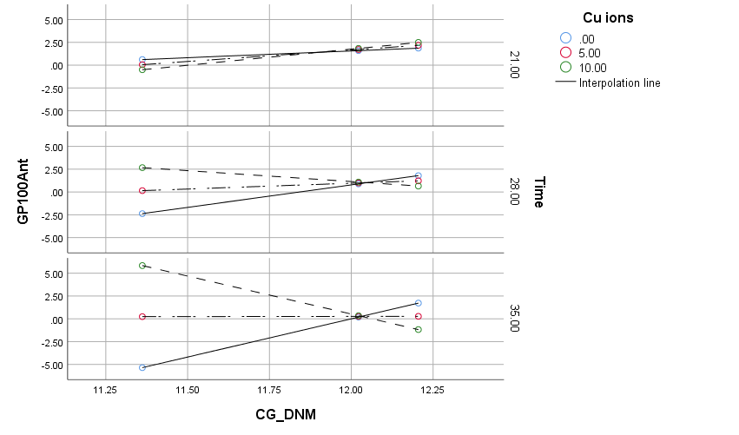
Moderation of GPs due to the de novo methylation of the CG DNA context by Cu²⁺ conditional on the time of in vitro anther cultures (Table S2, Analysis A). The longer the time of in vitro anther tissue cultures containing Cu²⁺ at the highest concentrations in the medium, the higher the number of GPs with the minimum de novo methylation of the CG context should be regenerated. With increased CG context de novo methylation, the reversed phenomenon is observed. The conditional CG_DNM*Cu interaction starts at the value of the time equal to 23.8 days (Table S4).

Fig. S2 Conditional effect of the focal predictor (Model 3). GP100Ant – green plants per 100 anthers, CG_DNM – de novo methylation of the CG contexts. Variables: Ag⁺ – W, Time – Z
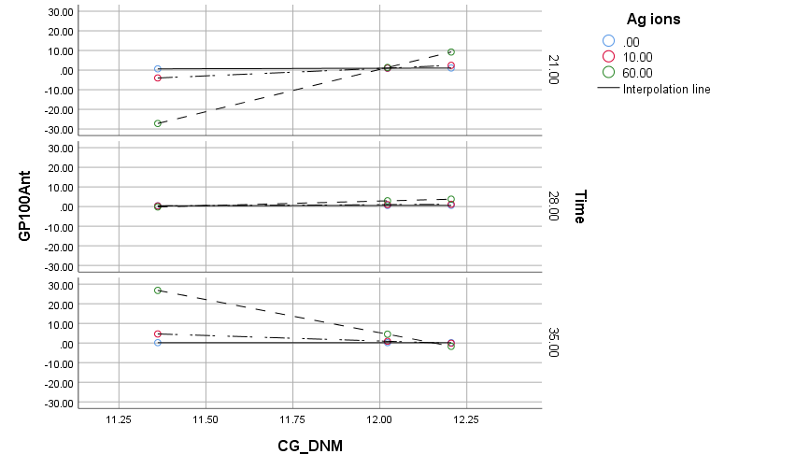
The longest time of in vitro anther tissue cultures containing Ag⁺ at the highest concentrations in the medium concentrations, the higher the number of GP with the minimum de novo methylation of the CG context (Table S2, Analysis B). With increased de novo methylation, the regeneration of the GPs is more probable at higher Ag⁺ concentrations when a short time of the tissue cultures is applied. Increasing the time above 28 days may significantly reduce the number of GPs. The conditional CG_DNM*Ag interaction is not valid at the time equal to 28.7 – 29.4 days (Table S5).

Fig. S3 Conditional effect of the focal predictor (Model 3). GP100Ant – green plants per 100 anthers, CXG_DNM – de novo methylation of the CXG contexts. Variables: Cu²⁺ – W, Time – Z
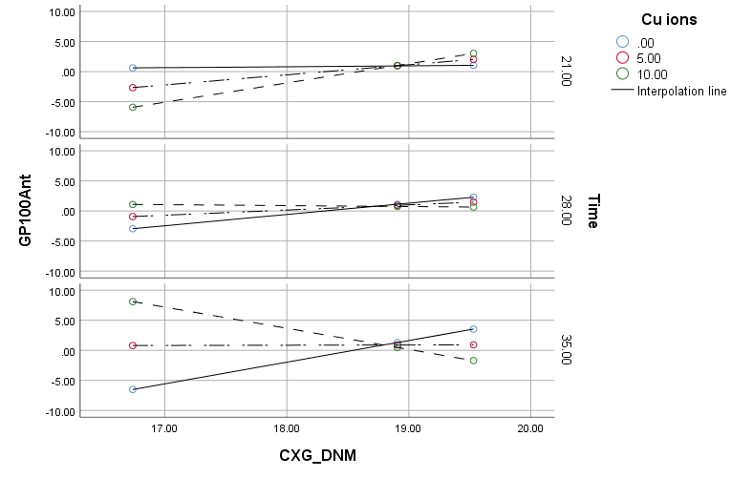
Moderation of the GPs due to the de novo methylation of the CXG DNA sequence context by Cu²⁺ (Table S2, Analysis C) conditional on the time shows that the longer the time of in vitro anther culture and the higher the concentration of the Cu²⁺ ions the greater the number of the GPs. The regenerants evaluated under such conditions should have a low level of de novo DNA methylation of the CXG contexts. However, under the low and moderate concentration of the Cu²⁺ ions, some GPs may also be regenerated. They should have exhibited a high level of the CXG context de novo methylation. The conditional CXG_DNM*Cu interaction starts at the time equal to 26.6 days (Table S6).

Fig. S4 Conditional effect of the focal predictor (Model 3). GP100Ant – green plants per 100 anthers, CXG_DNM – de novo methylation of the CXG contexts. Variables: Ag⁺ – W, Time – Z
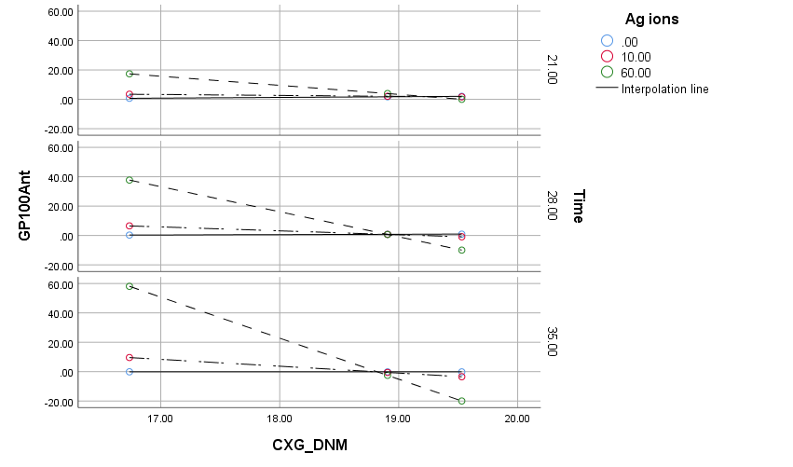
Moderation of GPs due to the de novo methylation of the CXG contexts moderated by Ag⁺ conditional on the time (Table S2, Analysis D) shows that the longer the time of tissue cultures containing Ag⁺ at the highest concentrations, the higher the number of GP with the minimum de novo methylation of the CG context. Under a long time of in vitro anther tissue cultures and the highest Ag⁺ ion concentration, the plants with the highest de novo methylation of the CG context should be regenerated; however, regeneration under such conditions should not be perfect. The conditional CXG_DNM*Ag interaction is valid, starting from the 21 days of in vitro anther cultures (Table S7).

Fig. S5 Conditional effect of the focal predictor (Model 3). GP100Ant – green plants per 100 anthers, CG_DMV – demethylation of the CG contexts. Variables: Cu²⁺ – W, Time – Z
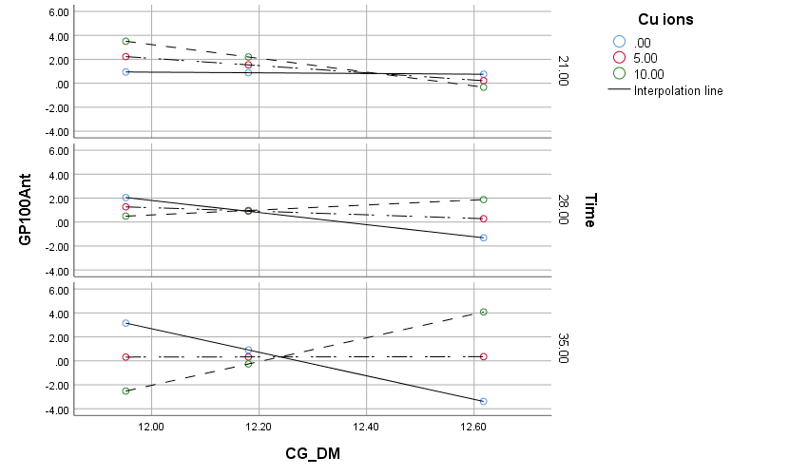
Moderation of the GPs due to the demethylation of the CG contexts moderated by Cu²⁺ conditional on the time of in vitro anther cultures (Table S2, Analysis E) shows that the longer the time of tissue cultures containing Cu²⁺ at the lowest concentrations the higher number of GP with the minimum demethylation of the CG context. Under a long time of tissue culture conditions and the highest Cu²⁺ ion concentration, the plants with the highest demethylation of the CG context should be regenerated. The conditional CG_DM*Cu interaction is not valid, starting from 23.5 to 24.5 days of the in vitro anther cultures (Table S8).

Fig. S6 Conditional effect of the focal predictor (Model 3). GP100Ant – green plants per 100 spikes, CG_DMV – demethylation of the CG contexts. Variables; Ag⁺ – W, Time – Z
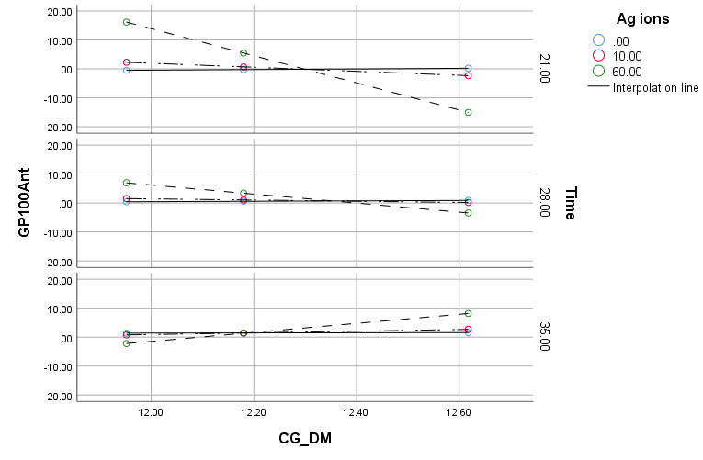
Moderation of GPs due to the demethylation of the CG contexts moderated by Ag⁺ conditional on the time (Table S2, Analysis F) shows that the shorter the time of in vitro anther tissue cultures containing Ag⁺ at the highest concentration should result in the highest number of GPs with the minimum demethylation of the CG context. Under a long time of tissue culture conditions and the highest Ag⁺ ion concentration, some regenerants may also be regenerated. If evaluated, they should exhibit the highest level of the CG sequence DNA context demethylation. The conditional CG_DM*Ag interaction is not valid, starting from 30.5 to 32.9 days of in vitro anther cultures (Table S9).

Fig. S7 Conditional effect of the focal predictor (Model 3). GP100Ant – green plants per 100 anthers, CXG_DM – demethylation of the CXG contexts. Variables: Cu²⁺ – W, Time – Z
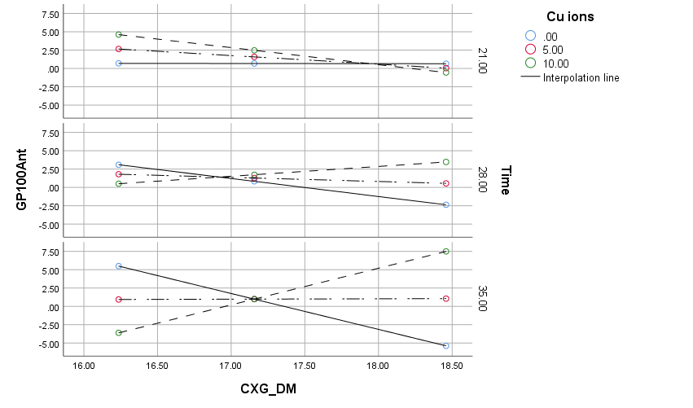
Moderation of the GPs due to the demethylation of the CXG contexts moderated by Cu²⁺ conditional on the time (Table S2, Analysis G) shows that a long time of tissue cultures containing Cu²⁺ at the lowest concentrations should result in the increased number of green regenerants. Such regenerants should have the lowest level of the CXG sequence context DNA demethylation. Increasing Cu²⁺ concentration and extending the time of in vitro anther cultures prone demethylation of the CXG sequences and result in the highest number of the GPs. The conditional CXG_DM*Cu interaction is not valid, starting from 23.2 to 24 days of the in vitro anther cultures (Table S10).

Fig. S8 Conditional effect of the focal predictor. GP100Ant – green plants per 100 anthers, CXG_DM – demethylation of the CXG contexts. Variables: Ag⁺ – W, Time – Z
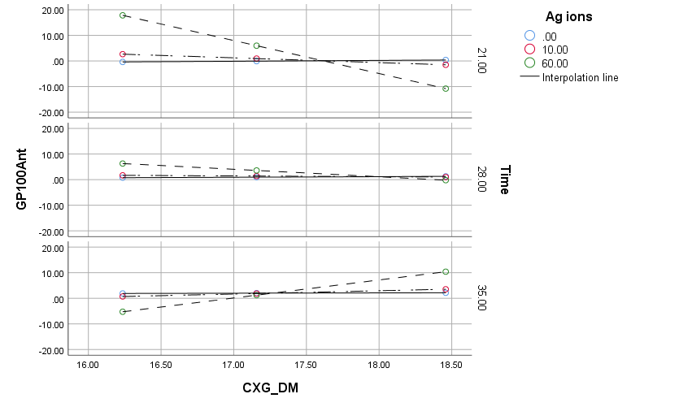
Moderation of GPs due to the demethylation of the CXG contexts moderated by Ag⁺ conditional on time in vitro anther tissue cultures (Table S2, Analysis H) shows that short time of in vitro tissue cultures containing Ag⁺ at the highest concentrations should result in the increased number of green regenerants with the lowest demethylation level of the CXG context. Increasing the time of in vitro anther tissue cultures under the same Ag⁺ concentration level should lead towards CXG context demethylation and reduction of the number of GPs. The conditional CXG_DM*Ag interaction is not valid, starting from 29.6 to 30.8 days of in vitro anther cultures (Table S11).

