Table S1 Negative moderation effects of cognitive reserve proxies within TILDA
Brain Structure | Cognition | Cognitive Reserve Proxy | n | ΔR² | β
Cx Thickness | Epi Mem | Occu + CogStim + Ex | 279 | .034 | -.340**
Cx Thickness | Epi Mem | Occu + CogStim + Leisure + Ex | 279 | .032 | -.335**
Cx Thickness | Epi Mem | Occu + Leisure + Ex | 279 | .030 | -.310**
Cx Thickness | Epi Mem | CogStim + Ex | 279 | .029 | -.286**
Cx Thickness | Epi Mem | Leisure + Ex | 279 | .026 | -.245**
Cx Thickness | Epi Mem | CogStim + Leisure + Ex | 279 | .025 | -.258**
Cx Thickness | Epi Mem | Occu + Ex | 279 | .022 | -.242**
Cx Thickness | Epi Mem | Edu + Occu + CogStim + Ex | 279 | .021 | -.270**
Cx Thickness | Epi Mem | Occu + CogStim | 279 | .021 | -.214*
Cx Thickness | Epi Mem | Edu + Occu + CogStim + Leisure + Ex | 279 | .020 | -.265*
Cx Thickness | Epi Mem | Edu + Occu + Leisure + Ex | 279 | .019 | -.255*
Cx Thickness | Epi Mem | Ex | 279 | .018 | -.200*
Cx Thickness | Epi Mem | Occu + CogStim + Leisure | 279 | .018 | -.204*
Cx Thickness | Epi Mem | Occu + Social + CogStim + Leisure + Ex | 279 | .015 | -.233*
GM Volume | Epi Mem | CogStim + Ex | 313 | .015 | -.176*
Cx Thickness | Epi Mem | Edu + Occu + Ex | 279 | .015 | -.205*
Cx Thickness | Glob Cog | Edu + Leisure + Ex | 277 | .015 | -.198*
Cx Thickness | Glob Cog | CogStim + Leisure + Ex | 277 | .014 | -.185*
Cx Thickness | Glob Cog | Leisure + Ex | 277 | .014 | -.175*
Cx Thickness | Epi Mem | Occu + Social + CogStim + Ex | 279 | .014 | -.227*
Cx Thickness | Epi Mem | Occu + Verbal IQ + CogStim + Leisure + Ex | 279 | .013 | -.223*
Cx Thickness | Glob Cog | Edu | 277 | .013 | -.113*
Cx Thickness | Glob Cog | Edu + CogStim + Leisure + Ex | 277 | .013 | -.187*
Cx Thickness | Epi Mem | Occu + Verbal IQ + CogStim + Ex | 279 | .012 | -.212*
Cx Thickness | Glob Cog | Edu + Occu + CogStim + Leisure + Ex | 277 | .012 | -.195*
GM Volume | Exec Func | Edu + CogStim + Ex | 311 | .011 | -.179*
Cx Thickness | Glob Cog | Edu + Leisure | 277 | .011 | -.131*
Cx Thickness | Glob Cog | Leisure | 277 | .011 | -.103*
Cx Thickness | Glob Cog | Edu + Occu + Leisure + Ex | 277 | .011 | -.189*
Cx Thickness | Glob Cog | Occu + CogStim + Leisure + Ex | 277 | .011 | -.191*
GM Volume | Glob Cog | Edu + CogStim + Ex | 311 | .010 | -.161*
Note: * = p < .05, ** = p < .01 Cx Thickness = Mean Cortical Thickness, GM Volume = Grey Matter Volume, Epi Mem = Episodic Memory, Glob Cog = Global Cognition, Exec Func = Executive Function, Occu = Occupational Complexity, CogStim = Cognitively Stimulating Activities, Ex = Exercise, Leisure = Leisure Activities, Edu = Educational Attainment, Social = Social Engagement, Verbal IQ = Verbal Intelligence.
Table S2 Positive moderation effects of cognitive reserve proxies within both datasets
Dataset | Brain Structure | Cognition | Cognitive Reserve Proxy | n | ΔR² | β
TILDA | HC Volume | Verb Flu | Occu + Ex | 313 | .019 | .227*
 | GM Volume | Proc Speed | Occu | 313 | .018 | .148*
 | GM Volume | Verb Flu | Occu + Ex | 313 | .017 | .214*
 | Cx Thickness | Verb Flu | Occu + Social + Ex | 279 | .015 | .235*
 | HC Volume | Verb Flu | Occu + Social + Ex | 313 | .015 | .243*
 | HC Volume | Verb Flu | Ex | 313 | .014 | .192*
 | GM Vol | Verb Flu | Occu + Social + Ex | 313 | .014 | .231*
 | HC Volume | Verb Flu | Social + Ex | 313 | .014 | .208*
CR/RANN | HC Volume | Glob Cog | Occu + Verbal IQ | 234 | .030 | .215**
 | HC Volume | Epi Mem | Occu + Ex | 234 | .026 | .232*
 | HC Volume | Glob Cog | Occu + Verbal IQ + Ex | 234 | .026 | .266**
 | HC Volume | Glob Cog | Occu | 234 | .025 | .155*
 | HC Volume | Epi Mem | Occu + Verbal IQ + Ex | 234 | .025 | .263*
 | HC Volume | Epi Mem | Occu | 234 | .024 | .151*
 | HC Volume | Exec Func | Occu + Verbal IQ | 234 | .018 | .168*
Note: * = p < .05, ** = p < .01. HC Volume = Hippocampal Volume, GM Volume = Grey Matter Volume, Cx Thickness = Mean Cortical Thickness, Verb Flu = Verbal Fluency, Proc Speed = Processing Speed, Glob Cog = Global Cognition, Epi Mem = Episodic Memory, Exec Func = Executive Function, Occu = Occupational Complexity, Ex = Exercise, Social = Social Engagement, Verbal IQ = Verbal Intelligence.

 | TILDA | CR/RANN
Glob Cog ~  Intell  | Hipp Vol,  Age, Sex  Mean ΔR² = .168 | 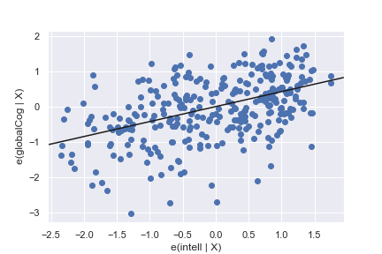 | 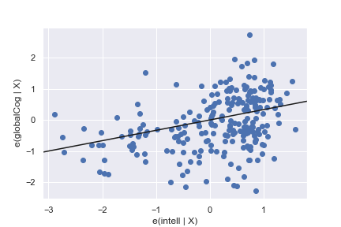
Glob Cog ~  Intell  | GM Vol,  Age, Sex  Mean ΔR² = .159 | 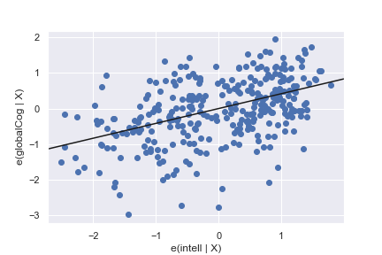 | 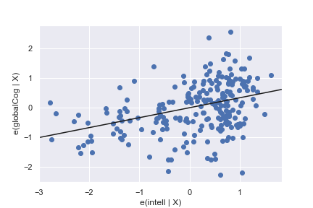
Glob Cog ~  Intell  | Cx Th,  Age, Sex  Mean ΔR² = .147 | 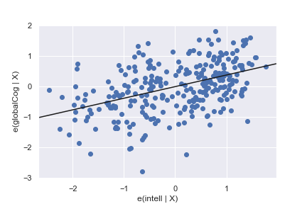 | 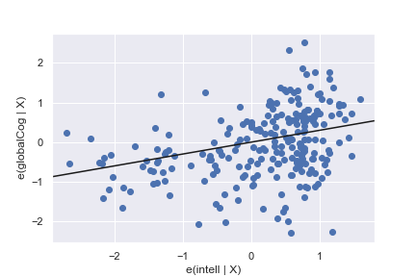
Exec Func  ~ Intell  | Hipp Vol,  Age, Sex  Mean ΔR² = .146 | 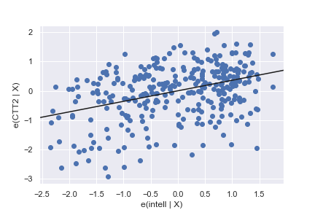 | 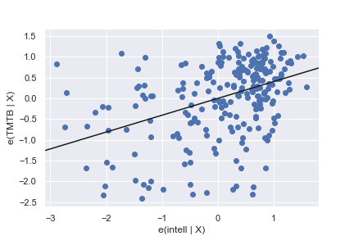
Exec Func  ~ Intell  | GM Vol,  Age, Sex  Mean ΔR² = .142 | 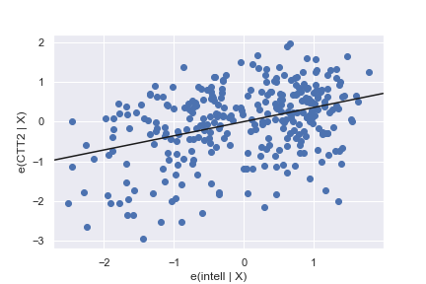 | 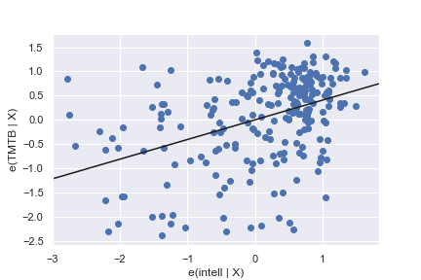
 | TILDA | CR/RANN
Glob Cog  ~ Edu_Intell  | Hipp Vol,  Age, Sex  Mean ΔR² = .136 | 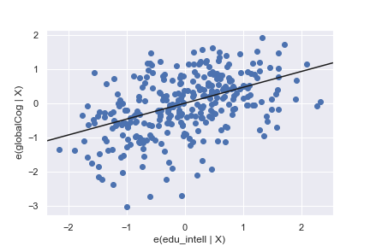 | 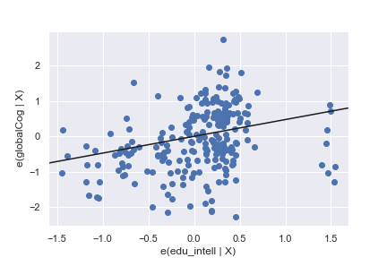
Glob Cog  ~ Edu_Intell  | GM Vol,  Age, Sex  Mean ΔR² = .127 | 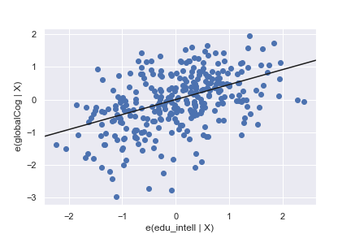 | 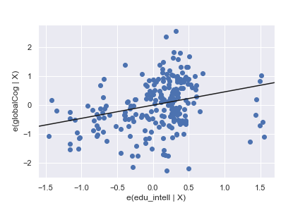
Exec Func  ~ Edu_Intell  | Hipp Vol,  Age, Sex  Mean ΔR² = .123 | 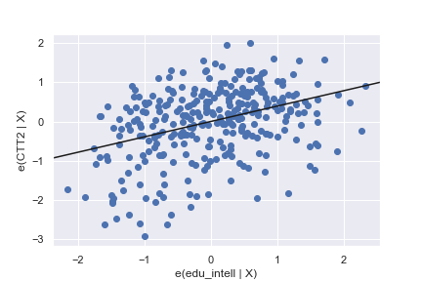 | 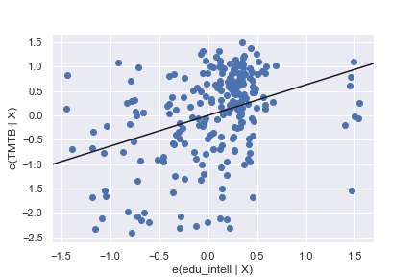
Glob Cog  ~ Edu_Intell  | Cx Th,  Age, Sex  Mean ΔR² = .121 | 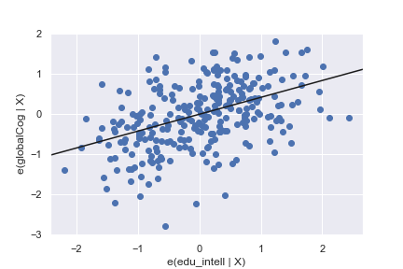 | 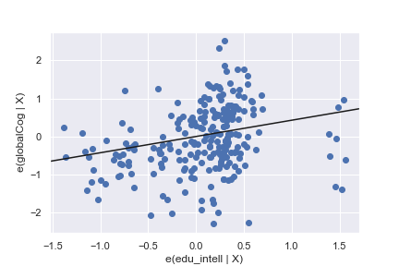
Exec Func  ~ Intell  | Cx Th,  Age, Sex  Mean ΔR² = .120 | 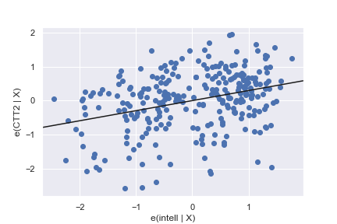 | 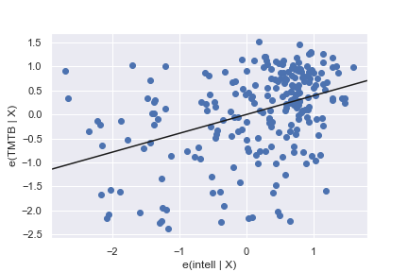
Figure S1: Association between proxies and cognition, adjusting for brain structure, age, and sex. Plots are shown for the 10 largest mean R² change across both datasets for proxies with significant effects. Glob Cog = Global Cognition, Exec Func = Executive Function, Intell = Premorbid Intelligence, Edu_Intell = Composite of Education and Premorbid Intelligence, Hipp Vol = Hippocampal Volume, GM Vol = Grey Matter Volume, Cx Th = Mean Cortical Thickness

