Figure
Figure S1 The haplotype network generated from the haplotypes of Prunus armeniaca and related species based on ITS dataset. The small black circles shown an intermediate haplotype not detected in this study.

Figure S2 The haplotype network generated from the haplotypes of P. armeniaca based on ITS dataset. The small black circles shown an intermediate haplotype not detected in this study.

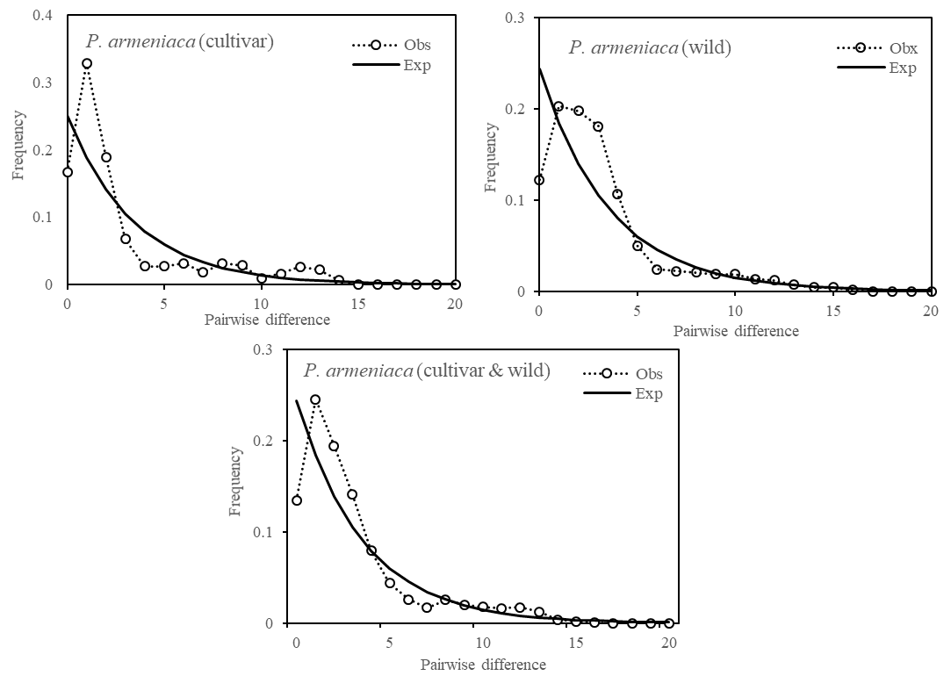
Figure S3 Mismatch distribution analysis of P. armeniaca based on ITS data.

