Identification of CRF89_BF, a new member of an HIV-1 circulating BF intersubtype recombinant form family widely spread in South America.

Elena Delgado, Aurora Fernández-García, Ismael Fernández-Miranda, Sonia Benito, Vanesa Montero, Horacio Gil, Silvia Hernáez, Josefa Muñoz, Miren Z. Zubero-Sulibarria, Elena García-Bodas, Mónica Sánchez, Jorge del Romero, Carmen Rodríguez, Luis Elorduy, Elena Bereciartua, Esther Culebras, Icíar Rodríguez-Avial, María Luisa Giménez-Alarcón, Carmen Martín-Salas, Carmen Gómez-González, José J García-Irure, Gema Cenzual, Ana Martínez-Sapiña, Lucía Pérez-Álvarez, and Michael M Thomson.

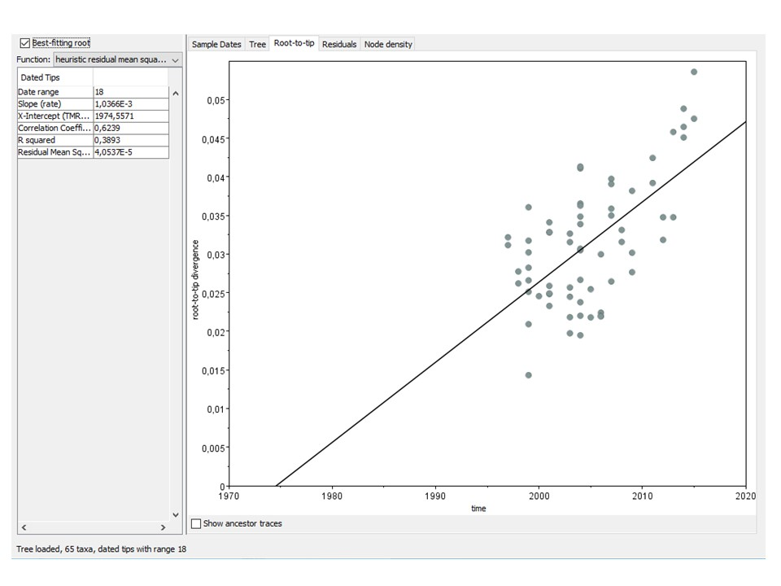
Supplementary Fig. S1. Analysis of root-to-tip divergence vs. year of sample collection of 65 CRF12_BF Pr-RT sequences with TempEst. The analysis was done after removing 8 outlying sequences identified in initial analyses.

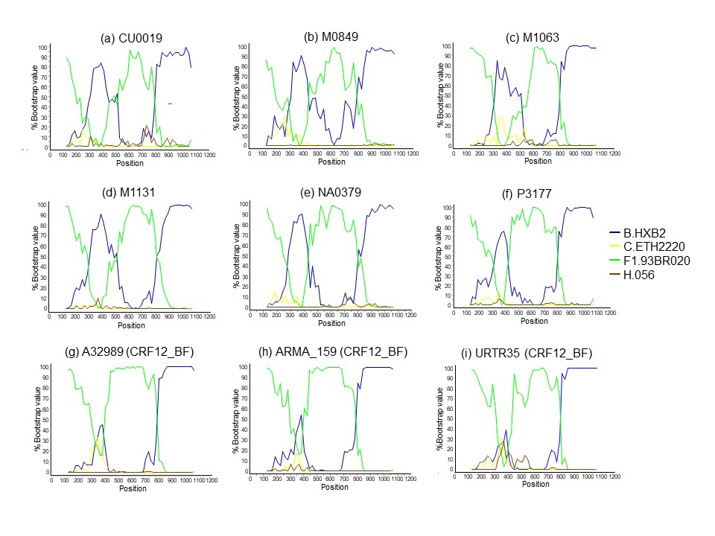Supplementary Fig. S2. Bootscan analyses of 6 Pr-RT sequences of the BF cluster (a-f) and 3 of CRF12_BF (g-i). The horizontal axis represents the position from the 3’ end of protease of the mid-point of a 250 nt window moving in 20 nt increments and the vertical axis represents bootstrap values supporting clustering with subtype reference sequences.

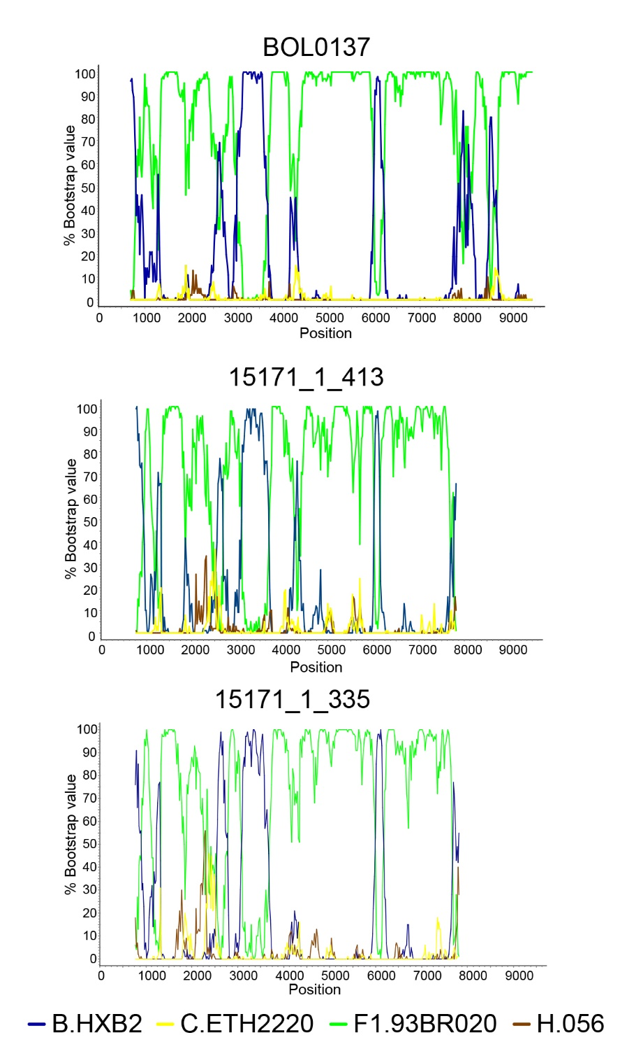
Supplementary Fig. S3. Bootscan plots of two sequences of ~7 kb of the BF cluster from UK. The horizontal axis represents the position in the HXB2 genome of the mid-point of a 250 nt window moving in 20 nt increments and the vertical axis represents bootstrap values supporting clustering with subtype reference sequences. The bootscan plot of the NFLG sequence of BOL0137 is shown on top for comparison.

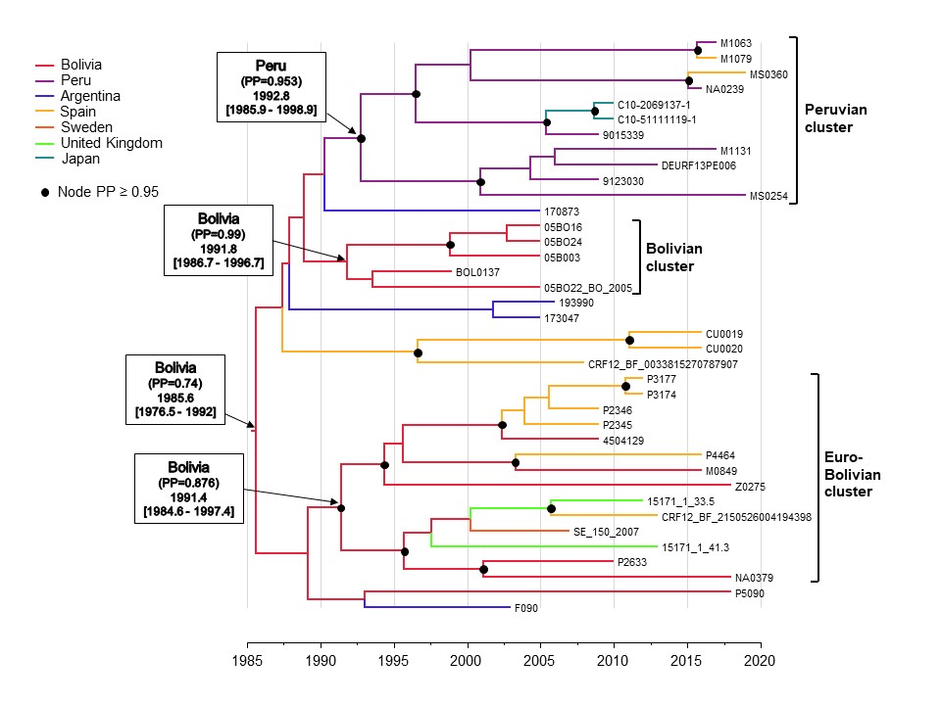Supplementary Fig. S4. Maximum clade credibility tree of CRF89_BF Pr-RT sequences with location traits of some sequences from Bolivian and Peruvian individuals residing in Spain changed to Spain. The analysis was done with the same parameters as an earlier analysis (whose posterior tree distribution is summarized in the MCC tree shown in Fig. 7), only changing the location traits of some samples from Peruvian (M1079, MS0360) or Bolivian (P2345, P3177) individuals residing in Spain belonging to clusters of relatively recent origin from Peru or Bolivia to Spain. The rest of the figure description is as in the legend of Fig. 7.

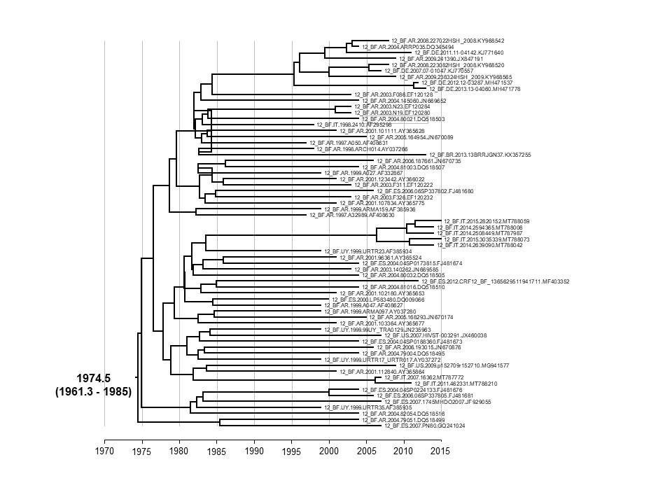Supplementary Fig. S5. Maximum clade credibility tree of CRF12_BF Pr-RT sequences. Mean tMRCA and 95% HPD interval at the root are shown.

