Supplementary Information for
Ionitronic manipulation of current-induced domain wall motion in synthetic antiferromagnets
Yicheng Guan^{1,2}, Xilin Zhou^{1,2}, Fan Li^{1,2}, Tianping Ma¹, See-Hun Yang¹, Stuart Parkin^{1,}*
¹Max Planck Institute for Microstructure Physics, 06120 Halle, Germany
²These authors contributed equally: Yicheng Guan, Xilin Zhou, Fan Li
*e-mail: stuart.parkin@mpi-halle.mpg.de

Supplementary Notes
1-D analytical model for current-induced domain wall motion in synthetic antiferromagnetic structures
As was discussed earlier^{S1}, the domain wall (DW) magnetization dynamics of each magnetic sub-layer in a synthetic antiferromagnetic (SAF) structure can be described by the following Landau-Lifshitz-Gilbert (LLG) equations:
$$\frac{∂M_{i}}{∂t}=-γM_{i}×H_{i}^{eff}+\frac{α_{i}}{m_{i}}M_{i}×\frac{∂M_{i}}{∂t}-b_{J}^{i}M_{i}×M_{i}×\frac{∂M_{i}}{∂t}-β_{i}b_{J}^{i}M_{i}×\frac{∂M_{i}}{∂x}+H_{she}^{i}M_{i}×M_{i}×\hat{y}$$
$M_{i}(r,t)$ is the local magnetization vector, where i = U and L correspond to the upper magnetic sub-layer, and lower magnetic sub-layer, respectively. The first two terms in each equation are the field-like and damping-like torques, in the presence of an external field, $H_{i}^{eff}$; the third and fourth terms are the Spin-Transfer Torque (STT) from polarized current injection, and the last term is the Spin-Orbit Torque (SOT) exerted via spin currents generated via the spin Hall effect from the injected current in the Pt underlayer. Here $γ$ is the gyromagnetic ratio; $α_{i}$ is the Gilbert damping parameter and $β_{i}$ is the non-adiabatic parameter of the STT, for the corresponding ferromagnetic layer i; $b_{J}^{i}=J\frac{μ_{B}P_{i}}{eM_{s}}$, where $μ_{B}$ is the Bohr magneton, $e$ is the electron’s charge and $P_{i}$ is the spin polarization of the current within the magnetic sub-layer i and $M_{i}$ is the saturation magnetization of the sub-layer i.
In addition to the distinct magnetic parameters of the two sub-layers, the effective spin Hall effect (SHE) field $H_{SHE}$ is also different in these sub-layers, because the spin current generated from the bottom Pt layer will experience spin depolarization as it diffuses through the lower magnetic layer, and finally, across the Ru spacer layer. Thus, we can write:
$$H_{SHE}^{U}=H_{SHE}^{L}exp⁡(-\frac{t_{L}}{λ_{L}}-\frac{t_{Ru}}{λ_{Ru}})$$
Here, $λ_{Ru}$ is the spin diffusion length within the Ru spacer layer, and $λ_{L}$ is the spin decoherence length of the lower FM layer, $t_{L}$ is the thickness of the lower magnetic sub-layer, and $t_{Ru}$ is the thickness of the Ru layer.
We now focus on the effective field exerted on the system from the relationship $H_{i}^{eff}=\frac{∂E}{∂M_{i}}$, where $E$ is the the energy per unit area, which can be written as:
$$E=2A_{L}t_{L}\frac{\sin^{2}θ_{L}}{∆^{2}}+t_{L}\left(K_{L}^{eff}+K_{L}^{u}\cos^{2}ψ_{L}\right)\sin^{2}θ_{L}-M_{L}H_{L}^{DMI}cosψ_{L}sinθ_{L}+2A_{U}t_{U}\frac{\sin^{2}θ_{U}}{∆^{2}}+t_{U}\left(K_{U}^{eff}+K_{U}^{u}\cos^{2}ψ_{U}\right)\sin^{2}θ_{U}-M_{U}H_{U}^{DMI}cosψ_{U}sinθ_{U}-2J_{ex}[sinθ_{L}sinθ_{U}\cos\left(ψ_{L}-ψ_{U}\right)+cosθ_{L}cosθ_{U}]$$
Here, we assume an identical DW width in both the upper and lower magnetic layers, because of the strong coupling between the two ferromagnetic sub-layers. $K_{i}^{u}$ is the DW shape anisotropy constant, $K_{i}^{eff}$ is the effective uniaxial anisotropy energy, and $H_{i}^{DMI}$ is the Dzyasloshinskii-Moriya Interaction (DMI) effective field. The last term in the equation above is the exchange energy. These individual terms in $E$ correspond to the various torques exerted on the ferromagnetic layers. The additional exchange term will give rise to an exchange coupling torque which increases the DW velocity in the SAF structure significantly, as found in earlier work (Ref. S1).
By including these various effective fields into the LLG equation, we derive the following set of equations that describe the DW motion in a SAF system:
$$\dot{q}=\frac{α_{L}α_{U}}{α_{U}M_{L}\left(1+α_{L}^{2}\right)+α_{L}M_{U}\left(1+α_{U}^{2}\right)}\left[-M_{L}\left(\frac{1}{α_{L}}+β_{L}\right)u_{L}-M_{U}\left(\frac{1}{α_{U}}+β_{U}\right)u_{U}∓\frac{γ∆M_{L}}{α_{L}}\{\frac{H_{L}^{k}}{2}sin2ψ_{L}-\frac{π}{2}H_{L}^{DMI}sinψ_{L}-\frac{2J_{ex}}{M_{L}}\sin\left(ψ_{L}-ψ_{U}\right)+\frac{α_{L}πH_{L}^{SH}}{2}cosψ_{L}\}±\frac{γ∆M_{U}}{α_{U}}\left\{\frac{H_{U}^{k}}{2}sin2ψ_{U}-\frac{π}{2}H_{U}^{DMI}sinψ_{U}-\frac{2J_{ex}}{M_{U}}\sin\left(ψ_{U}-ψ_{L}\right)+\frac{α_{U}πH_{U}^{SH}}{2}cosψ_{U}\right\}\right]$$
$$\dot{ψ_{L}}=±\frac{1}{∆}\frac{α_{U}}{α_{U}M_{L}\left(1+α_{L}^{2}\right)+α_{L}M_{U}\left(1+α_{U}^{2}\right)}\left[-M_{L}\left(\frac{1}{α_{L}}+β_{L}\right)u_{L}-M_{U}\left(\frac{1}{α_{U}}+β_{U}\right)u_{U}∓\frac{γ∆M_{L}}{α_{L}}\left\{\frac{H_{L}^{k}}{2}sin2ψ_{L}-\frac{π}{2}H_{L}^{DMI}sinψ_{L}-\frac{2J_{ex}}{M_{L}}\sin\left(ψ_{L}-ψ_{U}\right)+\frac{α_{L}πH_{L}^{SH}}{2}cosψ_{L}\right\}±\frac{γ∆M_{U}}{α_{U}}\left\{\frac{H_{U}^{k}}{2}sin2ψ_{U}-\frac{π}{2}H_{U}^{DMI}sinψ_{U}-\frac{2J_{ex}}{M_{U}}\sin\left(ψ_{U}-ψ_{L}\right)+\frac{α_{U}πH_{U}^{SH}}{2}cosψ_{U}\right\}\right]+\frac{γ}{α_{L}}\{\frac{H_{L}^{k}}{2}sin2ψ_{L}-\frac{π}{2}H_{L}^{DMI}sinψ_{L}-\frac{2J_{ex}}{M_{L}}\sin\left(ψ_{L}-ψ_{U}\right)\}±\frac{u_{L}}{α_{L}∆}$$
$$\dot{ψ_{U}}=∓\frac{1}{∆}\frac{α_{L}}{α_{U}M_{L}\left(1+α_{L}^{2}\right)+α_{L}M_{U}\left(1+α_{U}^{2}\right)}\left[-M_{L}\left(\frac{1}{α_{L}}+β_{L}\right)u_{L}-M_{U}\left(\frac{1}{α_{U}}+β_{U}\right)u_{U}∓\frac{γ∆M_{L}}{α_{L}}\left\{\frac{H_{L}^{k}}{2}sin2ψ_{L}-\frac{π}{2}H_{L}^{DMI}sinψ_{L}-\frac{2J_{ex}}{M_{L}}\sin\left(ψ_{L}-ψ_{U}\right)+\frac{α_{L}πH_{L}^{SH}}{2}cosψ_{L}\right\}±\frac{γ∆M_{U}}{α_{U}}\left\{\frac{H_{U}^{k}}{2}sin2ψ_{U}-\frac{π}{2}H_{U}^{DMI}sinψ_{U}-\frac{2J_{ex}}{M_{U}}\sin\left(ψ_{U}-ψ_{L}\right)+\frac{α_{U}πH_{U}^{SH}}{2}cosψ_{U}\right\}\right]+\frac{γ}{α_{U}}\{\frac{H_{U}^{k}}{2}sin2ψ_{U}-\frac{π}{2}H_{U}^{DMI}sinψ_{U}-\frac{2J_{ex}}{M_{U}}\sin\left(ψ_{U}-ψ_{L}\right)\}±\frac{u_{U}}{α_{U}∆}$$
By deriving the steady state solution that corresponds to $\dot{ψ_{L}}=\dot{ψ_{U}}=0$, we can calculate the current induced DW velocity. The following parameters are used for the simulation results presented in Fig. 2d of the main text: $∆=4.3 nm$, $u_{U}=u_{L}=12 m s^{-1}$, $α_{U}=α_{L}=0.1$, $β_{U}=β_{L}=0$, $H_{L}^{k}=H_{L}^{k}=1400 Oe$, $H_{L}^{SH}=380 Oe$, $H_{U}^{SH}=100 Oe$, $H_{L}^{DMI}=1100 Oe$ and $H_{U}^{DMI}=-300 Oe$, $J_{ex}=-0.4 erg {cm}^{-2}$.

Supplementary Figures

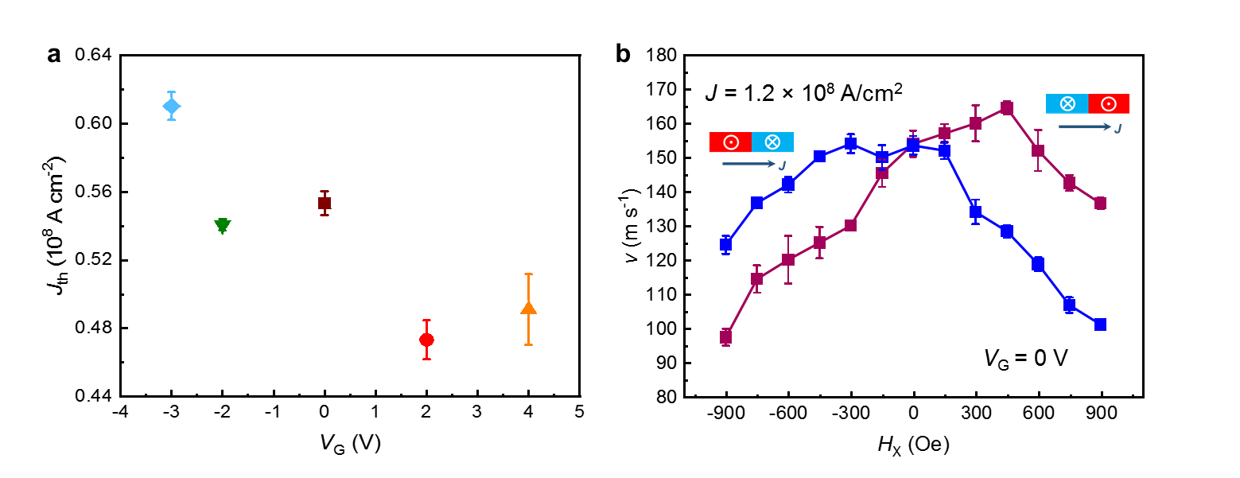
Figure S1| Threshold current density and longitudinal field dependence of DW velocity for two DW configurations at V_{G} = 0. a, Threshold current density, J_{th}, versus gate voltage V_{G}: a slight decrease in J_{th} is observed for positive V_{G}s while an increase in J_{th} is found for negative V_{G}s. b, The longitudinal field dependence of the DW velocity v for an up/down (filled navy square) and down/up (filled wine square) configuration, at a fixed current density (1.2×10⁸ A/cm²) for V_{G} = 0 (pristine state).

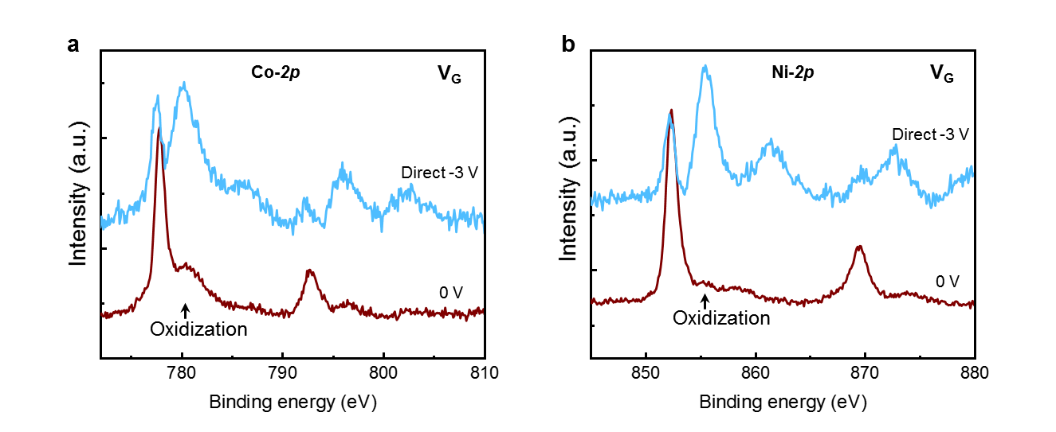
Figure S2| ILG induced ion migration in SAF structures. X-ray photoelectron spectra (XPS) of a, Co-2p, b, Ni-2p for SAF samples in the pristine state (wine) and after gating directly at –3 V (light blue). A much-enhanced satellite peak can be observed in both the Co-2p and Ni-2p edges, which illustrates oxidation of the Co and Ni that is induced by negative gate voltages during the ionic liquid gating process.

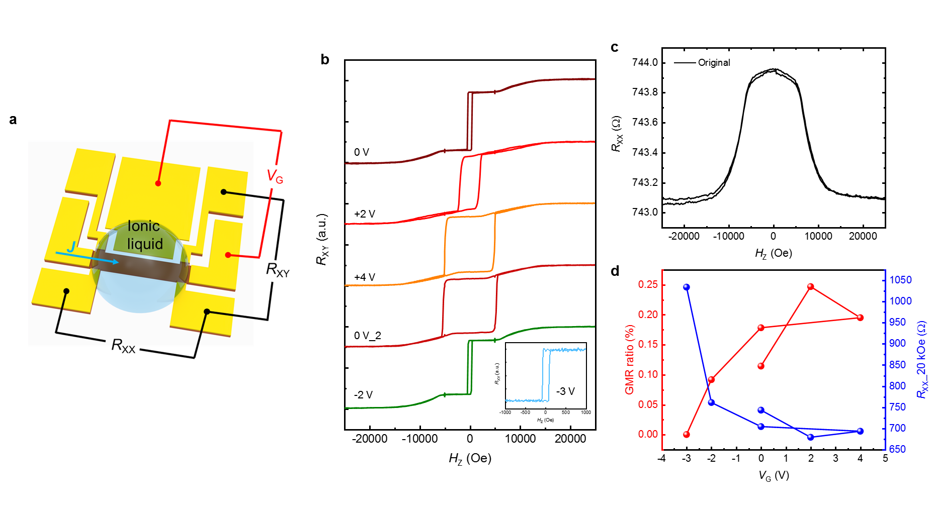
Figure S3| Ionic liquid gating effects on transport properties of a SAF structure. a, Sketch of Hall bar device used for transport measurements with a lateral gate electrode for ionic liquid gating. b, Hall resistance (R_{XY}) versus external perpendicular field at various V_{G} applied in the following sequence (each for 30 min): 0 V (pristine state), +2 V, +4 V, 0 V (gate voltage removed), –2 V, and –3 V. c, The longitudinal resistance (R_{XX}) versus external perpendicular field at pristine state. d, R_{XX} at a field of 20 kOe (right axis) and the giant magnetoresistance ratio (GMR ratio) (left axis) for the various V_{G} applied in b.

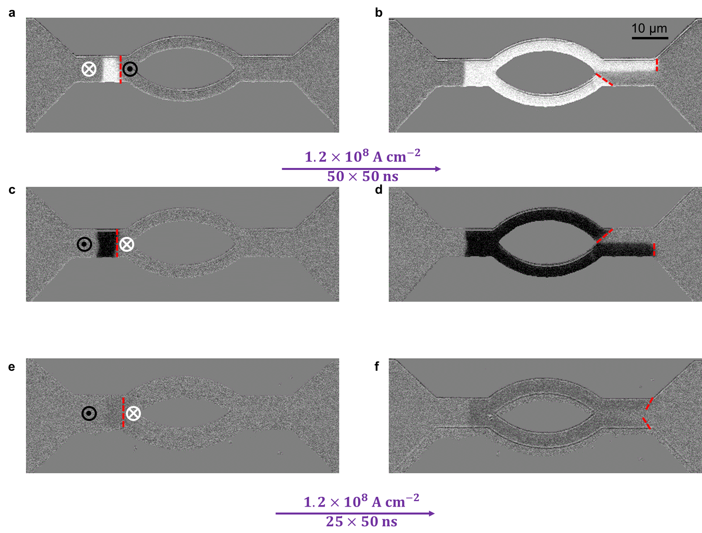
Figure S4| Current-induced domain wall motion through a knot device for FM and SAF structures. CIDWM through a knot device in a FM structure (with a stack sequence of TaN(20)/Pt(15)/Co(3)/Ni(7)/Co(1.5)/TaN(15), all units in Å) for up/down (a and b) and down/up (c and d) DWs. DWs with different configurations pass selectively one lane (the upper lane for the up/down DW and the lower lane for the down/up DW). In a well-compensated SAF structure (the stack corresponds to TaN(20)/Pt(15)/Co(3)/Ni(7)/Co(1.5)/Ru(8.5)/
Co(5)/Ni(7)/Co(1.5)/TaN(15), all units in Å), the incoming DW can pass through both lanes (e and f).

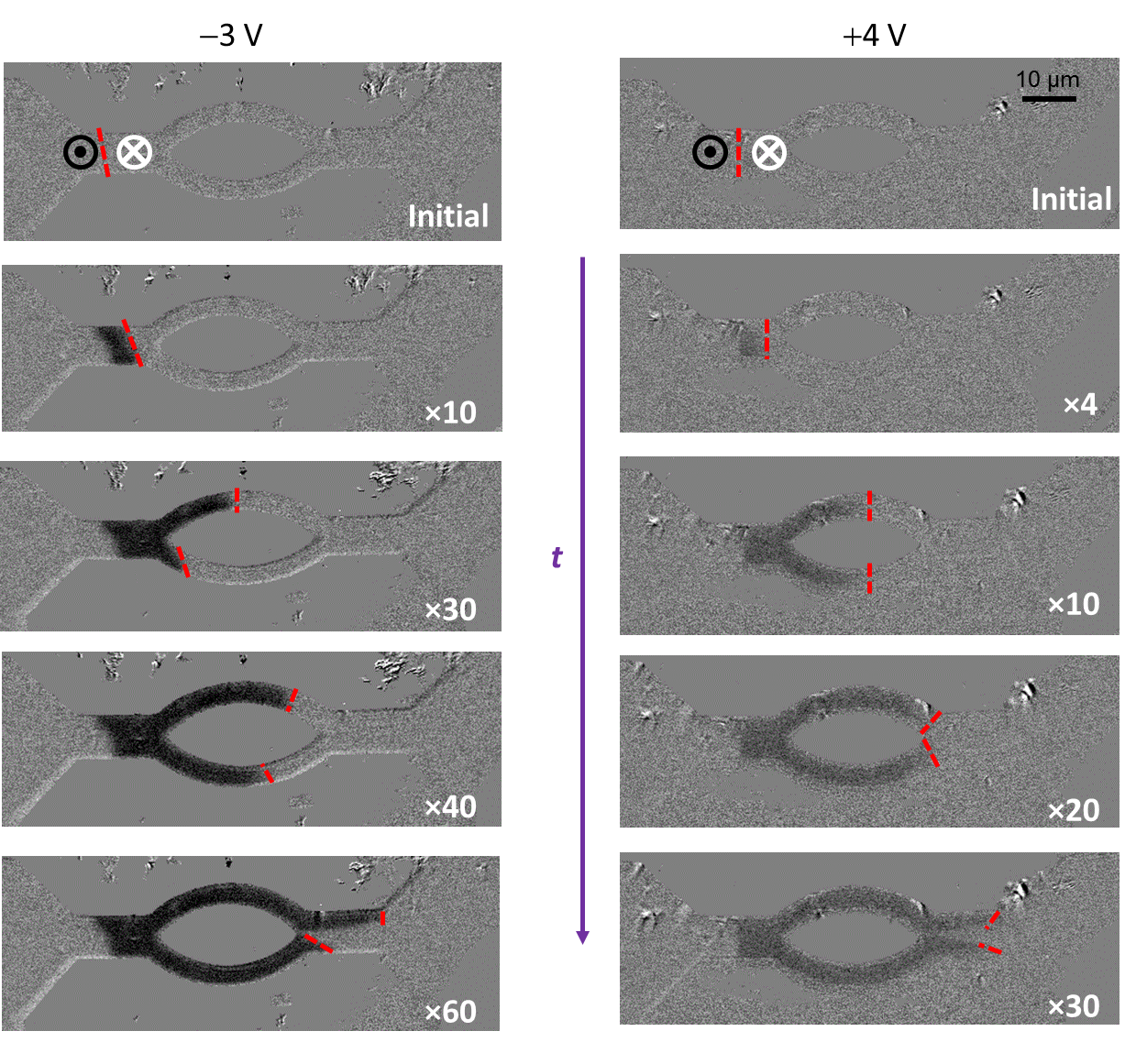
Figure S5| Ionic liquid gating effects on CIDWM of a SAF structure in a knot device. Current-induced up/down domain wall motion for a SAF knot device under a ionic liquid gate voltage of –3 V (left column) and +4 V (right column). Each current pulse has a current density of 1.2×10⁸ A/cm² and a pulse length of 50 ns. The position of the DW(s) after a succession of current pulses is shown by red dashed line(s). The number of current pulses in each case is indicated by the number in white at the lower right-hand corner of each image.
Reference
[S1] Yang, S. –H., Ryu, K. –S., & Parkin, S. S. P. Nat. Nano. 10, 221 (2015).

