Table S2. The detail comparison results of correlation ship between tumour infiltrating immune cells and risk sore.
immune cell_method | cor | pvalue
B cell memory_CIBERSORT | -0.11854 | 0.008624
B cell memory_CIBERSORT-ABS | -0.13494 | 0.002763
B cell memory_XCELL | -0.20416 | 5.22E-06
B cell naive_CIBERSORT | -0.08914 | 0.048608
B cell naive_CIBERSORT-ABS | -0.11382 | 0.011693
B cell naive_XCELL | -0.14831 | 0.000992
B cell plasma_CIBERSORT | -0.11778 | 0.009066
B cell plasma_CIBERSORT-ABS | -0.22396 | 5.48E-07
B cell plasma_XCELL | -0.32395 | 1.96E-13
B cell_EPIC | -0.31728 | 6.38E-13
B cell_MCPCOUNTER | -0.33911 | 1.19E-14
B cell_QUANTISEQ | -0.36241 | 1.18E-16
B cell_TIMER | -0.26153 | 4.18E-09
B cell_XCELL | -0.31926 | 4.51E-13
Cancer associated fibroblast_EPIC | 0.136037 | 0.002547
Cancer associated fibroblast_MCPCOUNTER | 0.156959 | 0.000488
Cancer associated fibroblast_XCELL | -0.12111 | 0.007274
Class-switched memory B cell_XCELL | -0.27205 | 9.21E-10
Endothelial cell_EPIC | -0.12614 | 0.005169
Eosinophil_CIBERSORT | 0.141797 | 0.001651
Eosinophil_CIBERSORT-ABS | 0.142203 | 0.001601
Hematopoietic stem cell_XCELL | -0.10463 | 0.020533
immune score_XCELL | -0.18419 | 4.10E-05
Macrophage M0_CIBERSORT | 0.162777 | 0.000297
Macrophage M1_CIBERSORT-ABS | -0.17361 | 0.000112
Macrophage M2_CIBERSORT | 0.20021 | 7.98E-06
Macrophage M2_QUANTISEQ | -0.13274 | 0.003241
Macrophage_XCELL | 0.109264 | 0.015532
Mast cell activated_CIBERSORT | -0.13045 | 0.00382
Mast cell activated_CIBERSORT-ABS | -0.15451 | 0.000599
Mast cell resting_CIBERSORT | 0.162595 | 0.000301
Mast cell resting_CIBERSORT-ABS | 0.108945 | 0.015838
microenvironment score_XCELL | -0.18449 | 3.98E-05
Monocyte_QUANTISEQ | -0.12014 | 0.007761
Monocyte_XCELL | 0.14329 | 0.001472
Myeloid dendritic cell_MCPCOUNTER | -0.19952 | 8.59E-06
Neutrophil_QUANTISEQ | 0.112313 | 0.012858
Neutrophil_TIMER | -0.11003 | 0.014815
NK cell activated_CIBERSORT-ABS | -0.16817 | 0.000184
NK cell resting_CIBERSORT | 0.164915 | 0.000246
NK cell resting_CIBERSORT-ABS | 0.144062 | 0.001386
NK cell_MCPCOUNTER | -0.20207 | 6.54E-06
NK cell_QUANTISEQ | -0.1849 | 3.82E-05
Plasmacytoid dendritic cell_XCELL | -0.09714 | 0.031566
T cell CD4+ (non-regulatory)_QUANTISEQ | 0.246377 | 3.29E-08
T cell CD4+ effector memory_XCELL | 0.131569 | 0.003527
T cell CD4+ naive_CIBERSORT | 0.104308 | 0.020923
T cell CD4+ naive_CIBERSORT-ABS | 0.104096 | 0.021186
T cell CD4+ naive_XCELL | -0.1531 | 0.000673
T cell CD4+_TIMER | -0.21051 | 2.59E-06
T cell CD8+ central memory_XCELL | -0.19139 | 2.00E-05
T cell CD8+ effector memory_XCELL | -0.09384 | 0.037841
T cell CD8+_CIBERSORT | -0.21997 | 8.78E-07
T cell CD8+_CIBERSORT-ABS | -0.26436 | 2.80E-09
T cell CD8+_EPIC | -0.22896 | 3.00E-07
T cell CD8+_MCPCOUNTER | -0.22865 | 3.12E-07
T cell CD8+_QUANTISEQ | -0.20777 | 3.52E-06
T cell CD8+_TIMER | -0.08935 | 0.04807
T cell CD8+_XCELL | -0.19013 | 2.27E-05
T cell follicular helper_CIBERSORT | -0.28752 | 8.82E-11
T cell follicular helper_CIBERSORT-ABS | -0.36118 | 1.52E-16
T cell gamma delta_XCELL | -0.17976 | 6.29E-05
T cell NK_XCELL | 0.139089 | 0.002029
T cell regulatory (Tregs)_CIBERSORT | -0.11779 | 0.009057
T cell regulatory (Tregs)_CIBERSORT-ABS | -0.18313 | 4.54E-05
T cell regulatory (Tregs)_QUANTISEQ | -0.21209 | 2.17E-06
T cell_MCPCOUNTER | -0.22263 | 6.42E-07

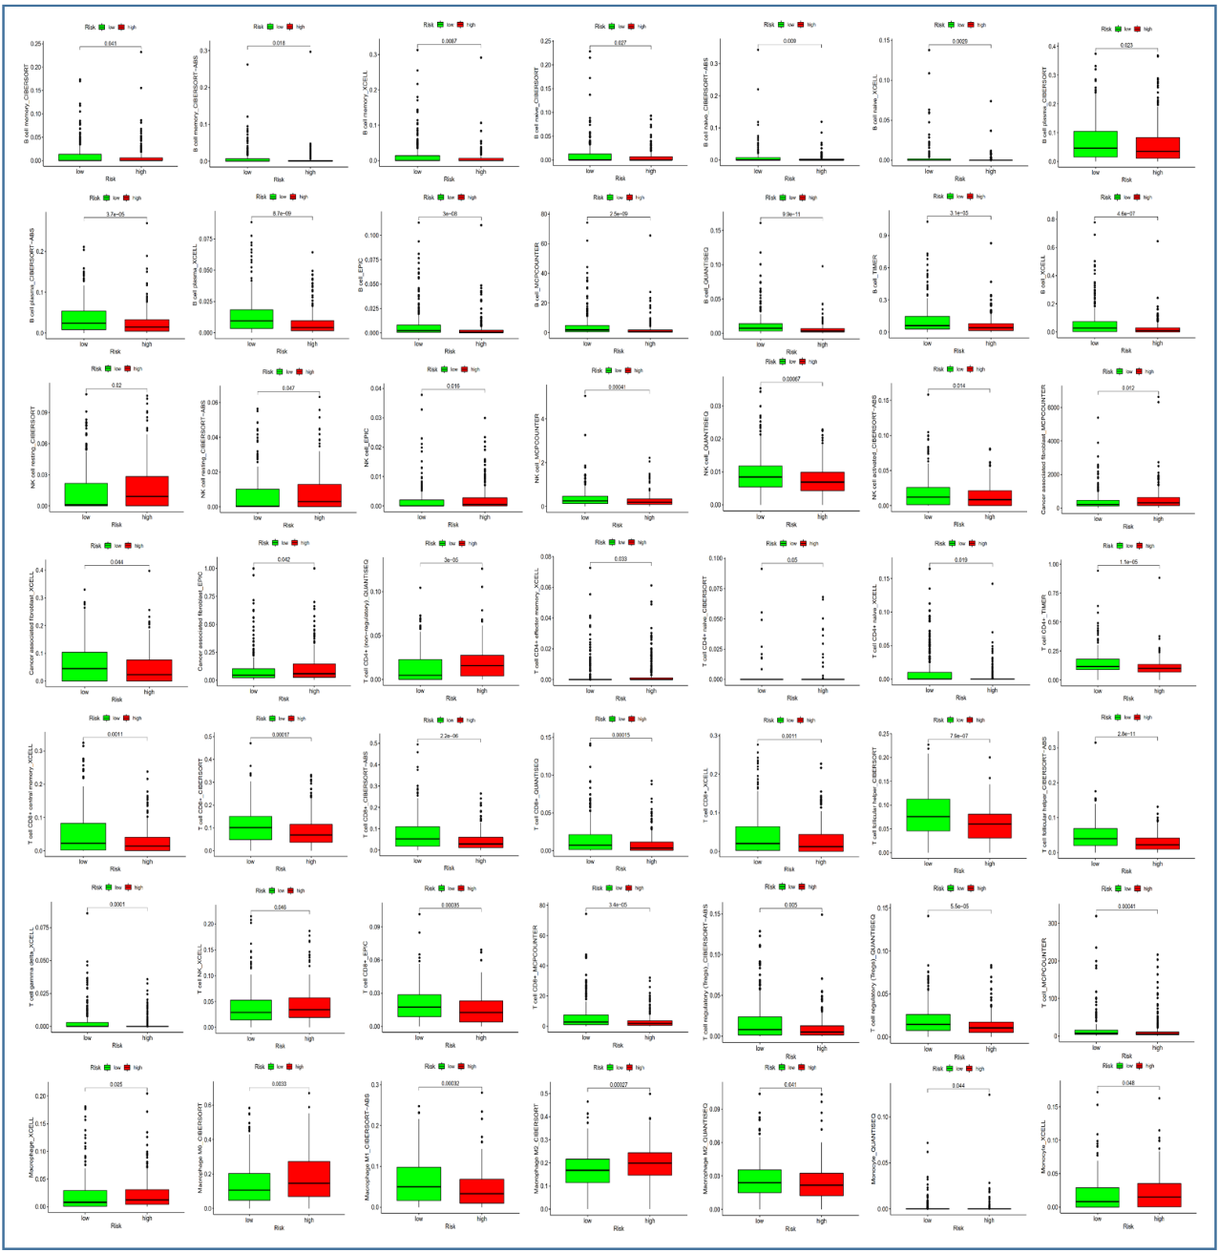
Figure S1. The representative results of the evaluation of tumor infiltrating immune cells with risk assessment model.

