**Supplementary Information**

**Different Zn loading in Urea-Formaldehyde influences the N controlled release by Structure Modification**

Amanda S. Giroto 1, Stella F. do Valle,1,2, Gelton G. F. Guimaraes 3, Nicolai D. Jablonowski4*, Caue Ribeiro1*, Luiz Henrique C. Mattoso1

*1Embrapa Instrumentação, National Nanotechnology Laboratory for Agribusiness* *(LNNA), XV Novembro Street, CP: 741, Zip Code: 13560-206 São Carlos, SP, Brazil*

*2Federal University of São Carlos, Department of Chemistry, Washington Luiz Highway, km 235, Zip Code: 13565-905 São Carlos, SP, Brazil*

*3Agricultural Research and Rural Extension Company of Santa Catarina, 6800 Highway, Antônio Heil, Itajaí, Santa Catarina, 88318112, Brazil*

*4Forschungszentrum Jülich GmbH, Institute of Bio- and Geosciences, IBG-2: Plant Science, 52425 Jülich, Germany*

*Corresponding authors: n.d.jablonowski@fz-juelich.de; caue.ribeiro@embrapa.br

Table S1. FTIR bands related to bonds of the materials.

|  |  |  |  |  |  |  |  |  |
| --- | --- | --- | --- | --- | --- | --- | --- | --- |
| **Bands** |  |  | **Wavenumber (cm-1)** | | | | | |
| **Urea** | **UF** | **UFZO** | | | **UFZS** | | |
| 0.5 | 1 | 0.2 | 0.5 | 1 | 2 |
| ν-NH2 (free) | 3425 | 3437 | 3437 | 3437 | 3437 | 3443 | 3443 | 3343 |
| ν-NH (bonded) | 3327 | 3327 | 3327 | 3327 | 3327 | 3327 | 3327 | 3327 |
| νCOfree | 1676 | 1646 | 1646 | 1646 | 1646 | 1646 | 1646 | 1646 |
| δN-H +νC-N | 1588 | 1599 | 1599 | 1599 | 1599 | 1599 | 1599 | 1599 |



Figure S1. EDX images of composites (a) UFZO 0.5, UFZO 1, UFZO 2, and (b) UFZS 0.5, UFZS 1 and UFZS 2.



Figure S2. Normalized FTIR spectra in (a) and (c) amplification to 3500-3000 cm-1 and (b) and (d) 1800-1500cm-1 for (i) urea, (ii) pure polymer UF, (iii) UFZO 0.5, (iv) UFZO 1, (v) UFZO 2 and (vi) ZnSO4, (vii) UFZS 0.5, (viii) UFZS 1 and (ix) UFZS 2, (x) ZnO and (xi) ZnSO4.

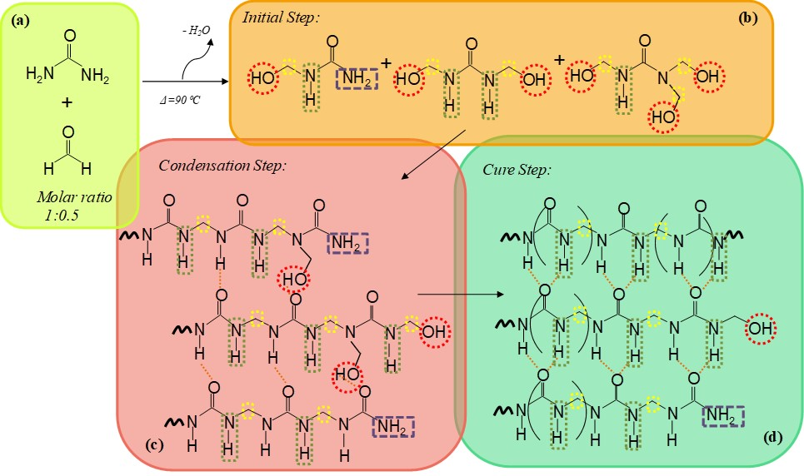

Figure S3. Schematic illustration of the possible chemical species corresponding to the 1H NMR Spectra: (a) urea and formaldehyde, (b) small molecules formed: mono, di- and tri hydroxylureas, (c) condensation step with hydroxyl groups and (d) cure step and H-bond formation.