Additional file 4. Relationship between Cyclin E and clinicopathological features.
1. Age
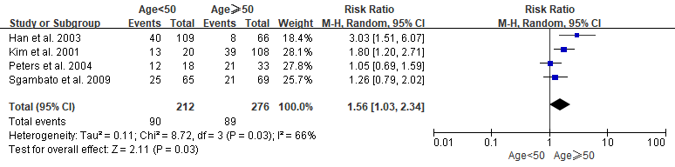
2. Disease stage
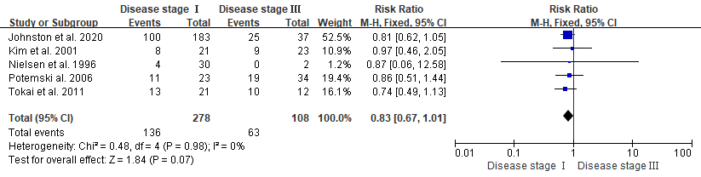
3. ER status
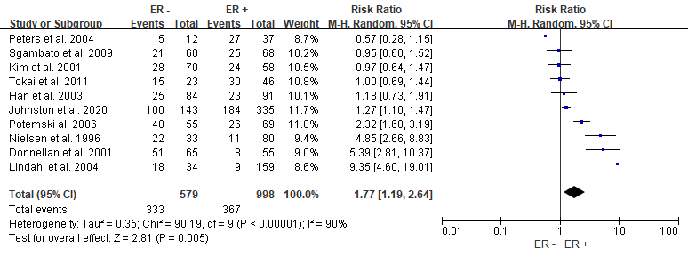
4. PR status
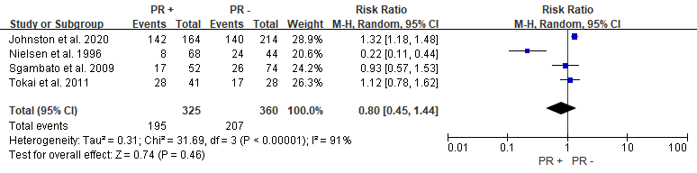

5. Menopausal status
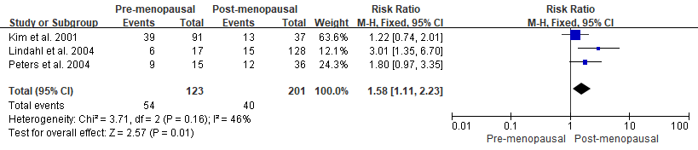
6. Histologic Grade
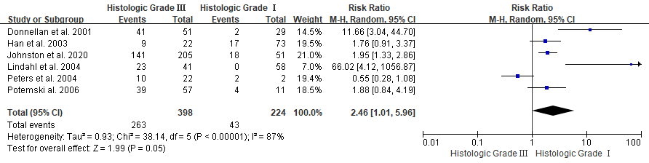
7. Histological type
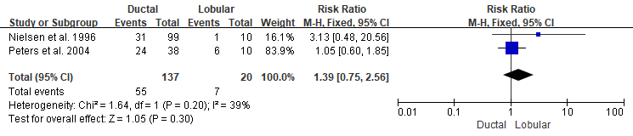
8. Lymph node status
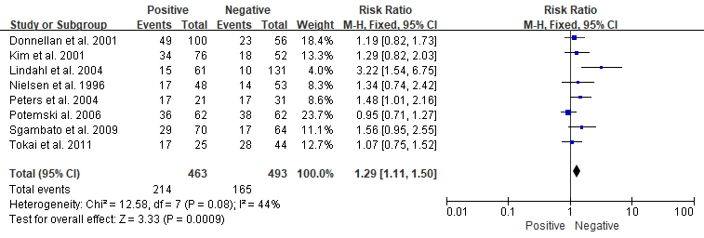

9. tumor size
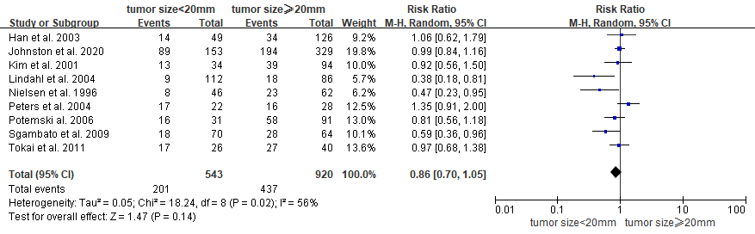
10.HER-2
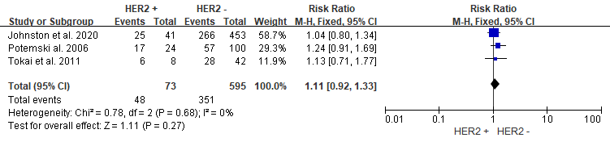
11.nuclear grade
