Synthesis, Structure, and Properties of a Dinuclear Cu(II) Coordination Polymer based on Quinoxaline and 3,3-thiodipropionic acid Ligands

Adedibu C. Tella^{a*}, Samson O. Owaludeª, Vincent O. Adimula^{a,b*}, Adetola C. Oladipoª, Victoria T. Olayemiª, Bushra Ismail^{b}, Amara Mumtaz^{b}, Attiq Ur Rehman^{b}, Asad M. Khan^{b}, Hadley S. Clayton^{c}, Nawaz M. Tahir^{d}

ªDepartment of Chemistry, P.M.B.1515, University of Ilorin, Ilorin, Kwara State, Nigeria
^{b}Department of Chemistry, COMSATS University, Islamabad, Abbottabad Campus, 22060, Pakistan
^{c}Department of Chemistry, University of South Africa, South Africa
^{d}University of Sargodha: Sargodha, Punjab, PK

*Corresponding author. ac_tella@yahoo.co.uk; vincentadimula@gmail.com

[Cu₂(TDPH)₄(QNX)].DMF 1 Cambridge Crystallography Database Centre (CCDC) Deposition No.: 2015762

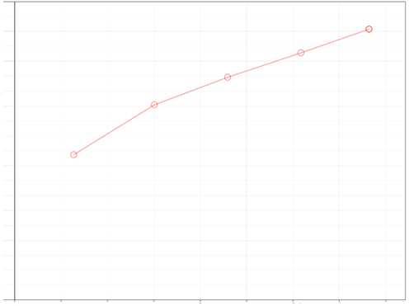
Volume adsorbed (cm³g⁻¹)
0.04
0.08
0.12
0.16
0.20
0.24
0.28
0.32
8000
16000
24000
32000
40000
48000
56000
64000
72000
80000
Relative Pressure (P/P_{o})

Figure S1. BET Nitrogen isotherm of compound 1

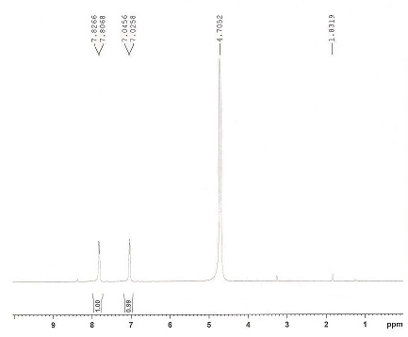
a

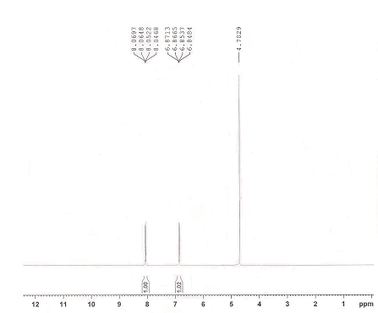
b
Figure S2. ¹H NMR Spectra of (a) 4-aminophenol; (b) 4-nitrophenol

Table S1: Rate constants (k_{app}) and thermodynamic parameters for the reduction reduction of 4-NP at different temperatures using 1 as catalyst.

Parameters | [Cu₂(TDPH)₄(QNX)].DMF 1
30 °C | 8.0 x 10⁻⁴ s⁻¹
40 °C | 4.0 x 10⁻⁴ s⁻¹
50 °C | 3.0 x 10⁻⁴ s⁻¹
60 °C | 8.0 x 10⁻⁴ s⁻¹
Ea (kJ mol⁻¹) | -3.290
ΔH (kJ mol⁻¹) | -5.929
Δs (J mol⁻¹ K⁻¹) | 326.872

