Transcriptome analysis of flower color reveals the correlation between SNP and differential expression genes in Phalaenopsis
Yu Ding^{1,#}, Ding-Hai Yang^{1,#}, Ma-Yin Wang^{1,#}, Dai-Cheng Hao², Wei-Shi Li², Peng Ling^{1,*}, Shang-Qian Xie^{1,*}
1. Key Laboratory of Ministry of Education for Genetics and Germplasm Innovation of Tropical Special Trees and Ornamental Plants, College of Forestry Hainan University, Haikou 570228, China
2. Hainan Boda Orchid Technology Co. Ltd. Haikou 570311, China

# These authors contributed equally to this work
* To whom correspondence should be addressed:
Peng Ling, Email: 18389807612@163.com;
Shang-Qian Xie, Email: sqianxie@foxmail.com

Table S1. Functional annotation of unigene
Database | No. of unigene | Percentage (%)
Nr | 21,143 | 90.7
Swiss-Prot | 15,062 | 64.6
GO | 10,827 | 46.4
KEGG | 9,854 | 42.3
COG | 18,954 | 81.3
Total | 23314 | 100

Table S3. Functional annotation of DEGs
Database | No. of DEGs | Percentage (%)
Nr | 1163 | 98.9
Swiss-prot | 898 | 76.4
GO | 474 | 40.3
KEGG | 431 | 36.7
COG | 882 | 75.1
Total | 1175 | 100

Table S7. Statistics of variation types of SNP

SNP type | Number of SNP | Percentage (%)
G/A | 27947 | 13.45
A/G | 27864 | 13.41
C/T | 27738 | 13.35
T/C | 27670 | 13.32
T/A | 17876 | 8.60
A/T | 17632 | 8.49
G/T | 11887 | 5.72
A/C | 11783 | 5.67
C/A | 11762 | 5.66
T/G | 11537 | 5.55
G/C | 7067 | 3.40
C/G | 6996 | 3.37
total | 207759 | 100.00

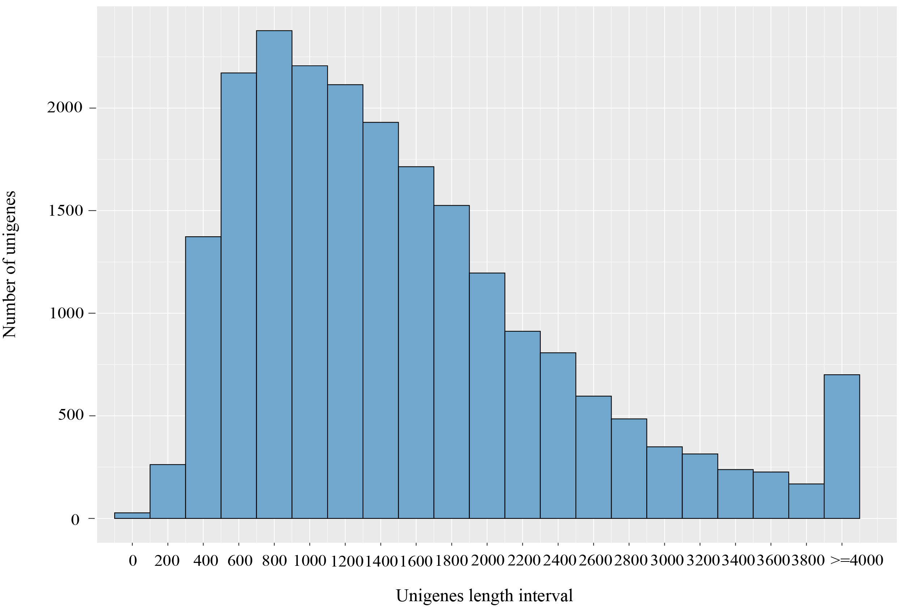
Figure S1 Distribution of unigenes length
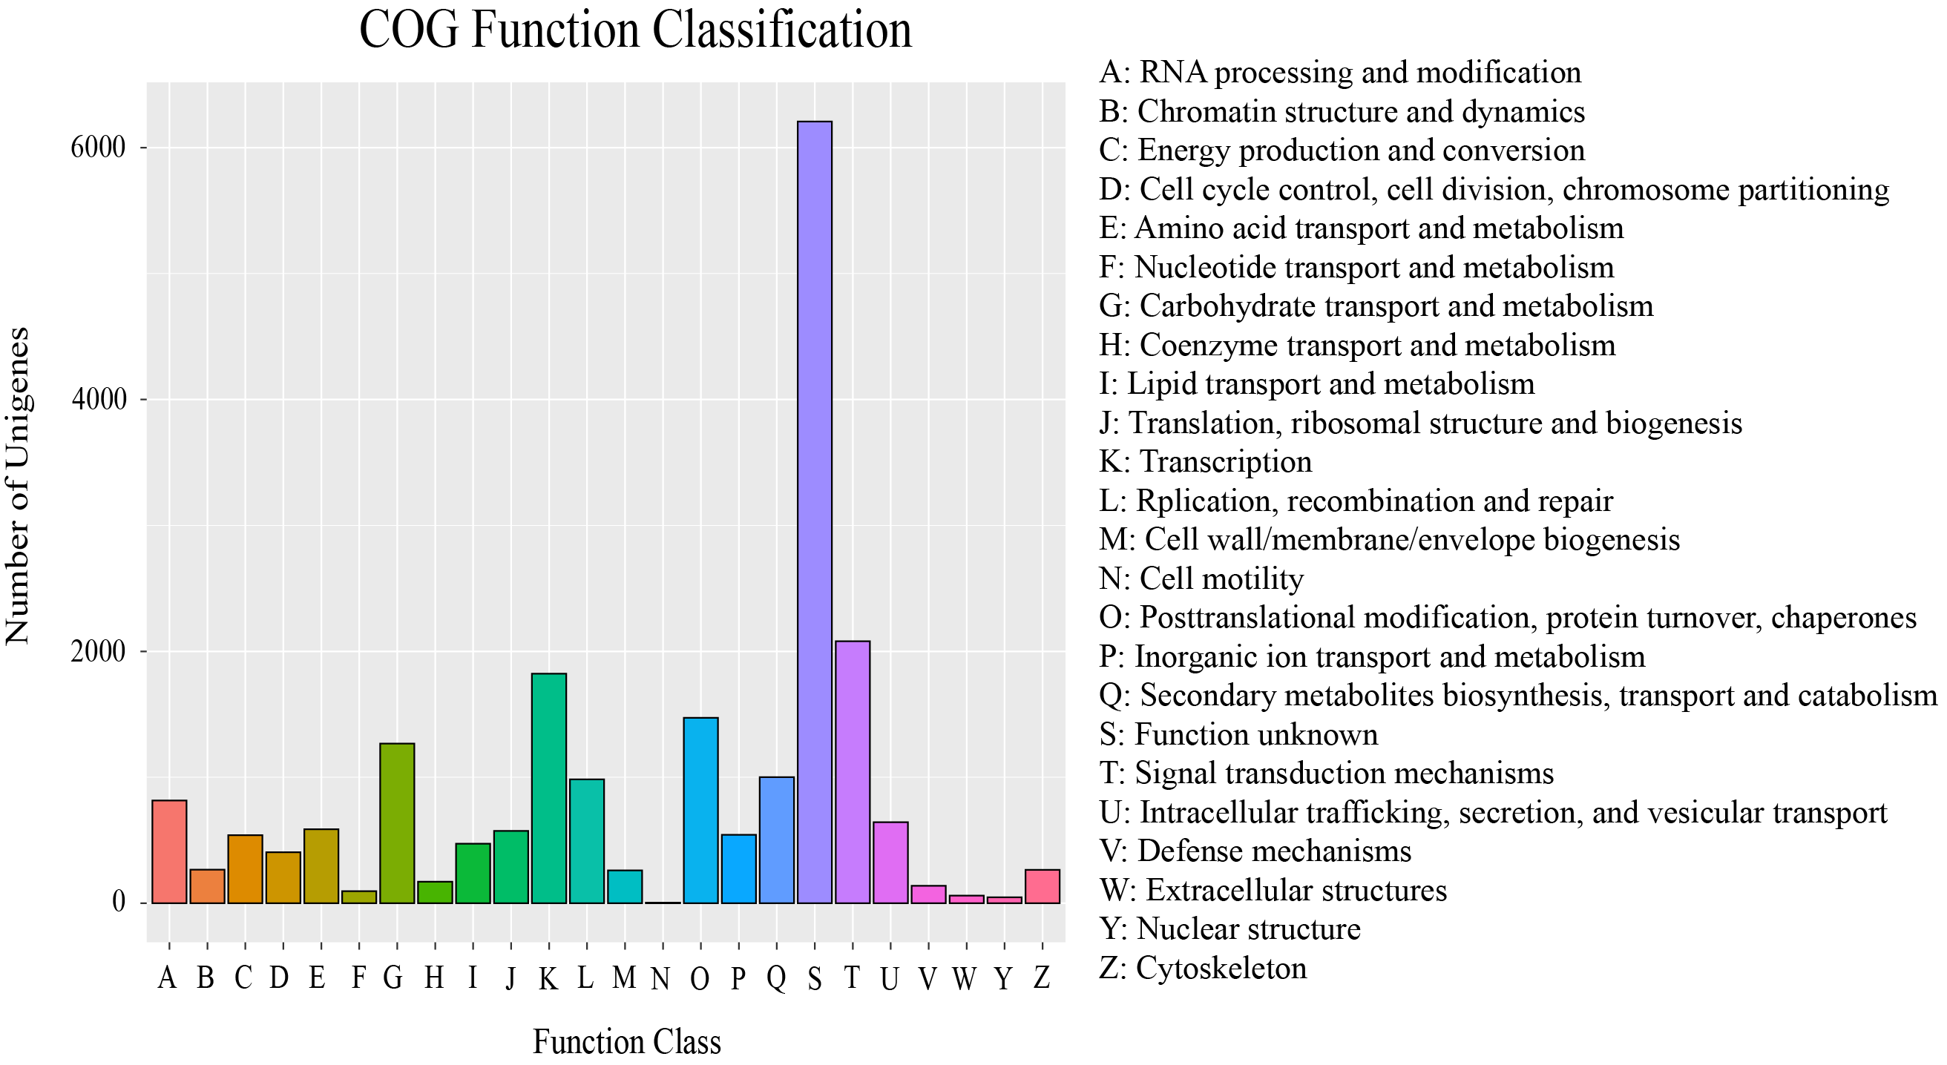
Figure S2 The COG annotation of unigenes

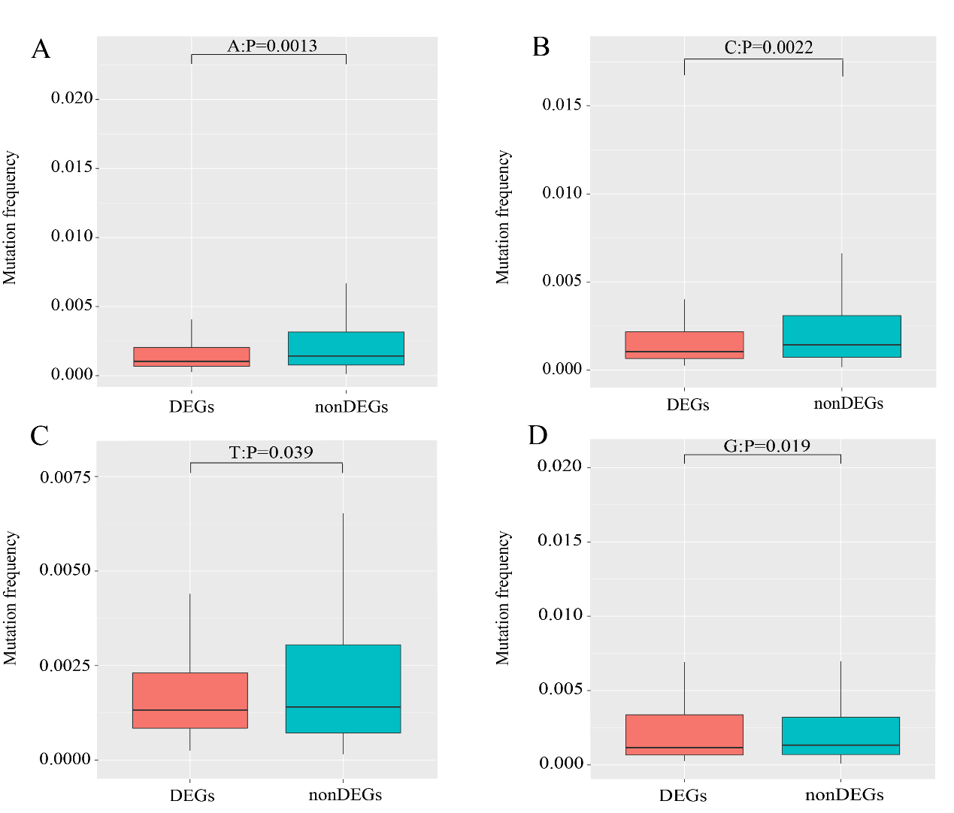
Figure S3 Comparison SNP mutation frequency between DEGs and non-DEGs in A, C, T and G four categories (A: A base; B: C base; C: T base; D: G base)

