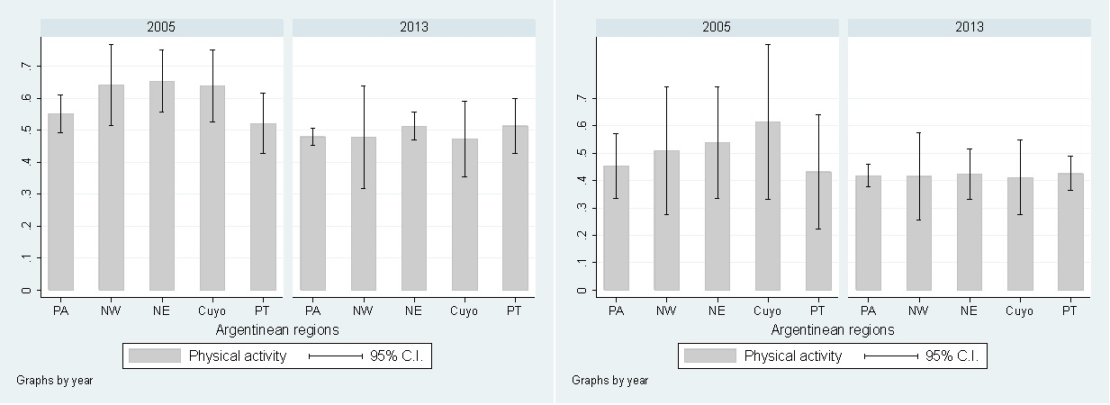
*p-value = 0.550
*p-value = 0.129
B
A
Supplementary figure 4. Prevalence of physical activity in Argentina according to geographical regions and stratified by gender (A - Prevalence of physical activity in men; B - Prevalence of physical activity in women).
*p-value for second order interaction between region and survey’s year.
PA = Pampeana; NW = Northwest; NE = Northeast; PT = Patagonica

