Supplementary Information

Interaction effect of serum serotonin level and age on the 12-week pharmacotherapeutic response in patients with depressive disorders

Wonsuk Choiª, Ju-Wan Kim^{b}, Hee-Ju Kang^{b}, Hee Kyung Kimª, Ho-Cheol Kangª, Ju-Yeon Lee^{b}, Sung-Wan Kim^{b}, Robert Stewart^{c,d}, and Jae-Min Kim^{b}

ªDepartment of Internal Medicine, Chonnam National University Hwasun Hospital, Chonnam National University Medical School, Hwasun, Korea, ^{b}Department of Psychiatry, Chonnam National University Medical School, Gwangju, Korea, ^{c} King’s College London, Institute of Psychiatry, Psychology and Neuroscience, London, UK, ^{d} South London and Maudsley NHS Foundation Trust, London, UK

Supplementary Table 1.
Baseline characteristics based on age in patients with depressive disorders
 |  |  |  | Up to 12-week treatment (N = 1086)
 |  |  | <60 years (N = 567) |  | ≥60 years (N = 519) | Statistical coefficientsª | P-value
Gender, N (%) female |  |  | 385 (67.9) |  | 360 (69.4) | χ² = 0.269 | P = 0.604
Education, mean (SD) years |  |  | 11.5 (3.7) |  | 6.5 (4.5) | t = 19.548 | P < 0.001
Marital status, N (%) unmarried |  |  | 179 (31.6) |  | 147 (28.3) | χ² = 1.359 | P = 0.244
Living alone, N (%) |  |  | 61 (10.8) |  | 106 (20.4) | χ² = 19.454 | P < 0.001
Religious observance, N (%) |  |  | 287 (50.6) |  | 320 (61.7) | χ² = 13.396 | P < 0.001
Unemployed status, N (%) |  |  | 156 (30.2) |  | 160 (28.1) | χ² = 0.614 | P = 0.433
Monthly income, N (%) <2,000 USD |  |  | 233 (41.1) |  | 415 (80.0) | χ² = 170.104 | P < 0.001
Body mass index, mean (SD) kg/m² |  |  | 23.1 (3.4) |  | 23.4 (3.0) | t = -1.643 | P = 0.101
Major depressive disorder, N (%) |  |  | 481 (84.8) |  | 444 (85.5) | χ² = 0.110 | P = 0.740
Melancholic feature, N (%) |  |  | 71 (12.5) |  | 91 (17.5) | χ² = 5.362 | P = 0.021
Atypical feature, N (%) |  |  | 56 (9.9) |  | 13 (2.5) | χ² = 24.748 | P < 0.001
Age at onset, mean (SD) years |  |  | 41.6 (13.0) |  | 63.1 (12.5) | t = -27.804 | P < 0.001
Duration of illness, mean (SD) years |  |  | 4.3 (7.1) |  | 5.9 (10.7) | t = -2.815 | P = 0.005
Recurrent depression, N (%) |  |  | 318 (56.1) |  | 252 (48.6) | χ² = 6.161 | P = 0.013
Number of depressive episodes, mean (SD) |  |  | 1.2 (1.6) |  | 0.9 (1.3) | t = 3.053 | P = 0.002
Duration of present episode, mean (SD) months |  |  | 7.4 (10.2) |  | 7.4 (10.6) | t = -0.133 | P = 0.894
Family history of depression, N (%) |  |  | 100 (17.6) |  | 58 (11.2) | χ² = 9.100 | P = 0.003
History of suicide attempt, N (%) |  |  | 76 (13.4) |  | 19 (3.7) | χ² = 32.233 | P < 0.001
Number of physical disorders, mean (SD) |  |  | 1.2 (1.2) |  | 2.1 (1.3) | t = -11.302 | P < 0.001
Hamilton Depression Rating Scale |  |  | 20.8 (4.2) |  | 20.7 (4.1) | t = 0.201 | P = 0.841
Hospital Anxiety & Depression Scale-anxiety subscale |  |  | 12.4 (4.2) |  | 11.2 (3.8) | t = 4.767 | P < 0.001
EuroQol-5D |  |  | 8.9 (1.5) |  | 9.0 (1.6) | t = -1.431 | P = 0.153
Social and Occupational Functional Assessment Scale |  |  | 55.5 (7.3) |  | 56.4 (7.6) | t = -1.892 | P = 0.059
ªIndependent two sample t-test or χ² test, as appropriate.

Supplementary Table 2.
Baseline characteristics based on initial antidepressant type in patients with depressive disorders
 |  |  |  | Up to 12-week treatment (N = 1086)
 |  |  | SSRIs (N = 672) |  | Non-SSRIs (N = 414) | Statistical coefficientsª | P-value
Age, mean (SD) years |  |  | 56.1 (15.4) |  | 58.3 (14.0) | t = -2.386 | P = 0.017
Gender, N (%) female |  |  | 450 (67.0) |  | 295 (71.3) | χ² = 2.191 | P = 0.139
Education, mean (SD) years |  |  | 9.2 (4.8) |  | 8.9 (4.8) | t = 1.232 | P = 0.218
Marital status, N (%) unmarried |  |  | 210 (31.3) |  | 116 (28.0) | χ² = 1.273 | P = 0.259
Living alone, N (%) |  |  | 100 (14.9) |  | 67 (16.2) | χ² = 0.334 | P = 0.563
Religious observance, N (%) |  |  | 370 (55.1) |  | 237 (57.2) | χ² = 0.497 | P = 0.481
Unemployed status, N (%) |  |  | 187 (27.8) |  | 129 (31.2) | χ² = 1.379 | P = 0.240
Monthly income, N (%) <2,000 USD |  |  | 392 (58.3) |  | 256 (61.8) | χ² = 1.306 | P = 0.253
Body mass index, mean (SD) kg/m² |  |  | 23.2 (3.1) |  | 23.3 (3.4) | t = -0.427 | P = 0.669
Major depressive disorder, N (%) |  |  | 564 (83.9) |  | 361 (87.2) | χ² = 2.169 | P = 0.141
Melancholic feature, N (%) |  |  | 96 (14.3) |  | 66 (15.9) | χ² = 0.554 | P = 0.457
Atypical feature, N (%) |  |  | 44 (6.5) |  | 25 (6.0) | χ² = 0.112 | P = 0.738
Age at onset, mean (SD) years |  |  | 1.5 (0.5) |  | 1.5 (0.5) | t = 0.036 | P = 0.971
Duration of illness, mean (SD) years |  |  | 4.8 (8.9) |  | 5.6 (9.2) | t = -1.435 | P = 0.152
Recurrent depression, N (%) |  |  | 345 (51.3) |  | 225 (54.3) | χ² = 0.930 | P = 0.335
Number of depressive episodes, mean (SD) |  |  | 1.0 (1.4) |  | 1.2 (1.6) | t = -1.600 | P = 0.110
Duration of present episode, mean (SD) months |  |  | 7.0 (9.8) |  | 8.0 (11.4) | t = -1.433 | P = 0.152
Family history of depression, N (%) |  |  | 98 (14.6) |  | 60 (14.5) | χ² = 0.002 | P = 0.967
History of suicide attempt, N (%) |  |  | 65 (9.7) |  | 30 (7.2) | χ² = 1.889 | P = 0.169
Number of physical disorders, mean (SD) |  |  | 1.5 (0.5) |  | 1.5 (0.5) | t = -0.083 | P = 0.933
Hamilton Depression Rating Scale |  |  | 20.4 (4.0) |  | 21.3 (4.4) | t = -3.512 | P < 0.001
Hospital Anxiety & Depression Scale-anxiety subscale |  |  | 12.0 (4.2) |  | 11.6 (3.8) | t = 1.602 | P = 0.110
EuroQol-5D |  |  | 8.9 (1.5) |  | 9.0 (1.5) | t = -1.994 | P = 0.046
Social and Occupational Functional Assessment Scale |  |  | 56.7 (7.1) |  | 54.7 (7.8) | t = 4.465 | P < 0.001
ªIndependent two sample t-test or χ² test, as appropriate.

Supplementary Table 3
Individual effects of baseline serum 5-HT level and age on 12-week remission based on type of initial antidepressant
Exposure | Group | 12-week remission
 |  | SSRIs (N = 672) |  |  | Non-SSRIs (N = 414)
 |  | No. (%) presence | OR (95% CI) |  | No. (%) presence | OR (95% CI)
 |  |  | Unadjusted | Adjustedª |  | Unadjusted | Adjustedª
Serum 5-HT | Lower | 149 (45.4) | 1.00 | 1.00 | 85 (39.5) | 1.00 | 1.00
 | Higher | 166 (48.3) | 1.12 (0.83-1.52) | 1.14 (0.83-1.58) | 90 (45.2) | 1.26 (0.85-1.87) | 1.15 (0.76-1.74)
Age | <60 | 162 (44.8) | 1.00 | 1.00 | 80 (39.0) | 1.00 | 1.00
 | ≥60 | 153 (49.4) | 1.20 (0.89-1.63) | 1.00 (0.60-1.66) | 95 (45.5) | 1.30 (0.88-1.93) | 0.86 (0.43-1.70)
ªAdjusted for education, living alone, religious observance, monthly income, melancholic feature, atypical feature, age at onset, duration of illness, recurrent depression, number of depressive episodes, family history of depression, history of suicide attempt, number of physical disorders, HADS-A, and SOFAS.

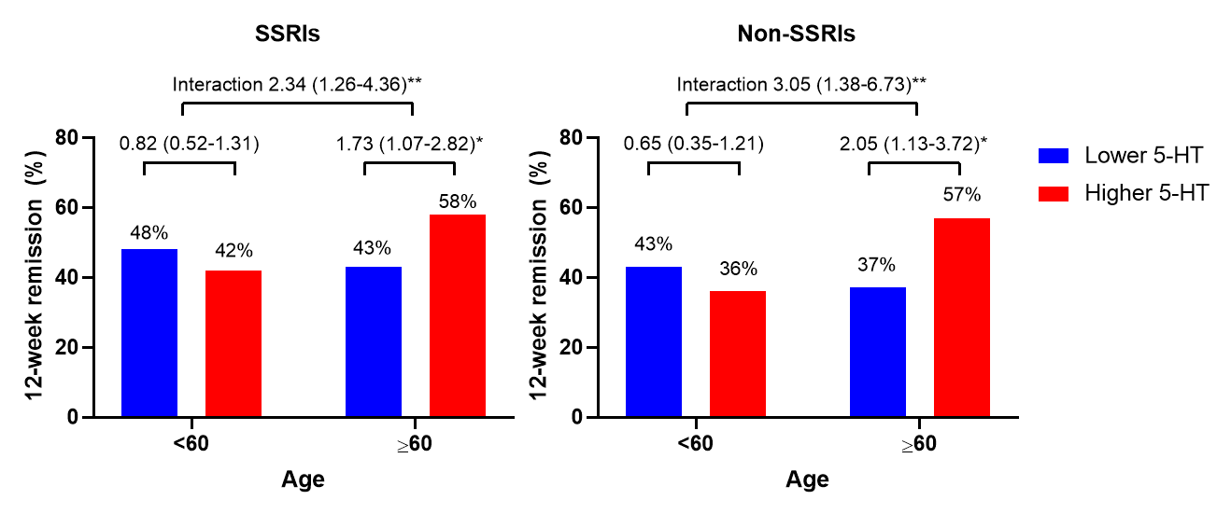
Supplementary Figure 1.
The 12-week remission rates according to baseline serum 5-HT level and age based on initial antidepressant type. Data are presented as odds ratios (95% confidence intervals) adjusted for educational level, living alone, religious observance, monthly income, melancholic features, atypical features, age at onset, duration of illness, recurrent depression, number of depressive episodes, family history of depression, history of suicide attempt, number of physical disorders, HADS-A score, and SOFAS score evaluated at baseline. *P < 0.05; **P < 0.01.

